**Lift your operations with our comprehensive Service Department!**

Set sail on a journey of efficiency and quality with Marine Fluid Technology's Service Department, specialized in pipe modification and fitting.

We understand the unique challenges faced in maritime operations, and our dedicated professional crew, including highly skilled fitters and certified welders, stands ready to navigate through these with precision and expertise.

**Why trust our Service Department?**

Specialized Expertise: Our team of experts with extensive knowledge from the shipping industry includes skilled fitters and certified welders. All work is executed according to EU standards, while ensuring quality complied with required Classification.

At Marine Fluid Technology we always have safety in mind, from entering the workplace till leaving a secure and clean worksite.

Timely Solutions: In a sector where time is of the essence, rely on our service department for prompt, reliable and efficient solutions. Our certified fitters and welders are always flexible, solution orientated and equipped to minimize downtime and keep vessels operating at peak performance.

Innovative Technology: With the hands-on skills of our team, we can help every aspect from planning, installation, commissioning and thereby diagnose issues, providing predictive maintenance, and implement solutions that benefits our customers.

Tailored Approach: Recognizing that each vessel has unique needs, our services, including those provided by our service team, are customizable to ensure a personalized approach that maximizes efficiency and cost-effectiveness. Onboard pre-inspections can be performed to ensure smooth installation and implementation.

We can provide custom designed material packages for each project/vessel, with traceable and class approved material.

24/7 Support: Operations in the shipping industry are 24/7, and so is our support. Our dedicated team is available round the clock, ready to assist whenever and wherever needed.

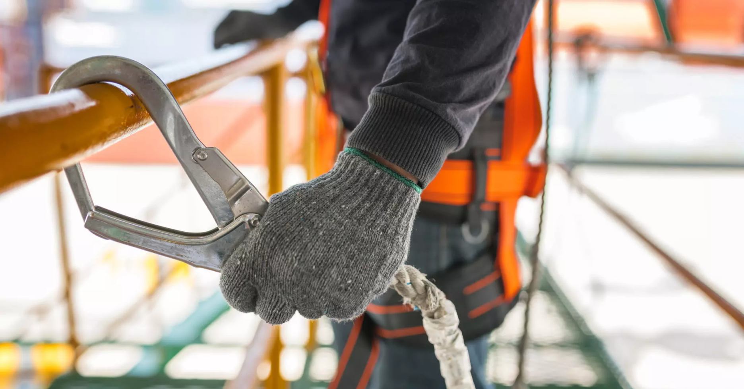

**Services We Offer:**

Maintenance and Repairs: From routine maintenance to complex repairs, our skilled technicians, including highly skilled fitters and certified welders, collaborate to keep vessels in excellent condition.



Offerings are among others:

* Pre-inspection
* Survey
* Project planning & execution
* Cable pulling



* Cable tray assembly
* Skilled in Hot works
* Working with scaffolding
* Pipe modification
* Installation of equipment



* Turnkey project installations

Upgrades and Retrofits: Stay ahead of the curve by upgrading your fleet with the latest technologies and benefit from our fabrication expertise for tailored solutions.

Performance Optimization: Improve fuel efficiency, reduce emissions, and boost overall performance through our optimization SEA-Mate® solutions.

Consultation Services: Tap into our industry expertise for valuable insights and strategic advice on improving your fleet's performance.

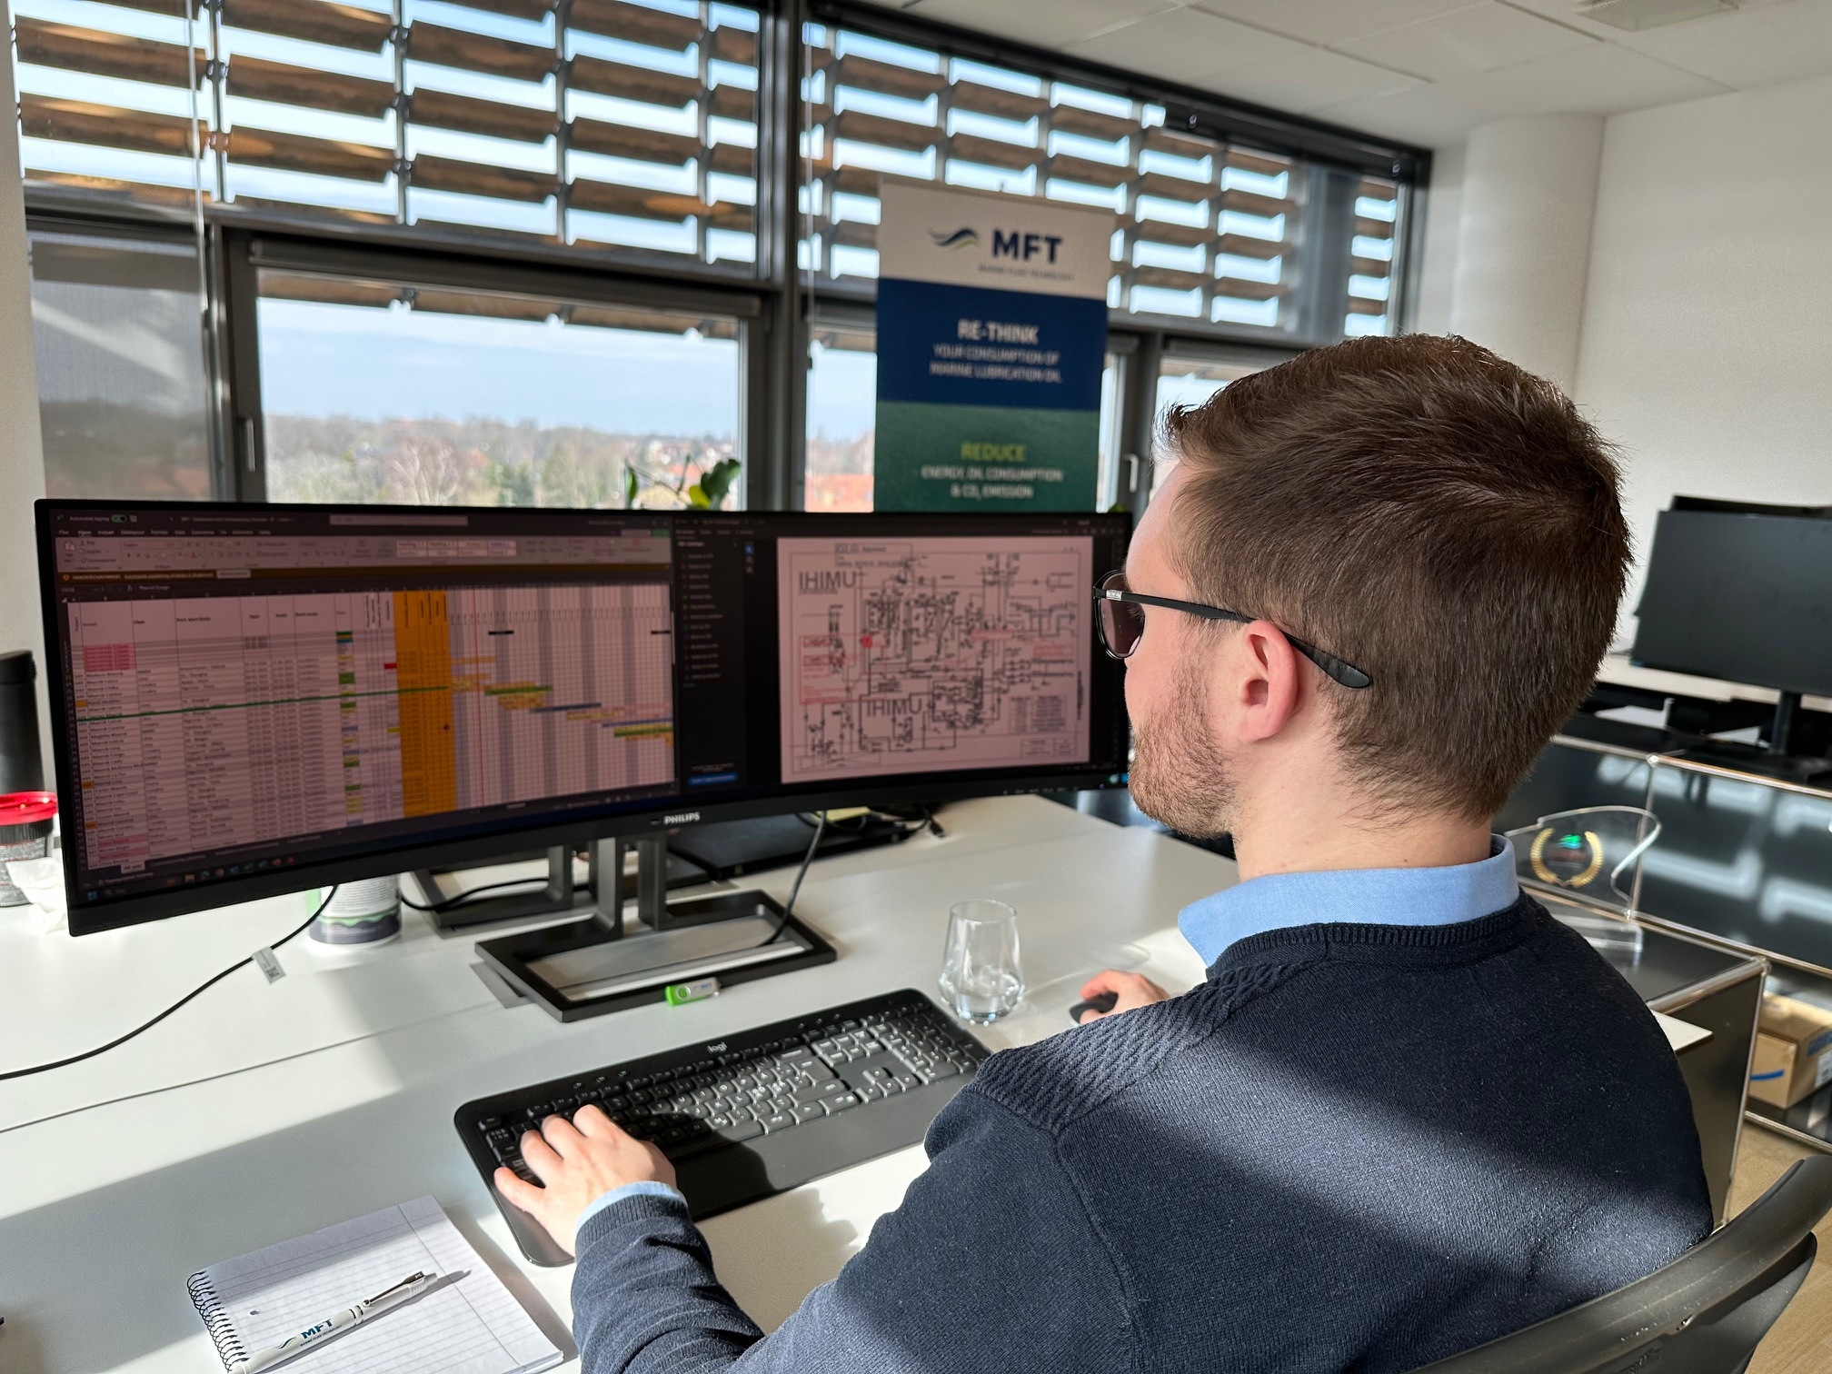

Partner with Marine Fluid Technology, where exceptional service meets the demands of the maritime world.

Let us be your partner in success at sea.

Contact us directly today on: [mftservice@marinefluid.dk](mailto:mftservice@marinefluid.dk) and allow us to provide you a highly skilled, reliable, and efficient team.