BYS Grup is a leading technology and R&D company established in 2010 and located in Gazi Technopark that aims to provide services in the fields of advanced analytics, information technologies (IT), data mining and artificial intelligence. BYS Grup provides project management, engineering, consultancy, and training services to many national and international reputable business partners in the public and private sectors with innovative solutions in the fields of digitalization, technology, and data management to improve their brand value and corporate capacity:

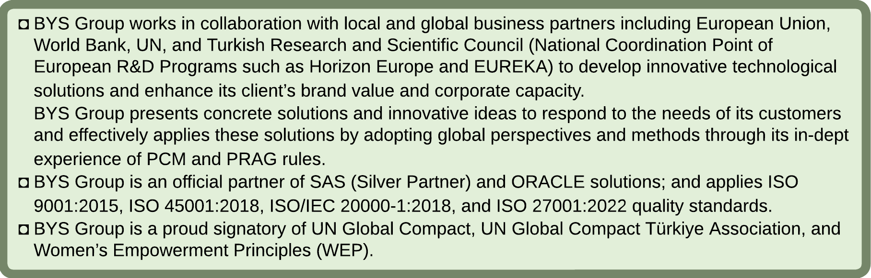

BYS Group’s Knowledge Capitalization is based on the pillars of Quality Management and Knowledge Management, Personnel and Knowledge Capitalization, Company Culture. We consider Quality Management system as part of our knowledge capital. Our view of Knowledge Capitalization and Quality Management is summarized in the figure below.

*Figure 1:Knowledge Capitalization and Quality Management of BYS Grup*

BYS GRUP has 4 quality certificates:

1) ISO 27001:2022 – The Information Security Management System

2) ISO/IEC 20000-1: 2018 – Information Technology Service Management System

3) ISO 9001:2015 – The Quality Management System

4) ISO 45001:2018 – Occupational Health and Safety Management System

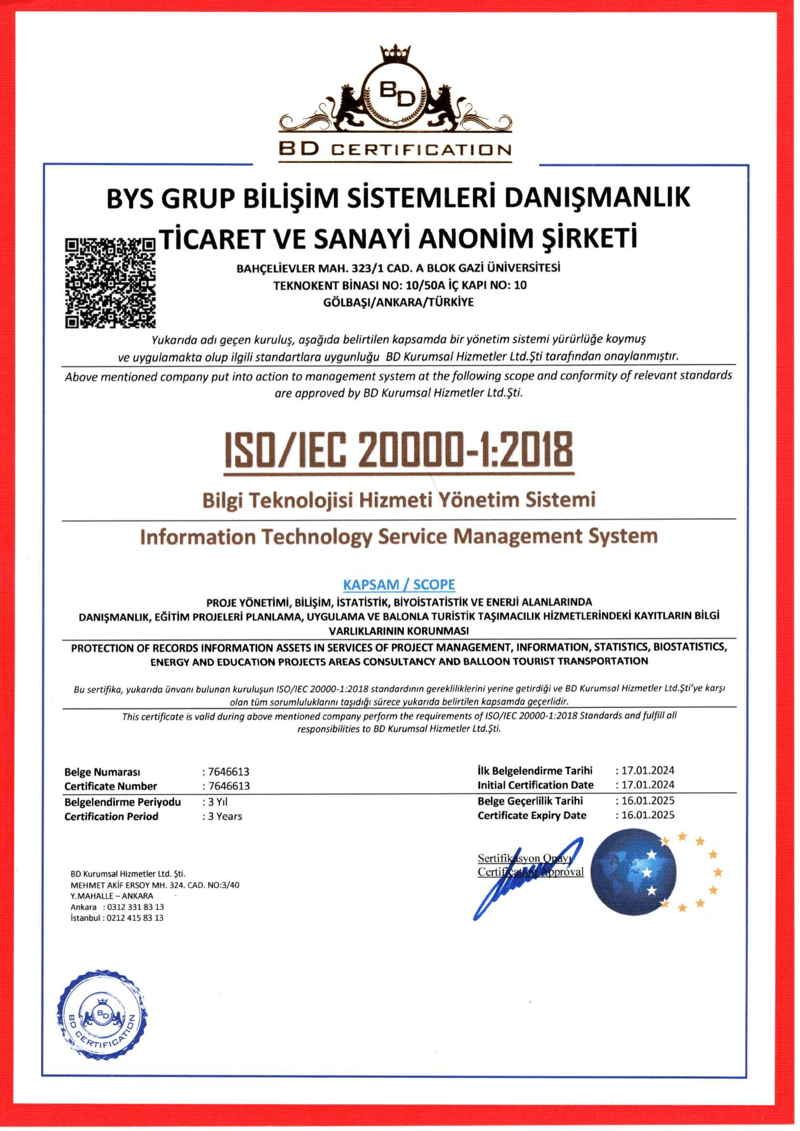 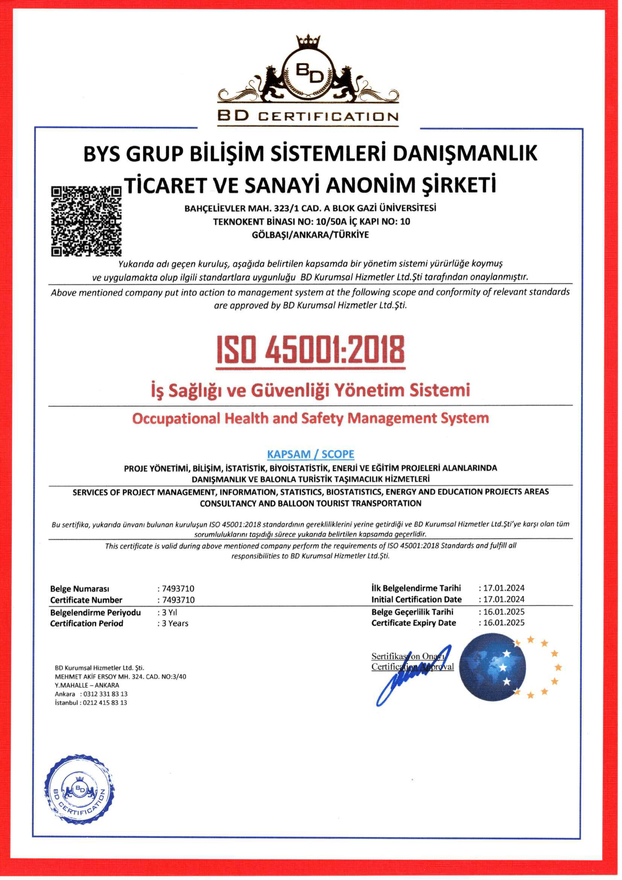 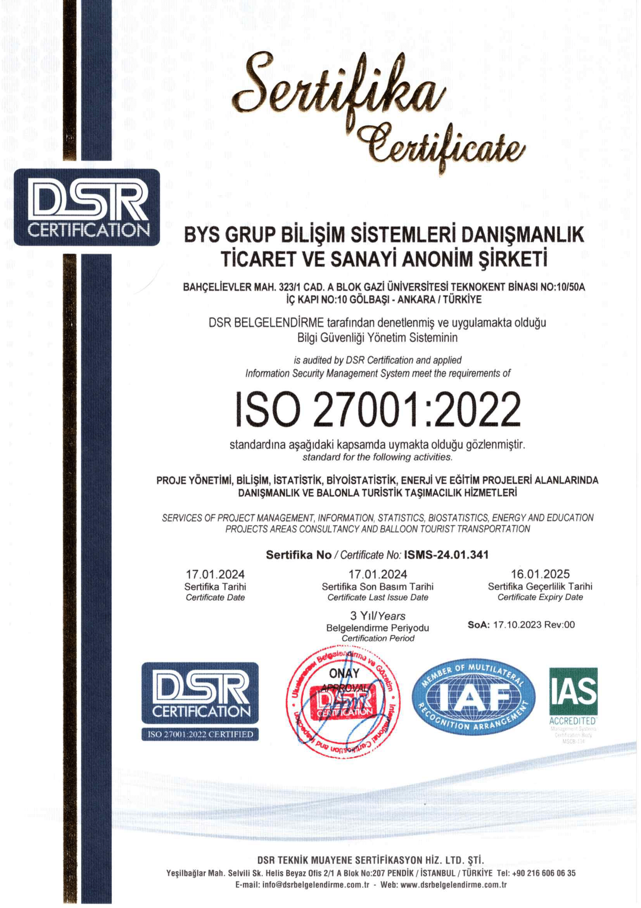

*Figure 2: BYS Grup's ISO Certificates*

In addition, BYS Grup has licences like SAS Advanced Analytics (SAS Enterprise Miner, SAS Enterprise Guide, SAS Forecasting, SAS data Quality-Data Flux, SAS IML, SAS Jump, SAS Connectors, SAS BI), and ORACLE Data Management (ORACLE Big Data and Analytics, ORACLE Big Data Appliance, ORACLE Data Miner, ORACLE ETL, ORACLE BI, ORACLE DWH).

BYS Grup’s headquarters is situated in Gazi Teknopark, Ankara, Türkiye. In addition to the main office, BYS maintain two separate project offices and sister companies that locates in İstanbul and Ankara. Furthermore, BYS Grup has expanded its presence to oversees; an affiliated company BYS Munich GmbH is based in Munich, Germany, which actively develops new projects for the company group. BYS Grup’s affiliated companies works in the fields of Genomics, Data Analytics, and Software and IT. BYS has implemented over 30 projects financed by the EU, the UN, the World Bank, and other international donors. In addition, BYS Grup currently implements two AI- based projects within the Southeast Asian and Oceania regions, namely Thailand, the Philippines, and Indonesia. Moreover, as BYS Group, we implemented many projects at the regional and national levels for Ministries, Governmental Agencies, Councils, and Universities. BYS Grup is specialized on the provision of the following services:

*Figure 3: BYS Grup's Area of Expertise*