**TÜBİTAK MARMARA RESEARCH CENTER**

**HYDROGEN AND FUEL CELL TECHNOLOGIES RESEACH GROUP**

**INFORMATION NOTE**

TÜBİTAK MAM – Hydrogen and Fuel Cell Technologies Research Group (HYPTAG) has been carrying out project-based R&D studies in the field of hydrogen technologies and applications for more than 22 years. The current main areas of activity and anticipated technology development areas are given below.

1. Green and blue hydrogen production technologies,

2. PEM type fuel cell technologies,

3. Hydrogen storage technologies,

4. Electrochemical production of green ammonia,

5. Electrochemical carbon dioxide evaluation technologies,

6. The use of hydrogen in the energy, industry, transportation and building sectors, and its conversion into fuel and valuable chemicals

The Group continues its activities on the subjects of reducing CO2 emissions, as well as research and activities aimed at the development and application of technologies within the hydrogen value chain, which includes hydrogen production, transmission, transportation and storage, thus reducing foreign dependency on energy and increasing our market share.

TÜBİTAK MAM - HYPTAG has been involved in more than 35 national and international projects (EU 6th, 7th and Horizon framework programs, CEPA program, etc.) in the field of hydrogen technologies as coordinator and/or partner. Some of our ongoing national and international products / projects developed by HYPTAG listed below:

1. “Powering EU Net Zero Future by Escalating Zero Emission Heavy Duty Trucks and Logistic Intelligence –ESCALATE” -HORIZON-CL5-2022-D5-01 Clean and Competitive Solutions for all Transport Modes” - Ongoing
2. “South Marmara Hydrogen Shore_HYSouthMarmara”- HORIZON-JTI-CLEANH2-2022-06-02- Hydrogen Valleys (small-scale) – Ongoing

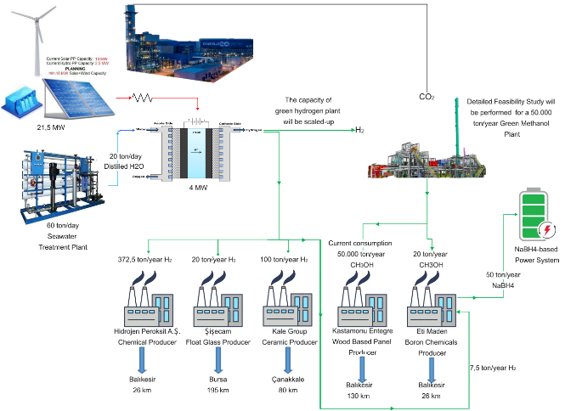

1. South Marmara Hydrogen Shore Platform Green Hydrogen Production Facility Project- Ongoing
2. Development of a Low Cost Membrane Electrode Assembly (MEA) for Fuel Cells for Marine Applications – LOCOMOTION – Martera 2021- Ongoing
3. Automotive Compatible PEM Type Fuel Cell Module and System Components Development and Integration Project – Ongoing
4. Fuel Cell and Electrolyser Technologies Development and Test Centre Project – Ongoing
5. PEM Type Electrolyser Development Project – Completed
6. Field Application of PEM Fuel Cell Microcogeneration System-Completed