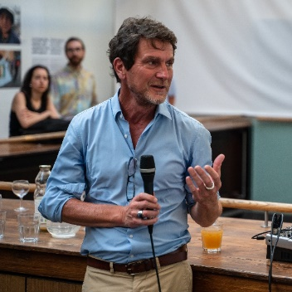

Bertrand Bainvel, a French national, is the UNICEF Representative to the European Union Institutions and the Director of UNICEF Partnerships Office in Brussels since 13 February 2023.

Previously, Mr. Bainvel was the Deputy Regional Director for UNICEF Middle East and North Africa.

Before his role in the MENA region, he served as UNICEF Representative in the Republic of the Union of Myanmar. Mr. Bainvel served as UNICEF Head of the Partnership Office in Moscow, and Representative in the Russian Federation, and UNICEF Representative in Jamaica. Other postings held by Mr. Bainvel were Deputy to the UNICEF Special Representative in Jerusalem, State of Palestine, Programme Officer with the UNICEF Health Section in New York, USA, and assignments in Albania and Mongolia. Prior to joining UNICEF in 1993, he worked in various capacities with financial and marketing private sector companies in France.

He holds a Master’s degree in Business Administration, from the Ecole des Hautes Etudes Commerciales (H.E.C, Paris, France), and a Master’s degree in Public Administration from the Kennedy School of Government at Harvard University, Cambridge, United States of America.