
H2Vector
Energy
Technologies
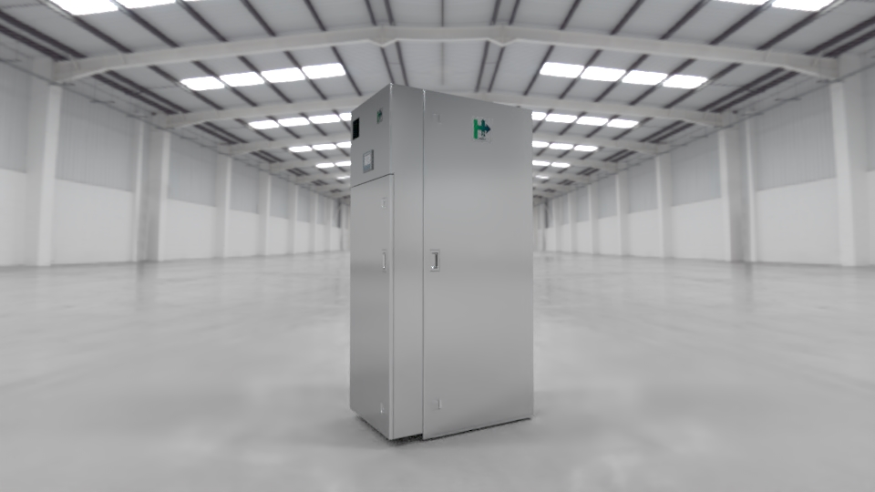
October 2025
PRODUCTS
Thrusting Ideas

Energy moves and connects us, it alllows our society development and growth.
For our environment, health and well-being, energy must be sustainable and non-polluting.

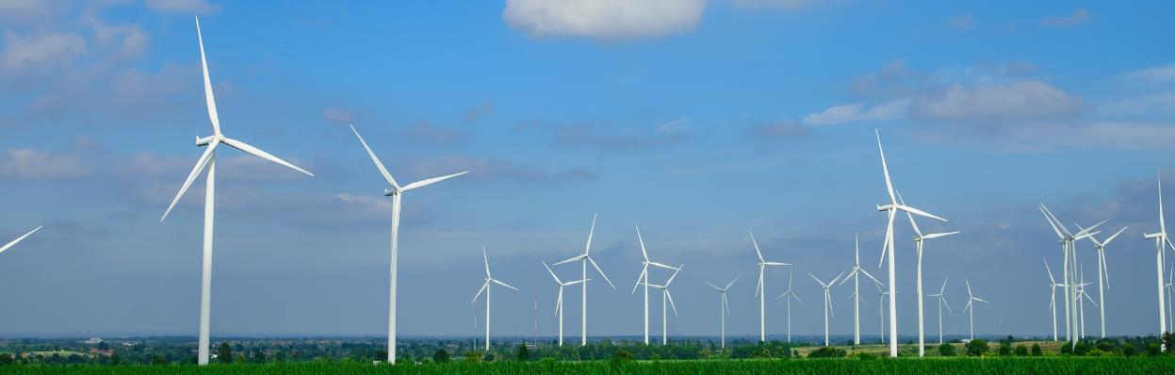
Hydrogen is the key factor to maximize and promote the use of renewable energy sources, generating a clean and safe energy cycle.

H2Vector offers comprehensive, modular and scalable solutions based on hydrogen that contribute to achieving better energy for everyone.

H2Vector Energy Technologies S.L. was born with the aim of offering new solutions addressed to the adoption of a self-sufficient, circular and climate-neutral energy model.

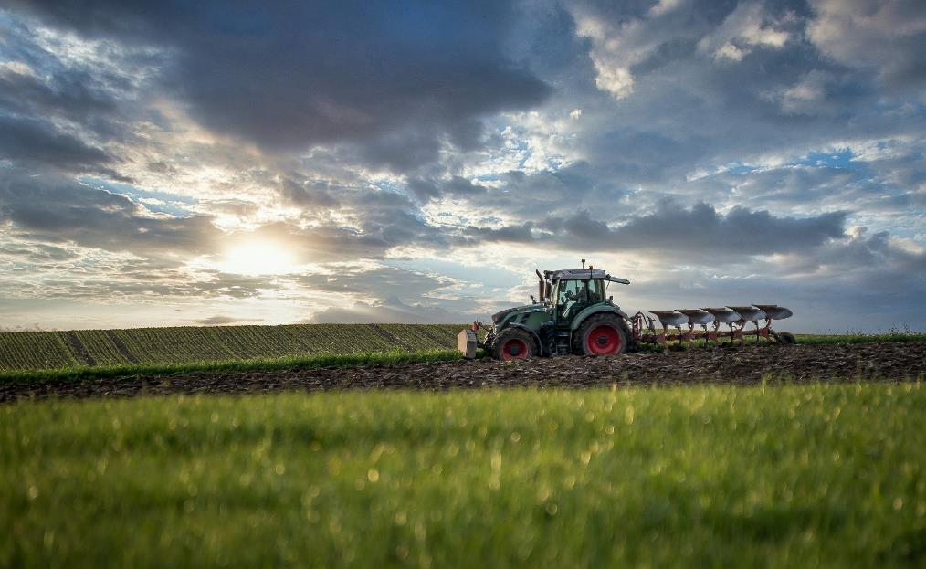
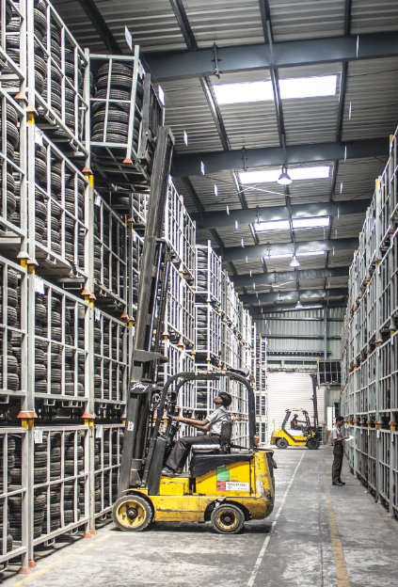

SECTORS
Our products and developments facilitate the transition to cleaner energy in different sectors and applications.
- Industrial machinery (forklifts, elevators, cranes, robots, cleaning machinery, among others).
- Mobility in the agricultural sector.
- Fuel cell light vehicles, trucks, boats or motorcycles.
- Electricity and heat generation system in hotels, homes and recreation centers.

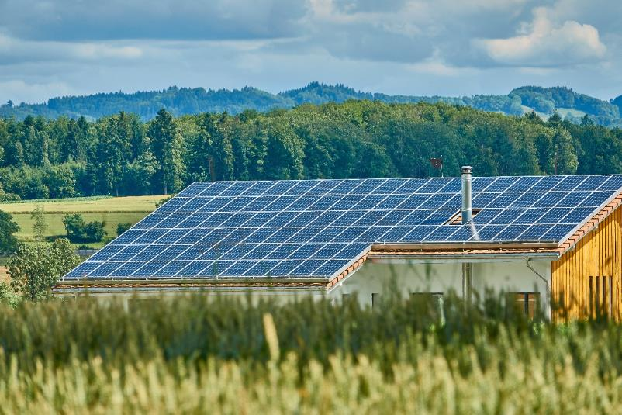
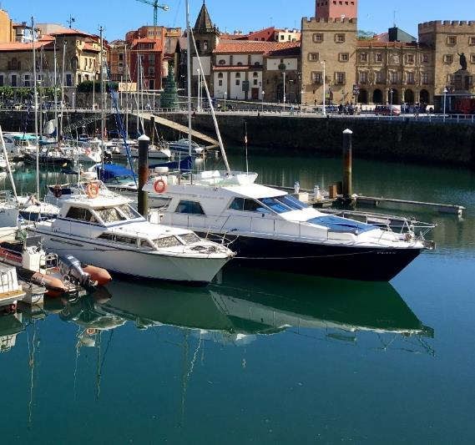

HYDROGEN SOLUTIONS FOR A SUSTAINABLE FUTURE

WHERE WE ACT






















Energy models based on green Hydrogen.

H₂
O₂
H₂0







Energy Security
Ssytems

Sustainable
Clean Tech

RESEARCH AND DEVELOPMENT

INNOVATIVE IDEAS FOR SUSTAINABLE SOLUTIONS

TECHNOLOGICAL DEVELOPMENTS TOWARDS A NEW ENERGY MODEL

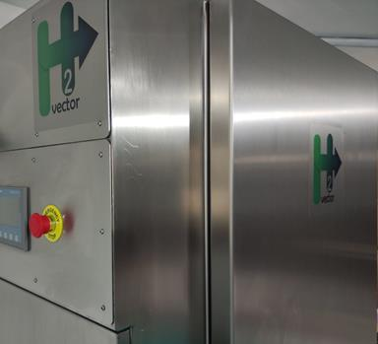
PRODUCTS
Product development is H2Vector´s heart and soul.

Our products seize the following key concepts:
- Adaptability to your Use case
- Easy to Install and Operate
- Smart process integration and interaction. Control your energy flow.

VECTOR SERIES

A Hydrogen Energy Management System to take full advantage of your renewable energy.

PET SERIES

Fuel cell systems designed to provide green energy in stationary and mobile applications.

Vector2DYNA - HYDROGEN SUPPLIER

Easy, quick and safe access to your new environmentally friendly fuel.
SISTEMA DE GESTIÓN DE ENERGÍA DE HIDRÓGENO
VECTOR SERIES
HYDROGEN ENERGY MANAGEMENT SYSTEM (HEMS)
The VECTOR Series products allows maximum use of renewable energy sources, using hydrogen to store their surpluses.












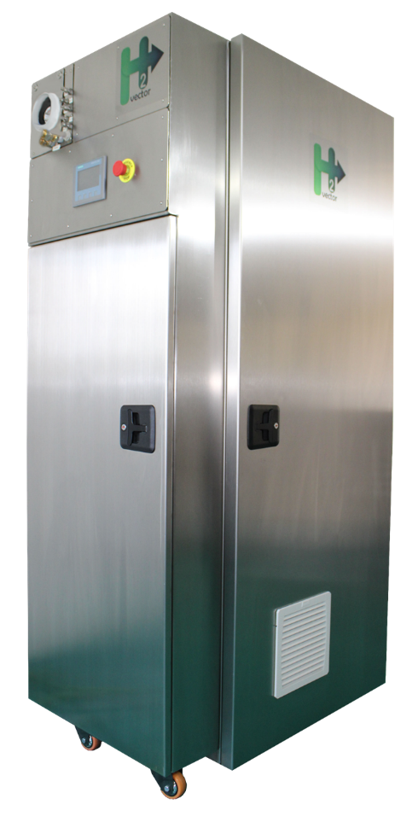
MOBILITY APPLICATIONS
H₂
FUEL CELL
HEAT SUPPLY
COMPRESSION UNIT
AUTOMATED & CONNECTED
ANY RENEWABLE SOURCES
SCALABLE
AC OUTLET
ELECTROYSER
WATER TREATMENT PLANT
CO₂
neutral
0% CO₂ EMISSIONS
OUTDOOR / INDOOR
PLUG & PLAY
MOBILITY APPLICATIONS

A sustainable solution that provides electricity and heat, without interruptions or CO₂ emissions.
Designed and manufactured with strict controls, risk analysis (Hazop / Sil) and CE certification, for efficient and safe energy management.

UTILITY MODEL – Publication number: ES1271780, Owner project: H2Vector Energy Technologies S.L.

HYDROGEN ENERGY MANAGEMENT SYSTEM (HEMS) | Technical Specifications

COMPARATIVE TABLE
VECTOR SERIES |  | VECTOR 10 |  |  | VECTOR 20 |  |  | VECTOR 40 |  |  | VECTOR 80 |  | VECTOR 160
MODEL |  | Vector 10 STD | Vector 10 + | Vector 10 Premium | Vector 20 | Vector 20 HRS | Vector 20 P2X | Vector 40 | Vector 40 HRS | Vector 40 P2X | Vector 80 HRS | Vector 80 P2X | Vector 160 HRS | Vector 160 P2X
HYDROGEN PRODUCTION | Number of Electrolysers | 1 |  |  | 2 |  |  | 4 |  |  | 8 |  | 16
HYDROGEN PRODUCTION | Hydrogen Production | 0,5 Nm³/h |  |  | 1 Nm³/h |  |  | 2 Nm³/h |  |  | 4 Nm³/h |  | 8 Nm³/h
HYDROGEN PRODUCTION | Hydrogen Outlet Pressure | Up to 350 barg |  |  | Up to 350 barg |  |  | Up to 350 barg |  |  | Up to 350 barg |  | Up to 350 barg
ELECTRICAL AND HEAT PRODUCTION | Equivalent Fuel Cell | PET-7 |  |  | PET-7 |  |  | PET-13 |  |  | 2 x PET-10 |  | 2 x PET-13
ELECTRICAL AND HEAT PRODUCTION | Technology | PEM |  |  | PEM |  |  | PEM |  |  | PEM |  | PEM
ELECTRICAL AND HEAT PRODUCTION | Maximum Electricity Production (Gross) | 6,8 kW |  |  | 6,8 kW |  |  | 13,6 kW |  |  | 21,2 kW |  | 27,2 kW
ELECTRICAL AND HEAT PRODUCTION | Maximum Heat Production | 6,8 kW |  |  | 6,8 kW |  |  | 13,6 kW |  |  | 21,2 kW |  | 27,2 kW
ELECTRICAL AND HEAT PRODUCTION | Output Option AC 400 V 3P or DC 25 - 800 V | 
HYDROGEN REFUELING STATION (HRS)

DC Output Voltage:

Vector 10: VDC 25-80
Vector 20: VDC 25-80
Vector 40: VDC 100-300
Vector 80: VDC 220-740
Vector 160: VDC 200-780
HYDROGEN ENERGY MANAGEMENT SYSTEM (HEMS) |  |  | TECHNICAL SPECIFICATIONS
 |  | VECTOR 10 |  | VECTOR 20 +
HYDROGEN PRODUCTION
Number of Electrolysers |  | 1 |  | 2
Hydrogen Production Capacity |  | 0,5 Nm³/h |  | 1 Nm³/h
Hydrogen Production Quality |  | 99,9% ³ |  | 99,9% ³
Hydrogen Output Pressure |  | up to 350 barg |  | up to 350 barg
Power Consumption with BOP |  | 6 kWh rated peak |  | 10 kWh rated peak ¹
Feed Water Quality |  | < 2 μS/cm |  | < 2 μS/cm
Feed Water Inlet Pressure |  | 1 - 4 barg |  | 1 - 4 barg
Electrolyser Operational Hours |  | >70.000 h |  | >70.000 h
Consumption in Hydrogen Production |  | 2,5 – 3,5 kWh |  | 5 – 10 kWh
ELECTRICAL AND HEAT PRODUCTION
Fuel Cell Model (FC) |  | PET-7 |  | PET-7
Peak Power Output DC |  | 6,8 kW Electrical  + 6,8 kW Heat |  | 6,8 kW Electrical  + 6,8 kW Heat
Voltage DC ⁴ |  | 25 - 80 V |  | 25 - 80 V
Current DC |  | 0 - 250 A |  | 0 - 250 A
Auxiliary Electricity Consumption + Heat Generation |  | 1,5 kWh |  | 1,5 kWh
Maximum Hydrogen Consumption |  | 80 Nl/min |  | 80 Nl/min
External Fuel Minimum Quality |  | Grade D ISO 14687-2:2008 |  | Grade D ISO 14687-2:2008
Fuel Cell Operational Hours |  | 24.000 h |  | 24.000 h
GENERAL
Cooling System |  | Air or Water cooled |  | Air or Water cooled
Closed Cooling Water Quality |  | < 10 μS/cm |  | < 10 μS/cm
Open Cooling Water Pressure |  | 1 - 10 barg |  | 1 - 10 barg
Open Cooling Water Temperature |  | < 50 ºC |  | < 50 ºC
Room Temperature |  | 5 - 45 ºC |  | 5 - 45 ºC
Dimensions (mm) (WxDxH) |  | 1000 x 650 x 2000 |  | 1000 x 650 x 2000
HYDROGEN VEHICLE REFUELING STATION
FCV Supply |  | Optional ³ |  | Optional ³

¹ Air compression power consumption accounted. Air compression unit NOT included.
² Output option to choose between AC 400V 3P or DC 500V.
³ Vector 10 HRS, Vector 10 P2X, Vector 20 HRS and Vector 20 P2X models have a refueling dispenser for hydrogen vehicles at 350 barg (pipeline up to 500 barg), with delivered hydrogen quality of 99.999%.

HYDROGEN ENERGY MANAGEMENT SYSTEM (HEMS) |  |  | TECHNICAL SPECIFICATIONS
 |  | VECTOR 40 |  | VECTOR 80
HYDROGEN PRODUCTION
Number of Electrolysers |  | 4 |  | 8
Hydrogen Production Capacity |  | 2 Nm³/h |  | 4 Nm³/h
Hydrogen Production Quality |  | 99,9% ³ |  | 99,999%
Hydrogen Output Pressure |  | up to 350 barg |  | up to 350 barg
Power Consumption with BOP |  | 22 kWh rated peak ¹ |  | 32 kWh rated peak ¹
Feed Water Quality |  | < 2 μS/cm |  | < 2 μS/cm
Feed Water Inlet Pressure |  | 1 - 4 barg |  | 1 - 4 barg
Electrolyser Operational Hours |  | >70.000 h |  | >70.000 h
Consumption in Hydrogen Production |  | 10 – 22 kWh |  | 20 – 32 kWh
ELECTRICAL AND HEAT PRODUCTION
Fuel Cell Model (FC) |  | PET-13 |  | PET-10
Peak Power Output DC |  | 13,6 kW Electrical  + 13,6 kW Heat |  | 21,2 kW Electrical  + 21,2 kW Heat
Voltage DC ⁴ |  | 93.2 - 58.9 V |  | 145,6 – 92,2 V
Current DC |  | 0 - 230 A |  | 0 - 230 A
Auxiliary Electricity Consumption + Heat Generation |  | 2,25 kWh |  | 4 kWh
Maximum Hydrogen Consumption |  | 160 Nl/min |  | 240 Nl/min
External Fuel Minimum Quality |  | Grade D ISO 14687-2:2008 |  | Grade D ISO 14687-2:2008
Fuel Cell Operational Hours |  | 24.000 h |  | 24.000 h
GENERAL
Cooling System |  | Air or Water cooled |  | Air or Water cooled
Closed Cooling Water Quality |  | < 10 μS/cm |  | < 10 μS/cm
Open Cooling Water Pressure |  | 1 - 10 barg |  | 1 - 10 barg
Open Cooling Water Temperature |  | < 50 ºC |  | < 50 ºC
Room Temperature |  | 5 - 45 ºC |  | 5 - 45 ºC
Dimensions (mm) (WxDxH) |  | 600 x 800 x 2200  + 1200 x 650 x 1500 |  | 2 x (600 x 800 x 2200)  + 1200 x 650 x 1500
HYDROGEN VEHICLE REFUELING STATION
FCV Supply |  | Optional ³ |  | Included ³

¹ Air compression power consumption accounted. Air compression unit NOT included.
² Output option to choose between AC 400V 3P or DC 500V.
³ Vector 40 HRS, Vector 40 P2X, Vector 80 HRS and Vector 80 P2X models have a refueling dispenser for hydrogen vehicles at 350 barg (pipeline up to 500 barg), with delivered hydrogen quality of 99.999%.
⁴ Fixed voltage in DC, customizable 25 – 800 V.

HYDROGEN ENERGY MANAGEMENT SYSTEM (HEMS) |  |  | TECHNICAL SPECIFICATIONS
 |  |  |  | VECTOR 160
HYDROGEN PRODUCTION
Number of Electrolysers |  |  |  | 16
Hydrogen Production Capacity |  |  |  | 8 Nm³/h
Hydrogen Production Quality |  |  |  | 99,999%
Hydrogen Output Pressure |  |  |  | up to 350 barg
Power Consumption with BOP |  |  |  | 51 kWh rated peak ¹
Feed Water Quality |  |  |  | < 2 μS/cm
Feed Water Inlet Pressure |  |  |  | 1 - 4 barg
Electrolyser Operational Hours |  |  |  | >70.000 h
Consumption in Hydrogen Production |  |  |  | 40 – 51 kWh
ELECTRICAL AND HEAT PRODUCTION
Fuel Cell Model (FC) |  |  |  | PET-13
Peak Power Output DC |  |  |  | 27,2 kW Electrical  + 27,2 kW Heat
Voltage DC ⁴ |  |  |  | 186,4 – 117,8 V
Current DC |  |  |  | 0 - 230 A
Auxiliary Electricity Consumption + Heat Generation |  |  |  | 5 kWh
Maximum Hydrogen Consumption |  |  |  | 320 Nl/min
External Fuel Minimum Quality |  |  |  | Grade D ISO 14687-2:2008
Fuel Cell Operational Hours |  |  |  | 24.000 h
GENERAL
Cooling System |  |  |  | Air or Water cooled
Closed Cooling Water Quality |  |  |  | < 10 μS/cm
Open Cooling Water Pressure |  |  |  | 1 - 10 barg
Open Cooling Water Temperature |  |  |  | < 50 ºC
Room Temperature |  |  |  | 5 - 45 ºC
Dimensions (mm) (WxDxH) |  |  |  | 4 x (600 x 800 x 2200)  + 1200 x 650 x 1500
HYDROGEN VEHICLE REFUELING STATION
FCV Supply |  |  |  | Included ³

¹ Air compression power consumption accounted. Air compression unit NOT included.
² Output option to choose between AC 400V 3P or DC 500V.
³ Vector 160 HRS and Vector 160 P2X models have a refueling dispenser for hydrogen vehicles at 350 barg (pipeline up to 500 barg), with delivered hydrogen quality of 99.999%.
⁴ Fixed voltage in DC, customizable 25 – 800 V.

PET SERIES
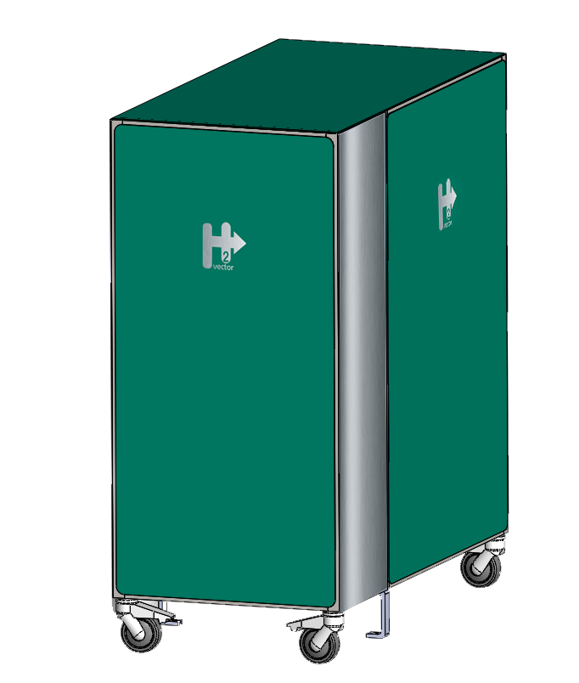
AC OR DC OUTPUT
CO₂
neutral
0% CO₂ EMISSIONS
SCALABLE
AUTOMATED & CONNECTED
PLUG & PLAY
OUTDOOR / INDOOR
MOBILITY APPLICATIONS
H₂
WATER TREATMENT PLANT
HEAT SUPPLY
FUEL CELL
COMPRESSION UNIT
PET Series consists of energy enabling equipment, which combines energy delivery and heat generation, all in an efficient and environmentally friendly way.
POWER ENABLING TECHNOLOGY (PET) | TECHNICAL SPECIFICATIONS

COMPARATIVE TABLE
PET SERIES | PET7 |  |  | PET10 |  |  | PET13 |  |  | PET20 |  | PET26 |  |  | PET50 |  | PET100 |  | PET250
MODEL | PET-7 STD | PET-7 + | PET-7 PREMIUM | PET-10-STD | PET-10 + | PET-10 PREMIUM | PET-13-STD | PET-13 + | PET-13 PREMIUM | PET-20 + | PET-20 PREMIUM | PET-26 + | PET-26 PREMIUM |  | PET-50 + | PET-50 PREMIUM | PET-100 + | PET-100 PREMIUM | PET-250 + | PET-250 PREMIUM
Number of PEM Fuel Cell (FC) Stacks | 1 |  |  | 1 |  |  | 1 |  |  | 2 |  | 2 |  |  | 4 |  | 8 |  | 20
Maximum Electricity Production (Gross) | 6,8 kW |  |  | 10,6 kW |  |  | 13,6 kW |  |  | 21,2 kW |  | 27,2 kW |  |  | 54,4 kW |  | 108,8 kW |  | 272 kW
Maximum Heat Production | 6,8 kW |  |  | 10,6 kW |  |  | 13,6 kW |  |  | 21,2 kW |  | 27,2 kW |  |  | 54,4 kW |  | 108,8 kW |  | 272 kW
Cooling System
AC 400 V 3P Output
DC V 25 - 800 Output

DC Output Voltage:

PET-7-DC/DC: VDC -25-80
PET-10-DC/DC: VDC -42-80
PET-13-DC/DC: VDC 100-300
PET-20-DC/DC: VDC 220-740
PET-26-DC/DC: VDC 200-780
PET-50-DC/DC: VDC 340-800

POWER ENABLING TECHNOLOGY (PET) |  |  | TECHNICAL SPECIFICATIONS
 |  | PET-7 |  | PET-10
ELECTRICAL AND HEAT PRODUCTION
Number of Fuel Cell Stacks |  | 1 |  | 1
Peak Power Output DC |  | 6,8 kW Electrical  + 6,8 kW Heat |  | 10,6 kW Electrical  + 10,6 kW Heat
DC Net Electric Power Delivered (Max. BOL) |  | 5,0 kW |  | 9,8 kW
AC Net Electric Power Delivered (Max. BOL) |  | 4,0 kW |  | 9,0 kW
DC Voltage |  | 25 - 80 V |  | 42 - 80 V
DC Current |  | 0 - 250 A |  | 0 - 250 A
Auxiliary Electricity Consumption + Heat Generation |  | 1,5 kWh |  | 1,75 kWh
Maximum Hydrogen Consumption |  | 80 Nl/min |  | 120 Nl/min
External Fuel Minimum Quality |  | Grade D ISO 14687-2:2008 |  | Grade D ISO 14687-2:2008
Supply Pressure |  | 0,35 barg |  | 0,35 barg
Supply Pressure (Optional) |  | up to 350 barg |  | up to 350 barg
Fuel Cell Operational Hours |  | 24.000 h |  | 24.000 h
GENERAL
Water Treatment Plant |  | Included |  | Included
Cooling System |  | Water cooled |  | Water cooled
Closed Cooling Water Quality |  | < 10 μS/cm |  | < 10 μS/cm
Open Cooling Water Pressure |  | 1 - 10 barg |  | 1 - 10 barg
Open Cooling Water Temperature |  | < 50 ºC |  | < 50 ºC
Room Temperature |  | 0 - 45 ºC |  | 0 - 45 ºC
Dimensions (mm) (WxDxH) |  | 1200 x 650 x 1500 |  | 1200 x 650 x 1500

POWER ENABLING TECHNOLOGY (PET) |  |  | TECHNICAL SPECIFICATIONS
 |  | PET-13 |  | PET-20
ELECTRICAL AND HEAT PRODUCTION
Number of Fuel Cell Stacks |  | 1 |  | 2
Peak Power Output DC |  | 13,6 kW Electrical  + 13,6 kW Heat |  | 21,2 kW Electrical  + 21,2 kW Heat
DC Net Electric Power Delivered (Max. BOL) |  | 11,0 kW |  | 16,9 kW
AC Net Electric Power Delivered (Max. BOL) |  | 10,0 kW |  | -
DC Voltage |  | 93,2 – 58,9 V |  | 145,6 – 92,2 V
DC Current |  | 0 - 230 A |  | 0 - 230 A
Auxiliary Electricity Consumption + Heat Generation |  | 2,25 kWh |  | 4 kWh
Maximum Hydrogen Consumption |  | 160 Nl/min |  | 240 Nl/min
External Fuel Minimum Quality |  | Grade D ISO 14687-2:2008 |  | Grade D ISO 14687-2:2008
Supply Pressure |  | 0,35 barg |  | 0,35 barg
Supply Pressure (Optional) |  | up to 350 barg |  | up to 350 barg
Fuel Cell Operational Hours |  | 24.000 h |  | 24.000 h
GENERAL
Water Treatment Plant |  | Included |  | Included
Cooling System |  | Water cooled |  | Water cooled
Closed Cooling Water Quality |  | < 10 μS/cm |  | < 10 μS/cm
Open Cooling Water Pressure |  | 1 - 10 barg |  | 1 - 10 barg
Open Cooling Water Temperature |  | < 50 ºC |  | < 50 ºC
Room Temperature |  | 0 - 45 ºC |  | 0 - 45 ºC
Dimensions (mm) (WxDxH) |  | 1200 x 650 x 1500

POWER ENABLING TECHNOLOGY (PET) |  |  | TECHNICAL SPECIFICATIONS
 |  | PET-26 |  | PET-50
ELECTRICAL AND HEAT PRODUCTION
Number of Fuel Cell Stacks |  | 1 |  | 4
Peak Power Output DC |  | 27,2 kW Electrical  + 27,2 kW Heat |  | 54,4 kW Electrical  + 54,4 kW Heat
DC Net Electric Power Delivered (Max. BOL) |  | 21,9 kW |  | 47,8 kW
DC Voltage (BOL) |  | 186,4 – 117,8 V |  | 372,8 – 235,6 V
DC Current |  | 0 - 230 A |  | 0 - 230 A
Auxiliary Electricity Consumption + Heat Generation |  | 5 kWh |  | 6,25 kWh
Maximum Hydrogen Consumption |  | 320 Nl/min |  | 640 Nl/min
External Fuel Minimum Quality |  | Grade D ISO 14687-2:2008 |  | Grade D ISO 14687-2:2008
Supply Pressure |  | 0,35 barg |  | 0,35 barg
Supply Pressure (Optional) |  | up to 350 barg |  | up to 350 barg
Fuel Cell Operational Hours |  | 24.000 h |  | 24.000 h
GENERAL
Water Treatment Plant |  | Included |  | Not included
Cooling System |  | Water cooled |  | Water cooled
Closed Cooling Water Quality |  | < 10 μS/cm |  | < 10 μS/cm
Open Cooling Water Pressure |  | 1 - 10 barg |  | 1 - 10 barg
Open Cooling Water Temperature |  | < 50 ºC |  | < 50 ºC
Room Temperature |  | 0 - 60 ºC |  | 0 - 60 ºC
Dimensions (mm) (WxDxH)

POWER ENABLING TECHNOLOGY (PET) |  |  | TECHNICAL SPECIFICATIONS
 |  | PET-100 |  | PET-250
ELECTRICAL AND HEAT PRODUCTION
Number of Fuel Cell Stacks |  | 8 |  | 20
Peak Power Output DC |  | 108,8 kW Electrical  + 108,8 kW Heat |  | 272 kW Electrical  + 272 kW Heat
DC Net Electric Power Delivered (Max. BOL) |  | 98,9 kW |  | 247,3 kW
DC Voltage (BOL) |  | 745,6 – 471,2 V |  | 1.864 – 1.178 V
DC Current |  | 0 – 230 A |  | 0 - 230 A
Auxiliary Electricity Consumption + Heat Generation |  | 9,6 kWh |  | 24 kWh
Maximum Hydrogen Consumption |  | 1.280 Nl/min |  | 3.200 Nl/min
External Fuel Minimum Quality |  | Grade D ISO 14687-2:2008 |  | Grade D ISO 14687-2:2008
Supply Pressure |  | 0,35 barg |  | 0,35 barg
Supply Pressure (Optional) |  | up to 350 barg |  | up to 350 barg
Fuel Cell Operational Hours |  | 24.000 h |  | 24.000 h
GENERAL
Water Treatment Plant |  | Not included |  | Not included
Cooling System |  | Water cooled |  | Water cooled
Closed Cooling Water Quality |  | < 10 μS/cm |  | < 10 μS/cm
Open Cooling Water Pressure |  | 1 - 10 barg |  | 1 - 10 barg
Open Cooling Water Temperature |  | < 50 ºC |  | < 50 ºC
Room Temperature |  | 0 - 45 ºC |  | 0 - 45 ºC
Dimensions (mm) (WxDxH)

ISPENSADOR DE HIDRÓADOR DE HIDRÓGENO

Vector2DYNA – HYDROGEN SUPPLIER
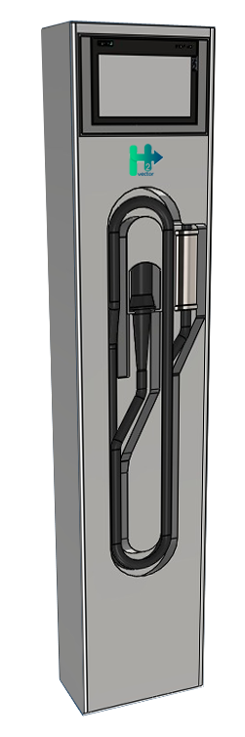
Our goal is to provide our customers with access to mobility through hydrogen in any sector and field of application, always in a sustainable and affordable way.
For this, our Hydrogen Supplier makes it possible to dispose of this new fuel in different outlet pressure requirements, quickly and safely.
Designed to handle refueling protocols at various scenarios, Vector2DYNA enables and ensures the smartest and fastest response:
- SAE J2601 Protocol
- SAE J2601-2 Protocol
- H2Vector Protocol – Maintains SAE safety requirements and adapts to customer installation

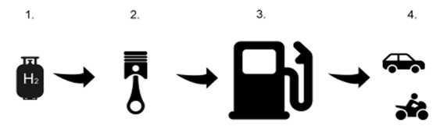
UTILITY MODEL – Publication number ES1290274, Owner project: H2Vector Energy Technologies S.L.

FCV Applications
Hydrogen Delivery using the H₂Vector Supplier: Vector2DYNA
Hydrogen Compression to Pressure Specified by Application
Hydrogen Supplyand Storage

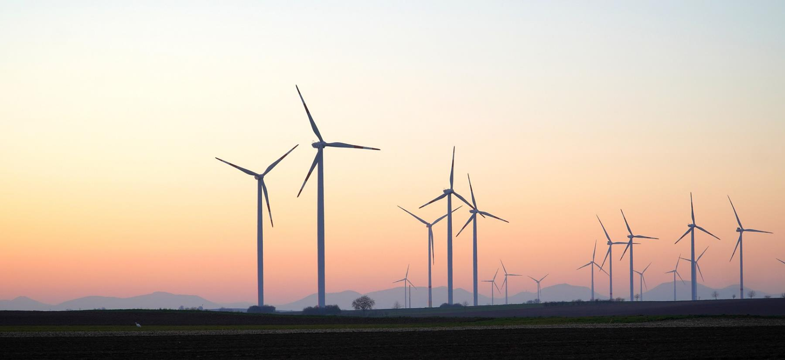









© 2025, H2Vector Energy Technologies, S.L., Spain. All rights reserved. Designs and specifications are subject to change without notice or obligation. Read all safety instructions in the manual before usage.
info@h2vector.com
www.h2vector.com
H2Vector Energy Technologies, S.L.
Thrusting Ideas
Certifications: Partners: Membership:

