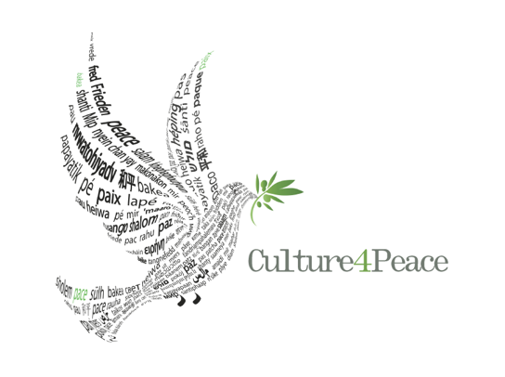

We are CULTURE4PEACE

an organization specialising in cultural and educational events for Peace, based in a little village of Salento, at the tip of the South-East of Italy, in the Region of Puglia.

.

We use Cultural Diplomacy and the Arts - Music, Theatre, Dance and the Performing Arts to promote ethical and sustainable values – for Peace and Social Inclusion.

We produce the SALENTO4PEACE FESTIVAL and are gathering an outstanding group of performers from all over Europe ready to come to the region throughout 2025. The Festival will involve the young, the elderly and the differently able in Salento’s 96 little villages. Workshops will precede the shows between artists and local people.

INCLUSION, RESPECT FOR DIVERSITY, HOSPITALITY and PEACEBUILDING are our values.

Every artist, from different regions of Europe, will be animating two/three workshops and performing in two/three shows, every time involving different villages of Salento in the off seasons. Salento’s villages are all beautiful! Each of them is unique. They go from Casamassella (990 inhabitants), Giuggianello (1,210 inhabitants), Sanarica (1,477 inhabitants), to Otranto (5,742 inhabitants), Gallipoli, (20,678), Galatina (27,056 inhabitants) + the other 90!

The SALENTO4PEACE FESTIVAL will be travelling in space and time, with performers crisscrossing Salento continuously, from January 2025 to December 2025.

Through our SALENTO4PEACE FESTIVAL we will disseminate our values of HOSPITALITY, an old tradition in Salento; INCLUSION, by a population that has been *métissée* for centuries, hosting communities of the Mediterranean and beyond with different ethnic, religious and linguistic backgrounds; RESPECT FOR DIVERSITY, with tolerance and grace towards immigrants and visitors today, from all over the world; creating a CULTURE for Peace and Inclusion for all, at any age from 0 to 110, from any origin and

This is what CULTURE4PEACE and the SALENTO4PEACE FESTIVAL represent: PEACEBUILDING at local and global level - in the strategic Region of Puglia - Italy.