Solar Energy Pilot for Municipal Kindergarten – Bandırma
Scope / Focus Area: Clean Energy Transition
- Background and Rationale
Bandırma Municipality is committed to advancing renewable energy adoption and sustainability awareness in public facilities. Children are key agents of change, as their awareness and learning can influence their families and communities. This project aims to combine technical innovation with social impact by demonstrating solar energy implementation in a municipal kindergarten, creating a model that can be replicated in other facilities.
- Objectives
- Demonstrate clean energy transition at a small-scale municipal facility.
- Install solar panels on the kindergarten roof (~400 m²).
- Integrate a closed-grid energy system for optimized energy management.
- Achieve net-zero emissions for the building.
- Foster social awareness among children and, through them, the wider community.
- Encourage children’s active participation in sustainability education, leveraging their natural curiosity and ability to influence parents.
- Pilot and Demonstration Site
- Location: Municipal kindergarten in Bandırma
- Roof Area: ~400 m² suitable for solar panel installation
- Technology: Solar PV panels integrated with a closed-grid system
- Key Features:
  - Energy monitoring dashboard for educational purposes
  - Workshops and interactive sessions for children on renewable energy
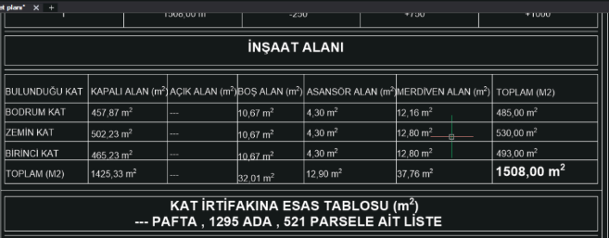
  - Engagement activities connecting children with their families

- Expected Benefits:
  - Reduced carbon footprint and energy consumption
  - Practical demonstration of solar energy integration for municipal buildings
  - Educational impact: children learning and influencing sustainable behaviors at home
- Expected Impact
Environmental:
- Reduction of carbon emissions in municipal buildings
- Demonstration of clean energy adoption and net-zero emissions

Social:
- Early awareness of sustainability and energy efficiency among children
- Children act as ambassadors of environmental consciousness to their families and community
- Promotion of active learning through hands-on workshops and participation
Technical:
- Pilot for integrating solar panels with closed-grid systems
- Data collection for performance evaluation and scalability to other municipal sites
- Conclusion
This pilot project exemplifies Bandırma Municipality’s commitment to combining clean energy innovation with social impact. By centering children as both learners and influencers, the project aims to create a replicable model that demonstrates environmental, social, and educational benefits. The concept note seeks to present this initiative for support in development and implementation.

