WEIGHTED, MULTI-DIMENTIONAL PROCESSING OF VARIABLE ELLIPTICAL POLARIZATION RADAR SIGNAL ALGORITHM
FOR HIGHEST DETECTION PROBABILITY
It is the NON TRADITIONAL RADAR SIGNAL PROCESSING METHOD

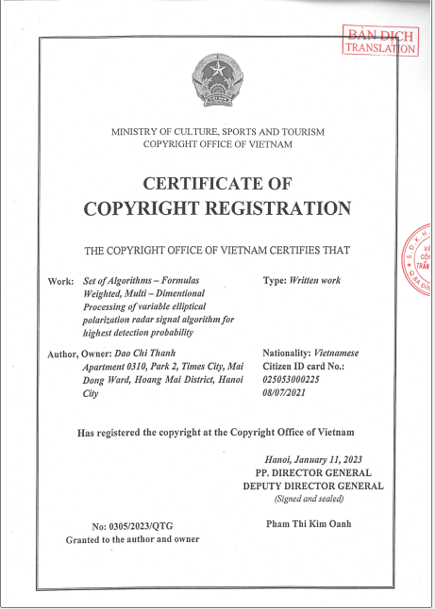 | 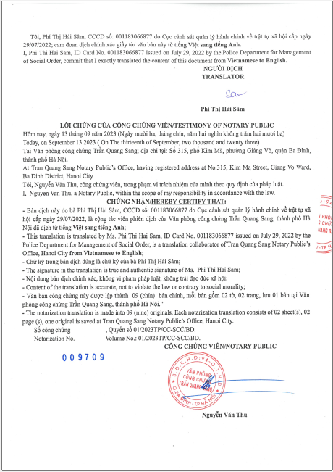 | 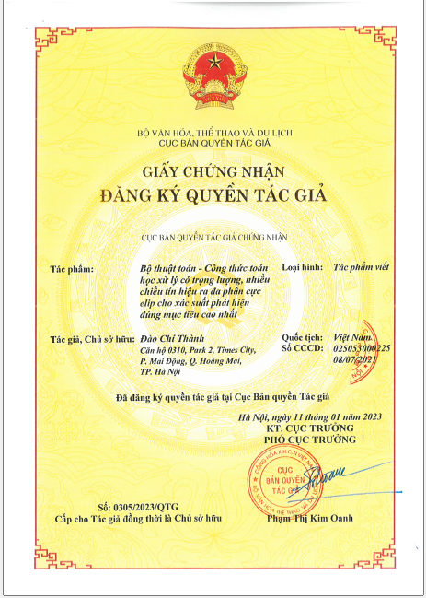 |  | 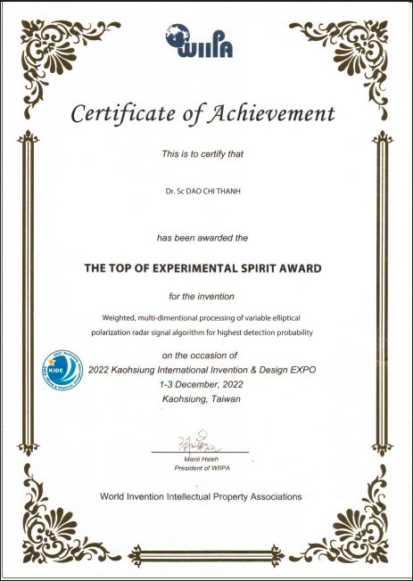 | 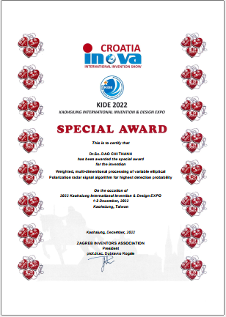

Block schema | 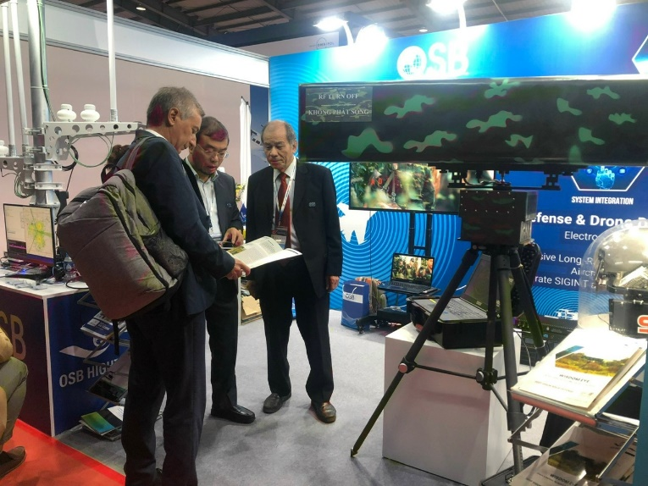  THE FIRST PRODUCT  Radar transmits circular polarization  exhibited at the Vietnam International Defence Expo 2022 on Dec. 8-10, 2022

Summary
The radar transmits a variable elliptical polarization signals e _{i} i= [1…N], N in [1 ÷ +∞ ), the reflected signals from the targets are received and processed in 2 receiver channels, the output signal from the 2 receiver channels is processed by weighted, multi-dimensions special algorithms - formulas for getting the highest detection probability.

Describe
Radar transmits an elliptical polarized signal of the form i : e _{i T}, ( i is positive integers in the range [1 ÷ I ], I is any positive integer that takes value in the range [1 ÷ +∞ ) (1) ), the elliptic signal i reflected from the target e _{i R} can be decomposed on the union of 2 circularly polarized signals: right circular polarization and left circular polarization having different amplitudes which are received and processed in 2 receiver channels; the output signals from receiver channels 1, receiver channel 2 are E _{i1} , E _{i2} ; E _{i1} , E _{i2} are sent to the Signal Processing System and then sent to the Digital Signal Processing System to compute:

- I_{iαβ} = $\frac{{αE}_{i1}}{{βE}_{i2} }$(2) is the Weighted Ratio (WR) of E _{i1} , E _{i2} ; α, β are positive integers in the range [1 ÷ M], M is any positive integer that takes value in the range [1 ÷ +∞ ) (3).
- Weighted Radar Cross Section (WRCS) of the target is computed:
Ϭ_{iαβ} = Ϭ_{iαβ} ( α, β, $E_{ i1}^{2}, E_{i2}^{2}$) (4)
- J_{iαβ} = J_{iαβ} ( I_{iαβ} ) (5)
J_{iαβ} is the coefficient reflecting the Weighted Eigenfeatures (WE) of the target.
J_{iαβ} will be in the range [-a, +a] (6), a is a definite positive integer, range [ -a, +a ] is divided into N segments, N is a positive integer in the range [1 ÷ 100 ) (7), each segment is assigned a color so in the range [ -a, +a ] there are N segments corresponding to N colors, each color corresponds to a target class with the same J_{iαβ} value. J_{iαβ} , Ϭ_{iαβ} will be taken to a 2-dimensional display: color type, color brightness; J_{iαβ} determines the color type, which is the color of the target marker; Ϭ_{iαβ} determines color brightness, which is the brightness of the target marker (8).

The number of color types N is enough to be easily distinguishable by the eye, in the case of auto-detection using Artificial Intelligence (AI) technology, the number of color types that can be selected is large enough to satisfy the target marker resolution.

For each set of values α , β we have a pair of values J_{iαβ} , Ϭ_{iαβ} , for each pair of J_{iαβ} , Ϭ_{iαβ} we have a value of P_{Diαβ} ( Target Detection Probability ); then we will have the value P_{Dimax} = Max { P _{Diαβ} }; α, β = [ 1,...,M] (9), so we have a pair of α , β for the P_{Dimax} for each signal type elliptic polarization e_{i} - P_{D} is a most important parameter of radar.
The transmitted signal is parameterized to have ellipses of the form i (i = [1…I], then we have P_{Dmax max} = Max {P_{Dimax} } (10) i= [1…I], which is the highest Detection Probability P _{Dhighest} = P _{Dmax max} (11).

Set of Algorithms - Formulas (1), (2), (3), (4), (5), (6), (7), (8), (9), (10), (11) have implemented a weighted processing variable elliptical polarization radar signal in 5-dimensional space: α , β , J_{αβ} , Ϭ _{αβ} , and time t give the highest Detection Probability. It is called “Weighted, multi-dimentional processing of variable eliptical polarization radar signal for highest Detection Probability”.

With this set of Algorithms – Formulas, we will not only choose the set of parameters α , β for the highest Detection Probability, but also base on J_{αβ} we can establish a library of Parameters J_{αβ} – Type targets to be able to identify and categorize targets. Furthemore It is very good interference of background supression by controlling Ϭ_{αβ}. These are very important issue in radar engineering.

In fact, we can have a very simple way of implementing the above Algorithms-Formulas: With the parameters I, M, N, α, β selected defined, the 2 important parameters J_{αβ}, Ϭ_{αβ} are computed while the radar continuously transmits e _{i T} and brought them ( J_{αβ}, Ϭ_{αβ} ) to the display.

ADVANTAGE
- With this technology radar can detect very small targets with the RCS small to 0.01 m² , and the potencial even smaller than 0.01 m²;
- Displaying only 1 color will choose a variant to get better ability to detect the target class of that color;
- Change color type assignment to J_{iαβ} value will select the color assignment plan for better target detection and classification;
- Very good interference of background elimination;
- Capable of detecting targets in the woods (forest) because the J_{αβ} of the target is different from J_{αβ} of the woods;
- Base on J_{αβ} we can classify and identify targets by creating a library of Target Types of Parameters Jαβ to defind target identification and classification, this is a very important issue in radar engineering.

Applicability
This Algorithms – Formulas can be applied for every radar type, specially for small target detection radar: Portable Coastal, Ground, Forest… surveillance radar; UAV, drone, rocket bullets,…detection radar.

This Algorithm is "The top of experimental spirit award" from WIIPA at KIDE 2022 Kaohsiung International Invention& design EXPO 1-3 December, 2022 Kaohsiung, Taiwan and the " Special award " from CROATIA INMOVA international invention show on the same day.

The first product (radar) made base on this algorithm exhibited on VIETNAM INTERNATIONAL DEFENCE EXPO 2022, December, 8-10.
Copyright belongs to Dr.Sc. Dao Chi Thanh
Adress: Apartment 0310, Park2, Times City, Hanoi, VietNam
Mobile phone +84-979263611
Email: dcthanh27@gmail.com
Việt Nam, Ha Noi August 12, 2023

Looking for Buyer / Investment

