
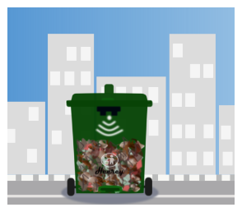
FASCINATE TECHNOLOGIES

AUTOMATING WASTEDISPOSAL
PROCESSES (TrashView)

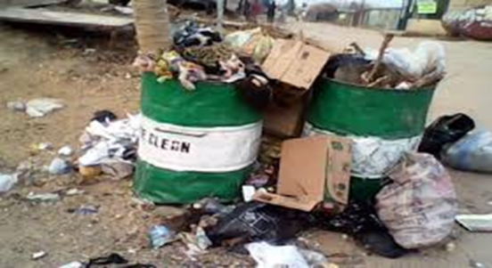

PROBLEM STATEMENT ➢Ineffective Waste Collection

➢Environmental Pollution

➢Improper Waste Disposal

➢Carbon Emission



SOLUTION

➢Sending real time data of waste bins from various locations.

➢Mitigate improper waste collection and disposal.

➢Promote reduction/recycle of waste

➢Route planning for Waste trucks

➢Keeping record of waste bill





HOW IT WORKS






TARGET MARKET

B2G B2C


TRACTION

➢Built a working Prototype

➢Installed 2 Smart waste bins
➢Presidential Standing Committee on Innovation
➢Collaborating with Waste Management Companies

➢Attended GITEX Dubai 2021
➢Undergoing training on installation & building of a biogas plant

➢ UNIDO/GCIP Cohort prog




BUSINESS MODEL

➢Sales of smart waste bins

➢ Subscriptions for the software

➢Maintenance and support fees



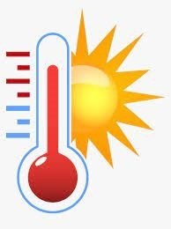

COMPETITIVE ADVANTAGE

Odour detecting Humidity and temperature detecting

Affordability Solar Powered/Power Bank




THE CORE TEAM

PETER OKOYE (Founder) petok2007@gmail.com

CHIJIOKE NGIGE (Co-founder)
chijiokengige@gmail.com https://fascinatetech.ng

IFEOMA IDIKA (Business Mgr) ifeomajoic@gmail.com

