Interest in joining an expert consortium for Horizon Europe:
Cluster 6 destination HORIZON-CL6-2025 calls
Farm Volk
Organization details:
Type of organization | Ecological farm
Size of organization | 20 hectares of cultivated land, 6 hectares of forest
Contact person | Alenka Volk
E-mail address | alenkavolk@hotmail.com
Phone number | 00386 31 773 474
Website and/or social media page | https://jahalnepocitnice.si/en/
Postal code | 6217
City/region | Vremski Britof
Country | Slovenia

organization introduction
We are a medium-sized ecological farm located in the western part of Slovenia. The area is well-preserved in terms of biodiversity, but due to the hilly terrain and natural conditions, traditional farming here is quite challenging.
Our farming philosophy is rooted in traditional knowledge, supported by modern approaches such as digitalization and innovation through the diversification of various on-farm activities. We place a strong emphasis on openness and collaboration; both with like-minded farms and with supporting institutions. We believe this is the only way to successfully adapt to the challenges of modern farming and ensure the long-term survival of our farm, which, with the succession of a young farmer in the family, is now in its fourth generation.
Our main activity is horse breeding, complemented by sheep and goats that help maintain the hilly terrain pastures. We also diversify into tourism and offer various social services on the farm.
Part of our efforts are also focused on participating in different projects and initiatives, as we believe that collaboration, exchange of experiences and best practices are key to preserving our farm in good condition for future generations.
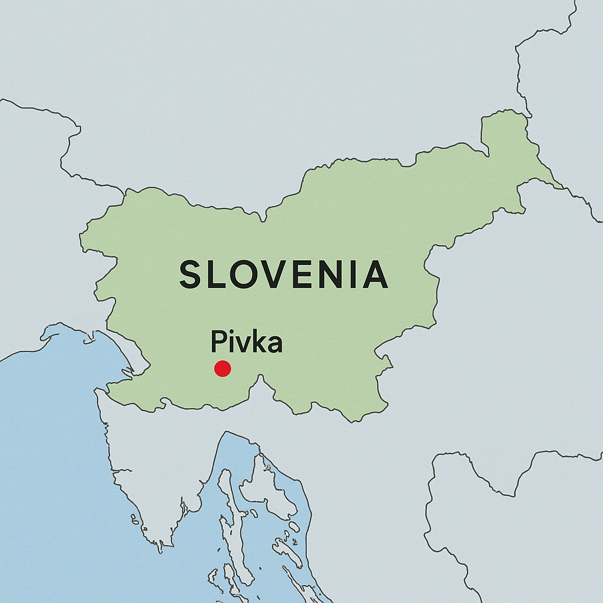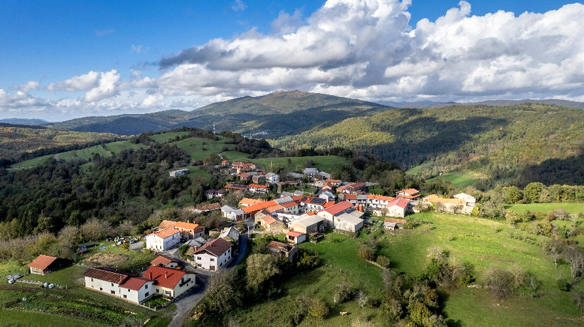
our contribution to the topic
Farm Volk can serve as a living lab and lighthouse site for assessing short, medium, and long-term socio-economic impacts, including benefits and costs of nature restauration.
With extensive experience in EIP-AGRI and several pilot projects implemented, the farm represents an excellent testing ground for carrying out relevant interventions, monitoring, and adjusting based on the results of the activities performed. In addition, with the wide network of partners we collaborate with, it provides an excellent foundation for exploiting results. We also have a good partnership with UNESCO site and Biosphere reserve Park Škocjan caves who manages protected areas we are part of.
On the farm we have already tested some tools for ecosystem services, climate adaptation, and have implemented social initiatives that integrate biodiversity conservation, education and rural well-being. We have also piloted the restoration of traditional orchards, which serve as grazing areas (ensuring animal well-being through shade) while preserving traditional fruit species, maintaining biodiversity and addressing adaptation to climate changes.
Our specific role in the project (competences)
The members of the farm possess a diverse range of knowledge and experience:
- agriculture, pasture maintenance, orchard growing,
- animal care and welfare,
- skills related to monitoring protected plants and animals, particularly birds and Natura 2000 species (citizen science approach),
- knowledge in the field of applying for and implementing H2020 and HE projects (these are skills acquired outside the farm).
All of the above makes us reliable partners who are familiar with the mechanisms of implementing similar projects, are committed to fulfilling obligations, know how to meet the relevant administrative requirements, and proactively participate in carrying out relevant project activities as well as communication and dissemination activities.
In terms of topic(s) addressed we are also flexible in meeting the needs of an existing consortium.
selection of ouR previous projects
Duration | Name of project | Program name
2023-2025 | Innovative Fire Prevention Model for Holistic Farm Revitalization | CAP (EIP-AGRI)
2022-2025 | The contribution of farms to climate change mitigation and adaptation through the concept of ecosystem services | CAP (EIP-AGRI)
2022-2024 | The farm as a therapeutic space | CAP (Pilot Projects-AGRI)
2020-2023 | Piloting timber extraction with an improved mobile forest cableway and innovating a new method for constructing wooden structures from lower-grade wood | CAP (Pilot Projects-AGRI)
2020-2022 | Traditional high-stem grazing orchards as a new agricultural practice | CAP (Pilot Projects-AGRI)
2020-2022 | Development of new practices for forest estate management and strengthening all their functions. | CAP (Pilot Projects-AGRI)
2021-2022 | With nature to new eco-services and products – EKOTRIP | CAP (LEADER project)
2019-2021 | Development of a model for implementing day-care living on farms | CAP (Pilot Projects-AGRI)
2019-2021 | Learning work ethics and skills on the farm | CAP (Pilot Projects-AGRI)

