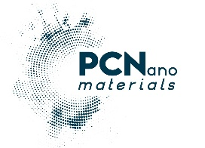PCN Materials
VIOPAN, Anopolis, 70008 Hersonisos, Herakleion, Crete, Greece
e-mail: info@pcnmaterials.com / Tel: +30-2810-781895
-------------------------------------------------------------------------------------------------
Company profile:
PCN Materials (www.pcnmaterials.com) is a deep-tech SME, spin-off of FORTH, targeting indoor air quality (IAQ). The company produces patented, high-performance, visible-light-activated photocatalytic (P/C) nanomaterials designed to decontaminate air and water, as well as disinfect surfaces in health-sensitive and polluted environments.
Executive Summary
- Legal Name: Photo-Catalytic Nano Materials P.C. (PCN Materials) / EU PIC No: 894829851 / VAT: EL 801218340
- Foundation: 2019 (Spin-off from the Foundation for Research and Technology - Hellas / FORTH / www.forth.gr)
- Location: Heraklion, Crete, Greece (VIOPAN Park of Anopolis)
- Contact: Dr. George Kiriakidis/ kiriakid@pcnmaterials.com
- Core Competence: Production of modified TiO₂ powders (10-40nm) and P/C dispersions, active under solar and indoor artificial lighting for self-cleaning, anti-pollutant, and antimicrobial applications.

Company Overview & Origin
Born out of over a decade of dedicated research at FORTH’s Institute of Electronic Structure and Laser (IESL), Greece, PCN Materials bridges top-tier academic nano-science and industrial-scale manufacturing. The enterprise holds exclusive international patents (Europe, USA, China) for modifying Titanium Dioxide (TiO₂) to activate efficiently under visible light—overcoming the traditional limitation of requiring high-intensity UV radiation.
Core Technology & Innovation
PCN's technology relies on advanced oxidation-reduction reactions (photo-catalysis) triggered by light striking TiO2 particle-coated surfaces.
- Air & Environmental Purification: Degrades harmful gaseous pollutants, including nitrogen oxides (NOx up to 95% in minutes), along with volatile organic compounds (VOCs), and toxic aromatic hydrocarbons (BTXs).
- Pathogen Inactivation: Neutralizes airborne and waterborne bacteria (e.g., E. coli, Staphylococcus aureus, Klebsiella pneumoniae) and viruses (e.g. SARS-CoV-2, Bacteriophages).
- Matrix Integration: Engineered as an additive or coating. It integrates smoothly into conventional building and industrial materials—such as wet and powder paints, cement, concrete, plasters, wood, metals, textiles, and plastics—without requiring external energy inputs to operate.
Validation & Certifications
PCN Materials’ efficacy has been rigorously tested and validated by prominent independent international and national bodies, ensuring compliance with high European scientific standards:
- Joint Research Centre (JRC), Italy
- NCSR “Demokritos”, Greece
- Aims Labs, Ireland
- GUANGDONG Detection Center of Microbiology, China
- University of Birmingham, UK / Dpt of Immunology and Immunotherapy

Current Partnership in EU projects:
* “SUPREME”: HADEA.B – Digital, Industry and Space / Project: 101058422 — HORIZON-CL4-2021-RESILIENCE-01
* “WISE” : HADEA.B – Digital, Industry and Space B.3 – Industry / Project: 101138718 — HORIZON-CL4-2023-TWIN-TRANSITION-01
Strategic Alignment with EU Priorities
PCN Materials is ideally positioned to participate in collaborative Horizon Europe, program proposals matching key EU policy goals:
- The European Green Deal: Delivering zero-pollution ambitions through active urban surfaces that clean ambient air (road tunnels, public infrastructure, green buildings).
- The European Clean Industrial Deal: Targeting the development and scaling of clean technologies needed for climate neutrality.
- Public Health & Resilient Healthcare: Mitigating nosocomial (hospital-acquired) infections via self-disinfecting medical and public environment contact surfaces.
- Circular Economy & Sustainable Construction: Enhancing the functional longevity of standard building materials through self-cleaning properties
PCN’s Core Technology & Technical Value Proposition
- Visible-Light Activation: Unlike traditional UV-dependent photocatalysts, our patented formulation activates under standard, visible interior lighting, continuously cleaning the air and surfaces without specialized radiation equipment.
- Zero Operational & Energy Footprint: Once applied as an interior coating, it provides passive, around-the-clock air clearance at zero running cost in HVAC systems, reducing the building/vessel energy operation footprint
- Confined Space Optimization & Material Safety: Non-corrosive, non-toxic, and free of harsh outgassing. It is ideal for life-critical, sealed HVAC volumes, ensuring absolute safety for users/occupants
PCN’s Core production/pilot-line Infrastructure
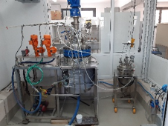
- Two pilot-line set-ups composed of 250
and 10 lit capacity hydrothermal reactors
with heating capacity of up to 250 ⁰C

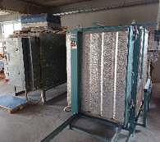
- Four, Lab- and Industrial scale drying and
calcination units

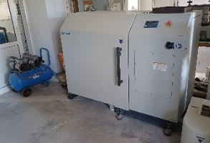
- Dry Ball milling system

- ISO standard (EN 16980-01:2021) decomposition of NO test chamber for photocatalytic (P/C) materials (Visible and UV)
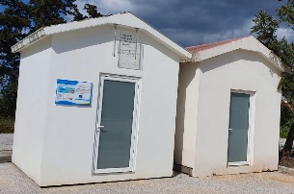
- A set of real scale “Demo-Houses” for
field-test (P/C) materials & compounds analysis

PCN Materials
July 2026

