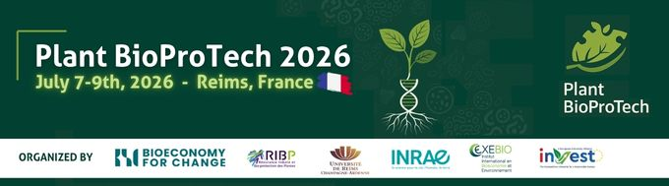

Plant BioProTech 2026

Reims, July 7th – 9th, 2026

Instructions for participating to the Innovation Awards

All applicants to the award need to be registered and participate to the symposium.
To apply to the award, after your registration, submit the completed application form (below) and a leaflet or other additional information in PDF format about your product or technology in English, including printable digital images (300 dpi) that we can use free of charge in our subsequent media advertising. The documents should indicate what is special about the innovation, when it was or will be introduced to the market & how your product/innovation is sustainable (industry standards, SDG’s, certifications, labelling, etc.). Please send with your entry the logo of the company, a short bio of the company (<150 characters including spaces), social media links & websites related to the product and the company. You can also send us a short video of your innovation.
The jury, composed of the academic personalities from our scientific committee, will examine the applications and elect the winner. The president of the jury will award the prize during the plenary session on Thursday July 9th.

The abstract should be written according to the following instructions:
- The application must be submitted before May 29th, 2024.
- The application must be sent to j.deconinck@bioeconomyforchange.eu as word or PDF file
- The application should not exceed two pages (as per the here below model)
  - First page for identification datas
  - Second page for description and competitive advantage
- Incomplete application will not be taken into consideration.
- Selected entries and the representatives register according to the normal prices mentioned on the website.
All files bigger than 5MB would need to be sent via a downloading platform.

NB: By applying you agree to make yourself available for the whole dates of the symposium. Any winner absent during the symposium will not be awarded.

Plant BioProTech Innovation Award

ENTITY:
CONTACT NAME:
CONTACT DETAILS
Email:
Phone: ……………………………………………………………… Mobile:
Address:
JOB TITLE:

Is your innovation already in the market:

  - Yes
Date:……………………………………….

  - If yes, then indicate the revenue generated (or estimated to generate) by your product per year (in Euro)
……………………………………….

  - No
Expected date of market introduction: ………………………….
  - If no, then what is the expected revenue from your innovation in one year (in Euro)
……………………………………….

Product name (or Project Name, if not yet in the market):

…………………………………………………………………………………….

Product description and competitive advantage of your innovation should not be longer than one page, both together.
Product description:

Competitive advantage of your innovation:

How is your product sustainable ? Mention any certifications, labelling, industry standards, sdgs it follows, etc.

