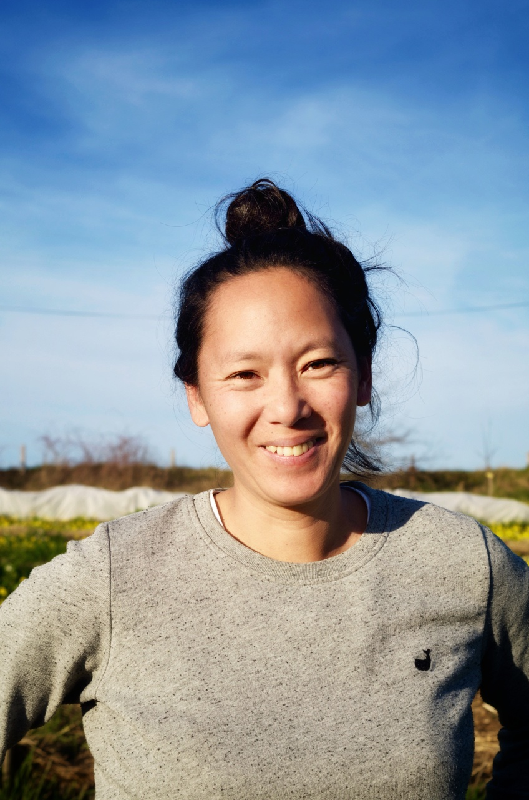

Thien Uyen Do is a former legal expert turned organic farmer and winemaker now based in Dordogne (South-west of France). After a decade in Brussels working on environmental law and biodiversity protection, she transitioned to agriculture, aligning her career with her ecological values. She and her partner, Florent Girou, took over the family-owned vineyard in 2018, transforming it into a model of sustainable, diversified farming.
At Combrillac, they practice permaculture, integrating 500 fruit trees, wheat, hops, medicinal and edible plants, livestock, resistant grapes varieties and vitiforestry techniques into their 25-hectare estate. This approach aims to enhance biodiversity and resilience against climate challenges.
Thien Uyen Do is also a passionate advocate for natural fermentation as a cultural and ecological practice. In her book Fermentation Rébellion (published in 2024), she explores fermentation not just as a culinary technique but as a form of resistance to industrial food systems and intensive farming.
Through her work, she emphasises the importance of micro-organisms—whom she calls her "invisible allies"—in both soil health and food preservation, highlighting their role in sustainable agriculture and human well-being, and also a way to reconnect with living ecosystems.

