Guradian Patrol drone
Project Sentinel: A Technical and Regulatory Framework for an Autonomous Security Patrol UAV
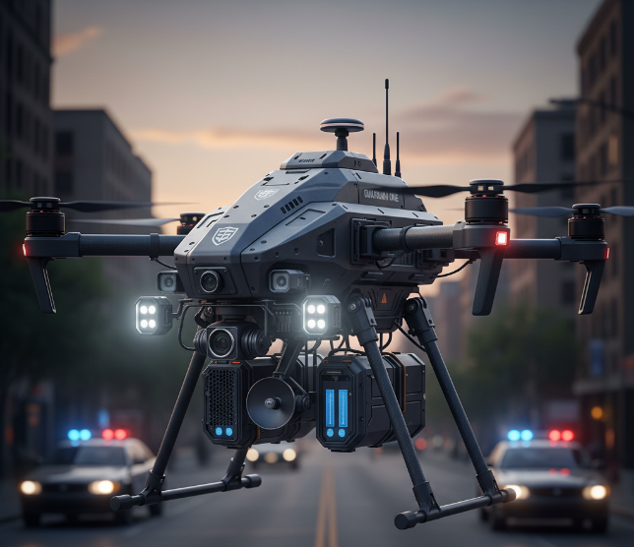
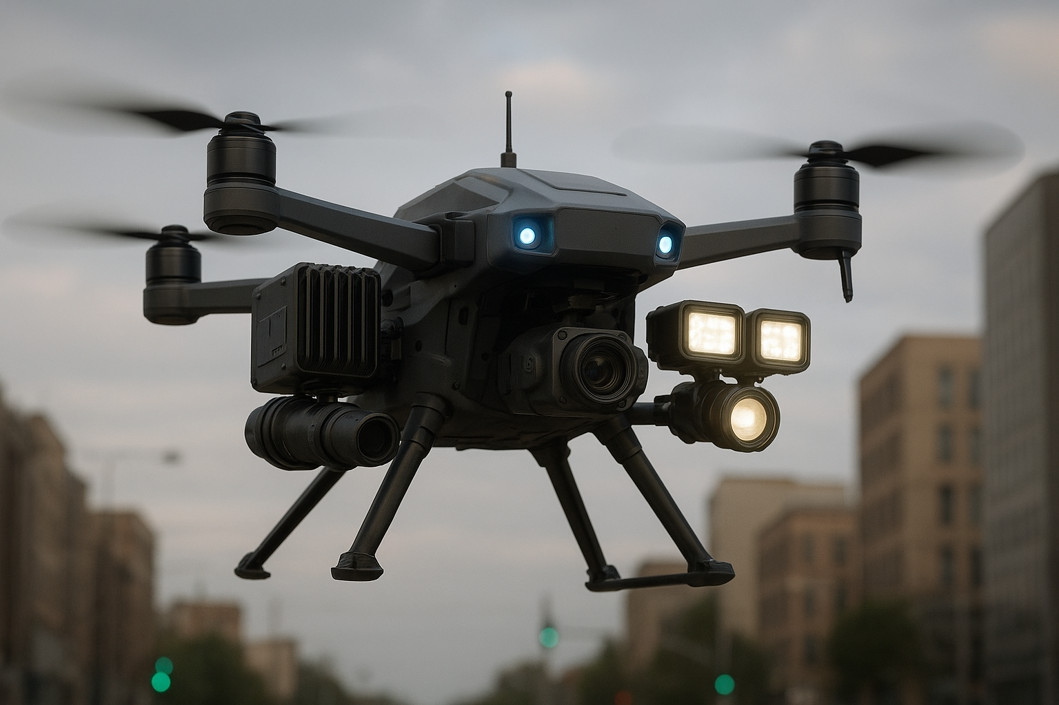
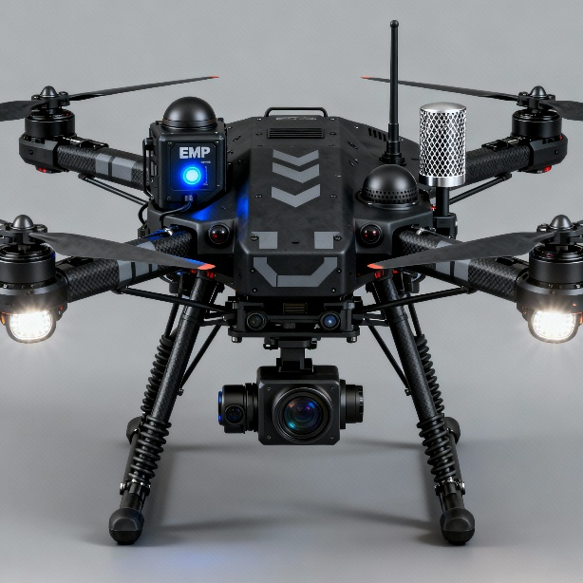

Section 1: Airframe Platform Analysis and Recommendation
The foundational design of an Unmanned Aerial Vehicle (UAV) is dictated by its intended mission profile. For an autonomous security patrol drone, the operational requirements are uniquely demanding, necessitating a platform that can cover vast, open territories with high efficiency while also retaining the ability to operate within and from confined spaces for close observation. This section analyzes these requirements, evaluates the primary UAV architectures, and recommends an optimal airframe platform that balances endurance, payload capacity, and operational flexibility.
1.1 Analysis of Operational Requirements
The envisioned mission profile for a security patrol drone spans a wide spectrum of environments, from dense urban centers to expansive rural farmlands. This diversity imposes a set of challenging and often conflicting demands on the aircraft's design.
A primary requirement is the ability to conduct long-endurance patrols. To be effective as a surveillance asset over large agricultural areas or along extensive perimeters, the drone must remain airborne for multiple hours per sortie. This capability is directly linked to the platform's aerodynamic efficiency and its ability to minimize power consumption during the cruise phase of flight.
Simultaneously, the platform must possess the flexibility to operate in complex, confined environments. This includes the ability to take off and land vertically from small, unprepared sites, such as rooftops, small clearings, or company depots, without the need for a runway or specialized launch equipment. Furthermore, the role of a first responder or close-observation asset requires the capacity to hover over a point of interest, providing a stable, persistent aerial viewpoint for detailed assessment.
The drone is also specified to carry a substantial and power-intensive payload suite, including advanced surveillance sensors, high-intensity lighting, and sophisticated long-range communication systems. This dictates a platform with a significant payload capacity, which in turn influences the overall size, weight, and power requirements of the aircraft.
Finally, the platform must exhibit robust performance in variable and potentially adverse weather conditions. Stability in wind is a critical safety and operational concern, particularly for a system intended to provide reliable, all-weather security. This is a known weakness of many smaller, conventional multi-rotor designs, which can struggle to maintain position and control in high winds, draining their batteries rapidly.
1.2 Comparative Assessment of UAV Architectures
To select the most appropriate airframe, a comparative analysis of the three principal UAV architectures—multi-rotor, fixed-wing, and fixed-wing hybrid VTOL—is necessary. Each design presents a distinct set of advantages and disadvantages that directly impact its suitability for the security patrol mission.
Multi-Rotor Drones: These platforms, most commonly seen as quadcopters, are defined by their ability to take off and land vertically and hover with exceptional stability and maneuverability. This makes them ideal for short-range inspection and aerial photography where precision flight in confined spaces is paramount. However, their core design is fundamentally inefficient for long-range flight. A significant portion of their energy is consumed simply to counteract gravity, leading to very limited flight times, typically under an hour, and often closer to 20-30 minutes when carrying a meaningful payload. This limited endurance makes them unsuitable for patrolling large areas as required by the mission profile.
Fixed-Wing Drones: In contrast, fixed-wing drones operate on the same aerodynamic principles as conventional airplanes. Their wings generate lift, making them highly energy-efficient in forward flight. This efficiency translates into vastly superior endurance, with flight times that can extend for several hours, and in the case of gas-powered models, for over 16 hours. They can also fly at higher speeds and altitudes and carry heavier payloads over greater distances. Their primary and disqualifying drawback, however, is their dependence on infrastructure. They require a runway or a catapult system for takeoff and a large, clear area for landing, which severely limits their operational flexibility and makes them impractical for deployment in the varied and often confined environments specified.
Fixed-Wing Hybrid VTOL (Vertical Take-Off and Landing): This advanced architecture represents the synthesis of the other two designs. VTOL aircraft merge the long-endurance, high-speed cruise efficiency of a fixed-wing platform with the vertical takeoff, landing, and hover capabilities of a multi-rotor. This hybrid approach directly resolves the central conflict in the mission's operational requirements. The drone can be deployed rapidly from a small footprint, transition to an efficient wing-borne flight for long-range patrol, and then transition back to hover for close observation or land vertically upon mission completion. This versatility makes the fixed-wing hybrid VTOL the unequivocally superior choice for this application.
Feature | Multi-Rotor | Fixed-Wing | Fixed-Wing Hybrid VTOL
Typical Endurance | < 1 hour | 2 - 16+ hours | 1.5 - 5+ hours
Max Speed | Low | High | High
Payload Capacity | Low to Medium | Medium to High | Medium to High
Operational Footprint | Very Small (VTOL) | Large (Runway/Launcher) | Very Small (VTOL)
Hover Capability | Excellent | None | Excellent
Relative Complexity/Cost | Low to Medium | Medium to High | High
1.3 VTOL Sub-Type Evaluation: The Endurance vs. Complexity Trade-Off
Having established the superiority of the VTOL architecture, a further critical engineering decision must be made regarding the specific mechanism used to achieve both vertical lift and forward flight. The two dominant designs are "Lift-and-Cruise" and "Tilt-Rotor," each presenting a fundamental trade-off between aerodynamic efficiency, mechanical complexity, and overall mission performance. The selection is not a matter of one being universally superior, but rather which design's compromises are more acceptable for a mission profile dominated by long-endurance surveillance.
Lift-and-Cruise (or "Hover plus Cruise") Design: This configuration employs two separate and dedicated propulsion systems: a set of rotors (typically four or more) for vertical lift and landing, and a separate motor with a propeller for forward, wing-borne cruise. The primary advantage of this approach is that each system can be highly optimized for its single purpose. The lift rotors can be designed with a large diameter and low pitch for maximum static thrust and efficiency in hover, while the cruise propeller can be optimized with a high pitch for efficient high-speed forward flight. This separation also provides a degree of redundancy; a failure of the cruise motor does not preclude the aircraft from using its lift motors to perform a safe vertical landing. However, the significant disadvantage is that the lift rotors and their supporting structures become inactive "dead weight" during the cruise phase. This creates substantial parasitic drag, which penalizes the aircraft's aerodynamic efficiency and, consequently, reduces its maximum range and endurance.
Tilt-Rotor Design: This configuration uses a single set of motors for both flight phases. The motors are mounted on nacelles that physically rotate, or "tilt," from a vertical orientation (for lift) to a horizontal one (for thrust). The principal advantage of this design is its superior aerodynamic efficiency in the cruise phase. Without the drag-inducing inactive lift rotors of a Lift-and-Cruise model, the airframe is much cleaner, allowing for longer range and higher speeds for a given amount of power. The main drawback is the mechanical complexity of the tilting mechanisms, which can increase manufacturing cost, introduce more potential points of failure, and require more intensive maintenance. Furthermore, the propellers themselves represent an engineering compromise. A propeller cannot be perfectly optimized for both high-thrust, low-speed hover and low-thrust, high-speed cruise simultaneously, resulting in sub-optimal efficiency in both regimes compared to a dedicated system.
For the specified mission, the drone will spend the vast majority of its operational time—likely over 95%—in the forward cruise phase while patrolling. The VTOL phases of takeoff, landing, and occasional hovering, while critical, are brief. Therefore, optimizing performance for the cruise phase is paramount to maximizing the drone's overall effectiveness and endurance. The significant parasitic drag from the inactive lift motors on a Lift-and-Cruise design imposes a continuous and substantial penalty on the aircraft's primary mission function. In contrast, the aerodynamic cleanliness of the Tilt-Rotor design, even with its compromised propeller efficiency, offers a greater overall advantage for long-endurance flight. The conclusion is that for a mission dominated by cruise, minimizing drag is more critical to overall endurance than achieving perfect propeller optimization in each flight phase. For this reason, the Tilt-Rotor configuration is the recommended platform.
1.4 Recommended Platform Specifications
Based on the analysis and drawing from specifications of commercially available high-endurance surveillance VTOL platforms, the drone would fall into the "Medium" or "Large" UAV category. The following specifications define a capable and realistic platform for the intended mission.
- Type: Tilt-Rotor Fixed-Wing Hybrid VTOL
- Conceptual Dimensions:
  - Wingspan: Approximately meters
  - Length: Approximately meters
- Weight & Payload:
  - Empty Weight: Approximately kg
  - Maximum Take-Off Weight (MTOW): kg
  - Payload Capacity: kg (This allows for a sophisticated sensor suite and sufficient battery capacity)
- Materials: The airframe should be constructed from advanced composite materials, such as carbon fiber and fiberglass, to achieve the necessary strength and rigidity while minimizing weight.
- Performance:
  - Cruise Speed: Approximately km/h ($ \approx 28$ m/s)
  - Maximum Flight Altitude: At least m Above Mean Sea Level (AMSL)
  - Wind Resistance: Capable of takeoff and landing in winds up to m/s ($ \approx 45$ km/h) and cruising in winds up to m/s ($ \approx 50$ km/h).
Section 2: Core Systems and Performance Specifications
The operational effectiveness of the Sentinel platform is determined by its core systems. This section details the specifications for the power, propulsion, navigation, and communication systems required to achieve the mission's objectives of long endurance, high-precision navigation, and robust Beyond Visual Line of Sight (BVLOS) operation. These systems are highly interdependent, and their design represents a complex optimization of weight, power consumption, and capability.
2.1 Power and Propulsion Systems
The endurance of the drone is fundamentally limited by its power system. Achieving a flight time of over two hours with a heavy payload requires leveraging the most advanced battery technology and an efficient propulsion system.
Propulsion: The recommended tilt-rotor design will be powered by high-efficiency brushless DC electric motors. A typical configuration would involve three motors: two tilting motors mounted on the wings to provide lift and forward thrust, and a third motor on the tail for stability, yaw control during hover, and potentially additional thrust in cruise flight.
Battery Technology: Standard Lithium-Polymer (LiPo) batteries, while common, do not offer the energy density required for this mission. To maximize flight time and usable payload, the platform must incorporate next-generation battery technology. The clear recommendation is for Semi-Solid State or Solid-State Lithium-ion batteries. These advanced cells offer a significant performance increase, with energy densities reaching Wh/kg, compared to the Wh/kg range of typical Li-ion batteries. This technological choice is a primary enabler of the drone's long-endurance capability.
Battery Size and Configuration: To power the high-performance motors and onboard systems efficiently, a high-voltage architecture is necessary. A 12-cell (12S) or 14-cell (14S) configuration, providing a nominal voltage of V or V respectively, is standard for this class of UAV. Based on the estimated power consumption during cruise, a total battery capacity in the range of mAh to mAh is required. The battery pack will be a substantial component of the drone's total weight, underscoring the importance of using high-density cells.
Flight Time Estimation: A realistic endurance estimate can be derived from a detailed power budget analysis. The total power draw of the aircraft is the sum of the power consumed by its various subsystems. The flight time is then calculated by dividing the usable battery energy by the average power draw, adhering to the standard 80% discharge rule to preserve battery health and provide a safety margin.
The design of a high-performance UAV is a process of managing interlocking dependencies. The goal of achieving a 2+ hour flight time necessitates the use of heavy, high-capacity solid-state batteries. This weight, combined with the weight of the payload and communications gear, increases the drone's All-Up Weight (AUW). A higher AUW requires more powerful motors and a stronger airframe, which in turn adds more weight and consumes more power. This feedback loop means that the final endurance figure is the result of a complex, multi-variable optimization, not a simple calculation based on battery capacity alone. The estimated flight time of approximately two hours represents a realistic outcome at the leading edge of current commercial technology for a platform with this level of capability.
Component | Estimated Weight (kg) | Estimated Power Consumption (Watts)
Propulsion (Cruise) | -
Propulsion (Hover) | -
Avionics & Flight Control
C3 Comms (Hybrid)
EO/IR Gimbal Payload
Lighting Payload (Active)
SLAM Navigation Payload
Total Payload & Systems | kg | W (Cruise, Lights On)
Flight Endurance Calculation Example:
- Battery: 12S 33,000mAh Semi-Solid State ( V)
- Total Energy:
- Usable Energy (80%):
- Estimated Cruise Time (Lights Off, Avg. Power $ \approx 595$ W): hours ($ \approx 118$ minutes)
- Estimated Cruise Time (Lights On, Avg. Power $ \approx 720$ W): hours ($ \approx 98$ minutes)
2.2 Navigation and Autonomous Control
For the drone to function as an effective autonomous patrol and first-response asset, its navigation system must be both highly precise and exceptionally robust, capable of operating reliably in all targeted environments.
Primary Navigation: The foundation of the navigation system will be a multi-constellation Global Navigation Satellite System (GNSS) receiver, capable of tracking signals from GPS, GLONASS, Galileo, and BeiDou satellites simultaneously. This multi-constellation capability provides redundancy and improves position accuracy and availability by increasing the number of visible satellites.
Precision Positioning: Standard GNSS provides accuracy within a few meters, which is insufficient for tasks like landing in precise locations or providing exact coordinates for an emergency. To achieve the required centimeter-level accuracy, the drone must be equipped with a Real-Time Kinematic (RTK) or Post-Processed Kinematic (PPK) module. RTK systems use data from a fixed ground station or a network of stations to correct for GNSS signal errors in real-time, yielding positional accuracy on the order of cm. Modern RTK modules are extremely compact and lightweight (e.g., 24 g) with very low power consumption (approx. W), making their integration a highly effective performance enhancement with minimal penalty to endurance.
GPS-Denied Navigation: A critical vulnerability of any GNSS-reliant system is the loss of signal, which can occur in "urban canyons" between tall buildings, under dense forest canopies, or as a result of intentional signal jamming. To ensure operational continuity, the drone must have a secondary navigation system that does not depend on satellite signals. The recommended solution is the integration of a Simultaneous Localization and Mapping (SLAM) system. SLAM algorithms use data from sensors like LiDAR or stereo cameras to build a 3D map of the immediate environment and simultaneously track the drone's position within that map. This allows for safe, autonomous navigation even in the complete absence of a GNSS signal. Commercial SLAM payloads suitable for drones typically weigh between kg and add to the overall power budget, representing a necessary trade-off for achieving true all-environment operational robustness.
2.3 Command, Control, and Communications (C3) Architecture for BVLOS
Operating a drone beyond the visual line of sight of the pilot is entirely dependent on the reliability and performance of its Command, Control, and Communications (C3) link. The user's requirement for a non-WiFi/Bluetooth solution points toward professional-grade, long-range technologies capable of supporting high-bandwidth data streams over tens or even hundreds of kilometers.
Cellular (4G/5G): Leveraging existing mobile networks offers a compelling solution for BVLOS operations, particularly in urban and suburban areas. 4G LTE and emerging 5G networks provide high bandwidth and low latency, which is essential for transmitting real-time, high-definition video feeds and enabling responsive remote control. However, the primary limitation is coverage. While Ofcom's "Connected Nations" reports indicate that 96% of the UK landmass has 4G coverage from at least one operator, this figure can be misleading for mission-critical applications. Coverage from all four major operators is significantly lower, and there are well-documented gaps in rural and remote areas where security patrols may be most needed. A drone relying solely on one operator's network could easily lose its link by flying into a coverage gap.
Satellite Communications (SATCOM): SATCOM offers the ultimate solution for coverage, providing a reliable link almost anywhere on the planet, including over oceans, mountains, and deserts where no cellular infrastructure exists. This makes it indispensable for true long-range and remote operations. The trade-offs are significant, however. SATCOM links are characterized by much higher latency (often ms), which can make real-time manual control challenging. They also offer substantially lower bandwidth compared to 5G and come with higher hardware and data subscription costs.
Recommended Solution: Hybrid Cellular/SATCOM System: The most resilient and capable C3 architecture is a hybrid system that intelligently combines both technologies. In this configuration, the drone uses the high-bandwidth 4G/5G network as its primary data link for tasks like video streaming. The system constantly monitors the quality of this link. If cellular connectivity degrades or is lost, the drone's flight controller automatically fails over to the SATCOM link. This secondary link would be used to transmit essential, low-bandwidth data for command and control (C2) and telemetry (e.g., position, altitude, battery status), ensuring the operator never loses control of the aircraft. When cellular coverage is re-established, the system can seamlessly switch back to the primary link.
Regulatory Framework (Ofcom): The use of cellular and satellite spectrum for drone control is a regulated activity in the UK. It is not sufficient to simply install a modem; the operating company must obtain a UAS Operator Radio Licence from Ofcom, the UK's communications regulator. A critical and often overlooked stipulation of this licence is that it requires the drone operator to have explicit, formal agreements in place with the mobile network operator(s) and/or satellite service provider(s) whose networks will be used. This is a significant business and regulatory step that must be addressed early in the project's development.
Section 3: Payload Integration and Legal Viability Assessment
This section addresses the specific payloads requested for the security patrol drone. It details the specifications for a compliant and highly effective surveillance package while providing a definitive assessment of the legal and regulatory prohibitions surrounding the other requested systems. This analysis is crucial, as it pivots the product concept from one that is legally untenable to one that is viable for commercial deployment in the UK and similar regulatory environments.
3.1 Advanced Surveillance Package (Compliant)
To fulfill its role as a security and first-informant asset, the drone must be equipped with a high-performance, all-weather imaging system.
- Sensor Suite: The core of the surveillance payload should be a 3-axis gyro-stabilized gimbal housing a dual-sensor camera system. This integration provides maximum versatility:
  - Electro-Optical (EO) Camera: A high-resolution camera with significant optical zoom (e.g., 30x or greater) for daylight operations. This allows for the identification of details such as vehicle license plates or the nature of an incident from a safe standoff distance.
  - Infrared (IR) Thermal Camera: A thermal imaging sensor that detects heat signatures, enabling effective detection of persons or vehicles in complete darkness, through smoke, or in low-visibility conditions like fog.
  - Payload Specifications: A capable EO/IR gimbal system suitable for this class of drone will typically weigh approximately kg and have an average power consumption of W.
- Lighting Package:
  - Floodlights: To serve as a first responder and to deter potential intruders, a powerful lighting system is required. This would consist of high-intensity LED modules capable of generating lumens, requiring a power draw of approximately W. It is critical to note that activating this payload will have a noticeable impact on flight endurance, as calculated in Section 2.
  - Night/Covert Illumination: For situations requiring discreet surveillance, the payload should include an infrared (IR) illuminator. This device emits light in the IR spectrum, which is invisible to the human eye but brightly illuminates the scene for the drone's thermal camera, allowing for covert observation at night.
3.2 Facial Recognition Technology (FRT): A Legal and Ethical Minefield
The proposal to use facial recognition to autonomously identify and report "criminals" to the police enters one of the most heavily scrutinized areas of data protection law. In the UK, the use of FRT is governed by the UK General Data Protection Regulation (UK GDPR) and the Data Protection Act 2018, with enforcement by the Information Commissioner's Office (ICO).
The High Legal Bar for Biometric Processing: Facial recognition involves the processing of biometric data to uniquely identify a person. Under UK GDPR, this is classified as "special category data," and its processing is prohibited by default. To be lawful, processing must satisfy both a lawful basis under Article 6 and a separate, more stringent condition under Article 9. For a private company conducting surveillance on the general public, establishing these is exceptionally difficult. Relying on "consent" is impractical in a public space, and an argument for "legitimate interests" is highly unlikely to be accepted by the ICO or the courts when weighed against the fundamental right to privacy of countless individuals being scanned without their knowledge.
The Principles of Necessity and Proportionality: Even if a potential lawful basis could be argued, the ICO requires any controller using FRT to demonstrate that its use is strictly necessary and proportionate to achieve a specific, legitimate aim. This involves proving that the objective cannot be achieved through less privacy-intrusive means. For the general purpose of "crime prevention," numerous less intrusive alternatives exist, such as standard high-resolution CCTV that is reviewed by human operators after an incident is detected, or using AI for non-biometric anomaly detection (e.g., identifying a person in a restricted area without identifying who the person is).
Conclusion on FRT: The proposed use case—a private commercial drone autonomously applying live facial recognition to the general public—is almost certain to be deemed unlawful in the UK. It fails the fundamental legal tests of necessity and proportionality and lacks a viable lawful basis for a non-law enforcement entity. Public support for FRT is strong when used by police for specific investigations but extremely weak for commercial use cases like tracking shoppers, a sentiment that would extend to private security patrols. Proceeding with this capability would expose the company to severe regulatory action from the ICO, including substantial fines and orders to cease processing.
3.3 Active Countermeasure Payloads: Regulatory Prohibition
The request for jamming and EMP payloads reflects a fundamental misunderstanding of the legal division of capabilities between private entities and the state. While technically feasible to mount such devices, their use by a civilian or commercial entity is strictly illegal.
Signal Jammers: The use, and in most cases the ownership, of any device designed to deliberately interfere with wireless telegraphy is a criminal offense in the UK under the Wireless Telegraphy Act 2006. This legislation is enforced by Ofcom. The purpose of the act is to protect the integrity of the entire radio spectrum, which is essential for critical services including air traffic control, emergency services communications (police, fire, ambulance), and legitimate commercial and public broadcasts. A drone-mounted jammer would indiscriminately disrupt these signals over a wide area, posing a significant public safety risk. Authorisation to use such technology is granted only to specific government bodies, such as the military and law enforcement, under strict protocols and for national security or public safety reasons. There is no legal pathway for a private security company to obtain a licence to operate a jamming device. Penalties for unlawful use are severe, including unlimited fines and imprisonment for up to two years.
Electromagnetic Pulse (EMP) Devices: While not always named with the same frequency as "jammers," a device designed to emit a powerful electromagnetic pulse to disable electronics falls under the same legal principles. Its purpose is to cause malicious interference and damage to property, and its use would constitute a serious criminal act under multiple statutes, including the Wireless Telegraphy Act and the Computer Misuse Act. There is no conceivable scenario in which a private company would be lawfully permitted to deploy such a weapon.
The stark reality is that the user's initial product concept, which includes these active countermeasures, is not legally viable. The most valuable strategic advice this report can offer is to recognize the chasm between what is technologically possible and what is legally permissible. The company must pivot away from a product that cannot be lawfully sold or operated and toward one that leverages its advanced aerial platform for powerful but legal security applications. This pivot is not a compromise; it is a prerequisite for market entry and commercial success.
Requested Payload | Legal Status in UK (Private Entity) | Governing Legislation / Body | Penalties for Unlawful Use | Recommended Compliant Alternative
Signal Jammer | Illegal | Wireless Telegraphy Act 2006 / Ofcom | Unlimited fines, up to 2 years imprisonment | Report unauthorized drone activity to police/CAA; use legal detection systems
EMP Device | Illegal | Wireless Telegraphy Act 2006; Criminal Damage Act 1971 | Severe criminal penalties, including imprisonment | None; this is considered a weaponized payload
Live Facial Recognition (FRT) | Almost certainly unlawful | UK GDPR; Data Protection Act 2018 / ICO | Fines up to £17.5m or 4% of global turnover; enforcement orders to cease processing | AI-powered anomaly detection; standard HD video for post-incident review
Section 4: Regulatory Compliance and a Path to Lawful Operation
Developing a technologically advanced drone is only one part of the challenge. Navigating the complex, multi-layered regulatory landscape of the United Kingdom is equally, if not more, critical to the project's success. A lawful operation rests on securing approvals and maintaining compliance across three distinct domains: air safety (Civil Aviation Authority - CAA), spectrum use (Ofcom), and data privacy (Information Commissioner's Office - ICO). Failure in any one of these areas renders the entire operation illegal.
4.1 Achieving Airworthiness: UK Civil Aviation Authority (CAA) Framework
The CAA is responsible for the safety of UK airspace. Any drone operation, especially a commercial one involving a large aircraft flying BVLOS, is subject to its strict oversight.
- Operator Registration: As a legal entity responsible for a drone, the company must register with the CAA to obtain an Operator ID. This ID must be clearly and securely affixed to the main body of every aircraft in the fleet.
- Remote Pilot Competency: The company is legally responsible for ensuring that any individual who pilots its drones holds the appropriate qualifications. For the type of flying envisioned, this will extend far beyond the basic Flyer ID and A2 Certificate of Competency (A2 CofC) required for simpler operations.
- Operating in the 'Specific Category': The UK's drone regulations are risk-based. The 'Open' category is for low-risk flights with small drones kept within visual line of sight. Given the Sentinel platform's proposed weight (well over 2 kg, potentially exceeding 25 kg depending on final configuration) and its intended use for BVLOS patrols, its operations will fall squarely within the 'Specific Category'.
- Operational Authorisation (OA): Flying in the Specific Category is not permitted by default. The company must apply to the CAA for an Operational Authorisation (OA). This is a rigorous and detailed process that requires the submission of two key documents:
  - Operations Manual: A comprehensive document detailing every aspect of the company's procedures, including pilot training, aircraft maintenance, pre-flight checks, emergency procedures, and command structure.
  - Risk Assessment: A thorough safety case, typically following a recognized methodology like SORA (Specific Operations Risk Assessment), that identifies all potential risks associated with the proposed flights (e.g., mid-air collision, loss of control link, system failure) and details the specific mitigating measures that will be put in place to reduce these risks to an acceptable level.
- Insurance: It is a legal requirement for any commercial drone operation in the UK to have valid third-party liability insurance.
4.2 Data Protection by Design: An ICO-Compliant Surveillance Strategy
To avoid the legal and ethical pitfalls of facial recognition, the drone's surveillance strategy must be re-engineered from the ground up with data protection principles at its core. This involves a strategic pivot from identifying people to detecting events.
- Less Intrusive Alternatives to FRT: The most effective way to comply with the ICO's emphasis on necessity and proportionality is to use the drone's powerful AI capabilities for non-biometric anomaly detection. Instead of attempting to identify every individual, the system should be trained to recognize specific events or patterns that indicate a potential security issue, such as:
  - Detecting a vehicle or person in a restricted area during specific hours.
  - Identifying the heat signature of a nascent fire or the visual signs of a flood.
  - Recognizing the signature of a traffic accident or disabled vehicle on a remote road.
  - Detecting a physical breach of a perimeter fence line. In these scenarios, the system generates an alert based on an event, not an identity. This dramatically reduces the privacy impact and strengthens the legal justification for the surveillance.
- Privacy-Preserving Identification: In the rare and specific circumstances where identification may be lawful (e.g., assisting law enforcement with a warrant to locate a specific, high-risk individual), the system should be designed to use privacy-enhancing technologies. This means avoiding the transmission and processing of raw, unencrypted facial images. Instead, techniques such as reversible chaotic masking (ReCAM) or homomorphic encryption can be used. In such a system, the drone would compare its live feed against an encrypted watchlist provided by the authorities. The mathematical comparison happens in the encrypted domain. The system can flag a potential match without the drone's operator ever having access to the unencrypted data of the individuals on the watchlist, and crucially, no data is retained or processed for the thousands of non-matching individuals captured in the video feed. This approach embodies the GDPR principles of data minimization and security by design.
4.3 Framework for Emergency Services Integration
The drone cannot legally function as an autonomous "first responder" with the authority to intervene. Its role must be redefined to that of a high-speed, aerial "First Informant" and "Overwatch Asset," providing critical, real-time intelligence to official emergency services who retain sole authority to act.
- Formal Agreements: To operate effectively, the company must establish formal Memoranda of Understanding (MoUs) and secure data-sharing agreements with the local police forces, fire and rescue services, and ambulance trusts in its areas of operation. These agreements will define the protocols for communication, data handling, and operational coordination.
- Proposed Operational Workflow: A compliant and effective workflow would be:
  - The Sentinel drone, on an autonomous patrol route, detects an anomaly using its AI-powered systems (e.g., a multi-vehicle collision on a rural road).
  - The drone's system automatically transmits an alert to a human operator. This could be at the company's central command center or, via a dedicated and secure link, directly to the relevant emergency service's dispatch center.
  - The alert package contains the precise RTK-derived GPS coordinates of the incident, along with a live, encrypted video feed from the drone's EO/IR camera.
  - The official, human emergency services dispatcher assesses the real-time information, verifies the nature and severity of the incident, and makes the command decision to dispatch the appropriate resources (police, ambulance, fire).
  - While official units are en route, the Sentinel drone remains on station, providing continuous aerial overwatch. It can supply updates on changing conditions, identify the number of vehicles and potential casualties, locate hazards (e.g., fuel spills), and identify the safest access routes for responding units, dramatically enhancing their situational awareness and safety.
This collaborative model positions the drone as a powerful force multiplier for official services, leveraging its technological advantages without overstepping legal boundaries. The critical path to a successful business model involves not just building the drone, but building these essential partnerships with the emergency services community.
Section 5: Synthesis, Final Configuration, and Strategic Recommendations
This report has conducted a comprehensive analysis of the technical requirements and regulatory landscape for a security patrol drone. The initial concept, while ambitious, contained elements that are legally prohibited for a private entity in the United Kingdom. By systematically addressing each component through the lens of both technical feasibility and legal compliance, a viable and powerful product concept has been defined. This concluding section synthesizes these findings into a final recommended configuration and provides a strategic roadmap for development.
5.1 Final Recommended Drone Configuration: The "Sentinel VT-3500"
The final proposed platform, designated the "Sentinel VT-3500," is a high-endurance, all-weather UAV designed for professional security and emergency support operations. Its specifications are a result of balancing performance, endurance, and strict adherence to UK law.
Component | Specification
Airframe | Tilt-Rotor Fixed-Wing Hybrid VTOL
Dimensions | Wingspan: m; Length: m
Weight | Max Take-Off Weight (MTOW): kg
Endurance | Approx. 2 hours cruise time (payload dependent)
Speed | Cruise: $ \approx 100$ km/h
Payload Capacity | kg
Power System | 12S/14S Semi-Solid State Li-ion Battery ($ \approx 33,000$ mAh)
Surveillance Payload | 3-axis gimbaled dual EO/IR camera with optical zoom
Lighting Payload | High-intensity LED floodlight ( lm) and covert IR illuminator
Navigation | Multi-constellation GNSS with RTK for cm-level accuracy
GPS-Denied Nav | Integrated LiDAR or Visual SLAM system
Communications | Hybrid 4G/5G and Satellite (SATCOM) terminal
Onboard Processing | AI-powered anomaly detection (intrusion, fire, crash, etc.)
Legal Status | Fully Compliant: No jamming, EMP, or unlawful facial recognition capabilities
5.2 Proposed Development Roadmap
The development of the Sentinel VT-3500 should be approached in a phased manner that prioritizes regulatory compliance as the foundation for all technical work. This "compliance-first" approach mitigates the significant risk of investing in a product that cannot be lawfully operated.
- Phase 1: Legal & Regulatory Foundation (Months 1-6)
  - Action: Immediately cease all research and development related to illegal payloads (jammers, EMPs).
  - Action: Engage specialist legal counsel with expertise in aviation law (CAA), telecommunications (Ofcom), and data protection (ICO).
  - Action: Begin formal engagement with the CAA to discuss the pathway to an Operational Authorisation for a BVLOS operation in the Specific Category. Start drafting the core Operations Manual and a preliminary risk assessment (SORA).
  - Action: Initiate discussions with mobile network operators and SATCOM providers regarding service level agreements for the hybrid C3 link.
- Phase 2: Platform Development & Prototyping (Months 4-18)
  - Action: Focus engineering resources on the core airframe design, leveraging the Tilt-Rotor VTOL architecture.
  - Action: Develop and test the power and propulsion system, validating endurance models with the selected semi-solid-state battery technology.
  - Action: Integrate and test the core navigation suite, including the GNSS/RTK and SLAM systems, to validate performance in varied environments.
- Phase 3: Compliant Payload & C3 Integration (Months 12-24)
  - Action: Procure and integrate the specified EO/IR gimbal and lighting package.
  - Action: Finalize the hybrid C3 hardware and software, including the automatic failover logic between cellular and satellite links.
  - Action: Formally apply for the Ofcom UAS Operator Radio Licence upon securing agreements with network providers.
- Phase 4: AI Development & Service Integration (Months 18-30)
  - Action: Develop and train the AI-powered anomaly detection algorithms. This should be a core intellectual property focus.
  - Action: Build the backend software infrastructure for managing the drone fleet, processing alerts, and providing a secure data portal for clients and emergency services.
  - Action: Formalize partnerships and data-sharing protocols with pilot emergency service agencies, conducting joint training exercises.
  - Action: Submit the final Operational Authorisation application to the CAA, supported by extensive flight testing data and a mature Operations Manual.
5.3 Conceptual Visualization
The Sentinel VT-3500 is envisioned as a sleek and professional unmanned aircraft, projecting an image of reliability and advanced technology. It has a fixed-wing design with a high aspect ratio, optimized for efficient long-duration flight, with a wingspan of approximately 3.2 meters. Its composite body is finished in a non-reflective, neutral grey suitable for security operations.
The defining feature is its tilt-rotor propulsion system. Two nacelles, each housing a multi-bladed propeller, are mounted mid-wing. In vertical flight mode, these rotors are oriented upwards, providing lift like a multi-rotor. For cruise, they tilt forward 90 degrees to act as efficient tractor propellers. A third, smaller motor is integrated into the tail assembly to provide stability and control during hover.
Beneath the fuselage, centrally located for an unobstructed view, is a prominent, spherical 3-axis stabilized gimbal pod containing the dual EO/IR sensors. Integrated into the leading edges of the wings are streamlined LED floodlight arrays and discreet IR illuminators. The overall design is clean and aerodynamic, with minimal external protrusions to reduce drag and maximize endurance. The aircraft's appearance is that of a purpose-built, high-performance tool for serious security and surveillance tasks, not a consumer-grade drone.

References:

auav.com.au
Drone Types: Multi-Rotor, Fixed-Wing, Single Rotor, Hybrid VTOL - AUAV
Opens in a new window
copter.bg
Types of drones and their advantages and disadvantages - Copter.BG
Opens in a new window
uavcoach.com
VTOL Drones: An In-Depth Guide [New for 2025] - UAV Coach
Opens in a new window

jouav.com
Different Types of Drones and Uses (2025 Full Guide) - JOUAV
Opens in a new window

rigi.tech
The Ultimate Comparison: Fixed-Wing, Multicopters or VTOLs for Delivery Applications
Opens in a new window

botlink.com
The 3 Main Categories Of Drones And Their Advantages And Disadvantages - Botlink
Opens in a new window
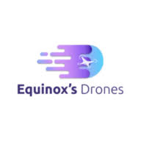
equinoxsdrones.com
10 Major Pros & Cons of Unmanned Aerial Vehicle(UAV) Drones
Opens in a new window

icas.org
Development and Performance Comparison of Optimized Electric ...
Opens in a new window

discuss.ardupilot.org
The VTOL compromise - VTOL Plane - ArduPilot Discourse
Opens in a new window

dewesoft.com
Understanding eVTOL: A Complete Guide to Electric Vertical Takeoff and Landing Aircraft
Opens in a new window

hinaray.com
5 Differences Between VTOL and CTOL: A Complete 2025 Guide - Hinaray
Opens in a new window

en.wikipedia.org
Unmanned aerial vehicle - Wikipedia
Opens in a new window

t-drones.com
How Much Weight Can a Drone Carry? (2025 Complete Guide)
Opens in a new window

nextechnology.myshopify.com
VTOL Vertical Take off and landing drone - nextechnology
Opens in a new window

deltaquad.com
Long Range VTOL Fixed Wing Drones - DeltaQuad
Opens in a new window
jouav.com
JOUAV VTOL Drone - Up to 10 Hours and 200km Range
Opens in a new window

genstattu.com
Tattu Drone UAV Lipo Battery - GensTattu
Opens in a new window
foxtechfpv.com
Diamond Pro 330wh/kg High Energy Density Semi-Solid-State Li-ion Battery
Opens in a new window

dronelife.com
New Next-Generation Battery Technology Doubles Drone Flight Time - Dronelife
Opens in a new window

grepow.com
Grepow High Energy Density Battery Solutions for Commercial Drone
Opens in a new window

chinahobbyline.com
How to Calculate LiPo Battery Flight time - CNHL
Opens in a new window

omnicalculator.com
Drone Flight Time Calculator
Opens in a new window
jouav.com
BVLOS Drones: Complete Guide to Beyond Visual Line of Sight - JOUAV
Opens in a new window

droneops.co.za
DJI M300 RTK Specs - Drone Ops
Opens in a new window
uavcoach.com
Security Drones: An In-Depth Guide [New for 2025] - UAV Coach
Opens in a new window

dslrpros.com
Buy DJI Mavic 3 Enterprise RTK Module - DSLRPros
Opens in a new window
dronesmadeeasy.com
Mavic 3 Enterprise RTK Module - Drones Made Easy
Opens in a new window

sciepublish.com
4DoF Rat-SLAM with Memristive Spiking Neural Networks for UAVs Navigation System
Opens in a new window

geosunlidar.com
China LiDAR Scanning System & SLAM LiDAR Solutions factories
Opens in a new window

freeflysystems.com
Drone Payloads - Freefly Systems
Opens in a new window

geoweeknews.com
Hovermap: Powerful SLAM for Drone Autonomy and Lidar Mapping | Geo Week News
Opens in a new window

unmannedsystemstechnology.com
BVLOS Communications - Unmanned Systems Technology
Opens in a new window
unmannedsystemstechnology.com
Satellite & Wireless Connectivity for Drones, UAV, UGV, USV - Unmanned Systems Technology
Opens in a new window
groundcontrol.com
No Signal, No Problem: Enabling BVLOS Drone Operations Anywhere on Earth
Opens in a new window

commonslibrary.parliament.uk
Rural mobile coverage in the UK: Not-spots and partial not-spots
Opens in a new window

ofcom.org.uk
Connected Nations update: Spring 2025 - Ofcom
Opens in a new window
ofcom.org.uk
Introduction - Ofcom
Opens in a new window

accesspartnership.com
Access Alert | Enabler for drones beyond visual line of sight (BVLOS) operations in the United Kingdom
Opens in a new window
ofcom.org.uk
Statement: Spectrum for Unmanned Aircraft Systems (UAS) - Ofcom
Opens in a new window
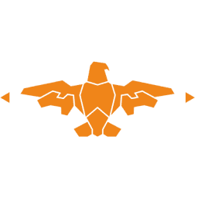
shuziying.singoosite.singoo.xyz
Drone Gimbal Camera with Daylight and Thermal Imaging YPO-05P - Digital Eagle
Opens in a new window

motionew.com
U30TIRM Pro Gimbal Camera for Drone - MotioNew
Opens in a new window

litelume.com
The Ultimate LED Flood Lights Buying Guide | LITELUME
Opens in a new window

paclights.com
A Comprehensive Guide to Selecting the Best Wattage for LED Flood Lights - PacLights
Opens in a new window

ico.org.uk
Facial Recognition Technology (FRT) and surveillance | ICO
Opens in a new window
ico.org.uk
Video surveillance (including guidance for organisations using CCTV) | ICO
Opens in a new window

urmconsulting.com
Facial Recognition Technology and Data Protection Compliance - URM Consulting
Opens in a new window

hunton.com
UK ICO Considers Application of Data Protection Law to Live Facial Recognition Technology - Hunton Andrews Kurth LLP
Opens in a new window

eyeonprivacy.com
ICO Has Concerns Over Facial Recognition Use - Eye On Privacy
Opens in a new window

digit.fyi
ICO Issues Guidance on Facial Recognition Technology - Digit.fyi
Opens in a new window
ico.org.uk
ICO orders Serco Leisure to stop using facial recognition technology to monitor attendance of leisure centre employees | ICO - Information Commissioner's Office
Opens in a new window
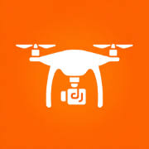
hiredronepilot.uk
UK Drone Jammers: The Illegal Gadget That Could Land You in ...
Opens in a new window

jammermaster.com
The Legal Question of Signal Jammers in the United Kingdom
Opens in a new window

blakistons.co.uk
Drones, Security, and the Law: Understanding the UK's Counter-Drone Framework
Opens in a new window

caa.co.uk
Registering to fly drones and model aircraft | UK Civil Aviation Authority
Opens in a new window

dronesitesurveys.co.uk
UK Drone Laws 2025 & Law Classifications - Drone Site Surveys
Opens in a new window

coptrz.com
British Drone Laws 2024: A Guide to UK Drone Licencing - Coptrz
Opens in a new window
caa.co.uk
Flying drones for work | UK Civil Aviation Authority
Opens in a new window

uavnavigation.com
EASA Drone Regulations: A Comprehensive Guide for Compliance - UAV Navigation
Opens in a new window
uavcoach.com
Drone Laws in the United Kingdom - UAV Coach
Opens in a new window

mdpi.com
Privacy-Preserving Surveillance as an Edge Service Based on ...
Opens in a new window

researchgate.net
Towards real-time privacy-preserving video surveillance - ResearchGate
Opens in a new window
mdpi.com
Privacy-Preserving Face Recognition Method Based on Randomization and Local Feature Learning - MDPI
Opens in a new window

