Photodegradation of Suprameolecular Photocatalysts Investigated by HPLC

Research Proposal by

Dr. Hamid M. Younis Ahmed

# Abstract

Light-driven water splitting by (supra)molecular photocatalysts promises efficient conversion and storage of solar energy in chemicals. To improve their performance and stability a detailed understanding of degradation pathways is necessary. This can be investigated by high performance liquid chromatography (HPLC).

# Background & State of the Art

Combustion of fossil fuels such as coal, oil and gas, leads to emission of greenhouse gases like carbon dioxide (CO2) which causes global warming. Green hydrogen gas (H2) – produced with renewable energy – is considered as one of the clean and sustainable energy carriers of the future. Many researchers put tremendous effort in investigating ways to produce H2in a sustainable manner.

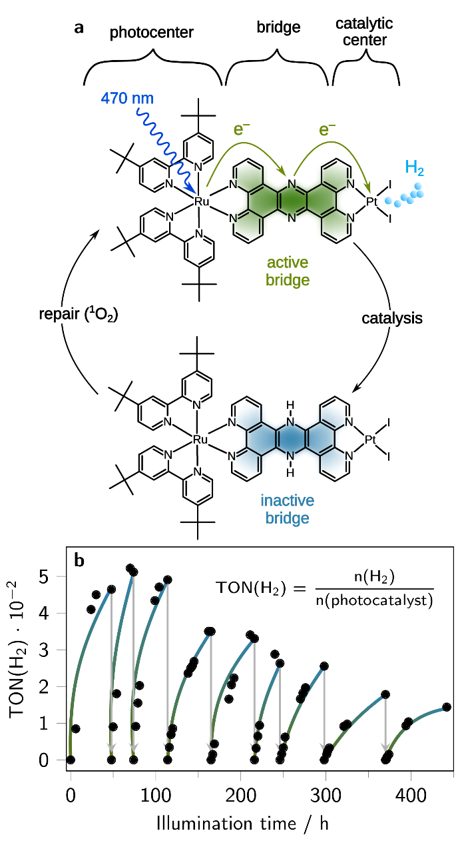In natural photosynthesis (NP) solar energy is directly converted and stored in chemical bonds by formation of energy-carrier molecules such as ATP and NADPH which is later used to reduce CO2 to carbohydrates. Artificial photosynthesis tries to mimic this process e.g. by splitting water (H2O) into H2 and oxygen (O2). This is beneficial as the direct conversion of solar energy into solar fuels like H2 promises a higher efficiency compared to currently pushed technologies like power-to-X. Among the different approaches for AP, the use of (supra)molecular photocatalysts is deemed as one of the most promising because their properties can be tuned on a molecular level and they have much higher atom economy compared to use of bulk materials.[1,2]

Figure 1: RutpphzPtI2 in active and deactivated form (top) and catalysis results (bottom).

The group of Rau and co-workers have investigated the dinuclear photocatalyst [Ru(tbbpy)2(tpphz)PtI2](PF6)2 (tbbpy = 4,4’-di-tert-butyl-2,2’-bipyridine, tpphz = tetrapyrido[3,2-a:2’,3’-c:3’’,2’’- h:2’’’,3’’’-j]phenazine), short **RutpphzPtI2**.[3] This photocatalyst is able of light-driven production of H2 with a turnover number (TON = n(H2)/n(**RutpphzPtI2**) of around 500 before the photocatalytic reaction stops. It has been shown that the catalyst is deactivated by hydrogenation of the tpphz bridging ligand.[4] This deactivation can be reversed by reaction of the catalyst with O2 or chemical oxidants under irradiation.[5] By this reactivation process the catalytic activity can be prolonged for weeks and accumulated TONs reach several thousand. However, during recycling the maximum TON reached for each run drops over time. It is assumed that during the recycling process some of the catalyst is damaged by reactive oxygen species such as 1O2 (c.f. Figure 1). However, despite the detailed investigation on the hydrogenation process that leads to catalyst deactivation, there is little known about what species are formed during the repair process. Knowledge about this will be of outstanding importance to further improve recycling processes or the stability of new generations of photocatalysts.

High performance liquid chromatography (HPLC) is a method that significantly enhances the capabilities of standard chromatography techniques.[6,7] In HPLC the eluent/mobile phase is pumped with high pressure through the column/stationary phase by a mechanical pump. Separation of fractions takes place by interaction of the eluted compounds with the stationary phase leading to separation e.g. by polarity or size, depending on the column material. Due to this interactions, different compounds will elute with different speed and have different retention times. Further influences on the elution can be achieved by eluent gradients or changes in the temperature or operating pressure. This way, separation of very similar compounds such as isomers or even enantiomers is possible. Sample collection takes place at the end of the column and fractions are usually detected by optical spectroscopy like an absorption or emission detector. Despite the different retention times of different compounds these spectra can already provide information that can help to identify the specific compound. Combination with other characterisation methods such as mass spectrometry or NMR (for semi-preparative HPLC) is possible and can further help identifying certain fractions. Therefore, HPLC is ideally suited to investigate compounds of similar chemical composition like degradation products of metal complex photocatalysts.



Figure 2: ligand exchange in dinuclear Ruthenium complex triggered by irradiation (48h) and corresponding absorption spectra of the different species.[8]

During my PhD studies at Dublin City University in the group of Prof. Han Vos, I carried out detailed investigation of photoactive ruthenium polypyridyl complexes.[9] In this project different dinuclear ruthenium complexes and their photodegradation products have been investigated by HPLC in combination with other techniques. The compounds were also irradiated with visible light and the photolysis products have been investigated after different irradiation times (see Figure 2 for example). Results of these and related studies have also been published in the literature.[8,10] Therefore, I have great expertise in finding suitable HPLC methods for the separation of photocatalysts and their decomposition products and also in further investigating them with other analytical methods such as NMR.

# Outline of the Research Project

The complex **RutpphzPtI2** is the first example of a molecular photocatalyst that can be actively repaired. Despite this achievement and the knowledge on the (main) deactivation pathway, the influences on the compound by repair procedure are so far not investigated in detail. However, the drop in catalytic performance during consecutive recycling loops (see Figure 1, bottom) indicates that alteration or decomposition of the photocatalyst is taking place. To understand the decomposition pathways more research is necessary. This can then help to improve the recycling procedure or future generations of photocatalysts that are more stable.

At Institute of Inorganic Chemistry I of Ulm University, two HPLC setups are available. The instrument by JASCO is for analytical and semi-preparative measurements and features a photodiode array detector. The device by PerkinElmer is for analytical measurements and has a photodiode array detector or alternatively an IR detector.

To understand the decomposition of **RutpphzPtI2**, samples can be taken at different time points during photocatalysis and repair cycle. By HPLC analysis evolution of different species can then be followed. Identification of the species can be achieved by comparing retention times of the fractions with reference compounds. Furthermore, with UV/Vis spectra from photodiode array detector of the HPLC, additional information can be obtained. This is especially conclusive in the case of photoactive complexes, as changes in their ligand structure also usually lead to changes of their absorption spectra (c.f. Figure 2). Due to treatment with 1O2 and irradiation during the repair cycle, formation of active oxygen species can be expected. These can attack and oxidise the ligand structure of the complex which might lead to formation of e.g. carbonyl moieties on the ligand, which can be easily identified by IR spectroscopy due to strong absorption bands. Mass spectrometry is also good for investigating metal complexes because of the isotopic pattern of the included metals like ruthenium and platinum. Therefore, it is easy to identify fragments were one metal centre is lost. When using semi-preparative HLPC and sufficient sample size, it is also possible to investigate the fractions by NMR. Comparing all this information with reference compounds should be very helpful to identify degradation products and therefore understand what happens during catalysis and repair. This knowledge will be helpful to either establish softer repair methods that avoid destruction of the photocatalyst or also to make more stable new generations of photocatalysts.

The expertise gained with **RutpphzPtI2** will also be helpful for the investigation of other compounds from the Rau group that show dynamic behaviour under catalytic condition such as RutpphzRhCp*Cl or RubbipPtCl2.[11,12] In this way it can be found out if there are common degradation pathways among the different photocatalysts and if their structure can be changed in order to prevent this degradation and make a more stable catalyst.

One PhD student of the Rau group has already started to work on HPLC analysis of ruthenium complexes and I am sure that with my guidance and combined efforts we will be successful in this project. The HPLC analysis of metal complexes and also polymer matrices is also important for the CataLight Project (CRC/TRR 234) and in case of success during the funding period of PSI, a continuation of the work may be possible within CataLight.

# References

[1] M. E. El-Khouly, E. El-Mohsnawy, S. Fukuzumi, *J. Photochem. Photobiol. C Photochem. Rev.* **2017**, *31*, 36–83.

[2] A. J. Morris, G. J. Meyer, E. Fujita, *Acc. Chem. Res.* **2009**, *42*, 1983–94.

[3] M. G. Pfeffer, T. Kowacs, M. Wächtler, J. Guthmuller, B. Dietzek, J. G. Vos, S. Rau, *Angew. Chemie Int. Ed.* **2015**, *54*, 6627–6631.

[4] D. A. McGovern, A. Selmi, J. E. O’Brien, J. M. Kelly, C. Long, *Chem. Commun.* **2005**, 1402–1404.

[5] M. G. Pfeffer, C. Müller, E. T. E. Kastl, A. K. Mengele, B. Bagemihl, S. Fauth, J. Habermehl, M. Wächtler, M. Schulz, D. Chartrand, F. Laverdière, P. Seeber, S. Kupfer, S. Gräfe, G. S. Hanan, J. G. Vos, B. Dietzek, S. Rau, *Nat. Chem.* **2021**, *in revisio*.

[6] A. Weston, P. R. Brown, *High Performance Liquid Chromatography & Capillary Electrophoresis: Principles and Practices*, Elsevier Science, **1997**.

[7] L. R. Snyder, J. J. Kirkland, J. L. Glajch, *Practical HPLC Method Development*, John Wiley & Sons, Inc., Hoboken, NJ, USA, **1997**.

[8] Y. Halpin, D. Dini, H. M. Younis Ahmed, L. Cassidy, W. R. Browne, J. G. Vos, *Inorg. Chem.* **2010**, *49*, 2799–2807.

[9] H. M. Y. Ahmed, Investigation of the Photochemical Properties of Ruthenium Polypyridyl Complexes Using High Performance Liquid Chromatography ( HPLC ), Dublin City University, **2010**.

[10] S. Soman, H. M. Younis, W. R. Browne, J. G. Vos, M. T. Pryce, *Eur. J. Inorg. Chem.* **2017**, *2017*, 5598–5603.

[11] L. Zedler, A. K. Mengele, K. M. Ziems, Y. Zhang, M. Wächtler, S. Gräfe, T. Pascher, S. Rau, S. Kupfer, B. Dietzek, *Angew. Chemie Int. Ed.* **2019**, *58*, 13140–13148.

[12] S. Kaufhold, D. Imanbaew, C. Riehn, S. Rau, *Sustain. Energy Fuels* **2017**, *1*, 2066–2070.