D E S C R I P C I Ó N

SINGLE-DOSE PACKAGING FOR MEDICINAL TABLETS OR CAPSULES FOR FOOD SUPPLEMENTS
It is a single-dose container for medicinal pills or capsules for food supplements, composed of a film of malleable material, where the container has a partial cutting line, which can be provided inside another package or box.
On the other hand, it aims to ensure the environmental sustainability of the material to be used, which must be of organic or biological origin and compostable, from materials such as corn starch, potato starch, chitosan, cotton, an alloy of carnauba and tree resin or other suitable materials. In any case, malleable, easy to open and also not likely to cause any cut in the skin or mouth of the user or consumer.
Allowing greater hygiene, safety and protection against viruses, microbes, bacteria or communicable diseases.

TECHNICAL SECTOR

Pills for medicinal purposes and capsules for food supplements.

BACKGROUND TO THE INVENTION

According to the searches carried out by the Spanish service of Industrial Property (Oficina Espanola de patentes marcas) , there is no film in format, with the characteristics and materials that are intended to be developed.

EXPLANATION OF THE INVENTION

The packaging allows the opening and introduction of the medicinal tablet or capsule into the mouth, without touching or handling the content and without swallowing or swallowing the container itself.
It can also be taken without the use of the hands and opened only with the mouth by disabled people.

BRIEF DESCRIPTION OF THE DRAWINGS

As for the format of the container that surrounds the pills or capsules (Figures 1, 2 and 3), it can be produced in an approximately circular, oval or rectangular shape, with an incision or cut, but only partial of half of its extension and thickness, adaptable to the different contents.
This allows it to be easily opened and the contents of the tablet or capsule to be inserted directly into the mouth, without touching or handling and without swallowing the container itself.

Figure 1.- Show a side view of the oval-shaped container and the incision or cut.
Figure 2.- Shows a side view of the container in approximately rectangular \ oval or capsule shape and the incision or cut.
Figure 3.- Show a side view of the circular container and the incision or cut.

PREFERENTIAL REALIZATION OF THE INVENTION

The use can occur in such a way that the pills and capsules can be brought to the mouth without having to pick them up and touch them directly, that is, lifting and touching the packaging with only the fingertips (namely the index and thumb), avoiding the manipulation of the contents of the pills or capsules and their possible contamination by viruses, avoiding possible cuts on the fingers or lips, due to the malleability of the materials to be used.

CLAIMS

What is claimed is a single-dose container for medicinal pills or capsules for food supplements, which allows the direct introduction of the medicinal tablet or capsule into the mouth, without touching or manipulating the contents and without swallowing or swallowing the container itself, composed of a film of malleable material, where the container has a partial cutting line, characterized by:
1 – Have an incision or cut, partial to half of its extension and thickness, adaptable to the different contents.
2 – According to claim 1, single-dose packaging for medicinal tablets or capsules for food supplements is distinguished by the fact that the material to be used is malleable and of organic origin.

DRAWINGS

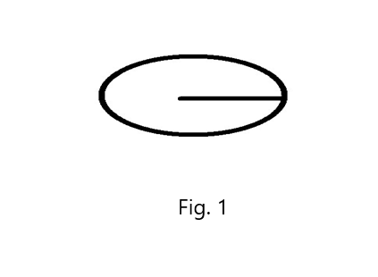
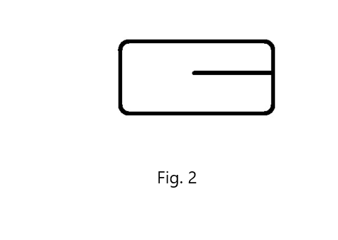

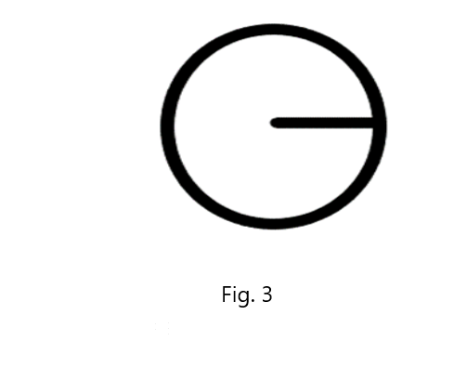

ABSTRACT

It is a single-dose container for medicinal pills or capsules for food supplements, composed of a film of malleable material, where the container has a partial cutting line, avoiding the manipulation of the contents of the pills or capsules and their possible contamination by viruses, microbes, bacteria or communicable diseases, even avoiding possible cuts on the fingers or lips.

