**CLOS DE LA MOLENIE « Michelot » 2021 Bordeaux Supérieur AOP**

[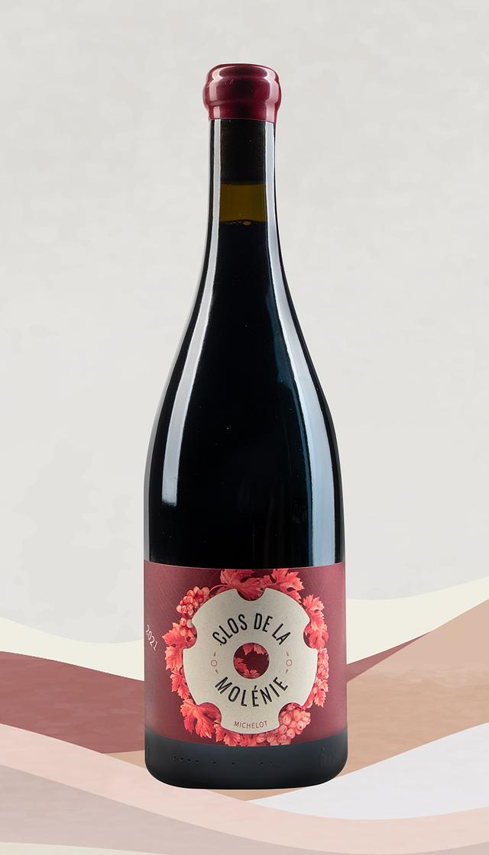](https://public-storage.qoqa.ch/vo3papx4angjpt1dj52orzt9hiw4)

Grapes: 60% merlot, 20% cabernet sauvignon and 20% cabernet franc

Plot: Michelot

Production surface: 2 ha

The vineyard is certified organic and biodynamic

Soil: clay limestone argilo-calcaire

Age of the vineyard: 35 years

Harvest: mechanical harvest

Vinification: pump over in stainless steel vats

Aging: 50% in one year oak barrel and 50% in second year oak barrel

Tasting notes: bright ruby colour, intense nose of fresh red fruits with spicy hints and fresh pepper.

The mouth is full and complex with a chalky and long aftertaste.

Jeb Dunnuck: 91/93

Médaille d’Or au Concours *Challenge* de Millésime Bio en 2023