 | Research Profile
Mildmay Uganda  Founded in Uganda: 1998  Incorporated in Uganda as a company limited by guarantee in 2010; and registered by the NGO Bureau in 2013.  Vision  Communities Transformed for Sustainable Health, Through High Quality Applied Research  Headquarters  Plot 454/455, 12 Km Entebbe Road Naziba  Kampala-Uganda  Key Contacts:  Dr. Ronald Mulebeke,  Director, Mildmay Research Center Uganda(MRCU)  P.O Box 24985 Kampala, Uganda.  Tel: +256312210200/  Mob: +256 785613467  Email: ronald.mulebeke@mildmay.or.ug  Twitter: @MildmayResearch  Facebook: @MildmayUgandaResearchCenter  Website: www.mrcug.org  Dr. Yvonne Karamagi  Executive Director  Mildmay Uganda  T: 0776-729800  E: yvonne.karamagi@mildmay.or.ug | Who We Are  Building upon the established foundation of Mildmay Uganda (MUg), a faith-based NGO with a proven track record in HIV prevention, care, and treatment since 1998, Mildmay Research Centre Uganda (MRCU) is dedicated to advancing health outcomes through rigorous scientific inquiry.  MRCU's overarching goal is to solidify its position as a leading health research institution by 2028. This is achieved through the implementation of three strategic pillars: the execution of high-quality clinical and operational research, the provision of research capacity-building programs, and the continuous enhancement of organizational sustainability.  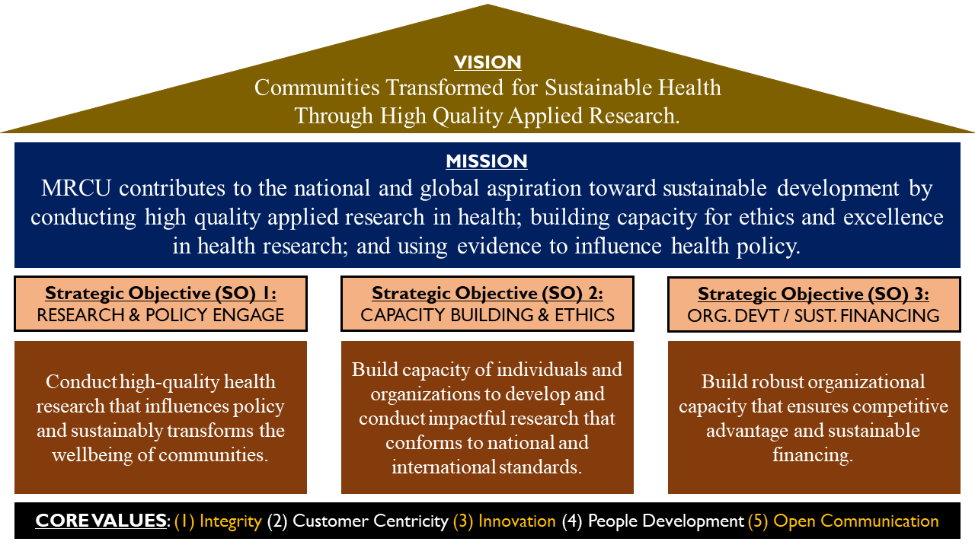  Operational Capacity  - Structural advantages: MRCU is a subsidiary within the broader Mildmay Uganda Group, which encompasses a hospital, an ISO 15189 accredited laboratory, and a health sciences institute. This integrated ecosystem facilitates conducting clinical research, laboratory-based research and the rapid dissemination of evidence-based interventions.  - The Hospital Laboratory supports clinical and research laboratory work that is ISO 15189 South African National Accreditation System (SANAS) accredited. The laboratory serves as a backup to the Central Public Health Laboratory/Ministry of Health (MoH) Uganda for viral load testing, COVID-19 testing and HIV DNA PCR testing. The laboratory has departments such as Molecular, Microbiology, Hematology, Biochemistry, and Immunology with automated workflows and lab information management systems. Our current bio-repository capacity is for 50,000 samples.  - Dataset Profile: MRCU leverages accumulated substantial data from projects such as the HIV program in Uganda's Central region for the past 7 years and Mildmay Uganda Hospital for over 20 years, since 1998.  - The data covers HIV/AIDS and comorbidities such as Tuberculosis (TB), Hepatitis B, Cancer, Diabetes Mellitus, Cardiovascular Diseases, Pneumonia, Hepatic Diseases and Mental Health.  - There is a maintained comprehensive hospital patient records for approximately 44,498 patients, including demographic profiles, counselling information, and viral load data. The dataset has over 456,590 observations, and over 633,188 laboratory test results over the years. This data facilitates in-depth analyses and provides valuable insights into patient demographics, treatment outcomes, and disease trends.  - MRCU operates the Mildmay Uganda Research Ethics Committee (MUREC), an institutional review board accredited by the Uganda Council for Science and Technology (UNCST). MUREC ensures ethical compliance in all research activities, reviewing and approving over 100 protocols annually.  - MRCU maintains a strong publication record, currently manages 7 active research protocols, including a Phase IV clinical trial, and fosters collaborative partnerships with diverse stakeholders.  Finance and Grants Management  Mildmay Research Centre Uganda (MRCU) strongly believes that fostering and building research infrastructure shall deliver national and international benefits.  The MRCU Grants Management Unit (GMU) has developed policies and standard operating procedures to assist researchers, administrative and other staff involved in the grant writing and management of the research process. The policy provides guidelines for research projects sponsored by funders, cooperative agreements, contracts, and memorandum of understanding to enhance increased collaboration, accountability, and proper stewardship of funds. The guidelines are also aimed at ensuring that management is aware of the commitments and obligations made by both internal and external researchers on behalf of the institution.  At MRCU all research budgets must be approved by the Grants Management Unit (GMU) before submission to a funder; the authorized organizational representative will not sign off any proposals that have not been routed through GMU. MRCU believes that offering comprehensive grants management where performance is tracked and risks are identified and managed increases donors’ confidence in the institution’s management structures and processes. MRCU is in the process of securing Good Financial and Grants Practices (GFGP) certification from the Global Grants Community (GGC) and the Africa Academy of Science (AAS)

