**Hydrogen-Tolerant High Entropy Alloy Coated and Clad Steels**

**Background and research focus:** The efficient use of Hydrogen (H2) as a green energy carrier enables many emerging technologies with reduced or zero carbon footprint in industry and society. There are, however, challenges in the full implementation of H2 as a fuel. Namely, the infrastructure requires more development, characterized by so far more than 300-billion-dollar global investments until 2030. This project aims to design and develop high-performance coatings that are durable against hydrogen embrittlement (HE). The entire value chain of H2 will benefit from this research, from production to storage and consumption in a spectrum of sectors from transportation to energy and household.

**Purpose and aim:** We aim to study hydrogen embrittlement susceptibility and manufacturability testing, the new coating/cladding design deposited on clean carbon and low-alloyed steels which should exceed the performance of existing metals (stainless steels) and double the lifetime of future hydrogen pipelines. The resulting lighter and tougher designs also should ensure lower manufacturing and assembly costs, while improving safety and reducing repairs. Time to market is estimated to be 5-10 years because of the amount of work required to optimize compositions, coating adhesion and manufacturing technologies. Specifically, the objectives are (TRL 4-5):

* Prepare safe, cost-effective and long-lasting alternatives to 316L austenitic stainless steel pipe by providing a C-Mn steel + Internally Clad solution.​
* Use novel alloy design strategies (High Entropy Alloy, HEA) to roll-clad tubular grade and ERW weld them in the future.
* Material characterization for understanding the microstructure-performance-processing correlation and HE testing.​
* Demonstrator of a pipe using thermal spray, and laser cladding, and HE testing.​

**Potential partners: Sweden:** Uni. West (HV), Jönköping Uni (JTH), ESAB?, **Germany:** Fraunhofer IWS, **Hungary:** Bay Zoltan Institute, Hungarian Gas Storage

**Funding**: From Clean Energy Transition (CET) partnership in EU: <https://cetpartnership.eu/calls/joint-call-2023>; aiming for for 36 months; 100% funding universities; Swedish industrial SMEs up to 45% funding, medium enterprises up to 35%. Large companies, up to 25% (the rest in-kind contribution). Energimyndigheten for Swedish partners: <https://www.energimyndigheten.se/utlysningar/clean-energy-transition-partnership-cetpartnership/>;

**EXPECTED BENEFITS**:

1. The resulting designs could operate at higher pressures, could carry any mixture of natural gas and hydrogen (up to 100% H2), at a variety of temperatures, including cryogenic.
2. Knowledge transfer for novel materials and technologies development contributing to the expansion of H2 gas usage as an energy carrier, leading to CO2 reductions and achieving the clean environment targets of 2035 and 2050.
3. The potential to reduce the risk of leaks and accidents would improve the image of the company (PR), together with less likely maintenance operations disturbing the environment.
4. 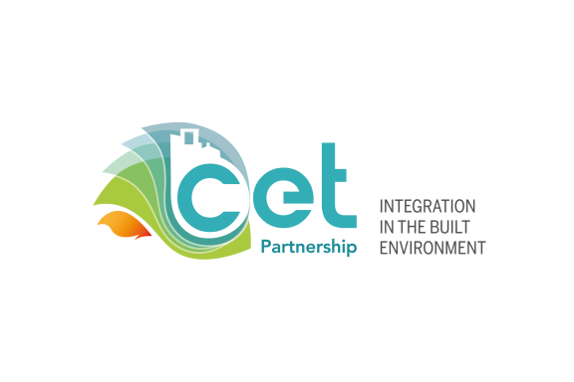The company would be known for indirectly contributing to the reduction in dependence on strategic metals such as Ni, Co, etc., by pursuing clean steel substrate designs.