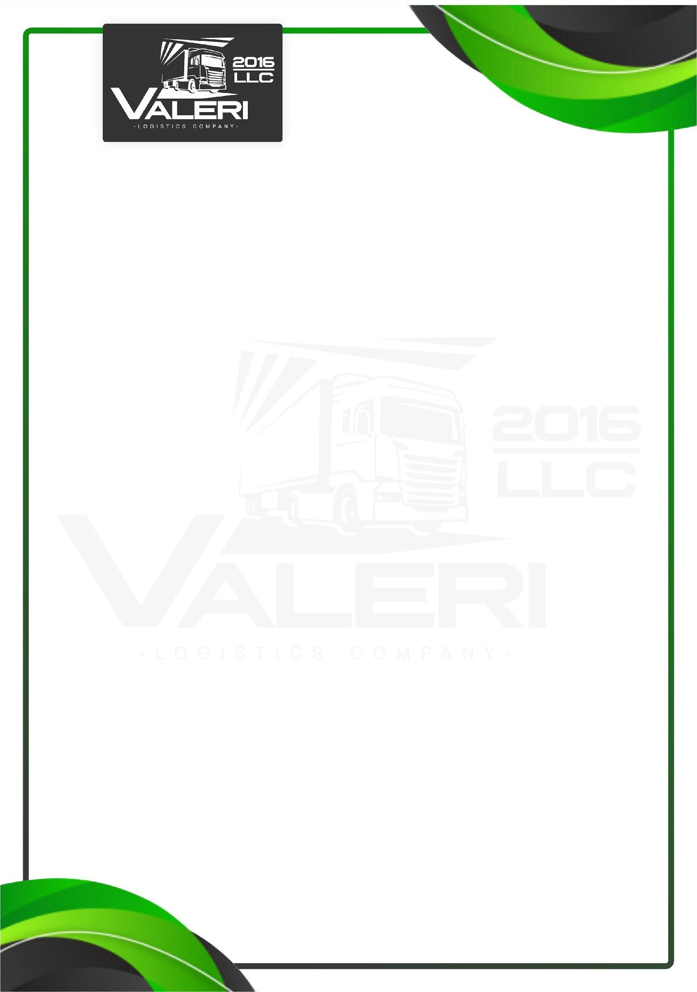

LLC «Valeri 2016»
Reliable International Transportation Without Compromises
Own Fleet • Dedicated Forwarding •
Price, Speed, Responsibility
LLC “Valeri 2016” is a transport and logistics company providing efficient domestic transportation within Ukraine and international freight transportation between any countries worldwide.
We operate using our own vehicle fleet as well as dedicated forwarding partners under long-term contractual conditions, which allows us to quickly allocate transport according to specific client requirements and ensure stable execution regardless of the route or destination.
Our core specialization is on-time cargo delivery without delays. We take full responsibility for transportation coordination, provide control at every stage of the route, and guarantee a predictable result.
Our key advantages:
- competitive and transparent pricing with no hidden costs;
- reliability and strict compliance with delivery deadlines;
- fast vehicle availability for any volumes and routes;
- international transportation between any countries.
We work with manufacturers and cargo owners for whom clear processes, fast decision-making, and guaranteed results are critically important.
Our goal is to become your long-term logistics partner, not just a one-time carrier.

Sincerely,Director Vasyl Zholob
Contact phone: +380956732098 E-mail: marynvalery2016@gmail.com

