Lisa Reehten
CEO Bosch Energy and Building Solutions GmbH

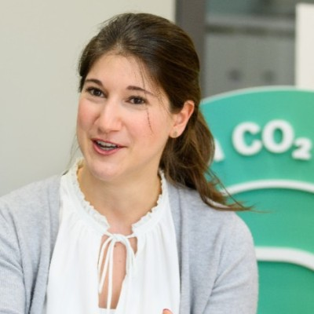
After graduating in International Business Management and working abroad in Abu Dhabi and Hungary, Lisa Reehten began her career at IBM in 2012. After business development with cloud start-ups, she took over various key account and management functions for industrial companies, in which she built up her expertise in the electronics, automotive and manufacturing industries, as well as with technologies such as IoT, AI, analytics and cybersecurity. In 2021 she moved to Bosch Climate Solutions and in 2023 took over the CEO role for the boutique consultancy in the field of sustainability and climate protection. At the same time, she completed her MBA in Sustainable Management and Future Trends. In 2023, she furthermore took over the CEO role of Bosch Energy and Building Solutions GmbH, another BOSCH subsidy in the area of energy services.

Source (pic): (27) Lisa Reehten | LinkedIn

