Dr. Marc Pauchard

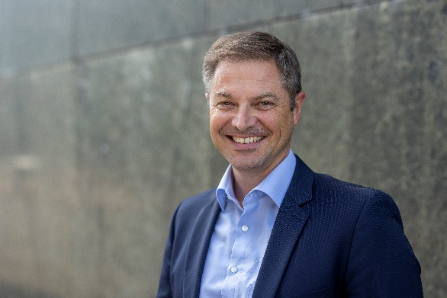

Dr. Marc Pauchard has been head of Innosuisse's Knowledge Transfer and International Collaborations Department and a member of the management board since 2018.
He is the high-level Eureka representative of Switzerland and a member of the Eureka Executive Board. He is a member of the steering committee of Swisscore, the Swiss information and liaison office for European policies and programmes in research, innovation and education (ERI), located in Brussels.
He studied chemistry at the University of Fribourg, obtained his doctorate at the University of Bern and continued his research career in the USA in the group of Nobel Prize winner Prof. Alan J. Heeger at the University of California Santa Barbara.
Until 2008, he was head of section in the research department of an internationally active Swiss company and then became deputy director at the Adolphe Merkle Institute, a leading international center of excellence for soft nanomaterials.

