

**BEAD Challenge Process FAQs**

This document includes questions submitted by attendees of ADECA’s Challenge Process webinar, which have been condensed and edited for clarity.

Note: ADECA will be holding virtual office hours for the Challenge Process on Thursdays (9:30 am to 10:30 am) from August 1, 2024, through August 29, 2024. During these times, join by [clicking here](https://teams.microsoft.com/l/meetup-join/19%3ameeting_NmNjZDM2YjQtY2E3Zi00MzExLTkxOTUtM2M3NzZmMWRiYzFm%40thread.v2/0?context=%7b%22Tid%22%3a%22e2fecc02-e27c-4b87-8890-f3d47972f835%22%2c%22Oid%22%3a%226b688179-0854-4f25-ab9e-dd988c83084b%22%7d) or using the meeting details on [ADECA’s website](https://adeca.alabama.gov/alipv1v2/).

# About the Challenge Process

1. **When does Alabama’s Challenge Process open?**

ADECA will begin accepting challenges through the Challenge Portal on August 1, 2024. The Challenge Process includes three phases, with the following timeline:

* Challenge Phase: August 1, 2024 – August 31, 2024
* Rebuttal Phase: September 16, 2024 – November 2, 2024
* Final Determination Phase: November 4, 2024 – December 4, 2024

1. **Are rebuttals due on a rolling basis, or are all rebuttals due on the same date?**

Once notice of an accepted challenge is provided, rebuttals are due by November 2, 2024.

1. **When will the lists of eligible and ineligible locations be published?**

The map and data downloads have been released as of July 25, 2024, and can be viewed here: <https://adeca.alabama.gov/alipv1v2/>. These files show the pre-Challenge Process classification (unserved, underserved, or served) of each Broadband Serviceable Location (BSL) in Alabama by FCC Location ID, as well as ADECA’s list of community anchor institution (CAI) locations.

1. **How can local governments view a map of the specific locations that are included in the list of un/underserved FCC Location IDs so we can understand where these locations are?**

You may view a map of the locations eligible and ineligible for BEAD funding on Alabama’s Challenge Portal website: <https://register.broadband.alabama.gov/register/bead/map>. (You do not need to register as a challenger to view the public map.)

1. **What version of the Fabric is the state using to make eligibility determinations?**

The map and data of eligible locations depicted in the Challenge Process have undergone pre-challenge deduplication and have been updated to Version 4 of the Broadband Serviceable Location Fabric (showing National Broadband Map Availability Data as of December 31, 2023, updated May 14, 2024).

1. **Will additional awards be made under the Alabama Capital Projects Fund (CPF) program and what effect will these awards have on unserved and underserved areas that are eligible for BEAD? Will these awards be reflected on the map?**

ADECA will announce additional CPF awards. Locations addressed by those awards will be removed from the BEAD-eligible addresses at the end of the Challenge Process.

1. **How do local governments make their citizens aware of the Challenge Process? Does ADECA have any community contact templates to assist challenging entities?**

ADECA will share information about the Challenge Process through the Be Linked Alabama website and standard social media accounts. Local governments are encouraged to elevate those posts on their own social media platforms to raise awareness with residents.

1. **How do local governments receive challenges from their individual residents?**

Challenges may only be submitted by units of local and Tribal governments, broadband service providers, and nonprofits. While residents are not allowed to submit challenges directly to ADECA, they are an essential part of the Challenge Process and may work directly with any of these entities to submit their challenge data. For many types of challenges, the data submitted by the permissible challengers will be gathered directly from residents and/or businesses that cannot access the level of broadband service that is reportedly available to them.

1. **What should a community do if they believe they are not served but do not have the capacity or resources to participate in the Challenge Process?**

ADECA encourages a community representative to attend our office hours to work through specific challenges your community may be facing. ADECA will be holding virtual office hours on Thursdays from 9:30 am to 10:30 am from August 1, 2024, through August 29, 2024. You may also schedule a call with ADECA by contacting broadband.fund@adeca.alabama.gov.

# Eligible challenges

1. **If wireless service is available but businesses in the area would be better served by fiber, is that a valid challenge?**

If the address is served by a fixed wireless option that meets the minimum speed requirements, it is not eligible for BEAD funding and the challenge would not be accepted. However, locations exclusively served by a wireless service using entirely unlicensed spectrum are considered unserved for the purposes of the BEAD Program.

1. **What if broadband service is available at a sufficient speed but residents cannot afford it?**

ADECA recognizes this is an issue. However, if an address is considered served (100/20 Mbps or higher speeds provided by a reliable broadband service), it is ineligible for BEAD funding, regardless of the affordability of the service.

1. **The Challenge Process Resource Guide indicates that for planned service or existing service challenges an agreement is required between the provider and ADECA. Will a draft copy of the agreement be made available, or do I need to speak with ADECA in advance of the Challenge Process?**

Planned or Existing Service challenges have a list of required evidence to support the challenge. There is no agreement required with ADECA, but there are requirements for proof of service availability. We have updated the Challenge Process Resource Guide for clarity.

1. **Since the planned service date of June 30, 2024, has passed, is ADECA considering extending this date?**

No. ADECA followed NTIA’s Model Challenge Process and used the date NTIA provided in that guidance for its approved Initial Proposal Volume 1.

1. **With the planned service build date cutoff being in the past, does this mean that ADECA will not accept challenges for any locations currently in the process of being built that fall outside of an enforceable commitment?**

That is correct.

1. **Will there be any support for existing service challenge types? During previous BEAD Challenge Processes in other states, my organization occasionally found errors in our reported service footprint. Would I submit any corrections via the planned service challenge type and, if so, could I provide evidence of existing service as opposed to evidence of upcoming construction?**

The Challenge Process Policy Notice and Alabama Initial Proposal Volume 1 include a Type P “Planned service” challenge, with the definition: “[t]he challenger has knowledge that broadband will be deployed at this location by June 30, 2024, without an enforceable commitment or a provider is building out broadband offering performance beyond the requirements of an enforceable commitment." This Type P challenge includes both planned service (that will be completed by the date specified) and existing service (that has already been completed but is not reflected in the current map). The Challenge Portal contains options for selecting either planned service or existing service, depending on the nature of the challenge.

Entities planning to file an Existing Service challenge should do the following: In the Challenge Portal, under “Select challenge class and type,” select “Planned or existing service” and then select “Existing service.” See the Challenge Process Resource Guide for more details.

1. **Is the** **CAI service level based on FCC Broadband Data Collection (BDC) data? If so, would CAIs that lack BDC records default to unserved?**

Yes, CAI service levels are based on FCC data. For CAI locations that do not have reported speeds, ADECA approximated the service level by using the top speeds in the census block where the CAI is found, according to the approved methodology in the state’s Initial Proposal. A CAI located in a census block that does not have access to 1 Gbps symmetrical service is considered unserved.

1. **Are Q type challenges accepted to indicate that a CAI has qualifying broadband service available?**

Yes, Q type challenges were inadvertently rejected upon initial challenge submissions. Those rejections have been reversed and all Q type challenges with sufficient evidence have been accepted with the challengers notified. Because of this error, ADECA has extended the Rebuttal Phase until November 2, 2024.

# Submitting a challenge

1. **I have two FCC Registration Numbers (FRNs): one as an Incumbent Local Exchange Carrier (ILEC) and one as a Competitive Local Exchange Carrier (CLEC). Which one should I use to register?**

ADECA suggests you register using whichever FRN is associated with the brand name that is more recognizable in the region, but you may use either one. If the FRN is associated with the provider ID and provider name you select, you will be able to proceed with registration. The FRN is only used to further validate that you represent the provider in question.

1. **Is there an aerial background for the challenge map that can be used to help place challenge points?**

Yes, the map has four view options for the base map: dark, satellite, light, and terrain.

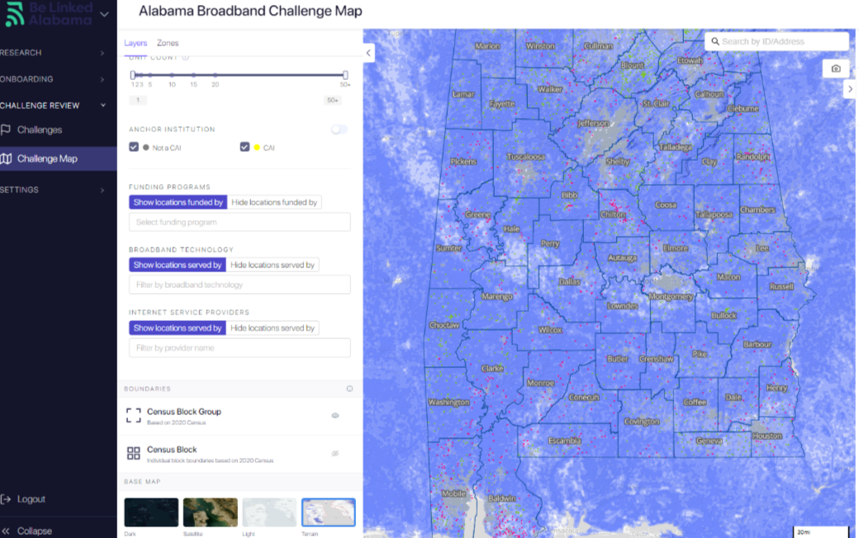

1. **Does the state allow bulk uploads of all Location IDs, including CAIs?**

Bulk uploads are available, but not for CAIs due to the standard of evidence necessary.

1. **When submitting network maps, is the inclusion of the BSL sufficient or should the map also include the USPS address?**

Including both the BSL ID and the postal address would be most helpful. The BSL’s associated address can be found in the portal.

1. **Can I upload shapefiles or .kmz files to define areas of interest?**

You can upload .kml, .kmz, or shapefiles for review.

# Resources

Challenge Process Portal: <https://register.broadband.alabama.gov/>

Alabama Initial Proposal Volume 1: <https://adeca.alabama.gov/wp-content/uploads/Alabama-BEAD-Initial-Proposal-Volume-1.pdf>

ADECA BEAD Challenge Process Resource Guide: <https://adeca.alabama.gov/wp-content/uploads/ADECA-BEAD-Challenge-Process-Resource-Guide.docx>

Challenge Process Data Download: <https://adeca.alabama.gov/alipv1v2/>

Challenge Process Webinar Slides and Recording: <https://adeca.alabama.gov/broadband-webinars-and-workshops/>