Title of Project: Commenting on PDFs
Target Audience: Newly hired Communications Associates
Directions for Reviewers:
- Please read over the audio script and on-screen text to check for accuracy, realistic dialogue, and completeness.
- Track Changes is on. Please make any simple corrections within the script or the text on screen columns.
- Use the “Comments” feature to ask questions or make comments on larger issues within the script or on-screen text.
- In the left column is the audio script. This will have a conversational tone. If it does not sound correct, please make changes as needed. The numbers in the script are for the video maker to know where to place the images and graphics and will not be read aloud.
- In the middle column is the on-screen text. Grammatical and spelling errors matter here, so please correct any mistakes you find in this column.
- The last column describes the visuals and the flow of the video. The numbers indicate where in the audio narration the action will occur.

Learning Objective: Upon completion of this training, the learner will be able to use functions in Adobe Acrobat Reader to indicate changes that should be made to PDF files.

Storyboard:
Audio Script | On-Screen Text | Visuals and Flow of Video
[1] Welcome to this training video about how to comment on a PDF file. This video will prepare you to use tools in Adobe Acrobat to make comments and indicate changes that should be made to a file.  Learning to use these tools will help you communicate effectively with graphic designers so they can implement your changes without error. This will save you time and improve the quality of the products you work on. | [1] Commenting on PDFs | [1] Welcome screen with title of video and an eye-catching design. Example:  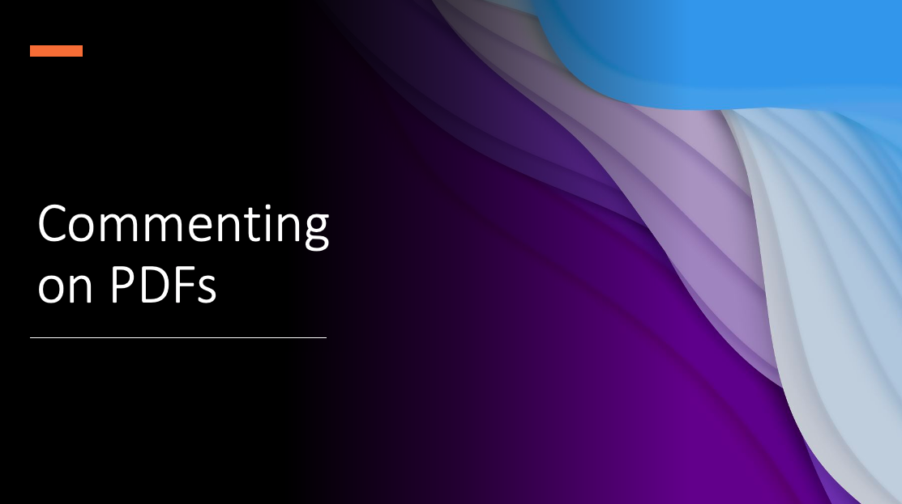  [2] Visual of a PDF that is open in Adobe Acrobat. The PDF contains generic text that might apply to any workplace, such as an office newsletter. PDF should have a title, 3 paragraphs of text, and 1 visual. There should be some aspects of the text, layout, and visual that could necessitate corrections or adjustments, and therefore provide examples of comments that could be made. Example:  
[3] We’ll start by selecting the Tools tab. Once you select this tab, several options will appear. [4] Select the Comment option. [5] Once you do this, you will see a ribbon at the top of the document with commenting tools, and you may see the commenting panel on the right. [6] | [Callout:] (Callouts fade in and out as audio refers to them.)  [3] Tools Tab | [PDF window is still visible from this point until the end of the video.]  [3] Mouse selects the Tools tab, new functions appear in the PDF as a result.  [4] Highlight box around Comment function, mouse selects the function. Highlight box fades in and out as audio refers to this function.  [5] View of PDF with comments ribbon and comments panel visible. Highlight box around commenting tools ribbon. Highlight box fades in and out as audio refers to this ribbon.  [6] Mouse points to commenting panel.
[7] One way to add a comment is to use the sticky note tool. [8] Select the tool, and then select the area of the document where you want to put the note. Then write your comment in the box that appears. | [Callout:] (Callouts fade in and out as audio refers to them.)  [7] Sticky Note | [7] Mouse selects sticky note tool, draws a text box.  [8] A comment is typed into the comment box at 2x normal speed. Audio is lowered to reduce sound of typing.
[9] You can use the strikethrough tool to indicate that text should be deleted. [10] Select the tool, then highlight the text you want to delete. [11] You can also add a note to the comment box that appears. | [Callout:] (Callouts fade in and out as audio refers to them.)  [9] Strikethrough | [10] Mouse selects the strikethrough tool, highlights a sentence in the PDF.  [11] Text is typed into the comment box at 2x normal speed. Audio is lowered to reduce sound of typing.
[12] If you want to replace some text with new text, you can use the tool that shows a strikethrough symbol with a comment box. [13] Select the tool and highlight the text you want to change. Then write the new text in the comment box that appears. [14] If you change your mind about any of your changes, you can always select the strikethrough lines and hit delete. | [Callout:] (Callouts fade in and out as audio refers to them.)  [12] Replace Text | [13] Mouse selects strikethrough tool, strikes through some text in the PDF, and replacement text is written in the comment box that appears.  [14] Mouse selects strikethrough lines from earlier point in video and they are deleted.
[15] Another way to add a comment is to use the text box function. [16] After you select this function, draw a text box somewhere on the document. [17] Then type your comment in the box. | [Callout:] (Callouts fade in and out as audio refers to them.)  [15] Text Box | [16] Mouse selects the text box function and draws a text box.  [17] Text is entered into the text box at 2x normal speed. Audio is lowered to reduce sound of typing.
[18] The pencil tool is helpful when you want to illustrate something or draw a quick sketch. [19] For example, you might want to cross something out or show how to rearrange some text.  [20] The eraser tool allows you to erase your drawings, but it is often easier to simply select the drawing and hit delete. [21] If you cannot select the drawing, make sure you select this arrow, and you will return to using the selection tool. Then you can choose your drawing and delete it. | [Callout:] (Callouts fade in and out as audio refers to them.)  [18] Pencil  [20] Eraser  [21] Selection Tool | [19] Mouse selects pencil tool and draws a quick sketch showing how a paragraph in the PDF should be moved. Time for this drawing clip can be sped up as necessary.  [20] Mouse selects eraser tool and erases part of drawing that was just made.  [21] Mouse selects arrow to pick selection tool in PDF, selects the drawing that was just made, and the drawing is deleted.
[22] The stamps tool is useful when you want to show that you have revised or approved a document. If you select dynamic, you can apply a stamp showing when you made your revisions or when you approved the file. Select the area where you want the stamp to appear, and it will be added to the document. | [Callout:] (Callouts fade in and out as audio refers to them.)  [22] Stamps | [22] Mouse selects stamps tool, then selects “Dynamic,” then selects a stamp to place on the document and places it.
[23] The attachment tool is useful when you want to add an image for somebody to reference. For example, let’s say I wanted the graphic designer to change this photo to a different one. I would select the attachment tool, place the paperclip on the document, choose my file, choose an icon, and now the photo is attached to the document. | [Callout:] (Callouts fade in and out as audio refers to them.)  [23] Attachment | [23] Mouse selects attachment tool, places the paperclip on the document, chooses a file from the desktop, and chooses the paperclip icon.
[24] Finally, you can use the drawing tools to draw items such as arrows, text callouts, and connected lines.  [25] The arrow is helpful for pointing to a part of the file that you are referencing in a comment. [26] The rectangle is useful for further clarifying what you are referencing.  [27] The text callout is useful for writing a comment and pointing to the area you want to reference. For example, I might reference this sentence and leave a comment about it.  [28] The connected lines work well for when you want to draw boxes and shapes showing how to change the arrangement of items on the page. For example, I can use it them to draw a bracket around this text. When you want to start a new line, click once, and when you want to stop drawing, click twice. | [Callout:] (Callouts fade in and out as audio refers to them.)  [24] Drawing Tools | [24] Mouse selects drawing tools function and menu appears.  [25] Mouse selects the arrow tool from the menu that appeared and draws an arrow from the text box comment to the text it refers to.  [26] Mouse selects the drawing tools function again and selects the rectangle. Mouse draws a rectangle around the text that the arrow is pointing to and the text box is referring to.  [27] Mouse selects the drawing tools function again and selects the text callout tool. Mouse draws a text callout and writes a comment in the box. Typing should be sped up to 2x normal speed and volume of typing should be reduced.  [28] The mouse selects the drawing tools function again and selects the connected lines tool. The mouse then draws a bracket around a paragraph of text.
[29] Let’s review what we’ve learned. To comment on a PDF, select the Tools tab at the top of the document. Then select the Comment function. Next, select the tool that best suits your needs. Now I encourage you to practice using these tools to make some of your own comments on a PDF file. Thanks for watching! | [none]  [29] Summary  To comment on a PDF:  - Select the Tools tab.  - Select the Comment function.  - Choose the tool that best suits your needs. | [29] Summary screen appears with same visual design as intro screen. Screen shows image of commenting toolbar. Example:  