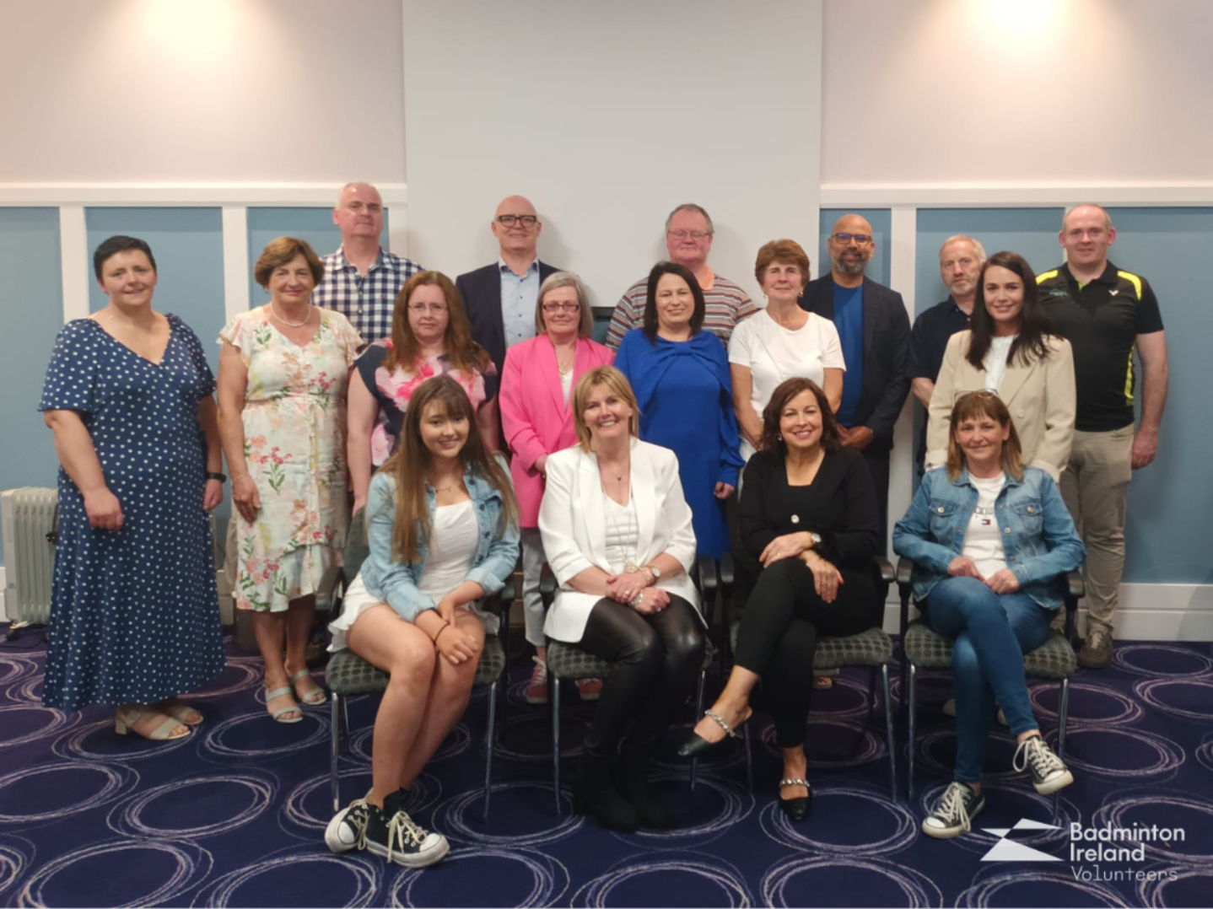

|  |
| --- |
| Volunteer Development Programme  2025  *A dynamic programme designed to support, develop, and inspire volunteers across all levels of badminton, squash and tabletennis through practical learning, leadership, and inclusion-focused training.* |

# *Overview*

We are pleased to relaunch the Volunteer Development Programme. This year Badminton Ireland, Squash Ireland and Tabletennis Ireland are cross collaborating to bring the programme to its volunteers. This initiative supports the development of volunteers across the country, building on the success of previous years.

This multi-week programme is designed to create a learning environment where volunteers can grow their skills, confidence and leadership through a range of engaging and accessible sessions.

Starts: Thursday, 16th October 2025

Duration: 8 Weeks

Delivery: Online via Zoom or E-Learning

|  |
| --- |
|  |

# *Programme focus areas*

* Club Leadership and Governance
* Personal Development
* Coaching and Volunteering
* Diversity and Inclusion

|  |
| --- |
| *“Tell me and I forget, teach me and I may remember, involve me and I learn.”*  – Benjamin Franklin  Programme schedule: |

|  |  |  |  |
| --- | --- | --- | --- |
| Governance & Leadership – leading from the top | | | |
| Topic | Tutor | Date | Points Awarded |
| Developing Projects and Initiatives | Blue Sky Training | 30th October  7-8.30pm | 20 Points |
| Volunteer Development: Succession Pathways | Stuart Garland,  Volunteer Ireland | 23rd October 7-9pm | 20 points |
| Diversity & Inclusion – a game for everyone | | | |
| Topic | Tutor | Date | Points Awarded |
| Disability Awareness Training | Active Disability Ireland | 20th of November  7pm-8.30pm | 20 points |
| LGBTQ+ in Sport | ShoutOut | 27th November 7pm-8.30pm | 20 points |
| Personal Development – guiding you on your journey | | | |
| Topic | Tutor | Date | Points Awarded |
| Building Resilience in yourself and others | Dr. Ciara Losty,  SETU Waterford | 13th November 7-8pm | 20 points |
| Developing Communication Skills | DCM Learning | 4th December  7-8.30pm | 20 points |
| On the Court – knowing your players and the game | | | |
| Topic | Tutor | Date | Points Awarded |
| Parents in Sport: Guiding the next generation | Dr. Lee-Ann Sharp,  UUJ | 16TH of October 7-8pm | 20 points |
| Engaging Young People in Sport | Dr. Amanda Ni Gabhainn, | 6th of November  7-8.30pm | 20 points |

|  |  |  |  |  |  |  |  |  |  |  |  |  |  |  |  |  |  |  |
| --- | --- | --- | --- | --- | --- | --- | --- | --- | --- | --- | --- | --- | --- | --- | --- | --- | --- | --- |
| *Who is this Programme for?* This programme is designed for:   * Chairpersons, Secretaries, Treasurers and Safeguarding Officers * Other club or committee members who are new to their roles * Anyone interested in taking on a volunteer role in the future   *The goal is to help people develop in their volunteer positions, which will improve the overall administration and experience of badminton across Ireland.*   |  | | --- | |  |  *HOW MUCH DOES IT COST?* The programme is completely free for all accepted participants. However, places are limited and interested individuals must apply in advance.   |  | | --- | |  |  *How Do i Apply?* You can apply to participate by completing the registration form at the link below.  <https://forms.office.com/e/4h8XLCLLPe>  Closing Date for Applications: 5pm Friday 10th of October  Applicants must:  • Be aged 16 or over by the start of the programme  • Be affiliated with Badminton Ireland, Squash Ireland or Tabletennis Ireland    *Spaces are limited, so early application is encouraged.*  *Participants who have already attended Volunteer Leadership Training or Active Disability Ireland Disability Awareness training in Sport will be exempt from those trainings and will be awarded the points towards the certified level.* *How does the Volunteer Development Award work?* Participants accumulate points for each session they attend. The level of award is based on the total number of points earned by the end of the programme. You will receive the award and recognition for 1 sport only. This will be in whatever sport you have membership with.   |  |  |  |  | | --- | --- | --- | --- | | **Award Type** | **Points Required** | **Additional Requirement** | **Recognition** | | Platinum | 160 Points | Reflective Log | Badminton: 5 tubes of feathered shuttles for your club-Badminton  Squash: A 1:1 private lesson with one of Squash Ireland's National Pathway/Elite Coaches  Tabletennis: 3 boxes of training balls | | Gold | 140 Points | None | Badminton: 4 tubes of shuttles  Squash: A gift voucher for Rackets.ie  Tabletennis: 2 boxes of training balls | | Silver | 120 Points | None | Badminton: 3 tubes of shuttles  Squash: A selection of squash balls and/or grips  Tabletennis: One box of training balls | |

*If you have completed relevant certified training in the past, you may receive credit toward your total. Be sure to include this information in your application.*