**Achieve a Brighter Smile with Crest Whitening Strips**

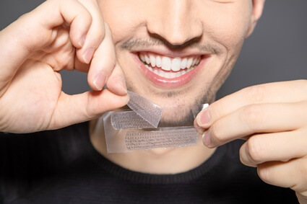

Looking for a fast and effective way to whiten your teeth at home? Crest Whitening Strips, available at The White Smiles, are a trusted solution for achieving a noticeably brighter, whiter smile in just days. These easy-to-use strips are designed to remove years of stains caused by coffee, wine, smoking, and everyday food consumption, delivering professional-grade results from the comfort of your home.

Why Choose Crest Whitening Strips?

[Crest Whitening Strips](https://thewhitesmiles.com/shop/crest-whitening-strips-professional/) use Advanced Seal Technology, ensuring they stay in place while you go about your day. Unlike messy gels or expensive in-office treatments, these strips offer a hassle-free and affordable whitening experience. Simply apply them for 30 minutes a day, and you'll see a noticeable difference in just a few applications.

Safe & Effective Teeth Whitening

[Crest Teeth Whitening Strips](https://thewhitesmiles.com/shop/crest-whitening-strips-professional/) are enamel-safe and dentist-approved, making them a reliable choice for those with sensitive teeth. They penetrate below the surface of the enamel to lift stains effectively without causing damage. Whether you're preparing for a big event or just want to enhance your daily smile, these strips provide an easy, non-invasive solution for long-lasting brightness.

Get Your Crest Whitening Strips Today!

At The White Smiles, we offer authentic [Crest 3d Whitening Strips](https://thewhitesmiles.com/shop/crest-whitening-strips-professional/) to help you achieve a dazzling, confident smile effortlessly. With a range of options, including Crest 3D White, Professional Effects, and Supreme FlexFit, there’s a perfect choice for every whitening need.

Shop now at The White Smiles and enjoy fast, visible results with Crest Whitening Strips—your go-to solution for a whiter, brighter smile!