**关键词密度**

**“portable sauna(s)” ：1.52%**

**"portable home sauna(s)：0.87%**

**"portable sauna box"： 0.43%**

**"home sauna(s)" ：1.09%**

**Meta原描述**

**Discover why portable home saunas are trending among Americans over 30 — from health benefits to stress relief and easy setup. Find out if it’s right for you.**

**H1（主标题）Why Are Portable Home Saunas So Popular Among Americans Over 30?**

**H2The Portable Sauna Market Is Growing Fast（一级小标题）**

**H3 Why Are Adults Over 30 Driving This Trend? （二级小标题）**

**Introduction: Shifting health awareness and the rise of portable home saunas**

**1.The portable sauna market is growing rapidly**

**1.1The expansion of the U.S. sauna market and the growth forecast for portable saunas**

**2.Financial study on sauna use and cardiovascular health**

**3.The growing trend of consumer interest in portable saunas**

**4.What drives this trend among adults over 30**

**5.Increased stress and the need for better recovery**

**6.Increased disposable income and larger living spaces**

**7.Greater focus on long-term health**

**8.What makes portable home saunas attractive?**

**8.1Stress relief**

**8.2Muscle recovery**

**8.3Improved sleep**

**8.4Detoxification and skin health**

**9.The convenience of portable saunas (compact, foldable, easy to set up and store)**

**10.Conclusion**

**Why Are Portable Home Saunas So Popular Among Americans Over 30?**

As we move into our 30s, priorities shift—especially when it comes to health and wellness. Long work hours, poor sleep, and growing stress levels often push people to look for easier and more effective ways to unwind and recover without leaving home.

This is exactly why portable home saunas are booming, especially among adults over 30. From improving sleep and detoxing the body to reducing stress, more Americans are choosing to bring the [portable sauna box](https://hybervitals.com/products/portable-steam-sauna) into their living rooms.

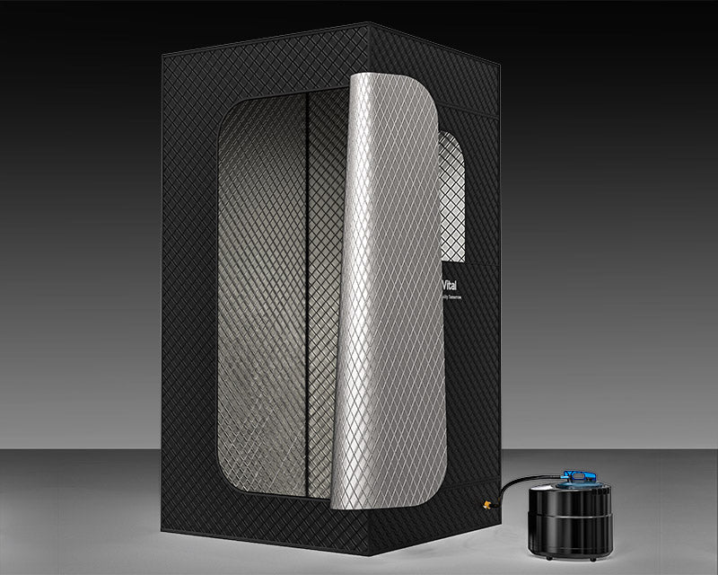

In this post, we’ll explore why portable saunas are trending with this age group and what benefits make them such a smart wellness investment.

The Portable Sauna Market Is Growing Fast

The U.S. home sauna market is expanding rapidly. [According to Technavio](https://www.technavio.com/report/us-sauna-market-analysis), the portable sauna segment is expected to grow by $151.3 million between 2025 and 2029, with a compound annual growth rate (CAGR) of 6.4%.



ScienceDaily reports on a long-term Finnish study published in[《JAMA Internal Medicine》](https://www.sciencedaily.com/releases/2015/02/150223122602.htm) that delved into the relationship between regular sauna use and cardiovascular health.

The follow-up study of middle-aged men in Eastern Finland lasted nearly 21 years and showed:

Significant reduction in risk of sudden cardiac arrest (SCD): Compared with men who only took a sauna once a week, men who took a sauna 2 to 3 times a week had a 22% lower risk of SCD. And men who took a sauna 4 to 7 times a week had a staggering 63% lower risk of SCD.

Google Trends data shows that searches for "portable steam sauna" and "home infrared sauna" have nearly doubled since 2021, reflecting growing interest among wellness-focused consumers.

**Why Are Adults Over 30 Driving This Trend?**

1. They Have More Stress—and Want Better Recovery

People in their 30s and 40s often juggle demanding jobs, family life, and a more hectic schedule. That also means they deal with more chronic stress and slower muscle recovery. A home sauna offers an easy, natural way to relax and recover without leaving the house.



2. More Disposable Income and Larger Living Spaces

Compared to younger adults, this demographic tends to have greater financial stability and larger homes, making it easier to invest in and install home wellness tools like portable saunas.

3. A Stronger Focus on Long-Term Health

A 2023 Statista wellness survey reported that over 60% of Americans aged 30–49 are actively investing in their personal health, with a focus on stress relief, sleep improvement, and immunity.

**What Makes Portable Home Saunas So Appealing?**

Portable saunas might look simply, but they offer a wide range of benefits that make them a perfect fit for health-conscious adults:

Stress Relief

Spending 15–30 minutes in home portable sauna is one of the most effective ways to lower cortisol levels and promote relaxation.



Muscle Recovery

Ideal after a workout or a long day at work, the heat helps soothe sore muscles and improve circulation.



Better Sleep

The calming effects of sauna sessions may help the body relax and increase melatonin production, improving sleep quality.



Detoxification and Skin Health

Sweating helps eliminate toxins and unclog pores, supporting clearer skin and a healthier body.

These portable saunas box is compact, foldable, easy to store, and typically take less than 10 minutes to set up. For busy adults, it’s a practical solution that fits into any routine. It's a practical solution for busy adults to unwind and unwind.

**Final Thoughts**

Whether it's to relieve stress, recover from workouts, improve sleep, or simply enjoy a peaceful moment at home, more Americans over 30 are choosing portable saunas—and it's easy to see why. If you’ve been thinking about trying one, now is the perfect time to experience the benefits of a home sauna without leaving your home.