Mani SEO
Professional SEO Consultant in India & Chennai

Website: https://maniseo.com
Email: consultantmaniseo@gmail.com
Helping businesses rank higher, attract traffic, and grow online.

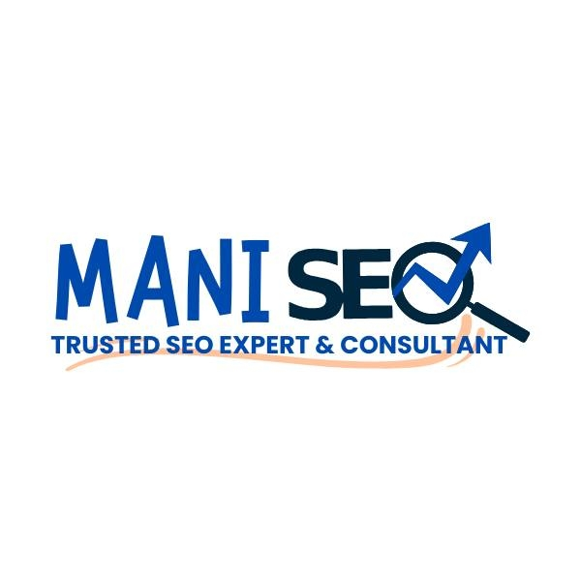

About Us
At Mani SEO, we are passionate about helping businesses build a strong online presence. As a trusted SEO consultant in India and reliable SEO consultant in Chennai, we deliver proven strategies that improve Google rankings, attract organic traffic, and increase business growth.
Our strength lies in ethical SEO practices and customized strategies tailored to your business goals. With years of experience, we know how to navigate competitive markets and position your brand for success.

Mission & Vision

Mission:
To empower businesses in Chennai and across India with SEO solutions that deliver visibility, credibility, and long-term growth.
Vision:
To be recognized as the most reliable SEO consultant in India and SEO consultant in Chennai, known for transparent strategies and measurable results.

Our Services

We provide complete SEO and digital marketing solutions:
- Keyword Research & SEO Strategy – Find the right keywords to attract the right audience.
- On-Page SEO – Optimize website content, titles, and structure for search engines.
- Technical SEO – Fix site speed, indexing, and other backend issues.
- Content Optimization – Improve blogs, landing pages, and web copy for better engagement.
- Link Building & Profile Creation – Build authority with ethical backlinks and directory listings.
- Local SEO (Chennai-Focused) – Help local businesses appear in Google Maps & "near me" searches.
- Web Design & UX – Create websites that look great and perform even better.

Why Choose Mani SEO?
✔️ Experienced SEO consultant in Chennai and across India
✔️ Tailored SEO strategies for every business type
✔️ Transparent and ethical methods—no shortcuts
✔️ Data-driven approach with measurable growth
✔️ Free SEO consultation to guide your business
At Mani SEO, we don’t just deliver rankings—we deliver results that drive sales, leads, and visibility.



Industries We Serve

Our SEO services are ideal for:
- Local businesses in Chennai targeting nearby customers
- Pan-India companies seeking nationwide visibility
- Startups looking for affordable digital growth
- E-commerce businesses growing sales organically
- Service providers building long-term brand authority

Client Benefits

When you work with Mani SEO, you gain:
✔️ Improved Google search rankings
✔️ Steady growth in organic website traffic
✔️ Stronger brand presence in local & national markets
✔️ Better ROI compared to paid advertising
✔️ Long-term digital success with sustainable strategies

Contact Us
📍 Location: Chennai, India
🌐 Website: https://maniseo.com
📧 Email: consultantmaniseo@gmail.com
👉 Take the first step toward smarter growth. Partner with Mani SEO—your trusted SEO consultant in India and SEO consultant in Chennai.

This expanded version will fill 5 pages in a PDF (About, Mission/Vision, Services, Why Choose Us, Industries/Benefits, Contact).
⚡ Would you like me to now design this into a branded PDF (with cover, icons, highlights, and clean layout) so you can directly use it for submissions?

