2022-02-17 Ben accessed:

http://oceaninformatics.ucsd.edu/euphausiid/
MySQL database (if you had the credentials to query the database; pull in SQL); just need login credentials

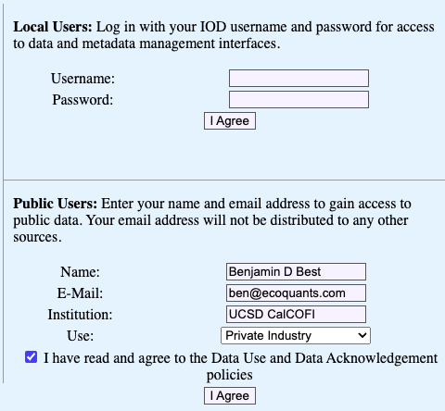

Methods Notes
The user should be aware that both the geographic coverage and temporal frequency of CalCOFI cruises have changed since the program was initiated in 1949. Care should be taken to evaluate these changes prior to generating time series of euphausiid abundances (see CalCOFI station occupation).
Lack of a plotted symbol indicates no data present.
The maximum zooplankton sampling depth in the CalCOFI time series increased from 0-70 m (1949-1950) to 0-140 m in 1951, was then maintained at 0-140 m (1951-1968), and then increased to 0-210 m in 1969, where it has remained since (see Ohman and Smith 1995). A 1-m diameter ring net was used from 1949-1976, which was then replaced with a 0.71-m diameter bongo net in December 1977 (Ohman and Smith 1995). Effects of these changes have been analyzed by Brinton and Townsend (1981), Ohman and Smith (1995), and Ohman and Lavaniegos (2002).
Only a subset of CalCOFI samples has been analyzed for euphausiids. Recently, M. Ohman's retrospective studies have focused on interannual variability in springtime cruises, hence more up-to-date temporal coverage is available for springtime cruises than for cruises at other times of year (see: Coverage Table).
The same group of 39 euphausiid species has been identified in all samples analyzed, using consistent morphological criteria. However, the level of resolution of life history phases or size classes has varied over time, according to the goals of the original study. The enumerations in this database were not originally conceived as a continuous time series, but represent a compendium of enumerations from many individual research projects. A table indicating the level of life history or size class resolution in different cruises may be found in the Coverage Table. For cruises in which samples were identified only by size, phases have been approximated using the information found in the Size-to-Phase Table.

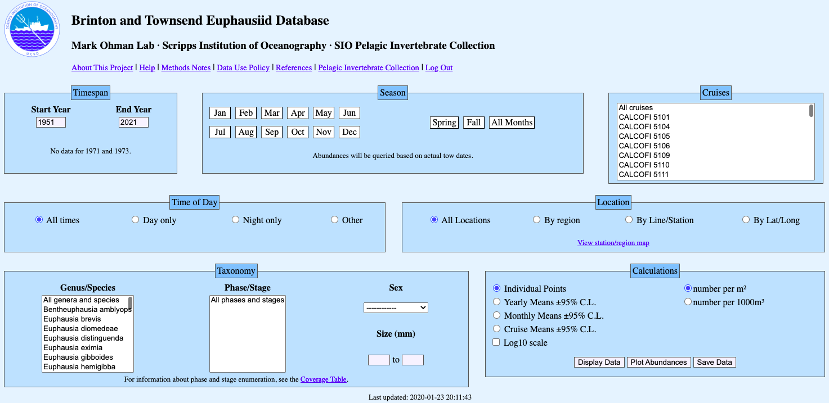
clicked Save Data

Saved to data.csv after stripping header:
All genera and species - All phases and stages
1951 to 2021
All times
All regions
Abundance per m2

