Celeste Maria  Fiallos  Actor / Creator | 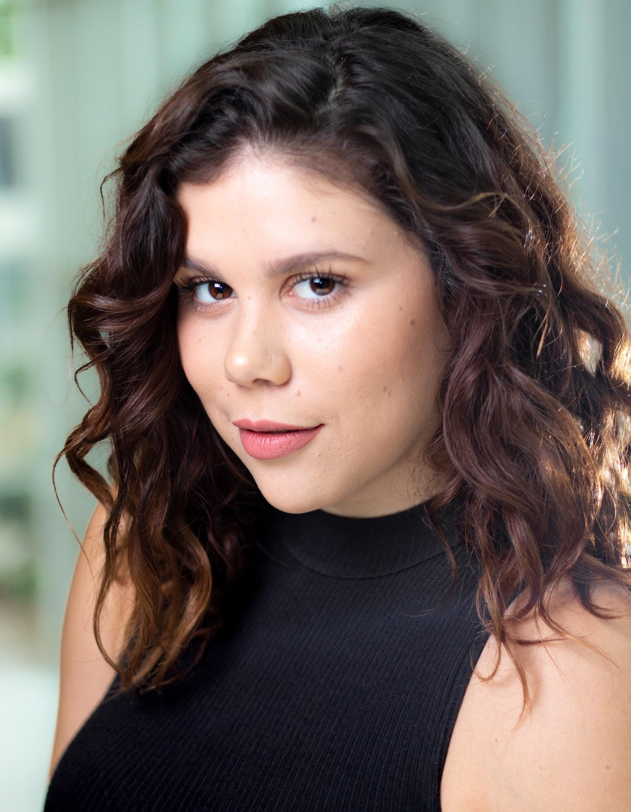  505 Rankin Avenue  Windsor, ON. N9B 2R6  519 878 1432  fiallos@uwindsor.ca
ㅡ  Selected Theatre | Medea / Medea  Works in Progress, (2019)  Directed by Christopher Manousos  Streetcar Named Desire / Mexican Woman  University Players, (2018)  Directed by Kelly Daniels  The Newcomer / Young Woman  Works in Progress, (2018)  Directed by Jim Warren  King Henry V / Scroop, Pistol, Orleans  The Edge Productions, (2018)  Directed by Miriam Goldstein  A Moment in Time / Jane  Met By Moonlight, (2018)  Directed by Anna Grace Howard  The Tempest / Dancer/ Ensemble  Western University Summer Shakespeare, (2017)  Directed by Julia McCarthy
ㅡ  Selected Film | Peer Support PSA / Woman (lead)  Directed by Jake Braden  1 AM At PJ’s / Jennifer (supporting)  Directed by Katie Grabaukas
ㅡ  Training | BFA Acting - University of Windsor (Expected 2020)  Theatre Performance Intensive - Stratford Shakespeare School (2015)

