USER GUIDE & TEMPLATE: Municipal Landscape Gap Analysis Tool for Planning & Development Review Standards and Procedures

Prepared for: Central Coast Low Impact Development Initiative
centralcoastlidi.org

Prepared by:

Wayne E. Carlson, AICP, LEED AP
(206) 658-2674, wecarlson@ahbl.com

Intent:

The State Water Resources Control Board (State Water Board) adopted a statewide general permit for Small MS4s in order to efficiently regulate storm water discharges (General Permit No. CAS000004). Section E.12 of the General Permit for Waste Discharge Requirements (WDRs) for Storm Water Discharges from Small MS4s (Permit) requires permittees to administer a post-construction storm water management program that includes low impact development (LID) runoff standards for regulated projects. Section E.12.J directs permittees to review their local planning and permitting process to assess any gaps or impediments impacting effective implementation of the post-construction requirements.

The Permit prioritizes the analysis of the landscape code, which is described as that portion of the municipal code detailing landscaping requirements and revisions which should be implemented to protect environmental quality. This initial emphasis is established through the requirement that permittees conduct an analysis of the landscape code to correct gaps and impediments impacting effective implementation of post-construction requirements within the first year of the effective date of the Permit (Section E.12.J(ii)(a)).

This document is intended to assist permittees with the review of those portions of municipal codes detailing landscaping requirements and considerations which should be implemented to protect environmental quality.

Using Landscape Areas for Stormwater Management

Water resources engineers have come to understand the value that landscape areas can have for stormwater management. The concepts and principles of low impact development (LID) emphasize conservation of vegetated areas and native soils to mimic a site’s pre-development hydrology. Additionally, created or engineered landscapes such as bioretention also support LID and water quality objectives. In 2011, a Municipal LID Gap Analysis Tool was created for the Central Coast Regional Water Board and the Central Coast Low Impact Development Initiative as part of the Municipal Regulatory Update Assistance Project (MRUAP). The MRUAP provided assistance to municipalities related to code updates to support LID implementation. One of the resources created for the MRUAP was a municipal code gap analysis template that allowed a systematic and comprehensive approach in reviewing municipal regulations for LID barriers and opportunities for improvement. The landscape portion of the gap analysis template was updated to support statewide Permit compliance. The Municipal Landscape Gap Analysis Tool allows review of the municipal regulatory structure (e.g. codes and ordinances) related to conserved and created landscapes in the following five areas:

- Vegetation Conservation
- Open Space Management
- Rooftop Runoff
- Open Space/Cluster Design Requirements
- Street and Parking Lot Standards

The organization of the template is on a continuum from conserved (e.g. open space) to created landscape areas (e.g., landscape strips) and can be used to evaluate the comprehensive use of landscaping for stormwater management rather than a more narrow evaluation of a locally-adopted landscape or water-tolerant landscape chapter. Each subsection includes questions for the permittee to consider when reviewing its codes and standards. We have denoted with double asterisks (**) specific gap analysis elements that most likely reside in a formal municipal “landscape code.” To most cost-effectively support a stormwater management program, we advise conducting review of all the landscape-related elements to identify LID implementation impediments.

Using the Municipal Landscape Gap Analysis Tool

The Municipal Landscape Gap Analysis Tool is in the form of a table. The table has three columns as depicted below. The first column lists an LID benchmark or objective. The second column provides space for permittees to reference existing code and summarize existing standards within adopted code that pertain to the objective. The third column provides space for permittees to identify if an impediment exists or there is an opportunity to improve existing code language to better address the objective. This column would include suggested amendments to existing codes and standards to improve implementation of the post-construction standards. The following is an example response:

Example
Benchmark / Objective | Code Reference and Summary of Existing Standards | Impediment / Opportunity to Improve
Parking Lot Runoff
- Is the use of bioretention islands and other stormwater practices allowed within landscaped areas and/or setbacks?  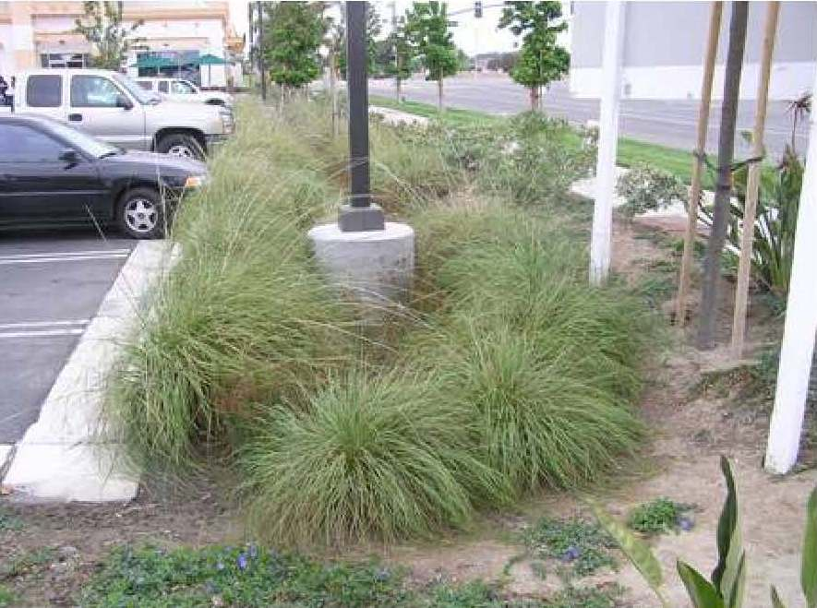 | 21.05.050.E.2.e  Landscaping shall be protected with raised planting surfaces, depressed walks, or curbs. Mowing strips shall be provided between turf and shrub areas.  21.10.230.B.2.b.iv  Parking lots should be divided into a series of connected smaller lots utilizing raised landscape strips and raised walkways. | The existing standards specify designs that are impediments to use the landscape areas for stormwater management.  Need to allow the elevations of parking lot landscaping to be designed to accept stormwater flows.  Need technical details and specifications to support stormwater management in landscape strip areas (e.g., curb cuts, bioretention plant lists, soil specifications, etc.).

Municipal Landscape Gap Analysis Tool Subsections
The following section provides additional context to the questions and the areas within a permittee’s codes and standards where applicable standards may reside. Potential opportunities are also presented that permittees may consider to improve codes and standards.

Vegetation Conservation

- Do regulations require or encourage the preservation of natural vegetation at development sites?

Code Reference Location

Regulations that address vegetation retention at development or redevelopment sites are often found in the zoning code, particularly in the landscape chapter or site design requirements. Additional retention requirements may be specified in planned unit development standards, subarea plans, design standards, and clearing and grading regulations.

Opportunity to Improve

Incorporate natural vegetation preservation standards into code based on land use and intensity. Define natural (or native) vegetation and soils and include a plant list which defines which plants are considered native or near native species. Consider minimum tree density, minimum canopy cover, minimum vegetation retention requirements, replanting requirements, soil amendment standards, management plan specifications, and maintenance requirements.

- If forests or specimen trees are present at development sites, must some of the stand be preserved?

Code Reference Location

Tree conservation regulations may reside in the zoning code. These standards, where they exist, may be found in landscape chapters or standards exclusively dedicated to trees. Tree preservation standards may also be addressed in design standards and performance criteria found in planned unit development regulations.

Opportunity to Improve

Consider language emphasizing the benefits of retaining trees or replacing trees where retention is infeasible. Include tree retention and replanting standards in the code language. Provide a tree species table in the code. Tree conservation standards can be based on a variety of criteria including tree unit credit systems and canopy coverage, which may be adjusted based on development type.

- If there is a stream buffer ordinance in the municipality, does the ordinance specify that at least part of the stream buffer be maintained with native vegetation?

Code Reference Location

Stream buffer ordinances are often found in local sensitive areas standards, floodplain standards, or ecological and biological resources performance standards.

Opportunity to Improve

Consider stream buffer standards that require the conservation of native vegetation. The buffer width should be of sufficient width to protect the habitat and water quality values of the stream.

Open Space Management

- Are mechanisms in place to manage open space in perpetuity?

Code Reference Location

Tools to ensure that open space areas are managed in perpetuity may be found in policies and practices that do not reside in the local municipal code. These mechanisms may include standard easement or covenant language that is routinely attached to development permits and recorded against the title of the property. Sometimes this language can be found in appendices to drainage manuals and standard details.

Opportunity to Improve

Where standard language does not exist, consider collecting template language that can be applied to relevant development permits where open space is intended to be conserved. The language should describe the party responsible for managing the open space, the nature of applicable management practices (if any), the frequency of required actions, and the remedies if management does not occur consistent with the conditions. If management of the open space is to occur by private parties, consider reserving a public easement that will allow the permittee to remedy deficiencies.

- Are open space areas required to be consolidated into larger units?

Code Reference Location

Design preferences and standards for open space areas may be found in locally-adopted site design standards and planned unit development or other performance design standards.

Opportunity to Improve

Consider standards that require the consolidation of open spaces into larger units as a way to encourage clustering and impervious surface minimization.

- Does a minimum percentage of open space have to be managed in a natural condition?

Code Reference Location

Discretionary land use approvals often require a minimum percentage of the development site be managed in a natural condition. Site design requirements and planned unit development or other performance subdivision standards often stipulate that a percentage of a development site be maintained as open space. Sometimes, this open space is further defined as to be maintained for recreational purposes, buffering between uses, or conserved in a natural condition.

Opportunity to Improve

Consider provisions in the code to encourage and/or require the conservation of open space in a natural condition.

- Are allowed uses in open space in areas defined?

Code Reference Location

Allowed uses and activities within open space areas are found in a variety of areas. In open space zones, the allowed uses would be found in a permitted or conditionally permitted use table. Allowed uses in open space areas that may occur on a development site may also be found in landscape chapters, definitions, and the review and approval criteria for various discretionary permits.

Opportunity to Improve

Consider adding language that would allow stormwater management practices to occur within open space areas as long as the primary use for the open space is not compromised.

- Can open space be managed by a third party using land trusts or conservation easements?

Code Reference Location

The ability for open space to be managed by a third party may be found in local environmental policies, as part of developer agreements, or as part of planned unit development or other performance design criteria.

Opportunity to Improve

Consider options that would allow the use of land trusts and conservation easements by third parties as a way of ensuring protection of open space areas in a manner that minimizes burdens on local staff. This may include assembling templates and draft agreements to support this approach.

Rooftop Runoff

- Can rooftop runoff be discharged into yard areas?

Code Reference Location

The opportunity to discharge stormwater into yard areas may be found in local stormwater design manuals, locally-adopted regional stormwater design manuals, and municipal code chapters related to stormwater management.

Opportunity to Improve

Consider code language that allows stormwater from non-pollution generating surfaces to be discharged into yard areas.

- Do current grading or drainage requirements allow for temporary ponding of stormwater on front yards or rooftops?

Code Reference Location

This regulation is very specific and may not be addressed directly in existing code or stormwater plans. If this is the case, are there regulations within the code that preclude temporary ponding of stormwater in front yards or rooftops? If so, that would be an impediment to the use of lawn areas for the temporary ponding of stormwater.

Opportunity to Improve

Consider amending existing codes to remove barriers that would preclude the temporary ponding of stormwater in front yards.

- Are vegetated roofs allowed? Do criteria exist to allow designers to receive credit for landscaping, stormwater, etc. for the use of vegetated roofs?

Code Reference Location

Vegetated roofs are generally described in building codes or local design standards. The California Green Building Code (Appendices A4 and A5) identifies vegetated roofs as voluntary residential and nonresidential measures that municipalities may adopt. Local design standards that require steep roof pitches may preclude vegetated roof designs.

Opportunity to Improve

Consider amendments to local building codes to encourage the use of vegetated roofs by allowing the rooftop space to satisfy passive open space requirements provided the space accessible. Consider amendments to local design standards that require steep roof pitches or specify roofing materials that do not allow vegetated roof designs.

Open Space/Cluster Design Requirements

- Does your municipality have open space/cluster design regulations?

Code Reference Location

Open space and cluster design regulations can reside in various locations within a municipality’s land use controls. Regulations are likely found in zoning chapters covering planned unit development or other performance design criteria, site design guidelines, and subarea plans that address open space and cluster design regulations within smaller defined areas of a municipality.

Opportunity to Improve

If your municipality does not have open space/cluster design regulations, consider adopting standards that encourage clustered development patterns and conservation of open space. These standards can be tied to a variety of land use application types.

- Is land conservation or impervious cover reduction a major goal or objective of the open space/cluster design regulations?

Code Reference Location

Goals and objectives of open space/cluster design regulations may be found in the zoning code, planned unit development regulations, design guidelines, and/or subarea plans discussed above.

Opportunity to Improve

Consider elevating stormwater management among the site design goals for an open space/cluster site design by encouraging the conservation of open space and reduction of impervious surface coverage as essential design objectives.

- Are the entitlement criteria for open space/cluster design more stringent than for standard subdivision design?

Code Reference Location

The entitlement process for open space/cluster developments is typically found in the zoning code or planned unit development sections of the municipal code.

Opportunity to Improve

Consider adopting an entitlement process for open space/cluster developments that is no more procedurally stringent or challenging than a non-cluster development.
- Are flexible site design criteria available for developers that utilize open space/cluster design options (setbacks, road widths, lot sized)?

Code Reference Location

Flexible site criteria may be located in a planned unit development or other performance design section of the zoning code. Flexible site design criteria may also reside in design guidelines or in bulk and dimensional standards.

Opportunity to Improve

Allow for design flexibility within the code. Examples include reduced setbacks, road widths, and lot sizes for cluster designs that conserve open space.

Street Standards

- Do adopted street sections allow for open treatment and conveyance of stormwater within landscape strips?

Code Reference Location

The design of the landscape strips and medians within street rights-of-way is typically described in local public works engineering standards and details or local landscape codes.

Opportunity to Improve

Consider adopting street standards to allow for treatment and conveyance of stormwater within landscape strips. Remove barriers that would require the use of bioretention within public-rights-of-way to require the approval of variances or design deviations. Consider adopting design templates that allow for desired street tree rhythm while managing stormwater.

- Can a landscape island be created within a cul-de-sac?

Code Reference Location

Street design requirements are typically found in local public works engineering standards.

Opportunity to Improve

Consider adopting street standards that provide designs which integrate landscape areas into the terminus of the cul-de-sac. In addition to the aesthetic qualities, integrating landscaping into the terminus of cul-de-sacs will result in reduced impervious surface coverage and may have the potential to serve stormwater management functions.

Parking Lot Runoff

- Is a minimum percentage of a parking lot required to be landscaped?

Code Reference Location

The percentage of a parking lot that is required to be landscaped is often found in the design criteria within the landscape or parking and loading chapters of a municipal code.

Opportunity to Improve

Where missing, consider requiring a percentage of parking lots to be landscaped. Landscaping can be in specified the form of islands and perimeter landscape. It can be described as a percentage of the overall parking area or based on the number of stalls.

- Is the use of bioretention islands and other stormwater practices allowed within landscaped areas and/or setbacks?

Code Reference Location

The uses and activities allowed within landscape areas may reside in the landscape chapter of the municipal code. The stormwater management chapter may also specify the nature of allowed stormwater management features and may be silent to the use of landscape areas for stormwater management.
There may also be instances where the stormwater management standards specify design solutions that do not include the use of landscape areas.

Opportunity to Improve

Where landscaping within parking areas is already required, consider language that will allow the use of landscape areas for stormwater management practices. This may involve amendments to local landscape and/or stormwater management chapters within the municipal code.

- Does your design manual specify required designs that would preclude the ability to use parking lot landscaped areas for bioretention?

Code Reference Location

The design of landscape islands and perimeter buffer areas is typically found in zoning chapters that address landscaping or parking and loading. Design details for landscape islands may also reside in locally-adopted public works engineering standards. Design details for landscape areas may also reside in locally-adopted public works engineering standards. These standards may identify barrier curbs or berm/mounding preferences that would preclude the ability of the landscape area to serve a bioretention function.

Opportunity to Improve

Where landscaping within parking areas is already required, consider adopting design details that will allow the landscape areas to receive stormwater. This may require modification to details related to barrier curbs around parking lot landscaping as well as the mounding or berming of the landscape that is often specified for parking lot islands.

Permittee Name
Objective | Code Reference and Summary of Existing Standards | Impediment / Opportunity to Improve
- Vegetation Conservation
- Do regulations require or encourage the preservation of natural vegetation at development sites?
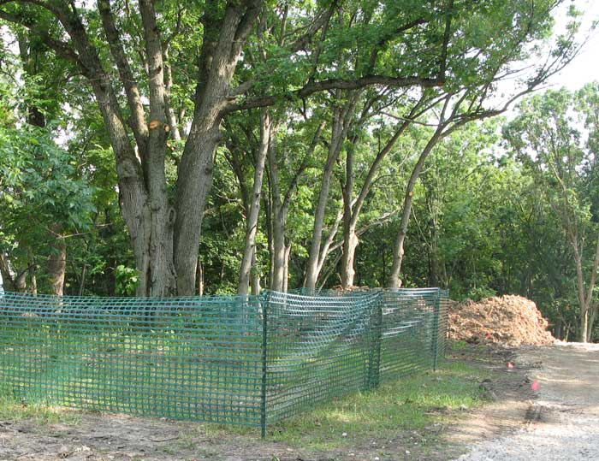
- If forests or specimen trees are present at development sites, must some of the stand be preserved? **
- If there is a stream buffer ordinance in the municipality, does the ordinance specify that at least part of the stream buffer be maintained with native vegetation?

- Open Space Management
- Are mechanisms in place to manage open space in perpetuity?
- Are open space areas required to be consolidated into larger units?
- Does a minimum percentage of open space have to be managed in a natural condition?
- Are allowed uses in open space in areas defined? **
- Can open space be managed by a third party using land trusts or conservation easements?
- Rooftop Runoff
- Can rooftop runoff be discharged to yard areas?
- Do current grading or drainage requirements allow for temporary ponding of stormwater on front yards or rooftops?
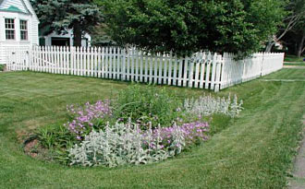
- Are vegetated roofs allowed? Do criteria exist to allow designers to receive credit for landscaping, stormwater, etc. for the use of vegetated roofs? **

- Open Space / Cluster Design Requirements
- Does your municipality have open space/cluster design regulations?
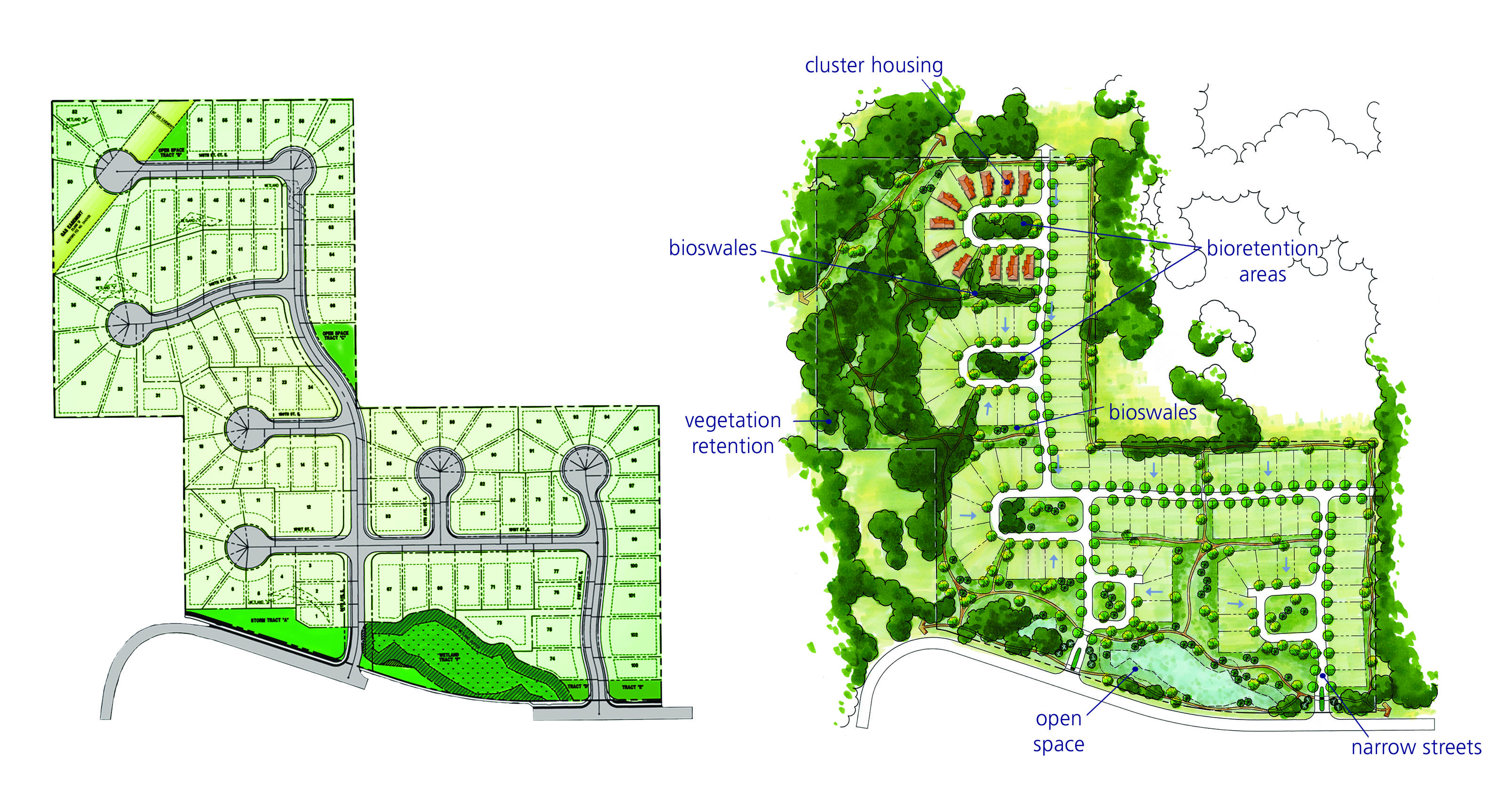
- Is land conservation or impervious cover reduction a major goal or objective of the open space/cluster design regulations?

- Are the entitlement criteria for open space/cluster design more stringent than for standard subdivision design?

- Are flexible site design criteria available for developers that utilize open space/cluster design options (setbacks, road widths, lot sized)?

- Street Standards
- Do adopted street sections allow for open treatment and conveyance of stormwater within landscape strips?

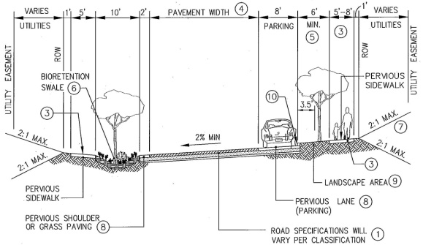
- Can a landscape island be created within the cul-de-sac?

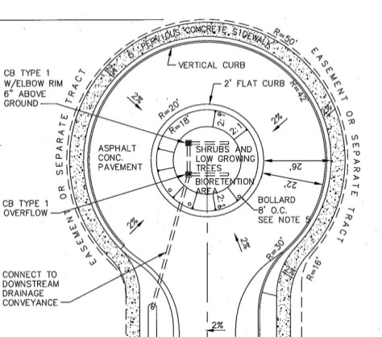

- Parking Lot Runoff
- Is a minimum percentage of a parking lot required to be landscaped? **

- Is the use of bioretention islands and other stormwater practices allowed within landscaped areas and/or setbacks? **

- Does your design manual specify required designs that would preclude the ability to use parking lot landscaped areas for bioretention? **

