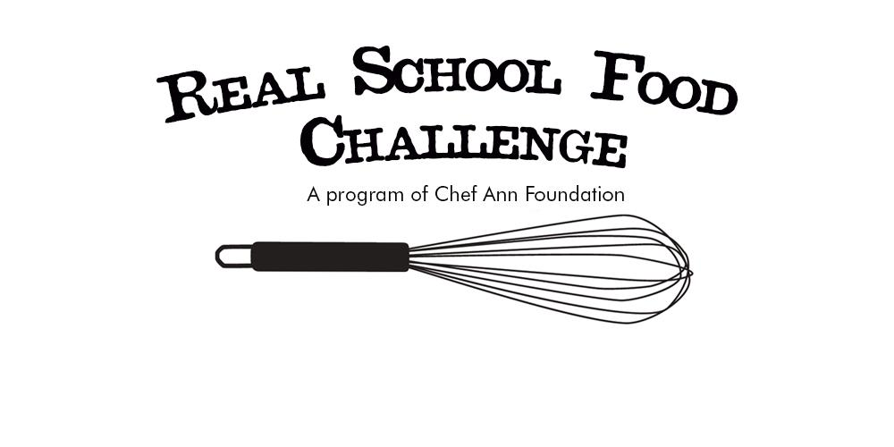



[Today’s date]

Dear ______,

[Insert personalized salutation] I’m reaching out to you because I’m hosting a cooking competition to help fundraise for healthy school food, and I immediately thought of you and your extraordinary culinary talent. The event is called “Real School Food Challenge” and I would love for you to be involved as one of the competitors. The challenge is to create a school lunch recipe that follows USDA healthy meal guidelines for just $1.25 per meal. Believe it or not, that’s the average amount schools have to spend on lunch for our kids. Your participation would mean creating a meal (enough for approximately [number of expected guests] samples) and having it judged against the other competitors by our party guests.

Any kid would be lucky to eat one of your homemade meals, and if your recipe is chosen as the winner, it will have the chance to be featured on [Chef Ann Foundation’s](http://www.chefannfoundation.org/) national school food recipe database, so that kids across the country can taste your delicious creation!

All funds raised at the event will go to Chef Ann Foundation, an organization that is helping schools across the country transition their meal programs from highly processed heat and serve food to cook from scratch with fresh, healthy ingredients. The Chef Ann Foundation supported over 11,000 schools and over 3 million kids through their programming, but with 30 million lunches served every day in public schools, we still have a long way to go. We need your help.

The competition will be held at [location] on [date/time], and I know that having you there will make it a success. Please let me know if you would like to be involved. If you would consider this, I can send you more information about your participation.

Thank you for your support of healthy school food for all kids!

Sincerely,

Event Organizer