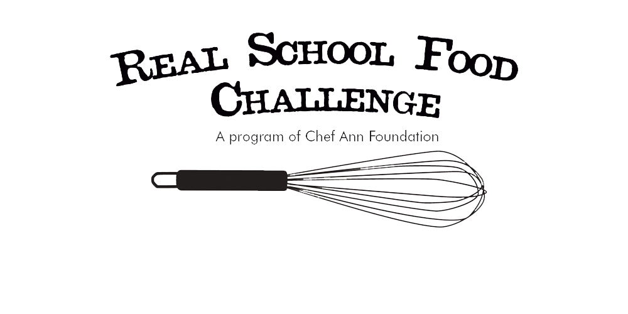**REAL SCHOOL FOOD CHALLENGE JUDGING SHEETS**

For each judging category, mark an “X” under the competitor who did the best job meeting the category criteria. Each “X” will be worth one point towards the competitor’s total score.

|  |  |  |  |  |
| --- | --- | --- | --- | --- |
|  | **[Recipe One]** | **[Recipe Two]** | **[Recipe Three]** | **[Recipe Four]** |
| **Presentation**   * Plating, Appearance of food, Color, Clean |  |  |  |  |
| **Taste**   * Flavorful, Properly Seasoned |  |  |  |  |
| **Scalability**   * Can this recipe be adapted to large batch cooking? (*For example, having to individually stuff and wrap dumplings may not be practical when making 13,000 servings.) |  |  |  |  |

|  |  |  |  |  |
| --- | --- | --- | --- | --- |
| **Total** |  |  |  |  |