

Ried Klaus - Riesling Federspiel® 2016

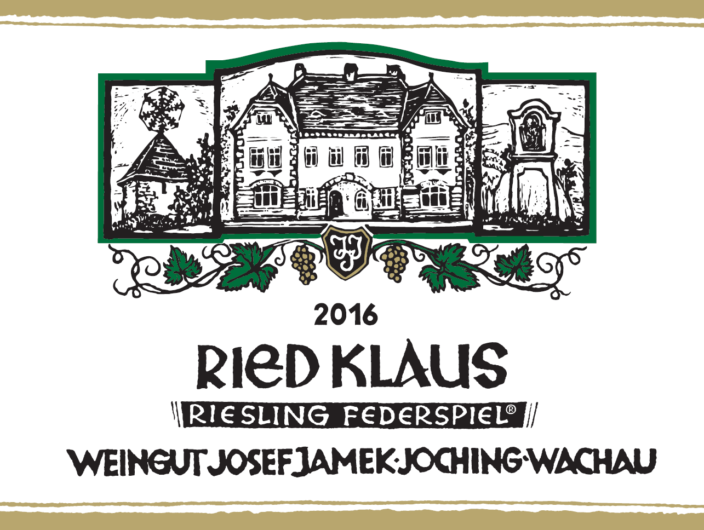

Vineyard: | Ried Klaus, Weissenkirchen in der Wachau  Klaus is the continuation of Achleiten, however, it is separated by a path that serves as a boundary, which also represents a geological fault. The name can be followed back to the old term "Kleyss" and designates a constriction; this is self-explanatory when looking at the old road to Wachau leading along the Klaus vineyard.
Grape variety | Riesling
Planting year | 1950-1970 after reconstruction of the natural stone walls of the steep terrasses
Harvest | Hand-picked
Category | Federspiel®
Alcohol contend | 12%vol
Total Acid | 7,1 ‰
Serving Temperature | 12° C
Soil: | Migmatite-amphibolite dominate in the terrace vineyards of the upper Klaus. In contrast, the lower Klaus is home to paragneiss. Paragneisses are also metamorphic rocks, but in contrast to migmatites, they were not subject to partial melting.  Underneath the sandy, stony topsoil in the profile, the amphibolite character dominates, visible by the dark-coloured rock. The white coatings are carbonates that were precipitated during the course of soil formation. The carbonate itself probably comes from the glacial loess cover, which, after being dissolved during the course of weathering, was precipitated in the cracks of the rock as a white coating. The Klaus is one of the best Riesling slopes in the Wachau."
Tasting notes: | lots of color but densely mineral on the palate, yet also a winsome soft stonieness; there’s some botrytis on the finish, or at least surmaturité, but the sheer forthright Riesling-ness is delightful.

