Producer: Pre-work | - Install the Mentimeter add-in for PowerPoint. This can be found on the Home tab of PPT. Mentimeter will be used to enhance participant engagement using a polling feature and the creation of a Word Cloud.  - Provide the Mentimeter link in chat when prompted (slides 5 and 23).
 | - There will be three breakout room activities. Five breakout rooms will be created with approx. 4-5 participants in each. The first two breakout room activities will be made up of the same participants (slides 13 and 19). The final breakout room activity should be randomly selected to create different groups from the first two (slide 22).
 | - Provide link to EI Quiz when prompted (slide 18). The quiz is part of an activity in which participants will complete a quiz independently to assess their EI and then discuss their results in a breakroom.
 | - Provide link to Kahoot! website when prompted (slide 25). This website will be used to assess learner retention of the course material in a fun and slightly competitive game format.

Facilitator Pre-Work: | - This guide was developed to be presented using a video call software program, such as Zoom, but can be used for an instructor-led training (ILT) course with modifications to the activities. Modifications may include forming discussion groups that meet in different locations of the room and ensuring that each participant has a web-based phone or other device for participation in the online portions of the training.
 | - Open the PowerPoint file associated with this guide. Share your screen with participants. Ensure that audio and video are in proper working order.
 | - There are three breakout room activities within this session. Refer to producer notes above for specific instructions. Participants will be directed to Mentimeter twice during the session on slides 5 and 23. Participants will take part in an online quiz on slide 18 and participate in a Kahoot! game on slide 25.
 | - Note slides in which (click) is inserted within the Say portion of this guide. When prompted by (click), additional information will appear on the slide when you click the mouse. Refer to slides 7-12, 15-17, and 24.
 | - The code for the Kahoot! game will need to be typed onto slide 25 once the producer begins the game. The code will also be included in chat by the producer. Screenshots of questions and answers can be found at the bottom of this guide.
 | - A script is provided within this guide for each slide, indicated by Say. However, feel free to modify for flow of course and for interest of participants. Likewise, directions are given for engaging participants in sharing, but allow conversation and questions to move at your pace.

Session 1
Slides | Approximate Timing | Topic
1-3 | 5 min | Introduction
4-13 | 40 min | What are Emotional Intelligences?
14-17 | 10 min | Why is it Important to Understand Emotional Intelligences?
18-19 | 25 min | Activity: EI Quiz and Breakout Room discussion
20-24 | 20 min | How can Emotional Intelligences be Developed?
25 | 5 min | Assessment: Play Kahoot! (10 questions)
26-28 | 3 min | Conclusion
Total: | Approx. 110 minutes

Slide#/  Duration | Slide | Facilitator Notes | Producer Notes
1  2 min. |  | Do:  - Welcome participants as they are admitted to the course.  - Remind participants to turn on their camera and mute their microphone. | Do:  Admit participants to the course that are in the waiting room.  Monitor chat for any questions. Continue to monitor chat throughout the course.
2  2 min. | 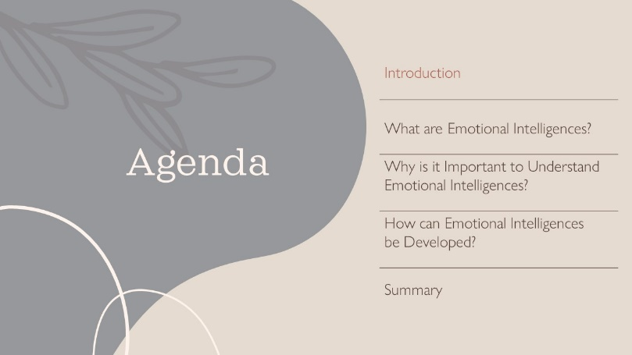 | Do:  Introduce yourself and the Producer to the group. Share some of your background information.  Say:  Today’s agenda will focus on three important questions related to emotional intelligences.  Do:  Read the agenda on the slide.
3  1 min. | 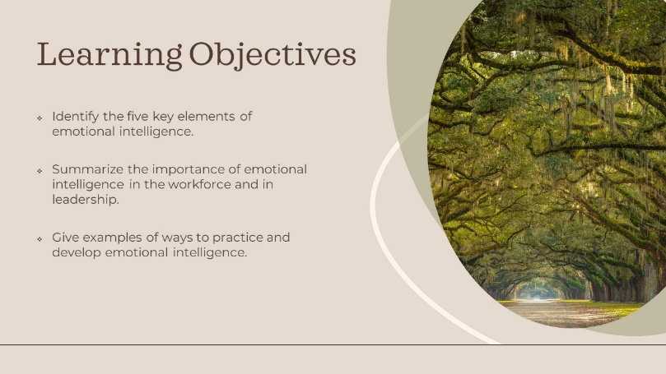 | Say:  We will be covering the following objectives in today’s course.  Do:  Read learning objectives.
4  1 min. |  | Say:  We will begin with the first question: What are Emotional Intelligences?
5  4 min. | 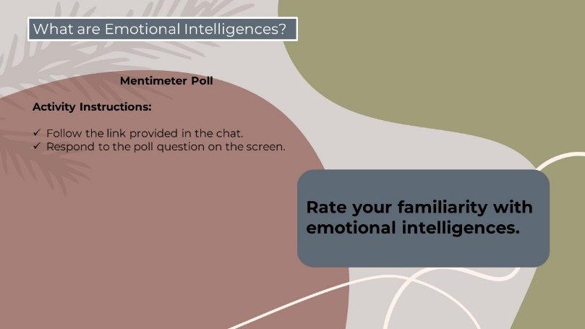 | Say:  I would like to know your starting place on this topic. You will see a link in the chat box that will take you to a poll question. You will need to install the Mentimeter app first if you have not already done so. Follow the directions you receive from Mentimeter.  Pause:  Wait until all participants have responded.  Do:  Discuss results with participants. Allow comments from participants based on results that anyone would like to share. | Put this link in chat: https://www.menti.com/aliuvznxsm6g.
6  2 min. | 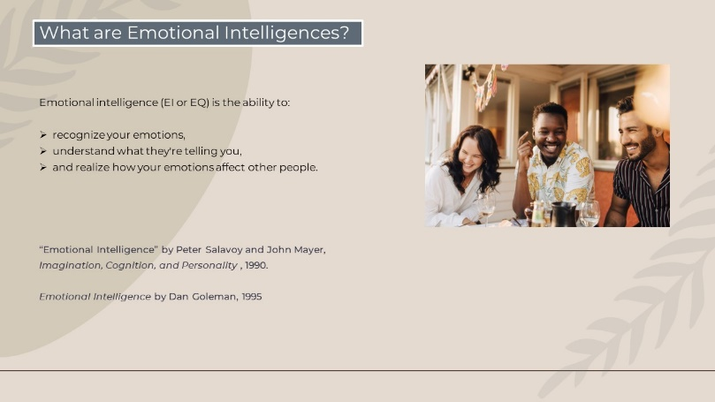 | Say:  Emotional intelligence, EI or EQ for short, is the ability to recognize your own emotions, understand what they are telling you, and realize how your emotions affect other people.  The term emotional intelligence is relatively new. It was created by two researchers, Peter Salavoy and John Mayer in their article “Emotional Intelligence” in the journal Imagination, Cognition, and Personality in 1990. It was later popularized by Dan Goleman in his 1995 book Emotional Intelligence.
7  1 min. | 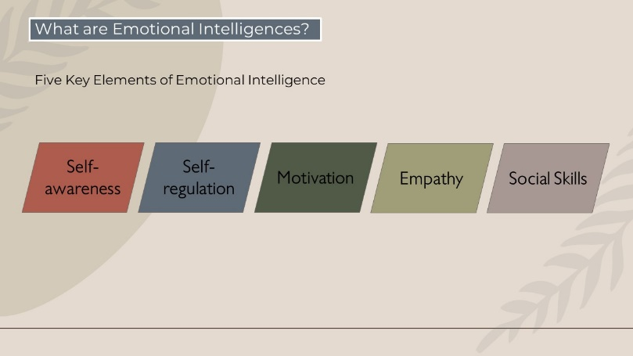 | Say:  There are five key elements of emotional intelligence. (Click)  Self-awareness (click)  Self-regulation (click)  Motivation (click)  Empathy (click)  And Social skills  Let’s look at each one individually. (Click)
8  4 min. | 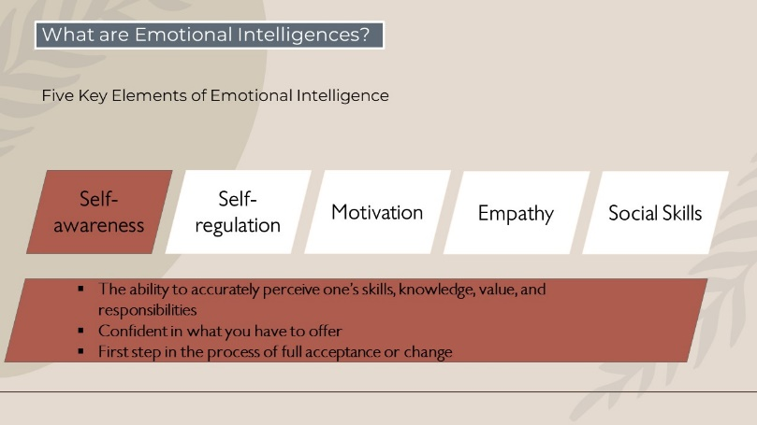 | Say:  The first element is self-awareness. (click) Being ‘aware’ of one’s self is (click) the ability to accurately perceive one’s skills and knowledge, value and responsibilities. (click) It is being confident in what you have to offer, whether it is personally or professionally.  Self-awareness is not only important for one’s self-esteem, (click) but it is also the first step in the process of full acceptance or change. Without understanding why one thinks the way he thinks or why he acts the way he acts, he may never fully appreciate himself or see the importance of making changes to improve him, if necessary. Self-awareness gives power and a sense of peace or happiness. This newly found strength will more than likely carry over into your work life, how you perform your duties as well as how you interact with others.  (Click to next slide)
9  2 min. | 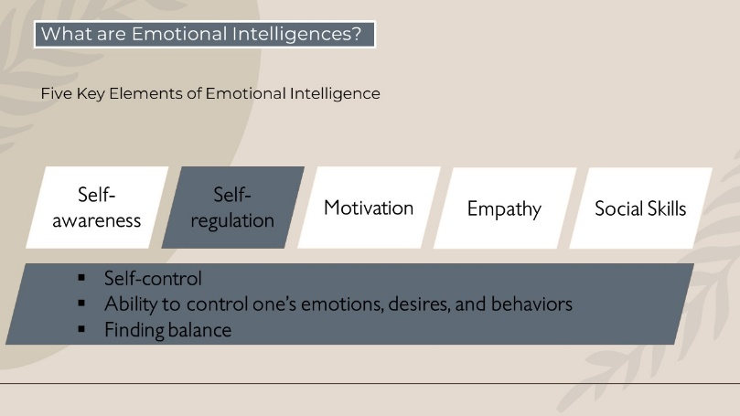 | Say:  The next element is self-regulation. (click) Self-regulation is another term for (click) self-control, which is defined as the (click) ability to control one’s emotions, desires, and behaviors in order to reach a positive outcome. Self-regulation is sometimes difficult because of the phenomenon that it is important to ‘express how you feel’. While this may be partially true, (click) the art to finding the balance between expressing one’s feelings and avoiding unnecessary tension is self-regulation.  (Click to next slide)
10  2 min. | 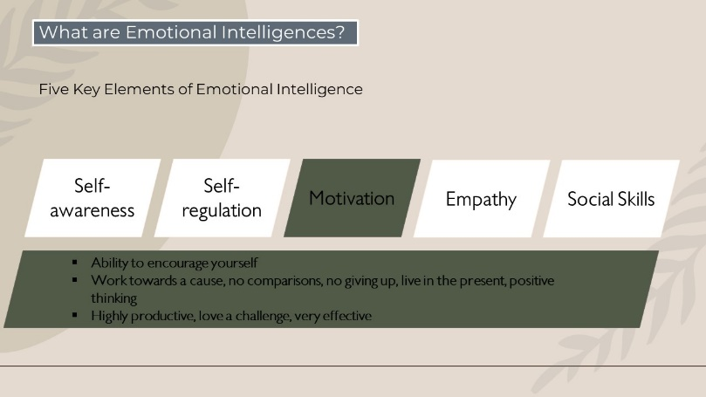 | Say:  Next is motivation. (click) Motivation is the (click) ability to encourage yourself, no matter how difficult the circumstance is. Motivation can be increased through (click) working towards a cause, refraining from comparing yourself to others, making the conscious effort to not give up, not living in past failures or successes, and focusing on positive thinking. Motivated people are willing to defer immediate results for long-term success. (click) They are highly productive, love a challenge, and are very effective in whatever they do.  (click to next slide)
11  2 min. | 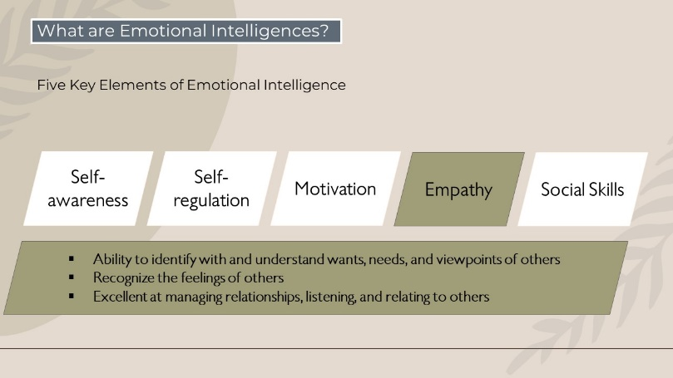 | Say:  Empathy is the next key element we will look at. (click) Empathy is the (click) ability to identify with and understand the wants, needs, and viewpoints of those around you. People with empathy are good at (click) recognizing the feelings of others, even when those feelings may not be obvious. As a result, empathetic people are usually (click) excellent at managing relationships, listening, and relating to others. They avoid stereotyping and judging too quickly, and they live their lives in a very open, honest way.  (click to next slide)
12  2 min. | 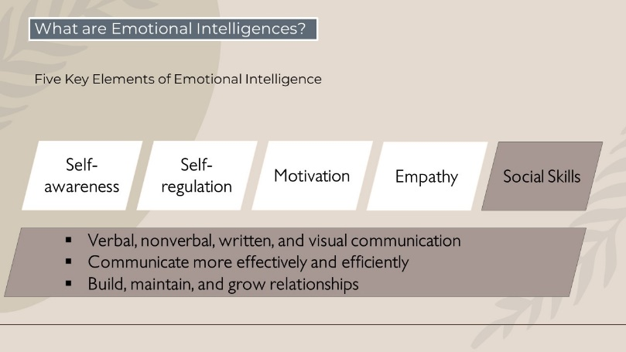 | Say:  Finally, let’s look at social skills as the fifth and final key element of emotional intelligence. (click) Social skills include (click) verbal, nonverbal, written, and visual communication with others. Social skills are important because they can help you (click) communicate more effectively and efficiently and, as a result, help you (click) build, maintain and grow relationships with others.  (Click to next slide.)
13  20 min. | 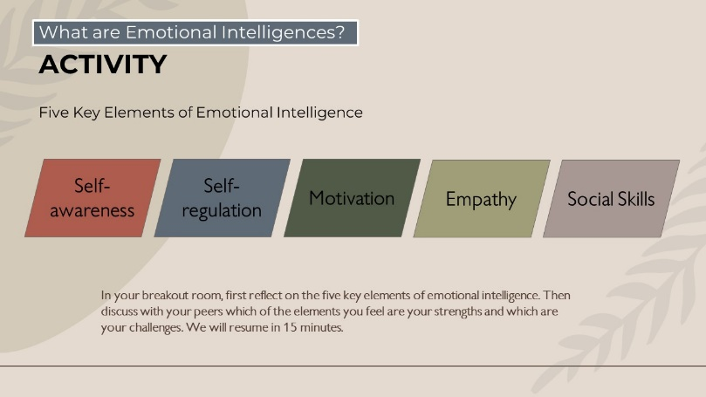 | Say:  We are going to spend some time reflecting and discussing the five key elements of emotional intelligence. You will be assigned a breakout room. Spend the first few minutes reflecting on the five elements. Then discuss with your group which of the elements you feel are your strengths and which are your challenges. We will take about 15 minutes for this activity.  Do:  After the 15 minutes have passed and breakout rooms have ended, offer to let any participants that wish to share their thoughts. Allow 5 minutes for debriefing. | Divide participants into five breakout rooms with an even number of participants (ideally 4-5).  Set a timer for 15 minutes.
14  1 min. |  | Say:  We are now going to look at the importance of understanding emotional intelligence.
15  1 min. |  | Say:  We will look at its use in two places: (click) the workplace (click) and in leadership.
16  4 min. | 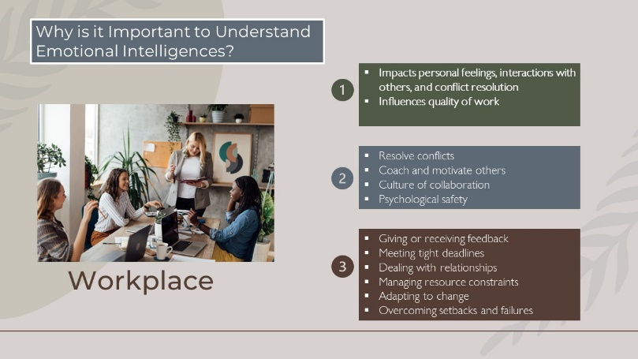 | Say:  (click) Emotional Intelligence plays an important role in the workplace. (Click, click) It impacts how individuals feel about themselves, interact with others, and manage conflicts. (click) Ultimately it influences the quality of their work.  Scientifically, emotions precede rational thought, and heightened emotions can impair cognitive functions, decision-making abilities, and interpersonal skills.  (click) Effective management of emotions enables individuals to (click) successfully resolve conflicts, (click) coach and motivate others, (click) create a culture of collaboration among team members, (click) and establish psychological safety within teams, which encourages open communication and innovation.  (click)Emotional intelligence is especially important in high-pressure situations, such as (click) giving or receiving feedback, (click) meeting tight deadlines, (click) dealing with challenging relationships, (click) managing resource constraints, (click) adapting to change, (click) and overcoming setbacks and failures.  (click to next slide)
17  4 min. | 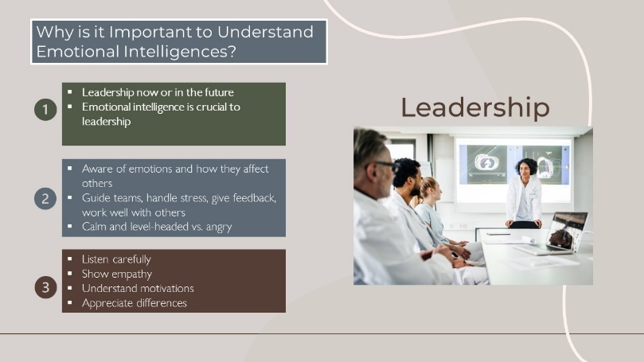 | Say:  (click) Even if you're not a leader right now, (click, click) it's still important to know how good leaders handle their feelings and actions. If you are a leader or will be one day, (click) understanding emotional intelligence is crucial.  (click) Being a good leader means (click) being aware of how your emotions affect the people around you. Leaders with strong emotional intelligence can (click) guide teams, handle stress, give helpful feedback, and work well with others. Emotional intelligence is really important for leadership success. (click) Leaders who stay calm and think clearly do better than those who get angry and shout when things are tough.  (click) Leading with emotional intelligence means making a real connection with people. This can make them more engaged and productive. To do this, leaders should (click) listen carefully to what others think, (click) show they care about people's feelings, (click) take time to understand what motivates their team members, (click) and appreciate how their team's different experiences can help the whole group and the organization.  (click to next slide)
18  15 min. | 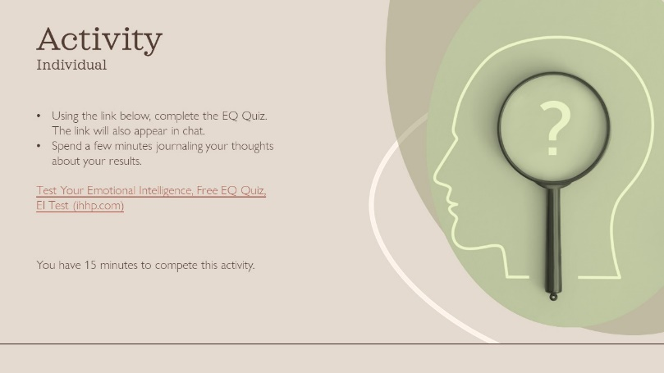 | Say:  We’re going to spend the next portion of this course completing several activities. The first activity is a free quiz to test your emotional intelligence. Click the link in the chat to get started. When you are finished, journal your thoughts on the results you received. We will come back together in 15 minutes. | Put this link in chat:  Test Your Emotional Intelligence, Free EQ Quiz, EI Test (ihhp.com)  Set a timer for 15 minutes.
19  10 min. | 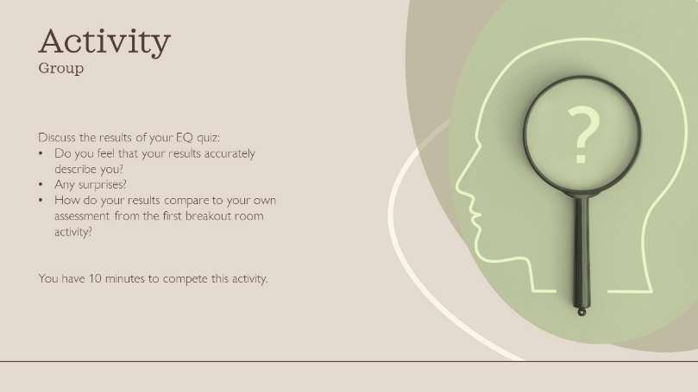 | Say:  You will now be assigned to the same breakout room that you were in at the beginning of this course. In your group, take turns discussing your results. Do you feel that your results accurately describe you? Were there any surprises? How do your results compare to your own assessment from the first breakout room activity?  We will come back together in 10 minutes.  Do:  After time is up, allow time for anyone who wishes to share their thoughts on this activity.  Say:  Would anyone like to share their thoughts with the whole group about this activity? | Assign participants to the same breakout room as in previous activity.  Set a timer for 10 minutes.
20  1 min. |  | Say:  Let’s move on to answering the question of how emotional intelligences can be developed. We’re going to start off with one more activity.  (Advance to next slide)
21  1 min. | 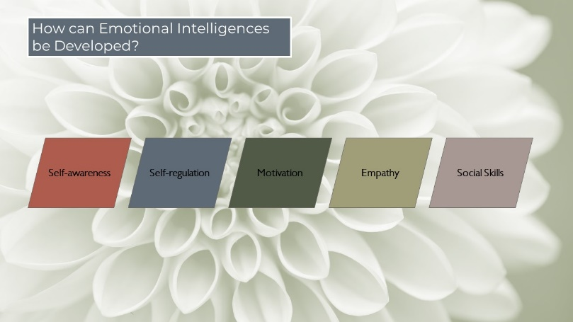 | Say:  The good news is that emotional intelligence can be practiced and developed. You may already be thinking of ways that you can improve some of your weaker areas and further develop your stronger areas. Being adaptable and willing to grow and change is a good sign that you already possess a high level of emotional intelligence. Let’s look at some practical ways to further develop our emotional intelligence.  (Advance to next slide by clicking the arrow. Clicking on the slide will only stop the video from playing.)
22  5 min. | 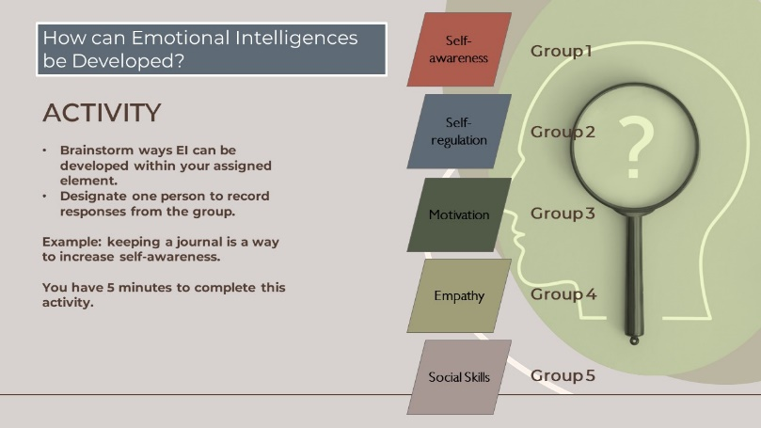 | Say:  In this activity, you will be assigned to a new breakout room. Each breakout room will be assigned one of the key elements of emotional intelligence. In your group, brainstorm ways EI can be developed within that element. For example: journaling can be one way to increase self-awareness. Designate one person in your group to record responses. We will come back together in 5 minutes. | Divide participants randomly into five new breakout rooms, 4-5 participants per room. Assign each group a number 1-5.  The facilitator may need to visit each breakroom to remind the group of their group number and topic.  Set a timer for 5 minutes.
23  3 min. | 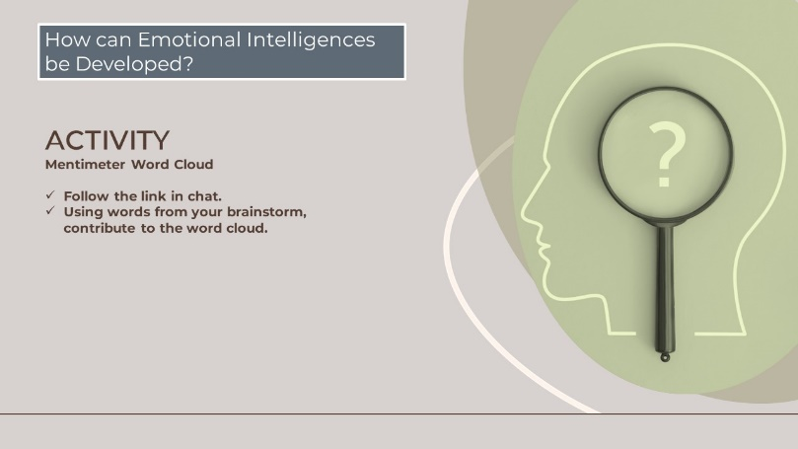 | Say:  We are now going to take the responses you generated in the brainstorm session and create a word cloud using Mentimeter. Follow the link provided in the chat.  Do:  Gauge length of activity – when words are no longer appearing, conclude activity (3-5 minutes)  Say:  What stood out to you in this word cloud? Would anyone like to share their thoughts? | Provide link in chat: Emotional Intelligences (vILT) - Mentimeter
24  10 min. | 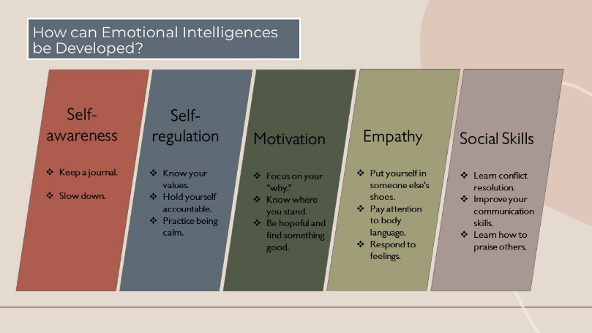 | Say:  Here are additional ways that emotional intelligences can be developed. See which ones you came up with already and which ones you would add to your personal list.  (click, click) Self-awareness: (click) Keep a journal - even just a few minutes a day spent writing down your thoughts and reactions to the day can help develop your self-awareness. (click) Slow down – when you do experience periods of anger or other strong emotions, slow down to examine why. Remember that you are in charge of your reactions, no matter the situation.  (click, click) Self regulation: (click)Know your values – what values are most important to you? Under what circumstances will you refuse to compromise? Knowing what is most important to you will help you when you face an ethical decision. You’ll be ready to make the right choice. (click) Hold yourself accountable – own up to your mistakes and face the consequences. Don’t resort to blaming others for your mistakes. By admitting your shortcomings and accepting the consequences, you will earn the respect of those around you. (click) Practice being calm – Be aware of your reaction during a challenging situation. Is your typical reaction to scream and shout at others? Practice deep breathing exercises to help you calm down. Also, trying writing out your negative emotions on paper and then rip it up and throw it away! You can still express how you feel, but not at the expense of another person. (click, click) Motivation: (click) focus on your why – think about why you are in this job. Are you able to help others? Do you contribute to a larger picture? Set some realistic goals, at your work and in your personal life, and go for it! (click) Know where you stand – take an honest look at your motivation levels and if necessary, take steps to improve it. Check out a self-help book or find a motivating podcast. (click) Be hopeful and find something good – Work at developing optimism, no matter what problems you face. Try to find something good about each situation you encounter. Did the situation allow you to engage with someone new? Did you learn from a mistake? Even if it’s a seemingly small thing, there’s almost always something positive that can be gained if you are looking for it. (click, click) Empathy: (click) put yourself in someone else’s shoes – take the time to look at situations from other people’s perspectives. Even if you don’t agree, putting yourself in their shoes can help you develop empathy. (click) Pay attention to body language – what is your body language communicating to another person? Are you approachable and friendly? Or do you come off as withdrawn and disinterested? In addition to paying attention to your own body language, reading another person’s body language is also important. What are they “telling” you in the situation? What can you do to help change their message, if it isn’t positive? Can you adjust your tone of voice? Give an encouraging word? Show understanding? Reading people’s non-verbal communication is just as important as the words they use. (click) Respond to feelings – Sometimes what is said does not match the feeling being communicated. Listen for the feeling as well as the words that are spoken and respond to the feeling as well as the words. (click, click) Social skills: (click) learn conflict resolution – staying mad or treating someone with indifference, or worse, with a revengeful mindset never solves the problem. Ask for a mediator if the issue is beyond what you feel can be handled alone. (click) Improve your communication skills – are you a good listener? Do you use eye contact and reflect back to the person what you have heard? Are you trustworthy when trusted with sensitive information? Do you follow through on tasks assigned to you? Communication is key to improving your social skills. (click) Learn how to praise others – genuine praise and appreciation goes a long way in developing positive relationships. But be careful! Non-specific praise or insincere praise just comes off as noise and does nothing to benefit the other person.  (Advance to the next slide)
25  5 min. |  | Say:  Let’s test your knowledge by playing a game of Kahoot! Open a new tab and go to www.kahoot.it. When prompted, enter the game code: _______  Do:  Write code on slide once it has been generated by Producer. | Provide this link in chat: https://create.kahoot.it/share/emotional-intelligences/ac03cd9a-1058-4fed-90cf-15ad305882ee.  Share code in chat after it generates.
26  1 min. | 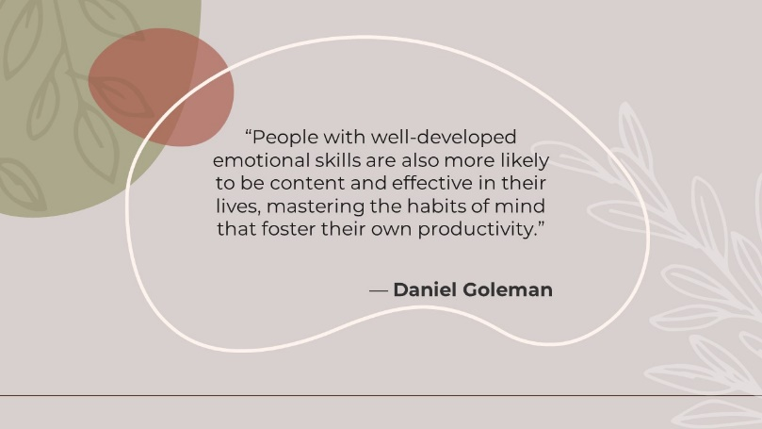 | Say:  Daniel Goleman, author of the book, Emotional Intelligences, sums up the importance of emotional intelligence when he said:  Do:  Read quote on the slide.
27  1 min. | 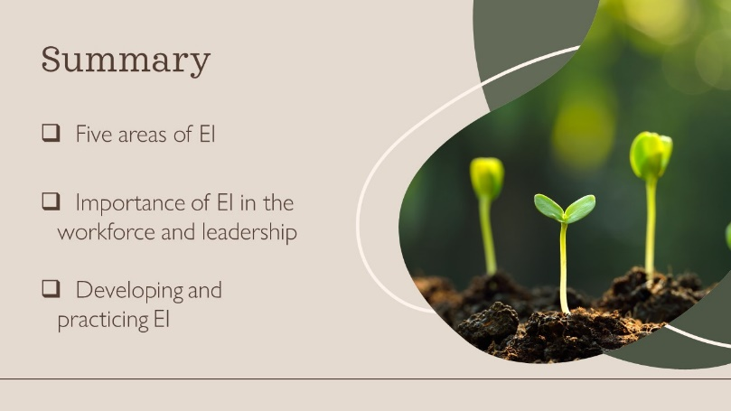 | Do:  Review definition of EI: ability to recognize emotions, understand them, and how they affect others.  Review five areas of EI: self-awareness, self-regulation, motivation, empathy, social skills.  Review importance of EI in workforce and leadership: better work productivity, optimistic attitude towards failures and setbacks, stronger relationships with others, able to look for EI attributes in others, especially those in leadership.  Review examples of developing and practicing EI: (name a few of those presented.)
28  1 min. | 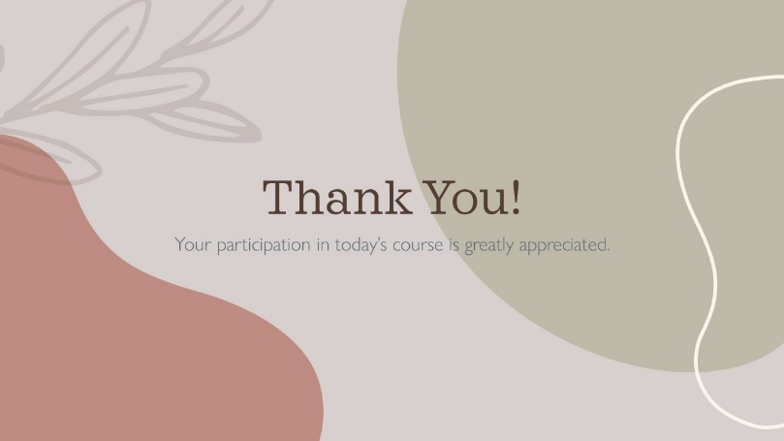 | Do:  Thank the participants in today’s course. Acknowledge the producer who helped out in today’s course. Answer any questions participants may have. End the session.

Kahoot! Screenshots with questions and answers:
