Introduction: This Vyond video is part of a larger project on Business Etiquette. It is intended for employees from other countries who are entering the workforce in the United States. Employees new to the United States will become familiar with social norms that take place within the workplace.

Learning Objectives:
- Identify how to properly answer the phone in a business setting.
- Demonstrate proper voice mail etiquette.
- Describe cell phone dos and don’ts.

Outline:
I. Answering the phone
- Greeting
- Identify yourself and the company
- Inquire how you may help
II. Voicemail
- Leaving a voice mail
- Managing personal voice mail
- recording personal greeting
- stay on top of messages
III. Cell phone use – Dos and Don’ts
- Don’t:
- take a call in a business meeting or in a conversation with another person
- talk in public locations where silence is expected
B. Do:
- set ringer to silent or vibrate
- answer calls at least 10 feet away from another person (10 foot rule)
- set phone to VM when out in public
- keep business calls to business hours

Characters:

A man (John) and woman (Anna) demonstrating proper phone etiquette. Narrator voice in the background.

Color Palette: 
Hex #FAB41E (orange) Hex #4B80BC (blue) Hex #DB5461 (red)

Scene 1
Introduction
Visuals/Graphic | Script/Audio | Programming/Animation Notes | Comments
Narrator is in an office setting, talking on the phone.  Title of course in on the right:  “Phone Etiquette in a business setting”  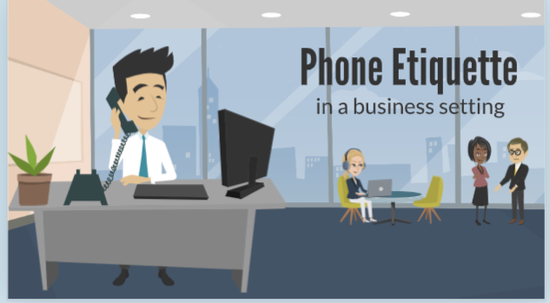 | Thank you for calling. Have a great day! (hanging up the phone).

Scene 2
Introduction
Visuals/Graphic | Script/Audio | Programming/Animation Notes | Comments
Same scene.  Black square on the right with learning objectives in white.  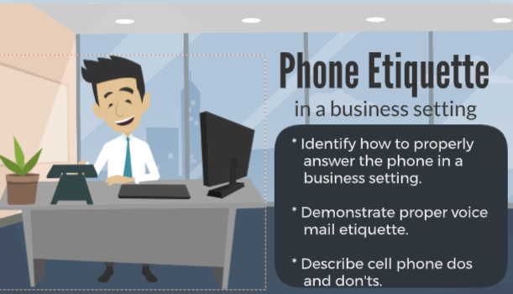 | Hello there! I’m glad you’re here. You know, phone etiquette is an important part of being in the workforce. Knowing how to properly answer the phone, manage voicemail, and the doos and don’ts of cell phone use are essential skills in this modern world of communication. Today, we'll follow the story of two individuals, John and Anna, as they demonstrate the proper use of phone etiquette in a business setting. When we’re finished, you will have the skills you need to follow proper phone etiquette.  Our story begins with Anna, a professional office manager, answering a call in her office.

Scene 3
Answering the Phone
Visuals/Graphic | Script/Audio | Programming/Animation Notes | Comments
Anna in her office on the phone.  Title: Answering the Phone  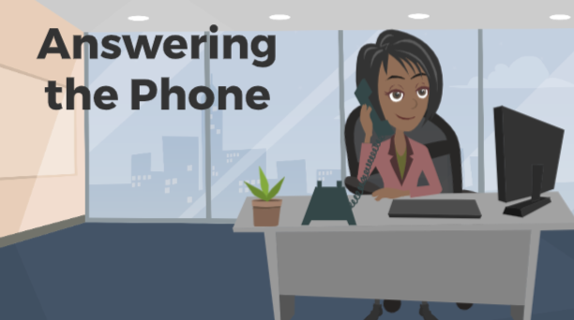 | (Sound effect of a phone ringing)  Good morning! Thank you for calling XYZ Incorporated. This is Anna. How may I help you?

Scene 4
Answering the Phone
Visuals/Graphic | Script/Audio | Programming/Animation Notes | Comments
Narrator standing in the same office scene as scene 1, gesturing to the right with a white text box.  Inside text box:  Greeting:  Company name  Your name  Friendly question  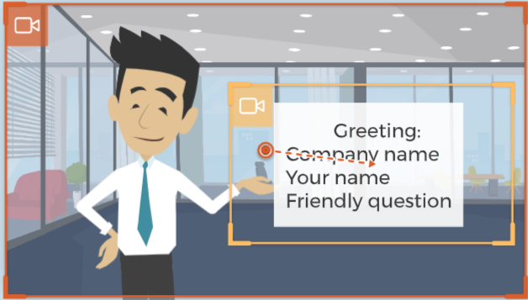 | Nicely done, Anna! Did you notice the different parts of Anna’s greeting as she answered the phone? Her greeting clearly communicated the company, her name, and a friendly question that let the caller know she’s ready to help.  Now, let's shift our focus to John, who is setting up his outgoing voicemail message. | Camera movement on the text box as the narrator is speaking.

Scene 5
Voicemail
Visuals/Graphic | Script/Audio | Programming/Animation Notes | Comments
John in his office with phone to his ear.  Title: Voicemail | Sound effect: beep  Hello, you have reached John with XYZ Incorporated. I'm unable to take your call right now. Your call is very important to me. Please leave your name, phone number, and a brief message, and I will return your call as soon as possible. Thank you!

Scene 6
Voicemail
Visuals/Graphic | Script/Audio | Programming/Animation Notes | Comments
Narrator standing in his office. Walks to middle of screen while talking.   | John’s outgoing voicemail greeting identifies who the caller has reached and gives short, but clear directions regarding the information the caller should leave. Letting the caller know that their call is important and ending the call with a “thank you” communicates respect to the caller, even when the phone call cannot be answered right away. While the outgoing greeting is important, leaving a voicemail is just as important. Let’s listen in. | motion path moving narrator to the left.  Stops and faces the camera.

Scene 7
Voicemail
Visuals/Graphic | Script/Audio | Programming/Animation Notes | Comments
Same as scene 5 – John is in his office talking on the phone.  Narrator enters from the right after John finishes speaking.  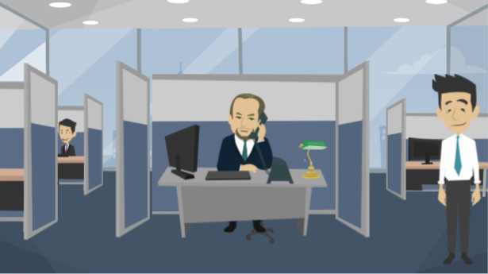 | Sound effect: beep of a voicemail  JOHN: Hi, this is John with XYZ Incorporated. My phone number is 555-5755. I’m calling in regards to a billing statement I recently received. Please return my call at your earliest convenience. Again, this is John and my number is 555-5755. Thank you!  Narrator: John’s voicemail is short and to the point. He provides the basic information needed such as his name, his company, his number, and a brief description regarding the reason for his call. By repeating his name and number at the end of the message, he provides the recipient the opportunity to write down this information without needing to hear the entire message replayed. Now let’s check back in with Anna and see how she is managing her voicemails. | Slide - left enter effect for narrator after John finishes dialogue.

Scene 8
Voicemail
Visuals/Graphic | Script/Audio | Programming/Animation Notes | Comments
Anna in her office, listening with the phone to her ear.   | Voice on the phone: Please give me a call as soon as possible. | Anna is listening. No mouth movement should be seen from Anna.

Scene 9
Voicemail
Visuals/Graphic | Script/Audio | Programming/Animation Notes | Comments
Same office scene with Anna  Anna puts down the phone receiver.   | Sound effect: phone hang up.  Anna: Ah, another task on my plate. I need to prioritize this one.

Scene 10
Voicemail
Visuals/Graphic | Script/Audio | Programming/Animation Notes | Comments
Same office scene with Anna now on the phone.   | Hello, this is Anna returning your call.

Scene 11
Voicemail
Visuals/Graphic | Script/Audio | Programming/Animation Notes | Comments
Narrator standing in his office.  Blue-framed box with text on his left appears when narrator’s dialogue matches text.  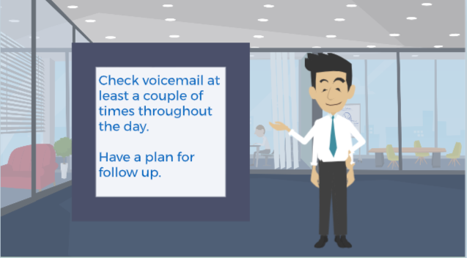 | Anna knows that staying on top of her messages is crucial for maintaining efficiency. It’s important to check voicemails at least a couple of times throughout the day, especially if you have been away from your desk. Have a plan for following up on the messages you receive.  Now let’s join John as he attends a business meeting, where proper cell phone etiquette is a must. | Narrator begins standing neutral then switches to a gesture when text box appears.

Scene 12
Cell Phone Dos and Don’ts
Visuals/Graphic | Script/Audio | Programming/Animation Notes | Comments
John in a business meeting, facing the presenter, listening and nodding. Phone is on the table.  Caption with “Phone set to silent” comes in about halfway through scene.  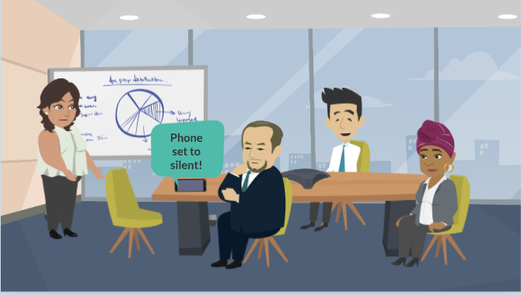 | Narrator: John is a master of the 'Don'ts' when it comes to cell phone use during meetings. He avoids taking calls in business meetings and stays engaged in the conversation.

Scene 13
Cell Phone Dos and Don’ts
Visuals/Graphic | Script/Audio | Programming/Animation Notes | Comments
Anna in a public library.  Cell phone set to vibrate.  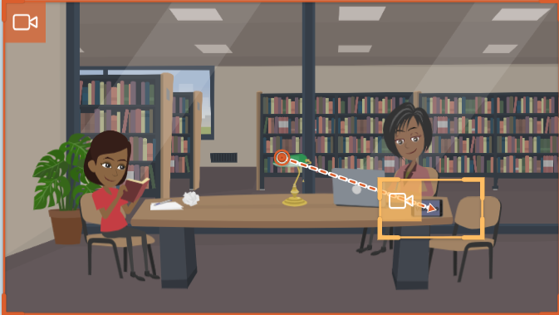 | Meanwhile, Anna understands the importance of silence in certain public locations. She sets her phone to vibrate to prevent any disruption. | Camera movement on cell phone zooms in to show the word “vibrate.”

Scene 14
Cell Phone Dos and Don’ts
Visuals/Graphic | Script/Audio | Programming/Animation Notes | Comments
John outside of meeting room talking on his cell phone  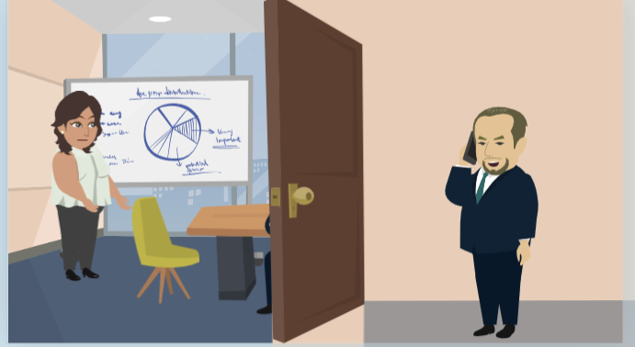. | John follows the '10-foot rule.'  If John’s call must be answered, he quietly excuses himself from the room and moves at least ten feet away from the meeting, ensuring that his conversation doesn't disturb others.

Scene 15
Cell Phone Dos and Don’ts
Visuals/Graphic | Script/Audio | Programming/Animation Notes | Comments
John is still outside of the office.  He hangs up the phone, looks at the clock, and smiles.  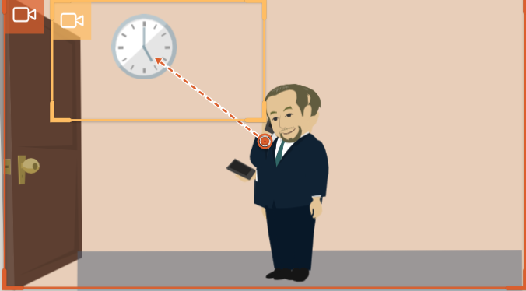 | Finally, John knows that business calls should stay within business hours. | camera zoom on the clock

Scene 16
Conclusion
Visuals/Graphic | Script/Audio | Programming/Animation Notes | Comments
Outside of office – narrator, John, and Anna. As narrator speaks, John and Anna are waving goodbye.  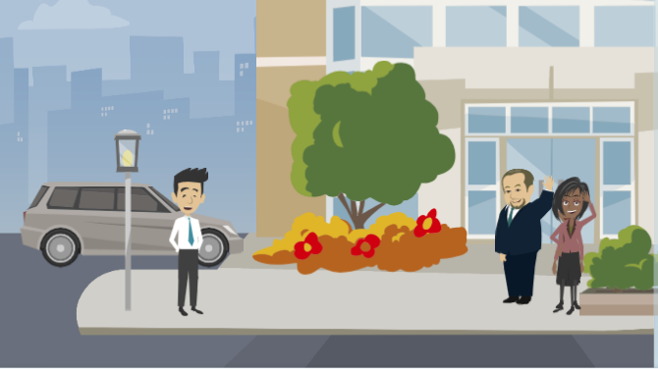 | It's the end of a productive day for both John and Anna, thanks to their correct use of phone etiquette.  As our story concludes, we learn that answering the phone with courtesy, managing voicemail efficiently, and practicing cell phone doos and don'ts can greatly enhance our professional lives.  So, whether you're at work or out in public, remember these simple rules, and you'll be well on your way to mastering the art of phone etiquette.

