A Hydrogen Guarantee of Origin scheme for Australia

Discussion paper

**Note to participants**: The issues canvassed in this paper are intended to facilitate consultation by the Department of Industry, Science, Energy and Resources and have not been endorsed by the Australian Government.

Date: June 2021

## Copyright

**© Commonwealth of Australia 2021**

**Ownership of intellectual property rights**

Unless otherwise noted, copyright (and any other intellectual property rights, if any) in this publication is owned by the Commonwealth of Australia.

**Creative Commons licence**



**Attribution**

**CC BY**

All material in this publication is licensed under a Creative Commons Attribution 4.0 International Licence, save for content supplied by third parties, logos, any material protected by trademark or otherwise noted in this publication, and the Commonwealth Coat of Arms.

Creative Commons Attribution 4.0 International Licence is a standard form licence agreement that allows you to copy, distribute, transmit and adapt this publication provided you attribute the work. A summary of the licence terms is available from <https://creativecommons.org/licenses/by/4.0/>

The full licence terms are available from <https://creativecommons.org/licenses/by/4.0/legalcode>

Content contained herein should be attributed as *Report title, Australian Government Department of Industry, Science, Energy and Resources*.

## Disclaimer

The Australian Government as represented by the Department of Industry, Science, Energy and Resources has exercised due care and skill in the preparation and compilation of the information and data in this publication. Notwithstanding, the Commonwealth of Australia, its officers, employees, or agents disclaim any liability, including liability for negligence, loss howsoever caused, damage, injury, expense or cost incurred by any person as a result of accessing, using or relying upon any of the information or data in this publication to the maximum extent permitted by law. No representation expressed or implied is made as to the currency, accuracy, reliability or completeness of the information contained in this publication. The reader should rely on their own inquiries to independently confirm the information and comment on which they intend to act. This publication does not indicate commitment by the Australian Government to a particular course of action.

# Contents

A Hydrogen Guarantee of Origin scheme for Australia 1

Copyright 2

Disclaimer 2

Contents 3

Executive Summary 5

How to have your say 8

1. Introduction 9

1.1 Why do we need a Guarantee of Origin scheme for hydrogen? 9

1.2 National Hydrogen Strategy 10

1.3 International context 11

1.4 Domestic consultation 13

1.5 Design approach 15

2. Scheme design, coverage and administration 16

2.1 Coverage 16

2.2 Carbon accounting frameworks 19

2.3 Treatment of offsets 21

2.4 Scheme governance and administration 22

2.5 Regulatory framework 22

2.6 Reporting 24

3. Carbon accounting methodology 25

3.1 Emissions sources 26

3.2 Methodologies for estimating scope 1 emissions 27

3.3 Measuring upstream emissions 28

3.4 Scope 2 emissions 28

3.5 Verifying and tracking renewable electricity inputs 30

3.6 Allocating emissions to co-products 35

3.7 Carbon Capture, Utilisation and Storage 42

3.8 Materiality threshold 43

4. Next steps 44

4.1 Trial phase 44

Attachment A: Description of hydrogen produced from electrolysis 46

Process description 46

Sources of emissions 47

Information to be reported 48

Attachment B: Coal Gasification with CCS 50

Process description 50

Sources of emissions 53

Information to be reported 56

Attachment C: Natural gas steam methane reforming with CCS 58

Process description 58

Sources of emissions 61

Information to be reported 64

Attachment D: Grid electricity emissions 66

Reporting 66

Renewable Energy Certificates 66

Renewable Energy Target (RET) 67

GreenPower 67

Power Purchase Agreements 68

Local Renewable Energy Generation 68

Jurisdictional Renewable Energy Targets 69

Climate Active Certified Carbon Neutral Electricity 69

Grid Imported (Residual) Electricity 69

Attachment E: Summary of NGERS methods and other guidance 70

Attachment F: Glossary 0

# Executive Summary

The establishment of a hydrogen Guarantee of Origin (GO), or certification scheme, is a priority action under Australia’s National Hydrogen Strategy. This scheme will be vital to give purchasers transparency as Australia and the world looks to facilitate clean hydrogen trade.

Hydrogen will be an internationally traded commodity, and Australia has the potential to be a major exporter. Therefore it is crucial that the methodology underpinning hydrogen GO schemes in countries seeking to trade hydrogen is consistent, enabling an accurate comparison of hydrogen produced by different countries. It is also important that a hydrogen GO scheme promotes choice and allows consumers to have access to information that will enable them to choose the product best suited to their needs.

This paper outlines methodologies for guaranteeing the origin of clean hydrogen from three main production pathways: electrolysis, coal gasification with carbon capture and storage (CCS), and steam methane reforming with CCS. In support of the scheme’s ability to distinguish between different sources of energy used in hydrogen production, the paper also outlines options for the verification of renewable electricity as an input.

The scheme may need to evolve over time to include additional hydrogen production pathways, additional components of the hydrogen value chain such as storage and transport, and downstream products such as low-emissions steel. In particular, it is important for hydrogen energy carriers such as ammonia to be covered. This work is underway and will be released for consultation in coming months.

Clean hydrogen can be used as an input to reduce the emissions associated with the production of ‘downstream’ products such as ammonia, electricity or steel. As with hydrogen itself, there may be a future need to track and verify the emissions associated with these products. It is intended that the approach presented in this paper can be built on over time, forming a broader framework for guaranteeing the origin of a range of decarbonised or low emission products.

The Department of Industry, Science, Energy and Resources (the Department) has been working both domestically and internationally on the development of an initial hydrogen GO scheme. Domestic consultation was undertaken during 2020, with a survey released through the Department of Industry, Science, Energy and Resource’s (the Department) consultation hub in June and a workshop held in September.

Internationally the Department is working on behalf of the Australian Government as a member of the International Partnership for Hydrogen and Fuel Cells in the Economy’s (IPHE) Hydrogen Production Analysis Taskforce, which is aiming to *develop a mutually agreed methodology to determine the carbon emissions associated with hydrogen production.*

Australia is leading the group’s efforts to develop proposed methodologies for the certification of hydrogen produced from electrolysis and from coal gasification with CCS. It is envisaged the methodology developed by IPHE will then form the inputs to a future international standard.

To identify priorities and trade-offs, the Department commissioned Australian energy consultancy Energetics to provide advice on options for a domestic GO scheme. This analysis identified an IPHE aligned domestic scheme, which could transition to an international scheme or standard over time.

IPHE is looking to build on the European CertifHy approach in developing its methodology, aiming to ensure that any future GO scheme agreed by IPHE members will be applicable to a broad range of countries and hydrogen production processes. The Department considers this represents the best way to balance the needs of timeliness and international alignment, and will position Australia to be consistent with the development of a global scheme that is most likely to achieve broad acceptance across export markets.

Through domestic consultation the Department also heard a strong desire for a hydrogen GO scheme to draw on existing reporting frameworks, such as the National Energy and Greenhouse Reporting Scheme (NGERS). However, industry stakeholders recognised NGERS alone would not be sufficient for the purposes of a hydrogen GO scheme. For example, the NGERS is designed to calculate emissions from a facility and assist with the compilation of Australia’s national carbon inventory, rather than to attribute emissions to a particular product, such as hydrogen.

Certification schemes for products such as hydrogen commonly draw on the foundational principles for carbon accounting presented in International Organization for Standardization (ISO) standards relating to the carbon footprint and life cycle assessment of products, and the Greenhouse Gas Protocol. These standards provide principles, framework, requirements and guidelines to support the estimation of emissions associated with a given product. These form the frameworks on which existing and emerging hydrogen guarantee of origin schemes are based, and that IPHE has agreed to use as the basis for its standard. The Intergovernmental Panel on Climate Change (IPCC) Guidelines for National Greenhouse Inventories also provide specific methods and emissions factors to support calculation of the GHG inventory for hydrogen. In Australia, the NGERS provides a national application of the IPCC guidelines.

This paper presents an approach to an initial hydrogen GO scheme that is consistent with the work so far through IPHE, based on feedback from stakeholders in 2020, and promotes informed choice. To date, IPHE members are broadly aligned on the high level aspects of the methodology, and are continuing to discuss details such as methods for allocating emissions to co-products (where hydrogen is not the only output of the production process). However, it should be noted that no decisions have been formally taken by IPHE, so the approach presented in this paper should not be taken as final. The scheme design should be adaptable over time to remain consistent with the international standard, or with global scheme developments, should this occur.

Following this consultation, next steps will include trialling the proposed methodologies for the three production pathways outlined here. This will test the methodologies on actual projects, allowing us to further refine the methodology. It is envisaged that trials will be launched in the second half of 2021.

This paper contains questions for stakeholders on the proposed design of an initial Australian hydrogen GO scheme. The feedback will be used to design a pilot scheme and confirm Australia’s position in IPHE. Feedback will further help to identify priorities for future expansion of the initial scheme.

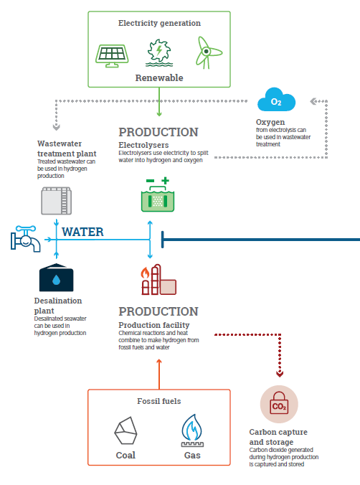

# How to have your say

The Department of Industry, Science, Energy and Resources are seeking feedback on the proposed approach for a Hydrogen Guarantee of Origin scheme for Australia. Responses to this discussion paper can be provided directly through the Department of Industry, Science, Energy and Resources [consultation hub](https://consult.industry.gov.au/).

Submissions close Friday 30 July 2021.

# 1. Introduction

## Why do we need a Guarantee of Origin scheme for hydrogen?

Hydrogen is a flexible, safe, transportable and storable fuel that can be used to power vehicles and generate heat and electricity. When it is used it produces no carbon emissions, but whether hydrogen is zero or low emissions depends on how it is produced.

Clean hydrogen production pathways are currently more expensive than the current production pathways that mostly use steam methane reforming without carbon capture and storage (CCS). However, consumers are showing interest in reducing carbon emissions and willingness to pay a premium for low-emission fuels.

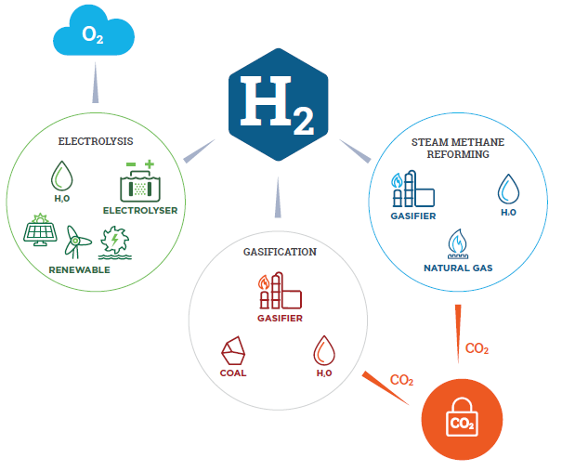

Production pathways for clean hydrogen—electrolysis and thermochemical reactions

A Guarantee of Origin (GO) or certification scheme for hydrogen will provide a consistent and accurate approach to track the key attributes associated with hydrogen production, in particular its carbon footprint. A GO scheme would provide much needed transparency to consumers around the environmental impact of the hydrogen being purchased and used.

Hydrogen will be an internationally traded commodity and Australia is well placed to be a major exporter. It is important that hydrogen GO schemes are internationally consistent to facilitate efficient international trade and enables informed choice for customers. This will be vital to allow Australia to scale up its domestic industry and reach our potential as a hydrogen producer and export powerhouse.

This paper focuses on developing the carbon accounting methodology and regulatory aspects of the scheme. The scheme would provide branding opportunities for certified hydrogen, however this aspect will be considered at a later date and there may be options for Government and non-Government branding.

## National Hydrogen Strategy

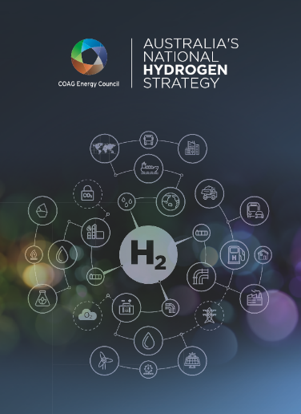Australia’s National Hydrogen Strategy (the Strategy) was released by the Australian Government in November 2019. It identifies 57 actions to build Australia’s hydrogen industry, themed around national coordination, developing production capacity supported by local demand, responsive regulation, international engagement, innovation and research and development, skills and workforce and community confidence.

The development of a hydrogen GO scheme is a key action item and an early priority agreed by the Australian and state and territory governments in the Strategy. The Strategy recognises that a global scheme would be ideal to facilitate international trade and provide consumers with the assurances they seek. The strategy therefore states that Australia will seek to be a leader in the development of an international hydrogen GO scheme, and that any domestic scheme should build on or harmonise with international schemes. The Strategy however notes that agreeing an international scheme should not delay investment in hydrogen production.

The Strategy identifies that ideally an initial scheme covering hydrogen production will emerge to support early projects. This could be changed or built on over time to consider other factors and other processes as needed to support industry growth and to align with international developments. This initial scheme would verify and track:

* Production technology,
* Carbon emissions associated with production (scope 1 and scope 2[1]), and
* Production location.

Feedback from stakeholders during consultations has identified that it will be essential to also track the source of energy used in production in any initial scheme.

Consistent with this approach, the focus of this paper is to develop methods for transparently calculating the carbon emissions associated with hydrogen production. This will allow buyers of hydrogen to set their own definitions of ‘green’ or ‘blue’ hydrogen with reference to agreed international standards.

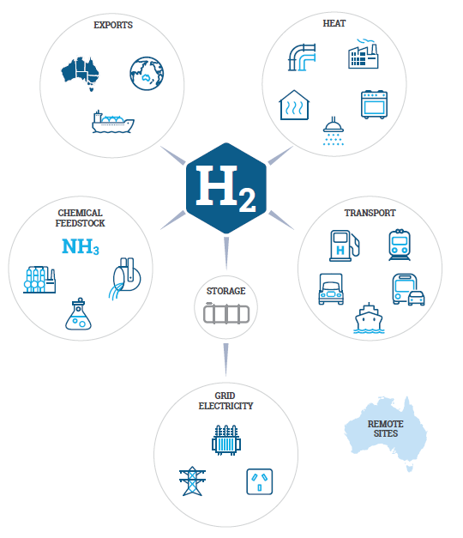

## International context

Several GO schemes for renewables based or low-carbon hydrogen are already in development, the most advanced of which is the European scheme CertifHy. CertifHy was founded in 2014 by a consortium of industry stakeholders with the aim of designing and implementing Europe's first comprehensive GO scheme for renewable and low-carbon hydrogen. The CertifHy scheme is closely aligned to European Union policies, specifically the Renewable Energy Directives (RED I and II). It includes eligibility requirements that set minimum thresholds of the emissions intensity of hydrogen that can be certified under the scheme. CertifHy has been implemented through a phased approach with Phase 1 (2014–16) focusing on the design of the scheme, phase 2 (2017–19) focusing on the governance infrastructure and four pilot projects to test the scheme design, and the third and current phase focussing on EU wide deployment.

Country specific hydrogen GO schemes in Germany (TUV SUD) and France (AFHYPAC) are less developed but similarly aimed at verifying the amount of hydrogen produced from renewable or sustainable sources. Renewable Guarantees of Origin for fuels exist across North America, Taiwan and Singapore through the Green-e® Energy Renewables Fuels standards and the greenhouse gases, regulated emissions and energy use in technologies (GREET) model. Hydrogen is not yet explicitly included in these schemes. For details of international GO schemes please refer to Chapter 2 and Appendices A, B, and C of the Energetics report *Hydrogen Guarantee of Origins for Australia – Options Paper* (Energetics 2021).

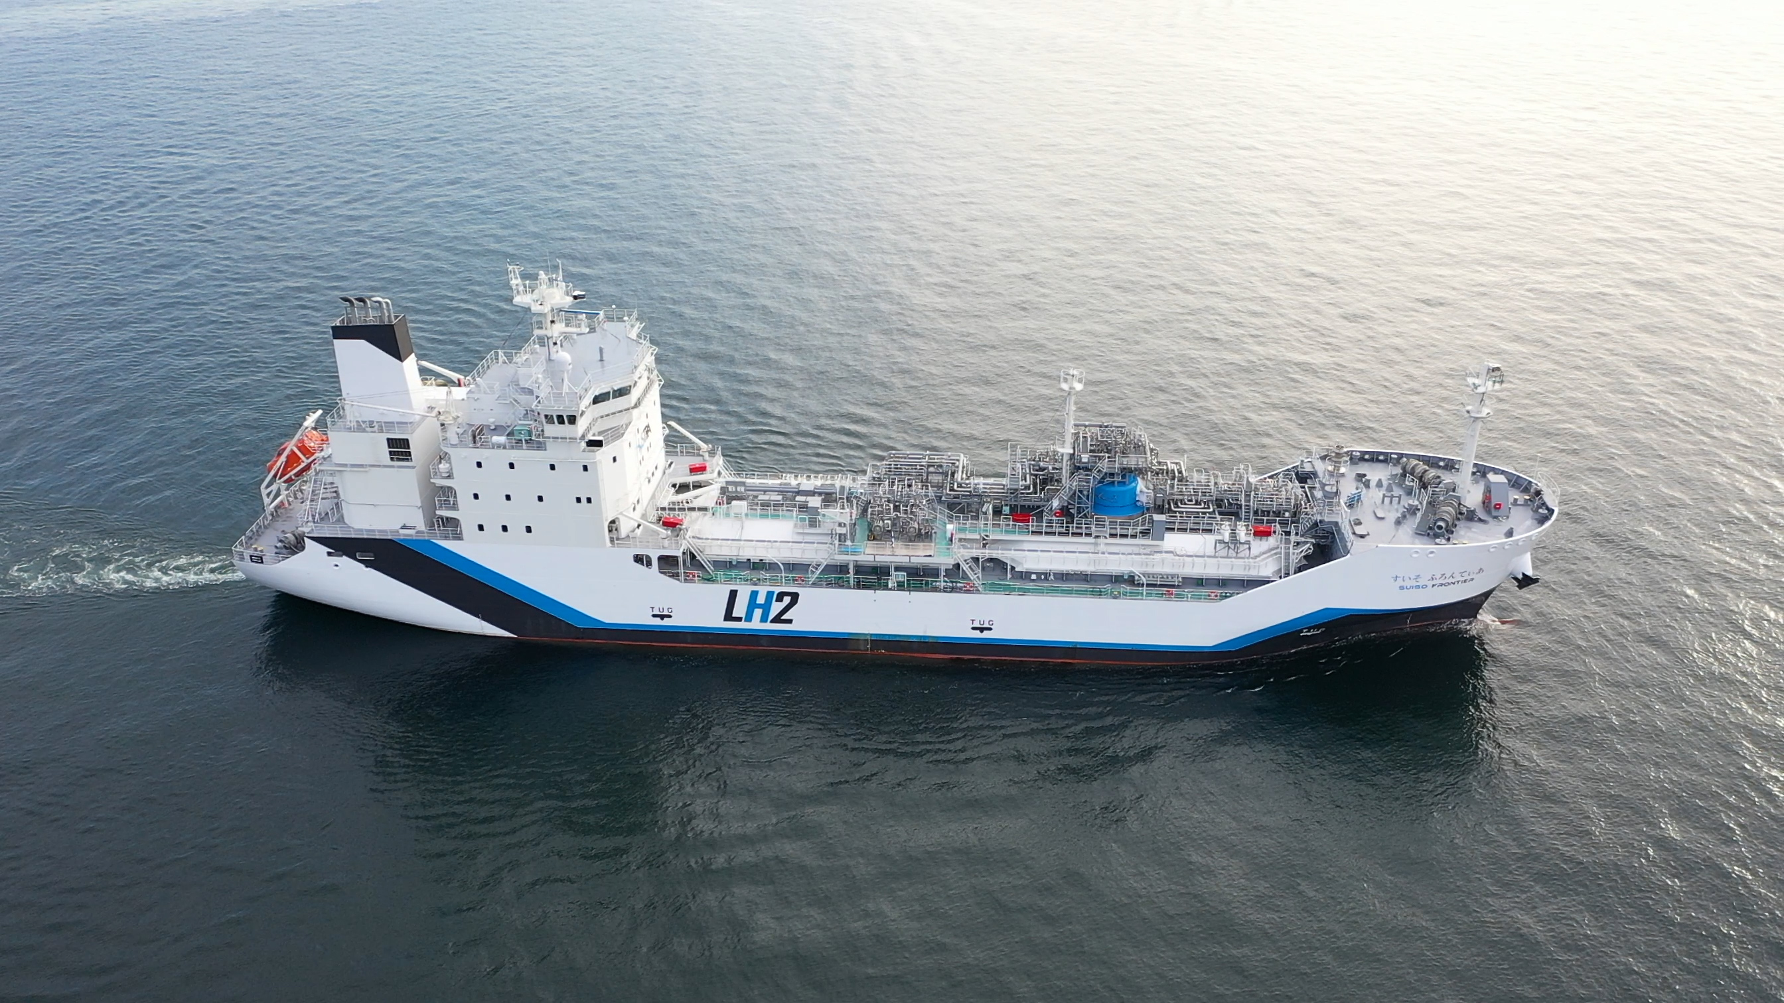

The Suiso Frontier: the world’s first liquefied hydrogen carrier. Image: HySTRA

### 1.3.1 International Partnership for Hydrogen and Fuel Cells in the Economy

The International Partnership for Hydrogen and Fuel Cells in the Economy (IPHE) is an international government-to-government partnership whose goal is to promote the advancement of technical hydrogen industry standards and protocols that are expected to underpin future trade and investment. This includes work on safety standards, regulation development, certification, trading, intellectual property, and education. IPHE has 22 members including many European countries, the United Kingdom, the USA, Japan, Republic of Korea, Chile and others.

The IPHE formed its Hydrogen Production Analysis Taskforce (H2PA) in March 2020 to develop a “mutually agreed methodology for determining the greenhouse gas and other emissions associated with the production of hydrogen”. This is the most advanced international forum for discussions on hydrogen certification and has broad representation. The IPHE H2PA Taskforce is led by France, with the USA and the European Commission as co-leads. Australia has taken a lead role throughout 2020 and 2021. Most of Australia’s key trading partners, including Japan, Germany and Republic of Korea are active in IPHE.

The H2PA Taskforce is aiming to develop a draft methodology by mid-2021, which could form the basis of an international standard. Establishing this methodology will help to facilitate market valuation and international trade in ‘clean’ hydrogen by recommending a common approach established by several countries. Alignment of Australia’s scheme with IPHE would greatly improve the prospects that a domestic GO scheme will be accepted by our export trade partners.

IPHE members (including Australia) are aligned in considering that a hydrogen GO scheme should include all technologies to produce clean hydrogen. However, a method for calculating greenhouse gas emissions for each production method needs to be developed before that technology can be included. Therefore IPHE has prioritised developing methods for the four of the most common current technologies in the short term. Sub-groups were formed within the Taskforce to look at the detailed carbon accounting methodology for each of these pathways. Australia has been leading two of these groups on coal gasification and on electrolysis and has been contributing to the Steam Methane Reforming (SMR) group. The pathways and sub-groups are detailed below.

| **Sub-group** | **Lead country** | **Members** |
| --- | --- | --- |
| Electricity (Renewable, Grid) with Electrolysis | Australia | France, Germany, Japan, UK, USA, EC |
| Coal Gasification with CCS | Australia | Japan, South Africa, USA |
| Steam Methane Reforming (SMR) of natural gas with CCS | France | Australia, UK, EC, The Netherlands |
| By-Product | The Netherlands | France, Japan, Republic of Korea, South Africa, UK, EC |

## Domestic consultation

In addition to international engagement, extensive domestic industry consultation occurred throughout 2020 to determine priorities and preferences for a hydrogen GO scheme.

In June 2020, an online survey was released to identify the most important features of a hydrogen GO scheme to industry. This survey found that timeliness is essential, with most stakeholders stating that a scheme will need to be in place by 2022 in order to not delay industry growth. International alignment with a domestic GO scheme was also identified as a required feature.

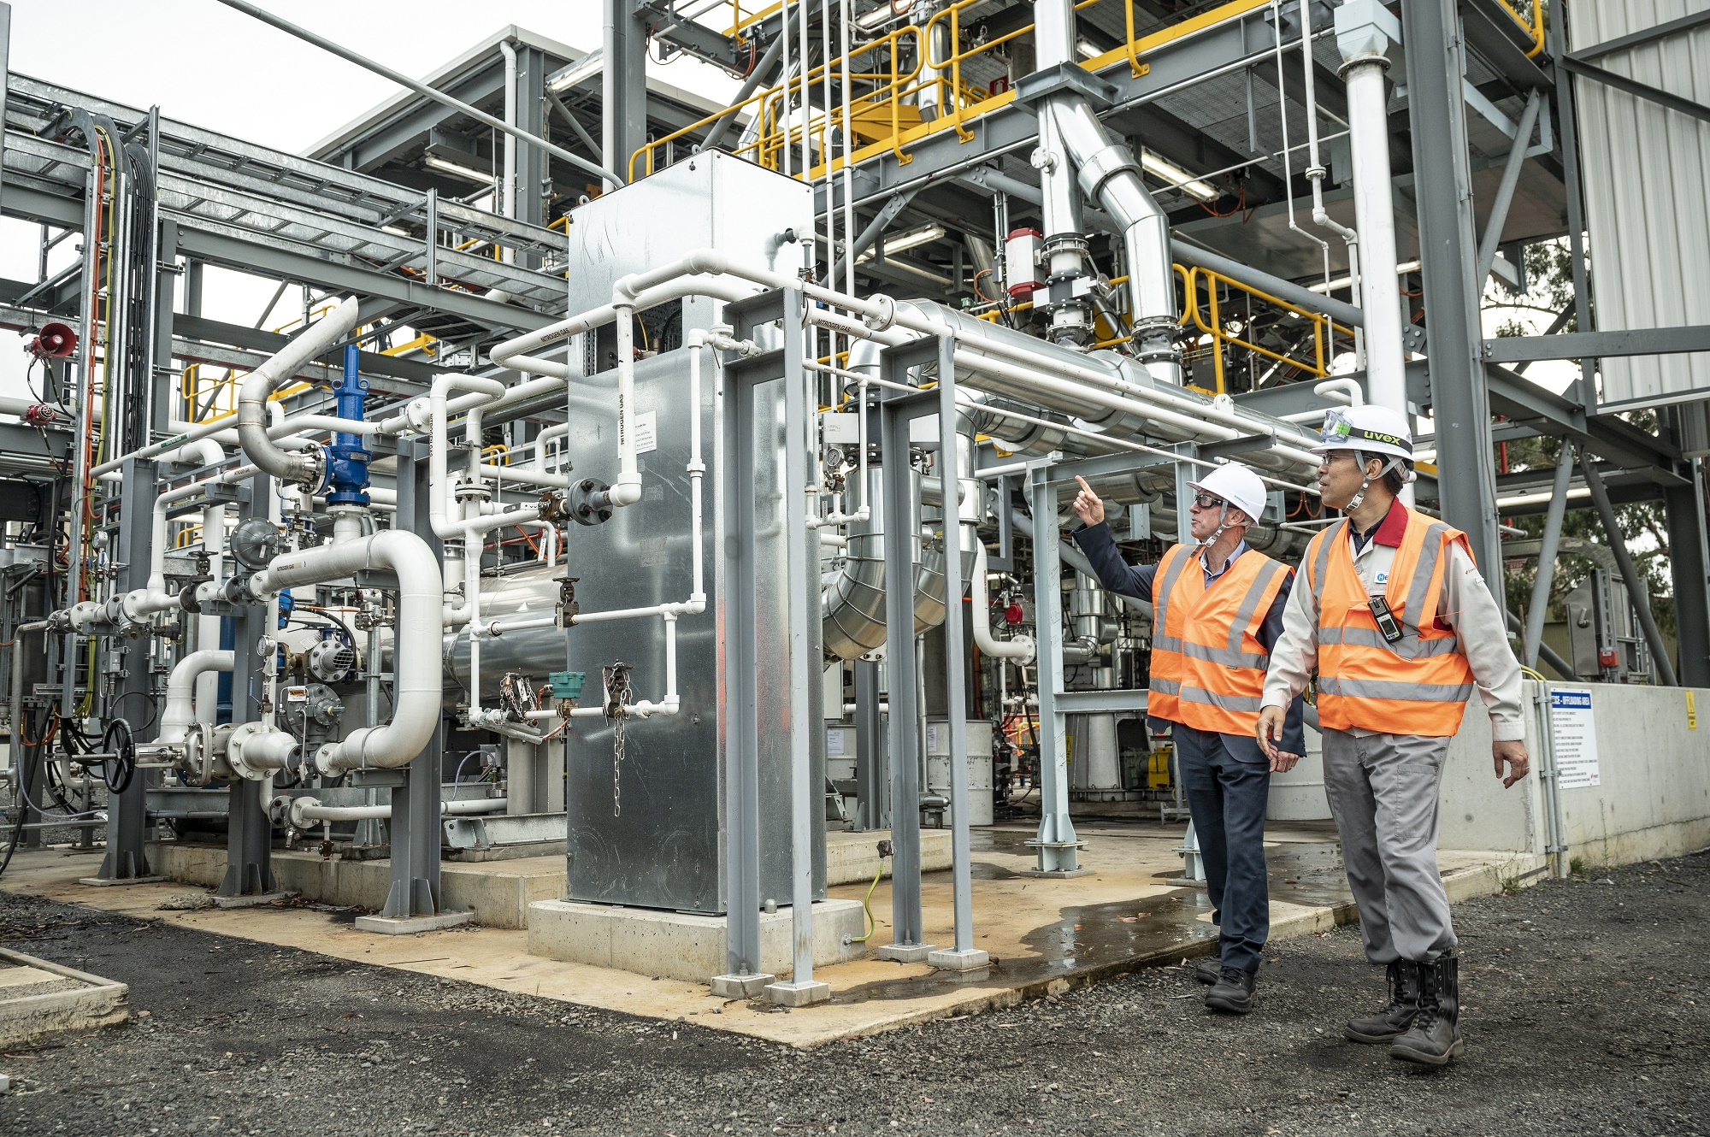

The Hydrogen Energy Supply Chain (HESC) pilot project uses coal gasification technology to produce hydrogen. Managed by J-POWER/J-POWER Latrobe Valley Pty Ltd.

The key findings from the survey are:

* Timing – 68% of survey respondents wanted a scheme to start in 2022.
* The scheme should be internationally aligned and supported by key trading partners – around 75% of stakeholders thought an international scheme is more important than a domestic scheme, or international and domestic schemes are equally important.
* The scheme should include transparent and robust carbon accounting provisions, leveraging existing Australian frameworks. In particular 40% thought the scheme should align with NGERS, but the Renewable Energy Target (RET) scheme, Climate Active and GreenPower were also frequently cited.
* Stakeholders supported leveraging the RET scheme as a framework for verifying the renewable energy input to hydrogen production. Some stakeholders noted that ‘below baseline’ renewable generation does not receive certificates under the RET, so an additional mechanism for tracking below baseline generation may be required.
* The scheme should distinguish between the energy sources and technologies used to produce hydrogen.
* The scheme should be technology neutral (i.e. all technologies for producing clean hydrogen should be included in the scheme).
* Credibility, simplicity and low compliance cost are important features.
* Preference for a government-led scheme.

A workshop with stakeholders held in September 2020 focused on better understanding the key features stakeholders identified through the survey. For the purposes of the workshop, participants were presented with three nominal models for a future Australian GO scheme, referred to as ‘strawman’ models. Workshop respondents were asked to consider their preferences for the nominal models, considering five key features of a GO scheme – system boundaries, coverage, emissions accounting frameworks, use of offsets and scheme governance. These features are covered in greater detail later in this report.

The workshop clarified findings from the survey and found that generally stakeholders had a preference for something set up quickly with a presumed domestic market focus that could be easily adapted to be in line with international approaches. Stakeholders recognised the tension between international alignment and timely development of a domestic scheme and it was broadly acknowledged that a domestic scheme would need to be flexible and evolve over time.

The consultation conducted during 2020 provided industry views on broad scheme parameters that helped shape the Department’s work through IPHE. For further detail on the consultations and findings please refer to Chapter 3 of the Energetics Report *Hydrogen Guarantee of Origins for Australia – Options Paper*.

## Design approach

Energetics was commissioned by the Department in July 2020 to collate the findings from the domestic consultation and the Department’s ongoing work through IPHE and provide design options for a hydrogen GO scheme. These options were designed to optimise the tensions inherent between industry need for a timely domestic scheme and alignment with international frameworks under development.

Energetics presented three potential design options on a GO scheme. All three options require the establishment of a new domestic scheme for the purpose of guaranteeing the origin of hydrogen. The three options are not discrete, there are many elements that are common to two or more options, and the path forward could involve incorporating desired features across the three options.

* **Option 1:** Collaborative development of a GO scheme with targeted trade partner
* **Option 2: Development of a scheme partially aligned with CertifHy**
* Option 3: Setting up an initial IPHE aligned domestic scheme, that transitions to an international scheme over time.



At the time the three options above were presented to the Department, discussions and agreements the IPHE had gathered momentum. This presented an opportunity for Australia to take a lead role in IPHE by driving some of the emissions accounting methodologies being developed by the group. Given IPHE’s broad representation and progress to date, it was considered in the Australian Industry’s best interest to progress along option 3.

Should the IPHE process stall, Australia could progress with a domestic scheme informed by the negotiations and discussions to date. Australia would continue to engage with key countries to ensure the development of a domestic scheme is in line with international trends and accepted by international markets.

# 2. Scheme design, coverage and administration

## 2.1 Coverage

### 2.1.1 Coverage of products

Clean hydrogen can be an input into downstream products such as ammonia and steel, reducing emissions associated with their production. Similar to hydrogen, there may be a need for guaranteeing the origin of the emissions associated with these products over time.

At the online workshop, stakeholders were asked for views on whether the scheme should cover hydrogen production, or be extended to include hydrogen derivatives (such as ammonia), related products (such as biomethane) and downstream products such as green steel. Stakeholders identified that the scheme will be an important input to guaranteeing the origin of other low emissions products, for example clean steel and blends of ‘green gas’ (including biomethane or renewables based hydrogen) in gas networks and should be designed with this in mind.

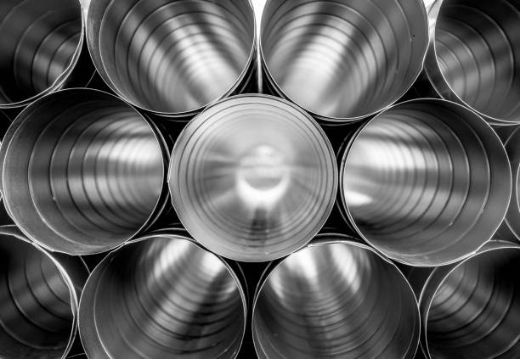

Hydrogen could be used to manufacture products such as low emissions or ‘green’ steel

Stakeholders were generally of the view that the scheme should create a consistent framework to support a range of low emissions technologies, but should initially focus on hydrogen production in order to allow timely establishment of the scheme. This could be expanded over time to cover additional products. In particular, stakeholders noted the importance for hydrogen energy carriers such as ammonia to be an early addition. This is not included initially, however work on energy carriers is underway and will be released for consultation later this year.

### 2.1.2 Coverage of production pathways

Coverage can also refer to the hydrogen production technologies or pathways that are eligible under the scheme. As mentioned above, the Government considers all technologies for producing clean hydrogen should be covered, however a methodology needs to be established before they can be included. This paper presents methodologies for consultation for the three main production pathways relevant to Australia, electrolysis, coal gasification with CCS and SMR of natural gas with CCS. Coal gasification or SMR without CCS would not be covered in the hydrogen GO scheme.

These methodologies are consistent with those under development by IPHE. Methodologies for biomass and by-product hydrogen are under development by IPHE but are less applicable to Australia and will be presented at a later date. However, as noted earlier, IPHE has not finalised any methodologies, so the methodologies presented here do not represent final decisions by IPHE.

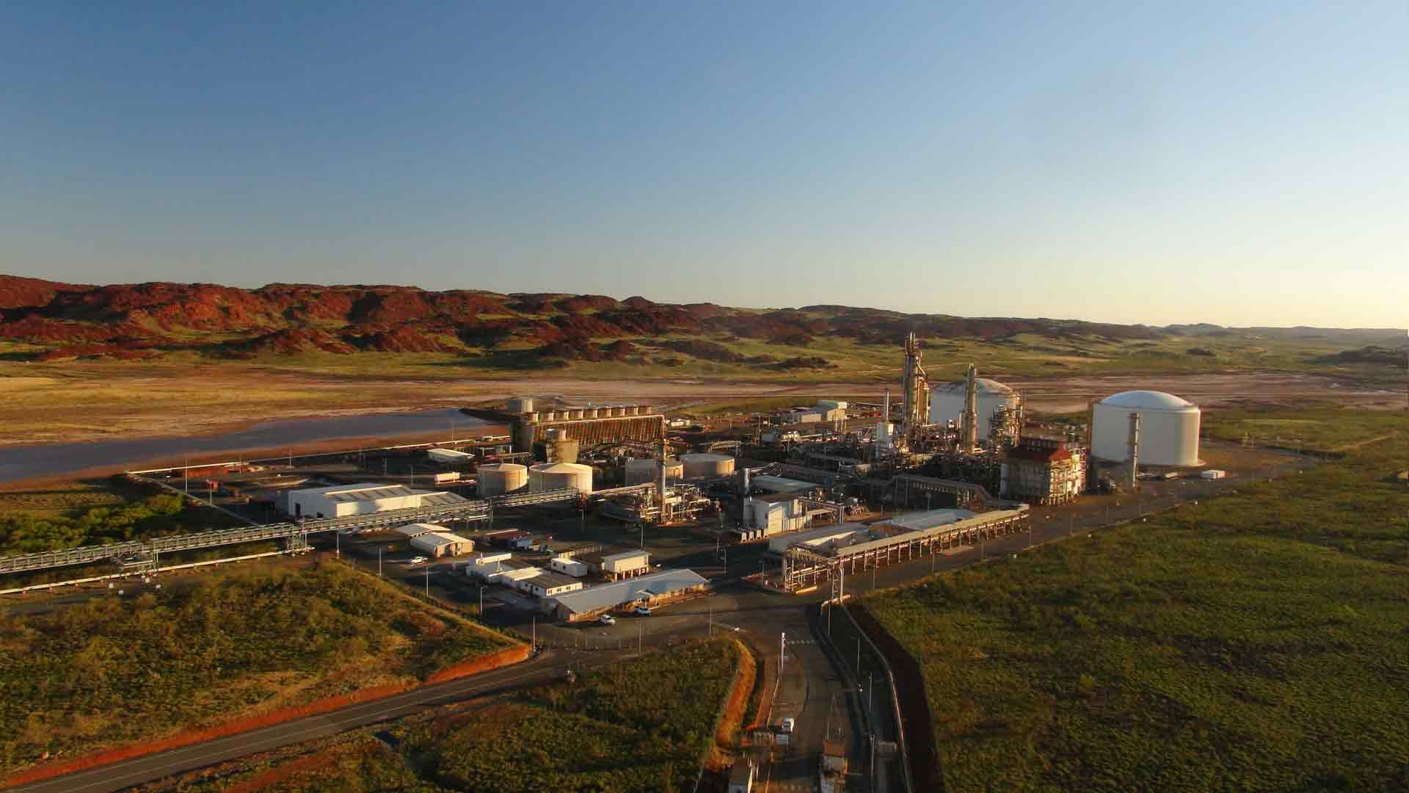

The Australian Renewable Energy Agency (ARENA) is investing in the construction of a 10MW electrolyser to produce renewable hydrogen at the Yara Pilbara Fertilisers ammonia plant   
in Karratha, Western Australia Image: YARA Pilbara

### 2.1.3 The system boundary

The system boundary refers to the part of the hydrogen value chain for which emissions are to be measured and to which guarantee of origin will apply. It is important that this is well defined and consistently applied so that emissions from one hydrogen producer can be accurately compared to another.

Figure 2.1 below illustrates the components of the hydrogen value chain and the different boundaries that could apply. The broadest boundary definition would cover the ‘cradle-to-grave’ or lifecycle emissions associated with a unit of hydrogen. The narrowest definition would be the ‘gate-to-gate’ boundary, which is similar to the boundary applied in NGERS. This would just cover the emissions occurring at the hydrogen production facility. Choosing a boundary involves a trade-off between completeness and complexity. A broader system boundary provides more complete information on the emissions associated with a product, but it becomes more complex to compile and accuracy may be lost as a result.

Figure 2.1 – System boundaries

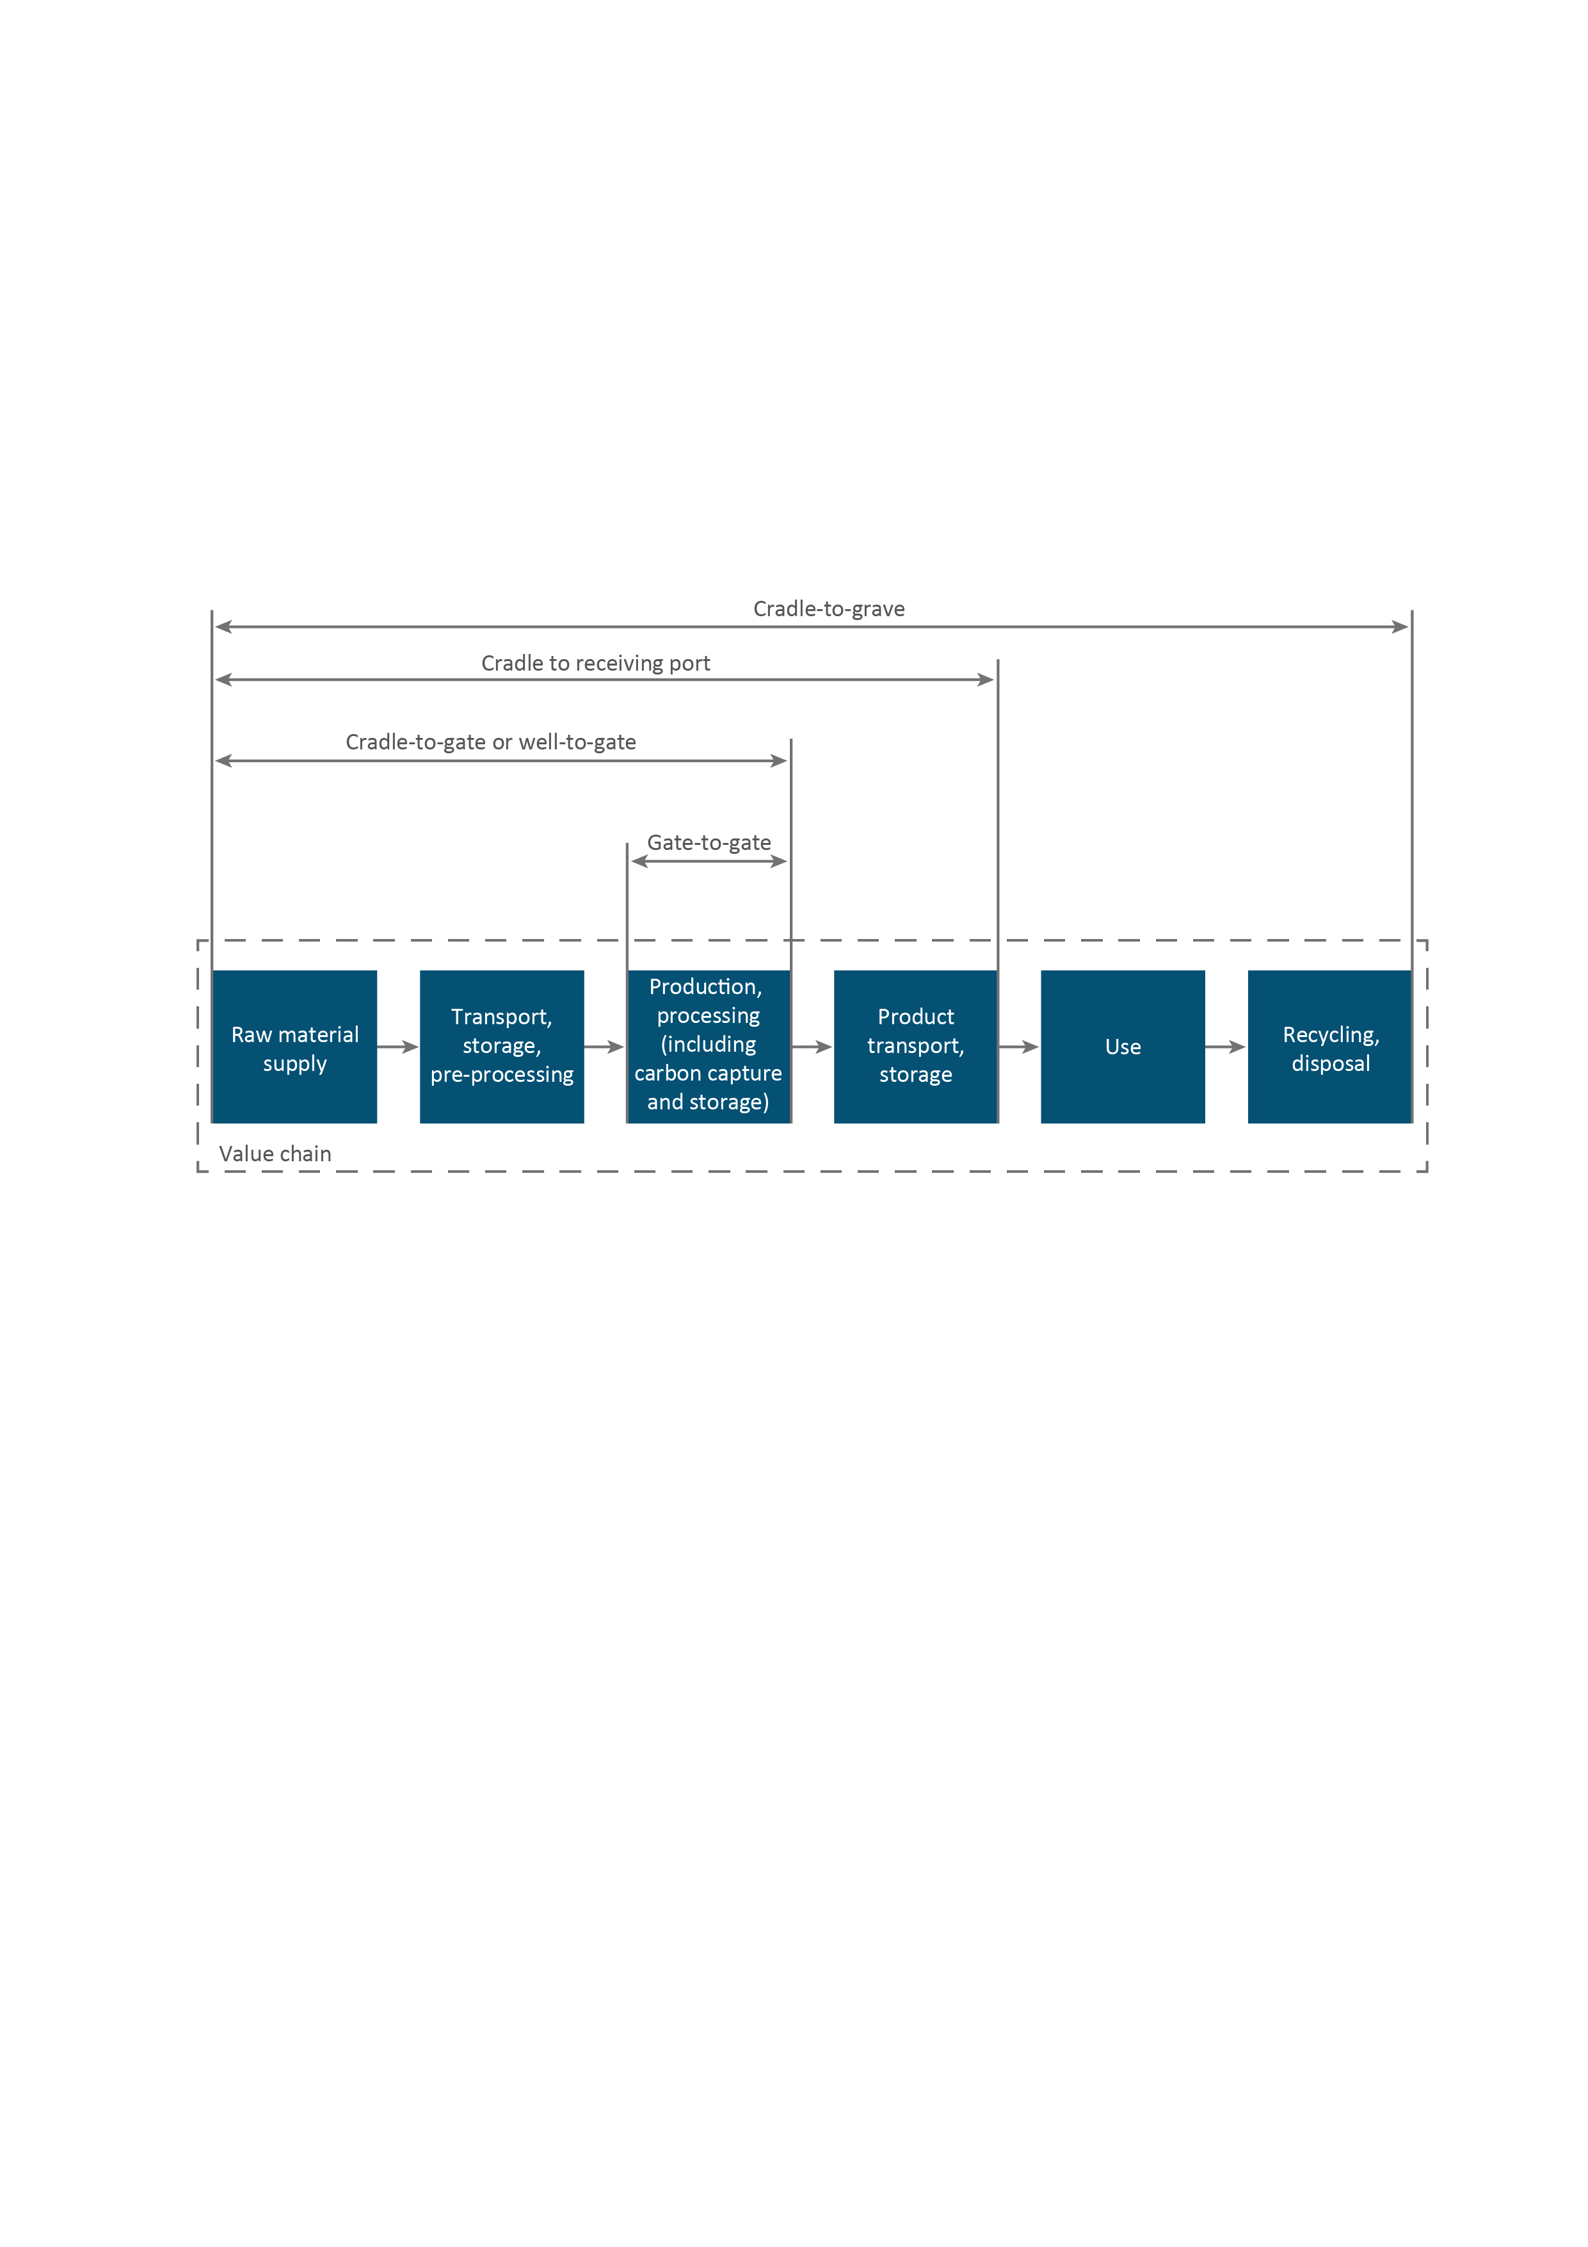

A ‘well-to-gate’ boundary is applied to CertifHy's scheme. This includes all upstream emissions associated with supply of feedstocks (including extraction, processing and transportation of fossil fuels) as well emissions incurred during hydrogen production. It excludes emissions associated with capital goods, and downstream emissions (hydrogen transport, supply, handling, consumption, and end-of-life).

The stakeholder workshop sought views from the domestic industry on the emissions accounting boundary for an initial Guarantee of Origin scheme, noting it is expected this scheme would be built on over time. Boundaries considered included well-to-gate, gate-to-gate and well-to-gate with the inclusion of energy carriers.

Gate-to-gate is most closely aligned with the facility definition under NGERS. It could be supported by existing NGERS methods and would not require the development of emissions factors or methods to cover upstream emissions. However, well-to-gate is the most common approach in international frameworks.

A majority of Australian stakeholders preferred a well-to-gate approach as a starting point, recognising that this is the boundary most likely to be adopted by international schemes.   
IPHE members share this view and are likely to suggest the use of a well-to-gate boundary for its methodology. The downstream boundary limit for hydrogen is proposed as the point of production of gaseous hydrogen at a pressure of 3MPa and a purity of 99% (on a volume basis). The exclusions in the CertifHy approach for emissions associated with capital goods, and downstream emissions apply.

However there is also a case for including the conversion, transport and storage steps within the system boundary as this would provide the consumer with transparency over the greenhouse gas emissions associated with delivered hydrogen (cradle to receiving port in Figure 2.1).

A well-to-gate boundary is proposed as a starting point. A well-to-gate boundary was strongly supported by stakeholders and balances the need for a domestic scheme to be quickly established which aligns with international frameworks. However the Department notes the scheme may eventually need to include other parts of the value chain.

### 2.1.4 Extending coverage over time

The hydrogen market today is at an early stage of development and consumer preferences around hydrogen are still developing. Through consultations, stakeholders recognised that a hydrogen GO scheme would need to evolve and adapt as markets and international schemes and standards develop.

The methodologies outlined in this paper are the first components of a broader scheme that could track and verify the use of hydrogen as an input to a range of renewable or low emission products. In time, the scheme could potentially be extended beyond clean hydrogen to include products where clean hydrogen is an input, such as clean steel or the blending of hydrogen with other products such as the injection of clean hydrogen into gas networks.

As mentioned above, an early step is to include the conversion to energy carriers (in the form of ammonia, liquid hydrogen and liquid organic hydrogen carriers, such as methylcyclohexane). This work is underway and will be released for consultation in the future. Beyond this, the Department will consider expanding the scheme to cover additional hydrogen production pathways and downstream products. The timing of these changes will be determined by the needs of the industry and the evolution of international practices.

***Questions:***

1. An initial focus on hydrogen production is proposed to facilitate timely establishment of a hydrogen GO scheme. Do you agree with this as a starting point?
2. A well-to-gate boundary is proposed as the initial boundary across which the emissions are to be calculated for hydrogen GO scheme. Do you agree this is an appropriate and acceptable starting point for the boundary?
3. Is hydrogen production at a pressure of 3MPa and 99% purity appropriate conditions for measuring the emissions associated with hydrogen? If hydrogen is produced at a different pressure and purity, can emissions be estimated for the conditions specified?
4. The Department recognises the need to extend the coverage of the scheme over time to include hydrogen derivatives and downstream products, additional production pathways and additional steps in the value chain. What additional components should be covered and when? (Noting the commitment to include hydrogen energy carriers as an early next step).

## 2.2 Carbon accounting frameworks

Stakeholder consultation showed a preference for a hydrogen GO scheme to leverage existing Australian carbon accounting frameworks, such as NGERS and Climate Active, to the extent practicable to minimise additional reporting burden. There are a number of carbon accounting frameworks that can be drawn on for emissions reporting in an initial Australian hydrogen GO scheme.

* **International Organization for Standardization (ISO) standards** - International standards relating to life cycle assessments (ISO 14040 and ISO 14044) and carbon footprint of products (ISO 14067) provide principles, framework, requirements and guidelines to support the estimation of emissions associated with a given product. These standards provide guidance around establishing system boundaries and allocating emissions to products and co-products of a system.
* **Greenhouse Gas Protocol (GHG Protocol)** - provides a global standardised framework to measure and manage greenhouse gas emissions from private and public sector operations, products and mitigation activities.
* **Intergovernmental Panel on Climate Change (IPCC)** - *guidelines for National Greenhouse Gas Inventories* provide guidance around the calculation of emissions including selection of emissions factors. IPCC also manages a broad database of default emission factors which may be leveraged.
* **National Greenhouse and Energy Reporting Scheme (NGERS) -** Australia’s national framework for reporting of emissions data for Australian facilities. NGERS is based on the IPCC Guidelines and forms the basis of Australia’s national greenhouse gas inventory.
* **Climate Active** - Australia’s Climate Active scheme is a voluntary standard to manage greenhouse gas emissions and achieve carbon neutrality. It draws its framework from selected ISO standards and the GHG Protocol.

It should be noted NGERS is not directly applicable to a hydrogen GO scheme. NGERS was designed as a framework for reporting of emissions from a particular facility, and to facilitate compilation of Australia’s national greenhouse gas inventory. NGERS legislation is not framed in a manner that easily allows for emissions accounting for products.

The ISO and GHG Protocol are used as the frameworks for existing hydrogen Guarantee of Origin schemes such as CertifHy and are likely to be used as the framework for international hydrogen GO schemes. Through consultation, stakeholders recognised that some elements of NGERS do not align with relevant ISO standards or the GHG Protocol’s suite of standards and guidance.

To be aligned with international developments, while drawing on Australian frameworks where practicable, it is proposed that an initial Australian hydrogen GO scheme is developed which uses:

* ISO standards and the GHG Protocol as an overarching framework
* IPCC and NGERS guidelines to support specific emissions calculations and to provide emissions factors; and
* Climate Active and GHG Protocol guidance on scope 2 (electricity) emissions.

Use of the ISO and the GHG Protocol for overarching guidance on a hydrogen GO scheme is needed to provide guidance around estimating emissions for a product and to provide consistency with other schemes under development. Advantages to this approach are that is provides comprehensive coverage for a ‘well-to-gate’ boundary (noting NGERS has a ‘gate‑to‑gate’ boundary) and includes guidance for allocation of emissions to products and co‑products that arise from the production process (see section 3.6).

The NGERS determination will be leveraged to provide guidance for emissions calculation methodologies and emissions factors that fall within the well-to-gate production boundary where processes are covered by NGERs legislation.

For electricity emissions, Climate Active’s recently released paper covering emissions accounting for electricity outlines electricity accounting rules adapted from principles outlined in the GHG Protocol Scope 2 Guidance. This is proposed to be drawn on to provide an Australian approach to market-based electricity emissions calculation for the hydrogen GO scheme that is consistent with the GHG Protocol. (For more detail see section 3.4 and Attachment D: Grid electricity emissions).

**Questions:**

1. Do you agree that ISO standards and the GHG protocol provide the appropriate basis for the overarching framework for a hydrogen GO scheme?
2. Should IPCC Guidelines, the NGERS determination and the Climate Active Electricity Accounting rules be leveraged to provide guidance on the detailed emissions calculations?

## 2.3 Treatment of offsets

Offsets are generated by projects that reduce, remove or capture emissions from the atmosphere such as reforestation, renewable energy or carbon capture and storage.

There is a degree of uncertainty around international and domestic customer preferences regarding use of carbon offsets and notably the most established hydrogen GO scheme, CertifHy, does not currently include the use of offsets for CCS. There is also uncertainty around the definition and treatment of offsets under the Paris Agreement (Articles 6 rules) and the future of offset markets more broadly. Internationally, there is scepticism by some about the permanence of non-geological carbon storage.

There is broad international consensus requiring some level of the direct carbon emitted through SMR or coal-gasification to be captured and permanently geologically stored as part of the production process before it can be considered ‘low-carbon’ hydrogen. For example CertifHy defines low-carbon hydrogen as hydrogen with emissions below 36.4gCO2/MJ, and this is likely to decrease over time. At this stage, the use of offsets has not been discussed by the IPHE in the development of an international standard. In this regard, international views on the use of offsets are at an early stage of thinking and positions on offsets may evolve over time.

Noting the definition of clean hydrogen in the National Hydrogen Strategy as hydrogen which includes substantial carbon capture and storage, the treatment of offsets in an Australian hydrogen GO scheme could initially follow one of two options.

**Option one:** For complete alignment with IPHE discussions to date, offsets would not be included in a hydrogen GO scheme meaning only gross emissions would recorded as an attribute on the GO certificate. A deduction in emissions would still be applied where CSS occurs onsite or where a third party permanently stores the emissions that arise from the hydrogen production facility in geological formations. Either could occur under a registered ERF CCS project and surrender of equivalent ACCUs, noting that the CER is currently developing an ERF method for carbon capture and storage. This position could evolve over time as international discussions progress (see section 3.7).

**Option two:** ACCUs from all registered ERF projects could be used to reduce the emissions from hydrogen production, effectively creating carbon neutral hydrogen. Previous consultation revealed a clear preference that if this option is pursued, emissions both gross and net of offsets should be recorded on the GO certificate to provide full transparency to the consumer. Noting scepticism about the permanence of non-geological carbon storage, this would need to include tracking of the source of the offset, to allow buyers to differentiate in their purchases on this point.

Option 2 would create an additional source of demand for ACCUs and may put upward pressure on the ACCU price. There is a risk under this option that Australia’s scheme may end up inconsistent with international developments. It is unclear whether international buyers will accept this approach and this action would move ahead of IPHE discussions about an international standard for clean hydrogen. In addition, there is a risk this may create a precedent for other countries to depart from the IPHE standard, meaning that Australian hydrogen could potentially compete against hydrogen produced overseas where offsets have been applied.

**Question:**

1. What is your preferred approach to offset inclusion within a domestic hydrogen GO scheme?

## 2.4 Scheme governance and administration

Once developed, a GO scheme can be administered in various ways, classified broadly into either an industry-led or government-led governance framework. For example, CertifHy operates under an industry-led, decentralised governance framework.

During consultations, industry stakeholders indicated a clear preference for the government to lead the administration of an Australian GO scheme. In this regard stakeholders were of the view that government administration would boost the credibility of the scheme. Industry was identified as having a critical role in the development of the scheme, but industry ownership and operation was not preferred. The Clean Energy Regulator was nominated as the most suitable body to administer the GO scheme given its strong reputation and experience in carbon accounting supporting the energy and emission reduction sector.

Given the needs of industry for any scheme to be aligned with international activities, to cover both renewable and non-renewables production pathways and the preference during consultations for a government led scheme, the Australian Government proposes to continue to develop a government administered Australian hydrogen GO scheme. It is proposed that the Clean Energy Regulator would be the body responsible for administering the scheme.

**Questions:**

1. Do you agree that the Australian government should lead the administration of an Australian GO scheme? If not, why not?
2. Do you agree that the scheme should be administered by the Clean Energy Regulator?
3. What should be the role of industry in co-designing a government led scheme?

## 2.5 Regulatory framework

The scheme proposed here represents the first components of a broader scheme that could track the use of renewable energy and clean hydrogen as an input to a range of renewable or low emission products.

Hydrogen could be distributed from its place of production to its place of use through pipelines, trucks or ships. Similar to electricity sourced from the grid, hydrogen from different production facilities could be mixed between its place of production and end-use, making it hard to attribute attributes to a particular unit of hydrogen.

Recognising these future potential uses of hydrogen, it appears preferable to implement the hydrogen GO scheme as certificate scheme. A certificate approach is considered the easiest way to verify and track the attributes of a unit of hydrogen as it requires only the hydrogen producer’s data to be reviewed. Certificate schemes are generally efficient by lending to more open market trading which allows for more transparency and efficiency. It can also leverage existing processes and systems used in the Large-scale Renewable Energy Target (LRET) for creating and trading certificates that are well known, efficient, and tested. A certificate approach is likely to be consistent with emerging international hydrogen GO schemes such as the European CertifHy scheme.

In order to verify and track emissions associated with hydrogen production, the scheme needs to be able to verify whether renewable electricity was consumed. At present, production of renewable electricity can be demonstrated if the electricity received Large-scale Generation Certificates (LGCs) under the LRET. However, this cannot be used to verify below baseline renewable electricity and will not be available for any renewable electricity produced after 2030. Therefore, alongside the Hydrogen Guarantee of Origin, a new renewable GO certificate is proposed that could be used to track and verify below-baseline renewable electricity and renewable generation post-2030 when LGCs cannot be created under the LRET. This scheme is outlined in detail in chapter 3.5.

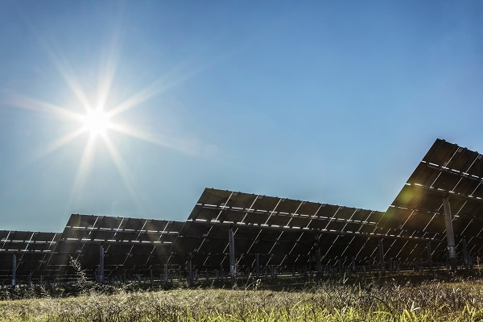

The alternative to a certificate scheme would be to maintain a register which tracks hydrogen contracts between consumers and hydrogen producers. This would require data from the producer and consumer in order to establish the Guarantee of Origin. This approach would quickly become administratively complex and burdensome as the hydrogen industry grows and as hydrogen is used as an input to other clean products and processes as anticipated. However, if necessary, a register could be used as an interim measure while the industry is at an early stage.

A certificate is proposed to relate to a tonne of hydrogen and include the following information:

* Emissions
* Production facility and location
* Production technology
* Primary fuel source

Administration of a hydrogen GO scheme will align closely to existing certificate based schemes such as the LRET. The LRET is administered through an online registry where renewable energy generators enter information relevant to calculate eligible LGCs and can subsequently create, trade and surrender LGCs. It is proposed a certificate based hydrogen GO scheme should also be administered through a similar registry. This registry would include: the application and registration of hydrogen projects; reporting; the creation, transfer and cancellation of units; risked based assessments; and compliance tasks. Where relevant, a hydrogen registry would be linked to or be part of current registries used by the CER to minimise duplication of information provided across schemes.

A regulatory framework is needed to cover a certificate-based hydrogen GO scheme and potentially a renewable GO scheme and downstream products. This could be established through new or existing legislation.

New legislation could set up an enduring certificate scheme for renewables, hydrogen and other low emissions products that can be adapted as hydrogen and other low emissions products and commodities markets evolve without being constrained by the requirements of other reporting schemes. Relevant functions and powers would be conferred on the Clean Energy Regulator by the new legislation and consequential amendments to existing legislation. The legislation would establish:

* A registration and reporting framework
* Renewable energy and hydrogen certificate creation, issuance, transfer and cancellation
* Verification, audit, compliance and enforcement provisions
* Arrangements for the use of offsets (if included with the scheme).

Alternatively new regulations could be established under the NGER Act to implement reporting requirements for the purposes of a hydrogen GO scheme. The NGER Act requires registered corporations to make annual reports to the Clean Energy Regulator relating to emissions, energy production and consumption for financial years, due 31 October after a year ends. However this reporting will not include all of the information needed to calculate the emissions-intensity hydrogen. For example, upstream emissions from fossil fuel extraction, processing and transportation would not currently be reported by a hydrogen producer. This could be addressed by amendments under the NGER Act to allow facilities to ‘opt into’ an additional hydrogen reporting framework.

The NGER framework would not provide for the creation of ‘certificates’ relating to the hydrogen. Certificate creation could be accommodated through amendments to the *Australian National Registry of Emissions Units (ANREU) Act*. This would leverage the compliance and enforcement provisions in NGERS and avoid the need for new legislation.

This option would provide the Clean Energy Regulator with a clear function of collecting, analysing and using the information and the compliance and enforcement framework on the NGER Act would be available to verify the truth and accuracy of the information. However this approach may be potentially less flexible in terms of accommodating future changes to set up a broader Guarantee of Origin scheme that covers renewable energy, hydrogen and other low-emissions products.

If new legislation is established for the scheme, the verification, audit, compliance and enforcement provisions would be modelled on the NGER Act.

**Questions:**

1. Do you support the creation of Australia’s hydrogen GO scheme as a certificate scheme?
2. What would you consider to be the best regulatory framework to support a hydrogen Guarantee of Origin scheme?

## 2.6 Reporting

We propose that data be reported over a 12 month period, which is a typical timeline for data collection for Life Cycle assessments. Hydrogen produced over a 12 month period would be given the same emissions factor per tonne of hydrogen. The IPHE is also considering a 12 month period. However, industry views are sought on the appropriate reporting period and frequency requirements for certificate creation for the purposes of hydrogen guarantees of origin. Data reporting and certificate creation may be on different timeframes to provide flexibility for industry and ensure the scheme provides adequate cash flow.

The information to be reported is outlined for each pathway in attachments A, B and C. Broadly reporting would include information on:

* Facility details (identity, location etc.)
* Production pathway
* Quantity of hydrogen produced (tonnes)
* Total emissions
* Process information
* Electricity (scope 2) emissions
* Fuel feedstocks
* Emissions calculations and factors for fuel feedstocks
* CCS information
* Details of waste or co-products.
* Time period

**Questions:**

1. How frequently do you consider hydrogen GO certificate creation will be required?
2. How frequently should data be reported; is the proposed 12 month period adequate? If not, what timeframe would you suggest?

# Carbon accounting methodology

Robust, trusted and comparable carbon accounting is core to the effective trade of clean hydrogen. Methods developed and used in any scheme need to be transparent, applicable to a broad range of technologies and broadly consistent with international approaches, to enable equitable comparison of carbon emissions between countries. This chapter details the methodologies proposed for measuring the emissions associated with the three main production pathways proposed to be used in Australia, electrolysis, coal gasification with CCS and SMR of natural gas with CCS.

As noted earlier, these are the methodologies proposed to be available for use in an initial hydrogen GO scheme. Additional methodologies for different production processes and for various hydrogen derivatives are proposed to be developed over time. Under the proposed approach for an Australian scheme, the conceptual formula for deriving the amount of emissions associated with hydrogen can be summarised as below:

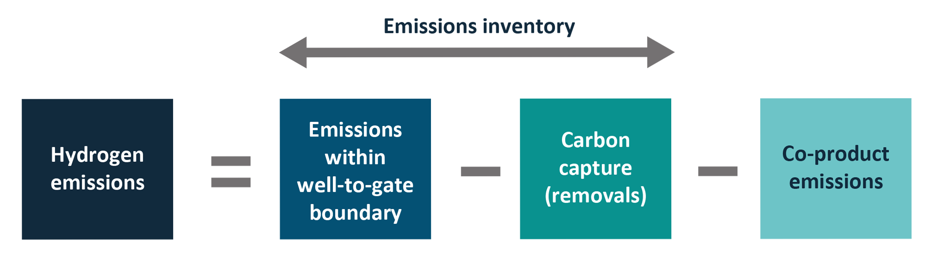

Where:

* Emissions include all scope 1 and 2 emissions[2] arising in the well-to-gate boundary (further details of calculations in section 3.2 Methodologies for estimating scope 1 emissions to section 3.4 Scope 2 emissions)
* Emissions permanently captured and stored will be subtracted from gross emissions. Carbon capture utilisation and storage is defined in line with the NGERS Determination (further details in section 3.7). Both the gross emissions and the stored emissions will be measured and tracked to provide process transparency.
* Emissions attributed to co-products (other saleable products produced through the hydrogen production process) will also be subtracted from the gross emissions (further discussed in section 3.6).
* Emissions associated with capital goods, overhead operations and corporate activities are excluded in accordance with the GHG Protocol Standard.

## 3.1 Emissions sources

Box 1 provides an overview of the three production pathways for hydrogen and the main emissions sources. Further detail is in Attachments A, B, and C.

**Box 1: Hydrogen production pathways and emissions sources**

**Electrolysis**

Electrolysis uses electricity to decompose water into its hydrogen and oxygen components (H2 and O2) within an electrolyser unit.

GHG emissions associated with electrolysis are subject to the nature of electricity supply for electrolysis as electricity can be sourced from the grid, generated on-site via the combustion of liquid, gaseous or solid fuels (in this case, this would be the key emissions source) or supplied from an on-site renewables system.

**Coal gasification with CCS**

Coal is reacted with oxygen and steam under high pressures and temperatures to form synthesis gas (syngas) made up of hydrogen and carbon monoxide. The syngas is conditioned to produce hydrogen which is purified and compressed for distribution to end users.

The main source of GHG emissions is the conversion of the carbon in coal to syngas and then H2 and CO2. Other significant emissions sources include emissions relating to the grid electricity used for air separation (including air compression and oxygen compression), CO2 removal, CO2 compression for CCS, coal processing (size reduction and cleaning) activities and fugitive methane emissions associated with coal mining.

**Steam methane reforming with CCS**

Desulfurized natural gas is pre-heated, mixed with steam and passed through a catalyst in a steam reformer to produce a synthesis gas (syngas), which is further processed in another catalytic reaction to increase the hydrogen fraction. Finally, the syngas is passed through a purification step to produce hydrogen.

The main emissions sources are steam generation and reforming of the natural gas feedstock (including fuel combustion in the burners). Other significant emissions sources include the fugitive emissions and combustion emissions associated with upstream gas extraction and processing, as well as the electricity use associated with CO2 removal.

## 3.2 Methodologies for estimating scope 1 emissions

The emissions inventory includes all scope 1 and scope 2 emissions arising in the well-to-gate system boundary.

Scope 1 emissions are emissions released as a direct result of the hydrogen production. These emissions can include:

* Combustion emissions – arise from the combustion of relevant solid, liquid and/or gaseous fuels including (but not limited to) coal, diesel and natural gas.
* Fugitive emissions – refers to the leakage or unintended release of greenhouse gasses. Often this occurs during the extraction of fossil fuels (for example methane gas is released during coal mining).
* Industrial process emissions – refers to emissions of specific greenhouse gases used across industrial activities such as hydrofluorocarbons (HFCs) used in industrial refrigeration and cooling systems and sulphur hexafluoride (SF6) used in electrical switchgear.

As noted earlier, it is proposed that an initial Australian scheme will use IPCC and NGERS guidelines to support specific emissions calculations and to provide emissions factors. The IPCC sets out a framework of the requirements to measure scope 1 emissions. Australia’s NGERS determination aligns with IPCC requirements such that in most cases scope 1 emissions will be calculated in accordance with the guidance in the NGER determination. The NGER determination outlines four different categories of methods summarised as follows:

* Method 1 – use of default emission factors
* Method 2 – site-specific sampling and use of Australian or international standards or their equivalent for analysis of fuels and raw materials
* Method 3 – similar to Method 2 but Australian or equivalent documentary standards must be used for sampling and analysis of fuels and raw materials
* Method 4 – direct or continuous emissions measurement.

Typically default emissions factors will be fairly conservative in emissions estimation, to account for varying emissions performance across industry. Hydrogen producers generating electricity onsite to support hydrogen production may use either combustion emissions determination guidance (for fossil fuel based generation) or may claim their scope 1 electricity emissions to be zero if the electricity is generated from renewable energy (see section 3.4).

**Question:**

1. Do you agree with the approach set out for scope 1 emissions?

## 3.3 Measuring upstream emissions

Activities associated with the extraction, processing and delivery of the coal or natural gas feedstock in the coal gasification or SMR pathways are included in the system boundary. Where these activities are integrated with hydrogen production, the emissions can be estimated in line with the relevant NGERS method as described in the section above. If these processes are undertaken by an external party they can be considered upstream activities. In this case, ideally supplier specific emissions data would be used, or, participants may refer to default emission factors such as the scope 3 emission factors provided in Appendix 4 of the National Greenhouse Accounts. Decisions made here should be reflective of the materiality of the relevant feedstock and the availability of data.

Other smaller input streams could generate upstream emissions. These include items such as salts used for electrolysis and chemicals used for water treatment. For these, it may also be appropriate to use default upstream emission factors (where available), as provided in Appendix 4 of the National Greenhouse Accounts.

**Question:**

16. Do you agree with the approach set out for upstream emissions?

## 3.4 Scope 2 emissions

The Greenhouse Gas Protocol (GHG Protocol) identifies a best-practice dual-reporting framework for scope 2 emissions comprising both location-based and market-based reporting. Australia’s Climate Active program has aligned with this reporting practice for participants seeking carbon neutral certification under this program. For the location-based method, emissions from electricity purchased from the main electricity grid in a state or territory are calculated by multiplying the quantity of electricity consumed by the average grid emission factor, in kilograms of CO2‑e emissions per kilowatt hour, for the State or Territory in which the consumption occurs. This is the methodology applied in NGERS for electricity consumption, where facilities use the National Greenhouse Account factor.

For the market-based method, companies who purchase renewable electricity through contractual arrangements (such as through the purchase of renewable energy certificates) are allowed to apply this renewable energy to reduce the emissions of the electricity used in production calculations. This approach means hydrogen production does not have to be physically co-located with or directly connected to the renewable energy generation.

Implementation of the market-based method may differ between countries as each country has their own mechanisms to account for renewable electricity claims, however a key principle is a requirement that renewable energy claims cannot be double counted. In Australia, the risk of double counting can be mitigated through renewable electricity certificates (e.g. LGCs) and a residual mix factor. One certificate represents a unique claim on the zero emissions attribute of renewable electricity generation (note this is not legislated but how the market has interpreted the use of LGCs in the voluntary market). A ‘residual mix’ factor can be applied to **electricity consumed that does not have a renewable energy certificate. The residual mix factor would represent all unclaimed energy emissions. It is calculated by removing contractual claims data from electricity production data. This ensures the zero emissions attributes of renewable generation can be claimed without being double counted.**

**It is proposed that in an initial Australian hydrogen GO scheme, the market-based method will be used to calculate the emissions from hydrogen production.** If no eligible “contractual arrangements” are in place, electricity emissions will be calculated using the residual mix factor. Entities will be required to provide data for the location based method to support comparisons with NGERS data.

The market-based method has recently been adopted by Australia’s Climate Active Program, and the guidance for the Climate Active program has provided the basis for the proposed approach presented here. This is summarised in Box 2 below and explained in detail in Attachment D. The application of these rules to the hydrogen GO scheme may evolve over time as international preferences over the application of the market based approach become clearer.

The approach takes a broad interpretation of “contractual arrangements” to allow for inclusion of mandatory LGC surrenders under the LRET. The LRET requires a proportion of Australia’s electricity mix to be from renewable energy. A business may not have a ‘contract’ to procure and surrender LGCs as this is typically done by the electricity retailer, but each business would be able to claim its share of grid based electricity consumption attributed to the LRET as being emissions free. This deduction would not be available to businesses, or parts of businesses, that are exempt from the LRET (for example, Emissions Intensive Trade Exposed Industries) because their electricity consumption is excluded from the calculation of the Renewable Power Percentage (RPP).

**Box 2: Summary of the market-based and location-based approaches to accounting for scope 2 emissions.**

***Market-based approach***

* Large-scale generation certificates (LGCs) can be used as a unique claim on the zero emissions attributed to renewable generation. One surrendered LGC equates to one megawatt hour (MWh) of zero emissions electricity consumption.
* The percentage of electricity consumption by an energy user attributable to the LRET (denoted by the Renewable Power Percentage, which varies for a given reporting year), is assigned an emission factor of zero. For example, a business using a total of 1,000 MWh of electricity in 2021 may list 185 MWh as zero emissions (1,000*18.5% (RPP for 2021)).
* This deduction for the LRET would not be available to businesses, or parts of businesses, that are exempt from the LRET (e.g. Emissions Intensive Trade Exposed Industries), because their electricity consumption is excluded from the calculation of the RPP.
* Accredited GreenPower usage is assigned an emission factor of zero in a carbon account.
* Zero emission electricity claims (above any mandatory LRET obligations) must be made through surrendered LGCs.
* Behind the meter usage of electricity from large scale renewable energy generation systems may be assigned an emissions factor of zero, only if any LGCs associated with that generation are surrendered or none will be created.
* Unlike LGCs, Small-scale Technology Certificates (STCs) issued under the Small-scale Renewable Energy Scheme are not a direct measure of renewable energy generated at a point in time as STCs are deemed up-front. Furthermore, STCs are issued for solar water heaters which do not directly generate renewable energy but rather displace electricity consumption from the grid. For these reasons, STCs cannot be used to make a zero emissions claim under the market-based approach.
* Behind the meter usage of electricity from small-scale renewable energy generation systems may be reported and assigned an emissions factor of zero in the carbon account, regardless of whether any STCs associated with this generation have been created, transferred or sold.
* Jurisdictional renewable energy targets – a business operating in a jurisdiction where the government surrenders LGCs can claim the corresponding percentage of emissions impact on their electricity consumption as zero, provided that the LGCs are cancelled on behalf of the jurisdictions’ residents and the claim is auditable for the given reporting year.
* The emissions for any electricity not covered by one of the above instruments are calculated by multiplying the quantity of electricity by the residual mix factor in kilograms of CO2‑e emissions per kilowatt hour.

***Location-based approach***

* The quantity of electricity consumed is multiplied by the average grid emission factor, in kilograms of CO2‑e emissions per kilowatt hour, for the State or Territory in which the consumption occurs.

Please refer to Attachment D: Grid electricity emissions for details.

**Questions:**

17. Do you agree that the calculation of electricity (scope 2) emissions should be based on the market-based method?

18. Would you suggest any changes to the Climate Active approach (set out in detail in Attachment D) for the purposes of a hydrogen GO scheme?

## 3.5 Verifying and tracking renewable electricity inputs

To verify and track emissions associated with hydrogen production, the scheme needs to be able to verify whether renewable electricity was consumed. At present, production of renewable electricity can be demonstrated if the electricity received LGCs under the LRET. However, this cannot be used to verify below baseline renewable electricity and will not be available for renewable electricity produced after 2030.

**Verification of above-baseline renewable electricity under the Renewable Energy Target**

The Renewable Energy Target (RET) is a legislated, market-based mechanism that provides a financial incentive for the deployment of new renewable energy projects. The RET operates through the creation of renewable energy certificates, which can be traded with ‘liable entities’ (primarily electricity retailers), who surrender the certificates to meet their annual renewable energy obligations. Liable entities have separate obligations for both the LRET and the Small-scale Renewable Energy Scheme (SRES). The RET is legislated through the *Renewable Energy (Electricity) Act 2000* (REE Act) and the *Renewable Energy (Electricity) Regulations 2001* (REE Regulations).

Under the LRET, accredited renewable power stations such as wind and solar farms may create an LGC for every MWh of eligible renewable electricity they generate. To be accredited and create LGCs, a power station must generate electricity from an eligible renewable energy source as set out in Section 17 of the REE Act which includes but is not limited to wind, solar, hydro, eligible biomass sources, landfill gas and sewage gas. A renewable power station may trade LGCs through contracts (i.e. power purchase agreements) or on the spot market.

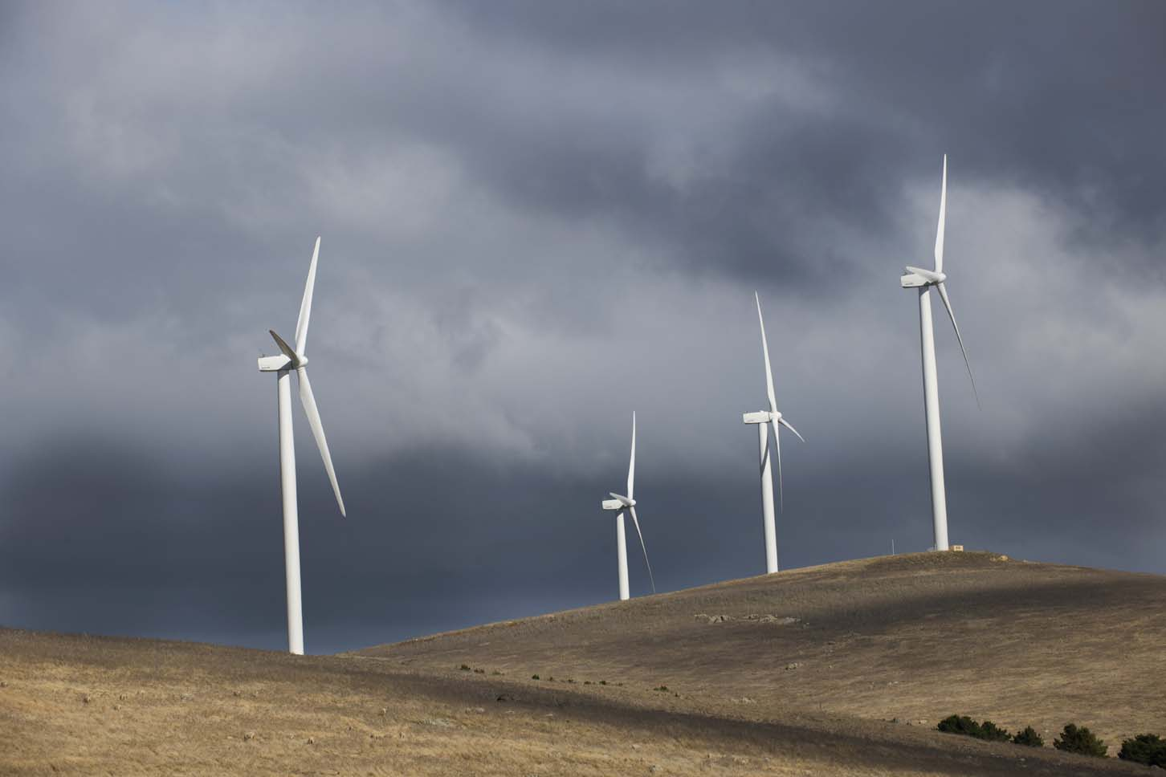

Accredited power stations can only create LGCs for electricity generated above their renewable power baseline. For power stations that existed before 1997, a baseline was set by the Clean Energy Regulator based on past generation in accordance with the REE Regulations. Power stations commissioned after 1 January 1997 have a baseline of zero. There was an estimated 32.3 million MWh of eligible renewable energy generation in Australia in 2020 and 9.5 million MWh of below baseline generation.[3]

Liable entities are required to surrender LGCs each year against the legislated LRET target which peaks at 33,000,000 MWh (or 33 million LGCs) in 2020 and remains at that level until 2030. However, governments, companies or individuals are also able to purchase and voluntarily surrender LGCs. Voluntarily surrendered LGCs are not able to be transferred or used to acquit liability under the RET.

This paper proposes that LGCs, which are voluntarily surrendered, could be used to track and verify renewable electricity claims of hydrogen producers.

This proposed use of LGCs requires an agreed understanding of what these certificates represent being 1 MWh of eligible renewable electricity generation. The standard size of 1 MWh is also in line with international approaches, including in Europe, and a unit to only be accounted once.

Consider the example of a grid-connected hydrogen producer in Queensland, which voluntarily surrenders an LGC created by a wind farm in Victoria. By importing electricity from the grid, the actual electrons that the hydrogen producer consumes would be provided by the specific generators which are exporting electricity to the grid at that time. The hydrogen producer would therefore be consuming electrons produced by a mix of coal, gas, renewables and other generation technologies, irrespective of whether they surrender LGCs.

However, claims about the consumption of renewable electricity through the surrender of LGCs can be supported by the use of the market based method of emissions accounting, which is set out in section 3.4 above.

The market based method applies a ‘residual mix’ factor to each jurisdiction, which is formulated by removing contractual or investment claims data from electricity production data. To avoid double counting, the residual mix factor removes the emissions reduction benefit of renewable generation (issued with LGCs that have subsequently been surrendered) from the jurisdiction’s grid factor. Alternatively, a national residual mix factor could be used.

In the above example, under the market based method, the zero emissions benefit associated with the LGCs which the Queensland hydrogen producer surrenders would be fully removed from the emissions factor of the Victorian grid. This results in a higher ‘residual mix’ grid emissions factor for the Victorian grid.

The higher ‘residual mix’ emissions factor is justified on the basis that the specific ‘renewable’ benefit of generation associated with each LGC is attributed to the entity that surrenders it, for example the Queensland hydrogen producer, and should not be double counted.

The residual mix factor for Victoria would apply to all entities reporting under the market based method in that jurisdiction. As the renewable attribute is only counted once under the market based method, the claim of the hydrogen producer regarding the use of renewable electricity can be represented as a claim that they have exclusively used the renewable benefit associated with that LGC.

Not all companies will use the market based method for emissions accounting outside the hydrogen GO scheme. For example, facilities use the location based method in NGER scope 2 reporting. Companies which use the alternative location based method would apply an emissions factor to electricity that does not remove renewable contractual or investment claims from production data. This would result in a lower emissions factor because it would incorporate all the renewable generation in the grid (even if the LGCs are being surrendered by entities operating in another grid or jurisdiction). There may therefore be some double counting between, but not within, the two reporting methods. However, under the hydrogen GO scheme, surrender of LGCs can only be used under the market based method to make renewable energy claims.

In summary, by obtaining and voluntarily surrendering LGCs, under the market based method, the LRET provides an existing mechanism by which entities can verify and track their consumption of renewable electricity. The market based method allows LGCs to be used to make a zero emissions claim from renewable energy input into hydrogen production. This provides hydrogen producers with flexibility to purchase zero emissions electricity from the grid.

**Verification of below-baseline and post-2030 renewable electricity**

There are two limitations on the long-term use of LGCs for the market based approach.

* Only above baseline renewable generation is eligible for LGCs under the RET. This is inconsistent with international approaches (e.g. in Europe and the United States of America) where all renewable generation is credited and could put our hydrogen producers at a competitive disadvantage.
* After 2030, LGCs cannot be created under the RET legislation.

This section describes an approach by which a new renewable GO certificate could be established. Such a certificate could be used to track and verify below-baseline renewable electricity. It could also be used after 2030, when LGCs cannot be created under the RET.

Like LGCs, renewable GO certificates could represent 1 MWh of eligible renewable generation, and could be traded between renewable electricity generators and other entities in private commercial arrangements, or sold openly in a spot market. A renewable GO certificate could be voluntarily surrendered using the Renewable Electricity Certificate (REC) Registry which is administered by the Clean Energy Regulator. Other eligibility conditions could be similar to LGCs as set out in the REE Act and Regulations, except the requirement to be above baseline.

The long-term objective of this option would be to have a single renewable GO certificate mechanism to verify all eligible renewable generation. However, a transitional arrangement would be that until 2030, LGCs would continue to be used to verify above-baseline renewable generation, while renewable GO certificates could only be created for below-baseline generation or generation ineligible under the LRET.

After 2030 when no LGCs can be created and no liability under the LRET applies, the transitional arrangement would end and renewable GO certificates would be exclusively used for verifying all renewable energy generation.

This option would provide an enduring mechanism for tracking all renewable generation and ensuring no double counting under the market based method. Under the market based method, surrender of renewable GO certificates, like LGCs, would be assigned a zero emissions factor.

Surrender of renewable energy certificates is emerging internationally as the primary approach to verifying and tracking renewable electricity inputs into hydrogen production, for example under the industry-led CertifHy scheme. Additionally, under the CertifHy scheme, no distinction is made between above and below baseline renewable electricity. Other countries such as the European Union and the USA have Guarantee of Origin schemes that cover all renewable generation. Therefore, without a mechanism to recognise below baseline renewable electricity, domestic hydrogen producers would be at a competitive disadvantage compared to those operating under international schemes.

Outside of industry, the Tasmanian Government has advocated for a mechanism to track below baseline renewable electricity to provide a basis for the lowest cost renewable electricity as an input to hydrogen production. There has also been non-governmental organisation interest in creating below baseline renewable electricity certificates in Australia ahead of an Australian Government scheme.

Verification of below-baseline generation might alternatively be supported through a second option to establish and maintain a register which tracked renewable electricity agreements between hydrogen producers and renewable generators.

Given existing responsibilities, the Clean Energy Regulator would be suitable for administering the register. The Regulator could then verify that the entity had funded a specific quantity of renewable electricity to produce their product. However, a register would not be the preferred approach as it would likely be relatively inefficient and may make tracking of renewable electricity increasingly complex as the hydrogen industry grows and products are moved through supply chains and blended.

**Questions:**

1. What are your views on using voluntary surrender of LGCs to verify the consumption of renewable electricity under the market based method, compared to the alternative of a location-based method?
2. Do you agree that a means of identifying consumption of below-LRET-baseline renewable electricity generation would be beneficial for the hydrogen certification scheme?
3. What are your views on establishing a new renewable guarantee-of-origin certificate for verifying below-baseline and post-2030 renewable electricity?
4. What would be the effect of having a general certification scheme for renewable electricity?

### 3.5.1 Recognition of other renewable energy sources

Under the approach described above, surrender of LGCs for above baseline electricity and renewable GO certificates for below-baseline electricity would be the primary way in which renewable electricity would be verified for hydrogen production.

However, a company might purchase renewable electricity from other sources which are not recognised under the framework described above. As section 3.4 sets out, these other sources of electricity are also proposed to be treated as renewable electricity and be assigned a zero emissions factor. This includes cases where:

* A company purchases electricity through GreenPower.
* A business is located in a state or territory which surrenders LGCs, on behalf of energy consumers, equivalent to a certain percentage of renewable energy consumed in that jurisdiction.
* A company makes renewable energy purchases attributable to the Renewable Power Percentage (RPP).
  + However, this does not include companies with exemptions from liability such as under emissions-intensive trade-exposed activities or in remote facilities not subject to the LRET.
  + This is justified on the basis that, under the LRET, the RPP sets the level of liability for liable entities who must purchase and surrender proportionate LGCs. The cost of purchasing and surrendering LGCs is passed on to electricity consumers who can therefore be understood to implicitly purchase a share of renewable electricity corresponding to the RPP.
* A company uses electricity from behind-the-meter solar photovoltaic (PV) generation. If above 100 kW, the company would need to generate and surrender LGCs if calculating under the market based method. If below or at 100 kW, behind-the-meter usage may be reported and assigned an emissions factor of zero, regardless of whether any STCs associated with this generation have been surrendered.

**Question:**

1. Do you agree that certification should recognise other sources of renewable electricity, including those outlined above?

## 3.6 Allocating emissions to co-products

Production pathways for hydrogen can result in various waste products, by-products and co‑products. Co-products are products that have value from being on-sold or re-used in the facility. For example through electrolysis, water is split into hydrogen and oxygen. The hydrogen is the main product and oxygen could be considered a co-product if it is sold.

ISO 14044 and the GHG Protocol Standard distinguish between the main product which is being studied as part of the GHG analysis and other co-product(s). Consequently, the total emissions resulting from the hydrogen production should be separated between the hydrogen and the number of co-products where these products are on-sold.

In many cases the emissions associated with main product and co-products cannot be independently measured, and therefore it is necessary allocate a share of emissions to each of the products. This is not always clear cut, and the choice of allocation method can have a significant impact on the results of the GHG analysis. To achieve consistency across the pathways, the same allocation method should be applied to similar inputs and outputs.

ISO 14044 identifies two main methods for allocation (dividing emissions between products): the system expansion method and the allocation method. The standard suggests using system expansion whenever possible and where it is not, the allocation method can be used instead.

In the system expansion method, co-products are considered alternatives to other products on the market. The co-product can be considered to displace the alternative product, and therefore the emissions of the alternative product could be attributed to the co-product. For example, where electricity is a co-product it can be assumed that the sale of that electricity would displace an equivalent amount of electricity that would have been sourced from the relevant electricity grid. Therefore, emissions could be attributed to the electricity co-product by using the relevant electricity grid emissions factor in that region.

A system expansion approach is not always applicable to co-products from hydrogen production pathways. In some cases a substitute system or product may not be available and there may be a lack of certainty around co-product uses.

Where both direct measurement and use of the system expansion method are not options, the GHG Protocol and ISO 14044 both suggest that, where possible, emissions should be allocated on the basis of an underlying physical relationship between the product, co-product(s) and emissions. There are three physical relationships that could apply to apportioning emissions from hydrogen production to co-products; division by relative energy, mass or molar content. Economic allocations are also possible based on the market value of each of the products as they exit the process. However economic allocation can introduce variability in hydrogen emissions intensity due to fluctuations in exchange rates and market dynamics for the varying products and co‑products.

The guidance included within the GHG Protocol Standard and ISO 14044 suggests that physical allocation should be prioritised, and if emissions and removals cannot be allocated on this basis, then economic allocation can be used.

Allocation on a mass basis is problematic for hydrogen production as hydrogen has a high energy to mass ratio compared to the other co-products.

Energy based allocation could be applied in a number of ways, including:

* to the amount of fuel or energy used to produce each co-product (efficiency method)
* to the useful energy contained in each co-product (energy content method)
* the ability of heat in each product to perform work (work potential method)

Of these, the energy content method is likely to be the simplest to apply, however it will result in zero emissions allocated to some co-products, such as oxygen that do not contain useful energy.

Allocation of emissions using any of the above mentioned processes can be viewed as subjective and the different methods for allocation will lead to differing results for the total emissions intensity of the hydrogen produced and the associated co-products. Therefore a consistent approach needs to be taken by hydrogen producers seeking certification, and this approach needs to balance practicality and robustness.

The CertifHy scheme appears to use energy-based allocation across all hydrogen production pathways, with the exception of the by-product pathway where an economic allocation is used (system expansion does not appear to be used). However CertifHy does not allocate emissions to non-energy co-products such as oxygen (a possible co-product for the electrolysis pathway), nor ash, slag or nitrogen (possible co-products of the coal gasification pathway).

To increase the accuracy of emissions estimates attributed to hydrogen and align with ISO standards and GHG protocol, the co-products excluded from the CertifHy approach have been included in Australia’s proposed approach. IPHE is also seeking to cover these co-products.

The approach presented here utilises both the system expansion and energy allocation approaches. In some cases, the production pathways have been partitioned into smaller systems (referred to as modules) to simplify analysis. Modules are distinct based on the relevant production pathway, allowing individual production processes to be analysed individually ensuring the most appropriate emissions allocation process can be applied.

It should be noted that allocation approaches are still under discussion at IPHE. The Department would like to gather feedback on the approaches discussed here, however this is a matter that may need to be investigated further and it may be appropriate to trial a couple of approaches during the pilot phase (see section 4.1 Trial phase).

### 3.6.1 Electrolysis

For electrolysis, the system can be analysed as a single module as the system has a single co-product, oxygen.

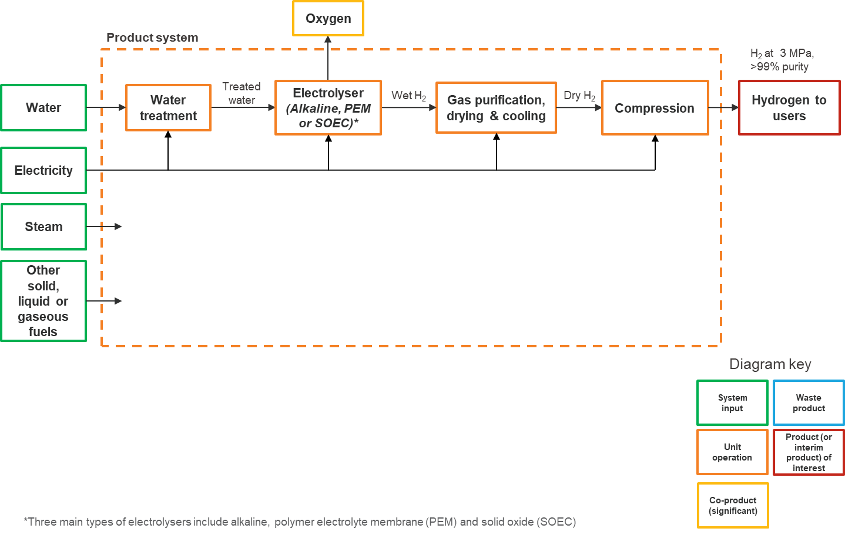

In this situation, system expansion could be applied to divide the emissions between hydrogen and oxygen. Given that oxygen is most commonly produced via cryogenic distillation of air into oxygen, nitrogen and argon components (i.e. the air separation system in the coal gasification pathway), this has been deemed the most appropriate substitute system. Emissions associated with the oxygen product stream can be estimated referring to the air separation model established within the ecoinvent life cycle database (as discussed in the context of Module 1 of the coal gasification pathway). This can be used to estimate the emissions associated with production of the relevant amount of oxygen and these emissions may then be readily scoped out of the inventory.

### 3.6.2 Coal gasification with CCS

For coal gasification, analysis is performed across three distinct modules, as described below. Modules 1 and 2 will result in intermediate products that are inputs into module 3.

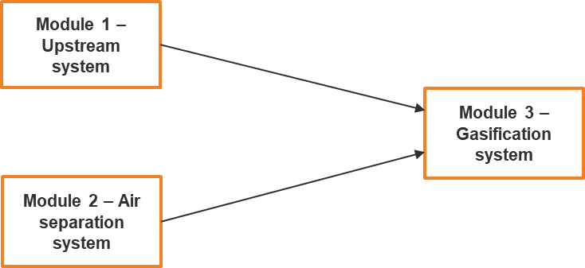

**Module 1 (Upstream system)** covers upstream activities associated with the extraction, processing and delivery of the coal feedstock. As this system has a single product, no emissions allocation is required and all emissions are attributed to a single output, coal for gasification. That is, all emissions associated with this system are allocated to the intermediate product: coal. These emissions are carried with the coal (as embodied emissions) into the gasification system (module 3). An appropriate scope 3 emissions factor covering coal supply may be used for assessment of module 1 to bypass the need for manual calculations.

*Module 1: Upstream System*

This figure illustrates the upstream coal gasification with CCUS production pathway.
The figure represents an upstream system containing coal extraction, coal processing and coal transport. Electricity, other liquid, solid and/or gaseous fuels, and utility water enter the upstream system as system inputs. Waste gases and other impurities, and overburden exit the system as waste products. Coal for gasification exits the system as a product.  

**Module 2 (Air separation system)** – covers the production of oxygen for the coal gasification process. For module 2, there are two potential co-products (liquid nitrogen and liquid crude argon) in addition to the intermediate product: liquid oxygen.[4] The liquid nitrogen stream will be significant given its abundance relative to oxygen in air and the oxygen demands of an industrial gasifier. The argon stream will be much smaller, reflecting the low argon concentration in air (approximately 0.93%). One or more of these co-products may be captured and sold noting that they have a variety of common uses. Where these co-products are sold they may be attributed some share of emissions.

System expansion is not appropriate to allocate emissions between the main product and the co-products as in this situation a suitable alternative system is not available.[5] The preferred approach is to allocate on the basis of physical relationships. The ecoinvent database’s *Life Cycle Inventories of Chemicals* outlines an approach for allocation of emissions across the three liquid products on the basis of the heat of vaporisation and heat capacity of the three liquid products assuming that the thermodynamic efficiency of the cooling and liquefaction process is the same for all three gases. This results in an allocation factors of 22.2% for oxygen, 76.9% for nitrogen and 0.9% for crude argon.

Emissions associated with the intermediate oxygen product can be estimated as follows:

$E_{liquid oxygen}=E_{air separation}-E_{liquid nitrogen}-E_{liquid crude argon}$

Where Eliquid oxygen is the emissions associated with liquid oxygen, Eair separation is the total emissions associated with the air separation module (as calculated in line with the guidance provided for emissions inventories), and Eliquid nitrogen and Eliquid crude argon are the emissions associated with the co-products as calculated using the allocation factors referred to above.

*Module 2: Air separation System*

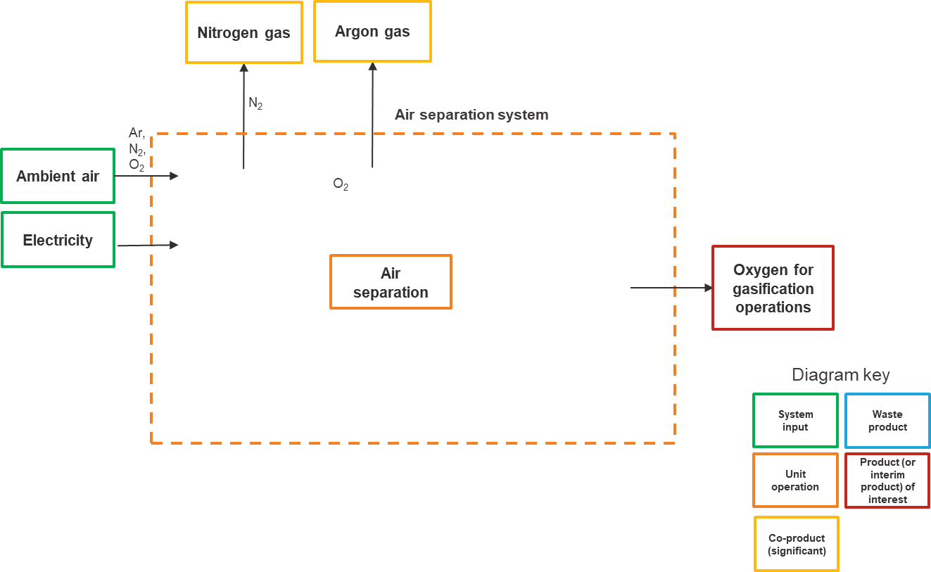

**Module 3 (Gasification system)** covers all remaining processes including further coal processing, gasification, syngas conditioning and waste heat recovery.

For module 3, inputs include the intermediate products from modules 1 and 2, which carry an emission factor (reflecting the embodied emissions).

The gasification system includes a range of potential co-products, including electricity and steam, generated via waste heat recovery, ash and/or slag recovered from the gasifier and sulphur recovered via syngas purification. The scale of production for these potential co-products remains uncertain and is likely subject to facility-specific commercial circumstances (i.e. energy costs, grid considerations, plant design and operation).

Where applicable, emissions may be scoped out for the co-products using system expansion. In order to do so, appropriate substitute systems must be identified and appropriate allocation factors established.

For the electricity co-product, either system expansion or energy allocation could be used. Electricity exported from the system could substitute grid electricity (kWh for kWh), and emissions could be estimated in line with relevant grid emission factor for that region. Alternatively an allocation could be based on energy content for this co-product.

Steam may also be an important co-product for the gasification system, but this is likely to be highly dependent on the availability of appropriate infrastructure and nearby consumers given the nature of steam supply. Currently the dominant technology for generation of high-grade steam (heat), is via combustion of natural gas within a boiler. As such, steam exported from the system could be estimated in line with the emissions associated with equivalent steam produced in a natural gas boiler of a pre-defined default efficiency.

The ash and slag products are significantly less material. Default allocation factors could be defined here relating to appropriate substitute systems. For ash and slag, these co-products vary in uses from low-value applications such as replacing natural aggregates to high-value applications such as replacing clinker in cement production. A conservative emission factor should be established as the default, but it may be important to include measures which allow and incentivise users of the scheme to seek out higher quality data specific to their value chain.

*Module 3: Gasification System*

This figure illustrates the system boundary associated with module 3 (gasification) for the coal gasification pathway.
The process further coal processing, feeding into coal gasification linked to a heat recovery unit. These feed into syngas conditioning with outputs going to carbon capture or hydrogen compression. Inputs to the production system include oxygen (from module 2), coal for gasification (to coal processing, from module 1), utility water, electricity, other fuels, and steam. System co-products include ash/slag (from coal gasification) and steam (from waste heat). Waste products include waste gases. Hydrogen is the primary product.  


### 3.6.3 Steam methane reforming using natural gas with CCS

For this pathway, analysis is performed across two distinct modules, as follows.

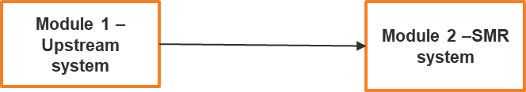

**Module 1 (upstream system)** covers upstream activities associated with the extraction, processing and delivery of the natural gas feedstock. Potential co-products from the gas extraction and processing steps include natural gas liquids such as ethane, propane, butane and pentane, as well as oil and condensates. These products often co-exist with the gas extracted from the reservoir and are typically separated out from the gas stream as they attract a higher value when sold as separate products.

It is difficult to eliminate the need for allocation for these co-products as there are many common processes in the extraction and processing. Furthermore, system expansion is not feasible for this application as an appropriate alternative method for producing these products does not exist. Therefore, allocation will need to be performed for these co-products based on the proportion of energy content of the individual products.

The net remaining emissions are carried with the gas product stream (as embodied emissions) into the steam methane reforming system (module 2).

*Module 1: Upstream system*

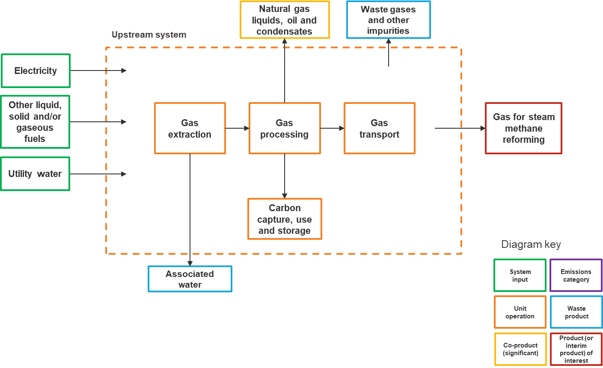

**Module 2 (steam methane reforming system)**

For the steam methane reforming system (module 2) the only co-products are electricity and steam (pending the nature of the individual production facility). Emissions can readily be scoped out for these products using system expansion, alternatively allocation could be based on energy content.

Steam may also be an important co-product, but this is likely to be highly dependent on the availability of appropriate infrastructure and nearby consumers given the nature of steam supply. As for the coal gasification pathway, combustion of natural gas within a boiler has been identified as the dominant technology (currently) for generation of high-grade steam (heat). As such, steam exported from the system could be estimated in line with the emissions associated with equivalent steam produced in a natural gas boiler of a pre-defined default efficiency.

*Module 2: Steam methane reforming system*

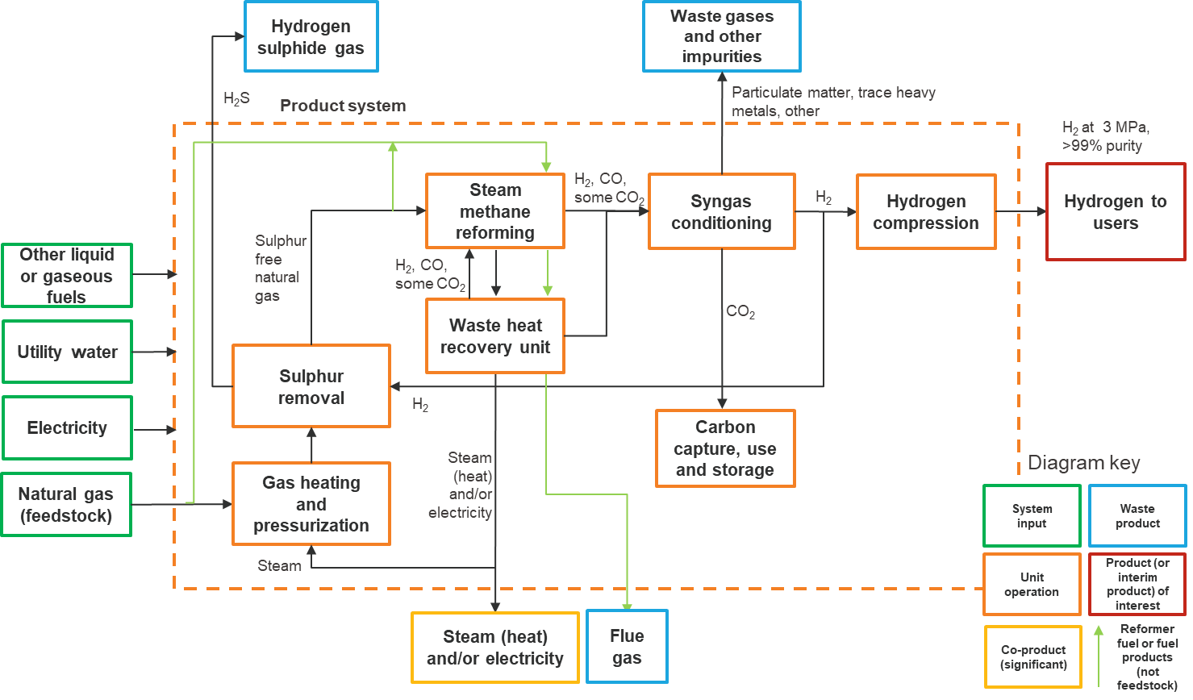

**Questions:**

24. Do you agree that emissions should be attributed to co-products where they are on-sold?

25. Are the by-products identified for each pathway likely to be co-products (or are they more likely to be waste products?)

26. Do you think that the allocation methods suggested in each pathway are appropriate and practical? How would you suggest emissions be allocated between the main product and co-products?

## 3.7 Carbon Capture, Utilisation and Storage

Carbon capture, utilisation and storage (CCUS) refers to the capture of CO2 for use in a product and storage in that product, or the capture of CO2 for permanent geological storage (carbon capture and storage or CCS). While IPCC provides guidance on the capture of CO2 for permanent geological storage (CCS), at this stage there is no international consensus on emissions accounting associated with the capture of CO2 for use and storage in a product, although the GHG Protocol is currently working on establishing international guidance to cover carbon removals and storage. It is important to note that there is some contention in establishing principles for emissions accounting for carbon stored in products. Of primary importance is the integrity of the capture, removal and storage of CO2 from the atmosphere. There are concerns about the risk of reversibility of carbon storage and this is particularly important in ensuring the validity of any CCS claims.

An additional consideration is whether embodied emissions can be allocated to a CO2 stream that is sold as a product. There is potential under the GHG Protocol Standard and ISO 14044, for embodied emissions to be allocated to this stream, in addition to the removal of emissions that constitute this stream from the product system emissions inventory. However this would represent a significant risk to the integrity of a hydrogen GO scheme as it presents potential for gaming of the system, particularly where other industries do not have a clear emissions accounting approach for CCUS. Given this risk and the broader treatment of CO2 as a waste stream, it is proposed to not allow allocation of embodied emissions to CO2.

At present, Australia’s NGER scheme has stringent requirements which must be met for CO2 designated as “captured for permanent storage” as outlined in Division 1.2.3 of the NGER Determination. The NGER Determination refers to injection for geological storage as the only measure of permanent CO2 storage. There is currently no provision to account for other forms of storage (e.g. mineral carbonation) and utilisation which constitutes storage (e.g. transformation of CO2 into building materials).

It is proposed that CCUS provisions should be limited to emissions permanently stored in geological formations until robust international accounting provisions are developed for other forms of CCUS. As such, at this stage it is recommended that the CCS and CCUS considerations for Australia’s hydrogen GO scheme be limited to the provisions included under the NGER Determination.

The Australian Government is currently developing a method for CCS under the Emissions Reduction Fund (ERF). This would allow businesses undertaking eligible CCS projects to earn Australian carbon credit units (ACCUs) for capturing greenhouse gases from resource and industrial processes and injecting them into geological formations for permanent storage. The hydrogen GO scheme will consider interactions with the ERF CCS method when developing its detailed guidance on CCS to ensure no double counting occurs.

CCUS is an evolving area, and while there is currently a lack of international and domestic guidance around accounting for carbon stored in products, it is expected that as the uptake of CCUS technologies increase so will the availability of data, allowing for the development of methods and default factors for estimation of CCUS related removals and associated emissions. The approach proposed here will be revised as NGER determinations are updated and other ERF methods are developed to include other forms of carbon storage.

**Questions:**

27. Do you agree with an approach limiting provisions for CCS and CCUS in an initial Guarantee of Origin scheme to those included under the NGER determination, noting that these will be expanded or adjusted as new CCUS technologies and industrial processes are implemented?

28. What are the likely or possible applications of CCUS technologies in the hydrogen industry?

## 3.8 Materiality threshold

Establishment of materiality thresholds may be helpful in managing and reducing compliance burden for scheme participants, particularly for small hydrogen producers and those with complicated production pathways. Both the GHG Protocol Standard and ISO 14044 include provisions to allow for exclusion or estimation of some portion of the emissions inventory for small, non­‑material emissions sources (for example the leakage of refrigerants or emissions from lubricants).

A materiality threshold of between 2.5 and 5% in total prior to carbon capture is proposed to apply across emissions calculations. This is consistent with GHG protocol. Industry consultation and pilot studies can further determine the appropriateness of this threshold to ensure there an equitable balance between accuracy and practicality or emissions reporting.

**Questions:**

29. Do you agree with setting a materiality threshold allowing entities to exclude a small amount (e.g. 2.5 to 5%) of total emissions from analysis?

30. What would you consider to be an appropriate threshold?

# 4. Next steps

## 4.1 Trial phase

The Australian Government has announced the 2021-22 Budget will provide for a trial of a hydrogen Guarantee of Origin scheme. The results from this consultation will be used to inform the trial phase and the Department and the Clean Energy Regulator will work together to design the trials. The trial phase would not create certificates until legislation has been developed.

Trials are expected to be launched in the second half of 2021. The timing of trials would be dependent upon having the necessary systems, legislative and regulatory instruments or contractual arrangements in place to complete trial activities.

The trial phase will test the accuracy, administrative burden and verification mechanisms associated with relevant emissions accounting methodologies outlined in this paper. In some instances, trials may cover multiple emissions accounting processes to determine which approach balances accuracy with regulatory burden. Trials could also explore how an Australian scheme could interact with international schemes that are operating or under development.

The specific attributes and features that may be tested include:

* Ensuring all material emissions sources in each pathway have been identified and accounted for.
* Determining the robustness of the carbon accounting methods, including that relevant emissions factors easy to find and able to be applied consistently.
* Assessing reporting burden for participants and the resource intensity of validating claims.
* Testing approaches to allocating emissions to co-products relevant to each pathway
* Determining the appropriate timeframes for reporting.
* Registration processes and systems needed to create certificates.

Data from the trials will be used to inform the final accounting methodologies and detailed design of registries underpinning the hydrogen GO scheme and inform on the appropriateness of leveraging provisions in the NGER Act on verification, audit, compliance and enforcement. It should be noted that trials will not cover certificate creation and surrender as legislation is needed for these components. The trials will focus on the carbon accounting elements of the scheme.

Participation in the trials will be voluntary. Criteria will be set to determine eligibility to participate in trials, and it is expected participants would be limited to hydrogen production facilities currently in operation or sufficiently progressed to ensure the necessary reporting obligations can be met.

Final design on a hydrogen GO scheme will seek industry consultation.

**Questions:**

31. Is a trial phase an appropriate next step for testing and refining the proposed methodologies?

32. Is the list of attributes and features to be tested correct? Is there anything else that could be tested through a trial phase?

33. Would you like to be involved in a trial (noting an affirmative response will not guarantee participation)?

34. What reporting frequency should be adopted for trials to deliver learnings and results quickly?

# Attachment A: Description of hydrogen produced from electrolysis

## Process description

This section outlines the different stages of production and unit operations required to produce hydrogen via electrolysis in line with the established system boundary conditions (i.e. well-to-gate, covering IPCC scope 2 and 2 emissions at each production stage). This electrolysis may be powered by electricity sourced from the grid or on-site generation. The process system is presented in **Error! Reference source not found.**.

In summary, electricity is used to decompose water into its hydrogen and oxygen components (H2 and O2) within an electrolyser unit.

### Water treatment

Each kilogram of hydrogen from an electrolyser requires at least 9 kilograms of water. This can be supplied from a water utility or sourced from the local environment. The latter could come from groundwater, surface (river) water, rainwater or seawater. Supply of groundwater, surface (river) water or rainwater involves pumping. Seawater will require desalination to be suitable for electrolysis and this consumes significant quantities of electricity.

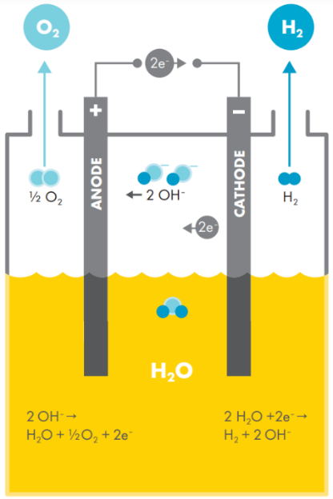Before entering the electrolysis unit, water is treated to achieve required purity levels which minimise mineral deposition in the electrolysis cells and reduce the occurrence of any adverse electrochemical reactions. Large scale electrolysers are currently in their infancy and vary significantly when it comes to water treatment and consumption (Johanna, 2004). Some electrolysers include purification functionality within the generation unit, while others require installation of external deioniser or reverse osmosis unit prior to the water feeding into the cell stacks.

Figure 1: An electrolysis unit (Source: Shell Hydrogen Study)

### Hydrogen production

Water electrolysis splits water into hydrogen and oxygen using electricity as the driver for this chemical reaction. This electricity may be grid supplied or sourced from on-site renewable (solar PV or wind) or fossil-fuel fired generators.

A water electrolysis unit consists of an anode and a cathode separated by an electrolyte (a conductive solution). When connected to a direct current power supply, electricity flows through the electrolyte and causes the water to split into hydrogen and oxygen. **Error! Reference source not found.** shows the basic configuration of an electrolyser as well as the reactions that occur at the anode and cathode. Each electrolyser system consists of a stack of electrolysis units, a gas purifier and dryer and an apparatus for heat removal.

There are currently three main electrolyser technologies, distinguished by the electrolyte (and associated production temperatures): alkaline electrolyser, polymer electrolyte membrane (PEM) electrolyser and solid oxide (SOEC) electrolyser (CSIRO, 2018).

Hydrogen and oxygen gas products must be purified, dried and cooled prior to storage or delivery to market, subject to required product specifications.

The oxygen gas must be safely vented to the atmosphere. Alternatively, pending availability of appropriate markets, this oxygen may be sold as a co-product.

## Sources of emissions

GHG emissions associated with electrolysis are subject to the nature of electricity supply for electrolysis as electricity can be sourced from the gird (noting that this may be impacted by contracting of renewable electricity supply and associated instruments), generated on-site via the combustion of liquid, gaseous or solid fuels or supplied from an on-site renewables system.

Aside from electricity used in electrolysis, there are a number of additional GHG emissions sources across the electrolysis production pathway as follows:

* Leakage of SF6 used in switchgear to support site electricity supply
* Electricity consumption for the supply, processing and distribution of utility water
* Combustion of liquid, gaseous or solid fuels for the purposes of steam generation
* General electricity consumption for a facility including pumping, cooling systems and ventilation
* Leakage of refrigerants used in cooling systems.

Each process unit or stage in the electrolysis process contains unique emissions sources outlined below.

Summary of emissions sources for electrolysis

| Process unit or stage | Key emissions sources | Other emissions sources |
| --- | --- | --- |
| Water supply and treatment | Electricity for purification and filtration |  |
| Hydrogen production | Electricity for electrolyser units | Steam (where purchased)[6]  Liquid, solid and gaseous fuel combustion for steam generation6  Liquid, solid and gaseous fuel combustion for electricity generation[7] |
| Hydrogen purification, drying and cooling | Electricity for relevant units | Steam (where purchased)  Solid, liquid and gaseous fuel combustion for relevant units and/or steam generation |

## Information to be reported

| Category | Matters to be identified |
| --- | --- |
| 1. Facility details | Facility identity  Facility location  Facility capacity  Commencement of facility operation |
| 1. Production | Production pathway |
| 1. GHG emissions overview | Emissions intensity of hydrogen batch |
| 1. Batch details | Beginning and end of batch dates  Batch quantity |
| Electricity | Location based emissions accounting:   * Quantity of purchased grid electricity [kWh] * Location based emission factor used [kgCO2-e/kWh]   Market based emissions accounting   * Quantity of purchased grid electricity [kWh] * Number of LGCs surrendered (through PPAs or GreenPower purchases * Electricity consumption attributed to the LRET * Elect consumption attributable to jurisdictional renewable energy targets * Residual electricity * Residual mix emission factor [kgCO2-e/kWh]   On-site electricity generation   * Quantity of on-site generation [kWh] * Emission factor for on-site generation (as applicable) [kgCO2-e/kWh] |
| 1. Other utilities | Sources of water  Sources of steam  Quantity of purchased water [kg]  Quantity of purchased steam [kg]  Quantity of steam exported [kg] |
| 1. Fuel feedstock | Types of fuels combusted  Quantities of fuel combusted [L, kg]  Relevant emissions calculations and factors used |
| 1. Process | Water treatment technology  Electrolyser technology  Hydrogen purification technology |
| Waste and co-products | Quantity of oxygen produced [kg]  Quantity of oxygen sold [kg] |

# Attachment B: Coal Gasification with CCS

## Process description

The process to produce hydrogen from coal via gasification includes:

* coal mining, including primary processing (size reduction, separation and cleaning) at the mine and coal handling and primary processing (CHPP) facility
* transportation from the mine to the gasification unit
* reacting of coal with oxygen and steam under pressure and at elevated temperatures to product “syngas” and
* conditioning the syngas to produce hydrogen which is further purified and compressed for distribution to end users.

### Air separation

The oxygen used in the gasifier is generated in an air separation unit. Oxygen is used in preference to air, to prevent nitrogen diluting and contaminating the hydrogen. Air separation technologies include cryogenic distillation, pressure-swing adsorption, and membrane separation. All consume large quantities of electricity.

In addition to liquid oxygen and liquid nitrogen, crude liquid argon may also be produced in smaller quantities (argon constitutes about 0.93% of air) (Althaus, 2007). Pending the scale and valorisation of these outputs, they may be considered as co-products and allocated emissions.

### Gasification

A gasifier is a high temperature reactor where coal undergoes partial oxidation and reaction with steam. There are three main types of gasifiers that can be used to create syngas, each varying in the method it uses to generate heat, to contact the reactants and the physical state of the residue it produces. These are fixed bed (e.g. Sasol-Lurgi gasifiers), fluidized bed (e.g. Winkler gasifiers) and entrained flow (e.g. Koppers-Totzek gasifiers) (Kopp, 2000) (Higman, 2008).

These different gasifiers have their advantages and disadvantages but at a macro level perform the same function. They have common inputs (coal, oxygen and water) but can produce syngas with varied properties (also subject to the properties of the coal) which will impact the configuration of downstream processing activities.

This unit also produces ash and or slag as waste products.

### Heat recovery and power generation

Waste heat recovery units are typical for coal gasification processes, reflecting the high temperature operation of coal gasification processes and the requirement for cooling of syngas products for subsequent processing.

Regulation of the gasifier temperature is managed through a heat exchanger which can be used to raise steam and generate electricity. Steam may be supplied elsewhere in the plant (i.e. steam use in regeneration of acid gas removal (AGR) absorption systems) or exported out of the product system boundary. Electricity may be generated from this steam and used elsewhere in the plant such as to drive the air separation process, or exported beyond the product system boundary.

Any exported steam or electricity is considered a co-product and should be allocated a share of emissions.

### Syngas conditioning

The output of the gasifier is a stream of raw syngas, which may contain a number of contaminants, including particulate matter and heavy metals. In addition, this stream contains significant CO gas. This section provides an overview of the processing of this stream.

#### Hydrogen enrichment

To maximise the quantity of hydrogen produced, syngas from the gasifier is sent through to another reactor where the carbon monoxide is reacted with water to yield additional hydrogen. This is known as the water-gas shift (WGS) reaction, as follows:

This is a reversible reaction, with an equilibrium established between CO and CO2, subject to the reaction conditions. Low temperatures favour the formation of CO2. As the conversion of CO to CO2 generates heat, there are often several water gas shift reactors in series with coolers between them (including high temperature and low temperature stages).

Typically, iron-chromium and copper-zinc catalysts are used to facilitate the reaction at high and low temperatures, respectively (Pal, Chand, Upadhyay, & Mishra, 2018).

High temperature WGS may include conversion of sulphur compounds to hydrogen sulphide (H2S), for removal in the acid gas removal (AGR) stage.

#### Syngas purification

The syngas now includes large quantities of CO2 in addition to other impurities including sulphur compounds (such as H2S) and heavy metals (such as mercury). These components must be removed from the syngas.

Particulate matter can be removed using a water scrubber. Mercury and other heavy metals can be removed by via adsorption, particularly using activated carbon beds. Drying (water removal) is also required (Higman, 2008). Sulphur compounds may be removed using lime. CO2 and sulphur compounds can also be removed together. The capture of CO2 and removal of these sulphur compounds simultaneously is discussed below.

Whilst configurations for syngas conditioning vary, the key inputs and outputs (electricity, heat) are largely common.

### Carbon capture and storage (CCS)

The CCS stage consists of three main “unit operations” including separation and capture, compression and transport and storage or utilisation.

#### CO2 capture and separation

Acid gas removal refers to the separation of H2S and CO2 (for carbon capture) via physical solvents (such as the SelexolTMsystem), chemical solvents (such as mono-ethanol amine, MEA), other means (such as pressure swing adsorption, PSA) or some combination which reflects syngas properties and product output requirements.

Removal of H2S and CO2 at a large scale is typically performed by passing the syngas through a counter-current absorption column with a regenerative solvent (physical or chemical). For pre-combustion carbon capture processes physical absorption is favoured given typically high CO2 partial pressures (Vega, et al., 2018). To pump the solvent through the absorber and recover the solvent, heat exchangers, reboilers, coolers and pumps are required.

Sulphur containing gas (particularly H2S) from the regeneration unit is produced which may be processed into sulphur in a Claus plant (Chiche, Diverchy, Lucquin, Porcheron, & Defoort, 2013). This sulphur may be sold as a co-product. However, given the scale of this sulphur source and the requirement for additional processing, the H2S stream is considered a waste stream.

Although solvent absorption is the most common method of syngas purification, if the gas contains significant concentrations of other gases besides H2 and CO2, other methods may be preferred (Hofbauer, Rauch, & Ripfel-Nitsche, 2007). The two main alternative processes are pressure-swing adsorption (PSA) and cryogenic distillation. However, membrane separation has also gained a lot of attention in the last decade (Rezaee & Naeij, 2020), and several types of membranes are now available which can be used to produce hydrogen streams of very high purity (Scholes, Smith, Kentish, & Stevens, 2010).

In summary, the various CO2 capture processes are complex involving multiple unit operations and processing steps. However, for the purpose of this work and at a macro level, they can each be treated as units that separate hydrogen from carbon dioxide through the application of electricity and heat (typically low-grade). The heat may be supplied from the waste heat recovery system.

#### Compression and transportation of CO2

Prior to transportation, the purified CO2 gas must be pressurised. Selection and design of compressors should be reflective of both the condition and scale of the carbon capture and transport required (Martynov, Daud, Mahgerefteh, Brown, & Porter, 2016). Key inputs will be electricity to power compression, with petroleum oils and greases required for operation.

This transport can occur in a number of ways including pipeline, road tankers, rail tankers and ships (National Research Council, 2007). For large volumes of CO2, pipelines are generally the most economical form of transportation. Where pipelines are used, leakage rates must be considered across the length of the pipeline, subject to operating pressure.

#### Storage of CO2

Geological storage typically involves the injection of supercritical CO2 into deep underground geological formations such as oil and gas fields, unmineable coal seams and saline formations (Environmental and Energy Study Institute, 2020). It may also be dissolved in aquifer water, with saline aquifers of particular interest (given frequency and potential storage volume) (Environmental and Energy Study Institute, 2020). Mineral sequestration refers to the reaction of CO2 to form stable minerals, particularly carbonates. The Hydrogen Energy Supply Chain (HESC) pilot project in the Latrobe Valley is planning to establish a CCUS network from the hydrogen production facility to offshore storage locations within the Gippsland Basin (HESC, 2020).

### Hydrogen compression and storage

Common to hydrogen produced via coal gasification, electrolysis, and any other means is the requirement for compression of the dry, high purity hydrogen product. This is particularly important given the low density of hydrogen gas. Subject to the nature of downstream hydrogen storage, transport and use, there will be different requirements for hydrogen compression. Common to both hydrogen produced by coal gasification and electrolysis, there are four main approaches to hydrogen storage: compressed gaseous hydrogen, liquid hydrogen and materials-based storage technologies (either physical or chemical).

With regards to hydrogen compression and storage, it is important to be clear about the boundary for GO. Where storage is required for the delivery of the functional unit (i.e. hydrogen under the specific boundary conditions) this must be included within the system boundary. However, where the hydrogen is processed (for storage or otherwise) in such a way as to provide additional functionality (i.e. the liquefaction of hydrogen for delivery to customer) this should be treated using a module (or annex, yet to be developed) covering hydrogen energy carriers. Different forms of storage are briefly described below but their inclusion within the defined system boundary is subject to the considerations noted above.

#### Compression

Compression refers to the storage of hydrogen in its gaseous form at higher pressures. This includes pressurisation of hydrogen within steel cylinders but also includes large-scale and longer-term storage in locations such as salt caverns and depleted gas fields, and the storage of hydrogen in existing natural gas pipelines (line packing) (Makridis, 2016).

#### Liquefaction

Liquefaction refers to the pressurisation and cooling of hydrogen to a liquid state. For hydrogen this is achieved by reducing its temperature to -253°C (Ghafri, 2019). Liquefaction of hydrogen is more energy intensive than compression but achieves a higher volumetric storage capacity making it more suitable where there is high hydrogen demand, limitations on storage space and mobility requirements. There are various challenges here including hydrogen boil off, tank design and the long-term impact of liquid hydrogen on storage materials.

#### Other storage

There are also various materials-based storage technologies under investigation. This includes liquid organic hydrogen carriers such as toluene and methanol; metal hydrides; chemical hydrides such as ammonia; and adsorbents (US Office of Energy Efficiency and Renewable Energy, n.d.). Largely these technologies are still in research and development phases and their potential to play a role in the hydrogen economy remains uncertain.

## Sources of emissions

For coal gasification with CCS, the main source of GHG emissions is the conversion of carbon in coal to CO2. Other significant emissions sources include the scope 2 emissions of grid electricity used for air separation (including air compression and oxygen compression), CO2 removal, CO2 compression for CCUS, coal processing (size reduction and cleaning) activities and fugitive methane emissions associated with coal mining.

There are several common GHG emissions sources across the supply chain including:

* Leakage of SF6 used in switchgear to support site electricity supply.
* Electricity consumption for the supply, processing and distribution of utility water.
* Combustion of liquid, gaseous and solid fuels for the purposes of electricity generation (where applicable, this may be a significant emissions source if this is the main electricity supply).
* Combustion of liquid, gaseous and solid fuels for the purposes of steam generation.
* General electricity consumption for a facility including pumping, cooling systems and ventilation.
* Leakage of refrigerants used in cooling systems.

Summary of emissions sources for coal gasification with CCUS

| Process unit or stage | Key emissions sources | Other emissions sources |
| --- | --- | --- |
| 1. Coal mining and processing | * Electricity and liquid fuel combustion for materials extraction and movement * Fugitive methane and carbon dioxide from coal extraction | * Explosives for coal extraction |
| Primary coal processing | * Electricity for loading and unloading of coal * Electricity for coal size reduction, washing and separation | * Chemical usage for coal processing |
| Coal transport | * Electricity and liquid fuel combustion for materials movement |  |
| Further coal processing | * Electricity for additional size reduction | * Electricity and liquid fuel combustion for materials movement |
| Air separation | * Electricity for air compression |  |
| Gasification | * Combustion of coal within the gasifier * Gasification of coal within the gasifier * Steam for gasification (if purchased from third party rather than self-generated) |  |
| Heat recovery and electricity generation | * No significant emissions other than those covered under common emissions sources |  |
| Hydrogen enrichment | * Water gas shift reactions occurring as part of hydrogen enrichment |  |
| Syngas purification | * Electricity and heat for operation of the relevant purification units | * Exhaust carbon dioxide due to sulphur removal of exhaust gases using lime (where applicable) |
| CO2 capture and separation | * Electricity and heat for relevant separation units |  |
| Compression and transportation of CO2 | * Electricity for compression of CO2 * Electricity and gaseous fuel combustion for pipeline transport * Liquid and gaseous fuel combustion for motive transport * Fugitive carbon dioxide from CO­2 transportation |  |
| Storage of CO2 | * Electricity for injection or transformation | * Fugitive carbon dioxide from permanent storage location |
| Utilisation of CO2[8] | * Electricity for utilisation of CO2 * Combustion of solid, liquid and gaseous fuels for utilisation of CO2 * Other emissions may vary widely pending nature of utilisation |  |
| Hydrogen compression and storage | * Electricity for compression and storage maintenance | * Fugitive hydrogen emissions[9] |

## Information to be reported

| Category | Matters to be identified |
| --- | --- |
| 1. Facility details | Facility identity  Facility location  Facility capacity  Commencement of facility operation |
| 1. Production | Production pathway |
| 1. GHG emissions overview | Emissions intensity of hydrogen batch |
| 1. Batch details | Beginning and end of batch dates  Batch quantity |
| Electricity | Location based emissions accounting:   * Quantity of purchased grid electricity [kWh] * Location based emission factor used [kgCO2-e/kWh]   Market based emissions accounting   * Quantity of purchased grid electricity [kWh] * Number of LGCs surrendered (through PPAs or GreenPower purchases * Electricity consumption attributed to the LRET * Elect consumption attributable to jurisdictional renewable energy targets * Residual electricity * Residual mix emission factor [kgCO2-e/kWh]   On-site electricity generation   * Quantity of on-site generation [kWh] * Emission factor for on-site generation (as applicable) [kgCO2-e/kWh] |
| 1. Other utilities | * Sources of water * Sources of steam * Quantity of purchased water [kg] * Quantity of purchased steam [kg] * Quantity of steam exported [kg] |
| 1. Fuel feedstock | * Types of fuels combusted * Quantities of fuel combusted [L, kg] * Relevant emissions calculation or factors used |
| 1. Process | * Coal gasification reactor type * Syngas purification technology * Air separation technology * Sulphur waste gas processing technology (if applicable) * Quantity and type of vented GHG gases [kg] * Quantity and type of flared GHG gases [kg] * Technology for monitoring fugitives from CO2 storage |
| Coal feedstock | * Type of coal * Coal composition * Quantity of coal used for gasification reactions [kg] * Quantity of coal used for heating [kg] * Embodied emission factor for coal [kgCO2-e/kg] (derived from primary and secondary data, provided by supplier or sourced from relevant source i.e. NGA Factors)*[10]* |
| Carbon dioxide treatment | * Type of CO2 storage * Location of CO2 storage * Transport type of CO2 to storage location (if applicable) * Quantity of CO2 captured [kg] * Quantity of CO2 stored [kg] * Quantity of CO2 sold [kg] * Quantity of fugitive emissions created during injection of CO2 into the storage location [kg] * Quantity of fugitive CO2 emissions from storage [kg] (in line with defined timeline) |
| Waste and/or co-products | * Quantity of ash produced [kg] * Quantity of slag produced [kg] * Quantity of nitrogen produced [kg] * Quantity of crude argon produced [kg] * Quantity of ash sold [kg] * Quantity of slag sold [kg] * Quantity of nitrogen sold [kg] * Quantity of crude argon sold [kg] * Quantity of other products [kg] |

# Attachment C: Natural gas steam methane reforming with CCS

## Process description

The Steam Methane Reforming (SMR) of natural gas process involves the extraction of natural gas from underground reservoirs, which is then transported to a processing plant to separate out hydrocarbon and to remove impurities. The gas is then pressurised by a compressor and transported by transmission pipeline. It then undergoes further sulphur removal, before being reacted catalytically with methane and steam to produce a synthesis gas (syngas), which is further processed in another catalytic reaction to increase the hydrogen fraction. Finally, the syngas is passed through a purification step to produce hydrogen for compression and subsequent distribution to end users. The process steps are described in more detail in the following sections.

### Gas conditioning – sulphur removal

Natural gas contains a variety of sulphur compounds that are dependent on the source location. As the reforming catalysts are poisoned by even trace quantities of sulphur, the natural gas must pass through a desulfurization stage to remove sulphur compounds (Nexant Incorporated, 2006). Even though the desulfurization technology depends on the form of the sulphur compounds present in the natural gas, at present, hydrodesulfurisation (HDS) followed by solvent absorption or physical adsorption is the conventional technology applied for removal of sulphur-containing compounds from natural gas.

During hydrodesulfurisation, natural gas and hydrogen gas are passed through a catalytic reactor, where organic sulphur species are hydrogenated to form hydrogen sulphide (H2S) gas. The gas from the reactor is subsequently sent through a solvent absorption (e.g. amine) or physical adsorption (e.g. metal oxide) system to remove the H2S from the natural gas (Bose, 2015) (Dutton, 2021) (Shah, Tsapatsis, & Siepmann, 2017).

To increase the rate of desulfurization, feed gas to the desulfurization unit must be heated and pressurised. Depending on the scale of the system, this feed pre-conditioning may occur in a separate unit before the reactor, else the heat exchange can be integrated with the steam methane reforming reactor (Nexant Incorporated, 2006).

The sulphur containing gases generated may be processed via a Claus plant to yield a pure sulphur product. This product may be sold. However, as noted for coal gasification, given the scale of this sulphur source and the requirement for additional processing, the H2S stream is considered a waste stream.

### Steam methane reforming

During steam methane reforming, natural gas is mixed with steam and undergoes the following reaction:

$$CH_{4}+H_{2}O+heat →CO+ {3H}_{2}$$

This is a reversible reaction, with the formation of hydrogen being favoured by high temperature and moderate pressure. The reaction consumes large amounts of heat and is carried out in hundreds of parallel tubes filled with catalyst (reformer catalyst), located inside a furnace (also called a reformer). The hot gas exiting the tubes (i.e. syngas) is sent to the heat recovery unit. To provide the heat of reaction, fired burners are located in the furnace, but outside the tubes. Several configurations of the burners are possible, with each forming a different type of reformer (Nexant Incorporated, 2006) (Zou & Rodrigues, 2001). Natural gas or other fuels are used in the furnace. The purification of syngas can result in a flammable gas stream containing CO, CO2, H2, and CH4 and this gas is also fed to the burners. The hot combustion products are also sent to the heat recovery unit and subsequently vented.

Carbon deposition on the reformer catalyst can cause degradation of catalyst. To eliminate this problem, a pre-reformer is used to convert all higher hydrocarbons present in the gas to methane (Benito & Sanz, 2005).

#### Heat recovery and power generation

Waste heat recovery units are typical for steam methane reforming, reflecting the high temperature operation of reforming processes and the requirement for cooling of syngas products for subsequent processing.

Regulation of the reformer temperature is managed through a heat exchanger extracting waste heat from the hot flue gas and hot syngas, which can be used to raise steam and generate electricity. Steam may be used elsewhere in the plant or exported out of the product system boundary. Electricity may be generated from this steam and used elsewhere in the plant or exported out of the product system boundary.

Any exported steam or electricity is considered a co-product and should be allocated a share of emissions.

### Syngas conditioning

#### Hydrogen enrichment

To maximise the quantity of hydrogen produced, cooled syngas from the reformer is sent through to another reactor where the carbon monoxide is reacted with water to yield additional hydrogen. This is known as the water-gas shift (WGS) reaction, as follows:

This is a reversible reaction, with an equilibrium established between CO and CO2, subject to the reaction conditions. Low temperatures favour the formation of CO2. As the conversion of CO to CO2 generates heat, there are often several water gas shift reactors in series with coolers between them (including high temperature and low temperature stages).

Typically, iron-chromium and copper-zinc catalysts are used to facilitate the reaction at high and low temperatures, respectively (Pal, Chand, Upadhyay, & Mishra, 2018).

#### Syngas purification

The syngas now includes large quantities of CO2 in addition to other impurities including particulate matter and heavy metals (such as mercury). These components must be removed from the syngas.

Particulate matter can be removed using a water scrubber. Mercury and other heavy metals can be removed by via adsorption, particularly using activated carbon beds. Drying (water removal) is also required (Higman, 2008). The removal of CO2 is discussed below.

Whilst configurations for syngas conditioning vary, the key inputs and outputs (electricity, heat) are largely common.

### Carbon capture use and storage (CCS)

#### CO2 capture and separation

The syngas still includes large quantities of CO2 and small amounts of CO that must be removed, which can occur via a variety of approaches (as outlined in Appendix B) depending on syngas properties and product output requirements. For post-combustion carbon capture (typically carried out for SMR) PSA or other technologies may be preferred over solvent absorption (Hofbauer, Rauch, & Ripfel-Nitsche, 2007) (Vega, et al., 2018).

#### CO2 compression and transport

Refer to the carbon capture use and storage (CCUS) content in Appendix B.

#### CO2 storage

Refer to the carbon capture use and storage (CCUS) content in Appendix B

## Sources of emissions

For steam methane reforming, the main sources of GHG emissions are steam generation and reforming of the natural gas feedstock (including fuel combustion in the burners). Other significant emissions sources include the fugitive emissions and combustion emissions associated with upstream gas extraction and processing, as well as the electricity use associated with CO2 removal.

There are a number of common GHG emissions sources across the supply chain including:

* Leakage of SF6 used in switchgear to support site electricity supply
* Electricity consumption for the supply, processing and distribution of utility water
* Combustion of liquid, gaseous and solid fuels for the purposes of electricity generation (where applicable, this may be a significant emissions source if this is the main electricity supply)
* Combustion of liquid, gaseous and solid fuels for the purposes of steam generation
* General electricity consumption for a facility including pumping, cooling systems and ventilation
* Leakage of refrigerants used in cooling systems.

GHG emissions summary for steam methane reforming

| Process unit/stage | Key emissions sources | Other emissions sources |
| --- | --- | --- |
| Gas extraction | Fugitive methane and/or carbon dioxide from gas extraction flaring and venting activities  Electricity and liquid and/or gaseous fuel consumption for well site equipment |  |
| Gas processing | Exhausted carbon dioxide after removal from process stream (if CCUS is not applied)  Combustion of gaseous fuels for process heat and onsite power generation  Fugitive methane and/or carbon dioxide from gas processing flaring and venting activities |  |
| Gas transport and storage | Combustion of gaseous fuels and electricity for gas compression  Fugitive methane and carbon dioxide from gas transport and storage activities |  |
| Gas heating and pressurization | No significant emissions other than those covered under common emissions sources |  |
| Sulphur removal | Electricity and gaseous fuel combustion for relevant separation units |  |
| Steam methane reforming (including pre-reforming) | Combustion of gaseous fuels for providing the gasification reactor with heat  Significant quantities of steam are required for reforming | Exhaust carbon dioxide and carbon monoxide from exhaust flue gas |
| Heat recovery and electricity generation | No significant emissions other than those covered under common emissions sources |  |
| Hydrogen enrichment | No significant emissions other than those covered under common emissions sources |  |
| Syngas purification | Electricity for relevant purification units | Exhaust carbon dioxide due to sulphur removal of exhaust gases via lime (where applicable) |
| CO2 capture and separation | Electricity and heat for relevant separation units |  |
| Compression and transportation of CO2 | Electricity for compression of CO2  Electricity and/or gaseous fuel combustion for pipeline transport  Liquid and gaseous fuel combustion for motive transport  Fugitive carbon dioxide from CO­2 transportation |  |
| Storage of CO2 | Electricity for injection or transformation | Fugitive carbon dioxide from permanent storage location |
| Utilisation of CO2 | Electricity for utilisation of CO2  Combustion of solid, liquid and/or gaseous fuels for utilisation of CO2  Other emissions may vary widely pending nature of utilisation |  |
| Hydrogen compression and storage | Electricity for compression and storage maintenance | Fugitive hydrogen emissions[11] |

## Information to be reported

| Category | Matters to be identified |
| --- | --- |
| 1. Facility details | Facility identity  Facility location  Facility capacity  Commencement of facility operation |
| 1. Production | Production pathway |
| 1. GHG emissions overview | Emissions intensity of hydrogen batch |
| 1. Batch details | Beginning and end of batch dates  Batch quantity |
| Electricity | Location based emissions accounting:   * Quantity of purchased grid electricity [kWh] * Location based emission factor used [kgCO2-e/kWh]   Market based emissions accounting   * Quantity of purchased grid electricity [kWh] * Number of LGCs surrendered (through PPAs and/or GreenPower purchases * Electricity consumption attributed to the LRET * Elect consumption attributable to jurisdictional renewable energy targets * Residual electricity * Residual mix emission factor [kgCO2-e/kWh]   On-site electricity generation   * Quantity of on-site generation [kWh] * Emission factor for on-site generation (as applicable) [kgCO2-e/kWh] |
| 1. Other utilities | Source/s of water  Source/s of steam  Quantity of purchased water [kg]  Quantity of purchased steam [kg]  Quantity of steam exported [kg] |
| 1. Fuel feedstock | Types of fuels combusted  Quantities of fuel combusted [L, kg]  Relevant emissions calculations or factors used |
| 1. Process | Sulphur removal technology  Syngas purification technology  Sulphur waste gas processing technology (if applicable)  Quantity and type of vented GHG gases (includes flue gas) [kg]  Quantity and type of flared GHG gases (includes flue gas) [kg]  Technology for monitoring fugitives from CO2 storage |
| Natural gas feedstock | Quantity of natural gas used for reforming reactions [kg]  Quantity of natural gas used for heating [kg]  Embodied emission factor for natural gas [kgCO2-e/kg] (derived from primary and secondary data, provided by supplier or sourced from relevant source i.e. NGA Factors)[12] |
| Carbon dioxide treatment | Type of CO2 storage  Location of CO2 storage  Transport type of CO2 to storage location (if applicable)  Quantity of CO2 captured [kg]  Quantity of CO2 stored [kg]  Quantity of CO2 sold [kg]  Quantity of fugitive emissions created during injection of CO2 into the storage location [kg]  Quantity of fugitive CO2 emissions from storage [kg] (over defined timeline) |
| Waste and/or co-products | Type of co-products on-sold  Quantity of co-products sold [kg] |

# Attachment D: Grid electricity emissions

The following electricity emission accounting rules are proposed for a hydrogen Guarantee of Origin scheme. These are based on rules developed for use in the Climate Active electricity calculator which have been adapted from best-practice principles in the [Greenhouse Gas Protocol Scope 2 Guidance](https://ghgprotocol.org/scope_2_guidance) (GHG Protocol) and informed by stakeholder consultation. The rules may evolve over time.

## Reporting

A dual reporting approach (location- and market-based method of reporting) for electricity emissions is proposed for hydrogen Guarantee or Origin.

The **market-based method** provides a picture of a business’s electricity emissions in the context of its renewable energy investments. It reflects the emissions intensity of different electricity products, markets and investments.It uses a ‘residual mix factor’ (RMF) to allow for unique claims on the zero emissions attribute of renewables without double-counting.

The **location-based method** provides a picture of a business’s electricity emissions in the context of its location, and the emissions intensity of the electricity grid it relies on. It reflects the average emissions intensity of the electricity grid in the location (state) in which energy consumption occurs. The location-based method does not allow for any claims of renewable electricity from grid-imported electricity usage.

All organisations seeking hydrogen Guarantee of Origin must report electricity emissions using both location- and market-based methods (i.e. dual reporting approach).

The market-based method would be used to determine the carbon emissions arising from hydrogen production.

## Renewable Energy Certificates

Renewable Energy Certificates currently consist of Large-scale Generation Certificates (LGCs), from large-scale energy generation systems (greater than 100 kilowatt capacity), and Small Technology Certificates (STCs) from small-scale systems (less than 100 kilowatt capacity). LGCs can be used to reduce reported electricity emissions under the market-based method, STCs cannot be used.

Once established, Renewable Guarantee of Origin certificates would be treated in a similar way to LGCs.

**Proposed Guidelines:**

Market-Based Method

1. LGCs can be used as a unique claim on the zero emissions attribute of renewable generation.
2. LGCs are accounted for in MWh. One surrendered LGC equates to one MWh of zero emissions electricity consumption. The associated LGC must be voluntarily surrendered and be additional to mandatory LRET requirements.
3. In order for LGC creation to be reasonably close to the reporting period while giving enough flexibility for certificate procurement and delivery times, LGCs must have an issuance date of less than 36 months from the end of the reporting year. For example, a calendar year 2022 report (ending 31 December 2022) could use LGCs with an issuance date of no earlier than 1 January 2020.
4. STCs cannot be used to make renewable energy emission reduction claims for grid imported electricity consumption (see section 6 for behind the meter usage).

Location-Based Method

1. Neither LGCs nor STCs can be used to make renewable energy emission reduction claims for grid-imported electricity consumption.

## Renewable Energy Target (RET)

The Renewable Energy Target (RET) is a legislated scheme designed to reduce emissions from the electricity sector and incentivise additional generation of electricity from sustainable and renewable sources. The RET consists of two different schemes: the large-scale renewable energy target (LRET) and the small-scale renewable energy scheme (SRES). Business investments in the LRET are accounted for under the market-based method.

**Proposed Guidelines:**

Market-Based Method

1. The percentage of electricity consumption attributable to the LRET, as reflected by the [Renewable Power Percentage](http://www.cleanenergyregulator.gov.au/RET/Scheme-participants-and-industry/the-renewable-power-percentage), for a given reporting year, is assigned an emission factor of zero. For example, a business using a total of 1,000 MWh of electricity in 2021 may list 185 MWh as zero emissions (1,000*18.5% (RPP for 2021)).
2. This deduction would not be available to businesses, or parts of businesses, that are exempt from the LRET (e.g. Emissions Intensive Trade Exposed Industries or remote facilities not subject to the LRET).

Location-Based Method

1. There is no separate accounting treatment for the LRET as the renewable generation included in the LRET is already included in the state emissions factors used to convert electricity into tCO2-e.

## GreenPower

GreenPower is a voluntary government accreditation program that enables electricity providers to purchase renewable energy on behalf of a business or household. It works by retiring LGCs equivalent to an agreed percentage or amount of electricity usage of the business. GreenPower is additional to any mandated LGC surrenders under the LRET. GreenPower purchases are accounted for under the market-based method.

**Proposed Guidelines:**

Market-Based Method

1. Accredited GreenPower usage is assigned an emission factor of zero, regardless of the state in which GreenPower is used.

Location-Based Method

1. GreenPower cannot be used to make zero emission electricity claims under the location-based method.

## Power Purchase Agreements

Power Purchase Agreements (PPAs) are an increasingly common way for users of electricity to hedge against power price fluctuations and/or procure renewable electricity directly from a generator. PPAs may include the LGCs associated with the generation, bundled with or without electricity supply. Electricity sourced through PPAs is treated as grid-imported electricity, unless LGCs have been surrendered.

**Proposed Guidelines:**

Market-Based Method

1. Zero emission electricity claims (above any mandatory LRET obligations) under a PPA must be made through surrendered LGCs in accordance with points 1-5.
2. Supplier-specific emission factors cannot be used.

Location-Based Method

1. Surrendered LGCs, including under PPAs, cannot be used to make zero emission claims under the location-based method.

## Local Renewable Energy Generation

Businesses with their own solar or other renewable energy generation system can directly consume electricity from that system ‘behind the meter’, or export it into energy distribution networks. Behind the meter usage of renewable generation systems may be accounted for under both location and market-based methods. Exported electricity can be accounted for under the market-based method only.

**Proposed Guidelines:**

Market-Based Method

1. Behind the meter usage of electricity from large scale systems may be reported and assigned an emissions factor of zero, only if any LGCs associated with that generation are surrendered or none will be created.
2. If LGCs are created and sold, behind the meter usage from large scale systems must be treated the same as electricity consumption from the grid (that is, treated as residual electricity).
3. Behind the meter usage of electricity from small-scale systems may be reported and assigned an emissions factor of zero, regardless of whether any STCs associated with this generation have been created, transferred or sold.
4. Exported electricity from renewable systems is converted into an emissions reduction equivalent and netted from gross emissions. This is achieved by multiplying exported electricity by the national scope 2 electricity factor only (to account for transmission losses), for the year of the generation. Any LGCs must be surrendered or none will be created. Any STCs associated with this generation do not need to be surrendered.

Location-Based Method

1. Behind the meter usage of electricity from large scale systems may be reported and assigned an emissions factor of zero, provided any LGCs associated with that generation are surrendered or none will be created.
2. If LGCs are created and sold, behind the meter usage from large scale systems must be treated the same as electricity consumption from the grid.
3. Behind the meter usage of electricity from small-scale systems may be reported and assigned an emissions factor of zero, regardless of whether any STCs associated with this generation have been created, transferred or sold.
4. Exported electricity cannot be used as a reduction in electricity emissions under the location-based method.

## Jurisdictional Renewable Energy Targets

States and territories may have renewable energy targets over and above the LRET requirement. Where the jurisdictional government surrendered LGCs as part of a renewable energy target, a business operating in that jurisdiction can claim the corresponding percentage of their business’s total electricity consumption as zero emissions under the market-based method. This is provided that LGCs are surrendered on behalf of the jurisdiction’s citizens and the claiming business has either explicitly or implicitly paid for that investment.

**Proposed Guidelines:**

Market-Based Method

1. A business operating in a jurisdiction where the government surrendered LGCs as part of a renewable energy target, can claim the corresponding percentage of emissions impact on their electricity consumption as zero, provided that the LGCs are surrendered on behalf of the jurisdictions’ residents and the claim is auditable for the given reporting year.

Location-Based Method

1. There is no separate accounting treatment, as the emissions benefit is already included in the state factors used to convert electricity consumption into its emissions equivalent.

## Climate Active Certified Carbon Neutral Electricity

A business can purchase Climate Active certified carbon neutral electricity. The emissions associated with generating and consuming this electricity have been compensated for through the purchase of carbon offset units.

**Proposed Guidelines:**

1. Carbon neutral electricity uses offsets rather than renewables, therefore carbon neutral electricity cannot be used to represent zero emissions for the market-based or location-based approach.

## Grid Imported (Residual) Electricity

Under the location-based method, the emissions impact from a business’s use of grid electricity is calculated using the relevant emissions factors published in the [National Greenhouse Accounts](https://www.industry.gov.au/data-and-publications/national-greenhouse-accounts-factors). Under the market-based method, the published National Greenhouse Accounts (NGA) national electricity factor would be adjusted to remove the emissions benefit of all claimable renewable generation (through LGCs and Renewable GOs when established) to produce a residual mix factor (RMF). This residual mix factor will be applied to **electricity consumed that does not have a corresponding renewable energy certificate.**

# Attachment E: Summary of NGERS methods and other guidance

| Emissions / energy category | Method(s) | Energy content factors and emission factors | Additional guidance |
| --- | --- | --- | --- |
| Solid fuel combustion | Section 2.4 – Method 1 – solid fuels  Section 2.5 – Method 2 – estimating carbon dioxide using oxidation factor  Section 2.6 – Method 2 – estimating carbon dioxide using an estimated oxidation factor  Section 2.12 – Method 3 – solid fuels using oxidation factor or an estimated oxidation factor  Part 1.3 – Method 4 – Direct measurement of emissions | Part 1 of Schedule 1 – Fuel combustion – solid fuels and certain coal-based products  Table 40 from the National Greenhouse Accounts (Scope 2 and 3 emission factors – solid fuels including certain coal based products) | Subdivision 2.2.3.3 – Sampling and analysis for method 2 under sections 2.5 and 2.6  Division 2.2.5 – Measurement of consumption of solid fuels  Part 2.5 – Blended fuels |
| Electricity consumption | Climate Active Electricity Accounting Rules – location- and/or market-based methods of reporting  May be supported by Section 7.2 – Method 1 – purchase and loss of electricity from main electricity grid in a State or Territory  May be supported by Section 7.3 – Method 1 – purchase and loss of electricity from other sources | Table 44 from the National Greenhouse Accounts (Scope 2 and 3 emission factors – consumption of purchased electricity by end users)  May be supported by Part 6 of Schedule 1 – Indirect (scope 2) emission factors from consumption of electricity purchased or lost from grid | Climate Active’s Electricity Accounting Rules to support market-based electricity emissions accounting[13] |
| Liquid fuel combustion (other than petroleum based oils or greases) | Section 2.41 – Method 1 – emissions of carbon dioxide, methane and nitrous oxide  Section 2.42 – Method 2 – emissions of carbon dioxide from the combustion of liquid fuels  Section 2.47 – Method 3 – emissions of carbon dioxide from the combustion of liquid fuels  Section 2.48 – Method 2 – Emissions of methane and nitrous oxide from the combustion of liquid fuels  Part 1.3 – Method 4 – Direct measurement of emissions | Part 3 of Schedule 1 – Fuel combustion – liquid fuels and certain petroleum-based produces for stationary and energy purposes  Part 4 of Schedule 1 – Fuel combustion – fuels for transport energy purposes  Table 43 from the National Greenhouse Accounts (Scope 3 emission factors – liquid fuels including certain petroleum based products) | Section 2.43 – Calculation of emission factors from combustion of liquid fuel  Subdivision 2.4.3.2 – Sampling and analysis  Part 2.5 – Blended fuels |
| Liquid fuel combustion (from petroleum based oils or greases) | Section 2.48A – Method 1 – estimating emissions of carbon dioxide using an estimated oxidation factor  Section 2.48B – Method 2 – estimating emissions of carbon dioxide using an estimated oxidation factor  Section 2.48C – Method 2 – estimating emissions of carbon dioxide using an estimated oxidation factor  Part 1.3 – Method 4 – Direct measurement of emissions | Part 3 of Schedule 1 – Fuel combustion – liquid fuels and certain petroleum-based produces for stationary and energy purposes  Table 43 from the National Greenhouse Accounts (Scope 3 emission factors – liquid fuels including certain petroleum based products) | Subdivision 2.4.3.2 – Sampling and analysis  Division 2.4.6 – Measurement of quantity of liquid fuels  Part 2.5 – Blended fuels |
| Gaseous fuel combustion | Section 2.20 – Method 1 – emissions of carbon dioxide, methane and nitrous oxide  Section 2.21 – Method 2 – emissions of carbon dioxide from the combustion of gaseous fuels  Section 2.26 – Method 3 – emissions of carbon dioxide from the combustion of gaseous fuels  Section 2.27 – Method 2 – emissions of methane from the combustion of gaseous fuels  Part 1.3 – Method 4 – Direct measurement of emissions | Part 2 of Schedule 1 – Fuel combustion – gaseous fuels  Part 4 of Schedule 1 – Fuel combustion – fuels for transport energy purposes  Table 41 from the National Greenhouse Accounts (Scope 3 emission factors - natural gas for a product that is not ethane (inclusive of coal seam gas)) | Section 2.22 – Calculation of emission factors from combustion of liquid fuel  Subdivision 2.3.3.2 – Sampling and analysis  Division 2.3.6 – Measurement of the quantity of gaseous fuels |
| Coal mining fugitives (underground) | Section 3.5 – Method 1 – extraction of coal  Section 3.6 – Method 4 – extraction of coal  Section 3.14 – Method 1 – coal mine waste gas flared  Section 3.15 – Method 2 – emissions of carbon dioxide from coal mine waste gas flared  Section 3.15A – Method 2 – emissions of methane and nitrous oxide from coal mine waste gas flared  Section 3.16 – Method 2 – coal mine waste gas flared | Part 2 of Schedule 1 – Fuel combustion – gaseous fuels | Subdivision 3.2.2.2 – Fugitive emissions from extraction of coal |
| Coal mining fugitives (open cut) | Section 3.20 – Method 1 – extraction of coal  Section 3.21 – Method 2 – extraction of coal  Section 3.26 – Method 3 – extraction of coal  Section 3.27 – Method 1 – coal mine waste gas flared  Section 3.28 – Method 2 – coal mine waste gas flared  Section 3.29 – Method 3 – coal mine waste gas flared | Part 2 of Schedule 1 – Fuel combustion – gaseous fuels | Subdivision 3.2.3.2 – Fugitive emissions from extraction of coal |
| Carbon capture and storage fugitives[14] | Section 3.91 – Method 1 – emissions from transport of greenhouse gases involving transfer  Section 3.92 – Method 1 – emissions from transport of greenhouse gases not involving transfer  Section 3.95 – Method 2 – fugitive emissions from deliberate releases from process vents, system upsets and accidents  Section 3.96 – Method 2 – fugitive emissions from injection of a greenhouse gas into a geological formation (other than deliberate releases from process vents, system upsets and accidents)  Section 3.97 – Method 3 – fugitive emissions from injection of greenhouse gases (other than deliberate releases from process vents, system upsets and accidents)  Section 3.100 – Method 2 – fugitive emissions from geological formations used for the storage of greenhouse gases | Section 6.1 in the API Compendium | Division 1.2.3 – Requirements in relation to carbon capture and storage (where applicable)[15] |
| Steam/heat cogeneration | Section 2.70 – Amount of energy consumed in a cogeneration process |  | Emissions from a Combined Heat and Power (CHP) Plant Guide to calculation worksheets (September 2006) v1.0 |
| Refrigerants | Section 4.102 – Method 1  Section 4.103 – Method 2  Section 4.104 – Method 3 |  | Part 4.5 – Industrial processes – emission of hydrofluorocarbons and sulphur hexafluoride gases |

# Attachment F: Glossary

| **Term** | **Definition** |
| --- | --- |
| **ACCUs** | **Australian Carbon Credit Units** – a unit representing one tonne of carbon dioxide equivalent (tCO2-e) stored or avoided by eligible activities undertaken as part of the Australian Government’s Emissions Reduction Fund. |
| **ANREU Act** | ***Australian National Registry of Emissions Units*** *(ANREU) Act*. |
| **Carbon Offsets** | Units generated representing one tonne of carbon dioxide equivalent net abatement generated by projects that reduce, remove or capture emissions from the atmosphere such as reforestation, renewable energy or energy efficiency. |
| **CCS** | **Carbon Capture and Storage -** the process of capturing and permanently storing carbon emissions |
| **CCUS** | **Carbon Capture, Utilisation and Storage -** capture CO2 for use in some product and storage in this product |
| **CER** | **Clean Energy Regulator** |
| **CertifHy** | Europe's first comprehensive GO scheme for green and low-carbon hydrogen founded in 2014 by a consortium of industry stakeholders |
| **Climate Active** | An Australian Government program that awards certification to businesses and organisations are taking practical action to reduce or offset emissions, including businesses and organisations that have credibly reached a state of achieving net zero emissions, otherwise known as carbon neutrality. |
| **CO2** | Carbon dioxide |
| **Electrolysis** | The process of using electricity to split water into hydrogen and oxygen. This reaction takes place in a unit called an electrolyser |
| **Emissions factor** | The average emission rate of a given source, relative to units of activity or process/processes |
| **Gasification** | A process that converts fossil fuel based materials into gases |
| **GHG Protocol** | **Greenhouse Gas Protocol –** An initiative by the World Resources Institute (WRI) and the World Business Council for Sustainable Development (WBCSD), the GHG Protocol establishes comprehensive global standardized frameworks to measure and manage greenhouse gas (GHG) emissions from private and public sector operations, value chains and mitigation actions. |
| **GreenPower** | GreenPower is a government accredited renewable energy product offered by most electricity retailers to households and businesses in Australia. |
| **IPCC** | **The Intergovernmental Panel on Climate Change** is the United Nations body for assessing the science related to climate change. |
| **IPHE** | **International Partnership for Hydrogen and Fuel Cells in the Economy** - an international government-to-government partnership whose goal is to promote the advancement of technical hydrogen industry standards and protocols that are expected to underpin future trade and investment in hydrogen. |
| **ISO** | International Organization for Standardization |
| **LGCs** | Large-scale Generation Certificates |
| **NGA factors** | National Greenhouse Accounts (NGA) factors provide methods that help companies and individuals estimate greenhouse gas emissions. These are published by the Department of Industry, Science, Energy and Resources each year |
| **NGERs** | National Greenhouse and Energy Reporting scheme. The National Greenhouse and Energy Reporting (NGER) scheme is a single national framework for reporting company information about greenhouse gas emissions, energy production and energy consumption. The NGER Scheme is administered by the Clean Energy Regulator. |
| **PPA** | Power Purchase Agreement |
| **RET** | Renewable Energy Target scheme |
| **Scope 1 emissions** | Emissions released into the atmosphere as a direct result of an activity or series of activities. |
| **Scope 2 emissions** | Indirect emissions from consumption of purchased electricity, heat or steam. Most scope 2 emissions represent electricity consumption from a grid, but can include other forms of energy transferred across facility boundaries. |
| **Scope 3 emissions** | Indirect greenhouse emissions other than scope 2 emissions that are generated in the wider economy. They occur as a consequence of the activities of a facility, but from sources not owned or controlled by that facility's business. Some examples are extraction and production of purchased materials, transportation of purchased fuels, use of sold products and services, and flying on a commercial airline by a person from another business. |
| **STCs** | Small-scale Technology Certificates |
| **SMR** | **Steam Methane Reforming** is a method to extract hydrogen using natural gas. |

1. Scope 1 emissions are emissions released into the atmosphere as a direct result of an activity or series of activities. Scope 2 emissions are indirect emissions from consumption of purchased electricity, heat or steam. Most scope 2 emissions represent electricity consumption from a grid.
2. Consistent with definitions in the 2006 IPCC Guidelines
3. This figure remains an estimate as it is based on a combination of actual verified eligible generation data available to the Clean Energy Regulator and estimated eligible generation based on NEMReview data and submitted electricity generation returns (EGR). EGRs are used to confirm eligible generation for accredited power stations.
4. Some waste heat may also be produced as the electricity is consumed.
5. System expansion is not appropriate as cryogenic air separation is a typical, system for largescale oxygen supply and a suitable alternative system is not available.
6. Where high temperature SOEC are utilised.
7. Where onsite electricity generation is non-renewable
8. Not considered under this scope of work given availability of data, factors and methods to support estimation of emissions associated with utilisation of CO2. Subject to further assessment as this area emerges.
9. The impacts of hydrogen as an indirect GHG have not been considered as part of this work given current focus on (direct) GHG emissions accounting.
10. Note that where upstream emissions are derived using upstream data, there may be a requirement for additional information. This could include items such as coal source.
11. The impacts of hydrogen as an indirect GHG have not been considered as part of this work given current focus on (direct) GHG emissions accounting.
12. Note that where upstream emissions are derived using upstream data, there may be a requirement for additional information. This could include items such as coal source.
13. Note that this method is not included within the NGER scheme and therefore does not constitute a country-specific method as per IPCC. It may be important to discuss handling of items such as this where no country-specific method currently exists to support reporting consistent with a proposed future hydrogen GO scheme and some alternative method must be referenced or developed for this purpose.
14. Given that the NGER scheme is designed for annual reporting, there is a requirement to define a timeline or lifetime over which these accounting principles should apply. Also note that there may be additional guidance required around the forecasting of emissions over this timeline which is not currently provided within NGER. This guidance will need to be specified in the hydrogen GO scheme material (may require the development of new material or reference to existing legislation covering carbon capture and storage).
15. At this stage, the NGER Determination only considers geological storage as a means of long-term carbon capture and storage. Alternative material must be developed and/or sourced where alternative storage methods and/or utilisation is implemented.