Country of Origin Labelling for Complementary Medicines: Proposed Information Standard

Discussion Paper

## Copyright

**© Commonwealth of Australia 2020**

**Ownership of intellectual property rights**

Unless otherwise noted, copyright (and any other intellectual property rights, if any) in this publication is owned by the Commonwealth of Australia.

**Creative Commons licence**



**Attribution**

**CC BY**

All material in this publication is licensed under a Creative Commons Attribution 4.0 International Licence, save for content supplied by third parties, logos, any material protected by trademark or otherwise noted in this publication, and the Commonwealth Coat of Arms.

Creative Commons Attribution 4.0 International Licence is a standard form licence agreement that allows you to copy, distribute, transmit and adapt this publication provided you attribute the work. A summary of the licence terms is available from <https://creativecommons.org/licenses/by/4.0/>

The full licence terms are available from <https://creativecommons.org/licenses/by/4.0/legalcode>

Content contained herein should be attributed as *Country of Origin Labelling for Complementary Medicines Information Standard Discussion Paper Australian Government Department of Industry, Science, Energy and Resources.*

## Disclaimer

The Australian Government as represented by the Department of Industry, Science, Energy and Resources has exercised due care and skill in the preparation and compilation of the information and data in this publication. Notwithstanding, the Commonwealth of Australia, its officers, employees, or agents disclaim any liability, including liability for negligence, loss howsoever caused, damage, injury, expense or cost incurred by any person as a result of accessing, using or relying upon any of the information or data in this publication to the maximum extent permitted by law. No representation expressed or implied is made as to the currency, accuracy, reliability or completeness of the information contained in this publication. The reader should rely on their own inquiries to independently confirm the information and comment on which they intend to act. This publication does not indicate commitment by the Australian Government to a particular course of action.

This discussion paper does not cover all aspects of the proposed Information Standard for the complementary medicines sector. The paper seeks feedback on key provisions, to assist in the development and finalisation of labelling requirements for complementary medicine producers who will rely on the planned 2020 legislative and regulatory reforms, to claim Australian origin for their Australian manufactured complementary medicines.

# Contents

Country of Origin Labelling for Complementary Medicines: Proposed Information Standard 0

Copyright 1

Disclaimer 1

Contents 2

Country of Origin Labelling (CoOL) for Complementary Medicines: Proposed Information Standard 3

Background 3

Who is affected 5

Discussion points 5

Next steps 5

Proposed Information Standard Provisions 5

Part 1 – Measurement and reporting of the proportion of Australian ingredients 6

*Measurement of the proportion of Australian ingredients* 6

*Averaging of the proportion of Australian ingredients* 7

*Averaging Australian content—methods for providing consumers with content information* 7

*Accounting**for water when determining Australian origin and proportion of Australian ingredients* 8

Part 2 – Display of the proportion of Australian ingredients 9

*Bar chart to display the proportion of Australian ingredients* 9

*Accompanying statement to explain the proportion of Australian ingredients* 11

*Accompanying statement where an averaging method is used* 12

*Use of the AMAG logo with the bar chart and accompanying statement* 13

Part 3 – Sales for which labelling is and is not required 14

Part 4 – Legibility requirements, constraints and providing additional information 15

Part 5 – Labelling for small containers 16

Part 6 – Transition period 17

# Country of Origin Labelling (CoOL) for Complementary Medicines: Proposed Information Standard

## Background

### Operation of existing law

Australian country of origin labelling (CoOL) is governed by the Australian Consumer Law (ACL) under Schedule 2 of the *Competition and Consumer Act 2010* (the Act).

The ACL prohibits false or misleading representations about the origin of goods. To provide certainty for businesses, Part 5-3 of the ACL provides ‘safe harbour’[1] defences for country of origin claims where goods meet certain criteria. If goods satisfy the relevant criteria, the business is deemed not to have engaged in misleading or deceptive conduct or made a false or misleading representation under the ACL.

Manufacturers of goods that meet the safe harbour defences for Australian origin claims may make their own claim about Australia origin and/or apply to Australian Made Campaign Limited (AMCL) for a licence to use the Australian Made, Australian Grown (AMAG) logo. AMCL is a not-for-profit private company that owns and manages the AMAG logo under a deed with the Australian Government. AMCL will only license the use of their logo in accordance with the requirements of the ACL.

In practice, complementary medicines and other goods made in Australia from imported ingredients or components must be ‘substantially transformed’ to access a safe harbour defence for an Australian origin claim. The end product must be fundamentally different in identity, nature or essential character from its imported ingredients or components to be considered ‘substantially transformed’ and able to make a safe harbour Australian origin claim, enabling lawful use of the AMAG logo under licence from AMCL.

### Need for change

The complementary medicines sector expressed concerns in 2018 that the *Competition and Consumer Amendment (Country of Origin) Act 2017* altered the test for what constitutes ‘substantially transformed’, and that this meant that some, but not all, of their products would no longer have access to a safe harbour defence for an Australian origin claim. This raised a further issue that the sector could not meet the requirements to lawfully use the AMAG logo on those products, and highlighted the need for government intervention.

In examing policy options to respond to this concern, the Australian Government recognised the importance of providing consumers with country of origin information to make informed purchasing decisions, in line with their personal preferences. Research highlighted the great faith consumers placed in an Australian origin claim and in the widely recognised AMAG logo. The research further indicated that labels featuring an Australian origin claim, together with a bar chart and a statement of the proportion of Australian ingredients, best conveyed this information.

Acting on this need for change, in December 2019 state and territory ministers in the Legislative and Governance Forum on Consumer Affairs (CAF) supported the Government’s proposal to introduce interim reforms that allow complementary medicines manufactured in Australia, to Therapeutic Goods Administration (TGA) certification, to be claimed as ‘Australian made’. CAF ministers also agreed to further reforms to protect consumer interests by requiring complementary medicines to display the proportion of Australian ingredients on the label when the product is claimed to be ‘Australian made’.

These changes will provide long term certainty to the complementary medicines sector on their safe harbour defences for Australian origin claims, while responding to consumers’ concerns about ‘Australian made’ claims on complementary medicines manufactured in Australia. The changes will also fulfil the Government’s undertaking to the states and territories, to deliver these reforms.

### Proposed reforms

In June 2020, the Australian Government introduced the Competition and Consumer Amendment (Australian Consumer Law―Country of Origin Representations) Bill 2020 into Federal Parliament. The Bill is the first step towards implementing the proposed reforms for Australian made complementary medicines.

Following passage of the Bill through Parliament, as a second step the Government will make new regulations through an amendment to the *Competition and Consumer Regulations 2010*. These will replace the 2019 regulations[2] currently in place and will prescribe one or more processes in the Australian manufacture of complementary medicines that will meet the definition of ‘substantially transformed’ in the Act. Satisfying this definition will enable a complementary medicine manufactured in Australia from imported ingredients to continue to be claimed as ‘Australian made’ and to apply for licensed use of the AMAG logo.

The final step will be the creation of an industry specific Information Standard under section 134 of the ACL, to govern labelling on complementary medicines when an Australian origin claim is made under these 2020 reforms. The labelling requirements are expected to be similar to those used by the food sector to display the proportion of Australian ingredients on a product. Unlike the food sector, Australian origin claims for the complementary medicines sector are entirely voluntary.

Labelling to indicate the proportion of Australian ingredients will only be mandatory for complementary medicines manufacturers who choose to rely on this proposed 2020 amendment to the ACL, and the subsequent regulations, to establish the Australian origin of their products.

Complementary medicines that already claim Australian origin under the existing substantial transformation test will not be required to display the proportion of Australian ingredients on the product’s label, but may voluntarily provide this information. Furthermore, the bar chart and statement will not be required on products manufactured exclusively for export.

## Who is affected

The proposed Information Standard imposes labelling requirements on complementary medicines manufacturers who claim Australian origin for their products under these 2020 reforms. These labelling requirements will be new for some in the sector, but familiar to others through their food manufacturing operations.

Labelling will also provide Australian consumers with clear and accessible information on the proportion of Australian ingredients in a complementary medicine, addressing consumers’ concerns over the transparency of Australian origin claims.

## Discussion points

This discussion paper seeks to engage interested parties in an open consultation on specific provisions of the proposed Information Standard. The feedback provided will assist the Australian Government to develop and finalise an Information Standard for the complementary medicines sector.

We would appreciate it if you could respond to as many questions as you can so that your views are taken into account in drafting the Information Standard.

The consultation will not include administrative elements of the proposed Information Standard, or aspects that were agreed between the Commonwealth, state and territory governments in the CAF forum. Broader, related issues may be examined as part of the separate *Evaluation of Country of Origin Labelling (CoOL) for Food* process <https://consult.industry.gov.au/cool-taskforce/evaluation-of-country-of-origin-labelling-for-food/>.

## Next steps

The consultation will close on 24 September 2020. Please follow the directions on the Consultation Hub webpage to make a submission and/or answer the questions provided in the document below.

Once this round of consultation is completed, the proposed Information Standard will be drafted with a view to finalising by the end of 2020.

## Proposed Information Standard Provisions

Responses to the following set of discussion points will inform drafting of the proposed Information Standard. We are seeking your views on issues including measurement of Australian ingredients, the visual requirements of Australian origin claims on labels, the transition arrangements to introduce the labelling laws, and the appropriate level of information disclosure for industry and consumers.

If any graphics are required under the Information Standard they will be provided free of charge by the Australian Government.

AMCL will continue to manage voluntary licensing of the AMAG logo, should a business wish to use this on labelling for complementary medicines.

# Part 1 – Measurement and reporting of the proportion of Australian ingredients

The proposed Information Standard will outline how the complementary medicines sector will:

* measure the proportion of Australian ingredients;
* account for water used in the product intended for consumption; and
* use various methods to average ingredient inputs between periods of time.

Please note: labelling of the sources of imported ingredients is not proposed under this Information Standard. The only measure proposed to be required will be the percentage of Australian ingredients in the product.

## *Measurement of the proportion of Australian ingredients*

***Proposed Information Standard Provision***

*(1) In this Information Standard, a reference to the proportion by weight of the Australian ingredients of a complementary medicine is a reference to the total ingoing weight of the ingredients from Australia as a proportion of the total ingoing weight of all the ingredients of the complementary medicine, expressed as a percentage.*

*(2) To avoid doubt, a substance or ingredient used as a processing aid is not an ingredient for the purposes of subsection (1).*

**Consultation Questions**

1. Does this draft provision present any challenges? If so, please illustrate your response with examples. Include any Australian seasonal supply challenges that may impact the calculation.
2. Does the provision capture the ability to accurately calculate the weight of ingoing Australian and imported ingredients in the product? If not, please illustrate with examples.
3. Should the ratio of Australian ingredients to imported ingredients be based only on actives, or actives and excipients? Please illustrate with examples.
4. Can you suggest an alternative method for calculating the proportion of Australian ingredients?

## *Averaging of the proportion of Australian ingredients*

It is expected that an option to allow averaging of the proportion of Australian ingredients will reduce compliance costs for business while maintaining sufficient information for consumers to make an informed purchase. Businesses will not be required to use this option.

***Proposed Information Standard Provision***

*(1) In this Information Standard, a reference to the average proportion by weight of the Australian ingredients of a packaged complementary medicine is a reference to the average determined over a continuous 1, 2 or 3 year period that ends no later than 2 years before the date the labelling is affixed to the package.*

*(2) To avoid doubt, a substance or ingredient used as a processing aid is not an ingredient.*

*If the complementary medicine is made in Australia and the proportion by ingoing weight of Australian ingredients varies over time, the information may be in the form of a mark that includes a statement of the x-month average content of Australian ingredients.*

**Consultation Questions**

1. Does this draft provision present any challenges? If so, please illustrate your response with examples.
2. If the provision could be improved, please explain your alternative method.
3. Are there any particular circumstances surrounding tracking the average of Australian ingredients over a period of time that should be taken into consideration given the 1-3 year period of the draft provision? If so, please illustrate with examples.

## *Averaging Australian content—methods for providing consumers with content information*

If a producer uses an averaging method to measure the proportion of Australian ingredients, consumers will need information on how that averaging was calculated.

***Proposed Information Standard Provision***

*(1) The following are the methods to provide a consumer with information on the Australian content of complementary medicines when averaging information must be available for the consumer:*

*(a) the consumer may use a smartphone app or other software to scan a barcode or similar device;*

*(b) the consumer may contact a telephone number for the information by providing an identifier for the labelled food, such as a barcode, batch number, date of manufacture or date mark; or*

*(c) the consumer may use a website for the information by providing an identifier for the labelled food, such as a barcode, batch number, date of manufacture or date mark.*

*(2) The following are the identifying phrases that may be used in the mark to indicate a method mentioned in subsection (1):*

*(a) for an app or software—‘- Scan barcode for details’;*

*(b) for a telephone—‘- Call [phone number] for details’ where ‘[phone number]’ is a phone number that may be contacted during business hours; or*

*(c) for a website—‘- Visit [website] for details’, where ‘[website]’ is the website address.*

**Consultation Questions**

1. Do you have any comments on these possible methods? Can you suggest other methods?

## *Accounting**for water when determining Australian origin and proportion of Australian ingredients*

Water may be used in the manufacture of a complementary medicine. It may or may not be present in the final product for consumption.

***Proposed Information Standard Provision***

*(1) Water that reconstitutes dehydrated or concentrated ingredients or other components of a complementary medicine (including complementary medicine additives) is taken to have the country of origin of that ingredient or component.*

*(2) Water otherwise added as an ingredient to a complementary medicine is taken to have the country of origin in which it was collected or harvested.*

*(3) Where a liquid packing medium for a complementary medicine is not generally consumed as part of the complementary medicine, water that forms part of the liquid packing medium is not to be counted when determining the proportion by weight of specified ingredients.*

*For this section a liquid packing medium includes, but is not limited to, the following:*

*(a) water;*

*(b) aqueous solutions of sugars or salt (for example, brines or syrups).*

*(4) Water used in the production of the complementary medicine that does not form part of the product consumed will not be considered an ingredient in the product, for the purposes of determining the proportion of Australian ingredients.*

**Consultation Questions**

1. Does the draft provision raise any concerns? If so, please illustrate your response with examples.
2. Please provide any alternative measure of water in the final consumable product, explaining why that measure is more appropriate.
3. Please provide examples of how water is used in the processing/packaging of a final product.
4. Please provide examples of how water is used in the final consumable product.

# Part 2 – Display of the proportion of Australian ingredients

The proposed Information Standard will outline how the complementary medicines sector will:

* display the proportion of Australian ingredients on a product using a bar chart;
* include a statement to describe the representation made in the bar chart; and
* allow for the application of the Australian Made, Australian Grown (AMAG) logo, should companies choose to apply for a licence to use the logo.

## *Bar chart to display the proportion of Australian ingredients*

It is expected that the bar chart indicating the proportion of Australian ingredients in a complementary medicine will be visually similar to the bar chart used for food products. These representations of the bar chart depict equal increments of 20% (in green ruler markings), with a more accurate image of the proportion of Australian ingredients (in gold shading).

***Proposed Information Standard Provision***

*Reference to the appropriate bar chart for a label is a reference to the percentage of Australian ingredients in the bar chart. These representations of the bar chart depict equal increments of 20% (in green ruler markings), with increments of 10% of the proportion of Australian ingredients (in gold shading) with the exception of ‘less than 5%’ and ‘5% to 9%’. This style reflects the bar chart used on food products.*

*In the following table that represents ‘P%’ in the label:*

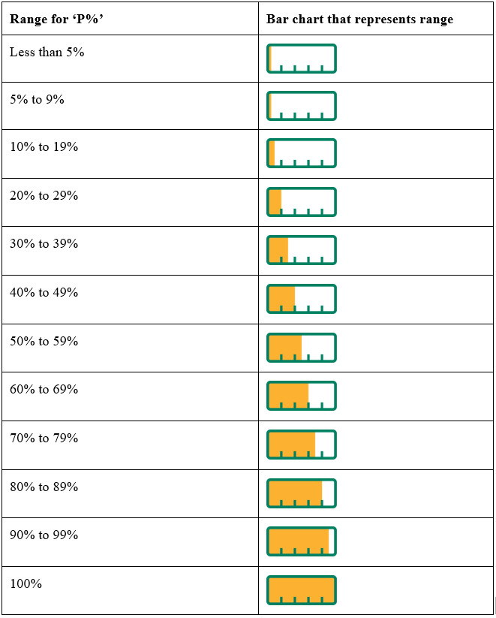

**Consultation Questions**

1. Will the bar chart representations depicted above be appropriate for the complementary medicines sector? If not, please illustrate your response with examples.
2. If these representations are not suitable for complementary medicines, what bar chart representations could be used? Please illustrate your response with examples.

## *Accompanying statement to explain the proportion of Australian ingredients*

The proposed Information Standard will require a statement to accompany the bar chart. The statement will describe the percentage of Australian ingredients in the product.

Key features of the statement include how it could be placed with the bar chart and contained within a box.

The proposed statements:

* ‘Made in Australia from at least % Australian ingredients’ would be used with the range 5% up to 99%,
* ‘Made in Australia from less than % Australian ingredients would be used with the range 1% to 4%, and
* ‘Made in Australia from % Australian ingredients’ would be used with 0% Australian ingredients.

***Proposed Information Standard Provision***

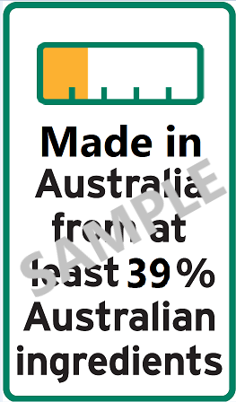 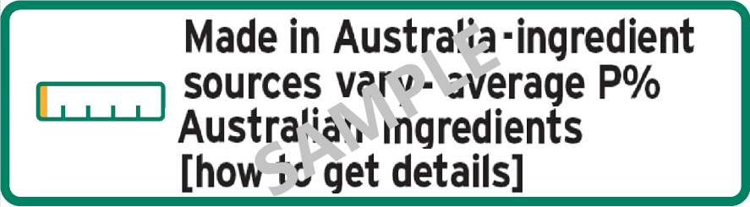

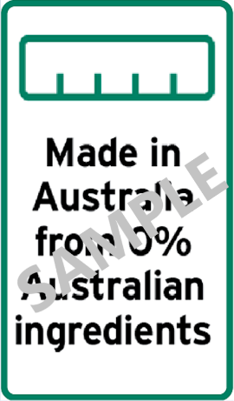 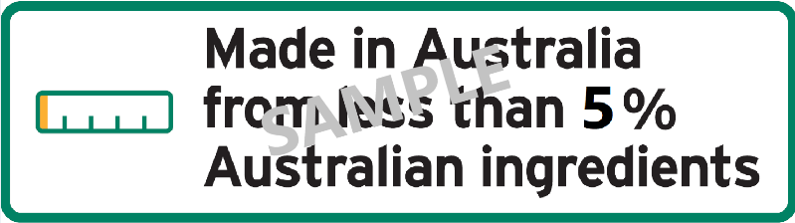

**Consultation Questions**

1. Do you anticipate any challenges with the use of any of the statements as depicted? If so, please illustrate your response with examples.

## *Accompanying statement where an averaging method is used*

When an averaging method is used to represent the proportion of Australian ingredients in an Australian made product, the statement will also explain how consumers can access more information on the averaging method used.

***Proposed Information Standard Provision***

*(1) The labelling of a complementary medicine complies with this Information Standard if:*

*(a) the labelling includes:*

*(i) one of the appropriate marks under this section; and*

*(ii) any information, such as a barcode or other device, batch number, lot, date of manufacture or date mark, that is needed to enable a consumer to obtain information by a method; and*

*(b) a consumer who follows the method indicated by the mark is able to find out:*

*(i) the proportion by weight of Australian ingredients of the complementary medicine in the package; and*

*(ii) if the period that was used to calculate the average specified in the mark does not appear on the labelling—that period.*

*(2) If the average proportion by weight of the Australian ingredients of the complementary medicine is not less than 1%, the following are appropriate marks.*

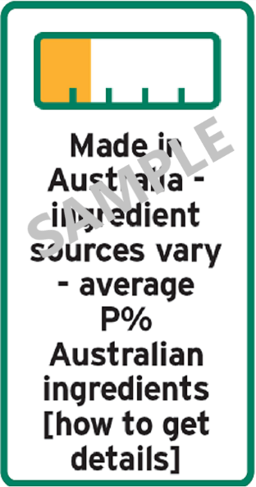 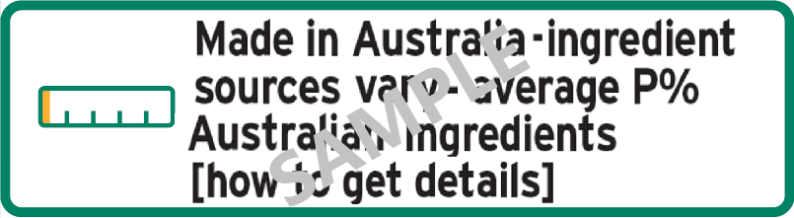

**Consultation Questions**

1. Do you anticipate any challenges with the accompanying statement when an averaging method is used? If so, please illustrate your response with examples. Can you suggest alternative text to ensure the consumer is adequately informed?

## *Use of the AMAG logo with the bar chart and accompanying statement*

Unlike Australian food products, Australian made complementary medicines will not be required to use the AMAG logo. However, if the AMAG logo is used on a product, the proposed Information Standard provisions require the co-location of the AMAG logo with the bar chart and accompanying statement. This will require the AMAG logo to be placed in the same box as the bar chart and statement.

***Proposed Information Standard Provision***

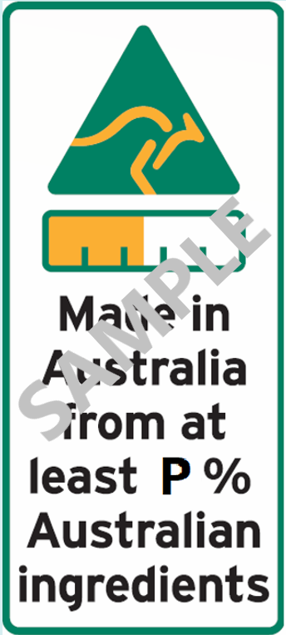 

**Consultation Questions**

1. Do you anticipate any challenges in co-locating the AMAG logo (if used) with the bar chart and statement? If so, please outline how the AMAG logo could be placed on the label.

# Part 3 – Sales for which labelling is and is not required

The proposed Information Standard will cover complementary medicines that are suitable for retail sale in Australia.

It is expected that country of origin labelling will not be required on products that are sold for special medical purposes to hospitals or other medical institutions in Australia. CoOL will also not apply to complementary medicines that are manufactured solely for export.

***Proposed Information Standard Provision***

*(1) This Part applies in relation to a sale of complementary medicine in Australia if:*

*(a) the sale is a retail sale; or*

*(b) the sale is not a retail sale, but the complementary medicine is sold as suitable for retail sale without any further processing, packaging or labelling.*

*(2) However, this Part does not apply to a complementary medicine that:*

*(a) is sold for consumption in a hospital or other medical institution; or*

*(b) is sold as a practitioner only product, where that product is not on-sold to an end consumer.*

*To be clear: A complementary medicine sold to a hospital or other medical institution may choose to display an Australian origin claim (assuming the product meets the 2020 safe harbour defences) but is not required to display the bar chart or accompanying statement unless those products are subsequently released into retail sale.*

*If complementary medicines, made in Australia, are exported and re-imported without substantial transformation and made available for retail sale then those products will be required to display the bar chart and the ‘Made in Australia’ accompanying text statement.*

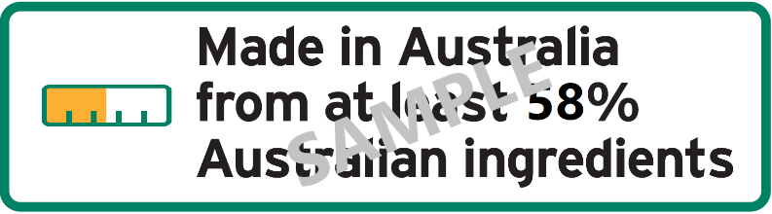

**Consultation Questions**

1. Is this provision relevant to the complementary medicines industry?
2. Are there any other sales that would not require the bar chart and accompanying statement?

# Part 4 – Legibility requirements, constraints and providing additional information

Note: Nothing in the Information Standard is intended to prevent additional information on country or region of origin being provided.

***Proposed Information Standard Provision***

*(1) If this Information Standard requires a word, statement, expression or design to be contained, written or set out on a label—any words must be in Australian English and any word, statement or expression must, wherever occurring:*

*(a) be legible; and*

*(b) be prominent so as to contrast distinctly with the background of the label.*

*(2) The minimum text size to display country of origin information on labels is 2.0 mm.*

*Taking into consideration the minimum specified text size for country of origin information:*

1. *the bar chart height must be equal to the capital letter height of the explanatory text; and*
2. *the explanatory text size accompanying the bar chart must be at least equal to the text size for listing active ingredients on the product’s label, as required by the TGA.*

**Consultation Questions**

1. Do you anticipate any challenges with the above general legibility requirements? If so, please outline those challenges.
2. How else could legibility be achieved in the depiction of the bar chart and accompanying statement?

# Part 5 – Labelling for small containers

In some cases, it may be challenging to fit the required labelling (bar chart and statement) on a small package.

***Proposed Information Standard Provision***

*(1) In the case of a small container*, it will be sufficient to include a statement of the proportion of Australian ingredients only, in a clearly defined box, without the bar chart or the AMAG logo.*

*(2) If the AMAG logo is used, then the bar chart and accompanying statement must be used, regardless of the packaging size.*

*\** *small container means a container that has a capacity less than or equal to 25 millilitres*

**Consultation Questions**

1. Do you anticipate any challenges with this approach? If so, please illustrate your response with examples.

# Part 6 – Transition period

It is anticipated that a 12 month transition period will provide manufacturers with sufficient time to design, commission and apply the new labelling, if they choose to rely on the proposed 2020 reforms to establish the Australian origin of their products.

Products labelled correctly under the 2019 regulations during the relevant transition period would not need to be re-labelled when that transition period ends. However, any complementary medicines labelled after the relevant transition period would be subject to the 2020 reforms.

**Consultation Questions**

1. We invite views on the impact of the proposed transition arrangements.

1. <https://www.legislation.gov.au/Details/C2020C00205/Html/Volume_3#_Toc45784009>
2. <https://www.legislation.gov.au/Details/F2019L01627>