

FullCAM Guidelines

Requirements for using the Full Carbon Accounting Model (FullCAM) in the Emissions Reduction Fund (ERF) methodology determination:
Carbon Credits (Carbon Farming Initiative) (Native Forest from Managed Regrowth) Methodology Determination 2013

Version X.0
(draft, not in force)
Disclaimer
This document has been developed to assist project proponents to calculate abatement in FullCAM as required by the Carbon Credits (Carbon Farming Initiative) (Native Forest from Managed Regrowth) Methodology Determination 2013. This document is the ‘FullCAM Guidelines’ incorporated by reference in sections 1.3, 4.8, 4.9, 4.12, 4.14, 4.16, 4.18, 4.19, 4.30 and 5.3 of the Methodology Determination. Project proponents should not use this document as a substitute for complying with the requirements in the Methodology Determination.
Before relying on any material contained in this document, project proponents should familiarise themselves with the requirements of the following legal documents: Carbon Credits (Carbon Farming Initiative) (Native Forest from Managed Regrowth) Methodology Determination 2013, Carbon Credits (Carbon Farming Initiative) Act 2011, Carbon Credits (Carbon Farming Initiative) Rule 2015, Carbon Credits (Carbon Farming Initiative) Regulations 2011 and Guidelines on stratification evidence and records for HIR and NFMR. Further explanation of the method can be found in the explanatory statement to the Carbon Credits (Carbon Farming Initiative) (Native Forest from Managed Regrowth) Methodology Determination 2013.
This document does not displace relevant legislative provisions or other laws. All users are encouraged to read this document in conjunction with the relevant legislation, including the Methodology Determination, referenced throughout this document. Where any inconsistencies are apparent, please be aware that the legislative provisions will take precedence.
Interested parties should make their own independent inquires and obtain their own independent professional advice prior to relying on, or making any decisions in relation to, the information provided in this document.
This document will be updated periodically and users should note that some inputs and values may change over time. It is the user’s responsibility to ensure that they are using the correct option in the latest version of FullCAM and following the relevant section (either Section 3 or Section 4) of this document and any tool/s required in association as in force at the applicable offsets report submission date (consistent with the definitions in section 1.3 of the Methodology Determination).
The Department of Industry, Science, Energy and Resources and the Commonwealth of Australia accept no responsibility or liability for any damage, loss or expense incurred as a result of the reliance on information contained in this document. This document does not indicate commitment by the Commonwealth to a particular course of action.
© Commonwealth of Australia
Unless otherwise noted, copyright (and any other intellectual property rights, if any) in this publication is owned by the Commonwealth of Australia.
Creative Commons licence Attribution CC BY
All material in this publication is licensed under a Creative Commons Attribution 3.0 Australia Licence, save for content supplied by third parties, logos, any material protected by trademark or otherwise noted in this publication, and the Commonwealth Coat of Arms. These are all forms of property which the Commonwealth cannot or usually would not licence others to use.
Creative Commons Attribution 3.0 Australia Licence is a standard form licence agreement that allows you to copy, distribute, transmit and adapt this publication provided you attribute the work. A summary of the licence terms is available from http://creativecommons.org/licenses/by/3.0/au/. The full licence terms are available from http://creativecommons.org/licenses/by/3.0/au/legalcode.
Content contained herein should be attributed as “The Department of Industry, Science, Energy and Resources Fullcam Guidelines: Requirements for using the Full Carbon Accounting Model (FullCAM) in the Emissions Reduction Fund (ERF) methodology determination Carbon Credits (Carbon Farming Initiative) (Native Forest from Managed Regrowth) Methodology Determination 2013”.
Contents
1. Introduction 6
1.1 Use of FullCAM with the Native Forest from Managed Regrowth Methodology Determination 2013 6
1.2 Determining which FullCAM option to use 6
1.3 Format of this document 8
1.4 FullCAM background 8
1.5 FullCAM plots and running simulations 8
1.6 Overview of the FullCAM interface 9
1.7 Development and updates to this document 10
2. Simulations overview 11
2.1 Baseline scenarios 11
2.2 Baseline materiality test 12
2.2.1 Overview of simulation for calculating C100_5% 13
2.2.2 Overview of simulation for calculating C10 13
2.3 Non-zero baselines 14
2.3.1 Overview of simulation for calculating a Default Baseline 14
2.3.2 Overview of simulation for calculating a Hybrid Baseline 15
2.3.3 Overview of simulation for calculating a Historic Baseline 16
2.4 Overview of simulation for calculating project carbon stocks 17
3. 2020 FullCAM option – Setting up simulations for carbon estimation areas 19
3.1 Creating a new plot from template 19
3.2 The Events Tab 23
3.2.1 Adding a regeneration event 24
3.2.2 Adding a clearing event 27
3.2.3 Adding a thinning event 28
3.2.4 Adding fire events 29
3.2.5 Adding a growth pause event 35
3.2.6 Creating and cloning events to add baseline scenarios to the events queue 37
3.3 The Output Tab 42
3.4 Running Simulations 44
3.5 Viewing outputs 44
3.6 Transferring outputs into a spreadsheet 45
4. 2016 FullCAM option - Setting up simulations for carbon estimation areas 48
4.1 Opening a file 48
4.2 Saving a plot file 49
4.3 The Configuration Tab 49
4.4 The Timing Tab 50
4.5 The Data Builder Tab 51
4.6 The Site Tab 52
4.7 The Tree Tab 52
4.8 The Soil Tab 52
4.9 The Initial Conditions Tab 53
4.10 The Events Tab 55
4.10.1 Adding a regeneration event 56
4.10.2 Adding a clearing event 61
4.10.3 Adding a thinning event 63
4.10.4 Adding fire events 65
4.10.5 Adding a growth pause event 75
4.10.6 Creating and cloning regimes 79
4.11 The Output Tab 83
4.12 Running Simulations 85
4.13 Viewing outputs 85
4.14 Transferring outputs into a spreadsheet 86
5. FullCAM simulations and offsets reporting 88

Introduction

Use of FullCAM with the Native Forest from Managed Regrowth Methodology Determination 2013
The calculation of carbon abatement under the Carbon Credits (Carbon Farming Initiative) (Native Forest from Managed Regrowth) Methodology Determination 2013 (the Determination) is dependent upon the use of the Full Carbon Accounting Model (FullCAM) consistently with the requirements of this document. In particular, sections 4.8, 4.9, 4.12, 4.14, 4.16, 4.18 and 4.19 of the Determination require that the materiality test, baseline scenario and project scenario for each carbon estimation area (CEA) must be modelled in FullCAM in accordance with the requirements in both the Determination and this document.
Section 4.18 of the Determination requires that any project specific inputs specified in this document must be used to determine the project carbon stocks for a CEA. Note that each of the simulations and modelling events detailed in this document have specific inputs that must be used. Section 4.19 also specifies that the relevant events that reflect actual management events and the relevant species setting specified in the document must be used to model the project period.
Sections 4.30 and 4.31 of the Determination also require key input and output data to be produced using FullCAM in accordance with the requirements in the Determination and this document. Where content of this document relates to provisions of the Determination, references are given to the location of those provisions.
Project proponents must only change FullCAM default settings as indicated in this document, and all other settings must not be changed. This is to ensure that defaults will apply where relevant (see subsections 4.14(3) and 4.18(3) of the Determination).

Determining which FullCAM option to use
The Department of Industry, Science, Energy and Resources updates the Full Carbon Accounting Model (FullCAM) from time to time to reflect the latest science and improve usability. At the time this document was last updated, the latest version was released for public use in 2020 on the Department’s website. The latest publicly released version of FullCAM is constituted by two options [new website link to be added – once the 2020 public release is available for use, the link will direct to a single location with both options. The pre-release version currently viewable contains the default 2020 FullCAM option].
- Default: 2020 FullCAM option
This is currently the 2020 FullCAM option. The year reflects when the latest version was released at the time this document was last updated. However, a reference to the default or 2020 FullCAM option in this document includes any subsequent release or update of FullCAM on the Department’s website. Accordingly, projects using the default 2020 FullCAM option will be required to use subsequent releases as they are made available.

- Alternative: 2016 FullCAM option
This is identified as the 2016 FullCAM option and is only available for use by some projects, as described below.
Project proponents must access the latest publicly released version of FullCAM from the Department’s website and then ensure they are using the appropriate FullCAM option for their project.
An exception to the requirement to use the latest publicly released version is for projects with reporting periods that end before 1 September 2020, under a method that specifies to use the version of FullCAM and the associated Guidelines for those periods. If you determine that you must use a version of FullCAM that is unavailable on the website, please contact the Department at erfforests@industry.gov.au to obtain a copy.
The requirements below explain when the default 2020 FullCAM option must be used and when the alternative 2016 FullCAM option can be used.
- Whichever FullCAM option is used by the proponent, all CEAs of a given project must be reported on using a single FullCAM option.
- Projects with section 22 declaration applications under the Carbon Credits (Carbon Farming Initiative) Act 2011 (CFI Act), submitted to the Clean Energy Regulator (the Regulator) on or after 1 September 2020, must use the default 2020 FullCAM option.
- Projects with section 22 declaration applications submitted to the Regulator before 1 September 2020 are able to use either the default 2020 FullCAM option or the alternative 2016 FullCAM option. These projects are able to move from the 2016 FullCAM option to the 2020 FullCAM option if they choose to do so. If a choice to use the 2020 FullCAM option is made, the entire project must be moved to 2020 FullCAM and once using 2020 FullCAM option in an offsets report, these projects cannot return to using the 2016 FullCAM option. Eligible offsets projects prior to 31 March 2019 have grandfathered growth pause provisions that they will no longer have access to if they move to the 2020 FullCAM option.
- If project proponents with section 22 declaration applications submitted to the Regulator before 1 September 2020 add a new project area or areas to the project under the section 29 of the CFI Act with effect on or after 1 September 2020, the entire project must use the default 2020 FullCAM option. The only exception to this is where all of the areas added to the project were already using the alternative 2016 FullCAM option under these guidelines as part of another eligible offsets project (these can continue to use the 2016 FullCAM option consistent with the dot point above – therefore the original project must also have been eligible to use the 2016 FullCAM option).
- Projects that transfer from an earlier to a later version of this method or transfer to this method from another method, with the application under section 128 of the CFI Act submitted on or after 1 September 2020, must use the default 2020 FullCAM option.
Note that FullCAM is not compatible with iOS systems, and must be run in a Windows operating environment.
[Screenshot of interface showing the two options]

Format of this document
This document provides:
- an overview of FullCAM relevant to the Determination, its features relevant to users and important requirements for using this document (section 1);
- an overview of the simulations you must run in FullCAM as per the Determination, including the process used to determine which type of baseline proponents must use (section 2);
- tables summarise the objective, time period and outputs for each simulation, as well as the project activities that may need to be simulated.
- two step-by-step walkthroughs of using FullCAM to run the simulations correctly (section 3 for those using 2020 FullCAM option and section 4 for those using 2016 FullCAM option); and
- users should familiarise themselves with the simulations in section 2 before following the steps in sections 3 or 4 to run the simulations.
- an overview of the FullCAM outputs as they relate to equations within the Determination (section 5).
The 2020 FullCAM option requires fewer data entries than the 2016 FullCAM option because many items have been automated in the 2020 FullCAM options through the use of templates.

FullCAM background
FullCAM is used in Australia’s National Greenhouse Gas Accounts for the land sector. FullCAM provides fully integrated estimates of carbon pools in forest and agricultural systems for Australia’s land sector reporting. In addition, it accounts for human-induced changes in emission and sequestration of major greenhouse gases. FullCAM was developed under the National Carbon Accounting System (NCAS) at the then Australian Greenhouse Office to provide a dynamic account of the changing stocks of carbon in Australia’s land systems since 1970 by integrating data on land cover change, land use and management, climate, plant productivity, and soil carbon over time. FullCAM estimates carbon stock change and greenhouse gas emissions at fine spatial and temporal scales, and uses a wide range of spatially referenced data.
Users of FullCAM can determine estimates of carbon stock change and greenhouse gas emissions for ERF projects on a similar basis to that used for land use and land use change in Australia’s National Greenhouse Gas Inventory.

FullCAM plots and running simulations
FullCAM can run simulations on a ‘plot’. A plot, for modelling purposes, is defined as a piece of land for which the event history, when modelled in FullCAM, is the same across that area of land. Separate plot files are created for each CEA (see section 3.3 of the Determination). This document outlines the steps required to run simulations in each FullCAM option as outlined in section 3 and section 4 respectively.
In the 2016 FullCAM option, there are several types of plots that can be selected. Only ‘forest system’ is relevant to this Determination. This selection does not need to be made in the 2020 FullCAM option because it has been automated through the creation of a default template. At the point in 2016 FullCAM option where users choose to create a new plot file, they instead select an appropriate template from a drop-down list and 2020 FullCAM option then populates FullCAM with the template plot.
FullCAM uses a single ‘model point’ location. Proponents do not need to define plot boundaries within FullCAM, rather proponents must input the coordinates for a single location that is at the approximate centre of the CEA (the model point – see paragraph 3.3(1)(c) of the Determination). The latest spatial data for a plot must be downloaded using the ‘Data Builder’ tab each time the software is run.
In order to ensure all settings are correct, including defaults, we recommend creating new plot files each time a new version of FullCAM or these Guidelines, or a different FullCAM option, is used. Plot files created under previous versions or options may contain different settings that will affect outputs and users are responsible for ensuring they have used the correct FullCAM version and option, and accurately followed the associated FullCAM Guidelines.
For each CEA, separate plot files must be created for:
- determining whether a zero baseline or non-zero baseline must be used (initial reporting period only);
- estimating carbon stocks under a non-zero baseline (if a zero baseline is not appropriate); which may be either a ‘default’ baseline, an ‘historic’ baseline or an ‘hybrid’ baseline;
- estimating carbon stocks for the current reporting period; and
- determining if a disturbance event must be reported prior to the next reporting period.

Overview of the FullCAM interface
The FullCAM software user interface displays menus and a series of tabs. Each tab has a suite of fields in which information may either be required to complete as instructed through these Guidelines or left unchanged. The program is designed so that certain tabs in a plot file are made available only if required fields have valid information entered in earlier tabs. If the text of a tab or field is red, then FullCAM requires information in that tab or field before a simulation can be run. When all the required fields within a tab have valid information entered, the tab text will become blue.
The below table provides a general overview of each tab selectable within FullCAM once a plot has been created. Help is provided within FullCAM by clicking on the symbol available in most windows. This general overview of the public version of FullCAM is not intended to instruct proponents of ERF projects on how to use FullCAM for this Determination.
Data entry requirements for this Determination, under each FullCAM option, are described in detail in section 3 and section 4 of these Guidelines.
Tab | Explanation
About | Includes a free text field where users can enter information about the plot file that they have created. This is a good space to keep track of changes that have been made or editing of event parameters.
Configuration | Users select the system (e.g. forest, agricultural) they want to simulate in the plot.
Timing | Enter the timing for starting and ending the simulation and the time steps required for output data.
Data Builder | In this tab users enter the latitude and longitude of the ‘Model Point Location’ where they wish to simulate a plot file. Internet access is required to complete this tab. By choosing to ‘Download Spatial Data’ the associated soil and climate data for that latitude and longitude are automatically loaded into relevant parts of the remaining tabs. In the tab users can then download tree and/or crop species information and management regimes as appropriate. This information is also automatically loaded into relevant parts of the remaining tabs.
Site | Specific parameters (e.g. water [rainfall], temperature, productivity) are described.
Trees | Description of the properties of the tree species.
Crops | Description of the properties of crop or pasture species (only displays if agricultural system selected).
Soil | Description of soil properties.
Initial Conditions | In this tab the values for carbon at the start of the simulation are described. Values will automatically be populated by Data Builder using data downloaded from the FullCAM server.
Events | All of the events for the entire simulation period are listed in this tab. Users can add or remove events. Care must be taken not to violate requirements for modelling ‘management events’ within the Determination. The names on the event list are colour-coded to indicate whether they are ready, whether they are simulating or not, and what system they affect. The colour codes are:  Red: Event not ready (renders event queue not ready);  Grey: Event non-simulating (outside simulation period, will not affect simulation);  Green: Forest;  Yellow: Agricultural; and  Brown: Mixed.  Finally, the events users select with the cursor are coloured in the usual highlight colour.
Output Window | Defines what outputs are presented in output windows.
Explorer | Display of the parameter settings for each tab.
Plot Digest | This tab only appears when a plot is saved as a ‘plot digest’ by changing the save as type. It allows users to clone and alter the inputs of a given modelling scenario, and combine the results or output them separately.
Log | This tab records changes made to the file to assist with analysis and error tracking.

Development and updates to this document
This document has been developed by the Department to give effect to the Determination and assist the Determination to continue to be effective and meet the offsets integrity standards in section 133 of the Carbon Credits (Carbon Farming Initiative) Act 2011. One of the most relevant offsets integrity standards for the Determination and this document to meet is that ‘to the extent to which a method specified in, or ascertained in accordance with, a methodology determination in accordance with paragraph 106(1)(c) involves an estimate, projection or assumption—the estimate, projection or assumption should be conservative’. The use of estimates, projections or assumptions is inherent to the calculation method of the Determination which uses a computer model (FullCAM) to estimate levels of carbon in both baseline and project scenarios.
The input of events and parameters into the FullCAM software is structured to help ensure that the Determination ultimately results in a conservative estimate of the net abatement amount. The need for conservativeness can have a different impact on how assumptions are used for baseline scenarios and project scenarios. For example, for a baseline scenario to be ‘conservative’, assumptions are needed which avoid underestimating the amount of carbon in an area of land. Conversely, in a project scenario, assumptions are needed which avoid overestimating the amount of carbon in an area of land.
Another important offsets integrity standard is that the Determination results in ‘eligible carbon abatement from the project’ such that it contributes to meeting Australia’s international emissions reduction obligations and complies with internationally accepted accounting rules. The development of both the FullCAM software and this document is mindful of the role of the Determination in meeting this offsets integrity standard and remaining consistent with international accounting rules. In particular, it is important that carbon abatement from each method is reflected in Australia’s National Inventory Report.
The Emissions Reduction Assurance Committee plays an important role in assessing, reviewing and monitoring methodology determinations for compliance with the offsets integrity standards. In particular, if the Committee considers that there is reasonable evidence that a determination (with its incorporated models and documents) does not comply with one or more offsets integrity standards, the Committee can make a legislative instrument suspending the processing of applications to apply the method. The Department takes into account the views of the Committee on the need to update this document over time and how best to achieve the offsets integrity standards. Where possible, the Department also considers the views of project proponents to ensure that the requirements in this document are practical to use and fair.

Simulations overview
Sections 4.8, 4.9, 4.12, 4.14, 4.18 and 4.19 of the Determination require that the materiality test, baseline scenario and project scenario for each CEA must be modelled in FullCAM in accordance with the requirements in both the Determination and this document.

Baseline scenarios
The baseline for each CEA will be either of two categories depending on the materiality test below (Section 2.2) – a zero baseline or a non-zero baseline.
Within the non-zero baseline category there are three possible baselines depending on the extent of historical information available regarding the clearing history – default, hybrid or historic. The decision flowchart below gives an overview of the process for determining which baseline to use.
Figure 1: Decision tree for determining the type of baseline to be used for each CEA. See section 4.12 of the Determination for the relevant provisions.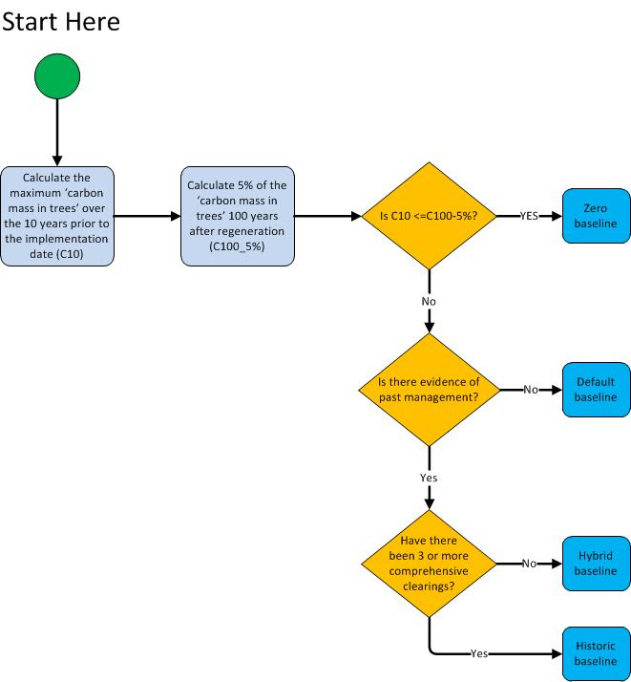

Baseline materiality test
To determine whether a zero baseline may apply in a CEA, project proponents must complete the materiality test explained by this section and to be undertaken by following either section 3 or section 4 of this document. Proponents must also comply with the provisions given for the materiality test in sections 4.7-4.9 of the Determination.
Completing the materiality test involves calculating two factors:
Factor | Explanation | Process for Calculating
C100_5% | 5 per cent of the ‘carbon mass of trees’ at 100 years after the implementation date | see section 2.2.1 below for how to calculate
C10 | the maximum ‘carbon mass of trees’ over the ten years prior to the implementation date | see section 2.2.2 below for how to calculate
Note: ‘Implementation date’ is defined in section 1.3 of the Determination. It is the date when the project mechanism (a change in land management enabling native vegetation to achieve forest cover) was implemented in a CEA. Each CEA may have a different implementation date.
The values calculated for these factors will allow you to determine which baseline to use:
Result | Baseline to use
C10 is less than or equal to C100_5% | Zero baseline
C10 is greater than C100_5% | Non-zero baseline (default, hybrid or historic)

Overview of simulation for calculating C100_5%
Table 1: Overview of simulation for calculating C100_5%
Objective | Calculate 5 per cent of the ‘C mass of trees’ at 100 years after the implementation date.
Simulation period | From the implementation date to 100 years after the implementation date.
Events permitted | Regeneration
Outputs | Monthly totals for ‘C mass of trees’ (FullCAM Output = Carbon / Forest / Plants / C mass of trees)

Overview of simulation for calculating C10
Note: When calculating C10, project proponents must have documentary evidence for each event that is entered into the FullCAM event queue.
Table 2: Overview of simulation for calculating C10
Objective | Calculate the maximum carbon mass of trees reached during the 10 years before the implementation date.
Simulation period | From the day after the last comprehensive clearing before the 10 year period that ends on the implementation date to the implementation date.
Events permitted | Regeneration  Growth pause  Clearing  Thinning  Management fire  Windrow and burn
Outputs | Monthly totals for ‘C mass of trees’ (FullCAM Output = Carbon / Forest / Plants / C mass of trees)
Note: ‘comprehensive clearing’ is defined in section 1.3 of the Determination. It means the destruction of trees or saplings, or both, by mechanical or chemical means that may be accompanied by use of fire, leaving the land in a non-forested state for pastoral land use.

Non-zero baselines
Non-zero baselines must be calculated if, according to the materiality test under the previous section, the maximum carbon stock during the ten years prior to the implementation date has reached a material level (i.e. C10 > C100_5%).

Overview of simulation for calculating a Default Baseline
A default non-zero baseline is suitable for project proponents whose records are not sufficient to model either an historic or a hybrid baseline. For further information about default non-zero baselines, see sections 4.12 and 4.15 of the Determination, and pages 19 to 21 and Appendix A of the Explanatory Statement for the original Determination. A default non-zero baseline is modelled in FullCAM by repeating the default baseline management event scenario over the baseline forecast period. This scenario consists of a sequence of comprehensive clearings that occur at 15 year intervals (refer to Table 3).
For the paragraphs below, the ‘applicable date’ for a CEA is the project registration date, except for land later added to the project area through a project variation, in which case it is the project variation date.
Modelling of fires within a Default Baseline where the applicable date is on or prior to 31/03/2019
If project proponents can demonstrate that fire was used to suppress regrowth on land that is part of the same pastoral property as the CEA then:
- a management fire event may be added occurring 7 years after each regeneration event; and
- a windrow and burn fire event may be added occurring 6 months after each clearing event.
Modelling of fires within a Default Baseline where the applicable date is after 31/03/2019
Management Fire
If project proponents can demonstrate that management fire was used to suppress regrowth on land that is part of the same pastoral property as the applicable CEA, but not within the applicable CEA, then:
- a management fire event may be added occurring 7 years after each regeneration event in every odd-numbered baseline interval.

If project proponents can demonstrate that management fire was used to suppress regrowth within the applicable CEA, then:

- a management fire event may be added occurring 7 years after each regeneration event.
Windrow and Burn
If project proponents can demonstrate that a windrow and burn fire event was used following clearing on land within the applicable CEA, then:

- a windrow and burn fire event may be added occurring 6 months after each clearing event.

Table 3: Overview of simulation for calculating a Default Baseline
Objective | Calculate the default baseline which estimates average carbon stocks in a CEA in the absence of an eligible offsets project. The average carbon stocks over the 100 years from the implementation date are used in the calculations within the method (the baseline forecast period), but the simulation period commences at an earlier date (see below).
Simulation period | From one day after the last comprehensive clearing event that occurred before the implementation date. Simulations end 100 years after the implementation date.
Events permitted | Regeneration  Management fire 7 years after regeneration event – where the use of management fires to suppress regrowth can be demonstrated in accordance with the notes above  Clearing  Windrow and burn fire 6 months after clearing event – where windrow and burning events can be demonstrated in accordance with the notes above
Outputs | Monthly totals for ‘C mass of trees’ (FullCAM Output = Carbon / Forest / Plants / C mass of trees)  Monthly totals for ‘C mass of debris’ (FullCAM Output = Carbon / Forest / Debris / C mass of forest debris)

Overview of simulation for calculating a Hybrid Baseline
A hybrid baseline is suitable for project proponents who have evidence of two comprehensive clearings that occurred less than 15 years apart and before the implementation date. For further information about hybrid baselines, see sections 4.12 and 4.15 of the Determination, and pages 19 to 21 and Appendix A of the Explanatory Statement for the original Determination.
A hybrid baseline is modelled in FullCAM by repeating the hybrid baseline management event scenario over the baseline forecast period. This scenario consists of a sequence of comprehensive clearings that occur at two alternating intervals, one default interval of 15 years, followed by one historic interval matching the interval between the last two clearings before the implementation date.
For the paragraphs below, the ‘applicable date’ for a CEA is the project registration date, except for land later added to the project area through a project variation, in which case it is the project variation date.
Modelling of fires within a Default Baseline where the applicable date is on or prior to 31/03/2019
If project proponents can demonstrate that fire was used to suppress regrowth on land that is part of the same pastoral property as the CEA then:
- a management fire event may be added occurring 7 years after each regeneration event in the default interval; and
- a windrow and burn fire event may be added occurring 6 months after each clearing event in the default interval.
Modelling of fires within a Default Baseline where the applicable date is after 31/03/2019
Management Fire
If project proponents can demonstrate that management fire was used to suppress regrowth on land that is part of the same pastoral property as the applicable CEA, but not within the applicable CEA, then:
- a management fire event may be added occurring 7 years after each regeneration event in every odd-numbered default interval.

If project proponents can demonstrate that management fire was used to suppress regrowth within the applicable CEA, then:

- a management fire event may be added occurring 7 years after each regeneration event in each default interval.
Windrow and Burn
If project proponents can demonstrate that a windrow and burn fire event was used following clearing on land within the applicable CEA, then:

- a windrow and burn fire event may be added occurring 6 months after each clearing event in each default interval.

Modelling of fires within the historic interval
If project proponents can demonstrate that fire was used in the historic interval in the applicable CEA, then corresponding fire events set out in these Guidelines may be included in modelling that interval.
If documentary evidence shows, to the satisfaction of the Regulator, that a management event other than a comprehensive clearing occurred in the CEA during the historic interval, that management event may be included in the historic interval if it is a permitted event in Table 4 below.

Overview of simulation for calculating a Historic Baseline
Project proponents wishing to model a historic baseline must have evidence for at least three comprehensive clearings that occurred in the CEA before the implementation date. For further information about historic baselines, see sections 4.12 and 4.15 of the Determination, and pages 19 to 21 and Appendix A of the original Explanatory Statement.
A historic baseline is modelled in FullCAM by repeating the historic baseline management event scenario over the baseline forecast period. There are stringent evidentiary requirements for modelling a historic baseline. Project proponents must have documentary evidence for each event modelled in the scenario (refer Table 4).
If documentary evidence shows, to the satisfaction of the Regulator, that a management event other than a comprehensive clearing occurred in the CEA before the implementation date, that event may be included in the historic baseline scenario if it is a permitted event in Table 4 below.
Table 4: Overview of simulation for calculating a Historic or Hybrid Baseline
Objective | Calculate historic and hybrid non-zero baselines which estimate average carbon stocks in a CEA in the absence of an eligible offsets project.
Simulation period | One day after the most recent comprehensive clearing event. Simulations end 100 years after the implementation date (the baseline forecast period).
Events permitted | Regeneration  Growth pause  Clearing  Thinning  Management fire  Windrow and burn
Outputs | Monthly totals for ‘C mass of trees’ (FullCAM Output = Carbon / Forest / Plants / C mass of trees)  Monthly totals for ‘C mass of debris’ (FullCAM Output = Carbon / Forest / Debris / C mass of forest debris)

Overview of simulation for calculating project carbon stocks
To determine the project carbon stocks, project proponents must model all events listed in the table below that reflect the actual management events that occurred in the CEA during the entirety of the simulation period (from one day after the last comprehensive clearing before the implementation date until the end of the current reporting period).
Table 5: Overview of simulation for calculating project carbon stocks
Objective | Calculate total carbon stocks in each CEA at the end of each reporting period. These carbon stocks will reflect the age of the regrowth within the CEA, observed climate, and activities and disturbance subsequent to the establishment of the offsets project.
Simulation period | From one day after the last comprehensive clearing before the implementation date. Simulations end at the end of the current reporting period.
Events permitted | Regeneration  Growth pause  Clearing  Thinning  Prescribed fire – to reduce fire risk  Wildfire – trees not killed  Wildfire – trees killed  Management fire  Windrow and burn
Outputs | Monthly totals for ‘C mass of trees’ (FullCAM Output = Carbon / Forest / Plants / C mass of trees)  Monthly totals for ‘C mass of debris’ (FullCAM Output = Other / Carbon Projects / C mass of forest debris)  Monthly totals for emissions of CH₄ from fire (FullCAM Output = Whole / Emissions / CH₄ emitted due to fire)  Monthly totals for emissions of N₂O from fire (FullCAM Output = Nitrogen / Whole / Emissions / N₂O emitted due to fire)

2020 FullCAM option – Setting up simulations for carbon estimation areas
Section 1.2 describes the requirements for which FullCAM option can be used. The general effect of requirements described in Section 1.2 is that the 2020 FullCAM option is the default. Only projects that satisfy the criteria described in section 1.2 are able to use the 2016 FullCAM option.
Simulations for each CEA are undertaken using plots. Project proponents must use the following steps for creating FullCAM plots and inputting values for each CEA registered under the Determination.
All steps must be followed when creating new plot files and inputting values.
Once a plot file has been setup for a CEA and scenario, it can re-opened for modelling at a later date. When reopening plot files, users must first navigate to the ‘Data Builder’ tab and click ‘Download Spatial Data’, before running the simulation, to ensure the latest spatial data is used for the simulation.

Creating a new plot from template
- With FullCAM open, select ‘File’ then ‘New from Template…’, a new window will appear titled ‘Templates’.
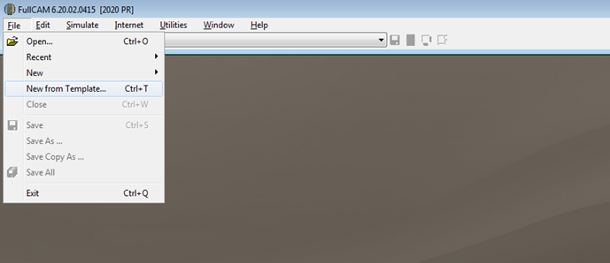

- Select, under the ‘ERF’ expandable folder, the ‘HIR NFMR and Avoided Clearing Methods’ option corresponding to the long-term average annual rainfall for the applicable model point location. The two rainfall options for the natural regeneration calibration differ in the root- to- shoot ratio used to determine biomass allocation to roots. Biomass in roots constitutes a higher proportion of total biomass in the low rainfall option.
The long-term average annual rainfall is determined using the Long Term Average [annual] Rainfall Map Layer, also known as the CFI rainfall map, previously available from the CFI Mapping tool.
A CEA (or CEA part) including areas of land on both sides of the 500mm rainfall boundary, according to the CFI rainfall map, does not in itself prevent the CEA being modelled with a single events queue.
The long term average annual rainfall map layer shows the long-term average annual rainfall (mm) across continental Australia, calculated for the period 1920-2010. The long-term average annual rainfall map layer (also labelled CFI Mapping tool - Rainfall map) can be accessed for viewing or downloading from data.gov.au under Emissions Reduction Fund Environmental Data (https://data.gov.au/dataset/ds-dga-b46c29a4-cc80-4bde-b538-51013dea4dcb/details?q=emission reduction fund).
Steps to view the long-term average annual rainfall data on data.gov using the Australian Government’s National Map:
- Go to (https://nationalmap.gov.au/) and select the up arrow located immediately to the right of the “Explore Data” button.
- Select “Add Web Data” and paste the following URL: https://data.gov.au/geoserver/emissions-reduction-fund-environmental-data/wms (which is located in data.gov.au under the ERF Environmental data – Preview dataset WMS) and click “Add”.
- Click the “” sign next to Long term average annual rainfall. The long term average annual rainfall map layer will be displayed.
- To check the rainfall amount of the model point location, enter the latitude and longitude in the search bar (located in the top left hand corner). The search result will be displayed below.
- Click the latitude and longitude under the ‘Locations’ tab to display the location in the map.
- Click the location marker on the map, this will show the feature information tab on the right hand corner.
- In the ‘Feature information tab’ click on the ‘Long-term average annual rainfall – Site Data’. This will display the long term average annual rainfall in mm. This information can be also downloaded by clicking the Download this Table tab.
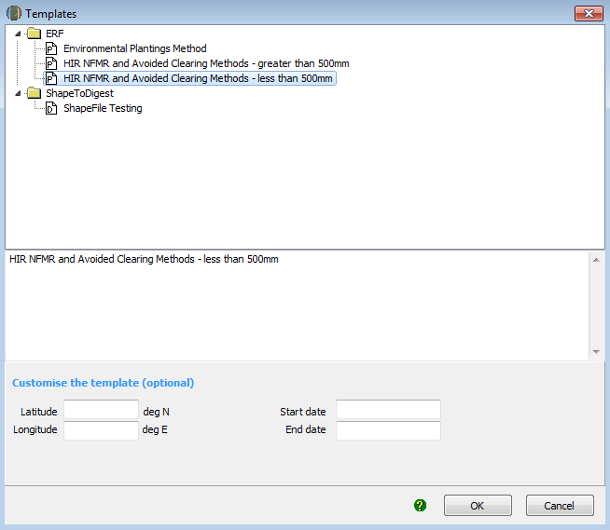

- Enter the latitude and longitude (in decimal degrees i.e. xx.xxx xx, xx.xxx xx) of the model point location in the latitude and longitude text fields. This should be the approximate centre of the CEA (as per section 21(4) of the Determination). Note that FullCAM may appear to round off the decimal degrees entered after clicking out of the text fields, but users must enter the full five decimal places as these will be recorded within the plot file itself and are visible in the ‘Data builder’ tab.
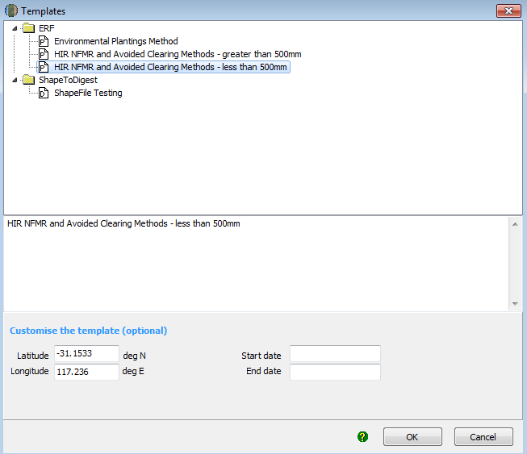
- Enter the modelling start and end dates for the simulation that you will run, in the start date and end date text fields. Acceptable formats include ‘DD MONTH YYYY’ or ‘D M YYYY’ (e.g. ‘1 July 2014’ or ‘1 7 2014’). These should correspond to those required for the modelling period, consistent with part 4 of the Determination.
Simulation Type | Timing
C100_5% | - Enter the date to start simulations as the implementation date.  - Enter the date to end the simulation as 100 years after the implementation date.
C10 | - Enter the date to start simulations as the day after the last comprehensive clearing that occurred before the 10 year period that ends on the implementation date. Enter the date to end the simulation as the implementation date.
Default baseline  Historic baseline  Hybrid baseline  Project carbon | - Enter the date to start simulations as one day after the last comprehensive clearing before the implementation date.  - Enter the date to end the simulation as 100 years after the implementation date.

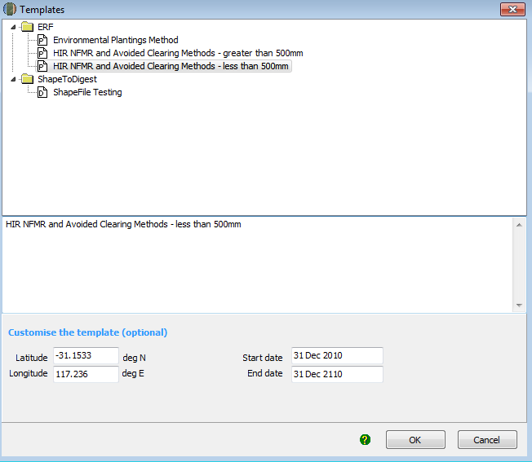

- Click ‘OK’, a new plot file will be created with the applicable default data for the method, as well as the location and dates entered.
- The new plot file can then be saved by clicking ‘file’, then ‘save’.
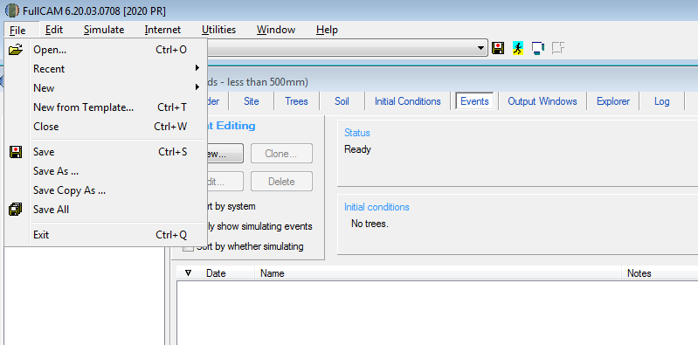

- The new plot file is now ready for adding events at the events tab.

The Events Tab
The Events Tab is where events for a simulation can be added and displayed in sequence. Events can be added individually by following the below steps for each event type. Alternatively, for the default baseline scenario, the corresponding sequence of repeated events can be added by following section 3.2.6.1 below.
Simulation Type | Permitted Events
C100_5% | Regeneration
C10 | Regeneration  Growth Pause  Clearing  Thinning  Management fire  Windrow and burn fire
Default baseline | Regeneration  Clearing  Management fire – where sufficient evidence (see s 4.12 of the Determination)  Windrow and burn fire – where sufficient evidence (s 4.12 of the Determination)
Historic baseline  Hybrid baseline | Regeneration  Clearing  Thinning  Management fire – where sufficient evidence (see s 4.12 of the Determination)  Windrow and burn fire – where sufficient evidence (s 4.12 of the Determination)
Project carbon | Regeneration  Growth Pause  Clearing  Thinning  Management fire  Windrow and burn fire  Prescribed fire – to reduce fire risk  Wildfire – trees not killed  Wildfire – trees killed

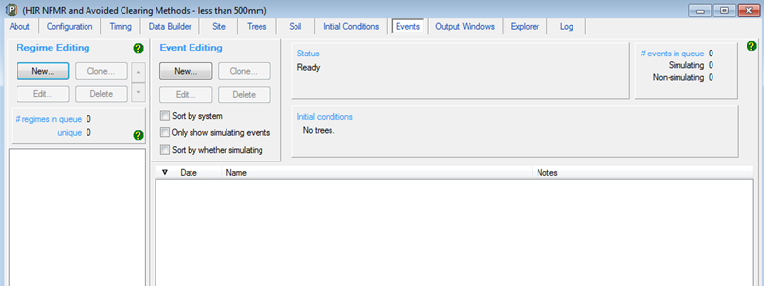

Adding a regeneration event
The notes below must be followed to add a regeneration event. There are different requirements for modelling a regeneration event according to the scenario type and when the CEA was first registered within a project area.
For the project carbon scenario, the timing of a regeneration event must be supported by evidence (subsection 4.19(2) and paragraph 5.5(b) of the Method), as well as conform with the input requirements specified here (paragraph 4.18(2)(a) of the Method). The start date of a regeneration event must correspond with the presence of forest potential within the CEA and the requirements set out below for differing project registration/variation dates.
Regeneration is an ongoing event where carbon continues to accumulate in vegetation, rather than a point in time occurrence such as fire or clearing. As per section 3.8, subsection 4.19(2) and paragraph 5.5(b) of the Method, the modelling of regeneration must be supported by evidence that regeneration has occurred throughout the modelling period. In the absence of evidence of ongoing regeneration, either, a growth pause should be modelled (see section 3.2.5) or the CEA should be re-stratified to exclude areas where regeneration has ceased (as per section 3.6 of the Determination).
For the paragraphs below, the ‘applicable date’ for a CEA is the project registration date, except for land later added to the project area through a project variation, in which case it is the project variation date.
If the applicable date is after 31 March 2019, no more than 10 years of cumulative regeneration may be modelled prior to the applicable date. The regeneration event may commence more than 10 years before the applicable date where growth pause events are modelled. For example, for a project registered on 1 January 2020, proponents may model regeneration commencing 12 years earlier in 2008, where a two-year growth pause has been identified and modelled as occurring from 2013-15.
If the applicable date is between 13 December 2017 and 31 March 2019, the timing of a regeneration event in the project carbon scenario cannot be more than 14 years prior to the applicable date.
If the applicable date is before 13 December 2017, the timing of a regeneration event in the project carbon scenario is not limited to a specific period prior to the applicable date. For these CEAs, proponents may optionally elect to model growth pause events in the event of suppression or slowing of regeneration (in accordance with section 3.2.5).
For the default baseline scenario, a regeneration event occurs 12 months after each comprehensive clearing. See subsection 4.12(6) and paragraph 4.15(2)(b) of the Determination.
For the C10, hybrid and historic baseline scenarios, the timing of a regeneration event is 12 months after each comprehensive clearing, unless evidence supports setting the date to another time. See section 4.6, and subsections 4.8(5), 4.12(9) and 4.12(15) of the Determination.
Steps for the Project Carbon Scenario Modelling
Simulation Type | Steps required
Project carbon | - Click the ‘New’ button under ‘Event Editing’ to create a new event. In the drop down menu next to ‘Type’, select ‘Tree planting’.  - Click ‘Insert standard values’. Select the row with the ‘Event Name’ of ‘Plant trees: natural regeneration in regeneration systems’ and then click ‘OK’ and ‘Yes’ to insert the name of the standard event.  - Enter the date of the event, determined with respect to the above notes.  - Do NOT change any other setting.  - Click ‘OK’ to finish adding the event to the event queue.

Steps for the Baseline and Materiality Test Modelling
Simulation Type | Steps required
C100_5%  C10  Default baseline  Historic baseline  Hybrid baseline | - Click the ‘New’ button under ‘Event Editing’ to create a new event.
C100_5% | - Insert the simulation start date in the blank field beside the ‘Timing’ section. This can be entered in the format dd mmm yyyy.
Default baseline | - Enter the date that is 12 months after the most recent comprehensive clearing in the blank field beside the ‘Timing’ section. This can be entered in the format dd mmm yyyy.
C10  Historic baseline  Hybrid baseline | - Enter the date as determined from the above notes in the blank field beside the ‘Timing’ section. This can be entered in the format dd mmm yyyy.
C100_5%  C10  Default baseline  Historic baseline  Hybrid baseline | - In the drop down menu next to ‘Type’, select ‘Tree planting’.  - Click ‘Insert standard values’. Select the row with the ‘Event Name’ of ‘Plant trees: natural regeneration in regeneration systems’ and then click ‘OK’ and ‘Yes’ to insert the name of the standard event.  - Do NOT change any other setting.  - Click ‘OK’ to finish adding the event to the event queue.

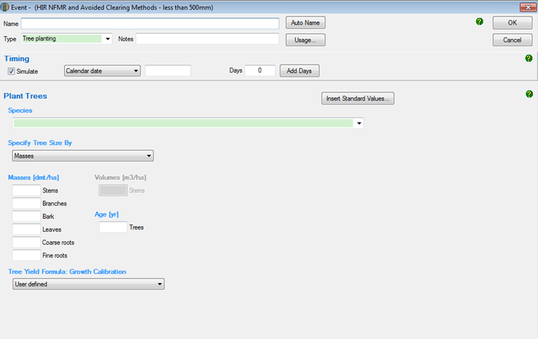
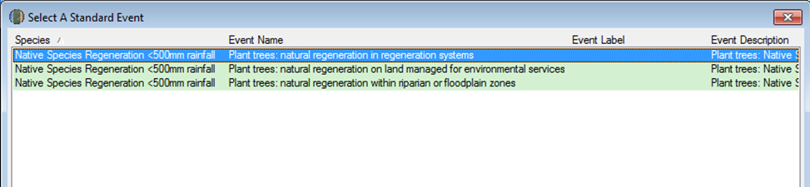
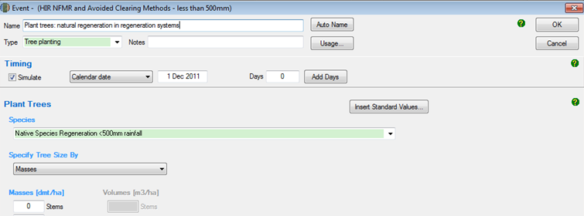
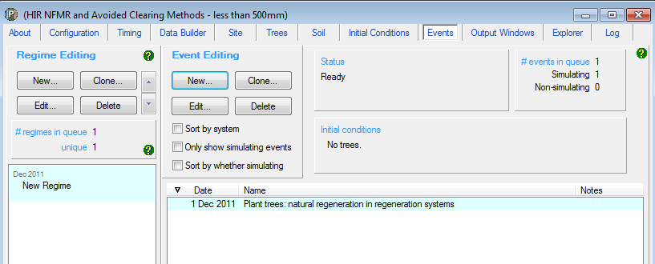

Adding a clearing event
These steps must be followed to add a clearing event, which corresponds to a comprehensive clearing referred to in the Determination.
Simulation Type | Steps required
C100_5% | - Not permitted
Project carbon | - Not permitted
C10  Default baseline  Historic baseline  Hybrid baseline | - Click the ‘New’ button under ‘Event Editing’ to create a new event.
C10  Historic baseline  Hybrid baseline | - Insert the date of the clearing event in the blank field beside the ‘Timing’ section.  - For the first clearing event, insert the date of the clearing event in the blank field beside the ‘Timing’ section based on what occurred historically. This can be entered in the format dd mmm yyyy.  - For subsequent clearing events, insert the date of clearing in this field to represent the observed date or default interval between comprehensive clearings as per section 4.6 of the Determination.
Default baseline | - Insert the date of the clearing event in the blank field beside the ‘Timing’ section. Each clearing event will be 14 years after the previous regeneration event.
C10  Default baseline  Historic baseline  Hybrid baseline | - In the drop down menu next to ‘Type’, select ‘Forest thinning’.  - Click ‘Insert standard values’. Select the row with ‘Event Name’ of ‘Initial clearing: no product recovery’ and then click ‘OK’ and ‘Yes’ to insert the name of the standard event.  - Ensure that the box next to ‘Affected portion’ contains the value ‘100’ to indicate a clearing event.  - Do NOT change any other settings.  - Click ‘OK’ to finish adding the event to the event queue.

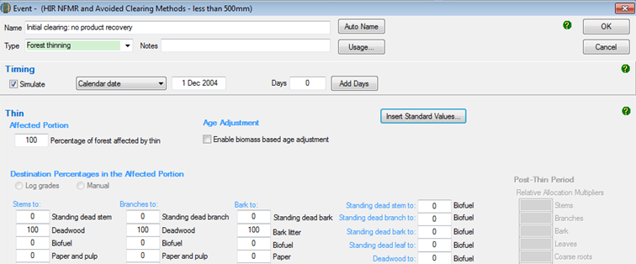
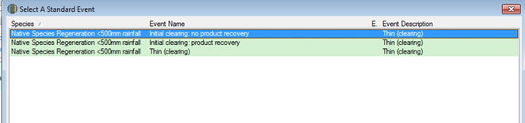

Adding a thinning event
These steps must be followed to add a thinning event.
Simulation Type | Steps required
C100_5% | - Not permitted
Default baseline | - Not permitted
C10  Historic baseline  Hybrid baseline  Project carbon | - Click the ‘New’ button to create a new event.  - Insert the date of the thinning event in the blank field beside the ‘Timing’ section. This can be entered in the format dd mmm yyyy. The intervals between events must reflect those that occurred historically.  - In the drop down menu next to ‘Type’, select ‘Forest thinning’.  - Click ‘Insert standard values’. Select the row with ‘Event Name’ of ‘Initial clearing: No product recovery’ and then click ‘OK’ and ‘Yes’ to insert the name of the standard event.  - In the box next to ‘Affected portion – the percentage of forest affected by thin’ change the number to an estimate of the proportion of the stems that were killed in the thinning. You must report on how the estimate was derived in your project report.  - Do NOT change any other settings.  - Click ‘OK’ to finish adding the event to the event queue.

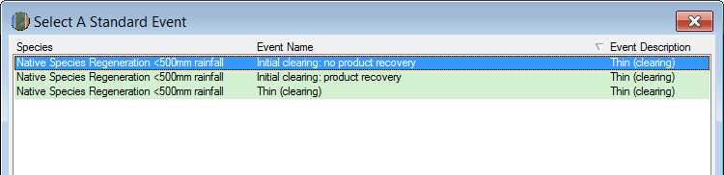
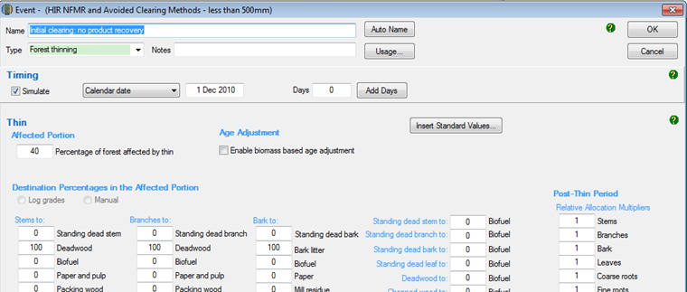

Adding fire events

Adding a management fire event
These steps must be followed to add a management fire event. A management fire event encourages grass for pasture. It is a fire that occurs within a clearing interval and is used to set back the regrowth, killing a substantial proportion of the above ground plant parts.

Simulation Type | Steps required
C100_5% | - Not permitted
C10 | - Not permitted
Default baseline  Historic baseline  Hybrid baseline  Project carbon | - Click on the ‘New’ button to create a new event.  - In the blank field besides the ‘Timing’ section, insert the date of the management fire in the simulation period. The intervals between events must reflect those that occurred historically. For example, for default values used in baselines, this is 7 years after the regeneration event.  - In the drop down menu next to ‘Type’, select ‘Forest fire’.  - Click ‘Insert standard values’. Select the row with ‘Event Name’ of ‘Management Fire’ and then click ‘OK’ and ‘Yes’ to insert the name of the standard event.  - Click ‘OK’ to finish adding the event to the event queue.

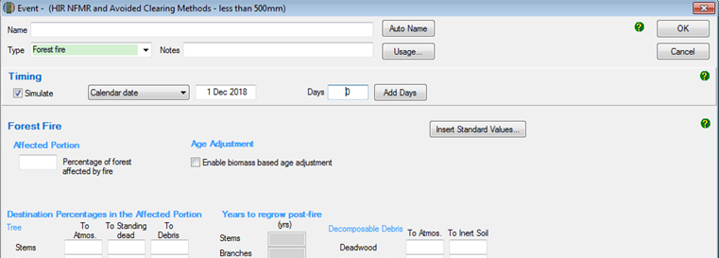
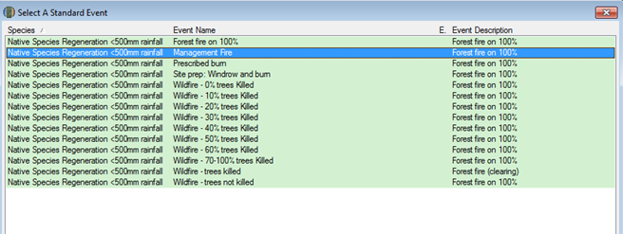
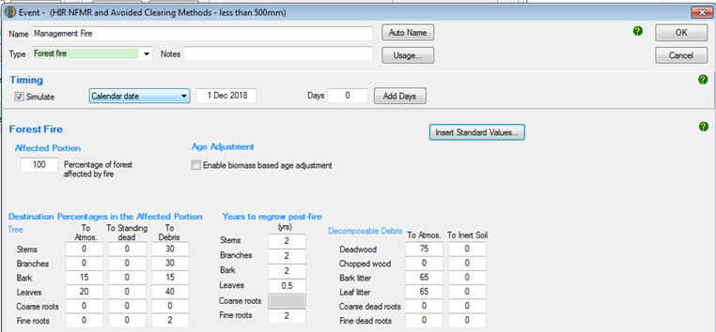

Adding a windrow and burn fire event
A windrow and burn fire event reduces the amount of debris that remains after the clearing event. Evidence is required to support modelling a windrow and burn event. See subsection 4.12(5) regarding evidence to support modelling this event under a default baseline scenario, and subsections 4.8(5), 4.12(10) and 4.12(14) for C10, hybrid baseline, and historic baseline scenarios respectively.
For the default baseline scenario, where a windrow and burn event is to be included, it must be modelled as occurring six months after each clearing event.
Simulation Type | Steps required
C100_5% | - Not permitted
Project carbon | - Not permitted
C10  Default baseline  Historic baseline  Hybrid baseline | - Click on the ‘New’ button to create a new event.  - Insert the date of the windrow and burn fire in the simulation period in the blank field beside the ‘Timing’ section.  - In the drop down menu next to ‘Type’, select ‘Forest fire’.  - Click ‘Insert standard values’. Select the row with ‘Event Name’ of ‘Site prep: Windrow and burn’ and then click ‘OK’ and ‘Yes’ to insert the name of the standard event.  - Do NOT change any other setting.  - Click ‘OK’ to finish adding the event to the event queue.

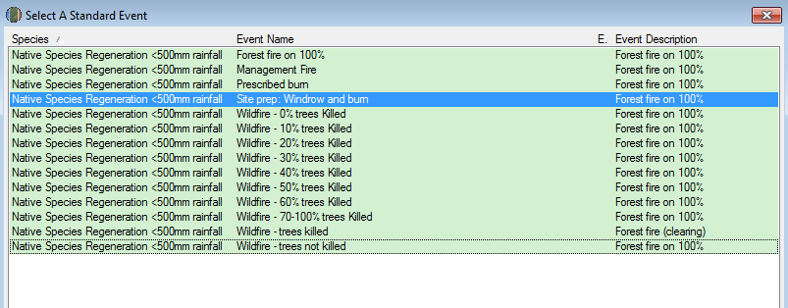
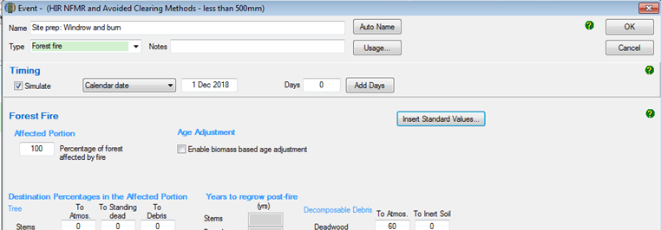

Adding a prescribed fire event – to reduce fire risk
These steps must be followed to add a prescribed fire event – to reduce fire risk. These events are aimed at reducing fuel loads and hence fire risk. They control the accumulation of the debris pool. The date modelled must reflect the actual date of that event.
Simulation Type | Steps required
C100_5% | - Not permitted
C10 | - Not permitted
Default baseline | - Not permitted
Historic baseline | - Not permitted
Hybrid baseline | - Not permitted
Project carbon | - Click on the ‘New’ button to create a new event.  - Insert the date of the prescribed fire in the simulation period in the blank field beside the ‘Timing’ section.  - In the drop down menu next to ‘Type’, select ‘Forest fire’.  - Click ‘Insert standard values’. Select the row with ‘Event Name’ of ‘Prescribed burn’ and then click ‘OK’ and ‘Yes’ to insert the name of the standard event.  - Do NOT change any other setting.  - Click ‘OK’ to finish adding the event to the event queue.

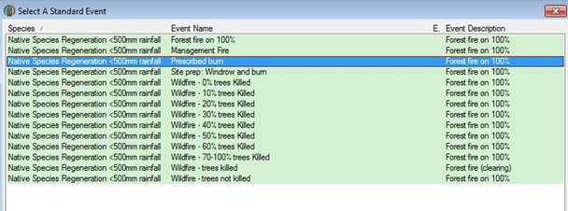
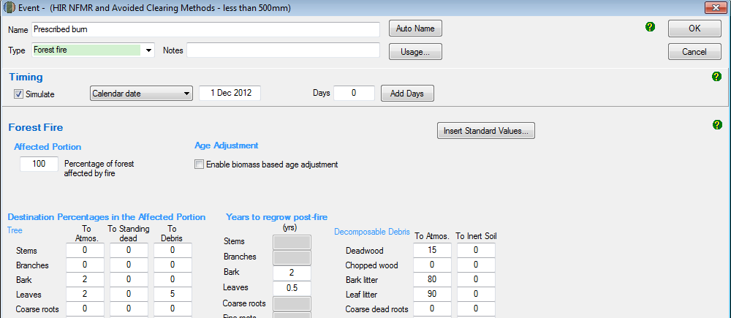

Adding a wildfire – trees not killed event
These steps must be followed to add a wildfire – trees not killed event.
Simulation Type | Steps required
C100_5% | - Not permitted
C10 | - Not permitted
Default baseline | - Not permitted
Historic baseline | - Not permitted
Hybrid baseline | - Not permitted
Project carbon | - Click on the ‘New’ button to create a new event.  - Insert the date of the wildfire where trees are not killed in the simulation period in the blank field beside the ‘Timing’ section.  - In the drop down menu next to ‘Type’, select ‘Forest fire’.  - Click ‘Insert standard values’. Select the row with ‘Event Name’ of ‘Wildfire – trees not killed’ and then click ‘OK’ and ‘Yes’ to insert the name of the standard event.  - Do NOT change any other setting.  - Click ‘OK’ to finish adding the event to the event queue.

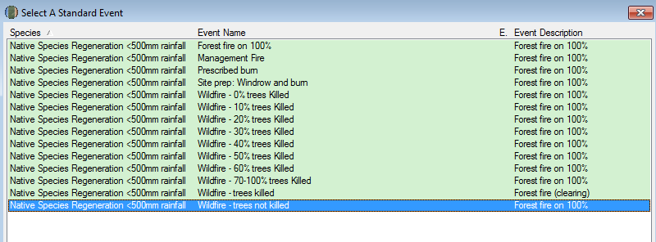
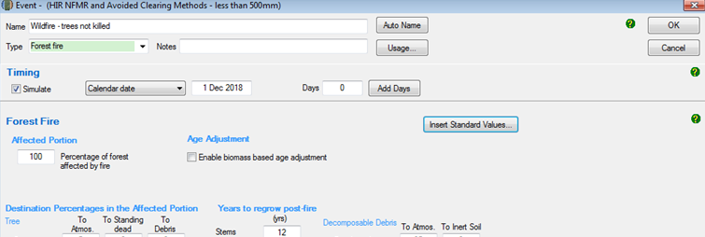

Adding a wildfire – trees killed event
These steps must be followed to add a wildfire – trees killed event.
Simulation Type | Steps required
C100_5% | - Not permitted
C10 | - Not permitted
Default baseline | - Not permitted
Historic baseline | - Not permitted
Hybrid baseline | - Not permitted
Project carbon | - Click the ‘New’ button to create a new event.  - Insert the date that the wildfire – trees killed event in the blank field beside the ‘Timing’ section. This can be entered in the format dd mmm yyyy.  - In the drop down menu next to ‘Type’, select ‘Forest Fire’.  - Click ‘Insert standard values’. Select the row with ‘Event Name’ of ‘Wildfire – trees killed’ and then click ‘OK’ and ‘Yes’ to insert the name of the standard event.  - Click ‘OK’.  - Do NOT change any other settings.  - Click ‘OK’ to finish adding the event to the event queue.

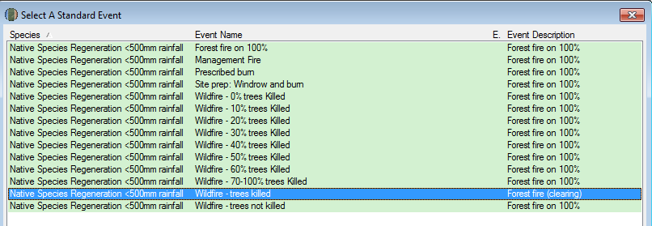
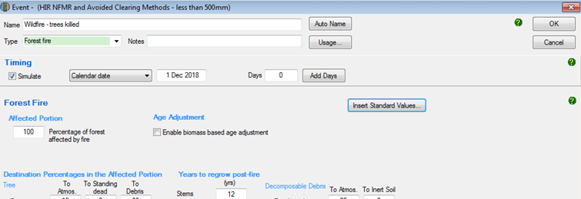

Adding a growth pause event
All projects using the 2020 FullCAM option must follow the growth pause requirements described in this section. This includes projects that previously reported under the 2016 FullCAM option and have moved to the 2020 FullCAM option, even if they were an eligible offsets project prior to 31 March 2019.
A growth pause event is used to model the stopping or slowing of vegetation growth due to a suppression disturbance event (or the combined impacts of more than one suppression disturbance event), such as grazing by livestock/feral animals, disease or pests, or another event. Normal climatic variability of wetter and drier periods (i.e. including droughts to an extent) causing fluctuations in the growth rate are already incorporated within the vegetation growth calibration used by the model, and are not required to be added as growth pause events in FullCAM.
The use and timing of any modelled growth pause must be consistent with the records that evidence the type, timing and extent of disturbance events (see section 5.5 of the Determination). Where there is uncertainty over timing, a longer period may be used to conservatively estimate the duration of the growth pause. Such uncertainty does not preclude including additional growth pauses where appropriate, but the timing of such pauses should best give effect to the available evidence. Growth pauses are applicable throughout the crediting period.
Growth pauses should be included where necessary to ensure consistency with both:
- paragraph 4.19(2)(a) of the Determination, that the modelling accurately reflects the set of ‘actual management events’ that have occurred in a CEA. Growth pauses for management and disturbance events assist in ensuring that the abatement estimates of the method do not overestimate carbon abatement achieved by a project.
- the requirements of the Regulator’s five yearly regeneration checks[1] —required under 70(3A) of the Carbon Credits (Carbon Farming Initiative) Rule 2015. In the absence of the use of growth pauses to account for a lack of regeneration progress, CEAs may be need to be re-stratified to exclude the areas where regeneration cannot be evidenced (refer to the Regulator’s Guidelines).
The start date for a growth pause is the date on which growth stopped or slowed. Where there are multiple factors contributing to a suppression disturbance event, or the source of suppression or actual date of suppression disturbance event cannot be identified, the date can be estimated.

Simulation Type | Steps required
Project carbon  C10  Hybrid baseline  Historic baseline | - Click the ‘New’ button under ‘Event Editing’ to create a new event.  - Select Forest treatment event for type from the drop-down menu.  - DO NOT select Insert Standard Values (Note: This differs from the directions for other events above).  - Enter the calendar date of the start date of the disturbance event. This can be estimated if the actual date is not known.  - Enter ‘Grazing’ as the event name (or similar, e.g. ‘Growth Pause’).  - In the Age advance due to treatment box enter an estimate for how long the growth pause event occurred as a decimal proportion in years, and as a negative number. For example, if the event occurred for 3 years and 9 months, then ‘-3.75’ would be entered in this box. As another example, if the event occurred for 5 years, then ‘-5’ would be entered in this box.  - In the Advancement period box enter the absolute value of the number added in the ‘Age advance due to treatment’ box. For example, using the examples above, the value to add to this box would be: (1) ‘3.75’, or (2) ‘5’.  - Following these steps has the effect of ‘pausing’ growth in carbon stocks for the duration of the growth pause event.  - DO NOT change any other values on this tab.  - Press ‘OK’.

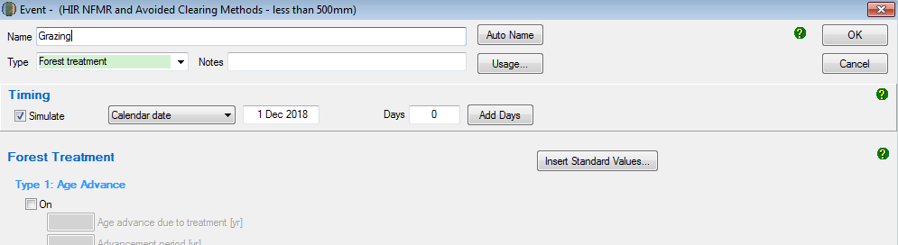

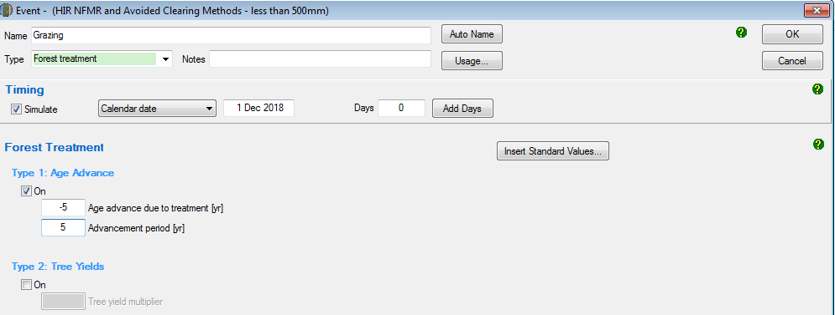

Creating and cloning events to add baseline scenarios to the events queue
For default, historic and hybrid baselines, the entire events queue that includes all simulated events for the entire baseline management event scenario (see section 4.12 of the Determination) must be cloned to cover the 100 year baseline forecast period.
Once the events queue has been cloned, the date of each event generated must be checked and adjusted if necessary by editing the event. This is because leap years and variability in month length can cause the date on which repeating events fall, to shift from the intended date.
Simulation Type | Steps required
Default baseline | - Follow the above steps to create a plot and the events forming a single clearing interval of 15 years (regeneration, windrow and burn where applicable, management fire where applicable, and clearing). By default, FullCAM will create a new regime for each event added.  - Highlight each of the existing regimes in the left hand column by holding ctrl on the keyboard and clicking on each regime.  - Select the ‘Edit’ button under the Regime Editing header.  - In the name field type ‘baseline’, then click ‘ok’. This will combine all existing events under one regime.  - Press the ‘Clone’ button under the Regime Editing header.  - Enter ‘15’ or ‘30’ for calendar years (depending on the length of the regime that is being repeated) and for ‘number of times’, a value high enough to clone events over the entirety of the 100-plus year baseline period and click ‘ok’.  - Any events that are highlighted grey towards the bottom of the events queue fall beyond the 100-plus year modelling period and will not be simulated. These can be left in the event queue as they will not affect the simulation.
Historic baseline | - Follow the above steps to create a plot and the events forming the two clearing intervals of the durations supported by historical evidence.  - Highlight each of the existing regimes in the left hand column by holding ctrl on the keyboard and clicking on each regime.  - Select the ‘Edit’ button under the Regime Editing header.  - In the name field type ‘baseline’, then click ‘ok’. This will combine all existing events under one regime.  - Calculate the number of years between the first event of the first interval and the last event of the second interval. Add 1 to this number. I.e. years between initial regeneration event modelled and the last clearing event modelled plus 1.  - Press the ‘Clone’ button under the Regime Editing header.  - Enter the number calculated above for ‘calendar years’ and for ‘number of times’, a value high enough to clone events over the entirety of the 100-plus year baseline period and click ‘ok’.  - Any events that are highlighted grey towards the bottom of the events queue fall beyond the 100-plus year modelling period and will not be simulated. These can be left in the event queue as they will not affect the simulation.
Hybrid baseline | - Follow the above steps to create a plot and the events forming the first clearing interval of 15 years, and the second clearing interval of the duration supported by historical evidence. By default, FullCAM will create a new regime for each event added.  - Highlight each of the existing regimes in the left hand column by holding ctrl on the keyboard and clicking on each regime.  - Select the ‘Edit’ button under the Regime Editing header.  - In the name field type ‘baseline’, then click ‘ok’. This will combine all existing events under one regime.  - Calculate the number of years between the first event of the first interval and the last event of the second interval. Add 1 to this number. I.e. years between initial regeneration event modelled and last clearing event plus 1.  - Press the ‘Clone’ button under the Regime Editing header.  - Enter the number calculated above for ‘calendar years’ and for ‘number of times’, a value high enough to clone events over the entirety of the 100-plus year baseline period and click ‘ok’.  - Any events that are highlighted grey towards the bottom of the events queue fall beyond the 100-plus year modelling period and will not be simulated. These can be left in the event queue as they will not affect the simulation.
C10  C100_5%  Project carbon | - Not applicable

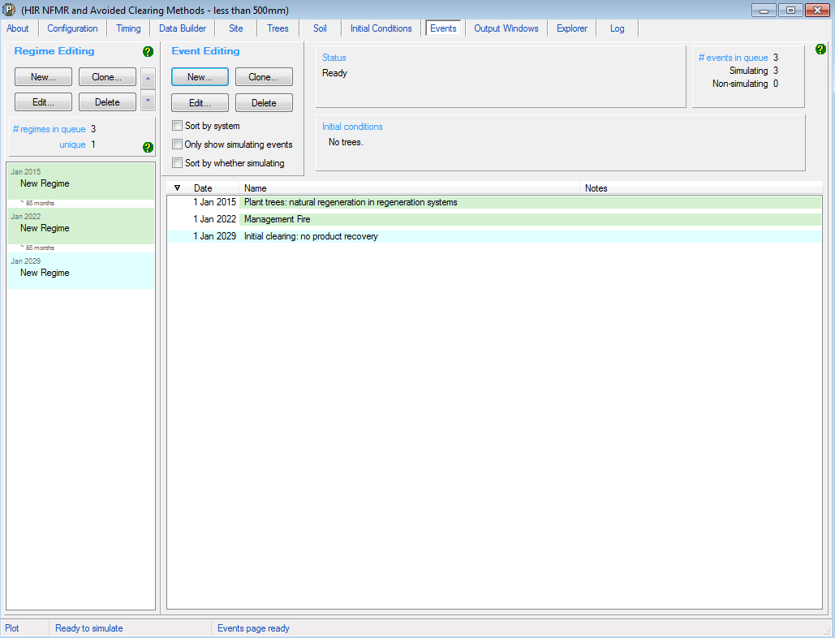
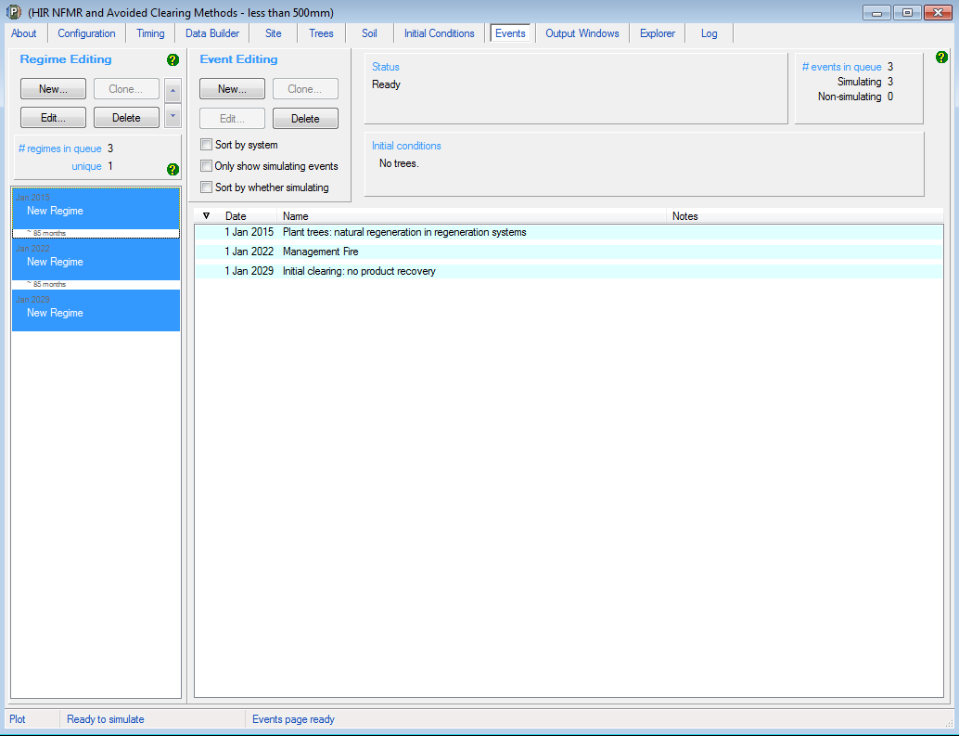

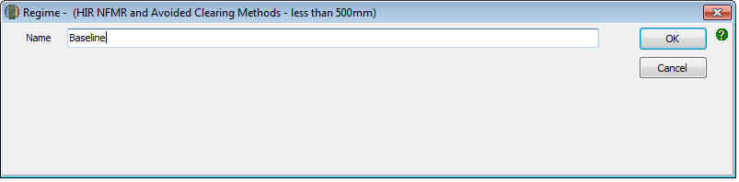
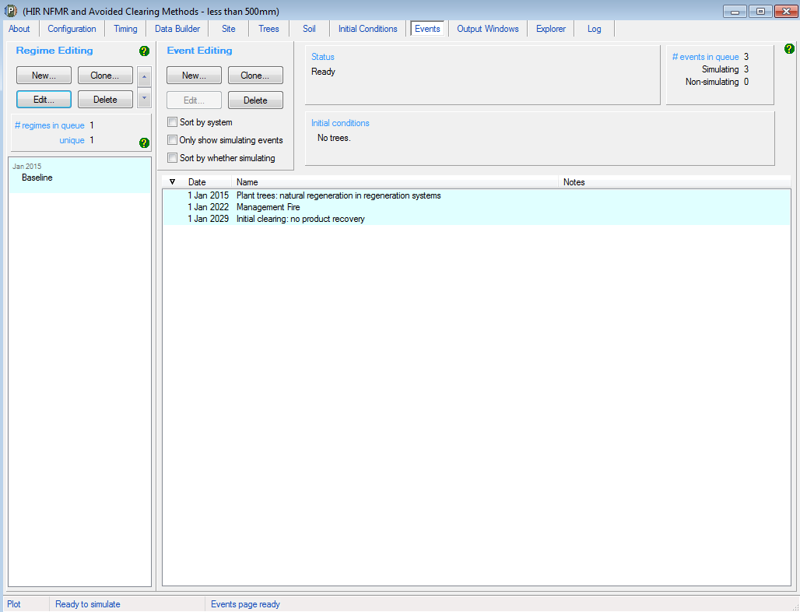
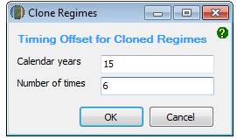

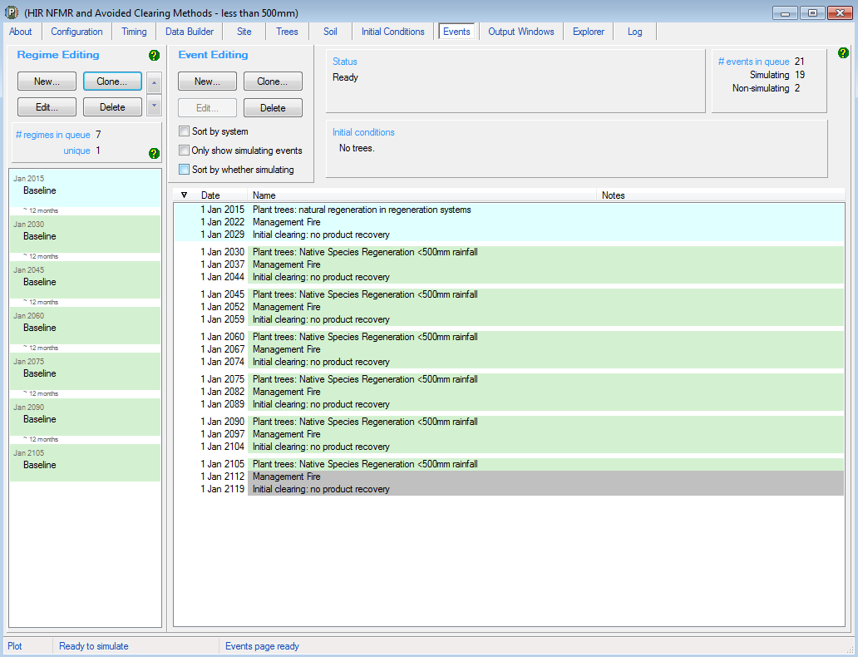

Check dates of all cloned events and edit date if required: select event, click edit, adjust date and click ‘ok’.

The Output Tab
The ‘New from template’ option used to create plot files will by default select the correct output types for the applicable scenario. The below steps can be followed to ensure the output types are correct, and to rectify any issues with those selected.
Simulation Type | Steps required
C100_5%  C10  Default baseline  Historic baseline  Hybrid baseline  Project carbon | - Double click on ‘Output1’ listed in the Output Window.  - Click on the icon at the top of the output window:  - Selected outputs have a tick next to their entry, and on the folder(s) where they are located. Unselect all items so that the text reads ‘0 outputs selected’.
C100_5%  C10 | - Select the tree carbon pools: Carbon / Forest / Plants / C mass of trees.  - Click ‘OK’.
Default baseline  Hybrid baseline  Historic baseline | - Select the tree carbon pools: Carbon / Forest / Plants / C mass of trees.  - Select the debris carbon pools: Other / Carbon Projects / C mass of forest debris.
Project carbon | - Select the tree carbon pools: Carbon / Forest / Plants / C mass of trees.  - Select the debris carbon pools: Other / Carbon Projects / C mass of forest debris.  - Select the CH₄ emissions from fire: Carbon / Whole / Emissions / CH4 emitted due to fire.  - Select the N₂O emissions from fire: Nitrogen / Whole / Emissions / N2O emitted due to fire.  - Click ‘OK’.

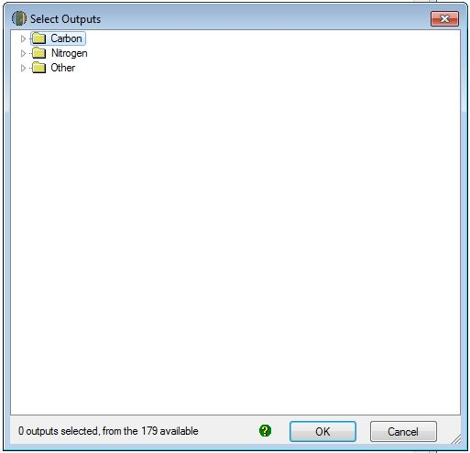
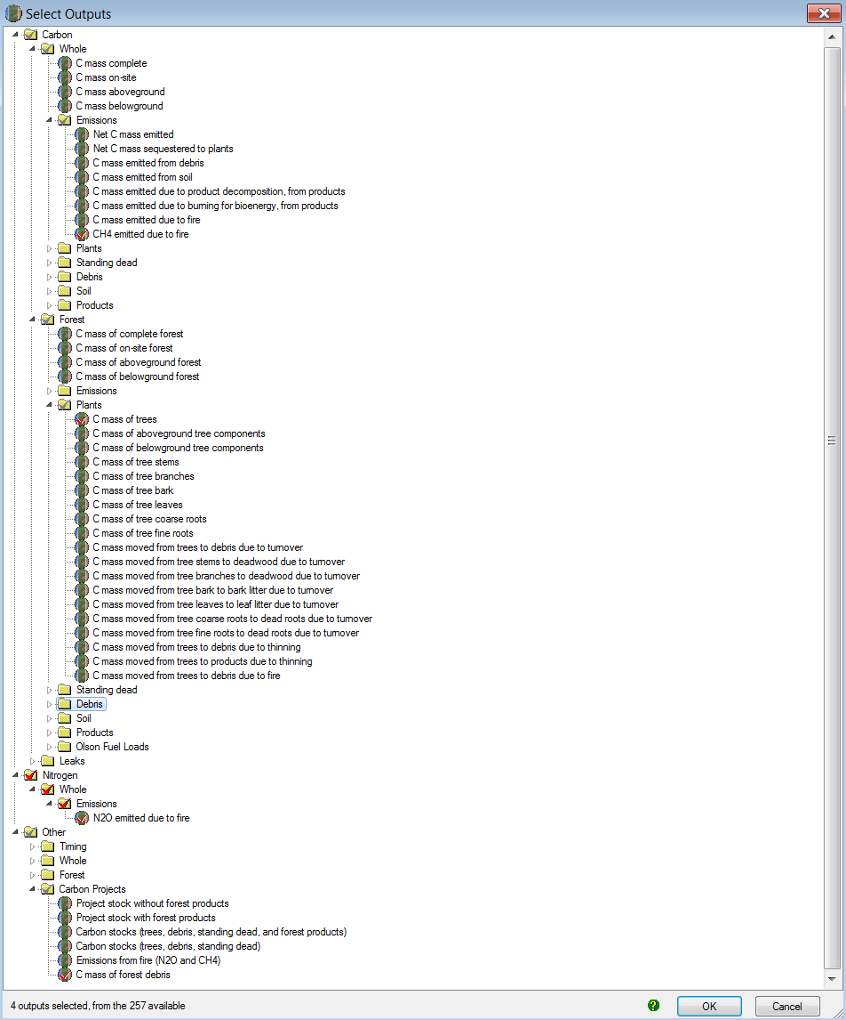

Running Simulations
To run the simulation, press the icon in the top menu bar:

Viewing outputs
Outputs can be viewed by clicking the icon (circled) at the top of the Output window as either:
- Graph
- Tabular form

Transferring outputs into a spreadsheet
To transfer data into a Microsoft Excel or equivalent spreadsheet for analysis:
Copy all the output data by clicking on the icon (circled) in the top of the Output window.
Open Microsoft Excel (or equivalent spreadsheet software), and ‘Paste’ the data copied from FullCAM into the spreadsheet. For example:
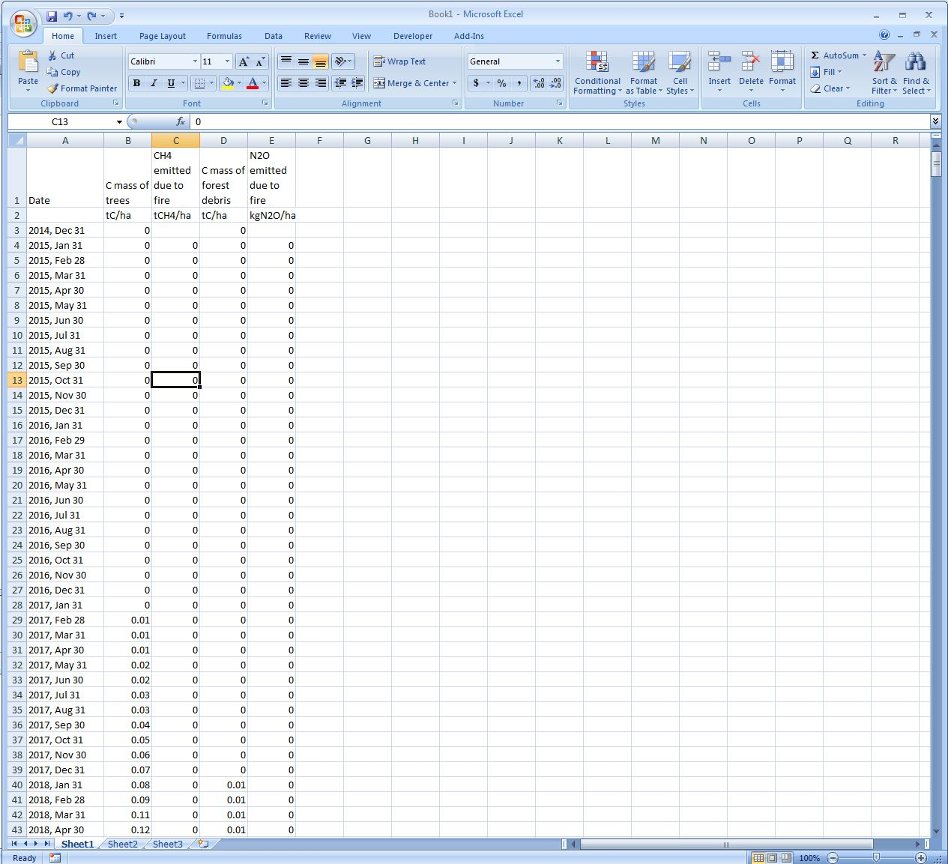
Simulation Type | Steps required
C100_5% | - Scroll down to the bottom rows of the data in the spreadsheet.  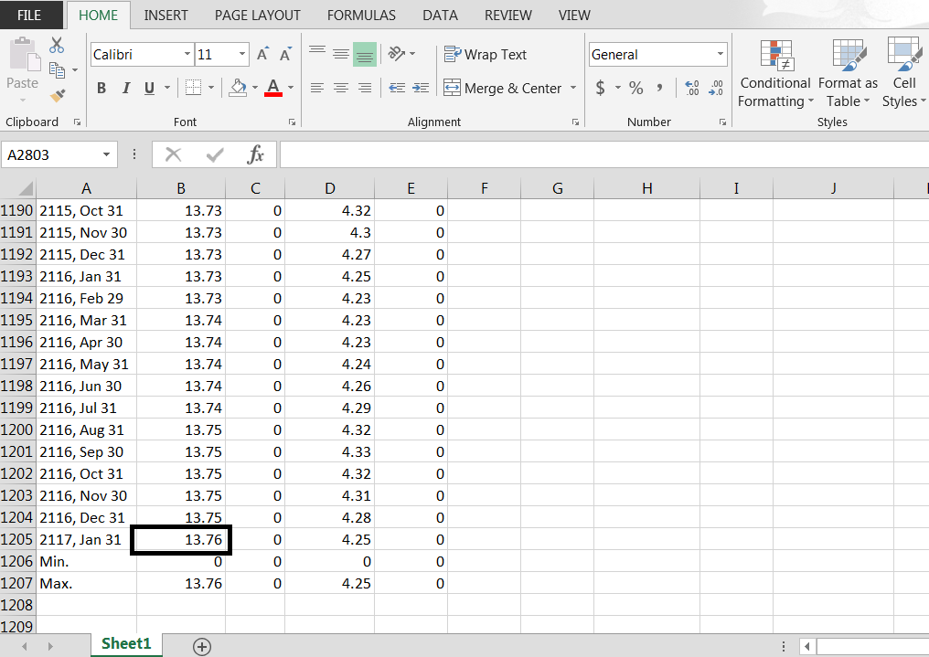  - Record the value in the ‘C Mass of Trees’ column for the last row of data pertaining to a date. This is C100 or the value of C at 100 years. To determine C100_5%, or 5% of this value, multiply C100 by 0.05. This value is used for the materiality test at section 4.7 of the Determination, calculated in accordance with section 4.8 of the Determination.
C10 | - Scroll down to the bottom of the spreadsheet, where the ‘Min’ and ‘Max’ values for each column will be shown.  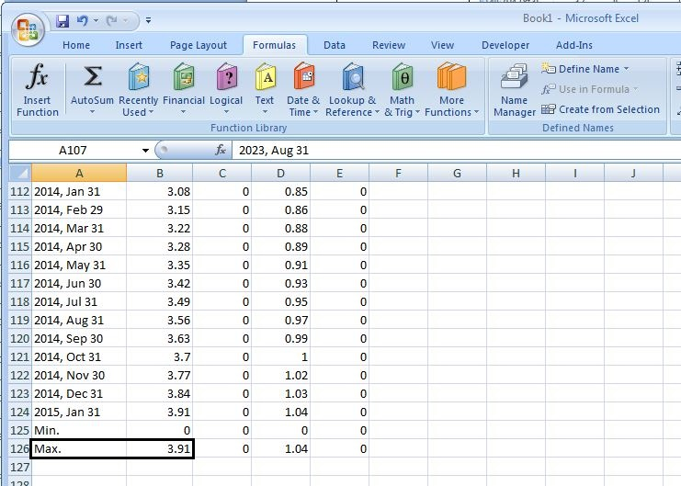  - Record the ‘Max’ value for the ‘C Mass of trees’ column (=C10). This value is used for the materiality test at section 4.7 of the Determination, calculated in accordance with section 4.9 of the Determination.
Default baseline  Historic baseline  Hybrid baseline | - Refer to Division 4.4 of the Determination for calculating baselines, specifically Equation 4 at section 4.24. Section 5 of these Guidelines details how each FullCAM output in the spreadsheet data corresponds to the equation parameters.
Project carbon | - Refer to Division 4.4 of the Determination for calculating end of reporting period Project carbon stocks, specifically Equation 2 at section 4.22. Section 5 of these Guidelines details how each FullCAM output in the spreadsheet data corresponds to the equation parameters.

2016 FullCAM option - Setting up simulations for carbon estimation areas
Section 1.2 describes the requirements for which FullCAM option can be used. The general effect of requirements described in Section 1.2 is that the 2020 FullCAM option is the default. Only projects that satisfy the criteria described in section 1.2 are able to use the 2016 FullCAM option.
The following steps must be followed for entering data into each tab in a FullCAM plot file. Each table provides a sequential list of steps in the right hand column. The left hand column indicates the Simulation Type that the steps are relevant to. Screenshots relevant to each set of steps, directly follow each table.

Opening a file
Simulation Type | Steps required
C100_5%  C10  Default baseline  Historic baseline  Hybrid baseline  Project carbon | - Open a new plot under the ‘File’ menu. Enter a name for the plot that reflects the identifier for the CEA and model scenario, e.g. ‘CEA1_baseline’.

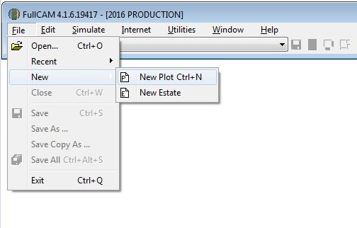

Saving a plot file
Simulation Type | Steps required
C100_5%  C10  Default baseline  Historic baseline  Hybrid baseline  Project carbon | - Save the plot file using the ‘File’ menu on the FullCAM toolbar.  - Save the plot file regularly when setting up and running simulations.
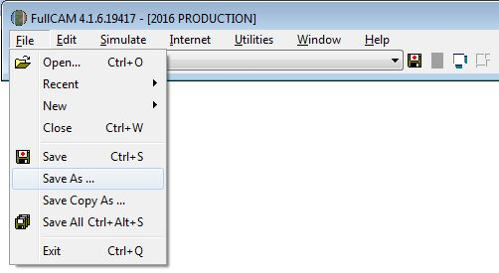

The Configuration Tab
Simulation Type | Steps required
C100_5%  C10  Default baseline  Historic baseline  Hybrid baseline  Project carbon | - From the ‘Plot’ drop down menu, select ‘Forest system’.  - Do NOT change any other settings.
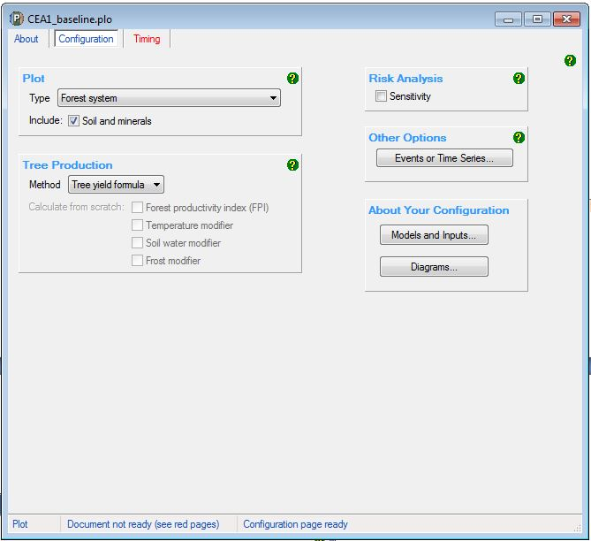

The Timing Tab
Simulation Type | Steps required
C100_5%  C10  Default baseline  Historic baseline  Hybrid baseline  Project carbon | - Set the Simulation Timing to ‘calendar’.  - Set the Output Steps to ‘months’.
C100_5% | - Enter the date to start simulations as the implementation date.  - Enter the date to end the simulation as 100 years after the implementation date.
C10 | - Enter the date to start simulations as the day after the last comprehensive clearing that occurred before the 10 year period that ends on the implementation date. Enter the date to end the simulation as the implementation date.
Default baseline  Historic baseline  Hybrid baseline  Project carbon | - Enter the date to start simulations as one day after the last comprehensive clearing before the implementation date.  - Enter the date to end the simulation as 100 years after the implementation date.
C100_5%  C10  Default baseline  Historic baseline  Hybrid baseline  Project carbon | - Do NOT change any other settings.  - New tabs will appear once this tab has been completed.
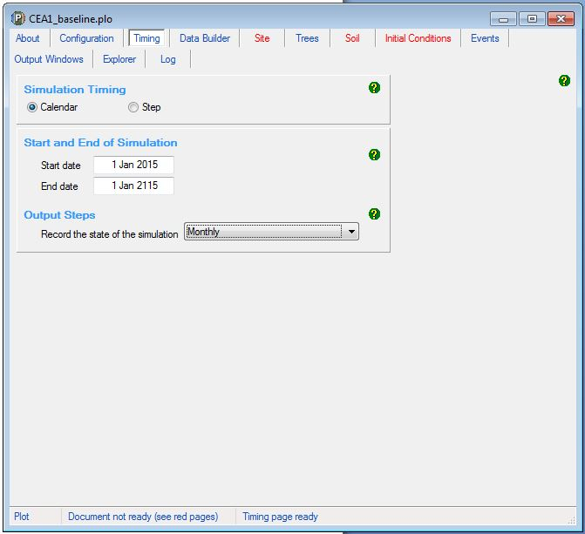

The Data Builder Tab
Simulation Type | Steps required
C100_5%  C10  Default baseline  Historic baseline  Hybrid baseline  Project carbon | - Check the box to turn on the Data Builder (this requires an internet connection).  - Enter the latitude and longitude (in decimal degrees) of the model point location central to the CEA being modelled and not in an exclusion area.  - Click the button to ‘Download Spatial Data’ and click ‘OK’ on the information box that pops up.  - Select ‘Mixed species environmental plantings’ from the dropdown box for ‘Tree species’ and then click the button to ‘Download This Species’ and ‘Yes’ to ‘Make mixed species environmental plantings the initial tree species’. NB: Do NOT use the ‘Mixed species environmental plantings temperate’ setting.  - Do NOT download a regime (and therefore the events associated with the regime) for this species.  - Do NOT change any other settings.
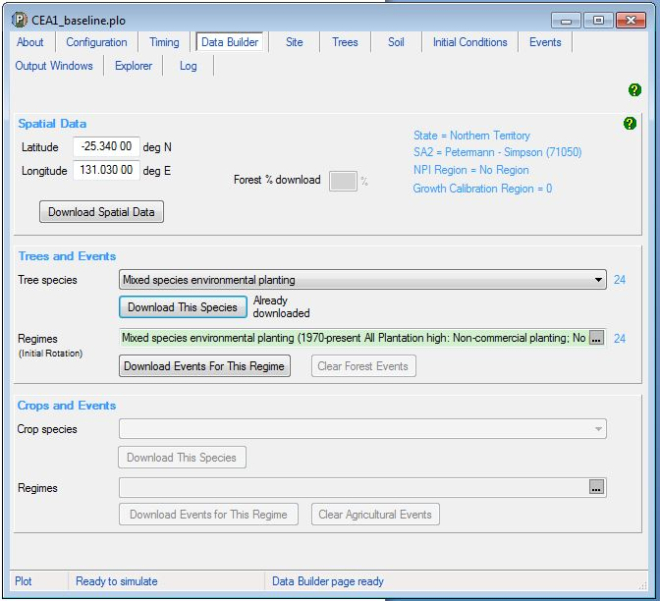

The Site Tab
Simulation Type | Steps required
C100_5%  C10  Default baseline  Historic baseline  Hybrid baseline  Project carbon | - Do NOT change any settings.

The Tree Tab
Simulation Type | Steps required
C100_5%  C10  Default baseline  Historic baseline  Hybrid baseline  Project carbon | - Do NOT change any settings.

The Soil Tab
Simulation Type | Steps required
C100_5%  C10  Default baseline  Historic baseline  Hybrid baseline  Project carbon | - Do NOT change any settings.

The Initial Conditions Tab
Simulation Type | Steps required
C100_5%  C10  Default baseline  Historic baseline  Hybrid baseline  Project carbon | - Click the button labelled ‘Trees’ and uncheck the box under ‘Existence’ to show that the site did not have trees growing on it at the start of the simulation. Click ‘OK’.  - Click the button labelled ‘Debris’ and change all the default settings for each debris pool to zero.  - Do NOT change any other settings.

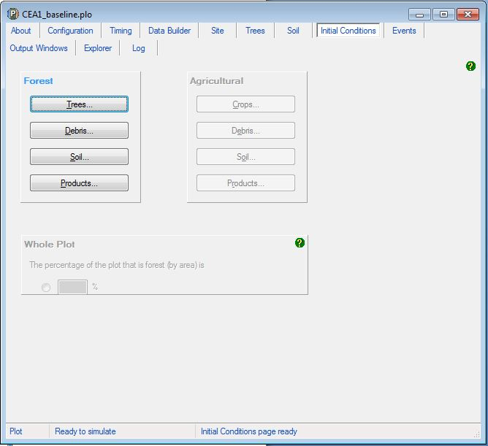

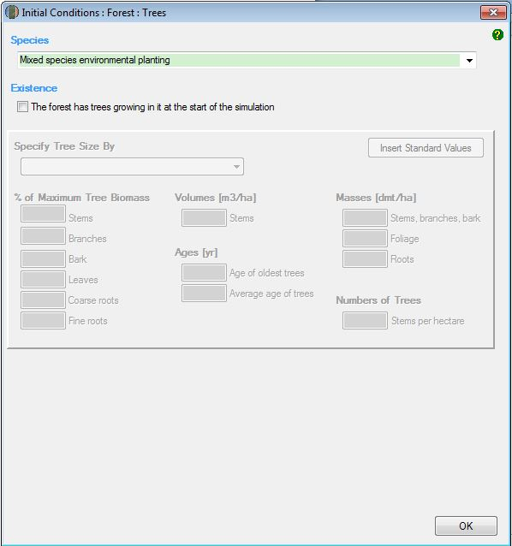

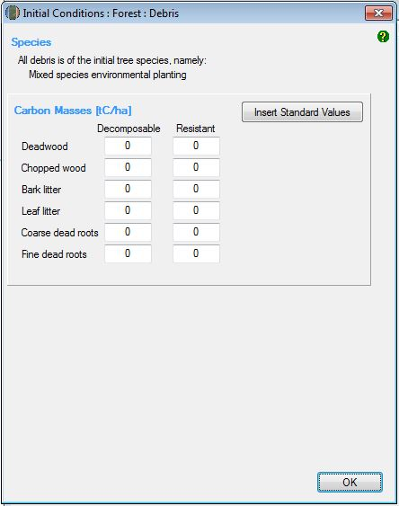

The Events Tab
The Events Tab is where events for a simulation can be added and displayed in sequence.

Simulation Type | Permitted Events
C100_5% | Regeneration
C10 | Regeneration  Growth Pause  Clearing  Thinning  Management fire  Windrow and burn fire
Default baseline | Regeneration  Clearing  Management fire – where sufficient evidence (see s 4.12 of the Determination)  Windrow and burn fire – where sufficient evidence (s 4.12 of the Determination)
Historic baseline  Hybrid baseline | Regeneration  Clearing  Thinning  Management fire – where sufficient evidence (see s 4.12 of the Determination)  Windrow and burn fire – where sufficient evidence (s 4.12 of the Determination)
Project carbon | Regeneration  Growth Pause  Clearing  Thinning  Management fire  Windrow and burn fire  Prescribed fire – to reduce fire risk  Wildfire – trees not killed  Wildfire – trees killed

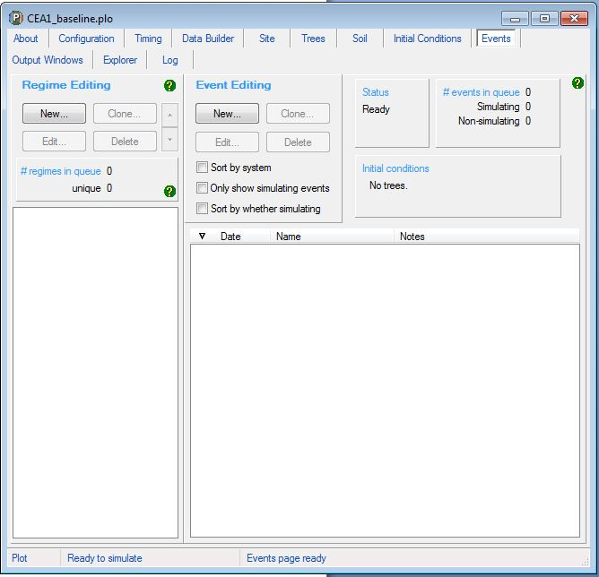

Adding a regeneration event
The notes below must be followed to add a regeneration event. There are different requirements for modelling a regeneration event according to the scenario type and when the CEA was first registered within a project area.
For the project carbon scenario, the timing of a regeneration event must be supported by evidence (subsection 4.19(2) and paragraph 5.5(b) of the Method), as well as conform with the input requirements specified here (paragraph 4.18(2)(a) of the Method). The start date of a regeneration event must correspond with the presence of forest potential within the CEA and the requirements set out below for differing project registration/variation dates.
Regeneration is an ongoing event where carbon continues to accumulate in vegetation, rather than a point in time occurrence such as fire or clearing. As per section 3.8, subsection 4.19(2) and paragraph 5.5(b) of the Method, the modelling of regeneration must be supported by evidence that regeneration has occurred throughout the modelling period. In the absence of evidence of ongoing regeneration, either, a growth pause should be modelled under section 4.10.5 or the CEA should be re-stratified to exclude areas where regeneration has ceased (as per section 3.6 of the Determination).
For the paragraphs below, the ‘applicable date’ for a CEA is the project registration date, except for land later added to the project area through a project variation, in which case it is the project variation date.
If the applicable date is after 31 March 2019, no more than 10 years of cumulative regeneration may be modelled prior to the applicable date. The regeneration event may commence more than 10 years before the applicable date where growth pause events are modelled. For example, for a project registered on 1 January 2020, proponents may model regeneration commencing 12 years earlier in 2008, where a two-year growth pause has been identified and modelled as occurring from 2013-15.
If the applicable date is between 13 December 2017 and 31 March 2019, the timing of a regeneration event in the project carbon scenario cannot be more than 14 years prior to the applicable date.
If the applicable date is before 13 December 2017, the timing of a regeneration event in the project carbon scenario is not limited to a specific period prior to the applicable date. For these CEAs, proponents may optionally elect to model growth pause events in the event of suppression or slowing of regeneration.
For the default baseline scenario, a regeneration event occurs 12 months after each comprehensive clearing. See subsection 4.12(6) and paragraph 4.15(2)(b) of the Determination.
For the C10, hybrid and historic baseline scenarios, the timing of a regeneration event is 12 months after each comprehensive clearing, unless evidence supports setting the date to another time. See section 4.6, and subsections 4.8(5), 4.12(9) and 4.12(15) of the Determination.
Steps for the Project Carbon Scenario Modelling
Simulation Type | Steps required
Project carbon | - Click the ‘New’ button under ‘Event Editing’ to create a new event. In the drop down menu next to ‘Type’, select ‘Plant trees’.  - Click ‘Insert standard values’. Select the row with the ‘Event Name’ of ‘Plant trees: natural regeneration’ and then click ‘OK’ and ‘Yes’ to insert the name of the standard event.  - Enter the date of the event, determined with respect to the above notes.  - Do NOT change any other setting.  - Click ‘OK’ to finish adding the event to the event queue.

Steps for the Baseline and Materiality Test Modelling
Simulation Type | Steps required
C100_5%  C10  Default baseline  Historic baseline  Hybrid baseline | - Click the ‘New’ button under ‘Event Editing’ to create a new event.
C100_5% | - Insert the simulation start date in the blank field beside the ‘Timing’ section. This will need to be entered in the format dd mmm yyyy.
Default baseline | - Enter the date that is 12 months after the most recent comprehensive clearing in the blank field beside the ‘Timing’ section. This will need to be entered in the format dd mmm yyyy.
C10  Historic baseline  Hybrid baseline | - Enter the date as determined from the above notes in the blank field beside the ‘Timing’ section. This will need to be entered in the format dd mmm yyyy.
C100_5%  C10  Default baseline  Historic baseline  Hybrid baseline | - In the drop down menu next to ‘Type’, select ‘Plant trees’.  - Click ‘Insert standard values’. Select the row with the ‘Event Name’ of ‘Plant trees: natural regeneration’ and then click ‘OK’ and ‘Yes’ to insert the name of the standard event.  - Do NOT change any other setting.  - Click ‘OK’ to finish adding the event to the event queue.

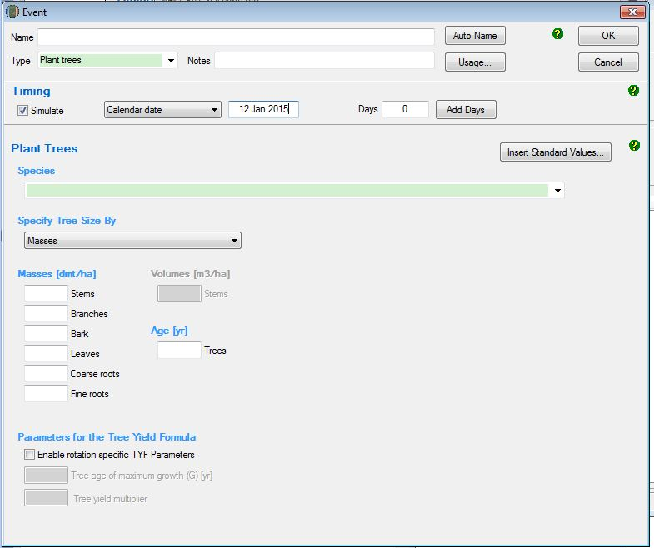
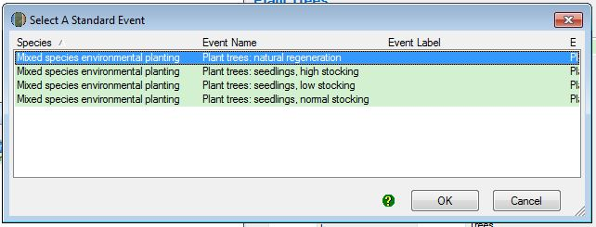
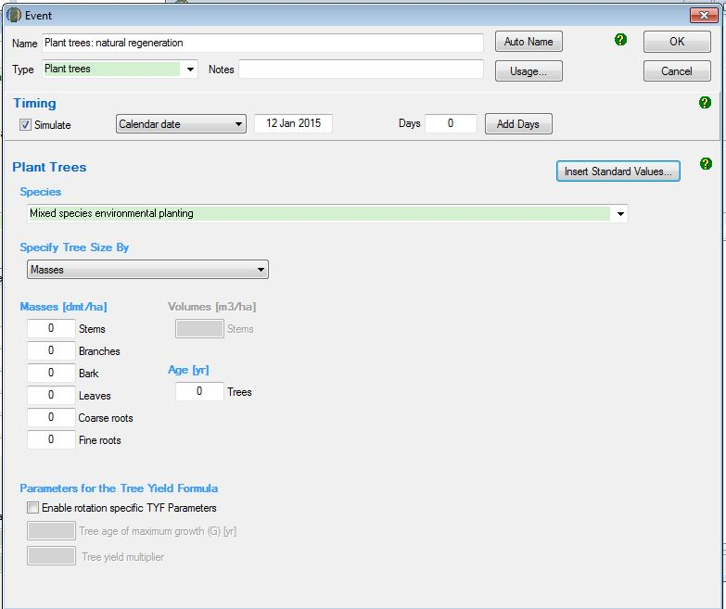
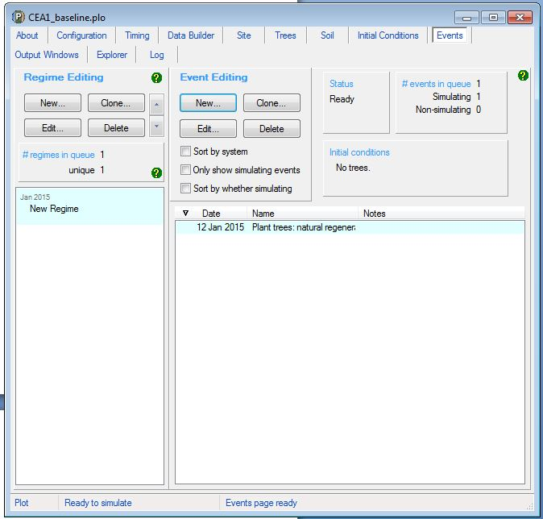

Adding a clearing event
These steps must be followed to add a clearing event, which corresponds to a comprehensive clearing referred to in the Determination.
Simulation Type | Steps required
C100_5% | - Not permitted
Project carbon | - Not permitted
C10  Default baseline  Historic baseline  Hybrid baseline | - Click the ‘New’ button under ‘Event Editing’ to create a new event.
C10  Historic baseline  Hybrid baseline | - Insert the date of the clearing event in the blank field beside the ‘Timing’ section.  - For the first clearing event, insert the date of the clearing event in the blank field beside the ‘Timing’ section based on what occurred historically. This will need to be entered in the format dd mmm yyyy.  - For subsequent clearing events, insert the date of clearing in this field to represent the observed date or default interval between comprehensive clearings as per section 4.6 of the Determination.
Default baseline | - Insert the date of the clearing event in the blank field beside the ‘Timing’ section. Each clearing event will be 14 years after the previous regeneration event.
C10  Default baseline  Historic baseline  Hybrid baseline | - In the drop down menu next to ‘Type’, select ‘Thin’.  - Click ‘Insert standard values’. Select the row with ‘Event Name’ of ‘Initial clearing: No product recovery’ and then click ‘OK’ and ‘Yes’ to insert the name of the standard event.  - Ensure that the box next to ‘Affected portion’ contains the value ‘100’ to indicate a clearing event.  - Do NOT change any other settings.  - Click ‘OK’ to finish adding the event to the event queue.

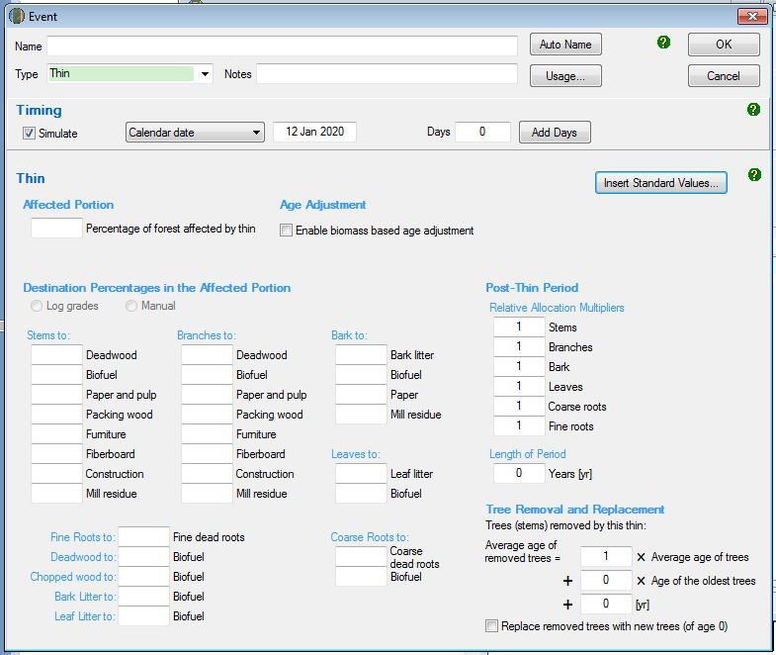
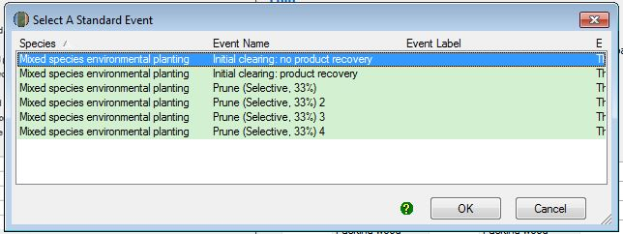
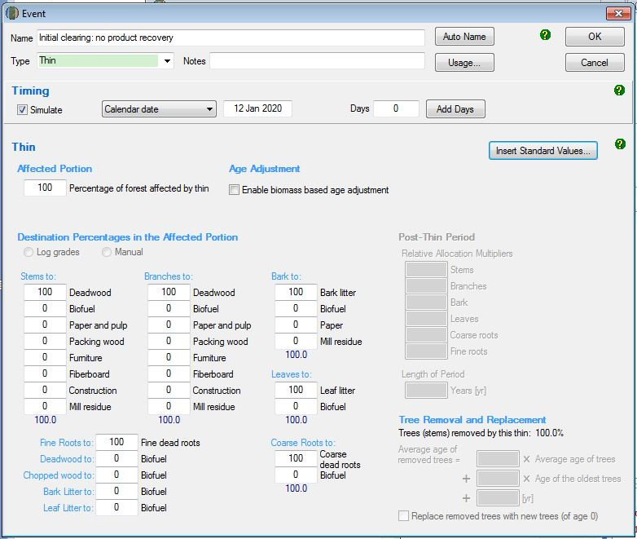

Adding a thinning event
These steps must be followed to add a thinning event.
Simulation Type | Steps required
C100_5% | - Not permitted
Default baseline | - Not permitted
C10  Historic baseline  Hybrid baseline  Project carbon | - Click the ‘New’ button to create a new event.  - Insert the date of the thinning event in the blank field beside the ‘Timing’ section. This will need to be entered in the format dd mmm yyyy. The intervals between events must reflect those that occurred historically.  - In the drop down menu next to ‘Type’, select ‘Thin’.  - Click ‘Insert standard values’. Select the row with ‘Event Name’ of ‘Initial clearing: No product recovery’ and then click ‘OK’ and ‘Yes’ to insert the name of the standard event.  - In the box next to ‘Affected portion – the percentage of forest affected by thin’ change the number to an estimate of the proportion of the stems that were killed in the thinning. You must report on how the estimate was derived in your project report.  - Do NOT change any other settings.  - Click ‘OK’ to finish adding the event to the event queue.

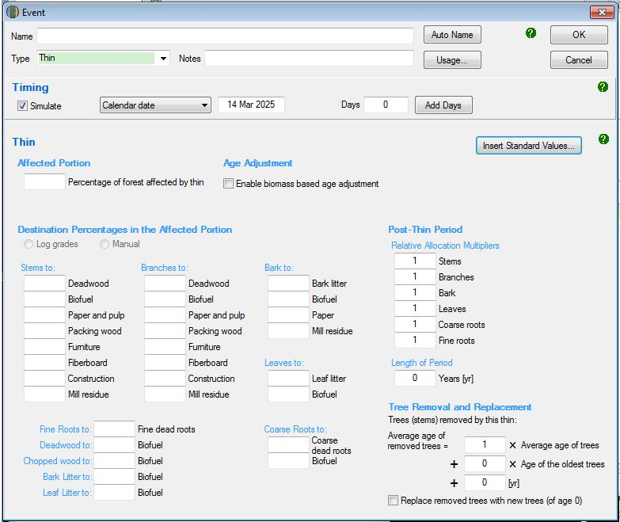
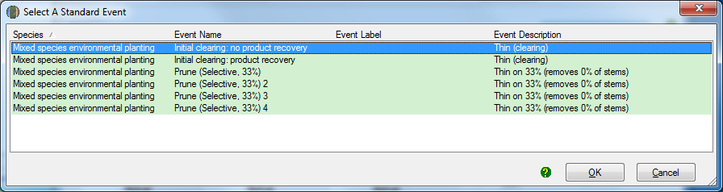
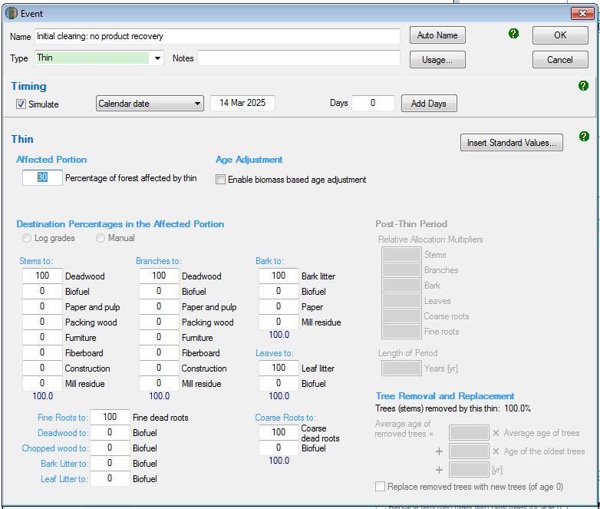

Adding fire events
      - Adding a management fire event
These steps must be followed to add a management fire event. A management fire event encourages grass for pasture. It is a fire that occurs within a clearing interval and is used to set back the regrowth, killing a substantial proportion of the above ground plant parts.
Simulation Type | Steps required
C100_5% | - Not permitted
C10 | - Not permitted
Default baseline  Historic baseline  Hybrid baseline  Project carbon | - Click on the ‘New’ button to create a new event.  - In the blank field besides the ‘Timing’ section, insert the date of the management fire in the simulation period. The intervals between events must reflect those that occurred historically. For example, for default values used in baselines, this is 7 years after the regeneration event.  - In the drop down menu next to ‘Type’, select ‘Forest fire’.  - Click ‘Insert standard values’. Select the row with ‘Event Name’ of ‘Wildfire – trees killed’ and then click ‘OK’ and ‘Yes’ to insert the name of the standard event.  - Change the name of the event to ‘management fire’.  - CHANGE THE SETTINGS TO MATCH THOSE IN THE SCREENSHOT BELOW.  - Tick the ‘Enable biomass based age adjustments’ box.  - Click ‘OK’ to finish adding the event to the event queue.

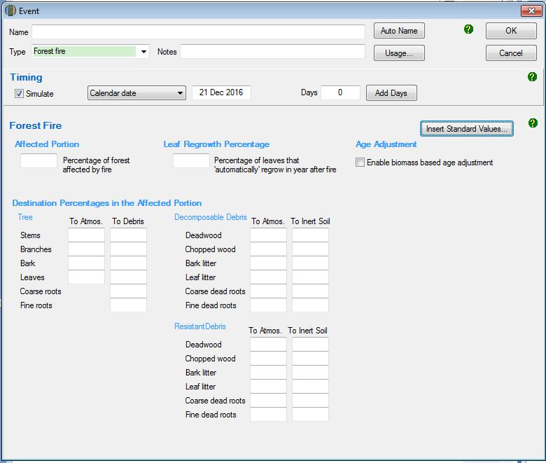
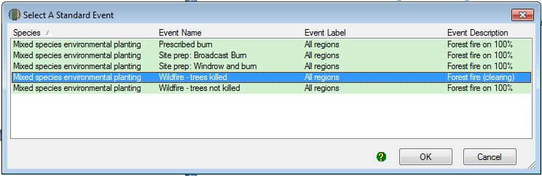
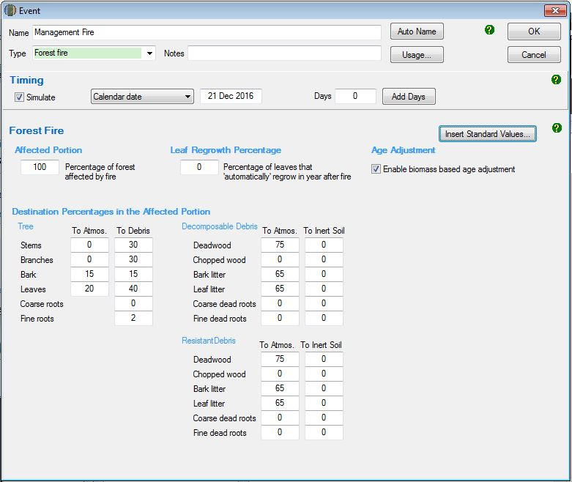
      - Adding a windrow and burn fire event
A windrow and burn fire event reduces the amount of debris that remains after the clearing event. Evidence is required to support modelling a windrow and burn event. See subsection 4.12(5) regarding evidence to support modelling this event under a default baseline scenario, and subsections 4.8(5), 4.12(10) and 4.12(14) for C10, hybrid baseline, and historic baseline scenarios respectively.
For the default baseline scenario, where a windrow and burn event is to be included, it must be modelled as occurring six months after each clearing event.
Simulation Type | Steps required
C100_5% | - Not permitted
Project carbon | - Not permitted
C10  Default baseline  Historic baseline  Hybrid baseline | - Click on the ‘New’ button to create a new event.  - Insert the date of the windrow and burn fire in the simulation period in the blank field beside the ‘Timing’ section.  - In the drop down menu next to ‘Type’, select ‘Forest fire’.  - Click ‘Insert standard values’. Select the row with ‘Event Name’ of ‘Site prep: Windrow and burn’ and then click ‘OK’ and ‘Yes’ to insert the name of the standard event.  - Do NOT change any other setting.  - Click ‘OK’ to finish adding the event to the event queue.

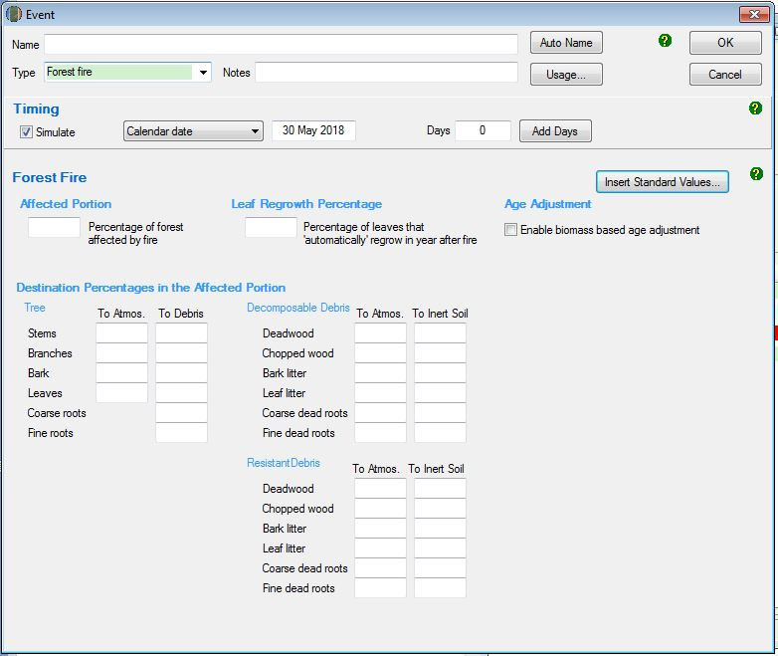
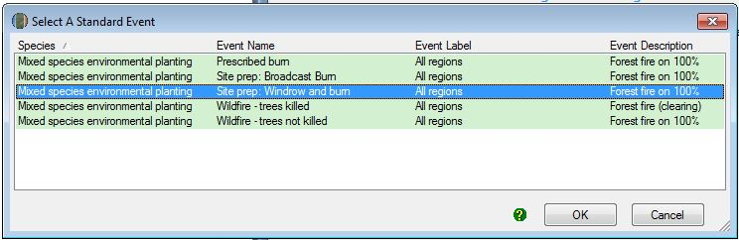
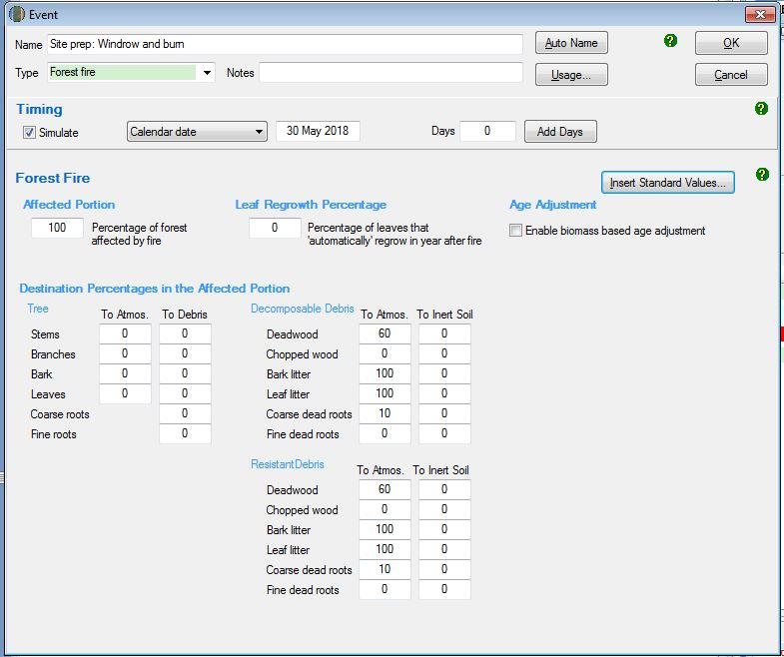
      - Adding a prescribed fire event – to reduce fire risk
These steps must be followed to add a prescribed fire event – to reduce fire risk. These events are aimed at reducing fuel loads and hence fire risk. They control the accumulation of the debris pool. The date modelled must reflect the actual date of that event.
Simulation Type | Steps required
C100_5% | - Not permitted
C10 | - Not permitted
Default baseline | - Not permitted
Historic baseline | - Not permitted
Hybrid baseline | - Not permitted
Project carbon | - Click on the ‘New’ button to create a new event.  - Insert the date of the prescribed fire in the simulation period in the blank field beside the ‘Timing’ section.  - In the drop down menu next to ‘Type’, select ‘Forest fire’.  - Click ‘Insert standard values’. Select the row with ‘Event Name’ of ‘Prescribed burn’ and then click ‘OK’ and ‘Yes’ to insert the name of the standard event.  - Tick the ‘Enable biomass based age adjustments’ box.  - Do NOT change any other setting.  - Click ‘OK’ to finish adding the event to the event queue.

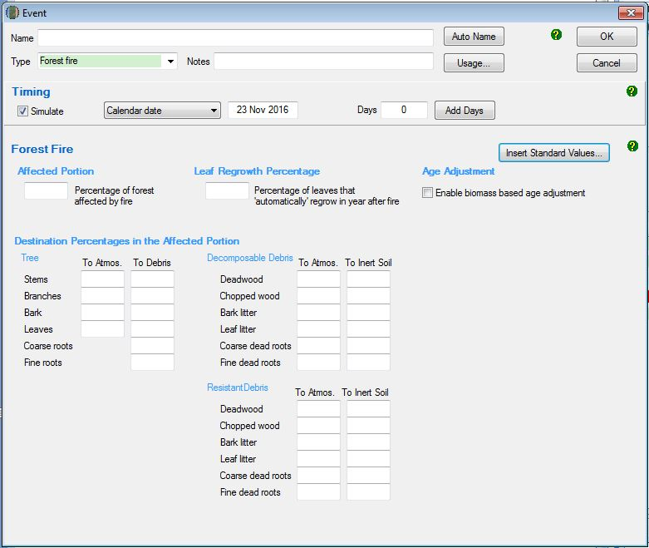
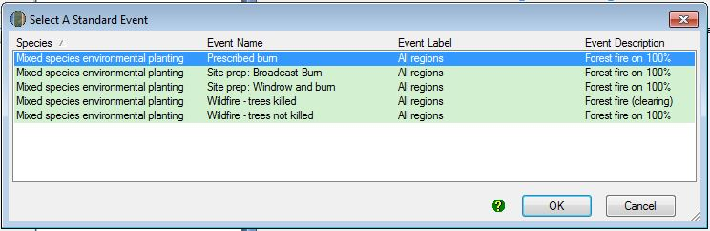
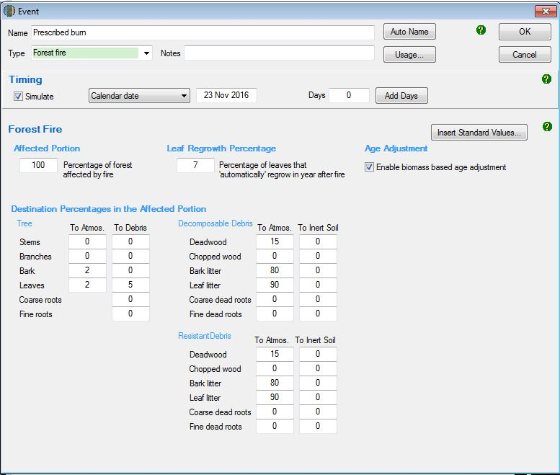
      - Adding a wildfire – trees not killed event
These steps must be followed to add a wildfire – trees not killed event.
Simulation Type | Steps required
C100_5% | - Not permitted
C10 | - Not permitted
Default baseline | - Not permitted
Historic baseline | - Not permitted
Hybrid baseline | - Not permitted
Project carbon | - Click on the ‘New’ button to create a new event.  - Insert the date of the wildfire where trees are not killed in the simulation period in the blank field beside the ‘Timing’ section.  - In the drop down menu next to ‘Type’, select ‘Forest fire’.  - Click ‘Insert standard values’. Select the row with ‘Event Name’ of ‘Wildfire – trees not killed’ and then click ‘OK’ and ‘Yes’ to insert the name of the standard event.  - Tick the ‘Enable biomass based age adjustments’ box.  - Do NOT change any other setting.  - Click ‘OK’ to finish adding the event to the event queue.

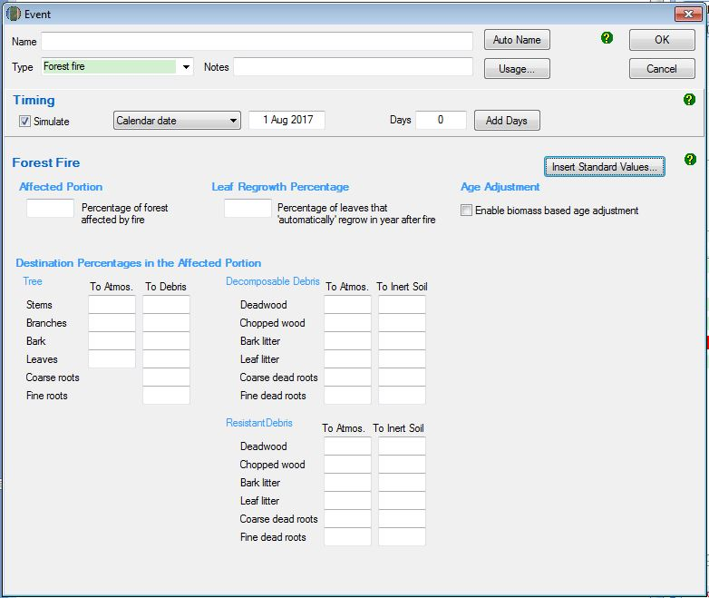
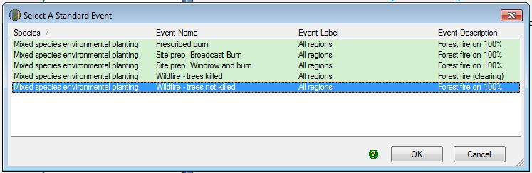
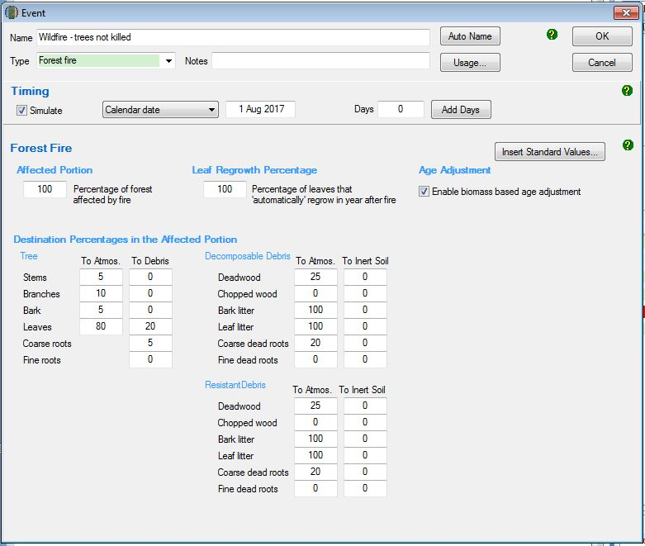
      - Adding a wildfire – trees killed event
These steps must be followed to add a wildfire – trees killed event.
Simulation Type | Steps required
C100_5% | - Not permitted
C10 | - Not permitted
Default baseline | - Not permitted
Historic baseline | - Not permitted
Hybrid baseline | - Not permitted
Project carbon | - Click the ‘New’ button to create a new event.  - Insert the date that the wildfire – trees killed event in the blank field beside the ‘Timing’ section. This will need to be entered in the format dd mmm yyyy.  - In the drop down menu next to ‘Type’, select ‘Forest Fire’.  - Click ‘Insert standard values’. Select the row with ‘Event Name’ of ‘Wildfire – trees killed’ and then click ‘OK’ and ‘Yes’ to insert the name of the standard event.  - Click ‘OK’.  - Do NOT change any other settings.  - Click ‘OK’ to finish adding the event to the event queue.

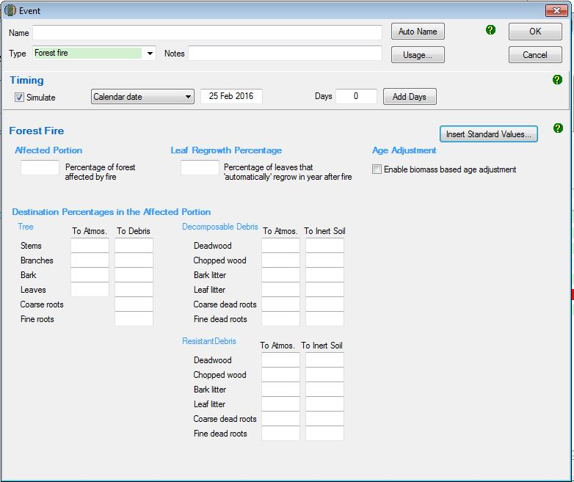
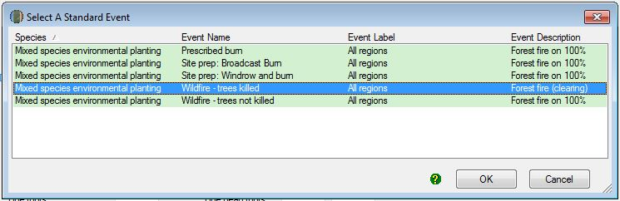

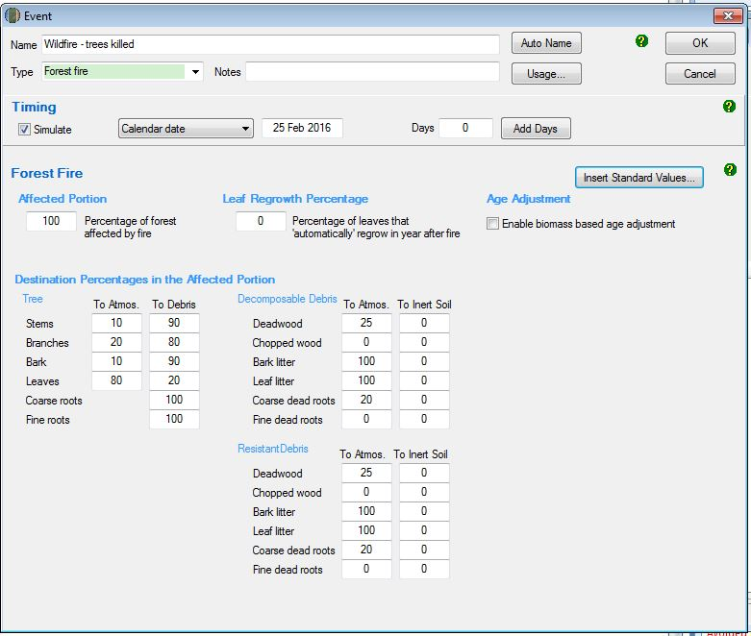

Adding a growth pause event
If a CEA was included in an eligible offsets project prior to 31 March 2019 and the 2016 FullCAM option is used, this section 4.10.5 is not taken to require any additional growth pauses to be modelled from the modelling start date under paragraph 4.19(1)(a) to the end of a reporting period included in an offsets report submitted before 1 July 2019. For example, if a project registered in July 2015 reported in June 2019 for a reporting period ending 1 June 2019, this section would not require extra growth pauses to be modelled from what was already included in previous offsets reports. However, if a CEA that was included in a project prior to 31 March 2019 but had not been reported by 1 July 2019, this section would apply. This exception does not override any other requirements in the Determination to accurately model regeneration and manage grazing.
A growth pause event is used to model the stopping or slowing of vegetation growth due to a suppression disturbance event (or the combined impacts of more than one suppression disturbance event), such as grazing by livestock/feral animals, disease or pests, or another event. Normal climatic variability of wetter and drier periods (i.e. including droughts to an extent) causing fluctuations in the growth rate are already incorporated within the vegetation growth calibration used by the model, and are not required to be added as growth pause events in FullCAM.
The use and timing of any modelled growth pause must be consistent with the records that evidence the type, timing and extent of disturbance events (see section 5.5 of the Determination). Where there is uncertainty over timing, a longer period may be used to conservatively estimate the duration of the growth pause. Such uncertainty does not preclude including additional growth pauses where appropriate, but the timing of such pauses should best give effect to the available evidence. Growth pauses are applicable throughout the crediting period.
Growth pauses should be included where necessary to ensure consistency with both:
- paragraph 4.19(2)(a) of the Determination, that the modelling accurately reflects the set of ‘actual management events’ that have occurred in a CEA. Growth pauses for management and disturbance events assist in ensuring that the abatement estimates of the method do not overestimate carbon abatement achieved by a project.
- the requirements of the Regulator’s five yearly regeneration checks[1] —required under 70(3A) of the Carbon Credits (Carbon Farming Initiative) Rule 2015. In the absence of the use of growth pauses to account for a lack of regeneration progress, CEAs may be need to be re-stratified to exclude the areas where regeneration cannot be evidenced (refer to the Regulator’s Guidelines).
The start date for a growth pause is the date on which growth stopped or slowed. Where there are multiple factors contributing to a suppression disturbance event, or the source of suppression or actual date of suppression disturbance event cannot be identified, the date can be estimated.

Simulation Type | Steps required
Project carbon  C10  Hybrid baseline  Historic baseline | - Click the ‘New’ button under ‘Event Editing’ to create a new event.  - Select Forest treatment event for type from the drop-down menu.  - DO NOT select Insert Standard Values (Note: This differs from the directions for other events above).  - Enter the calendar date of the start date of the disturbance event. This can be estimated if the actual date is not known.  - Enter ‘Grazing’ as the event name (or similar, e.g. ‘Growth Pause’).  - In the Age advance due to treatment box enter an estimate for how long the growth pause event occurred as a decimal proportion in years, and as a negative number. For example, if the event occurred for 3 years and 9 months, then ‘-3.75’ would be entered in this box. As another example, if the event occurred for 5 years, then ‘-5’ would be entered in this box.  - In the Advancement period box enter the absolute value of the number added in the ‘Age advance due to treatment’ box. For example, using the examples above, the value to add to this box would be: (1) ‘3.75’, or (2) ‘5’.  - Following these steps has the effect of ‘pausing’ growth in carbon stocks for the duration of the growth pause event.  - DO NOT change any other values on this tab.  - Press ‘OK’.
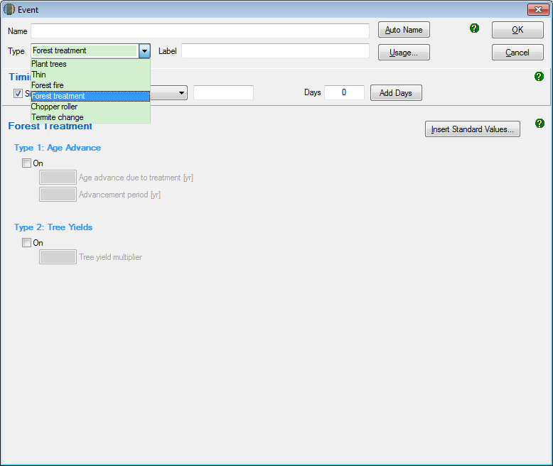
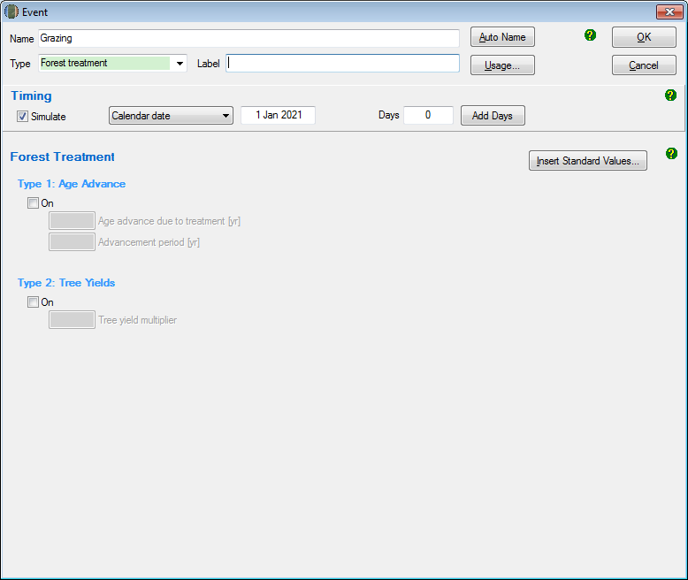
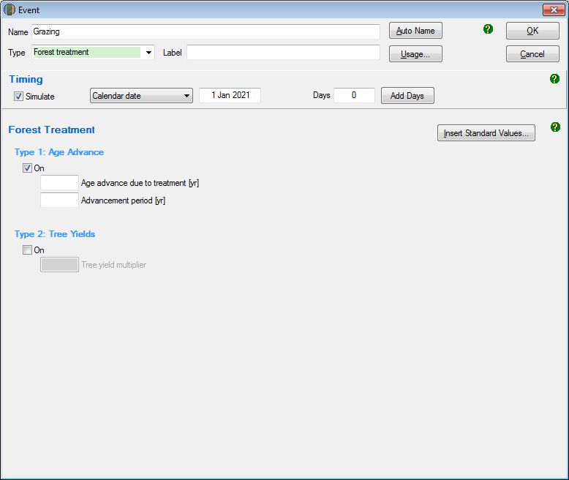
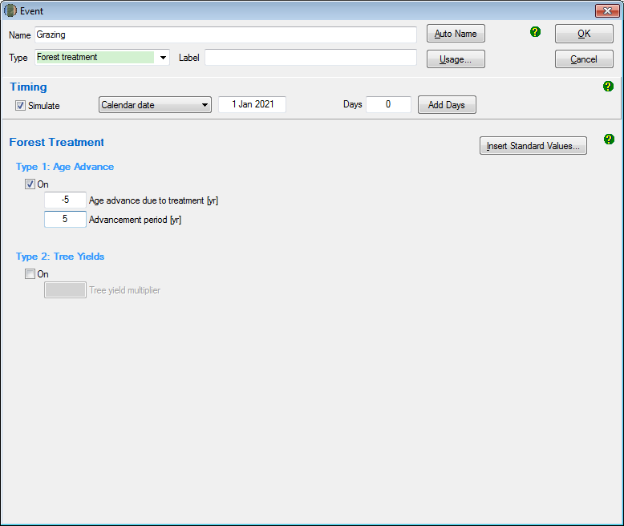

Creating and cloning regimes
For default, historic and hybrid baselines, the entire events queue that includes all simulated events for the entire baseline management event scenario (see section 4.12 of the Determination) must be cloned to cover the 100 year baseline forecast period.
Simulation Type | Steps required
Default baseline | - Follow the above steps to create a plot and the events forming a single clearing interval of 15 years (regeneration, windrow and burn where applicable, management fire where applicable, and clearing). By default, FullCAM will create a new regime for each event added.  - Highlight each of the existing regimes in the left hand column by holding ctrl on the keyboard and clicking on each regime.  - Select the ‘Edit’ button under the Regime Editing header.  - In the name field type ‘baseline’, then click ‘ok’. This will combine all existing events under one regime.  - Press the ‘Clone’ button under the Regime Editing header.  - Enter ‘15’ for calendar years and for ‘number of times’, a value high enough to clone events over the entirety of the 100-plus year baseline period and click ‘ok’.  - Any events that are highlighted grey towards the bottom of the events queue fall beyond the 100-plus year modelling period and will not be simulated. These can be left in the event queue as they will not affect the simulation.
Historic baseline | - Follow the above steps to create a plot and the events forming the two clearing intervals of the durations supported by historical evidence.  - Highlight each of the existing regimes in the left hand column by holding ctrl on the keyboard and clicking on each regime.  - Select the ‘Edit’ button under the Regime Editing header.  - In the name field type ‘baseline’, then click ‘ok’. This will combine all existing events under one regime.  - Calculate the number of years between the first event of the first interval and the last event of the second interval. Add 1 to this number. I.e. years between initial regeneration event modelled and the last clearing event modelled plus 1.  - Press the ‘Clone’ button under the Regime Editing header.  - Enter the number calculated above for ‘calendar years’ and for ‘number of times’, a value high enough to clone events over the entirety of the 100-plus year baseline period and click ‘ok’.  - Any events that are highlighted grey towards the bottom of the events queue fall beyond the 100-plus year modelling period and will not be simulated. These can be left in the event queue as they will not affect the simulation.
Hybrid baseline | - Follow the above steps to create a plot and the events forming the first clearing interval of 15 years, and the second clearing interval of the duration supported by historical evidence. By default, FullCAM will create a new regime for each event added.  - Highlight each of the existing regimes in the left hand column by holding ctrl on the keyboard and clicking on each regime.  - Select the ‘Edit’ button under the Regime Editing header.  - In the name field type ‘baseline’, then click ‘ok’. This will combine all existing events under one regime.  - Calculate the number of years between the first event of the first interval and the last event of the second interval. Add 1 to this number. I.e. years between initial regeneration event modelled and last clearing event plus 1.  - Press the ‘Clone’ button under the Regime Editing header.  - Enter the number calculated above for ‘calendar years’ and for ‘number of times’, a value high enough to clone events over the entirety of the 100-plus year baseline period and click ‘ok’.  - Any events that are highlighted grey towards the bottom of the events queue fall beyond the 100-plus year modelling period and will not be simulated. These can be left in the event queue as they will not affect the simulation.
C10  C100_5%  Project carbon | - Not applicable

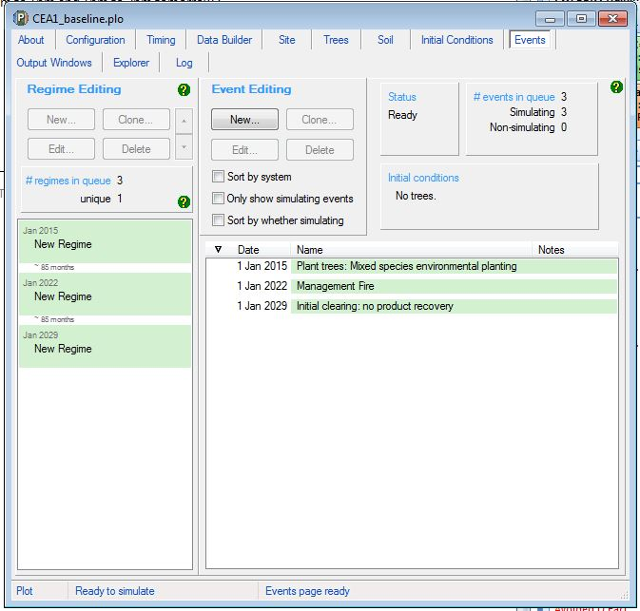
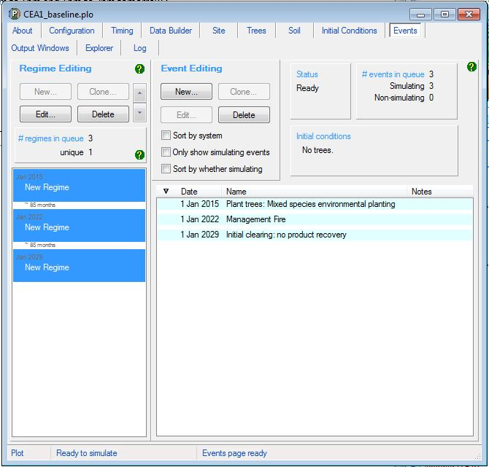

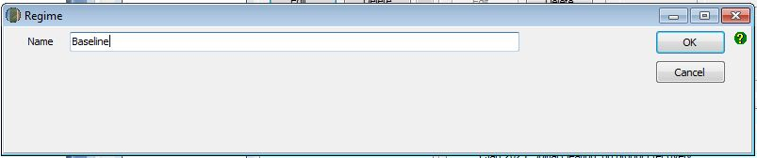
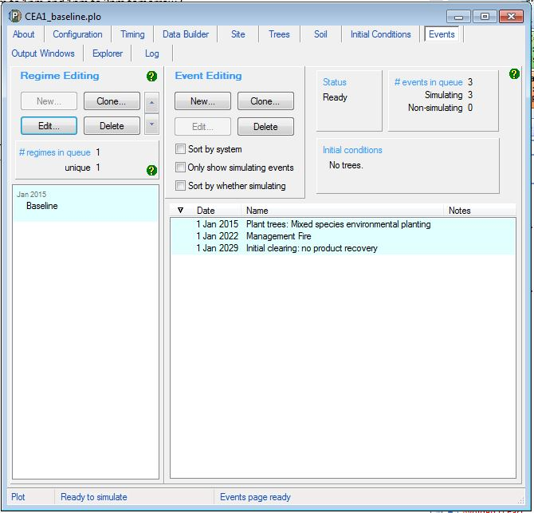
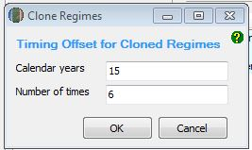

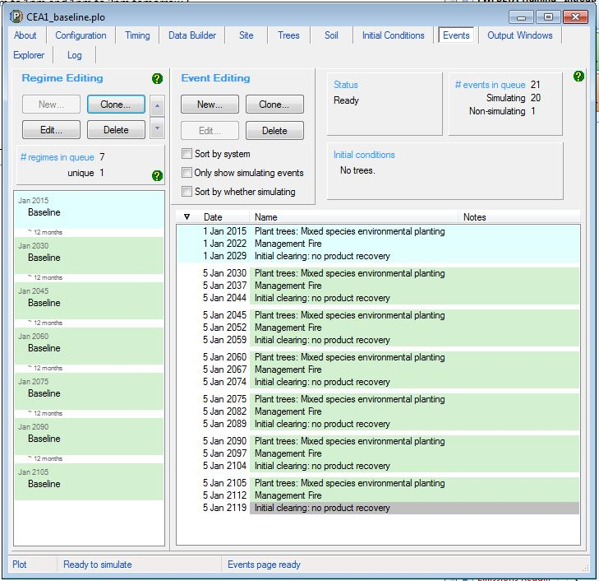

The Output Tab
Simulation Type | Steps required
C100_5%  C10  Default baseline  Historic baseline  Hybrid baseline  Project carbon | - Double click on ‘Output1’ listed in the Output Window.  - Click on the icon at the top of the output window:  - Selected outputs have a tick next to their entry, and on the folder(s) where they are located. Unselect all items so that the text reads ‘0 outputs selected’.
C100_5%  C10 | - Select the tree carbon pools: Carbon / Forest / Plants / C mass of trees.  - Click ‘OK’.
Default baseline  Hybrid baseline  Historic baseline | - Select the tree carbon pools: Carbon / Forest / Plants / C mass of trees.  - Select the debris carbon pools: Carbon / Forest / Plants / C mass of debris.  - Click ‘OK’.
Project carbon | - Select the tree carbon pools: Carbon / Forest / Plants / C mass of trees.  - Select the debris carbon pools: Carbon / Forest / Debris / C mass of forest debris.  - Select the CH₄ emissions from fire: Carbon / Whole / Emissions / CH4 emitted due to fire.  - Select the N₂O emissions from fire: Nitrogen / Whole / Emissions / N2O emitted due to fire.  - Click ‘OK’.

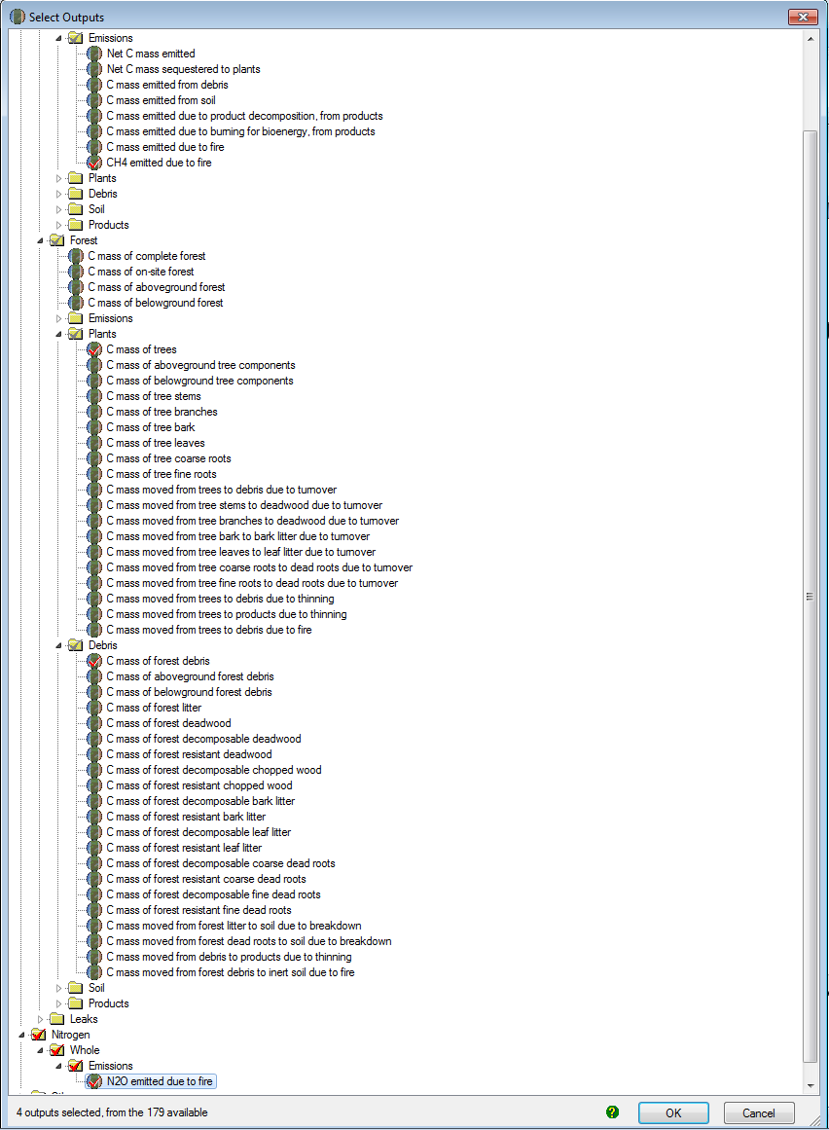

Running Simulations
To run the simulation, press the icon in the top menu bar:

Viewing outputs
Outputs can be viewed by clicking the icon (circled) at the top of the Output window as either:
- Graph
- Tabular form

Transferring outputs into a spreadsheet
To transfer data into a Microsoft Excel or equivalent spreadsheet for analysis:
Copy all the output data by clicking on the icon (circled) in the top of the Output window.
Open Microsoft Excel (or equivalent spreadsheet software), and ‘Paste’ the data copied from FullCAM into the spreadsheet. For example:

Simulation Type | Steps required
C100_5% | - Scroll down to the bottom rows of the data in the spreadsheet.  - Record the value in the ‘C Mass of Trees’ column for the last row of data pertaining to a date. This is C100 or the value of C at 100 years. To determine C100_5%, or 5% of this value, multiply C100 by 0.05.This value is used for the materiality test at section 4.7 of the Determination, calculated in accordance with section 4.8 of the Determination.
C10 | - Scroll down to the bottom of the spreadsheet, where the ‘Min’ and ‘Max’ values for each column will be shown.  - Record the ‘Max’ value for the ‘C Mass of trees’ column (=C10). This value is used for the materiality test at section 4.7 of the Determination, calculated in accordance with section 4.9 of the Determination.
Default baseline  Historic baseline  Hybrid baseline | - Refer to Division 4.4 of the Determination for calculating baselines, specifically Equation 4 at section 4.24. Section 5 of these Guidelines details how each FullCAM output in the spreadsheet data corresponds to the equation parameters.
Project carbon | - Refer to Division 4.4 of the Determination for calculating end of reporting period Project carbon stocks, specifically Equation 2 at section 4.22. Section 5 of these Guidelines details how each FullCAM output in the spreadsheet data corresponds to the equation parameters.

FullCAM simulations and offsets reporting
Project proponents must calculate the project net abatement by completing the equations in sections 4.21 to 4.29 of the Determination. Parameters generated in FullCAM are used in Equations in the Determination.
Note that for some of the equations the average of the FullCAM output over the simulation period will be required, whereas for others the value of the FullCAM output at the end of the simulation period will be used. Refer to the equations within the Determination to determine which value to use. Averages can be calculated using the average function within your spreadsheet software.
FullCAM Output | Parameter as defined in the Determination | Scenario | Equation in the determination
C mass of debris | CD_{CEA,i} | Project | 3
C mass of debris | BCD_{CEA,i,k} | Baseline | 4
C mass of trees | CT_{CEA,i} | Project | 3
C mass of trees | BCT_{CEA,i,k} | Baseline | 4
CH₄ emitted from debris due to fire | E_{CH4,i} | Project | 7
N₂O emitted due to fire | E_{N2O,i} | Project | 8

The 10-year limit reflects work undertaken by CSIRO for the Australian Government in 2018 that found that once carbon per hectare in the combined trees and debris pools within FullCAM reaches five tonnes of carbon per hectare, forest cover should be attained based on the relationship between biomass and canopy cover. FullCAM predicts that most land where the NFMR method is typically implemented attains this amount of carbon after 10 years of unhindered regeneration. The 10-year limit ensures that projects only model amounts of pre-project regeneration consistent with not having forest cover at the project commencement date (an eligibility requirement under section 2.4 of the Method).
The 14-year limit was similarly designed to restrict projects from modelling amounts of pre-project regeneration inconsistent with not having forest cover at the project commencement date. The limit was derived from consideration of the Method’s default baseline assumptions. The default baseline contains the assumption that after 14 years of regeneration the vegetation on the land would have been cleared again for pastoral purposes. Permitting the modelling of longer periods of pre-project regeneration under the project scenario than required under the default baseline (14 years) allows the baseline to be underestimated.
[1] Regulator’s Guidelines on stratification evidence and records for HIR and NFMR: http://www.cleanenergyregulator.gov.au/ERF/Forms-and-resources/Regulatory-Guidance/sequestration-guidance/crediting-abatement-%E2%80%93-human-induced-regeneration-and-native-forest-from-managed-regrowth-methods
The 10-year limit reflects work undertaken by CSIRO for the Australian Government in 2018 that found that once carbon per hectare in the combined trees and debris pools within FullCAM reaches five tonnes of carbon per hectare, forest cover should be attained based on the relationship between biomass and canopy cover. FullCAM predicts that most land where the NFMR method is typically implemented attains this amount of carbon after 10 years of unhindered regeneration. The 10-year limit ensures that projects only model amounts of pre-project regeneration consistent with not having forest cover at the project commencement date (an eligibility requirement under section 2.4 of the Method).
The 14-year limit was similarly designed to restrict projects from modelling amounts of pre-project regeneration inconsistent with not having forest cover at the project commencement date. The limit was derived from consideration of the Method’s default baseline assumptions. The default baseline contains the assumption that after 14 years of regeneration the vegetation on the land would have been cleared again for pastoral purposes. Permitting the modelling of longer periods of pre-project regeneration under the project scenario than required under the default baseline (14 years) allows the baseline to be underestimated.
[1] Regulator’s Guidelines on stratification evidence and records for HIR and NFMR: http://www.cleanenergyregulator.gov.au/ERF/Forms-and-resources/Regulatory-Guidance/sequestration-guidance/crediting-abatement-%E2%80%93-human-induced-regeneration-and-native-forest-from-managed-regrowth-methods

