Enhancing Australia’s decommissioning framework

For offshore oil and gas activities

Consultation Paper

December 2020

**Copyright**

**© Commonwealth of Australia 2020**

**Ownership of intellectual property rights**

Unless otherwise noted, copyright (and any other intellectual property rights, if any) in this publication is owned by the Commonwealth of Australia.

**Creative Commons licence**



**Attribution**

**CC BY**

All material in this publication is licensed under a Creative Commons Attribution 4.0 International Licence, save for content supplied by third parties, logos, any material protected by trademark or otherwise noted in this publication, and the Commonwealth Coat of Arms.

Creative Commons Attribution 4.0 International Licence is a standard form licence agreement that allows you to copy, distribute, transmit and adapt this publication provided you attribute the work. A summary of the licence terms is available from <https://creativecommons.org/licenses/by/4.0/>

The full licence terms are available from <https://creativecommons.org/licenses/by/4.0/legalcode>

Content contained herein should be attributed as *Enhancing Australia’s decommissioning framework for oil and gas activities, Australian Government Department of Industry, Science, Energy and Resources*.

**Disclaimer**

The Australian Government as represented by the Department of Industry, Science, Energy and Resources has exercised due care and skill in the preparation and compilation of the information and data in this publication. Notwithstanding, the Commonwealth of Australia, its officers, employees, or agents disclaim any liability, including liability for negligence, loss howsoever caused, damage, injury, expense or cost incurred by any person as a result of accessing, using or relying upon any of the information or data in this publication to the maximum extent permitted by law. No representation expressed or implied is made as to the currency, accuracy, reliability or completeness of the information contained in this publication. The reader should rely on their own inquiries to independently confirm the information and comment on which they intend to act. This publication does not indicate commitment by the Australian Government to a particular course of action.

Contents

Overview 2

Objectives 4

The challenge ahead and what an enhanced decommissioning framework will do 5

Financial oversight 7

Changes in company control 7

Assurance 8

Planning and management 10

Decommissioning planning and resource management 10

Accountability and trailing liability 11

Early and proactive use of directions 11

Public comment and transparent reporting 12

Trailing liability 12

Appendix 1 – High-level overview of the framework in operation 14

# Overview

Australia’s offshore oil and gas industry has supported Australia’s energy security and economic activity for over 50 years. As Australia’s offshore petroleum industry continues to mature, there will be an increased focus on the management of mid-to-late-life assets. This includes managing declining production while preparing to decommission offshore facilities, wells and pipelines.

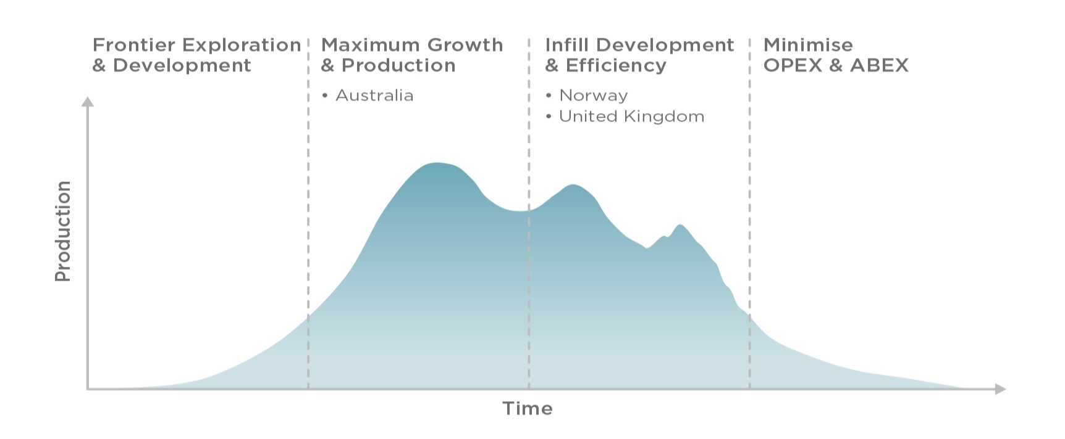

Figure 1: Industry and regulator maturation over time

There are particular points in the lifecycle of an industry when policies and regulatory practices need to adapt to changing circumstances. For Australia, that time is now. This paper outlines the department’s proposal for an enhanced framework to ensure the Australian regime is clear, fit for purpose and leading practice. This framework will ensure future decommissioning challenges have effective regulatory oversight and robust financial safety nets to strengthen protections for the environment, the industry, the Australian Government and taxpayers.

Decommissioning is a normal, planned activity for the petroleum industry. It includes:

* Maintaining and removing property, equipment, infrastructure, such as a facility or a pipeline and plugging/closing-off of wells associated with a petroleum activity.
* Restoring the environment.

As the industry continues to mature, large companies may move to divest their mature assets to focus on areas of new production potential. Australia can expect to see new entrants to the industry—smaller companies or joint ventures who bring a fresh perspective and a different risk profile. As this transition occurs, government will focus on appropriate stewardship and management of the resource, robust technical and financial capacity of operators and the planning for decommissioning.

This paper outlines opportunities to enhance the current framework to manage the financial and environmental risks associated with mature assets. These measure include:

* Increased oversight of changes in company control.
* Increased oversight of financial assurance, including the use of bonds and securities.
* Modernising Field Development Plans.
* Early and proactive use of remedial directions powers.
* Public comment and transparent reporting.
* Enhancing trailing liability to apply in a greater range of circumstances.

Wood Mackenzie modelled the Australian petroleum industry decommissioning liability (both onshore and offshore) to be more than A$60 billion over the next 30 years.[1] This figure is based on full removal of assets and no extensions to the productive life of any existing infrastructure. As the industry continues to mature, this liability and abandonment expenditure (ABEX) will be realised in part.

To ensure regulatory certainty for this liability, the Department of Industry, Science, Energy and Resources has undertaken a review of the legislative, regulatory and policy requirements for offshore oil and gas decommissioning. This review commenced in October 2018 with a [discussion paper](https://consult.industry.gov.au/offshore-resources-branch/decommissioning-discussion-paper/supporting_documents/Decommissioning%20Discussion%20Paper.pdf) released for public consultation, with workshops and consultation occurring throughout 2019.

As the review was underway, the Northern Oil and Gas Australia (NOGA) group of companies entered into voluntary administration in September 2019, followed by liquidation in February 2020. One of the companies in the NOGA group held two petroleum production titles in the Timor Sea and owned the Northern Endeavour floating production storage and offtake facility. All production has ceased at the facility. The Australian Government is now ensuring its safety and the protection of the marine environment.

This is an unprecedented event in Australia’s offshore industry and the government is considering how to minimise the risk of a similar event occurring. The Minister for Resources, Water and Northern Australia, the Hon Keith Pitt MP, appointed Steve Walker to review the circumstances that led to the administration. In August 2020, [the Walker Review](https://www.industry.gov.au/data-and-publications/independent-review-into-the-circumstances-leading-to-the-administration-and-liquidation-of-northern-oil-and-gas-australia-noga) was released and highlighted a number of areas where the framework needs enhancing.

Overall, the departments decommissioning review identified the framework under the [*Offshore Petroleum and Greenhouse Gas Storage Act 2006*](https://www.legislation.gov.au/Details/C2020C00344)(the Act) is broad enough to accommodate a maturing industry with a number of current provisions for decommissioning, such as:

* Arrangements for property and equipment, plugging and abandonment of wells and remediation activities prior to title surrender—section 270 of the Act.
* Financial assurance—section 571 of the Act.
* Maintenance and removal of property—section 572 of the Act.
* Directions relating to the restoration of the environment—part 6.4 of the Act.
* Regulatory process for the plugging and abandonment of wells—part 5 of the Offshore Petroleum and Greenhouse Gas Storage (Resource Management and Administration) Regulations 2011 ([RMA regulations](https://www.legislation.gov.au/Details/F2020C00990)).

However, consistent with the Walker Review, the departments review did identify areas within the framework that need enhancing. This paper outlines a high-level framework for decommissioning and does not replicate the detail of issues, most of which were covered in the department’s discussion paper. We seek your views to inform the implementation of the framework.

Stakeholders should be aware legislative measures are proposed to be backdated to be effective from 14 December 2020.

Complementing the framework are research and collaboration efforts by [National Energy Resources Australia](https://www.nera.org.au/) (NERA), Australia’s Industry Growth Centre for the energy resources sector. NERA is leading the development of the [National Decommissioning Research Initiative](https://ndriaustralia.org/) and other projects to improve community, regulatory and industry understanding of the impact of infrastructure on the marine environment. NERA has also undertaken a comprehensive study of the scale and timing of Australia’s decommissioning task, which is consistent with the Wood Mackenzie modelling.

In 2021, the department will provide the final framework to government for consideration.

## Objectives

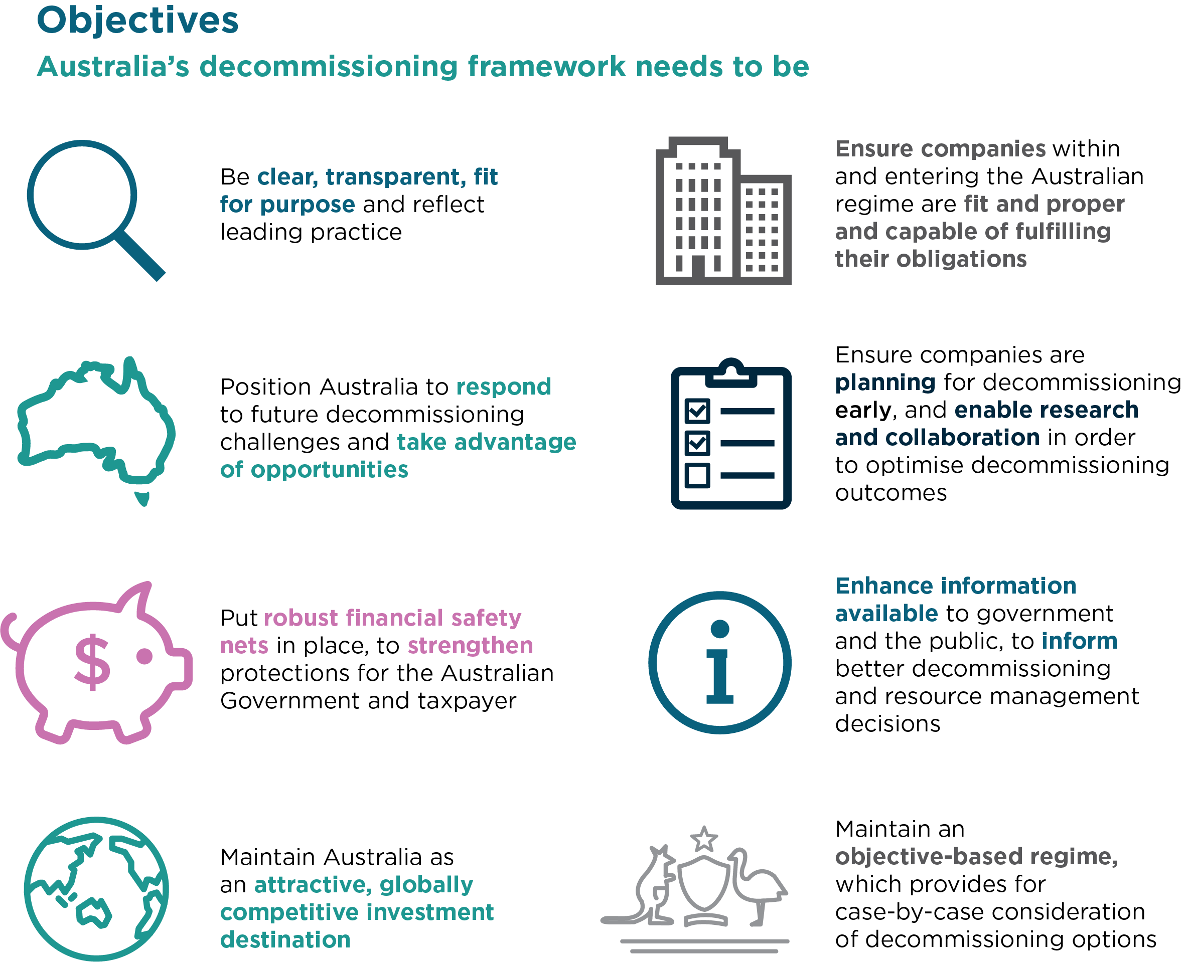

## The challenge ahead and what an enhanced decommissioning framework will do

Australia’s offshore oil and gas industry has an increasing number of mature assets that will require decommissioning over the next decade. The decommissioning framework needs enhancing to manage more effectively the financial and environmental risks associated with mature assets. While decommissioning is a normal and planned activity, Australia has only seen a relatively small amount of decommissioning activity to date.

Areas identified for enhancement are:

1. Financial oversight.
2. Planning and management.
3. Accountability and trailing liability.

### Financial oversight

The department’s policy review and the Walker Review both identified the need for more transparency in, and oversight of, commercial transactions that result in any change to ownership and/or control. In addition, enhancements to monitor the ongoing financial health of companies is also required.

The framework proposes to expand the types of transactions requiring government assessment and approval to include any change in the ownership or control of a titleholder entity through a corporate merger, acquisition or takeover. In doing so, there will be increased requirements for a titleholder to demonstrate its technical and financial capacity on an ongoing basis and at key points within the regime such as, progressing from one title type to another and renewals.

In addition, within the enhanced decommissioning framework, titleholders will be required to provide forms of financial assurance, such as bonds or securities, to demonstrate it can meet its obligations and liabilities as a project matures.

International and domestic experience shows that governments expect stronger guarantees that a company can meet the expenses and liabilities associated with undertaking petroleum activities. This includes decommissioning liabilities and being a safe and responsible titleholder.

Refer to page 7 for discussion.

### Planning and management

The planning for, and management of, decommissioning is an essential part of undertaking any petroleum activity. Under this framework, the requirements of a Field Development Plan will be modernised to reflect a maturing industry and to include early stage planning for decommissioning.

This will ensure the optimal long-term recovery of petroleum is not at the expense of a titleholder’s ability to meet its decommissioning obligations and will provide a better understanding of how a titleholder will balance the ongoing economic viability of the project.

By having greater oversight of the planning activities of companies, there are opportunities for broad-scale efficiencies and cost reductions across the industry and the scope to grow new capability in an Australian decommissioning services sector to support the forecast increase of activity over the next 30 years.

Refer to page 10 for discussion.

### Accountability and trailing liability

It is important the risks and liabilities of petroleum activities remain the responsibility of those who have derived the greatest financial benefit from the project. Under the framework, there will be enhanced linkages between decommissioning obligations, financial assurance and environment and safety considerations, by the pro-active use of remedial directions under the Act.

This review and the Walker Review found the limited scope of the existing trailing liability provisions does not provide adequate protection to the taxpayer and is out-of-step with comparable jurisdictions. Currently, the ability to ‘call back’ a previous titleholder to remediate the title area or conduct other activities is only available to government when a title has ceased through termination, expiration, revocation, cancellation or has been surrendered (depending on the title). Under this framework, the government’s scope of powers will be broader.

In addition, it is important that once a decommissioning activity is complete information is publicly available to enable stakeholders to understand how a titleholder has met its decommissioning obligations and the environment has been remediated.

Refer to page 11 for discussion.

# Financial oversight

## Changes in company control

The department’s policy review and the Walker Review both identified the need for more transparency in, and oversight of, commercial transactions by government that result in any change to ownership and/or control of a titleholder entity through a corporate merger, acquisition or takeover.

The Act currently requires a technical and financial assessment when a title is transferred and only captures changes in the registered titleholder or the interests of the registered titleholder.

In recent years, there have been occasions where companies have entered or exited Australia’s regime through a change in company control. For example, where a new company buys a registered titleholder—the name of the registered titleholder remains the same, but the entity controlling the registered titleholder has changed. The Titles Administrator does not currently assess this type of ‘indirect’ transaction.

The department proposes to expand the types of transactions requiring government assessment and approval to include any change in the ownership or control of a titleholder entity, such as through a corporate merger, acquisition or takeover. This type of control change results in a new entity ultimately controlling the titleholder and may affect the titleholder’s ability to meet its legislative obligations, and therefore should be subject to a government approvals process.

The department also proposes to enhance the decision-making criteria the government will use when deciding if a company is financially and technically capable, able to meet its obligations, has a satisfactory history of compliance and is appropriate to enter the regime. A key consideration in determining an entities financial capacity will include the remaining recoverable value of the resource.

These changes will bring Australia into alignment with comparable international jurisdictions who have greater oversight of control changes, particularly for mature and late-life projects.

### Implementation

To achieve this, the department proposes amendments to the Act, the RMA regulations, the [Guideline - Transfers and Dealings related to Petroleum Titles](https://www.nopta.gov.au/_documents/guidelines/transfers-and-dealings-guideline.docx) and other relevant guidelines to:

* Capture changes in ownership or control of a titleholder—Act change.
* Increase the focus on financial capacity at decision-making points across the regime—Act and guideline change.
* Provide clear decision-making criteria to assess a new entity applying to enter the regime—Act and guideline change.
* Amend the Annual Title Assessment Report requirements to mandate the consistent collection of financial information from all titleholders—regulation change.

## Assurance

To reflect the risks of a maturing asset portfolio, a core element of the framework is the enhancement of the financial assurance requirements. The department’s policy review and the Walker Review identified the need for a greater level of financial assurance from titleholders.

Section 571 of the Act places a duty on all titleholders to have sufficient financial assurance to meet the costs, expenses and liabilities that may arise in connection with carrying out a petroleum activity. Prior to accepting an environment plan, NOPSEMA assesses the level and form of assurance associated with a proposed petroleum activity to determine if it is acceptable—NOPSEMA currently does this consistent with the [Explanatory Memorandum](https://parlinfo.aph.gov.au/parlInfo/download/legislation/ems/r5011_ems_8e4341e4-fe51-4d93-97f5-eb1a86e47772/upload_pdf/378393.pdf;fileType=application%2Fpdf) to the *Offshore Petroleum and Greenhouse Gas Storage Amendment (Compliance Measures No. 2) Act 2013*.

Under an enhanced framework, NOPSEMA will expand its monitoring and compliance of a titleholder’s duty under section 571 of the Act. Assurance of a company’s financial health to meet both planned and unplanned expenses, costs and liabilities is a common feature in comparable jurisdictions, especially those managing mature industries.

Given the potential risks to the safety of workers and the marine environment if a titleholder does not have a sufficient level of financial capacity and capability, the department proposes that enforcement of this duty remain a function of NOPSEMA. The Walker Review proposed this be a function of the Titles Administrator (a statutory office holder within the department, supported by departmental employees) and/or the Joint Authority. As a corporate Commonwealth entity[2], NOPSEMA has a broad range of monitoring, compliance and enforcement powers that are consistent with this proposal.

The policy objective is for the regulator (NOPSEMA in this case) to be assured the titleholder has the capacity to meet the costs, expenses and liabilities associated with undertaking a petroleum activity. The regulator also needs to be satisfied with how a company will undertake its activities and manage the risks to as low as reasonably practicable (ALARP), through regulatory permissioning documents.

The department also expects forms of financial assurance, such as bonds and securities will be used under the enhanced framework. Where these tangible forms of assurance are required by NOPSEMA, these forms of financial assurance should be accessible by government or a third party endorsed by government in the event that decommissioning activities are not undertaken. This is consistent with the Walker Review.

In line with the Act and consistent with government policy, NOPSEMA will determine the form of financial assurance required taking into account the nature of the proposed activity, projects, fields and assets, the remaining field life and estimated decommissioning costs. Both the level and form of assurance is to be reviewed on a regular basis to reflect changing circumstances and costs.

Financial assurance requirements are common in comparable international and domestic jurisdictions in relation to offshore petroleum or onshore resources activities. The UK, Norway, US and Canada either expressly require, or empower an entity to require, security for decommissioning offshore petroleum infrastructure. Domestically, Western Australia, Victoria and Queensland all have mining-related financial security requirements.

Additionally, while there is a growing international market for decommissioning insurance policies, an insurance policy may not be an acceptable form of financial assurance under the enhanced framework if a company cannot demonstrate that the insurance policy will continue to be in force if for example, the company enters into administration. The voluntary administration of the NOGA group of companies highlighted this shortcoming in the use of these types of insurance products.

### Implementation

The department considers the existing financial assurance provisions in section 571 of the Act are sufficient to enable adjustments to how NOPSEMA undertakes its compliance and monitoring enforcement of a titleholder’s duty under section 571.

This will be achieved through changes to the policy and guidance material issued by government—with NOPSEMA to reflect this in its material—and a review of the methodology used for financial assurance.

# Planning and management

## Decommissioning planning and resource management

The department’s policy review identified an opportunity to enhance and modernise the requirements and use of a Field Development Plan (FDP) to reflect that a maturing industry requires regulatory tools to adapt and evolve as technology and industry practices do.

A FDP demonstrates how the titleholder will develop and manage the field in a manner that is consistent with good oilfield practice and compatible with optimal long-term recovery of petroleum. Currently, a FDP is based on information available at the time of the application, with minimal change over the life of a project and no mandatory review points when a field is in a steady state of production.

The department proposes to introduce a mandatory review period, consistent with other permissioning documents, such as an Environment Plan and Safety Case. The Joint Authority[3] will retain its ability to request a titleholder to review its FDP, as needed. This is to ensure that the ongoing economic viability of the project is reviewed regularly, is balanced against the optimal long-term recovery of petroleum, and not at the expense of a titleholder’s ability to meet its decommissioning obligations.

While an Environment Plan will remain the key permissioning document for undertaking decommissioning activities, an enhanced and modernised FDP will encourage a titleholder to engage with the Joint Authority and NOPTA earlier and to consider and develop decommissioning plans throughout the life of the field. Recognising that field knowledge and technology evolve over time, the decommissioning planning in an initial FDP is to demonstrate that in developing a field and commissioning infrastructure, the titleholder has considered how it will remove the infrastructure in the future.

This is a common feature in comparable jurisdictions, especially those managing mature industries.

### Implementation

The department is currently reviewing the RMA Regulations. It will consult, in detail, on the proposed changes and will consider the need for supporting policy material. Consultation comments received during this process will inform policy development for a revised FDP framework.

# Accountability and trailing liability

## Early and proactive use of directions

The department’s policy review identified an opportunity to enhance how regulatory tools are used to ensure decommissioning obligations are clear and fit for purpose.

Consistent with Australia’s international obligations and recognising the importance of protecting the marine environment, the Act dedicates part 6.4 to ‘Restoration of the Environment’. This part of the Act empowers NOPSEMA and the Responsible Commonwealth Minister to issue remedial directions to current titleholders, and in limited circumstances, to an immediate former titleholder about the:

* removal of property (NOPSEMA only)
* plugging or closing off wells
* conservation and protection of natural resources
* making good of damage to the seabed or subsoil.

Additionally, both NOPSEMA and the Minister have powers under the Act to take certain actions when a breach of a direction occurs. These actions include the ability to do anything required by the direction, with the cost of these actions being a debt due by the titleholder to the Commonwealth and possible civil and/or criminal penalties following a breach of a direction.

The framework will enhance the use of remedial directions by using these powers earlier in a project’s life. The early and proactive use of remedial directions will complement the duties of a titleholder, under section 572 of the Act, to maintain property and remove all structures, equipment and property when it is no longer in use or planned to be used.

The ability to regularly review and amend a remedial direction is to be introduced to remain flexible to changing circumstances. This review could align with existing permissioning documents such as a Field Development Plan, Environment Plan, Safety Case or Well Operations Management Plan.

In addition, the review recognised the need to enable post-decommissioning monitoring activities, and the need for management and monitoring of infrastructure if it has been or is to be, re-purposed. Recognising the interconnectedness of the titling structure under the Act with that in the *Petroleum Resource Rent Tax Assessment Act 1987*, the department proposes to explore the use of existing regulatory tools and licences to enable post-decommissioning monitoring, in the first instance, by a remedial direction. For example, following the plugging of a well, a direction could require the monitoring of the plugged well to ensure there is no leakage into the marine environment, prior to or after the surrender of a title.

### Implementation

The department considers the existing remedial direction provisions in the Act are sufficient to enable the early and proactive use by NOPSEMA and the responsible Commonwealth Minister. The development of policy documents will support this approach. If through this consultation process or during implementation the need for legislative change is identified, this also will be pursued.

## Public comment and transparent reporting

The department’s policy review identified the need to improve transparency and public engagement for petroleum activities in particular, decommissioning. When decommissioning activities are planned, there is currently no requirement for a public comment period on the proposed activities and once the activities are complete to NOPSEMA’s satisfaction, no mandatory public reporting to enable the community to understand when and how a titleholder met its decommissioning obligations. To complement existing transparency measures and to provide increased transparency, the department proposes to introduce:

* A public comment period on decommissioning environment plans that seek NOPSEMA’s acceptance.
* Public reporting of environmental performance once a petroleum activity is underway.
* Publication of ‘close-out’ reports once an activity has been complete, to NOPSEMA’s satisfaction.

### Implementation

The department is planning to undertake a review of the Offshore Petroleum and Greenhouse Gas Storage (Environment) Regulations 2009 within three years. Ahead of this, the department may seek to amend the Regulations to give effect to these measures and will consult on the proposed changes. Consultation comments received during this process will inform early policy development on these transparency measures.

## Trailing liability

The department’s policy review and the Walker Review identified the need to enhance the existing trailing liability provisions to protect the interests of the broader community and taxpayers. The Walker Review also observed the current limited application of trailing liability is inconsistent with comparable jurisdictions that manage a mature industry.

There are two key policy objectives of enhancing trailing liability to reduce the risk that existing titleholders may dispose of mature to late-life assets to entities who may not be financially or technically capable of undertaking petroleum activities and fulfilling their obligations:

1. Ensure the risks and liabilities of petroleum activities remain the responsibility of those who have derived the greatest financial benefits from the project.
2. Bring about a change in behaviour and increase the due diligence by companies of who it sells its titles and assets to.

### Options

To achieve the key policy objectives the department considered the following two legislative options to enhance the existing trailing liability provision.

#### A standing obligation

Creating a standing obligation in the Act would result in companies remaining continually liable for decommissioning, despite selling its assets and/or interests in a title. The result of this option is that a company will need to account for its liabilities on an ongoing basis, in some form, despite selling its assets to another party. Because of the impact this would have on investment, the preferred option is to expand the existing trailing liability provisions.

#### Expand existing provisions

Currently, the ability to ‘call back’ a previous titleholder to remediate the title area or conduct other activities is only available to government when a title has ceased through termination, expiration, revocation, cancellation or has been surrendered (depending on the title).

Under this framework, the existing powers will be expanded to apply in a greater range of circumstances—providing NOPSEMA and the Responsible Commonwealth Minister with the ability to ‘call back’ any former titleholder, regardless of how its interest in the title ceased. This includes the ability to call back companies who have been given consent to surrender the title by the Joint Authority or sold their interests via a transfer, dealing or other form of commercial transaction.

Recognising the ways in which companies are able to structure transactions to divest assets and titles to limit accountability for decommissioning obligations, under this framework the concept of a ‘related person’ for the purposes of trailing liability will be introduced. This will enable the government to require a range of entities such, as either a current or former titleholder or a parent company of one, to undertake and/or pay for remedial activities, including decommissioning in the event the current titleholder does not meets it obligations.

Where all other safeguards have failed and a current titleholder is unable to fulfil its obligations, the government should have broad-ranging trailing liability powers to ensure those who derived the greatest benefit from the development of Australia’s resources, throughout the life of a project, are responsible for decommissioning.

### Implementation

To achieve this, the department proposes amendments to the Act to expand the existing trailing liability provisions to apply to a greater range of circumstances. The department proposes that these provisions will apply to incumbent and future titleholders, rather than apply retrospectively. This will result in the ability of NOPSEMA and the Responsible Commonwealth Minister to issue a remedial direction to any former holder of a title and/or a ‘related person’ as a last resort option available to government when all other safeguards have failed.

# Appendix 1 – High-level overview of the framework in operation

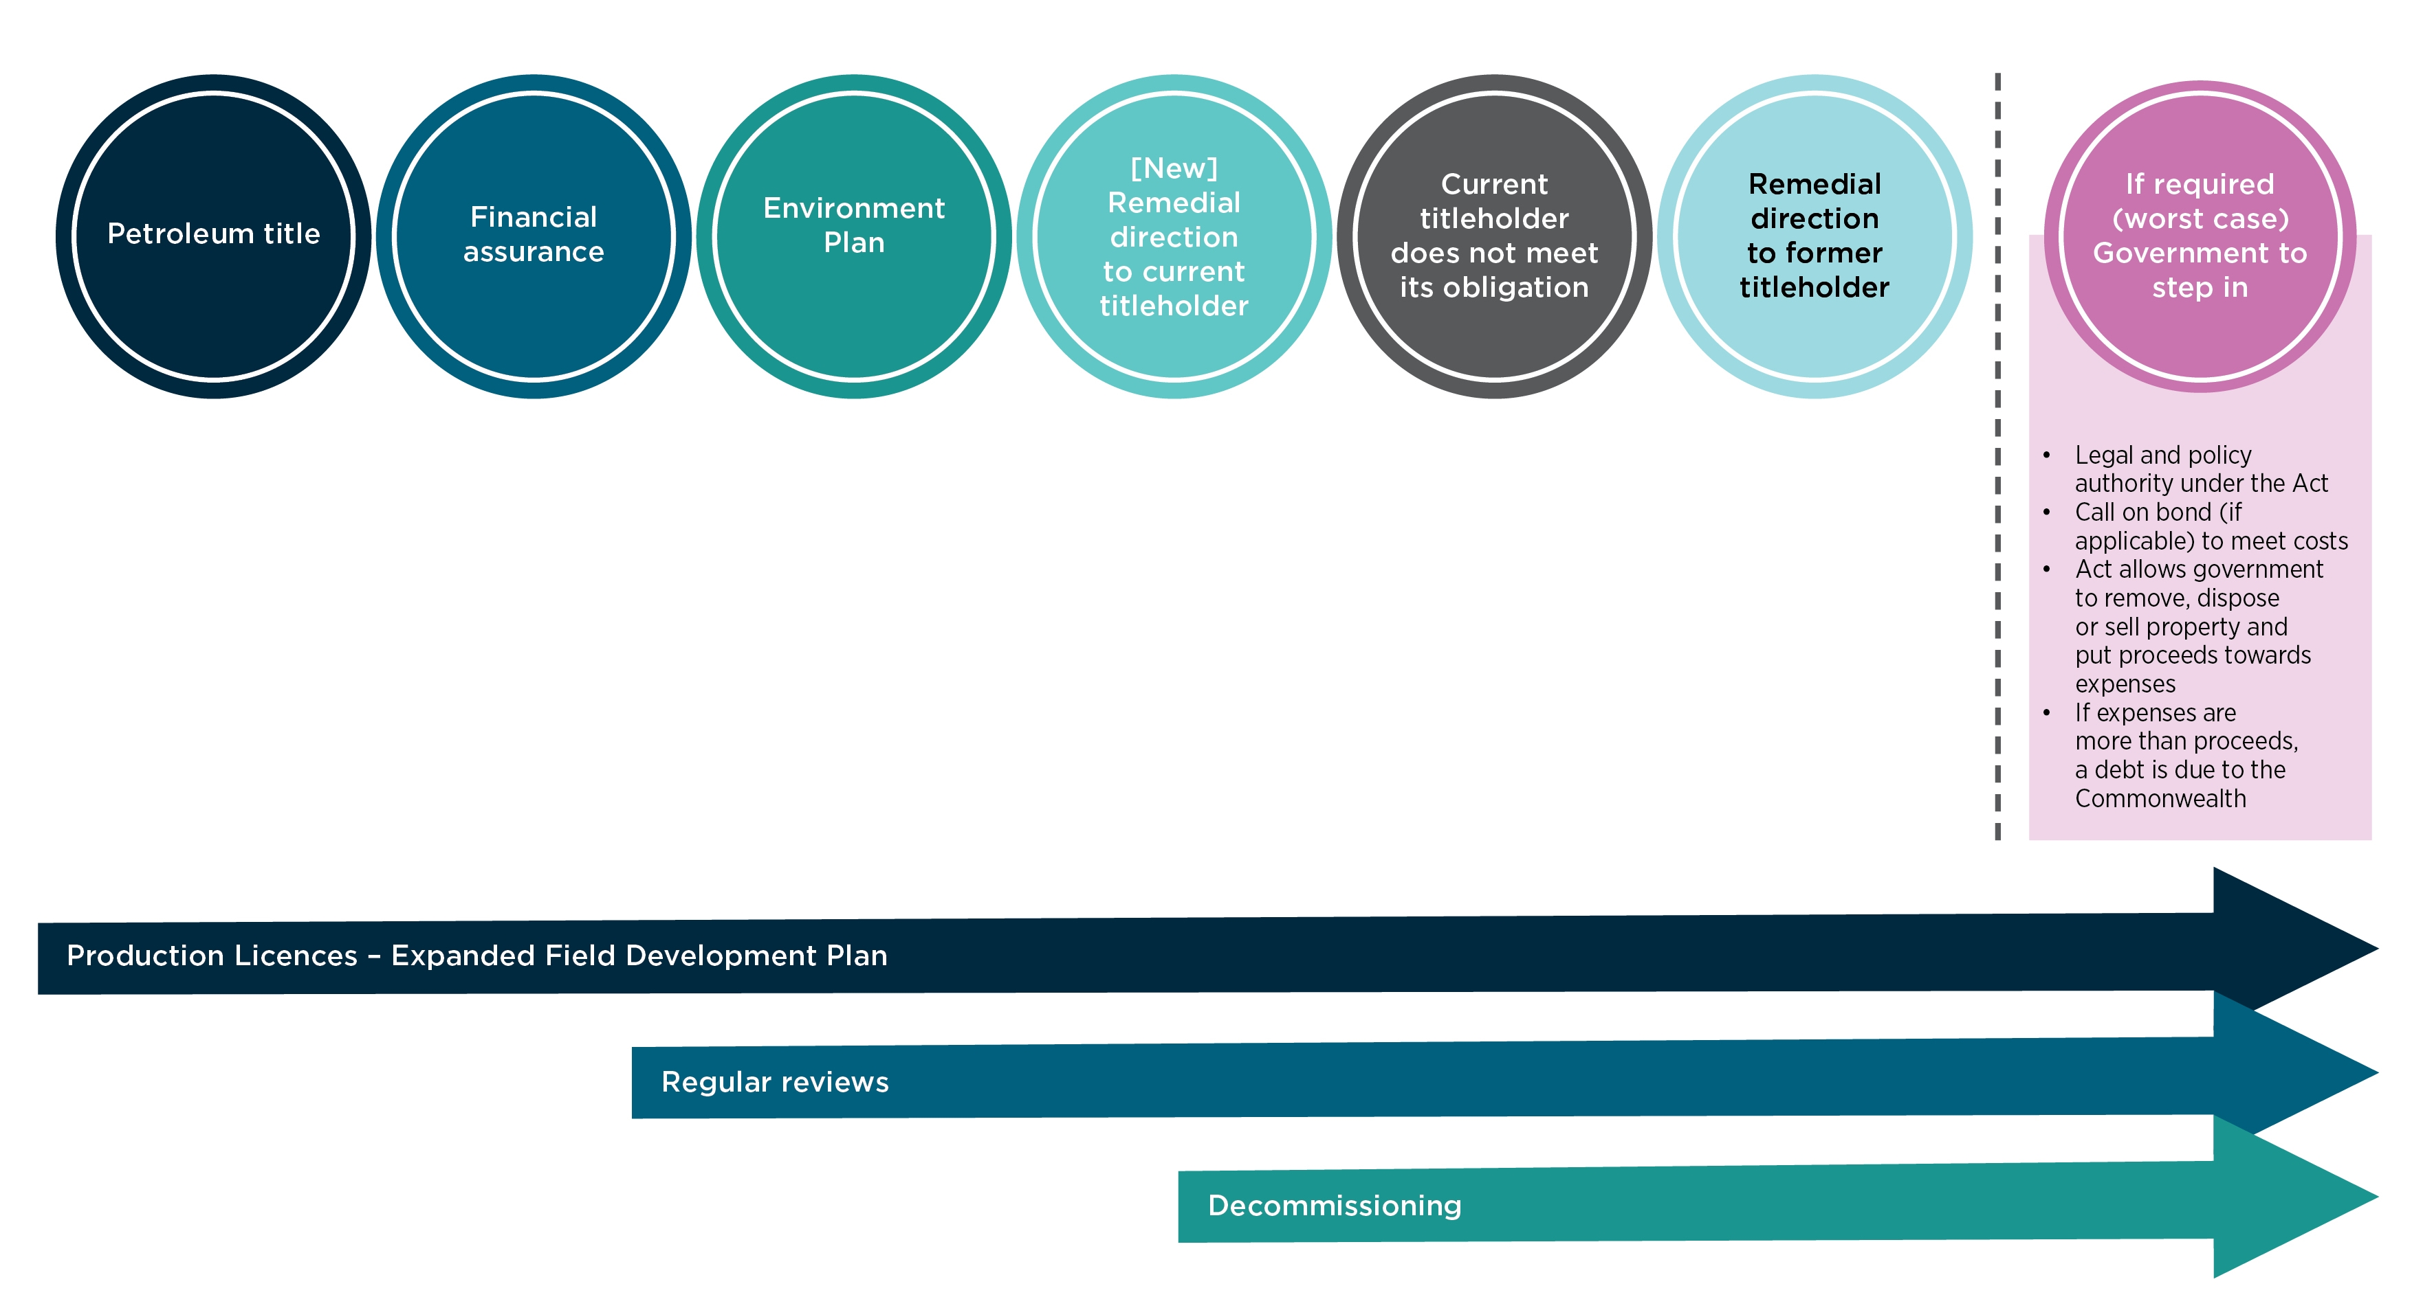

Figure 2. High-level overview of the framework in operation

1. Wood Mackenzie Australia Oil and Gas Industry Outlook Report, 9 March 2020.
2. https://www.finance.gov.au/government/managing-commonwealth-resources/structure-australian-government-public-sector/types-australian-government-bodies
3. The Joint Authority consists of the responsible Commonwealth Minister and the relevant state or Northern Territory minister who together, make key petroleum decisions, including those associated with resource management. To inform its decision, the Joint Authority receives technical advice from NOPTA and policy advice from supporting departments.