
NatHERS whole-of-home Expansion
Research into the key communication features that should be included in any whole-of-home tools through an analysis of needs of key users

Prepared for: Commonwealth Department of Industry, Science, Energy and Resources which has managed the project on behalf of all Australian jurisdictions under Measure 31.2 of the National Energy Productivity Plan.
Consultants: David Donnelly, Sally Faedda, Marie-Claire Buaud, Annaleise Lee
Reference: J2941
24 06 2020

Xx
Xx
xx

SYDNEY
Suite 302, 410 Elizabeth Street, Surry Hills
NSW, 2010 Australia
+61 (2) 9283 2233
LONDON
Suite 1,
7 Ridgmount Street
WC1 E7AE United Kingdom
+44 (0) 203 355 4454
CANBERRA
103/ 11 Trevillian Quay, Kingston
ACT, 2604 Australia
+61 (2) 6231 0350

Contents
- Executive summary 6
- Background and objectives 3
Research background 3
Research objectives 3
- Approach 4
Methodology 4
Qualitative sample 7
Quantitative sample 10
- Detailed findings 17
Use of energy rating tools and assessments 17
Information needs 29
NatHERS certificate—use and perception of change 40
- Discrete Choice Model 46
Which specific images appeal most—by user group? 583
- Appendix 71

List of figures
Figure 1: Relative importance of energy rating tool certificate attributes 7
Figure 2: Optimal whole-of-home certificate for all professionals from discrete choice model 8
Figure 3: Use of energy rating tools in career to date—by user group 17
Figure 4: Use of listed energy rating tools in career to date—by user group 18
Figure 5: Current energy rating tool use—own use 19
Figure 6: Current energy rating tool use – colleague use 21
Figure 7: Reasons for use of energy rating assessments—by user group 22
Figure 8: Current use of energy rating assessments compared with ideal uses of an use energy rating tool 23
Figure 9: Ideal purposes for use of energy rating tools by user groups 23
Figure 10: Timing of use of energy rating tools in construction process (Qualitative results) 24
Figure 11: Requirements for a whole-of-home tool (Qualitative results) 25
Figure 12: Requirements for different audiences for the whole-of-home tool (Qualitative results) 26
Figure 13: Use of NatHERS – by user group 27
Figure 14: Purposes for use of NatHERS – by user group 28
Figure 15: Information currently used from energy rating certificate when designing a new building 31
Figure 16: Information needed about energy costs when designing a house 32
Figure 17: Solar PV information needs when designing a house 32
Figure 18: Other useful information for design purposes 33
Figure 19: Information currently used from energy rating certificate for compliance purposes 33
Figure 20: Information needed about energy costs when seeking regulatory approval for a house 34
Figure 21: Solar information needs when seeking regulatory approval for a house 35
Figure 22: Other useful information when seeking regulatory approval for a house 35
Figure 23: Information currently used from energy rating certificate for construction purposes 36
Figure 24: Information needed on energy costs when constructing a house 37
Figure 25: Solar PV information needs for construction purposes 37
Figure 26: Other useful information for construction purposes 38
Figure 27: Ideal certificate information by user groups (Top 10 results) 38
Figure 28: Ideal certificate information by user group (remaining results) 39
Figure 29:Familiarity with current NatHERS certificate 40
Figure 30: Thoughts on current NatHERS certificate 41
Figure 31: Missing elements from current NatHERS certificate 42
Figure 32: Thoughts on NatHERS whole-of-home expansion 43
Figure 33: Likelihood of using NatHERS whole-of-home certificate 44
Figure 34: Concerns around NatHERS whole-of-home energy rating tool 45
Figure 35: Concerns around NatHERS whole-of-home energy rating tool (from qualitative research) 45
Figure 36: Discrete Choice Model Design certificate attributes 46
Figure 37: Relative importance of energy rating tool certificate attributes 49
Figure 38: Optimal certificate for all professionals 50
Figure 39: Most appealing certificate attributes – whole of home performance 51
Figure 40: Most appealing certificate attributes – thermal performance and checklist format 52
Figure 41: Most appealing certificate attributes – heating and cooling, potential savings 53
Figure 42: Most appealing certificate attributes – appliance breakdown, solar PV performance 54
Figure 43: Most appealing certificate attributes – access to technical details 55
Figure 44: Essential communication principles for a whole-of-home certificate (from qualitative research) 56
Figure 45: Relative importance of certificate attributes—by user group 57
Figure 46: Relative importance of certificate attributes for assessors 59
Figure 47: Optimal certificate for assessors 60
Figure 48: Relative importance of certificate attributes for certifiers, building surveyors and regulators 62
Figure 49: Optimal certificate for certifiers, building surveyors, and regulators 63
Figure 50: Relative importance of certificate attributes for architects, building designers and builders 65
Figure 51: Optimal certificate for architects, building designers, and builders 66
Figure 52: Essential features on NatHERS whole-of-home certificate – existing and new features 67
Figure 53: Necessity of features on NatHERS whole-of-home certificate 68
Figure 54: Ideal content for NatHERS whole-of-home certificate (from qualitative research) 69
Figure 55: Ideal NatHERS whole-of-home certificate structure (from qualitative research) 70
Figure 56: Front section Outcome of Assessment 1 71
Figure 57: Front section Outcome of Assessment 2 71
Figure 58: Front section Thermal Performance 72
Figure 59: Front section Appliances 1 72
Figure 60: Front section Appliances 2 73
Figure 61: Front section Appliances 3 73
Figure 62: Front section Potential Savings 74
Figure 63: Front section Solar PV 74
Figure 64: Front section Verification Details 75
Figure 65: Middle section Checklist 1 75
Figure 66: Middle section Checklist 2 76
Figure 67: Certificate shown to participants 77
Figure 68: Glossary of definitions 78
Figure 69: Introductory text 79
Figure 70: Whole of home mock-up template 80
Figure 71: Example of a mock up certificate shown to participants 1 81
Figure 72: Example of a mock up certificate shown to participants 2 82
Figure 73: Attribute 1— Thermal Performance 84
Figure 74: Attribute 2—Heating and Cooling 85
Figure 75: Attribute 3—Whole of home performance 86
Figure 76: Attribute 4—Appliance break-down 884
Figure 77: Attribute 5—Solar performance 895
Figure 78: Attribute 6—Potential savings 906
Figure 79: Attribute 7—Access to technical details 917
Figure 80: Attribute 8—Checklist format 1 928
Figure 81: Attribute 8—Checklist format 2 939
Figure 82: Attribute 8—Checklist format 3 94
Figure 83: Attribute 8—Checklist format 4 951
List of tables
Table 1: Existing communication tools used in online forums 5
Table 2: Qualitative sample—online forums 7
Table 3: Qualitative sample—depth interviews 9
Table 4: Quantitative sample profile by states– all states operated in 10
Table 5: Quantitative sample profile by states – primary state of operation 11
Table 6: Quantitative sample profile by gender 12
Table 7: Quantitative sample profile by age 12
Table 8: Quantitative sample profile by main profession 13
Table 9: Quantitative sample profile by organisation size 14
Table 10: Quantitative sample profile by role 14
Table 11: Quantitative sample profile by education 15
Table 12: Quantitative sample profile by experience 15
Table 13: Quantitative sample profile by profession and state (all states of operation) 16
Table 14: Quantitative sample profile by profession and state (primary state of operation) 16

Executive summary
This research highlighted that the move towards a whole-of-home energy rating tool is heading in the right direction. Indeed, the research has revealed that there is an appetite among professionals for the energy rating tools to have a broader use beyond the current regulatory purposes and council approval of buildings (Figures 8 and 10). And around half of all professionals surveyed reported being either excited or very excited about the expansion of NatHERS to include whole-of-home tools and ratings (Figure 32).

Use of energy rating tools
Whilst all thermal assessors surveyed have used energy rating tools at some point in their career (Figure 3), and four out of five professionals have ever used them, the level of understanding of the tools and their output can vary greatly, as revealed in the qualitative research. Assessors usually have a more intimate understanding of energy rating tools (99 per cent of them have used one of the NatHERS rating tools, Figure 4) and use them mainly for regulatory purposes (93 per cent, Figure 7). They are more likely to look for the detail (assumptions made, calculations, checklists, sealing and insulation details, etc), whilst architects, building designers and builders are more likely to use the energy rating tools to inspire design and model different outcomes (6 out of 10 architects, building designers and builders use them for this purpose). However, only 1 in 5 regulators, building certifiers/surveyors currently use energy rating tools for compliance purposes and on-site-checks, an area for significant improvement (Figure 7). As discussed in the online discussion forums and depth interviews, many professionals would like to see the documents used more regularly throughout the entire process, from the beginning of the design, through to the on-site construction checks at the end (Figure 10).

Feedback on current NatHERS certificate
In terms of the current certificate (the version from April 2020), analysis of the survey open-ended responses revealed that professionals like the fact that the current NatHERS certificate is simple and easy to read, they like that the information is relevant, detailed and itemised, and the graphics on it, particularly the stars (Figure 30). However, they also mention things missing such as extra information for verification/assurance, a more consumer-friendly certificate for a broader end user, inclusion of air tightness, and more aspirational elements (Figure 31).
This supports qualitative findings around some of the key principles of communication for the ‘ideal certificate’ which should be: visually appealing, consumer-friendly, communicate clearly and concisely, include relative and scalable scores, and flexible such that it can be a working document utilised end-to-end (see Figure 44).
In the ideal world, although the research did not cover the consumer viewpoint, professionals felt and expressed that it would be good for NatHERS communications tools to more broadly target ‘everyone’, such that homeowners treat them with care – and use them when renovating and buying new fixed appliances into the future. At the same time, professionals also want a certificate that clearly outlines all the technical and regulatory details (Figure 11).

Moving towards a NatHERS whole-of-home certificate
The research found that there is a strong consensus to make sure that whole-of-home assessment does not dilute the importance of the NatHERS thermal assessment and results (Figure 35). This was a consistent concern throughout the qualitative and quantitative research. In terms of concerns professionals have about the move to NatHERS whole-of-home, the 2nd and 3rd highest ranked concerns both included concerns around the thermal performance (Figure 34).
- 38 per cent answered ‘that the thermal performance assessment remains intact and separate from the new score relating to appliances only’ (Figure 34).
- 37 per cent answered ‘that the addition of fixed appliances could hide a poor thermal performance, leading to ‘trade-offs’ on the overall assessment’ (Figure 34).
The important elements and optimal imagery for the NatHERS whole-of-home certificate
The discrete choice model found that the inclusion of a whole-of-home performance score (thermal performance combine with appliances) was the most important attribute for a NatHERS whole-of-home Certificate (Figure 1). This was closely followed by the thermal performance score on its own, and a checklist with the column ‘on specs and plans’ (Figure 1).
The ‘whole-of-home’ performance score is the element most likely to drive interest in the new whole-of-home certificate (17%), followed closely by the ‘thermal performance score’ (16%), and the checklist format (14%) (Figure 1).
Figure 1: Relative importance of energy rating tool certificate attributes
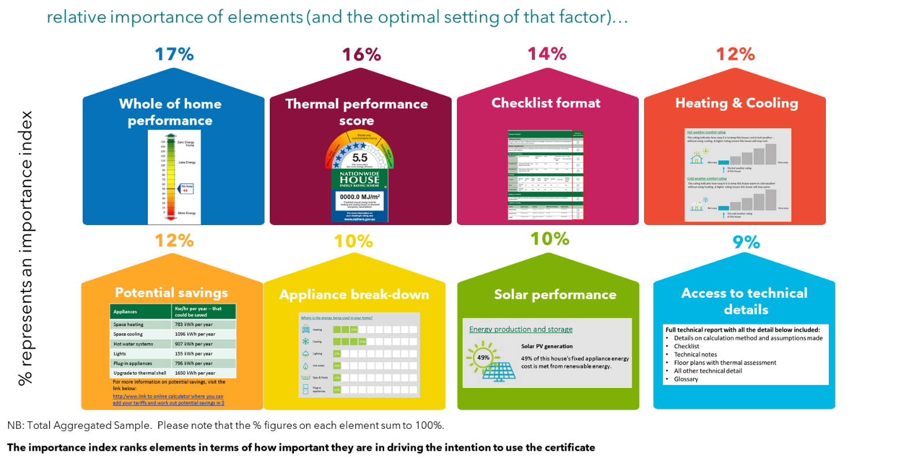
These findings reflect the qualitative discussions around a need for more of an explanatory scale, with more context around the score/result (Figure 44). The colour grading of green for positive results and red for negative results was a recommendation from some of the interviews. Further, they also reflect the findings that professionals want the documents to be visually appealing, consumer friendly and communicating in a clear manner (Figure 44).
For the ‘heating and cooling’, appliance break-down and solar performance attributes, the optimal images chosen were the mock-ups inspired by the Residential Efficiency Scorecard (Figure 1), which were all very positively responded to in the qualitative research. These choices again highlight a preference towards infographics, and a more visual and consumer-friendly way of presenting information (Figure 44).
For the heating and cooling, the optimal image has the simplest annotation, with arrows pointing to ‘the hot weather rating of this house’ and ‘the cold weather rating of this house’, and for the appliance break-down, the infographic was chosen with the icons, and for the solar performance, the optimal image was image 1, which had less detail than image 3 – all of these choices indicate a preference for simplicity (at least on the front page).
Finally, the ‘potential savings’ optimal image is the one with the link to the online calculator to enter the tariff rates (Figure 1). This echoes findings from the qualitative research that professionals are seeking an aspirational element to the certificate, as well as a monetary component.
The image below (Figure 2) shows all the preferred elements based on the discrete choice model exercise. It is a mock-up version, in reality there would be additional critical features such as the QR code and NCC text on it.
Based on all of the preferred elements, the image below reflects what the optimal certificate would look like for all professionals from the discrete choice model exercise.
Figure 2: Optimal whole-of-home certificate for all professionals from discrete choice model
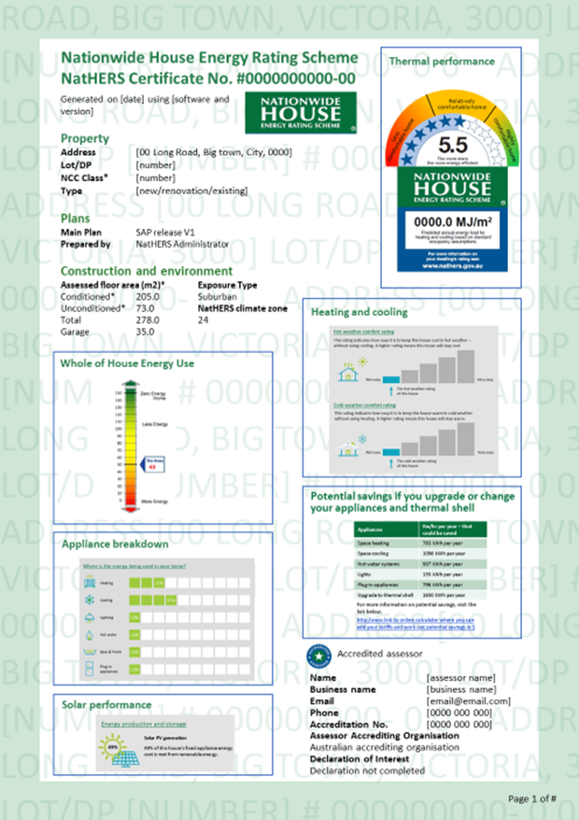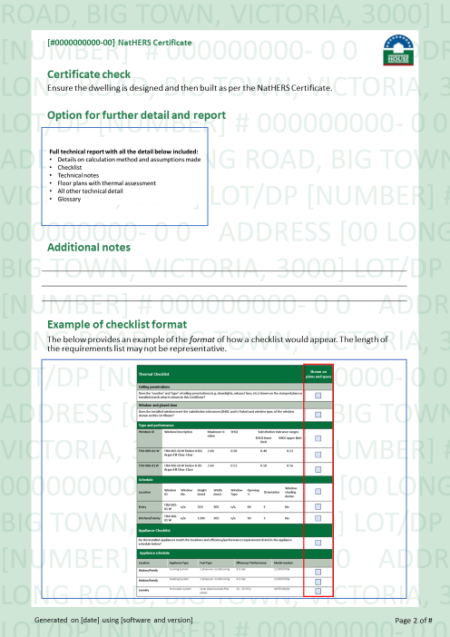

Background and objectives

Research background
In February 2019, the former Council of Australian Governments Energy Council (COAG EC) agreed to the Trajectory for Low Energy Buildings (the Trajectory), including that the Nationwide House Energy Ratings Scheme (NatHERS) should be expanded to offer nationally accredited whole-of-home tools to enable verification of requirements in the National Construction Code.
The expansion of NatHERS to provide a whole-of-home framework for residential building assessment and ratings tools aims to support consistent use, ease of understanding and communication for industry and consumers, and an efficient and effective use of government resources.
The expansion of NatHERS to whole-of-home will involve retaining the thermal performance of the building fabric and also estimating the energy performance of fixed appliances and the overall on-site energy generation of the home.
For regulatory purposes, it is proposed that NatHERS whole-of-home will include the energy performance of the following fixed appliances: heating and cooling appliances, hot water systems, lighting and pool pumps. Additionally, on-site energy generation will be a part of the NatHERS whole-of-home assessment.

Research objectives
The purpose of the research was to establish the key communication features that should be included in any whole-of-home tools through an analysis of needs of key user groups (Architects/Building Designers/Builders, Building Certifiers/Surveyors/Regulators and Assessors).
Specific objectives were to:
- Provide an overview of International and Australian examples of communication features that could be considered for inclusion in whole-of-home tools being used for regulatory purposes.
- Identify the advantages and limitations of the various communication features against the needs of the different user groups involved in the regulatory process, including:
  - groups using the outputs, such as certifiers, building surveyors regulators, and policy makers
  - groups using the tool interfaces such as assessors, building designers, and builders.
Note: consumers were excluded from the testing for the purposes of this project.
- Outline the motivators and barriers for each of the features for each user group.
- Identify any potential gaps for each of the features or user groups.
- Recommend the key communication features for inclusion in whole-of-home tools, noting the key features to be included for regulatory purposes and any variations of the same item if targeting particular user needs or other uses.
- Provide mock-up versions of the communication features to be tested with user groups and have been identified as having the majority of support for inclusion in whole-of-home tools for regulatory purposes.

Approach
Instinct and Reason’s approach to this project was unique because it recommended a process of divergent exploration that identified communication tool possibilities for industry and then a quantitative survey element that converged to provide evidence and prediction for the best way forward.
The research involved:
- a review of the current communications tools being used in Australia and overseas, conducted via a global online search
- generating discussion and ideas around communication elements and features of interest, through qualitative research
- testing alternate communication features that would work better (amongst industry and regulatory participants), through a quantitative survey.
The consumer was out of scope for this research. The research instead focused on three key user groups, which were defined as per below:

Group | Definition
Assessors | This group conduct energy assessments and ratings for planning approval processes, usually involving simulating a home’s energy performing using an approved software tool and producing a Certificate and report
Architects, building designers, and builders | As part of the planning and building approval processes, architects, building designers and builders will need to demonstrate they have met or exceeded minimum standards for the energy efficiency of a new or major renovation of a home as prescribed under state and territory legislation.
Building certifiers/surveyors, and Regulators | Regulators are the state and territory building administrators responsible for ensuring planning and building regulations are complied with. Building certifiers/surveyors are generally private contractors who certify the documents and building works comply with the relevant building requirements within the jurisdiction.

Methodology
The research involved a multi-staged approach, whereby each stage of research ‘built upon’ the previous stage in an iterative manner.
Ideas were generated from examining the content of various communication tools identified in the global search, which were discussed in the online discussion forum. Discussion forum participants identified specific elements that they liked across different examples of certificates and checklists.
These ideas were then refined further to produce a set of stimuli to be discussed via depth interviews, covering the front, middle and back sections of the certificate. The stimuli tested involved extracts of relevant information from certificates, for example on thermal performance, appliance break-down, checklist formats, etc presented in different ways.
Based on the qualitative feedback from these depth interviews, we then developed ‘mock-up’ images for different communication features to be tested in the quantitative research.
The research provides clear guidance on how to structure information, as well as what sort of content is needed, such that the outputs on the certificate are suitable for all the industry target audiences.

Global search of communication tools
Before commencing the qualitative research, Instinct and Reason conducted a global search for communication tools related to residential energy efficiency. This search was conducted in March 2020 and involved a desktop review of publicly available residential building energy efficiency communication tools (including certificates, checklists, but also supporting materials, manuals, and technical guides, forms, fact sheets, brochures, and other technical documents). The search generated around 150 records of different documents/’communication tools’ listed in an excel spreadsheet, provided to the Department. The excel spreadsheet can be filtered by tool type and country.
The communication tools were assessed for relevance, in terms of who they work for, their intended purpose, when they work (during what stage of planning/development/construction), as well as relevance to the Australian housing context. Together with the Department, Instinct and Reason generated a list of 18 certificates and checklists (Table 1) which were selected for discussion in the online forums, most of which were from the Anglosphere (including existing Australian tools, as well as examples from the UK, Canada, and North America).
Table 1: Existing communication tools used in online forums
Country | Energy rating tool | Type of document
UK | BREEAM New Construction | Certificate
AUS | NatHERS | Certificate
AUS | Residential Efficiency Scorecard | Certificate
US | Energy Performance Certificate | Certificate
US | Energy Star New Homes Construction | Certificate
US | HERS - Resnet (Residential Energy Services Network) | Certificate
US | Greenpoint | Certificate
US | Home Energy Score | Certificate
Canada | Energuide | Certificate
Global | PassivHause | Certificate
US | US Department of Energy - Home Energy Score | Certificate
Global | PassivHause | Checklist
AUS | NatHERS | Checklist
AUS | Basix Council Checklist | Checklist
AUS | Basix Certificate Single Dwelling | Checklist
US | NAHB Model Green Home Building Guidelines | Checklist
US | Energy Star Certified Homes | Checklist

The online forums
Instinct and Reason conducted two online discussion forums with 24 professionals from the identified user groups covering varying jurisdictions, States and climatic zones (see Table 2). These online forums ran in early April, from Monday 1st of April to Saturday 11th of April.
The two online discussion forums were:
- Forum A: 10 participants—assessors, building certifiers/surveyors
- Forum B: 14 participants—architects, building designers and builders.
It is also worth noting that the discussions were held in the period following the announcement of the national lock-down due to the Coronavirus pandemic. This resulted in the decision to reduce the number of forums from three to two. This decision was made because there was difficulty in recruiting participants as many professionals were busy transitioning to new ways of working. However, feedback from those invited to participate in the forums was that it was still an appropriate time to be consulting on the whole-of-home.
Participants were asked to log into the online forums every day or two and contribute to the discussion. In the forums, participants were asked to review examples of the certificates and checklists identified through the global search (see Table 1) and respond to specific questions about them. The types of questions asked were around their use and attitudes towards different types of energy rating tools and their output, use and attitudes towards existing certificates and checklists, the elements that appeal and that don’t appeal from these, and what features or elements are missing from them.
They could see and reply to comments from other participants. The online discussion forums were moderated by Instinct and Reason and co-moderated by a practising architect.
The online forums revealed that designing the ideal certificate is not an easy process and helped to identify 11 essential pieces of information to cover in any certificate, and well as to discuss the ideal format of the certificate. The forums were also used to identify a few experts that showed great insight to be further interviewed in the next stage.

The depth interviews
Depth interviews were conducted with 21 professionals from the user groups, including eight assessors, five architects, three builders, three building certifiers and two state government policy advisors (see Table 3).
The depth interviews were conducted using a combination of methods, such as via telephone, as well as a few conducted via Zoom/Skype. Each interview lasting 45-60 minutes. They were conducted between 20th of April to the 28th of April 2020.
These interviews built upon some of the discussions and findings from the online discussion forum, further exploring key pieces of information to be included in the certificates, and to be tested in the quantitative survey.
A set of stimuli was provided to the interview participants, to review prior to the interview, and to assist discussion around key features of the certificates (see appendix).
The interviews highlight once again, that the communication tools need to be multi-purpose, and that each audience has differing needs and levels of detail required. It also identified key features of interest, to appear and feed into the attribute images to be tested in the discrete choice model.

The quantitative survey
A quantitative survey was designed by Instinct and Reason, which covered key topics such as use of energy rating tools and assessments, the various information needs of different professional groups, thoughts on the current NatHERS Certificate from April 2020, as well as reactions to the concept of a NatHERS whole-of-home certificate. The survey tested ideas and concepts from the qualitative research.
The survey included a discrete choice model, designed to test the importance of various communication attributes on the new certificate, as well as what the optimal certificate for whole-of-home energy performance would look like.
Participants for the survey were recruited via:
- a direct link emailed to lists of professional contacts gathered during the qualitative recruitment by Instinct and Reason,
- social media including Facebook
- newsletters distributed by the Department and industry peak bodies.
The fieldwork ran over eight days from the 11th of May to the 19th of May. The survey took an average of 17 minutes to complete.

Qualitative sample

Online forums
There were 24 participants to the online forum, as per the table below:
Table 2: Qualitative sample—online discussion forums (n=24)
Role/Profession | State | Number of Participants
7x Certifiers/Building Surveyors | NSW | 2
 | VIC | 2
 | QLD | 1
 | WA | 1
 | TAS | 1
 | ACT | 1
7x Assessors | NSW | 2
 | VIC | 2
 | WA | 3
10x Building Designers/Architects | NSW | 2
 | VIC | 1
 | QLD | 3
 | SA | 2
 | ACT | 2

NB. The locations of professionals included a mix of urban as well as regional areas (for example, Melbourne, as well as Ballarat and the Bellarine Peninsula in Victoria, and Sydney, as well as Ballina and Wagga Wagga in NSW).

Depth interviews
There were 21 depth interviews conducted, as per the table below:
Table 3: Qualitative sample—depth interviews (n=21)
Role/Profession | State | Number of Participants
8x Assessors | NSW | 3
 | VIC | 1
 | QLD | 1
 | WA | 1
 | TAS | 1
 | NT | 1
5x Architects | NSW | 1
 | VIC | 2
 | ACT | 1
 | NT | 1
3x Builders | VIC | 1
 | SA | 1
 | ACT | 1
3x Certifiers/Building Surveyors | NSW | 1
 | VIC | 1
 | QLD | 1
2x State Government Policy Advisors | SA | 1
 | NSW | 1

NB. The depth interviews tried to cover a range of climate zones and included professionals in the Northern Territory for the tropical climate zone, as well as professionals from ACT/VIC who work in cooler climatic regions.

Quantitative sample
The total sample for the survey was 206 professionals, with a spread across the three key professional groups; n=67 assessors, n=57 architects, building designers and builders, and n=55 certifiers, building surveyors and regulators (Table 8). There was also another n=27 in the ‘other group’ which included a mix of professionals such as academics, researchers and real estate agents.
A total of 169 professionals completed the discrete choice modelling aspect of the survey.

Who did we speak with?
The ‘typical professional’ that completed our quantitative survey was more likely to be based in NSW or VIC (Table 5), and more likely to be aged between 45 and 64, with around half the sample in this age group (Table 7). They were also more likely to be male (Table 6).
Around half of them were either sole traders or operating a small business of under four employees (Table 9). Half of them were the business owners (Table 10), and a third of them had at least 26 years or more of experience in the industry (Table 12). Most were university educated (Table 11).

Profile by state
Table 4: Quantitative sample profile by states– all states operated in
State (multi response) | n= | %
Total sample | 206 | 100
NSW | 84 | 41
VIC | 77 | 37
QLD | 47 | 23
WA | 44 | 21
SA | 33 | 16
TAS | 29 | 14
ACT | 22 | 11
NT | 15 | 7
QA1a. Which states or territories do you operate in? (multi response)
Base: Total Sample n= 206

Table 5: Quantitative sample profile by states – primary state of operation
State (single response) | n= | %
Total sample | 206 | 100
NSW | 56 | 27
VIC | 57 | 28
QLD | 25 | 12
WA | 18 | 9
SA | 25 | 12
TAS | 13 | 6
ACT | 9 | 4
NT | 3 | 1
QA1b. Which state or territory do you mainly operate in? (single response)
Base: Total Sample n= 206

Profile by age and gender
Table 6: Quantitative sample profile by gender
Gender | n= | %
Total Sample | 206 | 100
Male | 156 | 76
Female | 41 | 20
QA2. Which do you most identify with? (single response)
Base: Total Sample n= 206

Table 7: Quantitative sample profile by age
Age | n= | %
Total Sample | 206 | 100
18-24 | 2 | 1
25-34 | 25 | 12
35-44 | 41 | 20
45-54 | 55 | 27
55-64 | 51 | 25
65 and over | 24 | 12
Prefer not to say | 8 | 4
QA1. Which of these age groups do you fit into?
Base: Total Sample n= 206

Profile by main profession
Table 8: Quantitative sample profile by main profession
Sample Group | Main Profession | N= | %
 | Total Sample | 206 | 100
Assessors (n=67) | NatHERS accredited Thermal Assessor | 56 | 27
 | Non-accredited Thermal Assessor | 11 | 5
Architects, Building designers and builders (n=57) | Architect | 20 | 10
 | Builder | 4 | 2
 | Building designer | 33 | 16
Certifiers, Building Surveyors and Regulators (n=55) | Certifier | 6 | 3
 | Building Surveyor | 46 | 22
 | Energy Regulator | 3 | 1
Others (n=27) | Energy Consultant | 14 | 7
 | Others: | 13 | 6
QA3. Which of these best describes your current role/profession? (single response)
Base: Total Sample n= 206

Profile by organisation size and role
Table 9: Quantitative sample profile by organisation size
Size of organisation | N= | %
Total Sample | 206 | 100
Sole trader (just me) | 55 | 27
Small business (2 - 4 employees) | 49 | 24
Small business (5-19 employees) | 22 | 11
Medium enterprise (20 – 49 employees) | 8 | 4
Large enterprise (50-199 employees) | 9 | 4
Large enterprise (200+ employees) | 21 | 10
Other (please specify) | 7 | 3
Prefer not to say | 35 | 17
QZ2. Which of the below best describes the size of your organisation?
Base: Total Sample n= 206

Table 10: Quantitative sample profile by role
Role | N= | %
Total Sample | 206 | 100
Self-employed, business owner | 97 | 47
Self-employed, contractor | 5 | 2
Employee, management level | 28 | 14
Employee, non-management | 36 | 17
QZ1. Which of the following best describes your role?
Base: Total Sample n= 206

Profile by education levels and number of years in the industry
Table 11: Quantitative sample profile by education
Education levels | n= | %
Total sample | 206 | 100
No formal schooling | 0 | 0
Primary school | 0 | 0
Some secondary school | 1 | 0
Completed secondary school | 3 | 1
Trade or technical qualification | 34 | 17
University diploma or degree | 133 | 65
QZ3. What is the highest level of education you have completed?
Base: Total Sample n= 206

Table 12: Quantitative sample profile by experience
Number of years in industry | n= | %
Total sample | 206 | 100
0–5 years | 20 | 10
6–10 years | 21 | 10
11–15 years | 31 | 15
16–20 years | 29 | 14
21–25 years | 16 | 8
26 years or more | 53 | 36
QZ4. How long have you worked in the building design, approval and construction industry in Australia?
Base: Total Sample n= 206

Profile by profession and state
Table 13: Quantitative sample profile by profession and state (all states of operation)
State | Profession
 | Total |  | Assessors |  | Architects, Building Designers and Builders |  | Certifiers, Building Surveyors and Regulators |  | Others
TOTAL | 206 | % | 67 | % | 57 | % | 55 | % | 27 | %
NSW | 84 | 41 | 36 | 54 | 29 | 51 | 8 | 15 | 11 | 41
VIC | 77 | 37 | 34 | 51 | 13 | 23 | 15 | 27 | 15 | 56
QLD | 47 | 23 | 20 | 30 | 5 | 9 | 14 | 25 | 8 | 30
WA | 44 | 21 | 16 | 24 | 6 | 11 | 14 | 25 | 8 | 30
SA | 33 | 16 | 9 | 13 | 7 | 12 | 10 | 18 | 7 | 26
TAS | 29 | 14 | 14 | 21 | 13 | 23 | 0 | 0 | 2 | 7
ACT | 22 | 11 | 10 | 15 | 77 | 12 | 0 | 0 | 5 | 19
NT | 15 | 7 | 6 | 9 | 3 | 5 | 3 | 5 | 3 | 11
QA1a. Which states or territories do you operate in? (multi response)
Base: Total Sample n= 206
Note: NB. The percentages for each column in the table above do not sum to 100, because this is a multi-response question and participants were able to indicate more than one state in which they operate

Table 14: Quantitative sample profile by profession and state (primary state of operation)
State | Profession
 | Total |  | Assessors |  | Architects, Building Designers and Builders |  | Certifiers, Building Surveyors and Regulators |  | Others
 | n=206 | % | n=67 | % | n=57 | % | n=55 | % | n=27 | %
NSW | 56 | 27 | 23 | 34 | 22 | 39 | 6 | 11 | 5 | 19
VIC | 57 | 28 | 23 | 34 | 10 | 18 | 13 | 24 | 11 | 41
QLD | 25 | 12 | 7 | 10 | 2 | 4 | 13 | 24 | 3 | 11
WA | 25 | 12 | 7 | 10 | 4 | 7 | 9 | 16 | 1 | 4
SA | 18 | 9 | 0 | 0 | 5 | 9 | 13 | 24 | 4 | 15
TAS | 13 | 6 | 4 | 6 | 9 | 16 | 0 | 0 | 0 | 0
ACT | 9 | 4 | 3 | 4 | 4 | 7 | 0 | 0 | 2 | 7
NT | 3 | 1 | 0 | 0 | 1 | 2 | 1 | 2 | 1 | 4
QA3. Which of these best describes your current role/profession? (single response)
Base: Total Sample n= 206

Detailed findings

Use of energy rating tools and assessments
The online survey asked participants ‘Which, if any, of these energy rating tools have you ever used, during your career?’ Possible answers included:
- Bers Pro
- AccuRate
- FirstRate5
- BASIX
- Residential Efficiency Scorecard
- Other (please specify only one)
- Not sure
- None of the above

Overall use of energy rating tools—tools ever used
All of the thermal assessors surveyed have used energy rating tools, and three quarters of architects, building designers and builders have used them (Figure 3).
Certifiers/building surveyors and regulators are least likely to have ever used energy rating tools, as found in the qualitative research they are more likely to use the outputs as opposed to the tools themselves (Figure 3).
Figure 3 shows the results of those who reported having ever used an energy rating tool versus those who have reported that they have never used an energy rating tool or were not sure if they had used an energy rating tool, by user group.

Figure 3: Use of energy rating tools in career to date—by user group
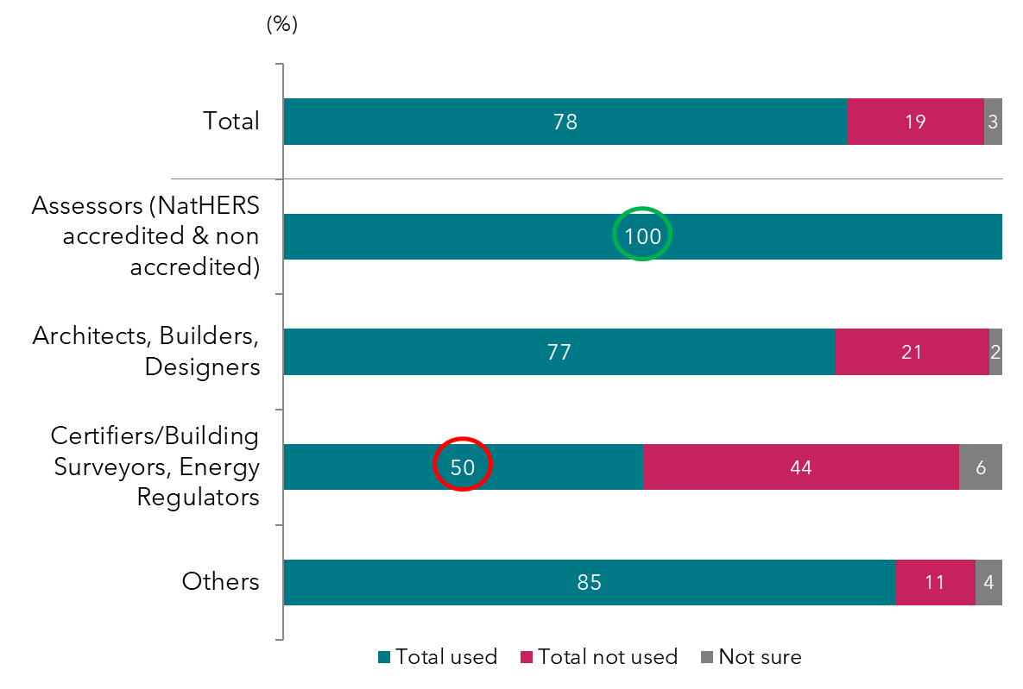
QB1a. Which, if any, of these energy rating tools have you ever used, during your career? (multi response)
Base: Total sample n=206; Assessors n=67; Architects, Building Designers and Builders n=57; Certifiers/Building Surveyors, and Regulators n=55; Others Group n=27*

Specific energy rating tools—ever used
Almost all assessors use one of the NatHERS tools (either FirstRate5, Bers Pro or AccuRate) (see Figure 4). FirstRate5 and BASIX are the two most common energy rating tools ever used among professionals, particularly among assessors, followed closely by Bers Pro. Four in ten assessors also use AccuRate (Figure 4).
It is worth nothing however that there are differences in states and territories regulations regarding the tools and their use. For example, BASIX is used in NSW and is mandatory. The Residential Efficiency Scorecard is voluntary and can’t be used for code compliance.
Architects, building designers and builders are more likely to have ever used BASIX than any other tool (Figure 4), whilst the “others group” are more likely to have ever used the Residential Efficiency Scorecard. This could be due to the fact that there were more architects, building designers and builders from NSW in the sample than from other states (with 54% of the architect group coming from NSW).
A frequency count of the tools listed reveals that over half of the professionals (56%) use either one or two tools only, one in five use three or more tools, and one in five use none. This finding is supported by the qualitative research and online forums, where professionals mentioned having knowledge of one or two tools at most, as it takes a lot of time to know a tool intimately.
Figure 4 includes the professionals who reported having ever used an energy rating tool by user group and the tool/s they have used.
Figure 4: Use of listed energy rating tools in career to date—by user group
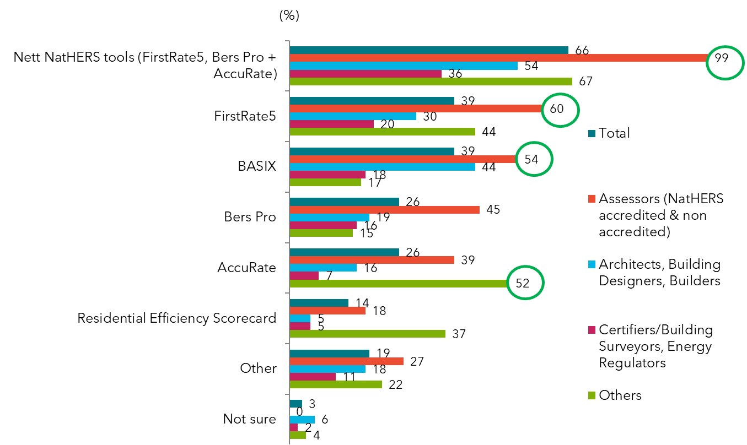
QB1a. Which, if any, of these energy rating tools have you ever used, during your career? (multi response)
Base: Total sample n=196; Assessors n=63; Architects, Building Designers, and Builders n=56; Certifiers/Building Surveyors, and Energy Regulators n=50; Others Group n=27*

Specific energy rating tools—currently using
Participants who reported having ever used an energy rating tool, were asked ‘and which of these energy rating tools are you currently using?’ Participants who reported that they have not used an energy rating tool, were asked ‘which of these energy rating tools do your colleagues currently use?’
Possible answers to both questions included:
- Bers Pro
- AccuRate
- FirstRate5
- BASIX
- Residential Efficiency Scorecard
- Other (please specify only one)
- Not sure
- None of the above
Figure 5 shows the tool/s currently used by each of the user groups. All assessors are currently using one of the NatHERS tools (Figure 5). In terms of current use, assessors are most likely to use FirstRate5 (one in two), followed closely by BASIX and Bers Pro (around 1 in 3 each) (Figure 5). Architects, building designers and builders are more likely to use BASIX, whilst the “others group” are more likely to use the Residential Efficiency Scorecard (Figure 5).
Figure 5: Current energy rating tool use—own use
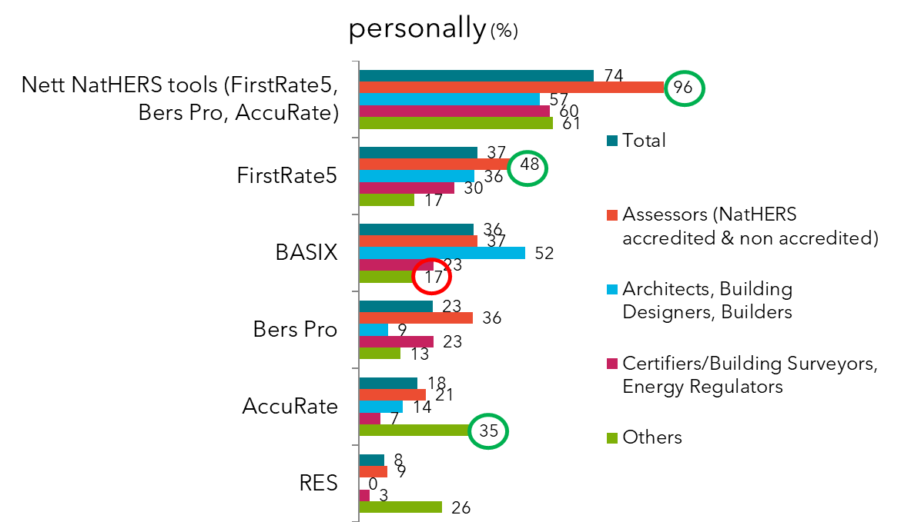
QB1b. And which of these energy rating tools are you currently using? (multi response)
Base: Those who have ever used energy rating tools n=164; Architects, Building designers, Builders n=44; Building certifiers/surveyors and Energy Regulators n=30; Assessors n=67; Energy consultant n=23*

Figure 6 shows the tool/s professionals claim their colleagues are currently using. This question was only asked to those professionals who were not sure whether or not they had used an energy rating tool. Among the professionals who are not sure whether they use any of the tools, a quarter of them claim that their colleagues are using FirstRate5 (Figure 6).

Figure 6: Current energy rating tool use – colleague use
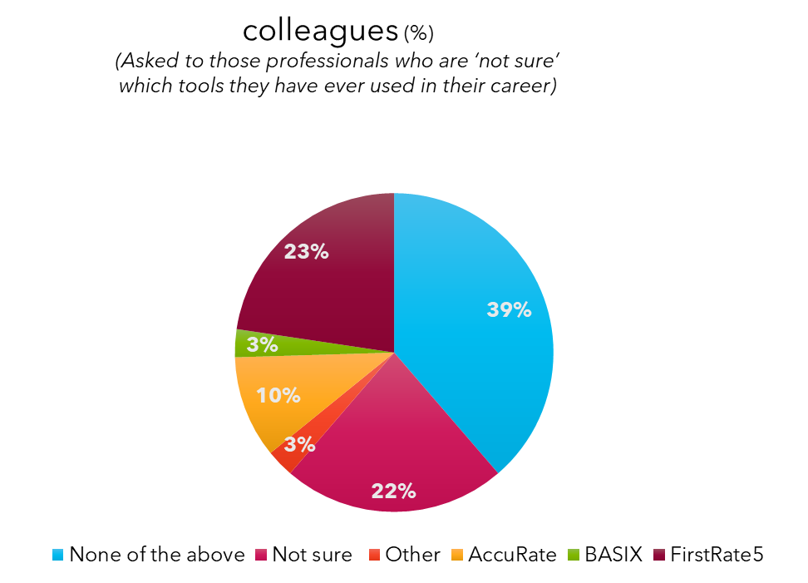
QB1c. Which of these energy rating tools do your colleagues currently use?
Base: Those who are not sure which tools they currently use n=37

Purpose of using any energy rating assessments
The online survey asked all participants ‘For what purpose do you or did you and/or your colleagues use energy rating assessments?’ Following this, participants were asked, ‘And for what purpose would you ideally like to be able to use an energy rating assessment, in the future?’
For both questions, participants could select one or more of the following answers:
- For proactive design: To inspire and model different house designs based on thermal performance and overall energy use, and make suggestions to our clients.
- For reactive design: To estimate the thermal and overall energy performance of a proposed design that is based on what our client asks for.
- For regulatory purposes: To assist with the process of obtaining a building permit for a proposed new building
- For regulatory purposes: To assess and verify the thermal and overall energy of a dwelling, based on regulatory requirements.
- For construction purposes: To check that the building is being built according to the requirements in the National Construction Code
- For compliance purposes: For on-site checks of the building to ensure that it is compliant.
- Other (please specify)

As shown in Figure 7, the survey found that most professionals (7 in 10) use energy rating assessments for regulatory purposes to assist with the process of obtaining a building permit for a proposed building, even more so for assessors (9 in 10 do so for this purpose) (Figure 7). Half of all professionals claim to use energy rating assessments for proactive design, and assessors are more likely than others to use the assessments for reactive design (estimating thermal performance) (Figure 7). One in five certifiers/building surveyors and regulators claim to use an energy rating assessment for on-site compliance checks (Figure 7).
Figure 7: Reasons for use of energy rating assessments—by user group
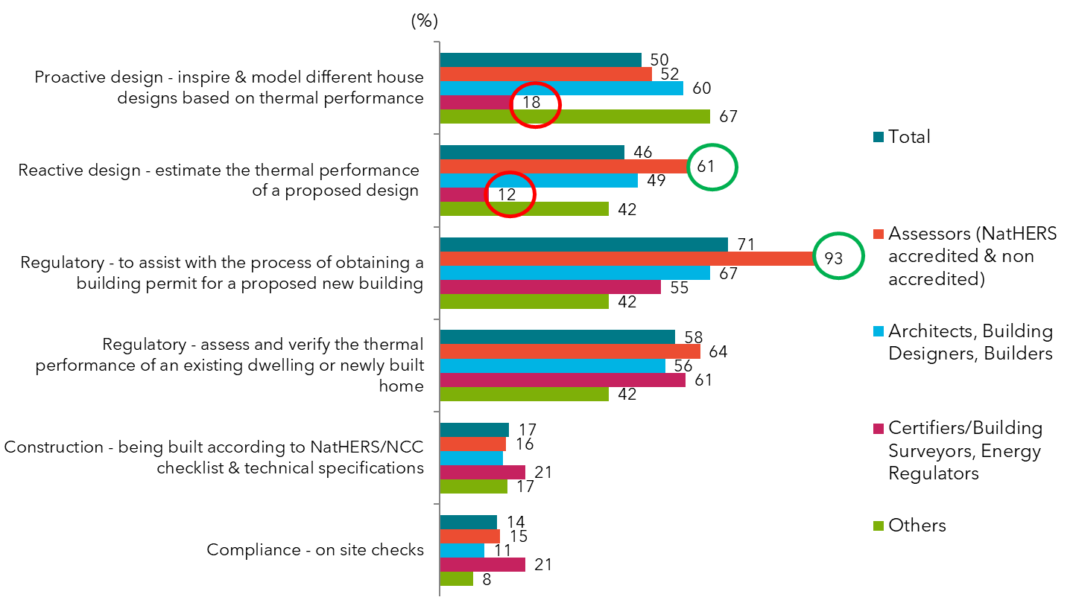
QB2. For what purpose do you or did you and/or your colleagues use energy rating assessments? (multi response).
Base: Total sample n=169; Architects, Building Designers and Builders n=45; Building certifiers / surveyors and Regulators n=33; Assessors n=67; Energy consultant n=24*

Current versus ideal use of energy rating assessment
Compared to how energy rating assessments are currently being used, professionals are more likely to ideally want to use energy rating tools for proactive design to inspire different thermal designs, as well later on for construction purposes, and also for compliance and on-site checks (Figure 8).
This supports findings from the qualitative research (Figure 10) that found that often the NatHERS certificate is not looked at beyond the regulatory phase and council approval of the house building.

Figure 8: Current use of energy rating assessments compared with ideal uses of an energy rating tool
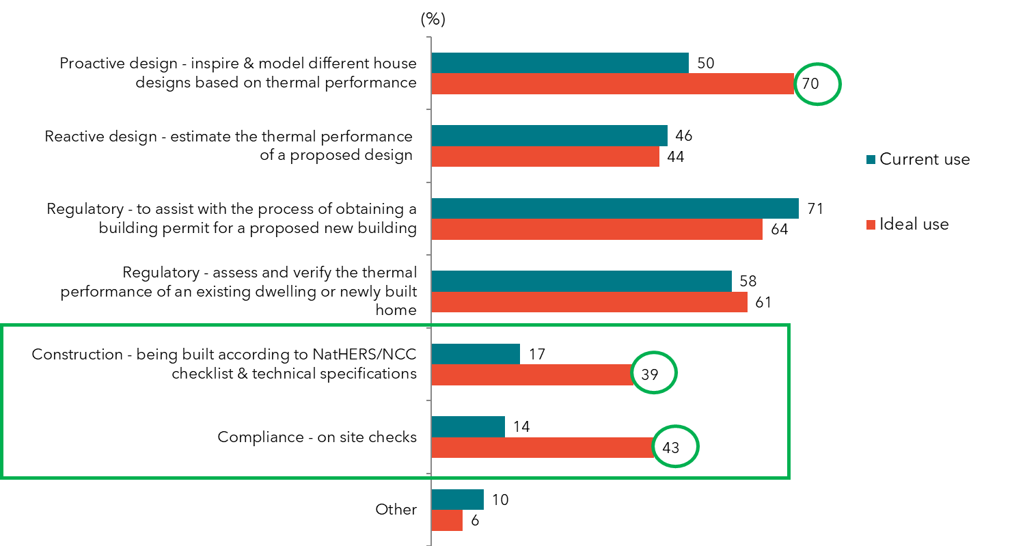
QB2. For what purpose do you or did you and/or your colleagues use energy rating assessments? (multi/response).
QB4. And for what purpose would you ideally like to be able to use an energy rating tool, in the future?
Base: Total sample n=169

Figure 9: Ideal purposes for use of energy rating tools by user groups
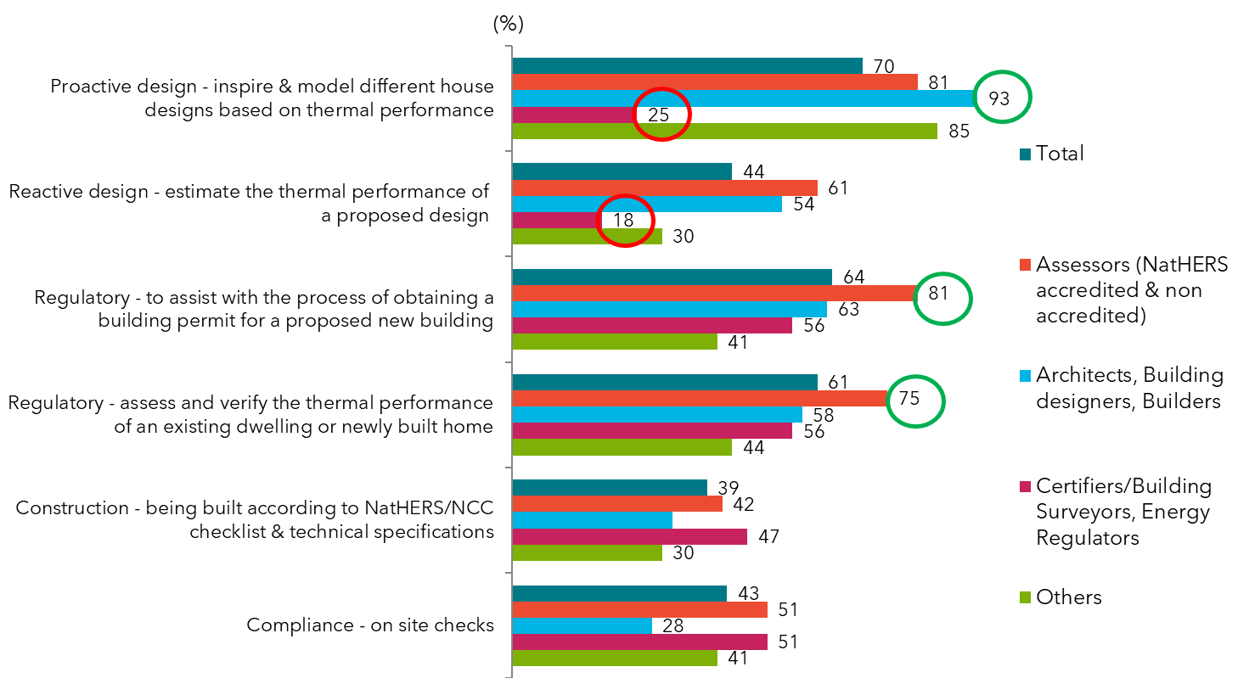
QB4. And for what purpose would you ideally like to be able to use an energy rating tool, in the future? (multi response)
Base: Total sample n=169; Architects, Building designers, and Builders n=45; Building certifiers / surveyors and Regulators n=33; Assessors n=67; Energy consultant n=24*
The different intended uses of the certificate also highlight the complexity of designing the ideal certificate, particularly for multiple audiences, this was a challenge discussed throughout the qualitative research (Figure 12).
Although the consumer was not included in the research, it is worth noting that during the online discussion forums, professionals also discussed the idea of whether the whole-of-home certificate should be for everyone (including the home-owner), or whether it should be for mainly professionals (Figure 11).

Where in the construction process are the communication tools used?
Results from the qualitative interviews revealed that many professionals talked about the need for NatHERS communications tools to be valued and understood, such that homeowners treat them with care – and use them when renovating and buying new fixed appliances into the future.
Figure 10: Timing of use of energy rating tools in construction process (Qualitative results)
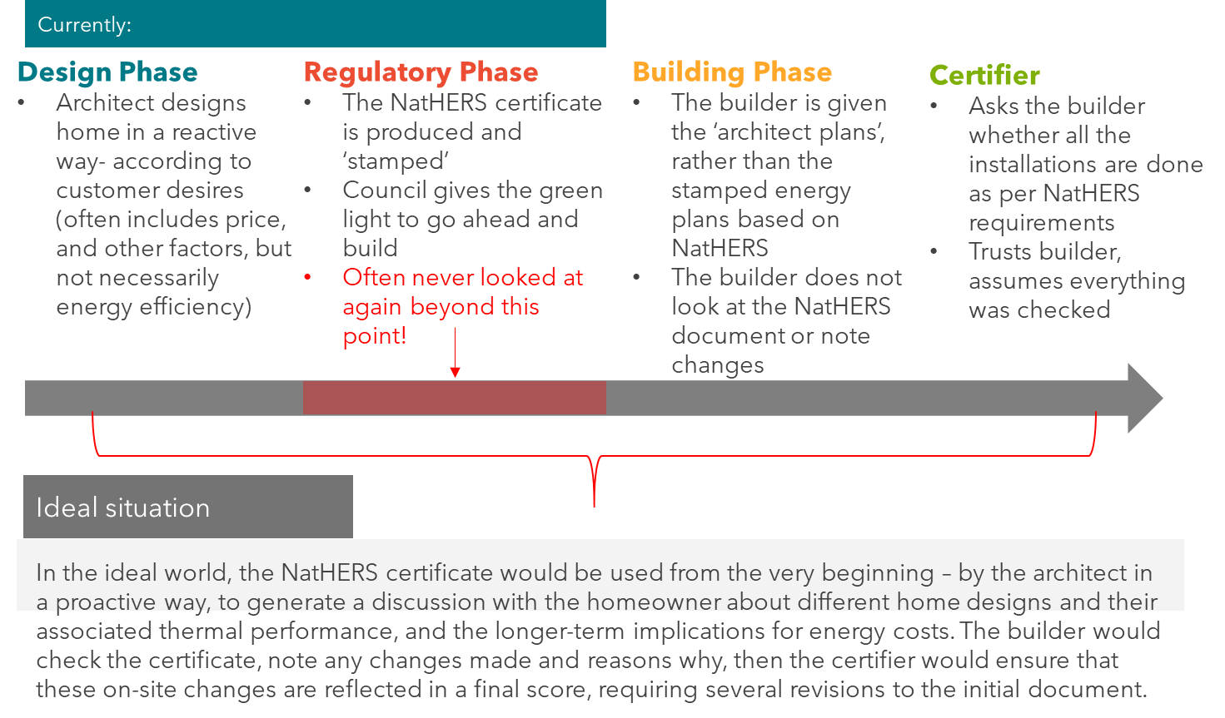
NB. The above is a general description of how a NatHERS Certificate might be used. However, it should not be considered as an accurate reflection of how it is used by all professionals and in all states and territories.

Purpose of ideal energy rating tool
Architects, building designers and builders have the strongest support for using energy rating tools for proactive design (Figure 9), this reflects viewpoints from depth interviews (Figure 10).
Assessors are most likely to want to see the energy rating tools used for estimating the thermal performance of a house, for regulatory purposes in the future and at the front end of the process to inspire the design of different houses based on thermal performance (Figure 9).
Figure 11: Requirements for a whole-of-home tool (Qualitative results)
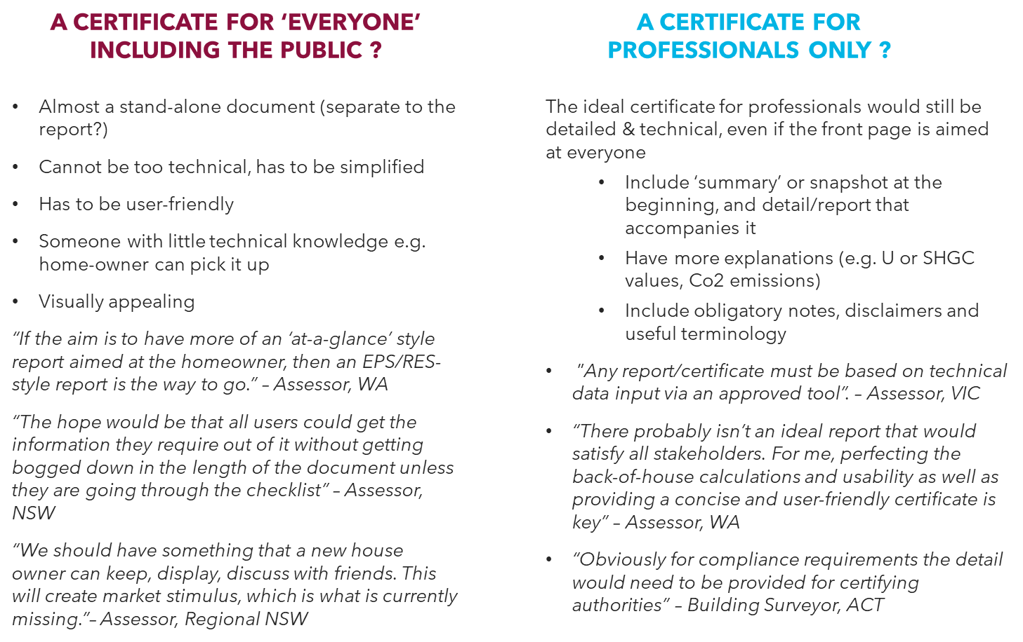

It was concluded that the communication tool ideally needs to be multi-purpose: the audiences are complex, and it is difficult to design one communication tool that meets everybody’s needs (Figure 11).
Most said the document should have a ‘duality’, where some of the communication tool meets universal needs (including the homeowner) and includes the appropriate level detail that meets other professions’ needs (Figure 12).
At present, experts report that many homeowners don’t receive, read or store away their energy efficiency certificate because they don’t understand it (Figure 10).

Figure 12: Requirements for different audiences for the whole-of-home tool (Qualitative results)
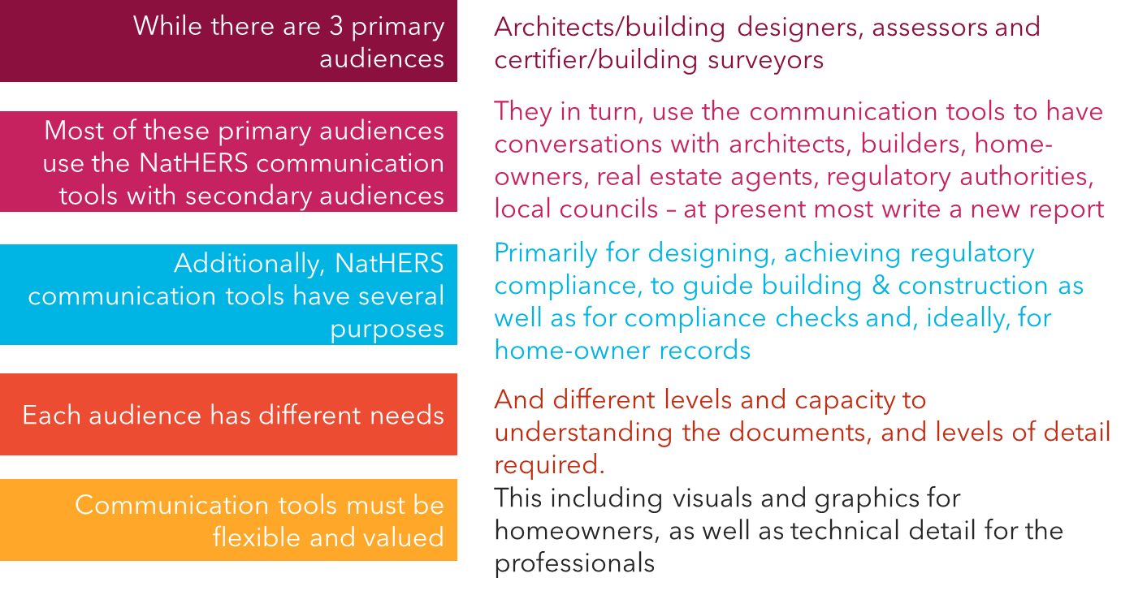

Use of NatHERS
Participants were asked ‘For what purpose do you or did you and/or your colleagues use NatHERS? Participants could select one or more of the following responses:
- Don’t use NatHERS
- For proactive design: To inspire and model different house designs based on thermal performance and overall energy use, and make suggestions to our clients.
- For reactive design: To estimate the thermal and overall energy performance of a proposed design that is based on what our client asks for.
- For regulatory purposes: To assist with the process of obtaining a building permit for a proposed new building
- For regulatory purposes: To assess and verify the thermal and overall energy of a dwelling, based on regulatory requirements.
- For construction purposes: To check that the building is being built according to the requirements in the National Construction Code
- For compliance purposes: For on-site checks of the building to ensure that it is compliant.
- Other (please specify)
Figure 13 shows those who reported to using NatHERS versus those who reported not using NatHERS, by profession. The majority (8 in 10) of professionals claim to use NatHERS. NatHERS is most likely to be used by assessors (almost all, 97 per cent use it), and at least 7 in 10 architects, building designers and builders use it as well. Certifiers /building surveyors and regulators are least likely to use NatHERS (but still two thirds use it) (Figure 13).

Figure 13: Use of NatHERS – by user group
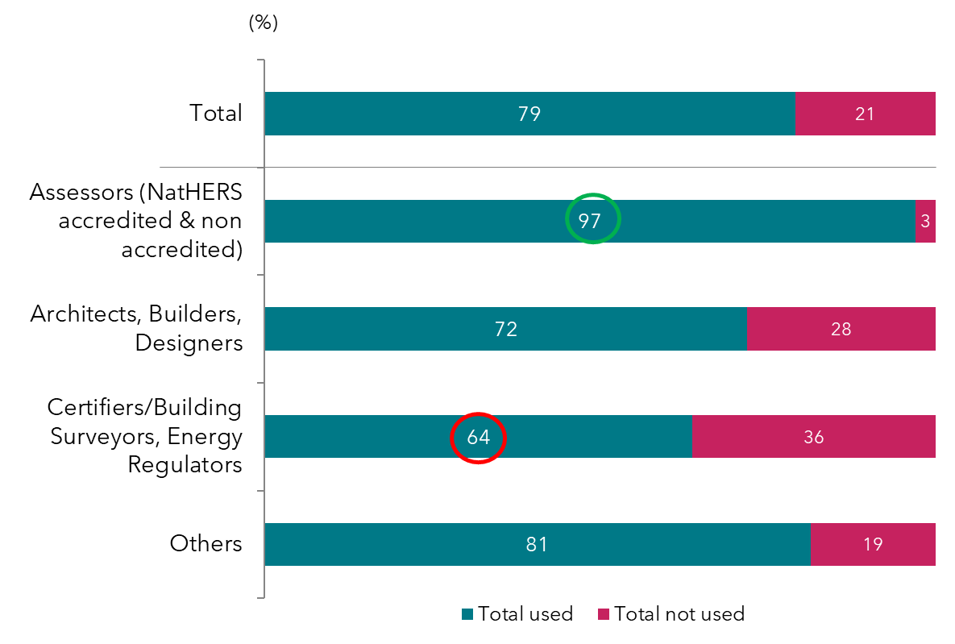
QB3. For what purpose do you or did you and/or your colleagues use NatHERS?
Base: Total sample n=206; Assessors n=67; Architects, Building designers and Builders n=57; Certifiers /building surveyors and Regulators n=55; Others n=27*

Purpose of using NatHERS
Figure 14 shows the purposes that professionals use NatHERS, by each of the user groups. Assessors are more likely to than any other group to use NatHERS for reactive design, as well as for regulatory purposes. Certifiers, building surveyors and regulators are least likely to use NatHERS for design or regulatory purposes. One in three certifiers don’t use NatHERS, hence their lower scores on the reasons for using NatHERS (Figure 14).

Figure 14: Purposes for use of NatHERS – by user group
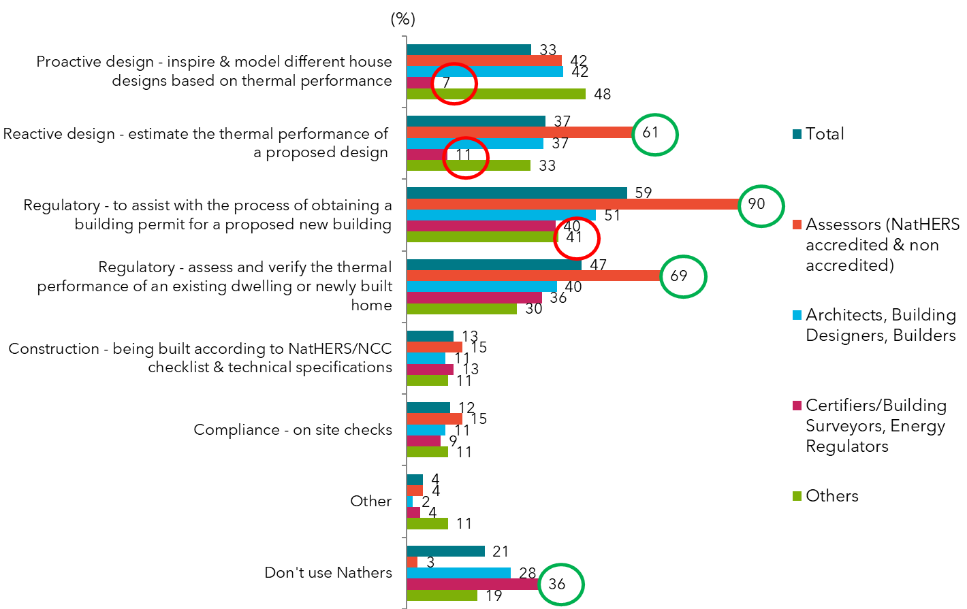
QB3. For what purpose do you or did you and/or your colleagues use NatHERS?
Base: Total sample n=206; Assessors n=67; Architects, Building designers and Builders n=57; Certifiers /building surveyors and Regulators n=55; Others n=27*

Information needs
Based on participant’s response to how they use energy rating tools, they were asked questions about what information they currently use from their energy rating certificate. The questions asked were:
- ‘What information do you currently use from your energy rating certificate when designing a new building?’
- ‘What information do you currently use from your energy rating certificate for compliance purposes?’
- ‘What information do you currently use from your energy rating certificate for construction purposes?’
Possible responses to all three questions were:
- The overall energy efficiency rating
- Room by room energy performance
- The impact of building orientation on its thermal performance
- Heating and cooling thermal loads – with information on floor size
- The requirements for building wrap/envelope (minimum thermal shell)
- Energy performance of the building by season (warmer and cooler)
- Energy performance of the building month-on-month
- The overall cost to get an increase in the NatHERS rating by 1 star for a building
- The thermal mass of the building
- The impact of suspended floor as opposed to concrete ground on thermal performance
- Building material considerations and their impact on thermal performance
- Climate related information and how climate affects thermal performance
- Information around air tightness of the building
- Ideas or suggestions to improve the overall thermal performance
- Impacts of increasing insulation
- The glazing calculator details
- Overall energy performance of the fixed appliances in the home
- Overall whole of home energy performance (appliances and thermal assessment)
- Performance of individual fixed appliances
- Information about on-site renewable energy generation and storage
- Other (please specify)
- All of the above
- None of the above
Additionally, they were asked what information they need about energy costs when designing a house/seeking regulatory approval for a house/constructing a house.
Possible answers were:
- The impacts of different heating and cooling appliances on energy use
- The impact of air leakage on energy use
- The amount of energy the house needs to maintain its comfort thermostat settings
- The % contribution of various appliances to overall energy consumption
- Recommendations on the most cost-effective appliances suited to the dwelling
- Potential energy savings to be made by switching or upgrading appliances
- The exact number of fixed appliances in the home (e.g. ceiling fans etc)
- The specific model and make of existing appliances being installed in the houses
- The amount of energy the dwelling uses and how much renewable energy would be needed to achieve a zero-energy home.
- Other (please specify)
- All of the above
- None of the above
They were asked what information they need about solar PV and the environment when designing a house/seeking regulatory approval for a house/constructing a house.
Possible answers were:
- The impact of solar PV on the overall yearly energy use drawn from the grid and the overall score of the dwelling
- The impact of solar PV on energy running costs
- The carbon emissions from the building
- The proportion of energy consumption that comes from renewable sources
- Other (please specify)
- All of the above
- None of the above
They were also asked what other information do you need when designing a house/seeking regulatory approval for a house/constructing a house.
Possible answers were:
- How to build a passive solar home (that requires no mechanical heating or cooling)
- The assumptions made in the rating calculation
- The levels of verification (who to check what and when) required to achieve the rating
- The on-site checks required during the construction process
- Details on who conducted the thermal assessment (including their profession, contact details, whether they are accredited)
- Other_(please specify)
- All of the above
- None of the above

Certificate information currently used when designing a house
The overall energy efficiency rating, heating and cooling loads are the top two most used information pieces when designing a building (Figure 15). And at least half also consider the building orientation, building materials and wall insulation impacts (Figure 15).
However, it is also important to note, following a couple of depth interviews with professionals in the Northern Territory, that in the tropics, the type of building that would work well “passively” is the opposite to the ideal cooler climate building, and thus ‘wall insulation’ is less relevant.
Quote from depth interview:
“NatHERS tends to encourage ‘sealed’ buildings with a concrete slab, insulation and ‘air tightness’, which is often the opposite of the type of building that is sustainable in the tropics. The shape of the building is important, orientating to the BREEZE as opposed to the SUN is more important here. We want to shade every single wall all year around, we want a long thin plan, big open windows, louvres, and opening, and venting roofs” - Architect, Darwin

Figure 15: Information currently used from energy rating certificate when designing a new building
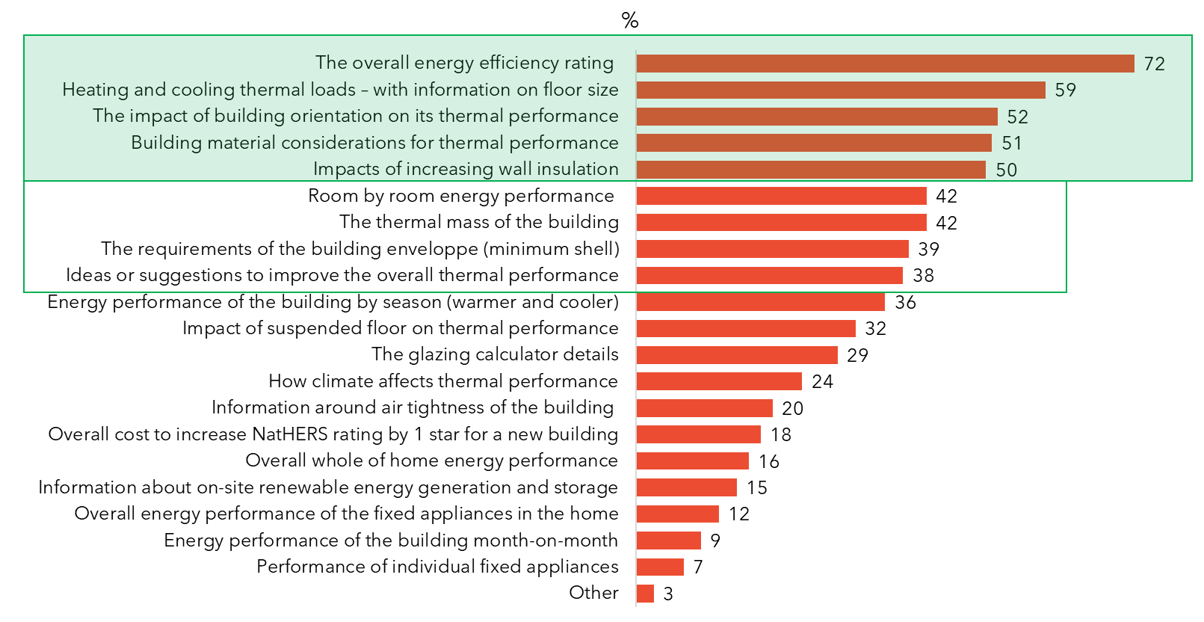
QB5a1. What information do you currently use from your energy rating certificate when designing a new building?
Base: Those who use energy rating tools for design purposes n=117

Energy cost information needs when designing a house
Figure 16 shows that information about the amount of energy the dwelling uses and how much renewable energy would be needed to achieve a zero-energy home, the amount of energy the house needs to maintain its comfortable thermostat settings, and the impacts of air leakage on energy use are considered the most important information needed in relation to ‘energy costs’ for those designing a house.
Figure 16: Information needed about energy costs when designing a house
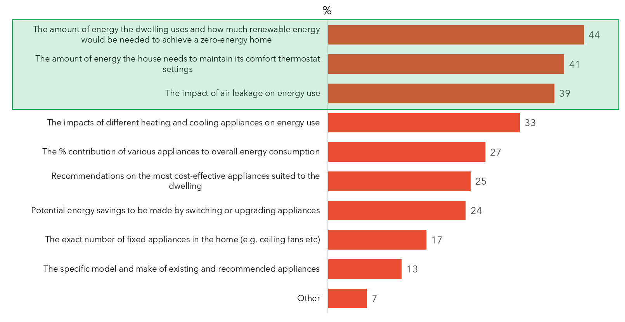
QB7b.1 What information do you need about energy costs when designing a house?
Base: Those who use energy rating tools for design purposes n=117

Solar PV information needs when designing a house
Those designing houses are equally interested in ‘the impact of solar PV on energy running costs’, as well as the impact on ‘the thermal performance of the home and overall score’ (Figure 17).
Quote from online discussion forum:
“Showing all parties how a house may have minimal or no impact through solar systems, a solar hot water system, even small localised wind generators would be good.” – Building designer

Figure 17: Solar PV information needs when designing a house
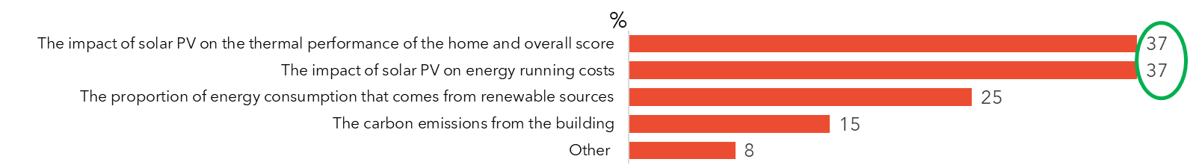
QB8.1. What information do you need about solar PV and the environment when designing a house?
Base: if purpose of certificate use is proactive or reactive design. Total sample n=117

Other information needs when designing a house
In terms of other information needs, for design purposes at least half would like to know the assumptions made in the calculation (Figure 18).
Figure 18: Other useful information for design purposes
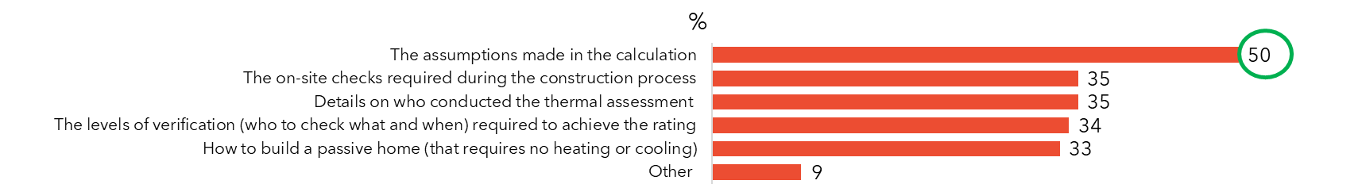
QB9.1. What other information do you need when designing a house?
Base: if purpose of certificate use is proactive or reactive design. Total sample n=117

Certificate information currently used when using it for compliance purposes
Interestingly, for compliance purposes, the same information features in the top two places as for design purposes, overall energy efficiency rating and the heating and cooling loads (Figure 19). Other important information for compliance purposes includes building materials and the glazing calculator (Figure 19).

Figure 19: Information currently used from energy rating certificate for compliance purposes
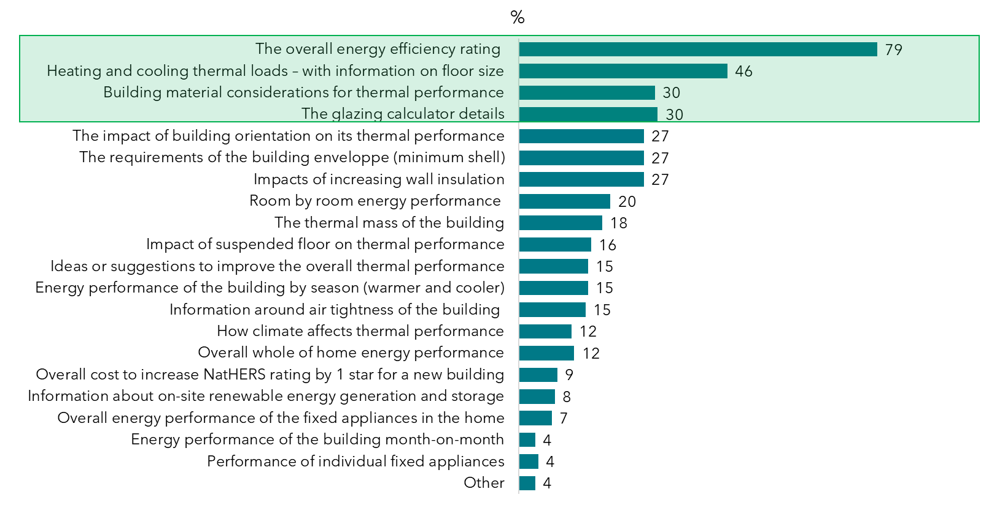
QB5a.2 What information do you currently use from your energy rating certificate for compliance purposes?
Base: Those who use energy rating tools for compliance purposes n=164.

Energy cost information needs for compliance purposes
When seeking regulatory approval for a house, the top three most important pieces of information about energy costs are the same as those listed when designing a house, with the ‘thermostat setting’ standing out from the crowd, one in three need this information (Figure 20).
One in five consider ‘the impacts of air leakage on energy use’ or ‘the amount of energy the dwelling uses and how much renewable energy would be needed to achieve a zero-energy home’ to be important when seeking regulatory approval for a house (as compared to 4 in 10 when designing a house) (Figure 20).
Quote from online discussion forum
“It could be useful to include some temperature graphs for the main living space (without AC running) on a page in the certificate which would show how comfortable the space is expected to be under different conditions”. Assessor, NSW

Figure 20: Information needed about energy costs when seeking regulatory approval for a house
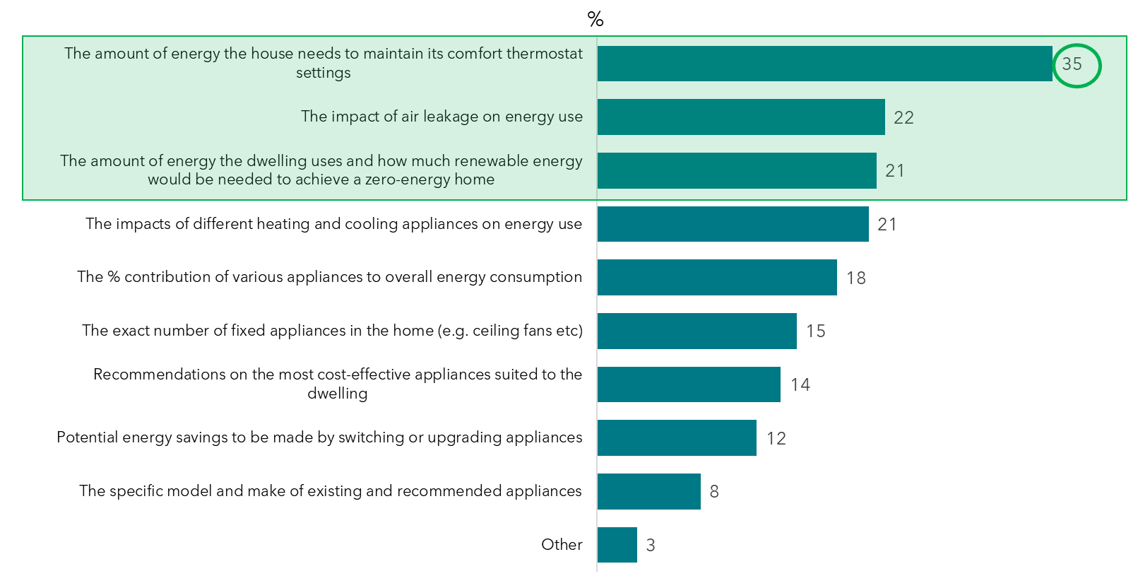
QB7b.2 What information do you need about energy costs when seeking regulatory approval for a house?
Base: Those who use energy rating tools for compliance purposes n=164.

Solar PV information need for compliance purposes
When seeking regulatory approval for a house, a third of professionals are interested in the impact of solar PV on the thermal performance of the home and overall score (Figure 21).
Figure 21: Solar information needs when seeking regulatory approval for a house
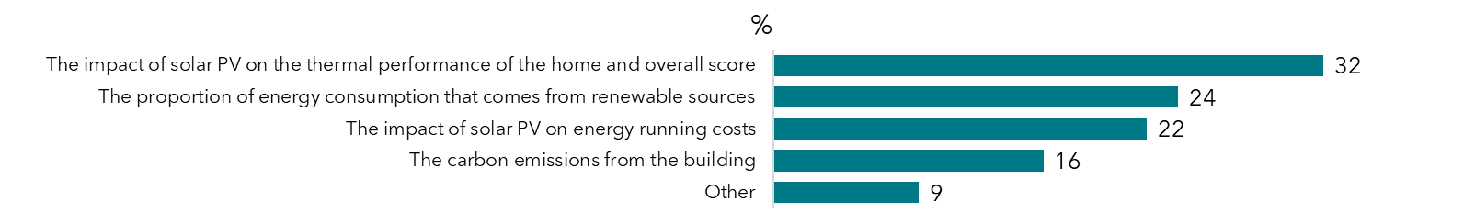
QB8.2. What information do you need about solar PV and the environment when seeking regulatory approval for a house?
Base: if purpose of certificate use is proactive or reactive design. Total sample n=164

Other information needs for compliance purposes
For compliance purposes, over half would like to know the details of who conducted the assessment, as well as the assumptions made in the calculation (Figure 22).
Figure 22: Other useful information when seeking regulatory approval for a house
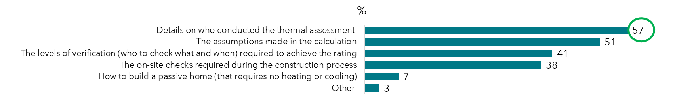
QB9.2. What other information do you need when seeking regulatory approval for a house?
Base: if purpose of certificate use is proactive or reactive design. Total sample n=164

Certificate information currently used when using it for construction purposes
For construction purposes, the top two pieces of information currently used from energy rating certificates includes the overall energy efficiency rating, and the impact of increasing wall insulation. These were considered important by at least half of those who use energy rating tools for construction purposes (Figure 23). Building material considerations and their impact on thermal performance was considered important for four people in 10 (Figure 23).
The qualitative research also revealed that the ideal certificate could take into account what happens at construction, as a lot of variation can happen along the way. For example, a checklist could specify “how insulation should be installed and how junctions and penetrations should be sealed etc”, Builder, SA.
Figure 23: Information currently used from energy rating certificate for construction purposes
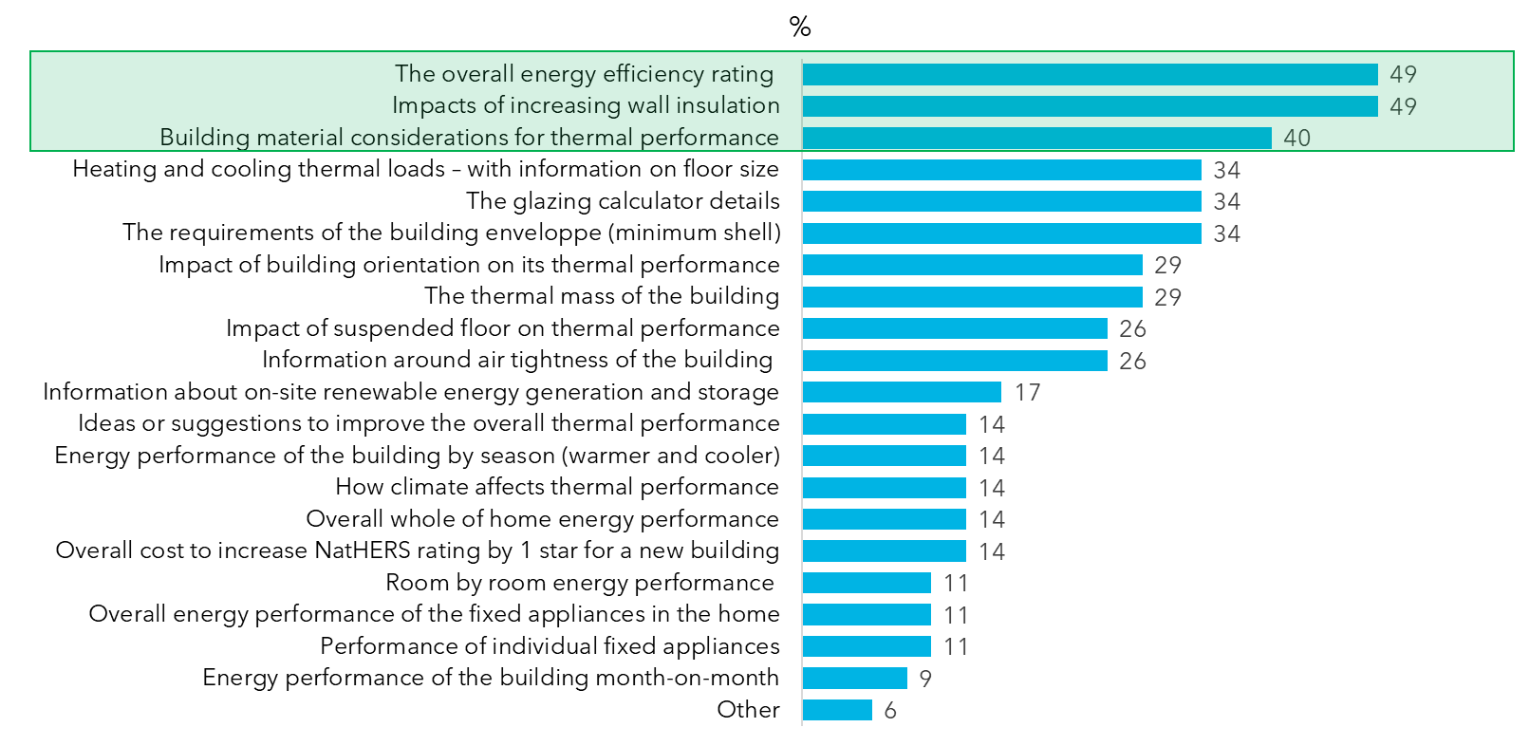
QB5a3. What information do you currently use from your energy rating certificate for construction purposes?
Base: Those who use energy rating tools for construction purposes n=35.

Energy cost information needs for construction purposes
When constructing a house, the top 3 pieces of information needed for energy costs are the same as those needed when designing a house and when seeking regulatory approval for a house (Figure 24).
Quote from depth interview:
“The rating assumes standard construction that we have in Australia with standard leakage rates. If I was to add air tightness to it, I’d put 5 overall ticks: ‘wall insulation’, ‘ceiling insulation’, ‘under floor insulation’, that the windows are as specified or better, the ‘holes in plaster have been counted (E.g. 10 downlights)’. These things can all affect air leakage”. Builder, SA

Figure 24: Information needed on energy costs when constructing a house
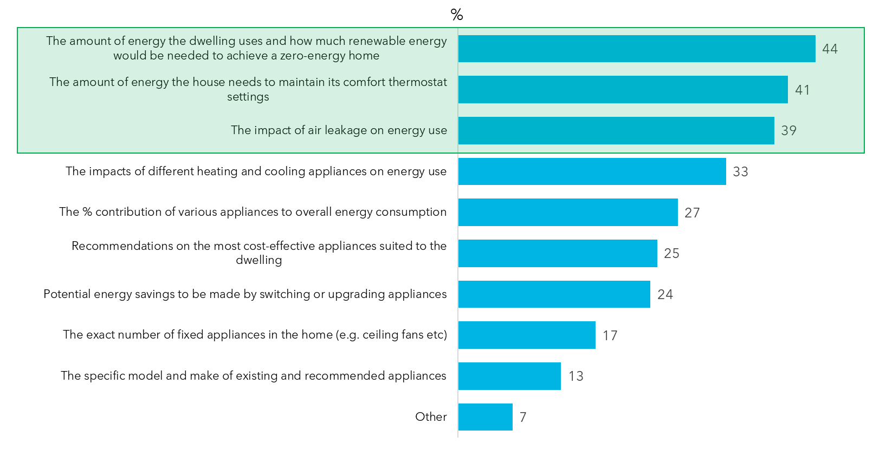
QB7b.3 What information do you need about energy costs when constructing a house?
Base: Those who use energy rating tools for construction purposes n=35.

Solar PV information needs for construction purposes
For construction purposes, over a third of professionals are interested in the impact of solar PV on the thermal performance of the home and the overall score (Figure 25).
Figure 25: Solar PV information needs for construction purposes
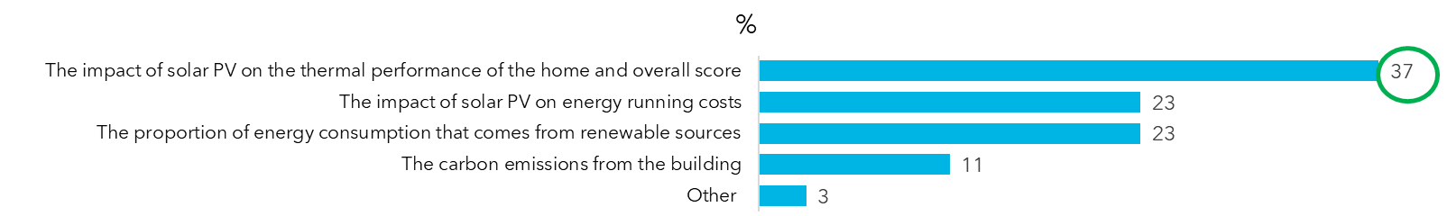
QB8.3 What information do you need about solar PV and the environment when constructing a house?
Base: if purpose of certificate use is proactive or reactive design. Total sample n=35

Other information needs for construction purposes
For construction purposes, six in ten professionals would like to have ‘on-site checks required’ during the process, and around half would like to know the levels of certification (who checked what when) required to achieve the rating (Figure 26).

Figure 26: Other useful information for construction purposes
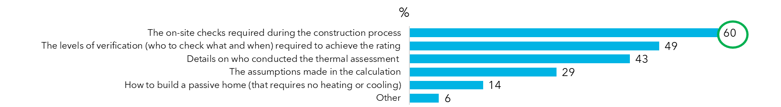
QB9.3. What other information do you need when constructing a house?
Base: if purpose of certificate use is proactive or reactive design. Total sample n=35

Certificate information ideally used (top 10)
Professionals were asked ‘What information would you ideally like to obtain from an energy rating certificate?’ The answers offered where the same as those listed for the questions about what information they currently use.
Figure 27 shows the top ten pieces of information that professionals would ideally like to obtain from an energy rating certificate.
Professionals are most interested in information such as ‘the overall energy efficiency rating’ (at least half expect this on the ideal certificate) (Figure 27). Then, ‘heating/cooling thermal loads with information on floor area’, ‘building material considerations and their impact on thermal performance’, and ‘information around air tightness of the building’ feature in the top four for all user groups (Figure 27). Certifiers, building surveyors and regulators are less interested in the impacts of increasing insulation, since their focus is more on ensuring that the insulation that was planned, modelled, and built all align (Figure 27).
Figure 27: Ideal certificate information by user groups (Top 10 results)
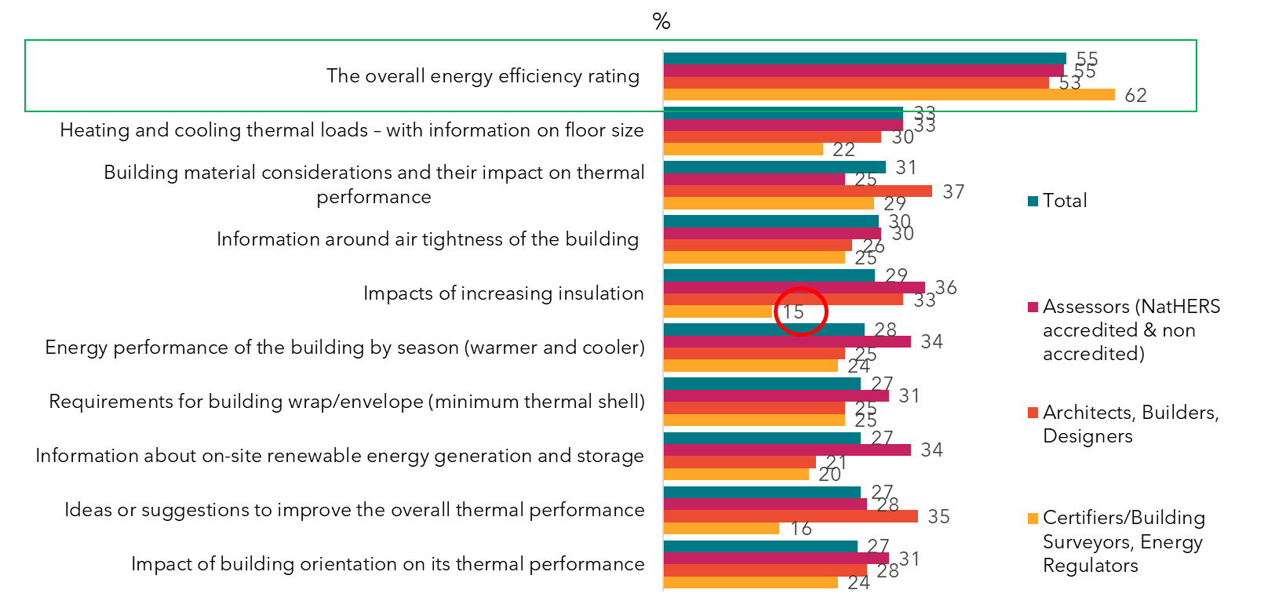
QB6. What information would you ideally like to obtain from an energy rating certificate?
Base: Total sample n=206; Assessors n=67; Architects, Building Designers and Builders n=57; Certifiers /building surveyors n=55; Others n=27*

Figure 28 shows the results for what professionals would ideally like to obtain from an energy rating certificate.
Assessors are more likely than others to want information on ‘room by room energy performance’, as well as the ‘performance of individual fixed appliances’ on an energy rating certificate (Figure 28). Certifiers, building surveyors and regulators are more likely to want information about ‘the glazing calculator details’ on an energy rating certificate than others. In the online discussion forums, they also mentioned the importance of glazing surface area and direction, as well as checking double glazing (Figure 28). ‘Climate related information and how climate affects thermal performance’ is of least importance (Figure 28).
Quote from online discussion forum:
“The HVAC modelling tools I'm used to will give information about what energy is coming through each element and allow a quicker understanding of what the problem is in a given space. I like to see that level of granularity”. – Assessor

Figure 28: Ideal certificate information by user group (remaining results)
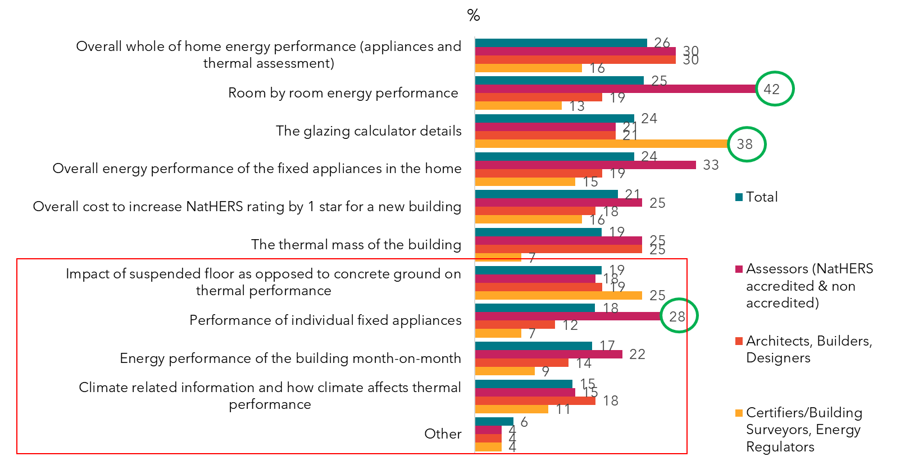
QB6. What information would you ideally like to obtain from an energy rating certificate?
Base: Total sample n=206; Assessors n=67; Architects, Building Designers, and Builders n=57; Certifiers /building surveyors and regulators n=55; Others n=27*

NatHERS certificate—use and perception of change

Self-assessed familiarity with the NatHERS Certificate
The survey asked participants to follow a link to an online version of the NatHERS Certificate. They were then asked how familiar or unfamiliar they were with this NatHERS Certificate.
It should be noted that the NatHERS Certificate used in this research was only released for public use in April 2020. Therefore, professionals may have reported that they were not familiar with this particular certificate but may have been familiar with the previous version of the certificate.
A copy of the NatHERS Certificate used in this research is provided in the Appendix.
Assessors are most likely to be very familiar with the NatHERS certificate (Figure 29). Certifiers, building surveyors and regulators are most likely to be ‘familiar’ with it overall, however only a third claim to be very familiar with it (Figure 29). This aligns with results seen in Figure 14 with this group being more likely to not actually use the NatHERS certificate.
Figure 29:Familiarity with current NatHERS certificate
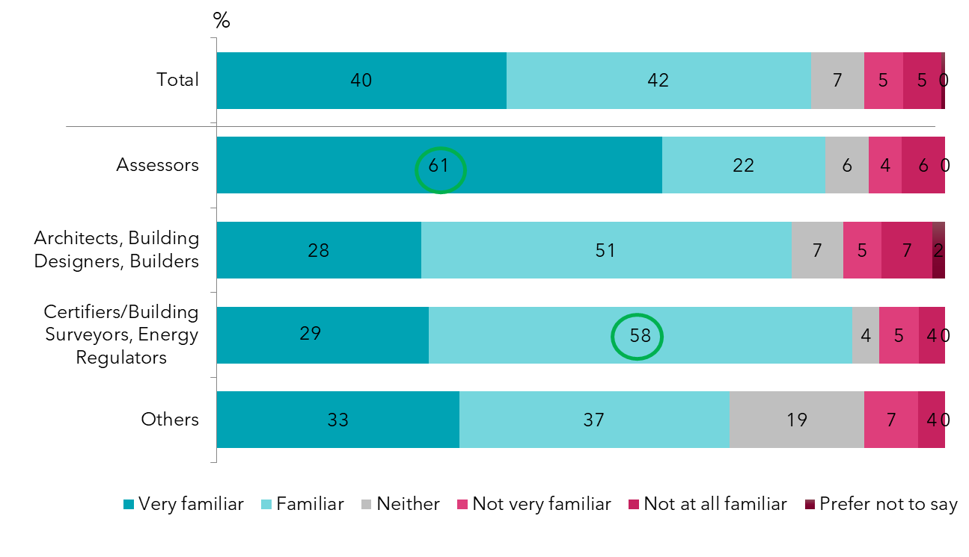
QC1. How familiar or unfamiliar are you with this NatHERS certificate?
Base: Total sample n=206; Architects, Building Designers and Builders n=57; Building certifiers / surveyors and regulators n=55; Assessors n=67; Energy consultant n=27*

Responses to the current NatHERS certificate
Survey participants were asked an open-ended question: “what do you like about the NatHERS certificate?” and “what don’t you like about it?” and shown the version from April 2020 as a pop up on the screen. Their responses were coded using the code frame in the image below and have been listed in order of mention.
Around one in four professionals like the fact that the current NatHERS certificate is simple and easy to read, that the information is relevant, detailed and itemised, and the graphics on it (23%), particularly the stars which got mentioned 14% of the time (Figure 30). One in five professionals believe that the current NatHERS certificate is missing specific/key elements or not comprehensive enough. Figure 31 lists the information professionals think is missing from the certificate.
Figure 30: Thoughts on current NatHERS certificate
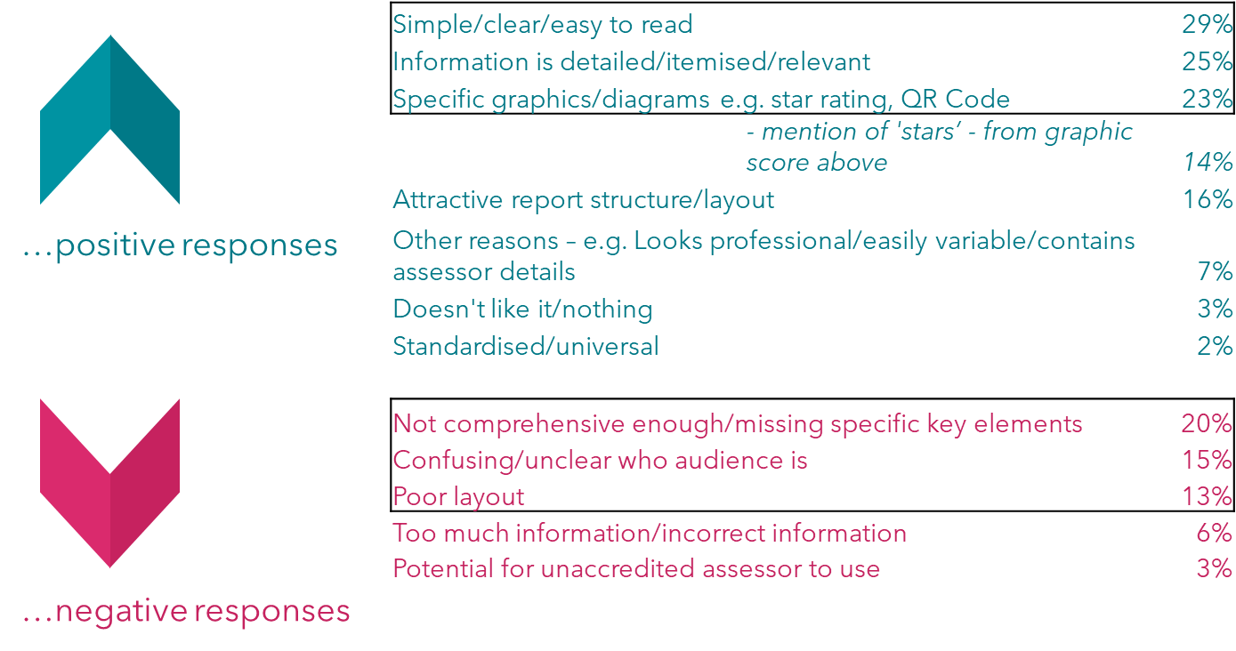
QC2a. What do you like about the NatHERS certificate? These were open ended questions
QC2b. What don’t you like about the NatHERS certificate? These were open ended questions
Base: Total sample n=206.

For almost a third of professionals, ‘nothing’ is missing from the current NatHERS Certificate (Figure 31). However, around one in ten mention extra information for verification/assurance, a more consumer-friendly certificate for a broader end user, inclusion of air tightness, and more aspirational elements (Figure 31).

Figure 31: Missing elements from current NatHERS certificate
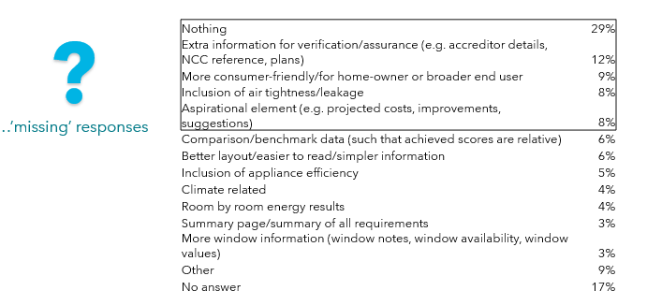QC2c. What, if anything, do you feel is missing from the NatHERS certificate? This was an open ended question
Base: Total sample n=206

Desire for a new NatHERS whole-of-home certificate
Survey participants were then told about the expansion of NatHERS to whole-of-home. They were provided with a short description of what NatHERS whole-of-home will include:
“The expansion of NatHERS to whole-of-home will keep the current NatHERS thermal performance rating, but also provide the energy performance of the fixed appliances and the overall home (combining the appliances with the thermal assessment).”
Participants were also provided a link to the NatHERS website containing more detailed information about the expansion of NatHERS to whole-of-home. https://www.nathers.gov.au/About/NatHERSExpansion
They were then asked ‘How do you feel about the expansion of NatHERS to include whole-of-home tools and rating?’ The ‘others group’ is most likely to be ‘very excited’ about expansion of NatHERS to include Whole-of-Home tools and ratings (Figure 32). Around half of assessors, architects, building designers and builders reported being excited or very excited about the expansion of NatHERS to include Whole-of-Home tools and rating. (Figure 32). Certifiers, building surveyors and regulators were the least ‘excited’ or ‘very excited’ (23%). (Figure 32).

Figure 32: Thoughts on NatHERS whole-of-home expansion
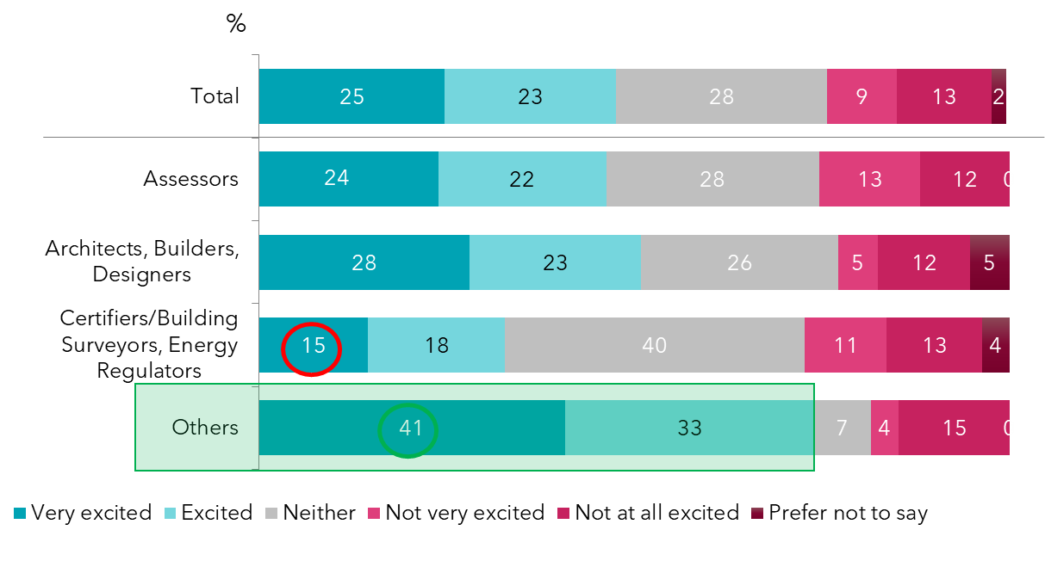
QC3. How do you feel about the expansion of NatHERS to include whole-of-home tools and ratings?
Base: Total sample n=206; Architects, Building Designers and Builders n=57; Building certifiers / surveyors and Regulators n=55; Assessors n=67; Energy consultant n=27*

Likely use for a NatHERS Whole-of-home rating assessment
Respondents were asked their likelihood to use a NatHERS Whole-of-Home rating assessment that would include the following fixed appliances:
  - heating and cooling appliances
  - hot water systems
  - lighting
  - pool pumps.
Certifiers, buildings surveyors and regulators reported that they were least likely to use the new NatHERS whole-of-home rating assessment, whilst the assessors are most likely to use it (Figure 33).
Assessors also reported (see Figure 28) that they would ideally like to have information on the fixed appliance included in an energy rating certificate.
This follows the same pattern as the current use of the current certificate, and as indicated in the qualitative research, it is the thermal assessors who are the group most likely to use these documents.

Figure 33: Likelihood of using NatHERS whole-of-home certificate
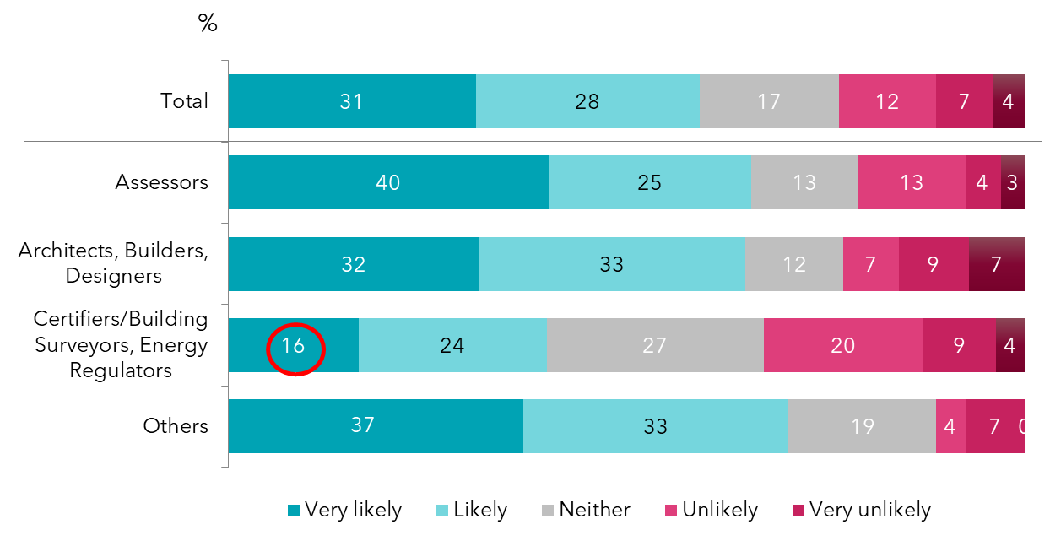
QC4. How likely or unlikely would you be to use a NatHERS whole-of-home rating assessment that would include…
Base: Total sample n=206; Architects, Building Designers and Builders n=57; Building certifiers / surveyors and regulators n=55; Assessors n=67; Energy consultant n=27*

Concerns around NatHERS to whole-of-home rating tools
Participants were asked ‘What would be your main concerns around the expansion of NatHERS to Whole-of-Home rating tools?’
The main concerns around the expansion of NatHERS to whole-of-home rating tools were ‘how the appliance score would be calculated and what assumptions would be made’, ‘that the thermal performance assessment remains intact and separate from the new score relating only to appliances’ and ‘that the addition of fixed appliances could hide a poor thermal performance, leading to trade-offs on the overall assessment’ (Figure 34). These are a concern for one in three professionals, there were no significant differences by user groups.

Figure 34: Concerns around NatHERS whole-of-home energy rating tool
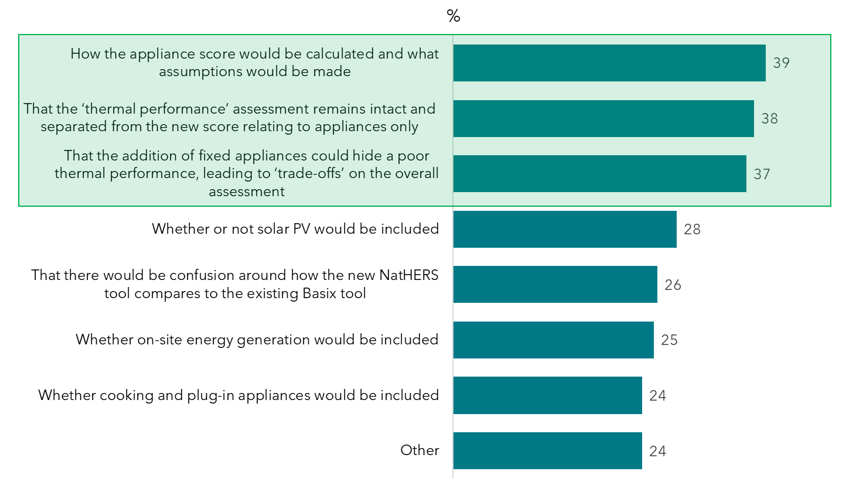
QC5. What would be your main concerns around the expansion of NatHERS to whole-of-home rating tools?
Base: Total sample n=206

The findings around the main concerns with the expansion of NatHERS to whole-of-home rating tools in the online survey reflect the qualitative findings from depth interviews, which found:
Figure 35: Concerns around NatHERS whole-of-home energy rating tool (from qualitative research)
- Almost all professionals interviewed believed that the ‘whole-of-home’ rating outcome should show a) the current thermal rating and b) the additional whole-of-home rating, as a separate score.
- The reason for keeping the original score, and not eliminating it, is to avoid a situation whereby buildings with a poor thermal shell but efficient appliances can still pass or score well.
- Having a separate whole-of-home performance score means that the ‘thermal component’ is retained, and this is important to maintain NatHERS existing brand and reputation.
Some professionals based in NSW like the way that BASIX separates the ‘thermal comfort’ score from the ‘energy’ and ‘water’ and suggested that a similar approach could work well for NatHERS.

Discrete Choice Model

Discrete Choice Model Design
The discrete choice model part of the survey tested the below eight attributes, with different alternatives for each attribute (i.e. different images for the way in which the information might be presented).
Figure 36: Discrete Choice Model Design certificate attributes
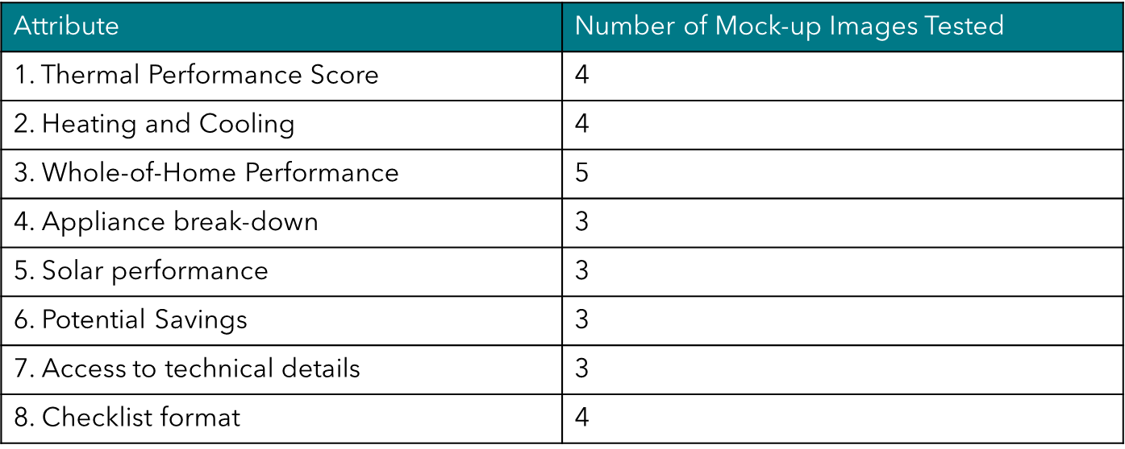
- Attributes 1, 2 and 8 above (thermal performance score, heating and cooling, and checklist format) feature on the current NatHERS Certificate.
- Attributes 3, 4 and 5 (whole-of-home energy score, solar PV and appliance break-down) are elements the Department has indicated are likely to be included in the new 'whole-of-home' certificate, and therefore were included to test different ways of showing the information.
- Attributes 6 and 7 (potential savings, and access to technical details) are options which are 'aspirational' and were all mentioned as being valuable in the qualitative research, hence their inclusion in the discrete choice model.
- The NCC reference and QR code that feature on the current certificate were not shown on the mock-up versions use in the discrete choice model, however survey participants were told that this was to focus their attention on the imagery and content during the exercise, but that they would normally otherwise be there.
Further notes on the discrete choice model design can be found in the appendix, as well as some examples of mock-up certificates, and the images that were tested for each attribute.
Survey participants were shown eight different mock-up certificates showing the way a whole-of-home NatHERS certificate might look. Each of the eight mock-up certificates included a mixture of the different attributes and images. They were shown each of the eight mock-ups one at a time and for each they were asked to look at the type of information it included (both pages 1 and 2) and then to answer the question: ‘Would you prefer to use the current certificate, the new certificate if it was displayed like this one below, or neither?’
Participants were also asked when viewing the mock-up certificates to ‘…focus on the overall way in which information is presented, and the type of information presented, and NOT on the specific data values themselves, as they are only an example.’ They were also told that ‘…the new certificate is missing some information like the QR code, the Floor area info, and the NCC text. Please don’t worry that they are not there, as we simply are not interested in testing them today, but they will remain on any new certificates of the future.’

Which elements drive interest in the new certificate?
The discrete choice model found that:
- The ‘whole-of-home’ performance score is the element most likely to drive interest in the new certificate whole-of-home certificate (17%), followed closely by the ‘thermal performance score’ (16%), and the checklist format (14%) (Figure 37).
- These findings support discussions from the qualitative research, which revealed that professionals expect to see a separate whole-of-home performance score and thermal performance score on the new certificate.
  - Many professionals spoke of the need to retain the ‘thermal score’ as this is what they are used to looking for, and that there could be a risk to the NatHERS brand and reputation within the industry if this element were removed.
- The format in which technical details are accessed was the least important element in driving interest in the certificate overall (although professionals expect to have access to the full technical details in the report) (Figure 37).
- Figure 37 also shows the optimal setting for each factor:
  - For the whole-of-home performance, mock-up image 4 (borrowed and adapted from the US HERS Resnet) showing a coloured scale from a ‘more energy’ required home in red, to a ‘zero energy home’ in green was the winner (also see Figure 30).
  - For the thermal performance score, mock-up image 4, showing the colour gradient around the stars ranging from ‘less comfortable home’ to ‘more comfortable home’ was the winner (see Figures 37 and 40).
  - And for the checklist format, image 4, the NatHERS mock-up version with only 1 column was the most optimal, contrary to qualitative findings which suggested ‘multiple checks for verification’. This could be that in practice, 1 column is more practical, as discovered when a forced choice is made by the survey participant (see Figures 37 and 40).
- These findings reflect the qualitative discussions around a need for more of an explanatory scale, with more context around the score/result. The colour grading of green for positive results and red for negative results was a recommendation from some of the interviews. Further, they also reflect the findings that professionals want the documents to be visually appealing, consumer friendly and communicating in a clear manner (Figure 44).
- For the ‘heating and cooling’, the optimal mock-up image was image 2, the one based on the Residential Efficiency Scorecard, which was responded to positively in the qualitative research.
  - Three different iterations of this infographic were tested, each one with different annotations down the bottom. The optimal image has the simplest annotation, with arrows pointing to ‘the hot weather rating of this house’ and ‘the cold weather rating of this house’ (see Figures 37 and 41).
  - This reflects our qualitative findings that the information should be visually appealing, consumer friendly (not overly technical) and clear.
- Similarly, the ‘appliance break-down’ optimal image was the one with the ‘infographic style’ with the icons for each appliance, which was viewed in the qualitative as being more consumer friendly (see Figure 42).
- And again, the optimal for the ‘solar PV performance’, was image 1 which is an infographic style image, with less detail than image 3, showing a preference for simplicity (see Figure 42).
- The ‘potential savings’ optimal image is the one with the link to the online calculator to enter tariff rates. This echoes findings from the qualitative research that professionals are seeking an aspirational element to the certificate, as well as a monetary component (see Figure 41).

Relative importance of elements (and the optimal setting of that factor)
Figure 37: Relative importance of energy rating tool certificate attributes
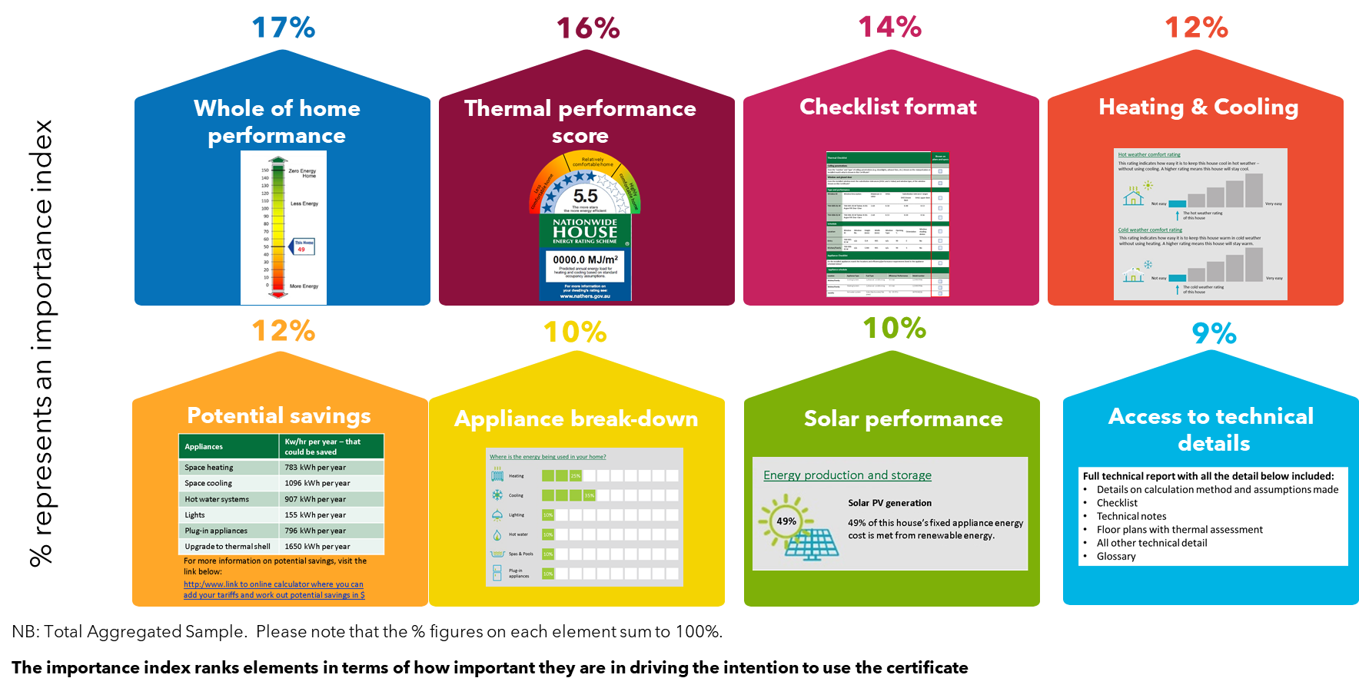

Based on the above results, the optimal certificate for all professionals would look like this (Figure 38) and 88% would uptake the new certificate.
Figure 38: Optimal certificate for all professionals
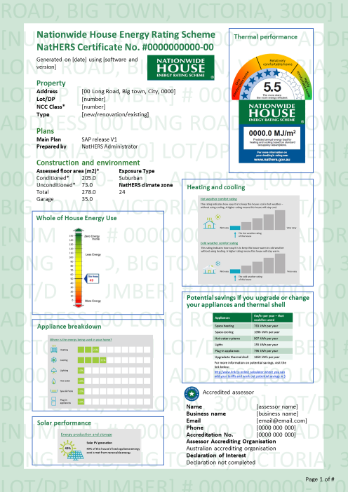

Which specific images appeal most?
Figures 39 to 43 show the order of preference (rank order) for each of the images tested in the choice model. The image at rank order 1 was the most appealing image for each attribute.
Figure 39: Most appealing certificate attributes – whole of home performance
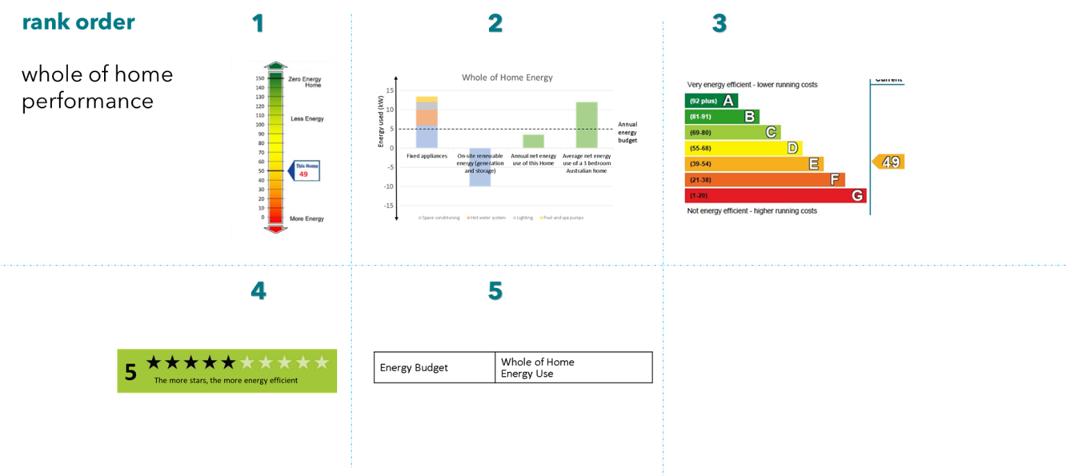

Figure 40: Most appealing certificate attributes – thermal performance and checklist format
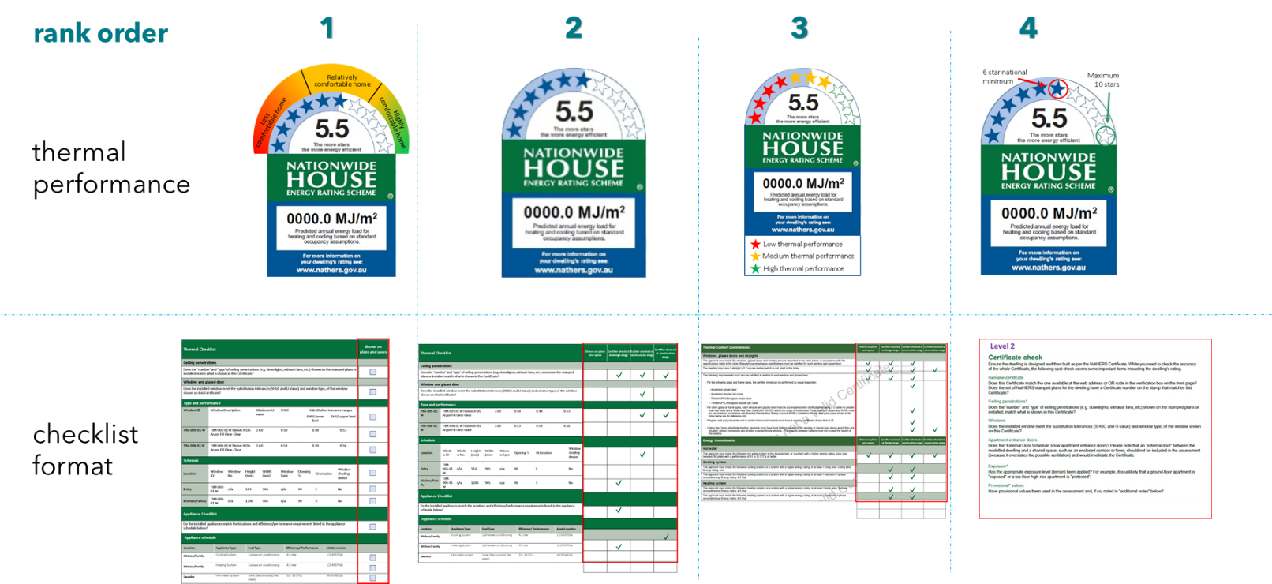
Figure 41: Most appealing certificate attributes – heating and cooling, potential savings
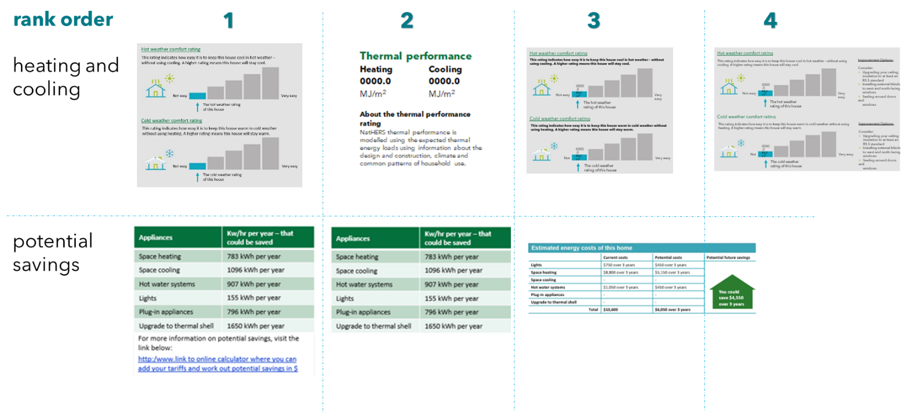

Figure 42: Most appealing certificate attributes – appliance breakdown, solar PV performance
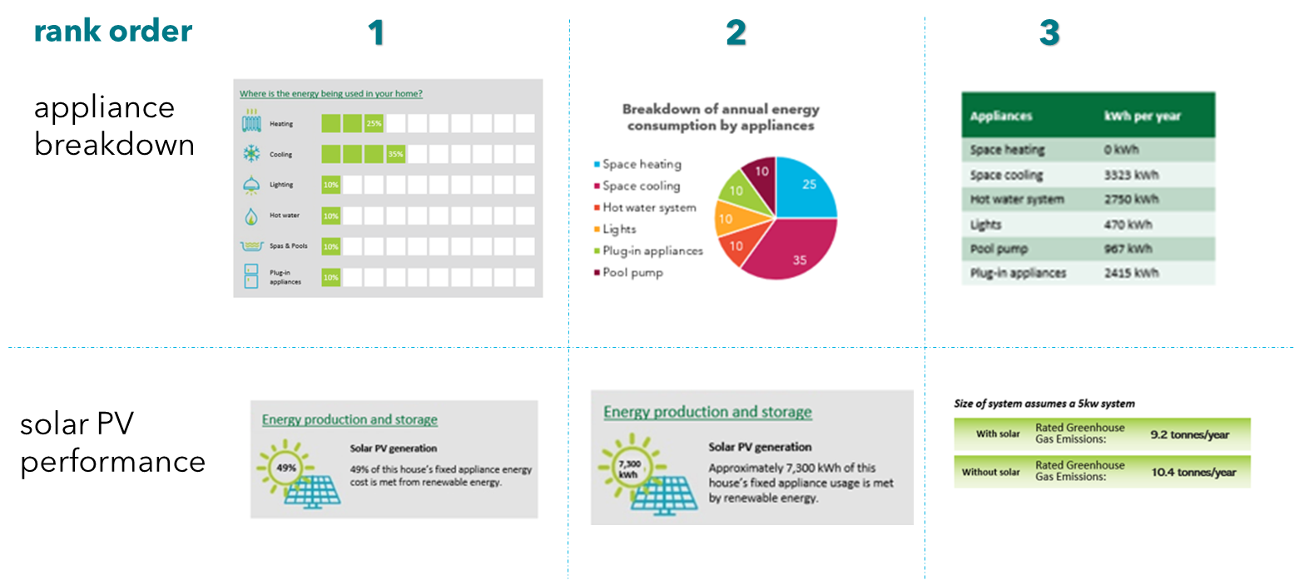

Figure 43: Most appealing certificate attributes – access to technical details
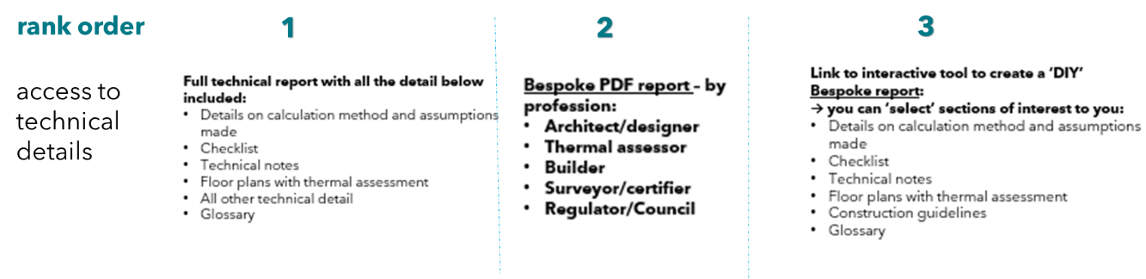

Essential communication principles for a whole-of-home certificate (from qualitative research)
The qualitative research revealed that professionals expect the whole-of-home certificate to abide by these 10 key communication principles:
Figure 44: Essential communication principles for a whole-of-home certificate (from qualitative research)
1. It must be visually appealing (and include for example snapshot summaries, infographics, and not too much heavy text)
2. It must be consumer friendly (with simple and easy to understand outputs, in plain English, with links to further explanations or information to aid understanding)
3. It must communicate outcomes clearly and with confidence (without any ambiguity or scope for misinterpretation)
4. The whole-of-home performance score must be scalable and relative (to aid understanding)
5. The whole-of-home certificate must be aspirational (and include elements such as potential savings, areas for improvements)
6. The certificate must also provide links or access to technical content (such as for example, tabular information, data, information around calculations and assumptions made)
7. The certificate must be flexible and be easy to tailor (to suit the needs of the various audiences)
8. The certificate must reflect a monetary component (such as dollar savings or kw savings that can be easily converted to dollar figures)
9. The certificate must include multiple checks and verification for accuracy, to ensure nothing is ‘missed’ – whether by error or deliberate, and for accountability.
10. The certificate must be utilised end to end throughout the entire process of energy assessment

Certificate attributes that drive interest in the new certificate—by user group
The graph below shows that the ‘thermal performance’ score is more important to certifiers, building surveyors and regulators (Figure 45).
This echoes the findings from the qualitative research, with several certifiers, building surveyors and regulators pointing out that they want to retain the ‘thermal performance score’ as separate. Having the thermal score present on the certificate eliminates any risk that very efficient appliances may hide a poor performing thermal shell.
Quote from qualitative:
“If we mould it into 1 number, it could create biases within that (e.g. walls made out of glass, but 10 air conditioners, solar panels). People would be able to trade-off components which is risky. I’d rather keep the separate thermal performance score”. Building Surveyor, VIC

Meanwhile, the ‘whole-of-home’ performance score is more important to architects, building designers, and builders (Figure 45).
This echoes general findings from the online forums that this group is interested in a more holistic outlook on house building performance, including energy produced on site that is used on site, to encourage energy efficiency earlier in the design process.
Figure 45: Relative importance of certificate attributes—by user group

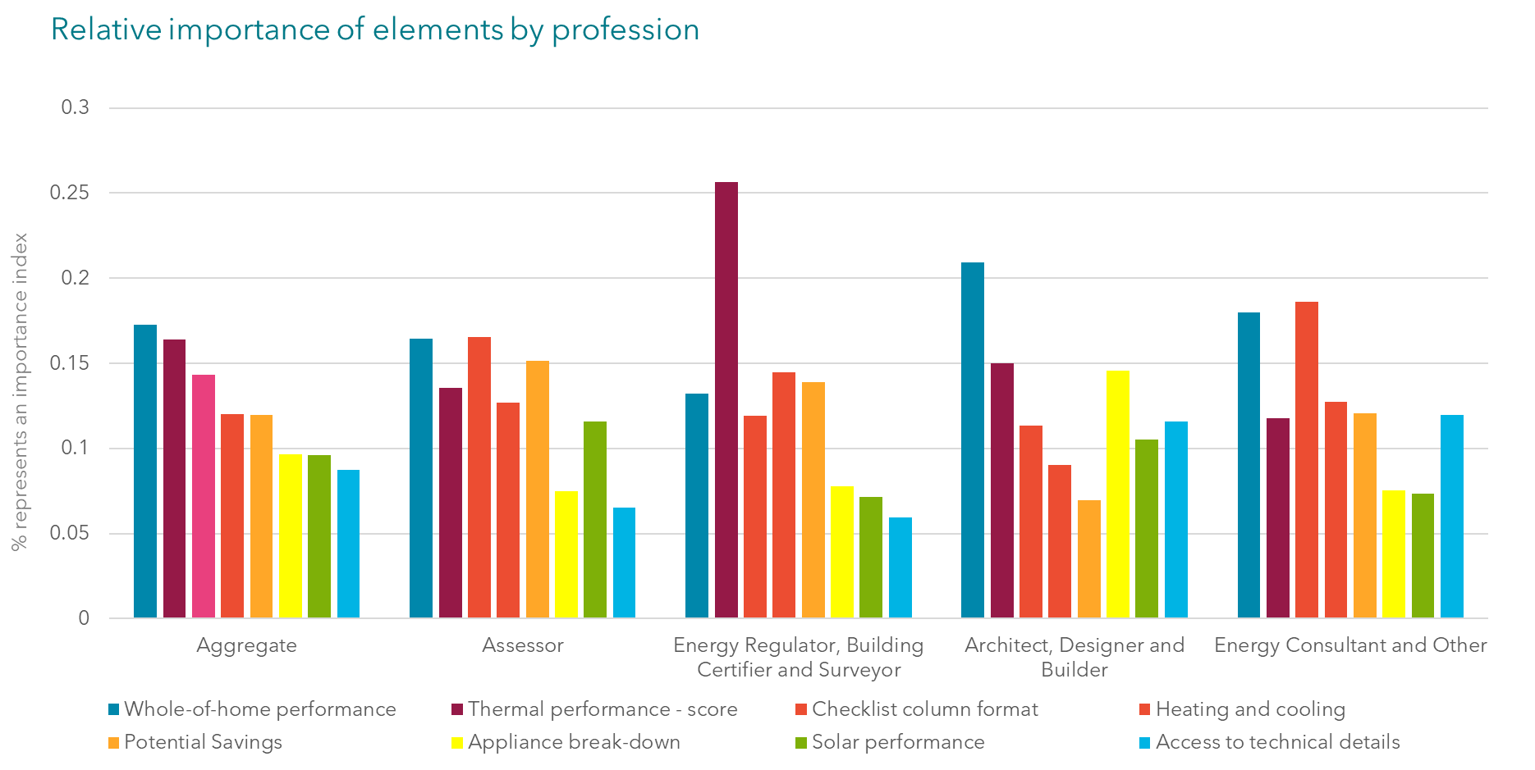
Base: Total sample n=169

Which specific images appeal most—by user group?

Which certificate elements drive uptake—assessors
Figure 46 shows results of the choice model for assessors. It shows the relative importance of each attribute and the preferred image for each attribute for this user group.
The optimal checklist format, whole-of-performance, potential savings and thermal performance images for assessors are the same ones as for the broader professional group (Figure 46).
However, for ‘heating and cooling’, the assessors prefer the mock-up image 1 based on the current NatHERS certificate, showing the MJ/m2 for each of heating and cooling (Figure 46). This could be explained by the fact that they are most familiar with the information presented in this way, and qualitative research revealed that this was an important element of the existing certificate.
For solar, they prefer the version with the KW/hr information (Figure 46), this finding supports their need for more detail and precision.
In terms of access to technical details, although it is their least important factor, assessors would prefer access to a bespoke PDF report by profession (Figure 46). This comes back to the need for ‘technical detail’ that is tailored, as well as ‘flexibility’ in the document, as mentioned in the interviews.

Figure 46: Relative importance of certificate attributes for assessors
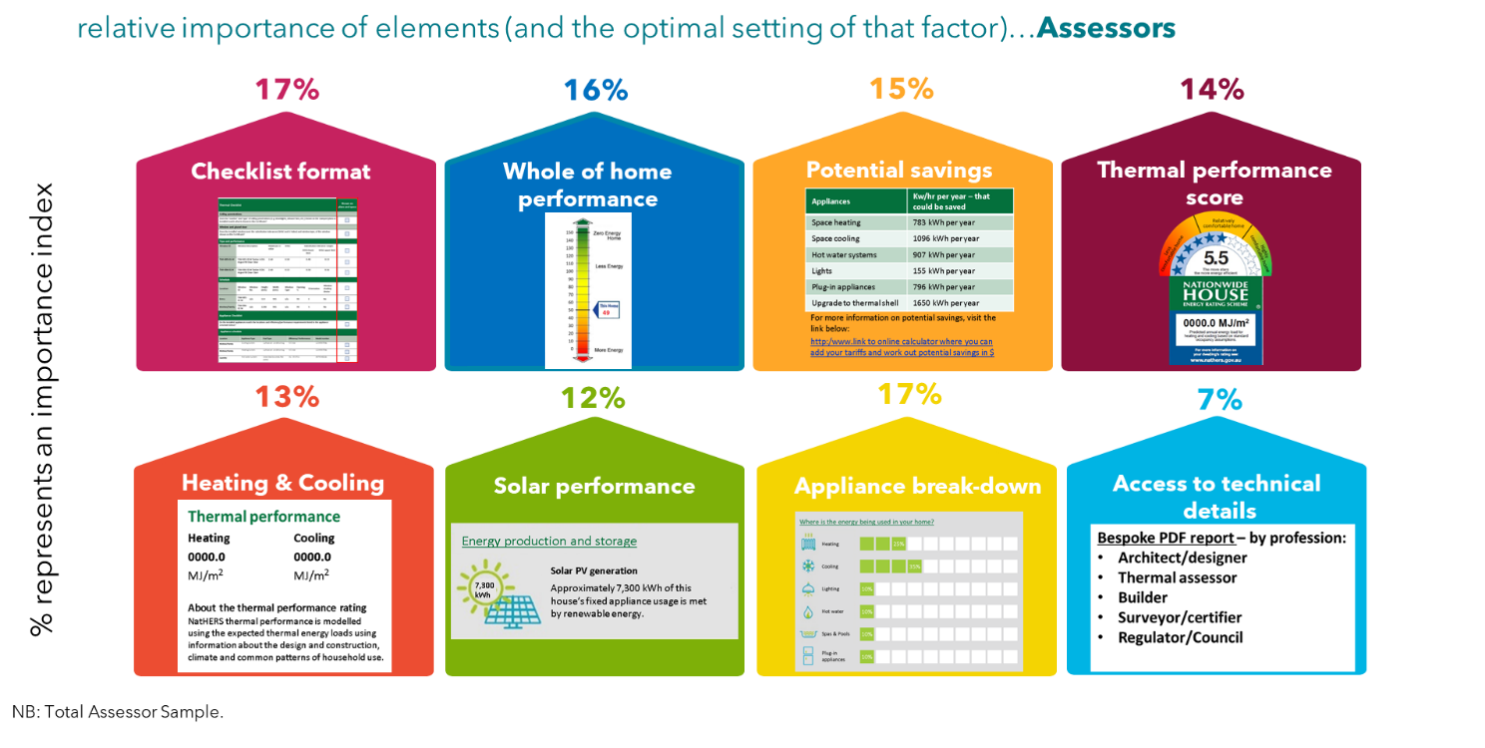

Based on the above results, the optimal certificate for assessors would look like this:
Figure 47: Optimal certificate for assessors
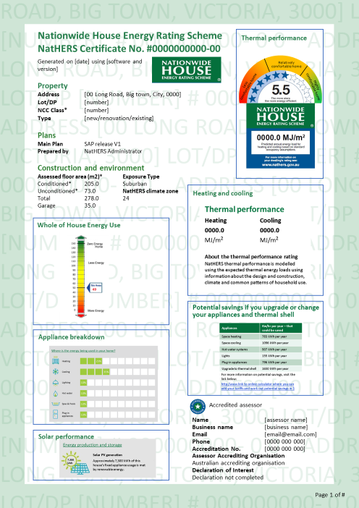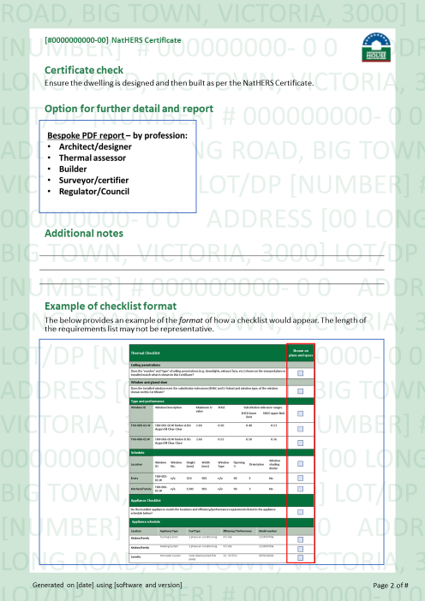

Which certificate elements drive uptake—certifier, building surveyor, and regulator
Figure 48 shows results of the choice model for certifiers, building surveyors and regulators. It shows the relative importance of each attribute and the preferred image for each attribute for this user group.
The graph below (Figure 48) shows that for certifier, building surveyors and regulators, ‘heating and cooling’ information, as well as ‘potential savings’ are very important, in fact more so than ‘whole-of-home performance’. Interestingly, the optimal image for the ‘potential savings’ is the image 3 showing $ figures (Figure 48), reflecting a desire to translate energy outcomes into a monetary value, as discussed in the qualitative interviews.
The ‘whole-of-home’ performance preferred image was image 2 for this group (borrowed mocked up from the EU’s Energy Performance Certificate), which contains a clear alphabetical scale (Figure 48). This may be because visually it more clearly communicates where the house sits (in which letter group), and it may be possible to easily add a comparison to this type of scale, which is what this group would like to do (compare to other houses).

Figure 48: Relative importance of certificate attributes for certifiers, building surveyors and regulators
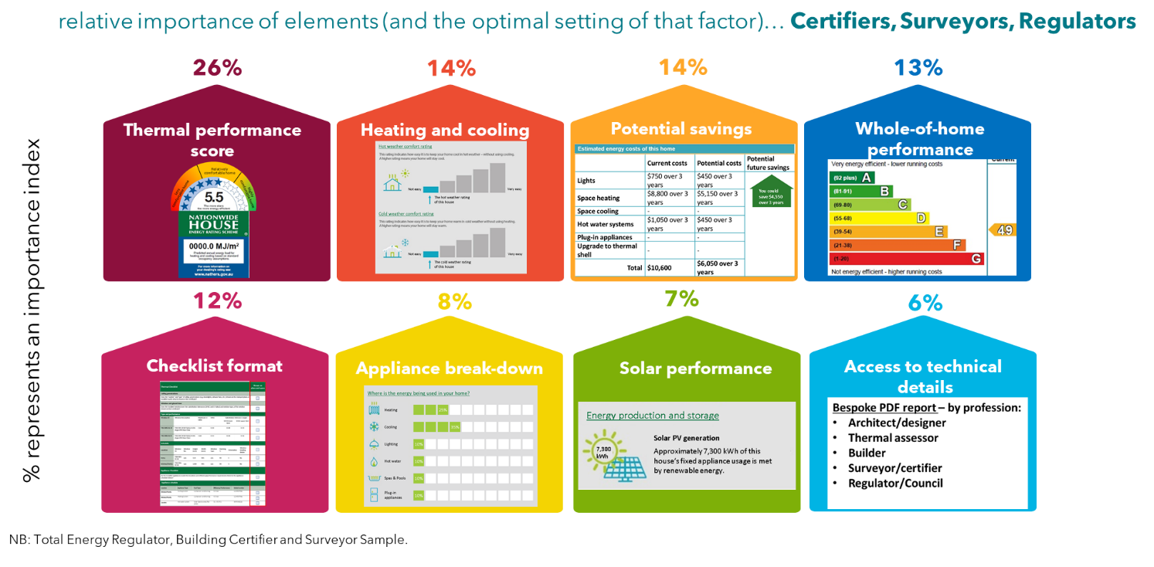

Based on the above results, the optimal certificate for certifiers, building surveyors and regulators would look like this:
Figure 49: Optimal certificate for certifiers, building surveyors, and regulators
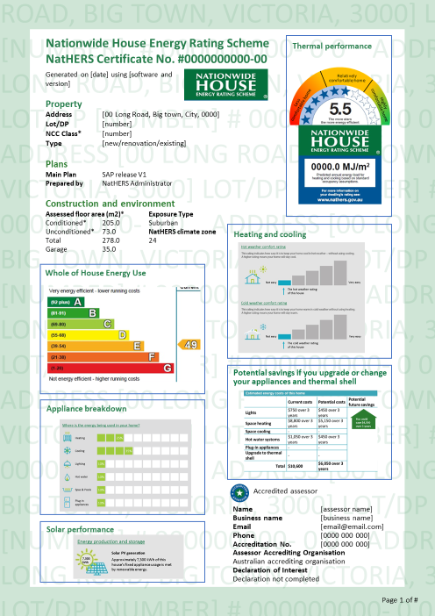

Which certificate elements drive uptake—architects, building designers and builders
Figure 50 shows results of the choice model for architects, building designers and builders. It shows the relative importance of each attribute and the preferred image for each attribute for this user group.
The graph below shows that architects, building designers and builders prefer the image 1 for the thermal performance score, which is the current NatHERS score (Figure 50).
Although 79% of this group are familiar with the current NatHERS certificate, it was found in the qualitative research, that this group are more likely to ‘glance’ at the documentation rather than to read the documentation in great detail. This lower level of understanding and experience with the documents in general, may explain why they stick to the format they already know and are comfortable with.
The appliance break-down is third in importance for this group (Figure 50)—some of them mentioned that a pie chart could work in the qualitative research.

Figure 50: Relative importance of certificate attributes for architects, building designers and builders
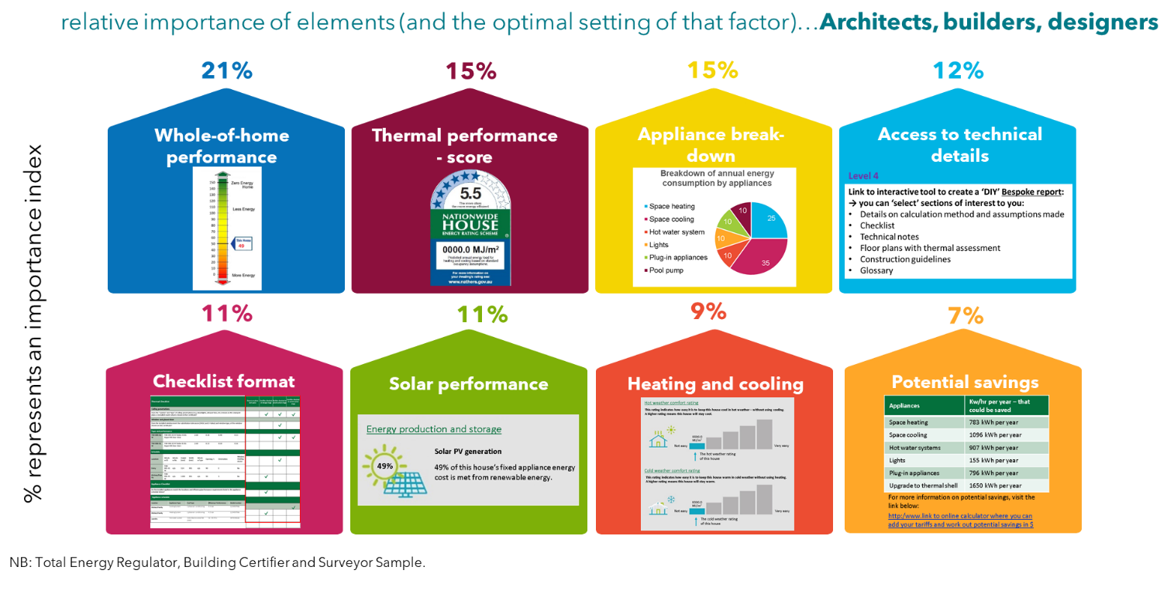

Based on the above results, the optimal certificate for all architects, building designers and builders would look like this:
Figure 51: Optimal certificate for architects, building designers, and builders
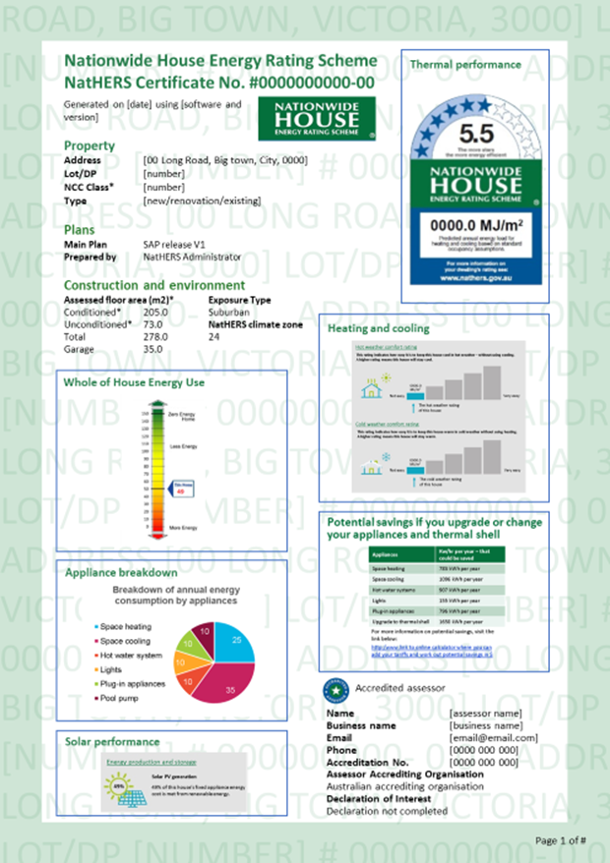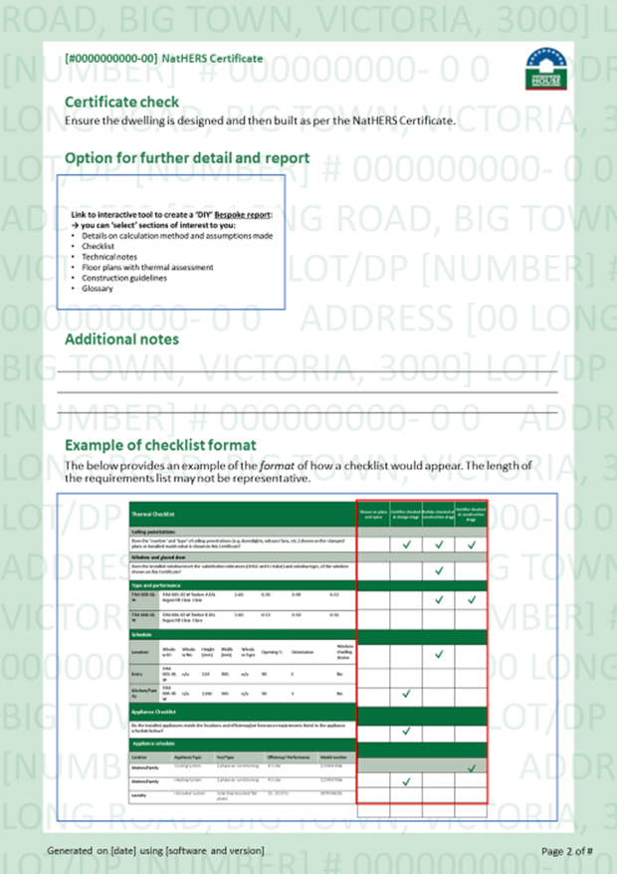

Essential features of the whole-of-home NatHERS certificate
Following the discrete choice model, participants were asked how important it was for the following features to be included on any new Whole-of-Home NatHERS Certificate.
- Appliance break-down
- Potential savings
- Access to technical details
- Solar performance
- Whole-of-Home performance
- Checklist column format
- Heating and cooling
- Thermal performance score
- NCC requirements
- Floor area
- QR code

Similar to the results of the choice model, the thermal performance score and the heating and cooling information remain top features that must be on whole-of-home certificate, the vast majority of professionals expect these to be on there (Figure 52).
Then three quarters reported that the ‘whole-of-home performance’ must be on the certificate too, this would be a new feature. Other new features that scored strongly include solar performance, which around 6 out of 10 professionals reported ‘must be on certificate’ (Figure 52).
Interestingly, less than half the professionals surveyed reported that access to technical details must be on the certificate, and similar for the checklist columns format (Figure 52). And although only a third reported that the potential savings information must be on the certificate, altogether two thirds reported that this information is important (see Figure 52).
Figure 52: Essential features on NatHERS whole-of-home certificate – existing and new features
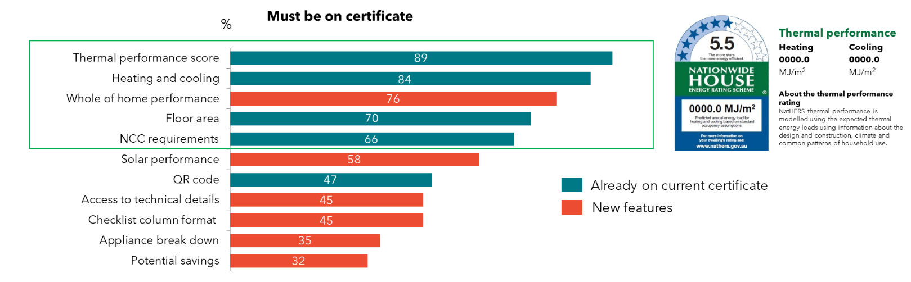
QD2. Using the scale below, please choose how essential it is for you to have them included on any new ‘whole-of-home” NatHERS certificate.
Base: Total sample n=206

The thermal performance score and the heating and cooling information are considered important to 96% of professionals (Figure 53).
Although only 45% of professionals say that ‘technical details’ must be on the certificate (Figure 52), seven in ten say that this is important (Figure 53), as did the qualitative research. In the online discussion forums, professionals mentioned looking for technical details such as window by window values (with height, width, U values, and window serial number/specs for builders), solar heat gain co-efficiencies, insulation details such as R values, on certificates.
Figure 53: Necessity of features on NatHERS whole-of-home certificate
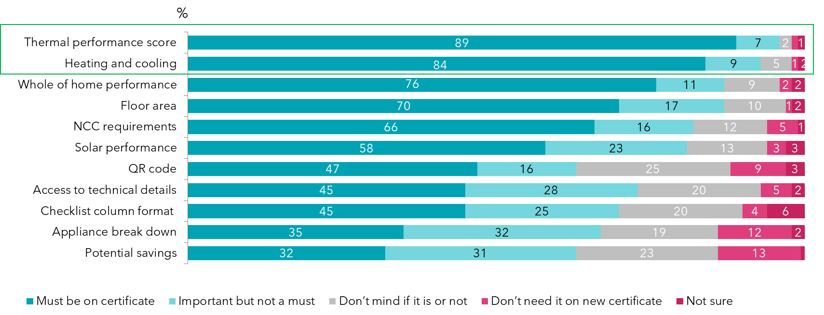
QD2. Using the scale below, please choose how essential it is for you to have them included on any new ‘whole-of-home” NatHERS certificate.
Base: Total sample n=206

What professionals expect to see on a certificate was also discussed at the start of the research process in the online discussion forums. This stage of the research found that the ideal certificate should include the following content:

Figure 54: Ideal content for NatHERS whole-of-home certificate (from qualitative research)
The ideal whole-of-home certificate would cover the below content:
- Air tightness (including the door blower test, impacts of wind conditions on thermal performance, and information on ‘proper ventilation’)
- Building sealing (including extraction fans being fully enclosed, and a duct leakage test)
- Thermal comfort (including temperature graphs for different rooms under different conditions)
- Glazing requirements (glazing surface area and direction, U-values and SHGC values)
- Insulation details (R values)
- Construction materials and methods (including colour of paint on roof and walls)
- Hot water systems / solar hot water systems
- Appliance efficiency (including space heating, space cooling, any heat recovery systems, and the supplier and model number for heating and cooling systems, whether natural gas/LPG, or other source of energy)
- Tank fittings and water (storm water, grey water, treated water, bore water)
- Lighting (including LEDs)
- Solar PV (and battery storage, and other energy renewables if applicable)
The ideal structure and format was also discussed in the online discussion forums, and it was suggested that the certificate be kept shorter, with most of the essential information on the first two pages, and access to technical details for those who want more information.
Figure 55: Ideal NatHERS whole-of-home certificate structure (from qualitative research)
The ideal whole-of-home certificate would have the below structure:
Front section:
- The first page is the ‘cover page’ which is for everyone including the home owner, it needs to provide a clear confirmation of what the house achieves, how it sits relative to other houses at a couple of levels of performance and generally what it is based on.
  - Total score/rating
  - Pass/Fail
  - A summary, graphics and whether compliance was achieved
  - Job details, credentials and outcomes easily readable on the first page
  - The owner shouldn't need to read beyond this page
- Second Page - for the professional to check that everything is correct AT A GLANCE. It would relate mostly to the building performance:
  - Details would be provided about building performance, construction materials, appliance performance
  - More information on how assessment was done, more details, and definitions
  - The assessment method and how the result was achieved
The middle section is the ‘detail’ required for assessors:
- One page could relate to occupancy – e.g. a couple of pie charts/graphs showing where energy was being used in the house (in a similar style to the Victorian Residential Efficiency Scorecard)
- Another page would be a set of comparative analysis charts showing how this particular house would perform with higher & lower performance appliances, insulation, glazing etc.
- The key pages - would be all the details forming a checklist for builder/certifier/owner to review as required, e.g. the BASIX or Universal certificate provide reasonable starting points for this
Almost all agree that at the back of the report, there should be:
- A final page would be the assessor’s notes and any required footnotes.
- Disclaimers and useful terminology
Other potential inclusions:
A brief table of contents may be required – with referencing to the relevant sections and pages of the report include a comparison to the standard house, it's energy use, compare to each of the star ratings used previously.

Appendix

Qualitative interviews—stimuli provided to participants for review and discussion
The below examples of ‘outcomes of assessment’ information found at front of various reports were provided to participants of the qualitative interviews for discussion and review during the interview.
Figure 56: Front section Outcome of Assessment 1
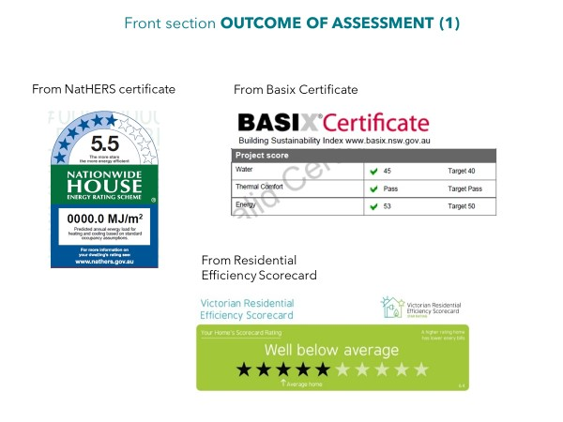

Figure 57: Front section Outcome of Assessment 2
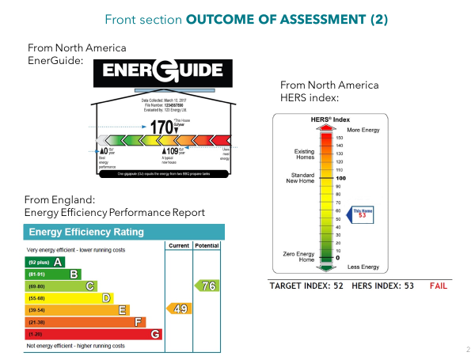
The below examples of ‘thermal performance’ information found at front of various reports were provided to participants of the qualitative interviews for discussion and review during the interview.
Figure 58: Front section Thermal Performance
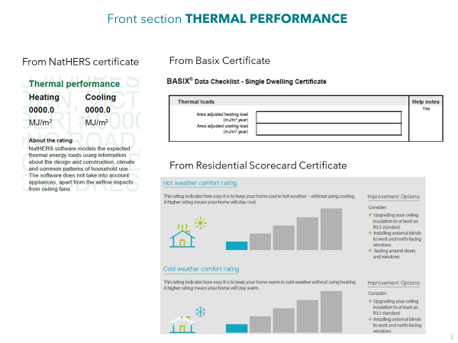

The below examples of ‘appliances’ information found at front of various reports were provided to participants of the qualitative interviews for discussion and review during the interview.
Figure 59: Front section Appliances 1
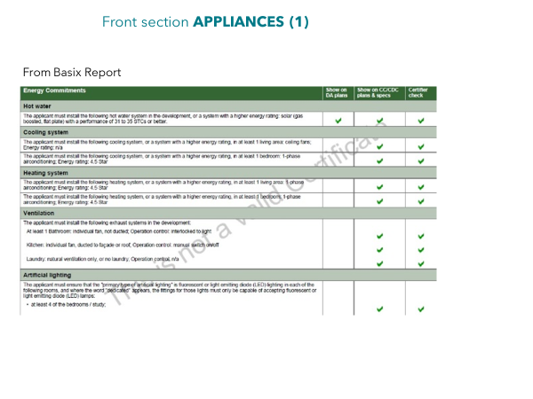
Figure 60: Front section Appliances 2
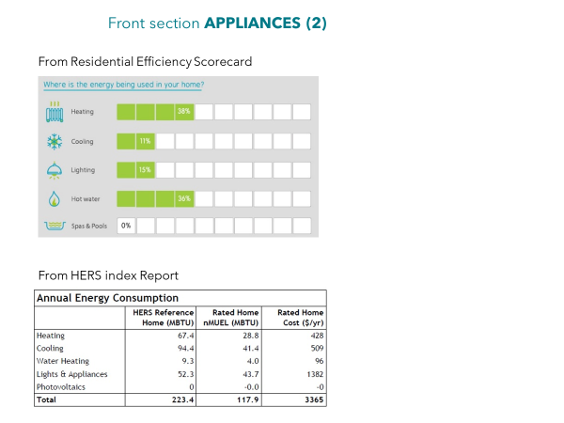

Figure 61: Front section Appliances 3
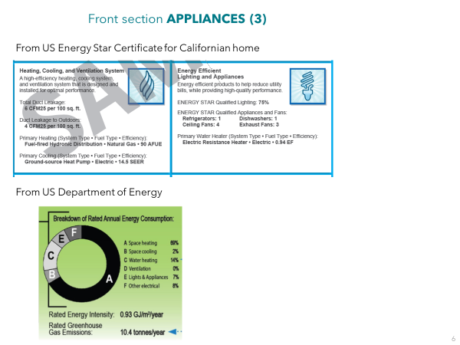

The below examples of ‘potential savings’ information found at front of various reports were provided to participants of the qualitative interviews for discussion and review during the interview.
Figure 62: Front section Potential Savings
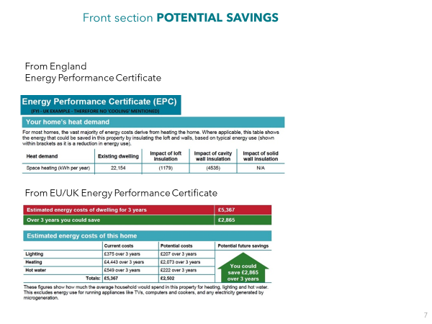

The below examples of ‘solar PV’ information found at front of various reports were provided to participants of the qualitative interviews for discussion and review during the interview.
Figure 63: Front section Solar PV
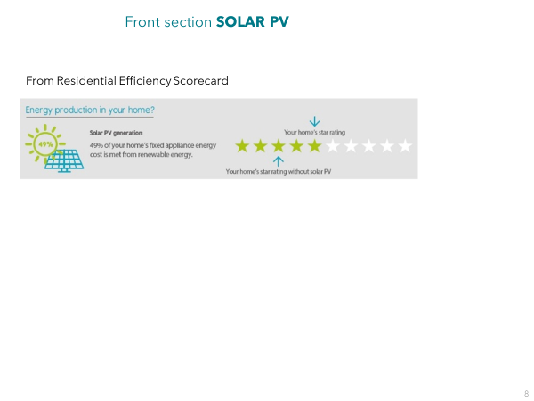

The below examples of ‘verification’ information found at front of various reports were provided to participants of the qualitative interviews for discussion and review during the interview.
Figure 64: Front section Verification Details
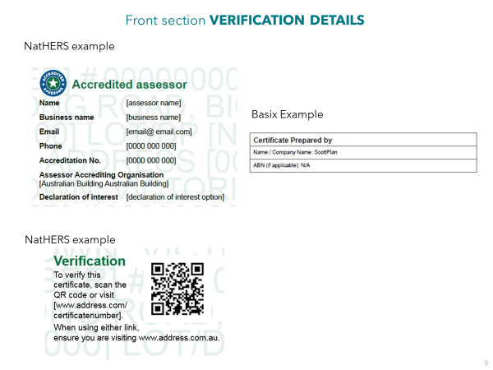
The below examples of ‘checklist’ information/format were provided to participants of the qualitative interviews for discussion and review during the interview.
Figure 65: Middle section Checklist 1
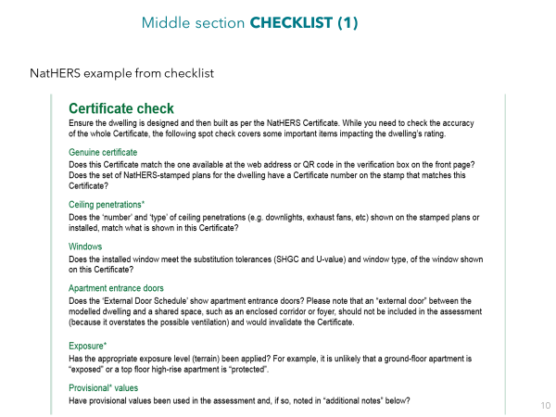
Figure 66: Middle section Checklist 2
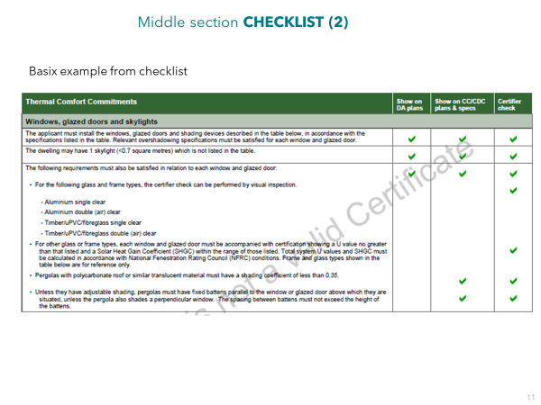

Copy of certificate shown to participants before question C1 (Familiarity with NatHERS certificate)
Figure 67: Certificate shown to participants
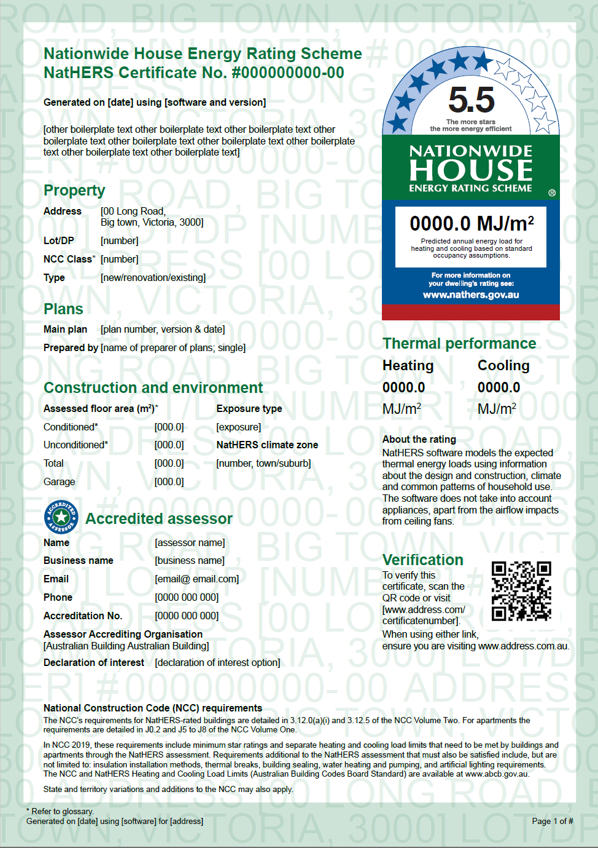

How the discrete choice model was explained to survey participants

It was explained to survey participants that this is a hypothetical exercise.

They were told they would be shown eight mock-up certificates for the whole-of-home.

Each mock-up whole-of-home certificate shown may look alike, but each is different.

In terms of what the survey respondents needed to do, for each alternative, was to review and decide whether this is a certificate that they would like to receive from the tool.

Then they were to tell us their choice by ticking one of the boxes at the bottom of the page, with each decision based on what they were shown on THAT page.

To help with some terms used that they may not be familiar with, we provided the below Glossary of definitions:
Figure 68: Glossary of definitions
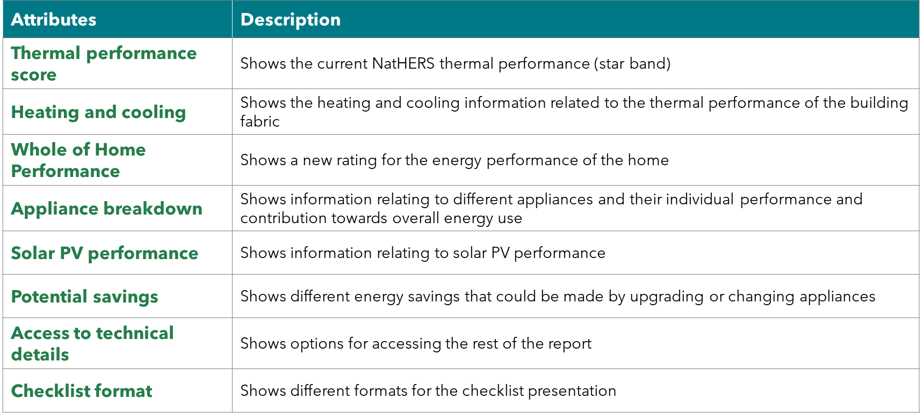
We asked that they take a few minutes to read through the Definitions before starting the scenarios. We also recommended they print out this Definitions page so you can refer to it while you choose your preferred option.

Introductory text shown to participants on the screen
Figure 69: Introductory text
In this section of the survey, we would like to know what you think about some possible new certificates that could replace the current one.
To get a really good indication from you, we will show you eight different new certificates. The new certificates we show you are for a “whole-of-home” NatHERS certificate.
Each of the 8 new Certificates you are shown may look similar, but each is different because some information will be shown on some certificates and sometimes they won’t be.
What do you need to do?
All you need to do, for each certificate, is look at the type of information it includes (both pages 1 and 2) and then decide whether this is a certificate that you would like to receive from the tool. You will be asked this question at the bottom of the page and you just need to TICK the answer that represents your opinion.
Please note…
1) When looking at the certificate features, please focus on the overall way in which information is presented, and the type of information presented, and NOT on the specific data values themselves, as they are only an example.
2) Also, the new certificate is missing some information like the QR code, the Floor area info, and the NCC text. Please don’t worry that they are not there, as we simply are not interested in testing them today, but they will remain on any new certificates of the future.
Let’s start!

Whole-of-home mock-up certificate layout
The below image shows an example of where the different attributes tested sat on the mock-up whole-of-home certificates.
Figure 70: Whole of home mock-up template
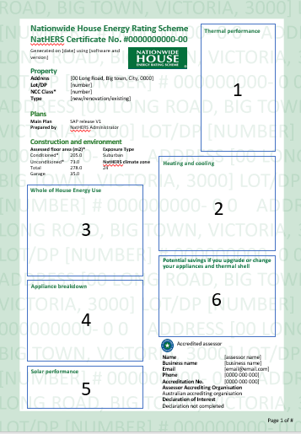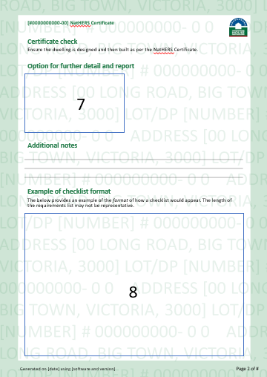

Example mock-up certificates (note that eight mock-up certificates were tested per participant)
Figure 71: Example of a mock-up certificate shown to participants 1
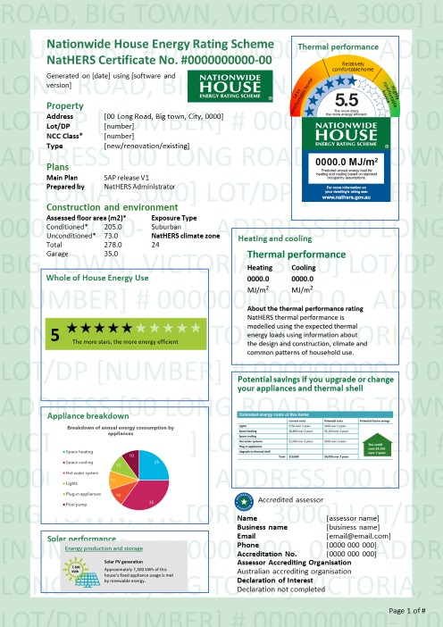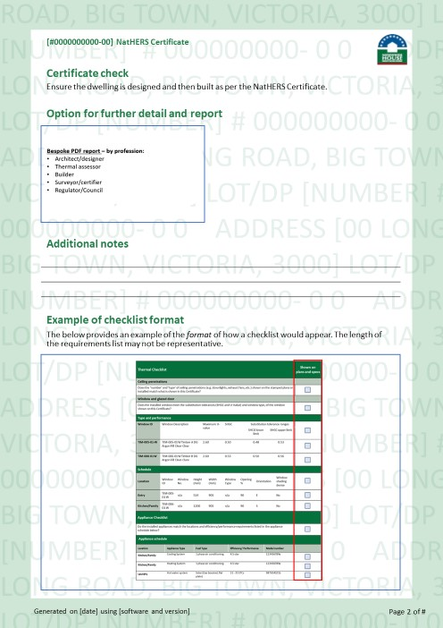

Figure 72: Example of a mock-up certificate shown to participants 2
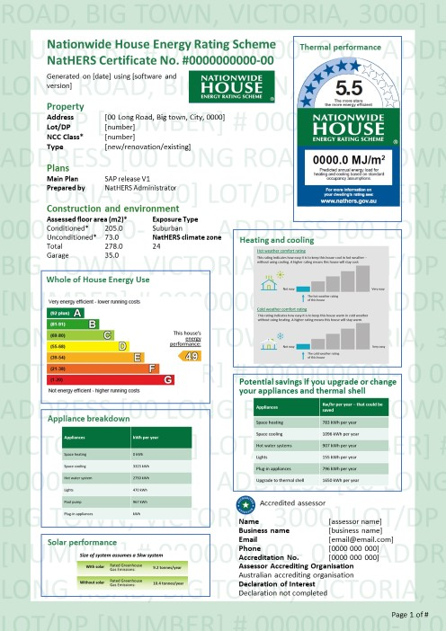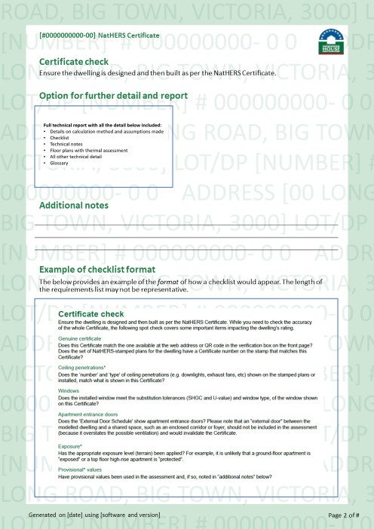

Discrete Choice Model – further detail and notes
- An excel table summarising the number of attributes and levels tested in the discrete choice model, including rationale for each attribute/level was provided to the Department.
- 'Thermal score comparisons' to average for the State, postcode, climate zone, or a 'best practice house' are not included. Although these were discussed in the qualitative study when looking at examples from overseas, it was decided that it would not be a key objective for the new NatHERS certificate.
- For each attribute we are testing an option 'none' which is the possibility that information is not shown. When we do this and show the text “this information is not available” we are reminding respondents that sometimes it IS there, but in this mock-up card/certificate it is not. If we don’t do this, we will not get a proper read on how important that information/attribute is.
- The discrete choice model tells us what is important and which attribute drove their decision to choose the new certificate or not. This is an outcome of the discrete choice model. We have also added an additional question AFTER the discrete choice model, to measure the stated extent of the attribute being a must have or not.
- The mock-up certificates shown on the screen were meant to dynamically fit any size screen, but you can imagine that it is more difficult to read the content on mobile phones. For this reason, we asked all participants to complete the survey on a computer.

Base case scenario
- All discrete choice models incorporate a base case scenario. For this exercise, survey participants were shown the current NatHERS Certificate as is (via a pop-up reminder on the screen), instead of a mock-up version, in order for the exercise to resemble reality as much as possible.
- Base case results showing the uptake of the current certificate were automatically generated by the discrete choice model and are available in the PowerPoint deck. However, these were kept out of the detailed findings section of the main report, since the objectives of the discrete choice model were mainly to understand the importance of various features of the mock-up certificates, rather than to focus on the existing certificate.

Discrete Choice Model images tested
The images tested for each attribute are shown below.
Attribute 1: Thermal Performance
Level 1 (This information is not available)
Figure 73: Attribute 1— Thermal Performance
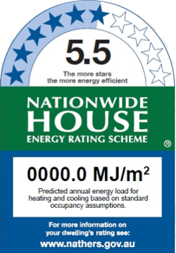  Level 2/Image 1 | 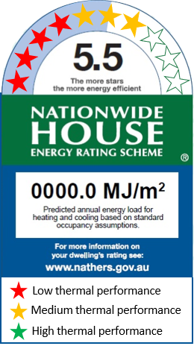  Level 3/Image 2
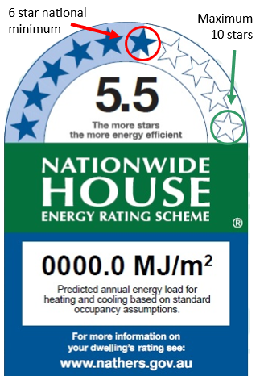  Level 4/Image 3 | 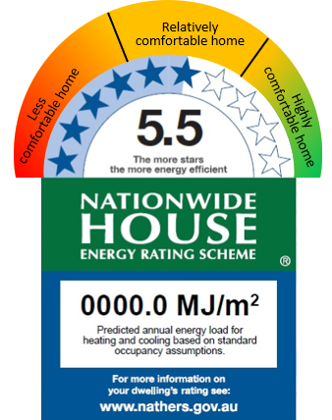  Level 5/Image 4

Attribute 2: Heating and Cooling
Level 1 (This information is not available)
Figure 74: Attribute 2—Heating and Cooling
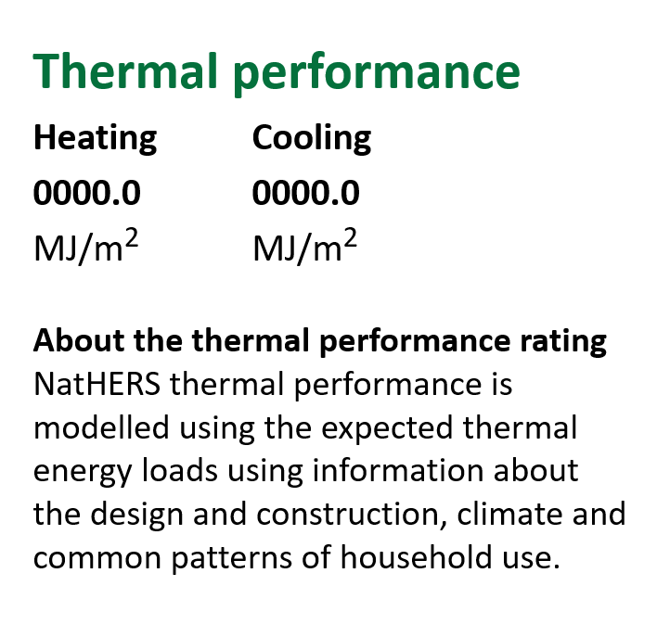  Level 2/Image 1 | 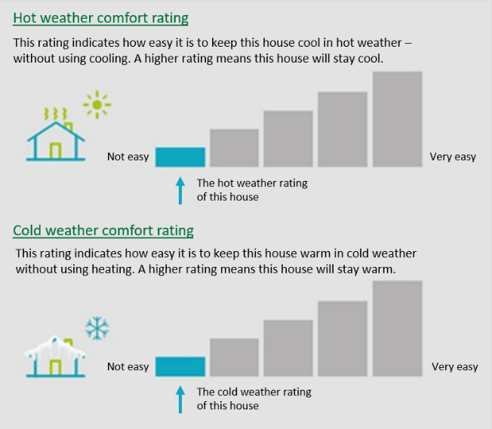  Level 3/Image 2
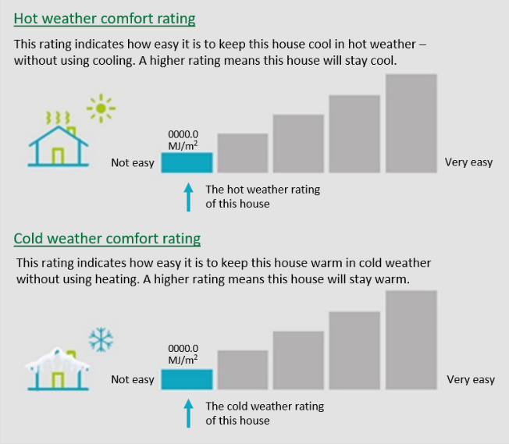  Level 4/Image 3 | 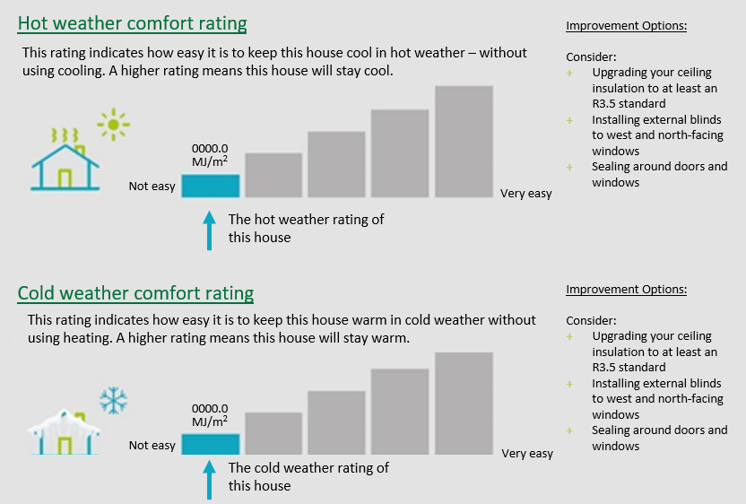 Level 5/Image 4
Attribute 3: Whole of home performance
Level 1 (This information is not available). For each attribute an option was tested where no image for that attribute was shown on the mock-up certificate.
Figure 75: Attribute 3—Whole of home performance
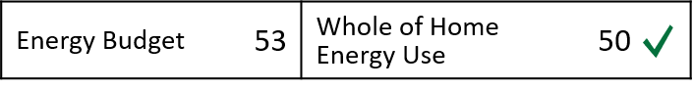  Level 2/Image 1 | 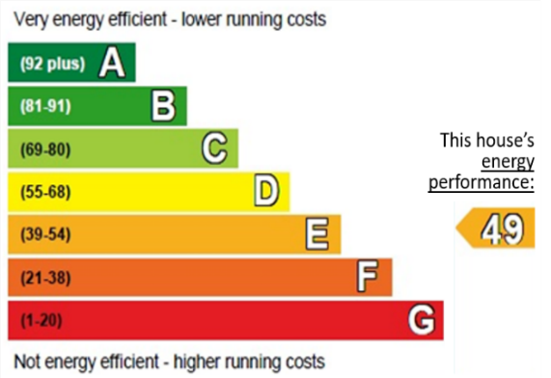  Level 3/Image 2
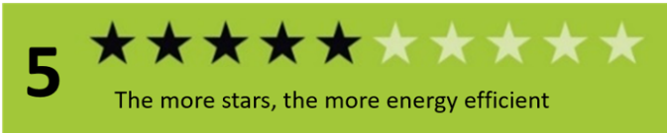  Level 4/Image 3 | 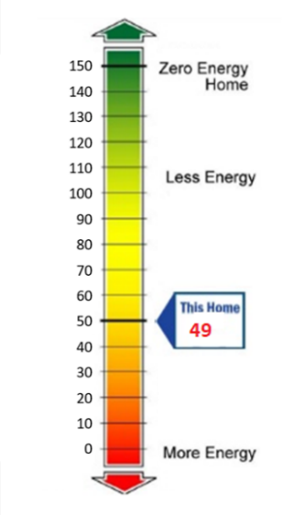Level 5/Image 4
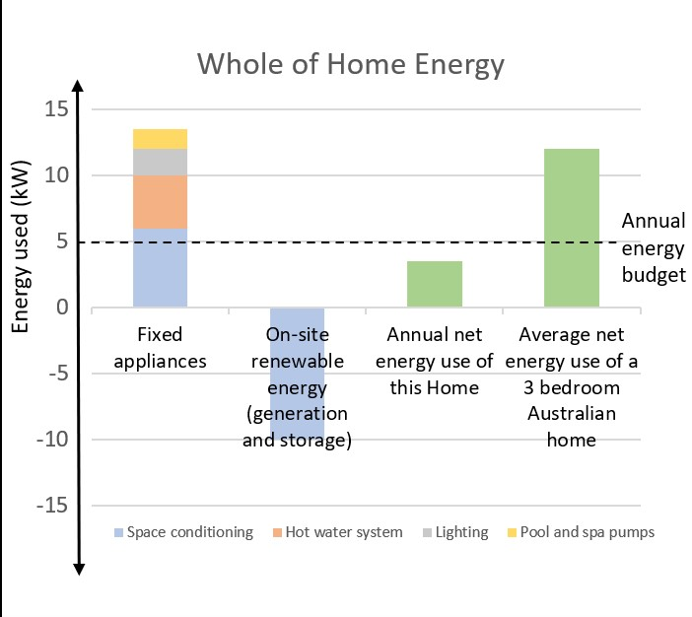 Level 6/Image 5

Attribute 4: Appliance break-down
Level 1: This information is not available
Figure 76: Attribute 4—Appliance break-down
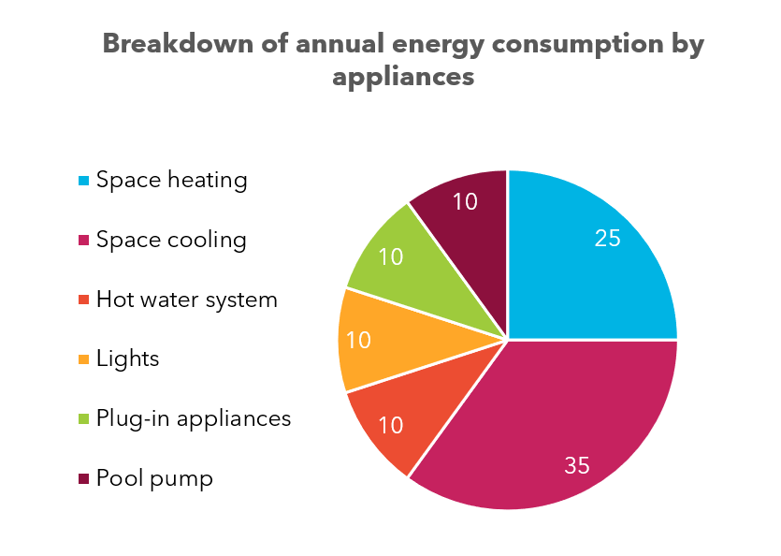  Level 2/Image 1 | 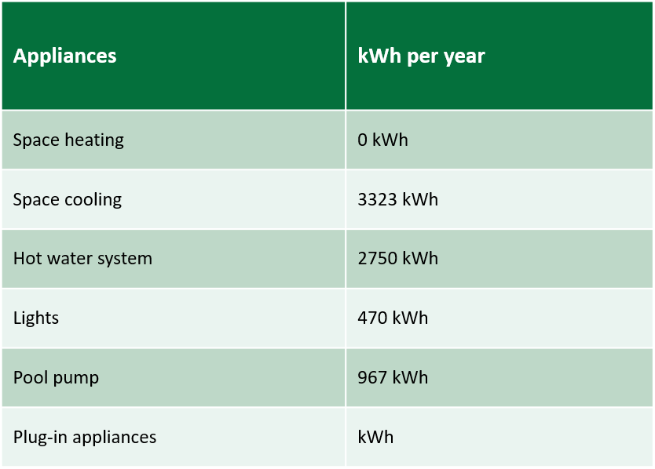  Level 3/Image 2
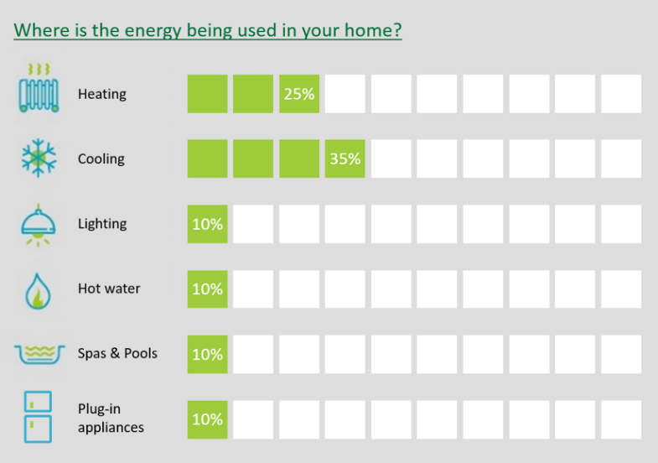
Level 4/Image 3

Attribute 5: Solar performance
Level 1: This information is not available. For each attribute an option was tested where no image for that attribute was shown on the mock-up certificate.
Figure 77: Attribute 5—Solar performance
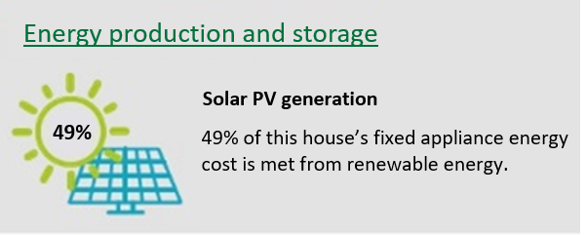  Level 2/Image 1 | 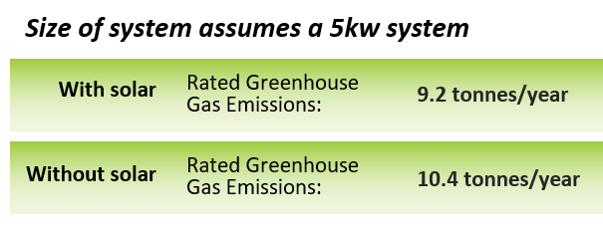  Level 3/Image 2
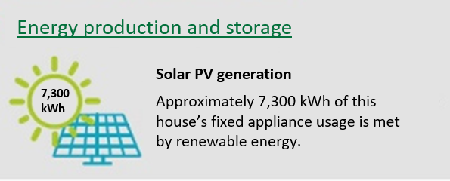
Level 4/Image 3

Attribute 6: Potential savings
Level 1: This information is not available. For each attribute an option was tested where no image for that attribute was shown on the mock-up certificate.
Figure 78: Attribute 6—Potential savings
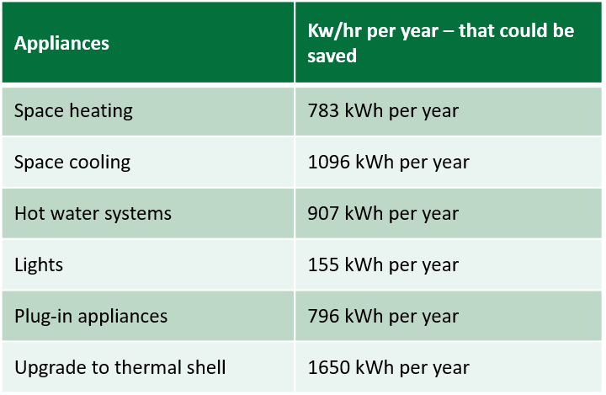  Level 2/Image 1 | 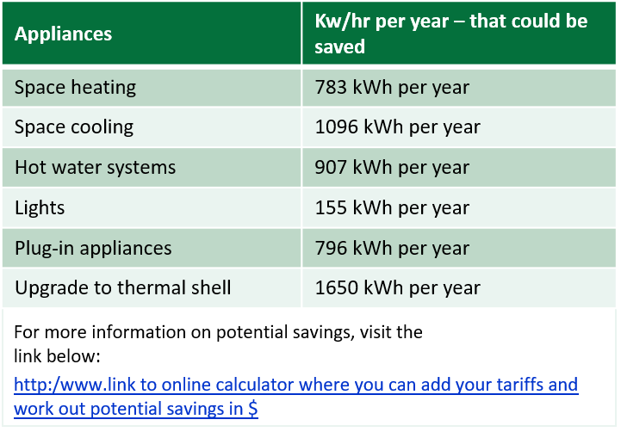  Level 3/Image 2
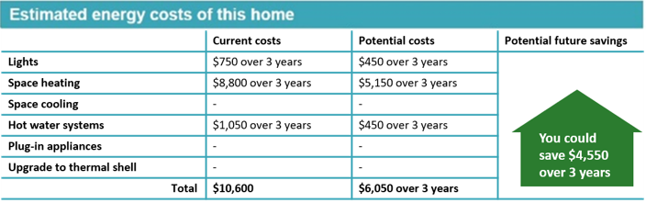
Level 4/Image 3

Attribute 7: Access to technical details
Level 1: This information is not available. For each attribute an option was tested where no image for that attribute was shown on the mock-up certificate.
Figure 79: Attribute 7—Access to technical details
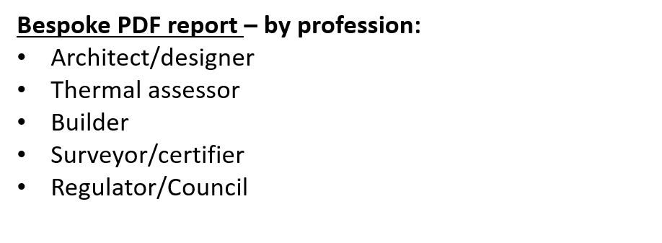  Level 2/Image 1 | 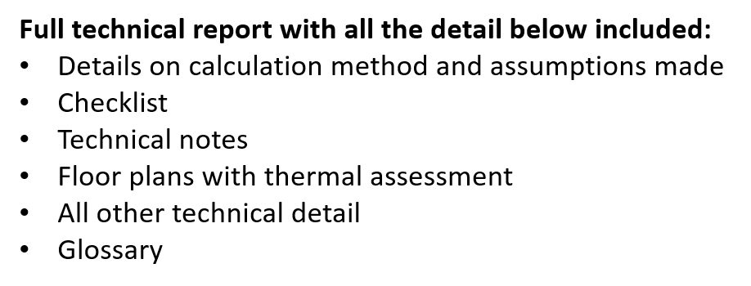  Level 3/Image 2
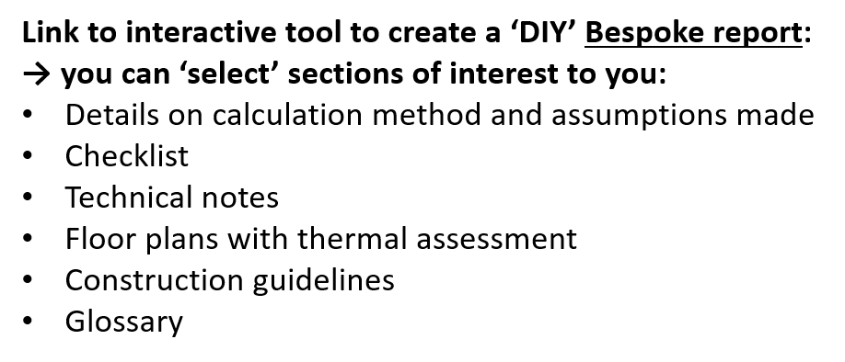
Level 4/Image 3

Attribute 8: Checklist format
Level 1: This information is not available. For each attribute an option was tested where no image for that attribute was shown on the mock-up certificate.
Figure 80: Attribute 8—Checklist format 1
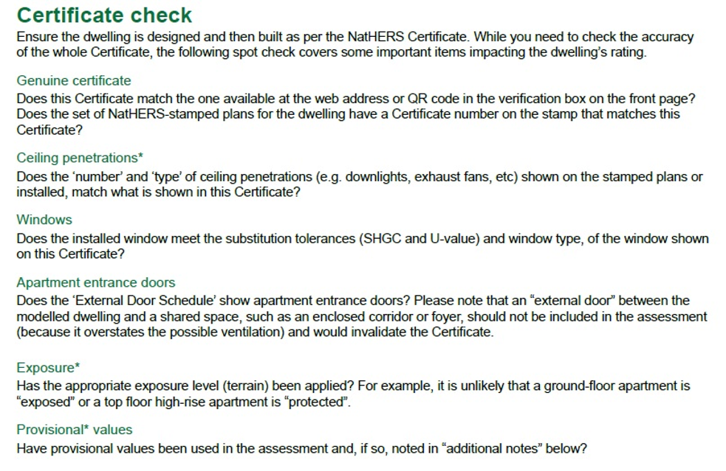
Level 2/Image 1
Figure 81: Attribute 8—Checklist format 2
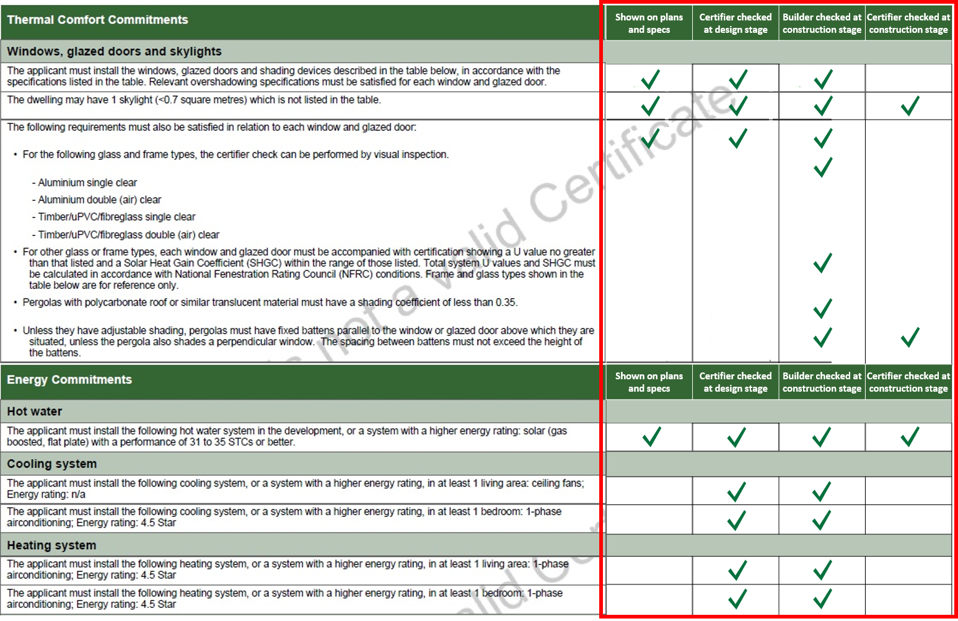
Level 3/Image 2
Figure 82: Attribute 8—Checklist format 3
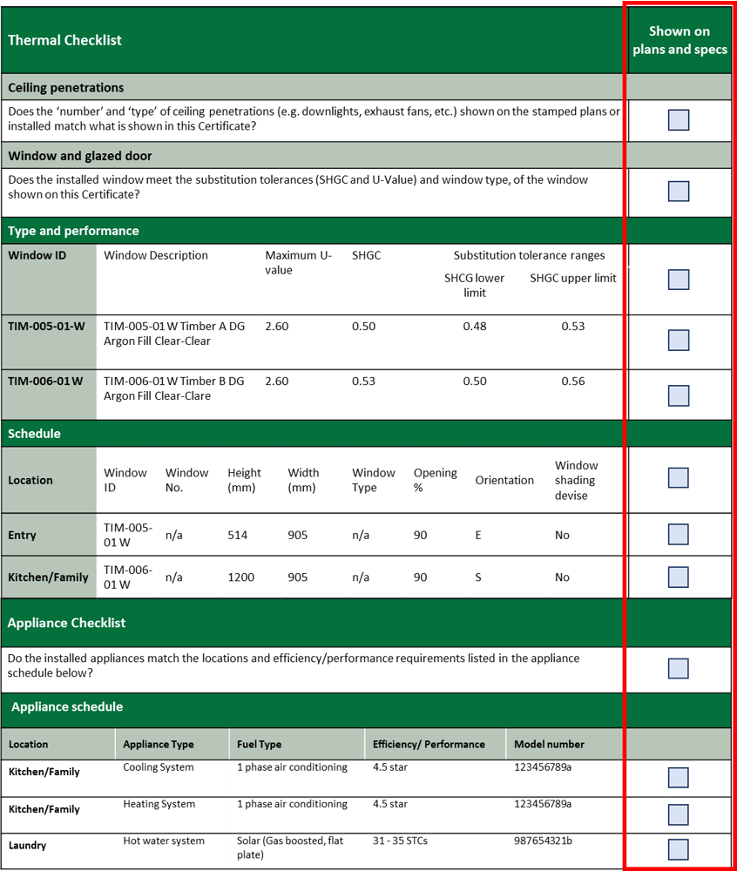
Level 4/Image 3
Figure 83: Attribute 8—Checklist format 4
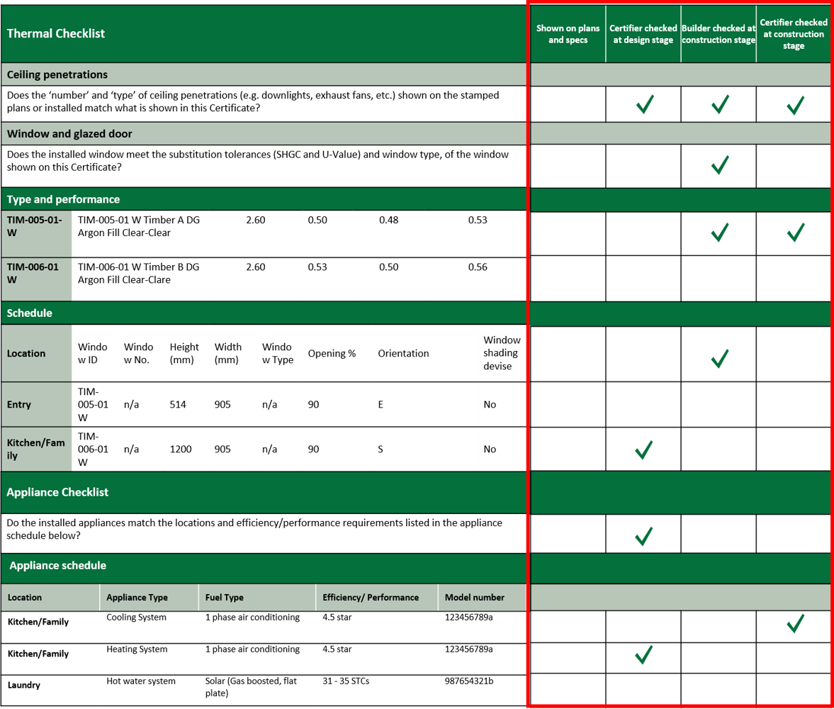
Level 5/Image 4

Online discussion forums covered NSW, VIC, QLD, ACT, TAS, WA, SA (all except NT). NT was captured in depth interviews.
NB. Multi Response means that the survey participant was able to select several States/Territories in which they may operate, Single Response means that the survey participant was asked to indicate the State or Territory in which they operate most of the time (one State or Territory only).
*Others includes: 1 Community organisation employee, 1 Financier, 1 New Home Sales Consultant, 1 Developer, 1 State gov work in energy efficiency, 1 Building Industry association, 1 Sustainability Manager, 1 University lecturer, 1 Mechanical Engineer (Building Services), 1 Sustainability Manager at a Developer, 1 Industry representative, 1 Researcher Supplier, 1 Project Manager
The NatHERS website only included content on the new NatHERS Certificate from 1 April 2020. Bers Pro has used the certificate since this date but the other two NatHERS tools (FirstRate5 and AccuRate) did not incorporate the new certificate until 1 May 2020.
Participants did not each see the same eight mock-up certificates. There were 1,344 variations of mock-up certificates tested with participants across the total sample. Each participant only saw eight of these.
For each attribute an option was tested where no image for that attribute was shown on the mock-up certificate.
For each attribute an option was tested where no image for that attribute was shown on the mock-up certificate.
For each attribute an option was tested where no image for that attribute was shown on the mock-up certificate.

