­­­

Understanding your plantation forestry project

Emissions Reduction Fund simple method guide for plantation forestry projects registered under the Carbon Credits (Carbon Farming Initiative—Plantation Forestry) Methodology Determination 2021

Draft for public consultation

Table of Contents

Table of Contents 2

Using this guide 3

The 2021 plantation forestry method 3

New activities and key changes from the 2017 method 5

Participating in the Emissions Reduction Fund 7

Project lifecycles for projects under the 2021 plantation forestry method 8

Step 1: Planning your plantation forestry project 8

1.1 General eligibility requirements 8

Step 2: Registering your project 15

Step 3: Delivering your plantation forestry project 20

Schedule 1: Establishing a new plantation 20

Schedule 2: Converting an existing plantation from a short rotation to a long rotation 22

Schedule 3: Avoided conversion of a plantation to non-forest land by continuing plantation activity 24

Schedule 4: Transition to a permanent forest 25

Step 4: Reporting and crediting 29

Estimating abatement and crediting 29

Getting started 38

Disclaimer 38

Appendix 1: National Plantation Inventory regions 39

Appendix 2: Issues that are out-of-scope 40

## Using this guide

This document provides a step-by-step guide on how to plan, register, deliver and report on a plantation forestry project under the draft 2021 plantation forestry method. It supports the draft Carbon Credits (Carbon Farming Initiative—Planation Forestry) Methodology Determination 2021 (the 2021 plantation forestry method). The method is a key technical part of the legislation that details the rules for how to run plantation forestry projects.

In addition to the 2021 plantation forestry method and this Simple Method Guide, further details on how to run a plantation forestry project are included in the:

* Plantation Forestry FullCAM Guidelines, which have been developed to assist project proponents to calculate abatement in FullCAM as required by the 2021 plantation forestry method.
* Forest Management Plan Guidance, which has been developed to assist proponents to prepare a forest management plan as required by the 2021 plantation forestry method.
* Financial Assessment Guidance, which has been developed to assist proponents to prepare a financial assessment as required by Schedules 3 and 4 of the 2021 plantation forestry method.

## The 2021 plantation forestry method

The 2021 plantation forestry method builds on the existing [2017 plantation forestry method](http://www.cleanenergyregulator.gov.au/ERF/Pages/Choosing%20a%20project%20type/Opportunities%20for%20the%20land%20sector/Vegetation%20and%20sequestration%20methods/Plantation-forestry-method.aspx) (the 2017 method) to provide more opportunities for the plantation forestry industry to participate in the ERF. A project under the 2021 plantation forestry method will accumulate or sequester carbon as the trees grow. Carbon stored in debris and harvested wood products (where relevant) will also be accounted for. The abatement calculations under the method also account for carbon stock changes and emissions due to management activities such as thinning, pruning, harvesting, fertilising and controlled burning, and material emissions from fossil fuel use.

Two activities have been retained from the 2017 method: establishing a new plantation and conversion from short rotation to long rotation. There are also two new activities that can earn carbon credits for retaining forest where the land would have otherwise been converted to non-forested land. These activities maintain permanent not-for-harvest plantings or continue plantation activities, where the avoided conversion of plantation land is demonstrated to be additional and go beyond business-as-usual activity.

Each activity available under the 2021 method is in a different schedule (Table 1). Figure 1 below provides a high-level overview of the activities in each schedule and is intended to assist in quickly assessing which schedule might be appropriate for an individual project’s circumstances. Please note that additional eligibility criteria also apply under each schedule, which are discussed throughout this document.

|  |  |
| --- | --- |
| Alert | The 2017 plantation forestry method Projects under the 2017 method will be able to transition to the new 2021 method. As is usual practice, it is proposed that the 2017 method will be revoked if the 2021 method is made, meaning that new projects can no longer register under the 2017 method. Two of the activities available under the 2017 method are available under the 2021 method. The only activity that has not been retained from the 2017 method is the ‘maintenance activity’, which allows existing projects registered under the farm forestry method to transition to the 2017 method as there has not been any uptake of this activity. As there are no minimum size requirements for participation under the plantation forestry methods, there are no restrictions on new farm forestry projects participating under the 2021 method. |

**TABLE 1: SCHEDULES UNDER THE 2021 PLANTATION FORESTRY METHOD**

|  |  |  |
| --- | --- | --- |
| Schedule | Activity | Activity type |
| Schedule 1 | Establishing a new plantation | Retained from the 2017 method with some updates |
| Schedule 2 | Converting an existing plantation from a short to a long rotation |
| Schedule 3 | Continuing plantation forestry activities | New avoided conversion activities to retain forest where it would otherwise be converted to non-forested land |
| Schedule 4 | Transition to a permanent (not-for-harvest) forest |

Note: The activities under Schedules 3 and 4 have been switched since stakeholder consultations undertaken prior to public consultation to align with the legal drafting in the method.

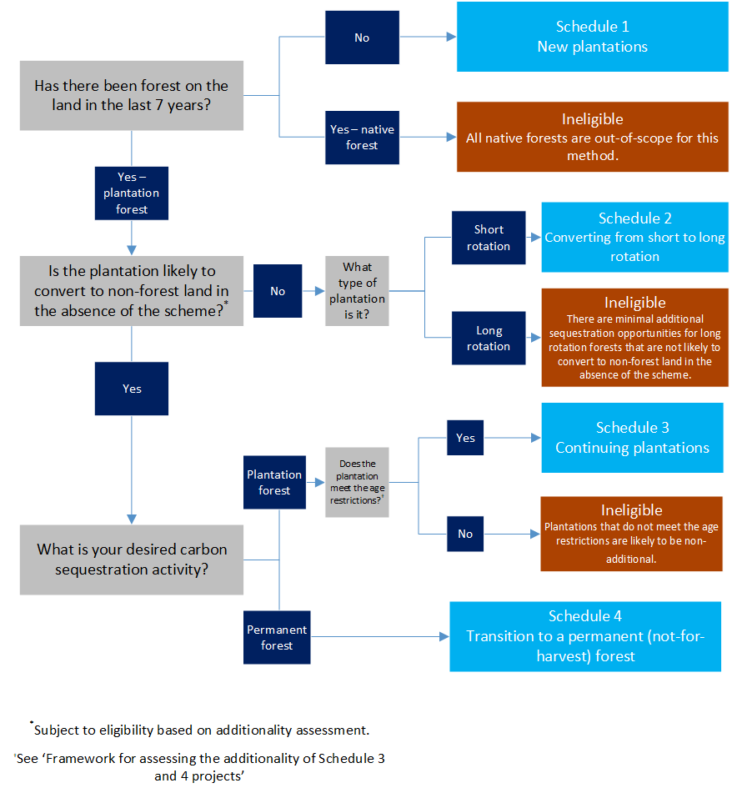

**FIGURE 1: NEW PLANTATION FORESTRY METHOD DECISION TREE**

# New activities and key changes from the 2017 method

The 2021 plantation forestry method builds on the 2017 method by:

* making targeted changes to the available activities (located in Schedules 1 and 2 of the 2021 method), and
* introducing new activities (located in Schedules 3 and 4 of the new method).

Key changes and new activities in the 2021 method are outlined in Table 2 below.

**TABLE 2: SUMMARY OF KEY ISSUES AND APPROACHES**

|  |  |  |
| --- | --- | --- |
| Issue | Details | Page |
| Cross-cutting issues | | |
| In lieu of newness provisions | We have introduced in lieu of newness provisions to permit some project activities to be undertaken after a complete registration application has been submitted and prior to project registration. These activities include site preparation and planting activities for Schedule 1, in addition to harvesting, clearing, or thinning the existing forest for Schedules 2, 3 and 4. | 12-13 |
| Plantations outside of NPI regions | Plantations outside of NPI regions are permitted to participate in the 2021 method, subject to eligibility requirements. Schedule 2 and 3 projects will be required to be located within 50km of an NPI region, and Schedule 2 projects will need to conform to the requirements and restrictions of the closest NPI region. | 15 |
| Excluded species | African Mahogany and Indian Sandalwood plantations were excluded from the 2017 method as evidence at the time indicated that the estates of these species were expanding. However, updated ABARES data shows that the estate of these species is now in decline, supporting their inclusion in the 2021 method as they are likely to be additional. | 21 |
| Estimating carbon | The 2021 method will continue to use a modelled only approach using FullCAM. Work is currently underway at DISER to update the plantations calibrations in FullCAM, and updated FullCAM guidelines have been developed to accompany the 2021 plantation forestry method. | 29 |
| Harvested wood product parameters | We have updated the harvested wood product parameters (located in Appendix 2 of the 2017 FullCAM guidelines) to reflect updated international emissions accounting rules, current market conditions and allow abatement to be calculated outside of NPI regions. | 16 |
| Forest Management Plan | The forest management plan will supersede the requirements of the management schedule (from the 2017 method) for all schedules. Schedules 2, 3 and 4 projects will be subject to specific requirements to develop a forest management plan to manage additionality, permanence and adverse impact risks. | 17,24,26-27 |
| Schedule 2 | | |
| Species lists | Targeted changes have been made to the species lists in the 2017 method to allow for increased uptake while still meeting the offsets integrity standards. This includes expanding the types of evidence that can be provided of intent to manage a plantation as a short or long rotation plantation, and updating the lists based on the latest ABARES data. | 23 |
| Schedules 3 and 4 | | |
| Additionality framework | A framework has been developed to assess the additionality for Schedules 3 and 4 projects. Key elements include:   * The provision of a ‘transformation statement’ (via a declaration by the CEO or CFO of the project proponent), which declares that the plantation is likely to convert to non-forest land in the next 12 months. * An independent financial assessment which demonstrates that the plantation is likely to convert to a feasible and financially attractive alternative land use relative to continuing plantation forestry. * Evidence of a feasible and financially attractive alternative land use relative to continuing plantation forestry. * Age restrictions for Schedule 3 (must be within 24 months or older than the average clearfell age for the relevant species and region) to reduce additionality risks (as plantations are unlikely to clear midway through a rotation) and to avoid incentivising the clearing of immature plantations. | 13-15 |
| Schedule 3 project activity | Schedule 3 is a new project activity in the 2021 method. This schedule involves the continuation of rotational harvest cycles in a plantation forest, in situations where that plantation is at risk of being converted to non-forested land. | 24 |
| Schedule 4 project activity | Schedule 4 is a new project activity in the 2021 method. This schedule involves transitioning a plantation forest to a permanent forest, in situations where that plantation is at risk of being converted to non-forested land. | 25-28 |

# Participating in the Emissions Reduction Fund

The Emissions Reduction Fund (ERF) offers landholders, communities, and businesses the opportunity to run new projects in Australia that reduce or remove greenhouse gas emissions from the atmosphere.

By running a project, you can earn Australian carbon credit units (carbon credits) and sell them to the Australian Government, or to companies and other private buyers. Each carbon credit represents one tonne of carbon dioxide equivalent emissions stored or avoided (noting that legislated discounts apply to abatement from projects that store carbon).

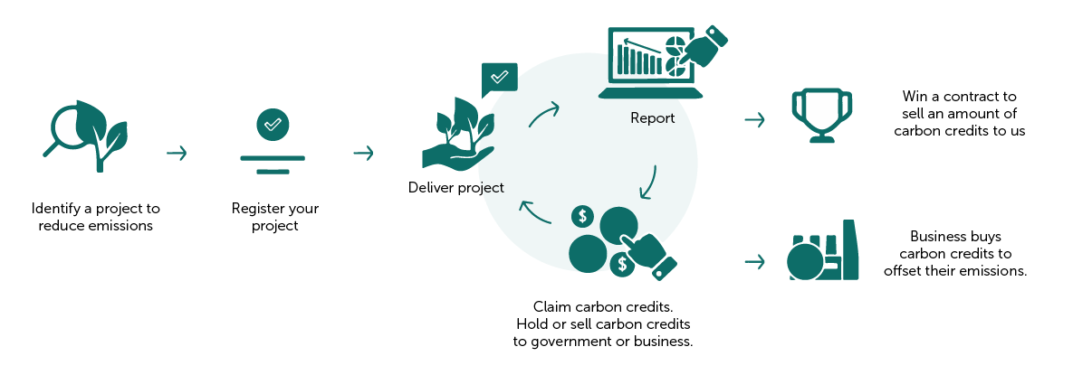

**FIGURE 2: EMISSIONS REDUCTION FUND PROJECT LIFECYCLE**

There are four general steps in running a project and participating in the ERF:

|  |  |
| --- | --- |
|  | 1. Plan your project, make sure the project is eligible, and ensure you hold legal right. |
|  | 1. Register your project with the ERF. |
|  | 1. Run your project and deliver on a project activity. |
|  | 1. Report on your project and claim carbon credits. You can sell your units to us or other buyers. |

See our [website](http://www.cleanenergyregulator.gov.au/OSR/ANREU/types-of-emissions-units/australian-carbon-credit-units)⁴ for more information on selling your carbon credits to the government or other interested buyers

## Project lifecycles for projects under the 2021 plantation forestry method

The key steps required in a 2021 plantation forestry method are outlined in Figure 3 below.

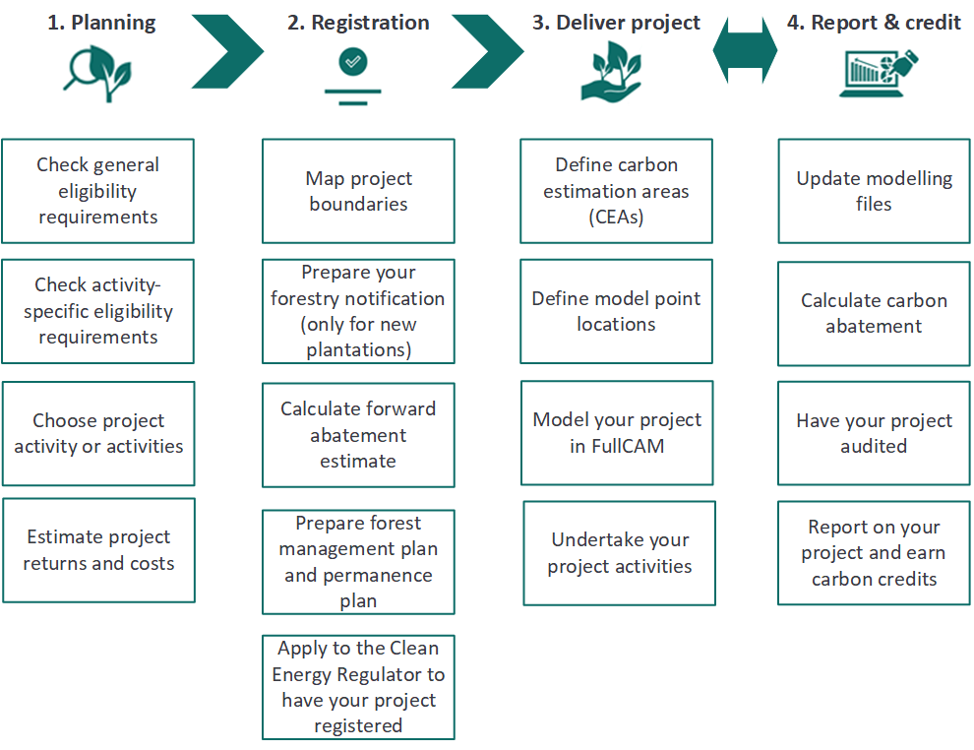

**FIGURE 3: KEY STEPS INVOLVED IN A 2021 PLANTATION FORESTRY PROJECT (ILLUSTRATIVE ONLY)**

# Step 1: Planning your plantation forestry project

## 1.1 General eligibility requirements

Key considerations are highlighted below. For more information on eligibility, visit [our website](http://www.cleanenergyregulator.gov.au/ERF/Want-to-participate-in-the-Emissions-Reduction-Fund/Planning-a-project)[1].

#### Hold legal right

You need to demonstrate that you hold and maintain the legal and forestry right[2] to run your project and claim carbon credits. It is likely you have the legal right if you own or hold a lease to the project land. Your legal right to carry out the project on or for the sites or assets included in the project must exist over a period of time that is not less than the duration of the crediting period for the project. You may need a written agreement if there are multiple owners or leaseholders to show you have the exclusive legal right to run the project and earn carbon credits.

#### Eligible interest-holder consent

You will need consent from all eligible interest-holders before you can submit a crediting application for your project. These are stakeholders who hold an interest in the land. They may include:

* Any mortgagees — typically banks.
* Other people or parties that share, have ownership or leases or native title rights to the land. See our [website](http://www.cleanenergyregulator.gov.au/ERF/Want-to-participate-in-the-Emissions-Reduction-Fund/Planning-a-project/native-title)[3] for more information.
* For leased Crown land – the Crown Lands Minister needs to provide consent, usually through a relevant state or territory lands department.

You can demonstrate eligible interest-holders have consented to your project by getting each eligible interest holder to sign a [Clean Energy Regulator eligible interest-holder consent form](http://www.cleanenergyregulator.gov.au/ERF/Choosing-a-project-type/Opportunities-for-the-land-sector/eligible-interest-holder-consent)[4].

#### Regulatory approvals

You need to ensure you have all relevant approvals, licenses or permits that are required to carry out your plantation forestry activities, such as obtaining relevant planning or environmental approvals.

|  |  |
| --- | --- |
| Alert | Deadlines for consent and approvals All eligible interest-holder consents and regulatory approvals must be supplied to us before you first report on your project (which will be, at the latest, five years after your project had been registered). Your project will be registered ‘conditionally’ until all consents and approvals are provided. Conditionally registered projects cannot receive carbon credits. You can apply to remove conditions by providing consents through a project variation application (see ‘[Making changes to your project](http://www.cleanenergyregulator.gov.au/ERF/Want-to-participate-in-the-Emissions-Reduction-Fund/Making-changes-to-your-project#Vary-your-conditional-registration)’[5] for more information). |

#### Fit and proper person assessment

You need to be recognised, and continue to be recognised, as a [**fit and proper person**](http://www.cleanenergyregulator.gov.au/About/Policies-and-publications/fit-and-proper-person-posture)5 for the purposes of the scheme. The fit and proper person test involves declarations about any convictions or insolvency and considers whether a person has the necessary capabilities to run a project.

#### Ineligible projects

Projects are currently ineligible if:

* For new plantation projects: The Minister for Agriculture determines that the project may lead to an undesirable impact on agricultural production in the region in which the project is to be located (please see the Plantation forestry notification section on pages 18-19).
* The land has been cleared of a native forest or drained of a wetland within the 7-year period prior to applying to register your project (CFI Regulations); or
  + This requirement is 5 years if there has been a change in ownership of the land after the clearing or draining event.
  + Note that clearing native forest after registration (excepting plantations) is also not permitted under the scope of the legislation.
* The plantation is currently being managed under a forestry managed investment scheme (MIS). This does not restrict ex-MIS plantations from participating if they are no longer managed under that scheme.
* For Schedule 3 projects: The plantation is aged more than 24 months or younger than the average clearfell age for the relevant species and region.

#### Excluded Offsets Projects

#### **Specified tree planting (‘the water rule’)**

* Applicable to all schedules.

Regulation 3.37[6] (‘the water rule’) enables plantation forestry and farm forestry projects in higher rainfall areas to proceed with registration under the ERF if located in an area where tree planting is unlikely to materially impact water availability.

Your project meets the ‘water rule’ if you meet at least one of the following criteria:

* + Projects in areas that receive more than 600mm of long-term average rainfall and the plantation site is in an approved forestry hub region[7] where it is determined planting is unlikely to have a material adverse impact on water availability; or
  + Your project is in a region where the Department of Agriculture determines the relevant state or territory government is adequately implementing the [National Water Initiative](https://www.agriculture.gov.au/water/policy/nwi)[8] commitments to manage water interception by plantations; or
  + You have a suitable water access entitlement for a plantation forest; or
  + Your project is in a region where water access entitlement cannot be obtained and can demonstrate — with advice from the relevant state or territory government agency — that the plantation will not have a material impact on water availability or water access entitlements; or
  + Your project can be shown to help manage dryland salinity — see the [Carbon Farming Initiative salinity guidelines](http://www.environment.gov.au/climate-change/government/emissions-reduction-fund/publications/cfi-salinity-guidelines)[9] for more information on how this may be demonstrated.
  + Your project is a Schedule 4 (permanent planting) project, and your permanent planting is an environmental planting (as defined in the CFI Regulations[10]).

These requirements are intended to help manage the impacts of commercial tree plantings in high rainfall areas on water availability.

Please note that changes to the CFI Regulations (including the Water Rule) are policy matters. The Department of Industry, Science, Energy and Resources leads on these matters (see Appendix 3).

#### **1.2 Project returns and costs**

#### Decide on a business model

To run a plantation forestry project under the Emissions Reduction Fund, you will need to decide on a business model that is right for you by choosing who the **project proponent** will be. The project proponent is the person or organisation legally responsible for running an ERF project. Choosing who the project proponent will be is an important business decision. For more information see our [Being a Proponent factsheet](http://www.cleanenergyregulator.gov.au/csf/how-it-works/Pages/Being-a-project-proponent-information-for-landholders.aspx)[11].

You can be the project proponent yourself, or you can engage another person or organisation to be the proponent. You can also be the project proponent and engage an agent to act on your behalf.

#### Estimating returns

The amount of carbon credits earned over a 25-year crediting period will depend on the size, species, activity, and the geographic location of your project.

The CER runs regular auctions to buy carbon credits from projects. By bidding at an auction you can secure a contract to sell carbon credits to the Australian Government — see our [website](http://www.cleanenergyregulator.gov.au/ERF/Want-to-participate-in-the-Emissions-Reduction-Fund/Step-2-Contracts-and-auctions/understanding-carbon-abatement-contracts) for more information on what it is to enter into a contract with us to sell Australian carbon credit units (ACCUs) if you are successful at an auction. There are 2 types of contracts available through an auction:

* **Fixed**: you are required to sell the nominated number of carbon credits at the bid price over the duration of the contract, and
* **Optional**: you have the choice to sell up to the nominated number of carbon credits at the bid price over the duration of the contract.

Selling carbon credits to us is not your only option: you can also sell carbon credits on the secondary market to other parties that hold a contract with us or to individuals, private companies or state and local governments looking to offset their emissions.

#### Estimating costs

There are establishment, operating (including monitoring and record-keeping), reporting and audit costs when running a plantation forestry project.

|  |  |
| --- | --- |
|  | Establishment and operating costs could include:   * Investing in establishing a project (e.g. buying seeds/seedlings, planting costs). * Conducting management activities (e.g. thinning, pruning, fuel reduction, harvesting). * Engaging consultants to assist with mapping and modelling of the estimated abatement.   You should also factor in time needed for monitoring and record-keeping. |
|  | Preparing project reports may have costs, mainly if hiring assistance (e.g. carbon service providers).  You will need to report at least once every five years. |
|  | You need to engage an auditor to prepare an audit report.   * At least 3 audits are required over the 25-year crediting period. * The first audit is due with your first project report. |

#### **1.3 Additionality under the Emissions Reduction Fund**

Under the ERF, project activities must be additional - that is, they would be unlikely to occur under normal business conditions, in the absence of the ERF. The scheme has a number of requirements that relate to additionality:

* At the method level, the ERAC’s approach for the additionality standard has been to apply two tests:
  + **Project test:** Whether activities covered by the method would occur in the absence of the incentive provided by the scheme.
  + **Baseline test:** what emissions or sequestration would be if the project was not implemented (i.e. sets the baseline for crediting abatement).
* The ERF also has three project-level additionality tests embodied in both the legislation and, for particular project types, in methods. The three additionality tests under the Act are:
  1. **Newness:** The project must not have begun at the time the ERF project is registered. However, methods can set out in lieu of newness requirements.

For the 2021 plantation forestry method, the following activities will be permitted to be conducted after a complete application to register the project has been submitted, and prior to project registration:

* + - For all schedules: Leasing or purchasing a tangible asset for the purpose of site preparation or planting activities, site preparation and planting activities, and preparation of the forest management plan.
      * For the above, site preparation involves any action that would be undertaken to prepare fallow land for planting. This includes (but is not limited to) windrow and burning, fertiliser application and weed control.
      * For the above, planting activities involve purchasing seeds and seedlings, and planting, seeding or coppicing to establish a new plantation or commence a new rotation.
    - For Schedules 2, 3 and 4: Harvesting, clearing or thinning the existing forest.

When undertaking these activities prior to registration, project proponents should be aware of the risk that project registration is not guaranteed.

* 1. **Regulatory additionality:** the project must not be required to be carried out by or under a law of the Commonwealth, a State or a Territory.
     + The CER has released [guidance](http://www.cleanenergyregulator.gov.au/ERF/Want-to-participate-in-the-Emissions-Reduction-Fund/Planning-a-project/regulatory-additionality-and-government-programs) outlining an approach that allows the regulatory additionality test to be met in certain situations where other Government laws require reducing or offsetting emissions whereby project proponents remove ACCUs used to meet those obligations from the market by transferring them permanently into a Commonwealth holding account

Regulatory additionality tests will be applied in the 2021 plantation forestry method to avoid crediting plantations that are already protected from conversion to non-forest land, such as under long-term conservation agreements, lease arrangements that require replanting or other commitments.

* 1. **Government programs:** the project must not be likely to be carried out under another Commonwealth, State or Territory government program or scheme.

#### **1.4 Framework for assessing the additionality of Schedules 3 and 4 projects**

There is an increasing trend to convert Australia’s plantation estate to non-forest, largely agricultural, land. Australia’s plantation estate declined by 10% between 2014–15 and 2019–20. The hardwood plantation estate decreased by 22% over the same period, while the softwood plantation estate decreased by 0.7%.[12]

The 2021 method includes two new activities to avoid this conversion by:

* Continuing plantation forestry activities (Schedule 3), or
* Transitioning a plantation forest to a permanent planting (Schedule 4).

Projects can only be considered additional if there is strong evidence that the plantation would likely convert to non-forest land in the BAU scenario.

To ensure that carbon credits are only earned for activities that would not occur under BAU, projects are only eligible to participate in Schedules 3 and 4 if it can be demonstrated under the framework below that the plantation would have likely converted to non-forest land in the BAU scenario.

#### Overview of additionality framework for Schedules 3 and 4

The additionality framework for assessing the additionality of Schedule 3 and 4 projects has several requirements that all need to be met for projects to be eligible. The framework aims to balance the need for a standardised additionality assessment at the method level to minimise subjectivity and administrative burden, while incorporating standardised project-level requirements to ensure integrity.

#### Transformation statement

Project proponents must provide a transformation statement which articulates and provides evidence of how the project activity (either transitioning to a permanent forest or continuing plantation forestry activities) is different to the BAU (what would have otherwise occurred in the absence of participation in the ERF).

The transformation statement must include a declaration signed by the CEO or CFO[13]. The requirements for the declaration will depend on the current ownership or tenancy of the land.

Where there has been no change in ownership over the last 12 months, the declaration must:

* state that the plantation forest would have been converted to a viable[14]  non-forest land use within the next 12 months of submitting a project registration application, or
* state that the fallow land, where there has been a plantation in the last 7 years, already has, or would have converted to a viable, non-forest land use within the next 12 months of submitting a project registration application, and
* identify and explain what the BAU would have been (i.e. sell or use the land for a non-forested use, such as grazing or cropping), and explain how financial and other broader strategic considerations would have influenced these decisions, for example if an existing plantation forest is part of an integrated supply chain, this should be taken into consideration.
* Where there was or currently is a short rotation plantation, the CEO/CFO declaration must also include a statement that it is unlikely that the plantation would have been converted to a long rotation plantation, even when carbon credits are taken into account. This requirement intends to reduce the risks of short rotation plantations applying to participate in Schedule 3 when they could otherwise have participated in Schedule 2 and were therefore not genuinely at risk of conversion.

Where the ownership or tenancy has changed over the last 12 months, the declaration must:

* state that the plantation forest or fallow land (where there has been a plantation forest in the last 7 years) was purchased during the last 12 months by the project proponent, or the project proponent entered into a lease for at least the duration of the project’s permanence period for the forest or fallow land during the last 12 months, with the intent to change its land use relative to what it would have been under the previous owners or leaseholders, and
* explain how financial and other broader strategic considerations would have influenced these decisions.

The declaration must be underpinned by:

* an independent financial assessment that demonstrates that continuing subsequent plantation forestry rotations would have been less financially attractive (all things being equal) relative to converting the land to a non-forest land in the business-as-usual (BAU) scenario. The financial assessment must also be informed by an independent land valuation, or where there has been a change in ownership or tenancy over the last 12 months, the sale or lease price, and
* a forest management plan (pages 16-17) signed-off by an independent Registered Forestry Professional.

The declaration may also be supported by other evidence, such as company reports, investor mandates, board minutes, firm offers to purchase a site, photos of the site etc.

#### Independent financial assessment

A financial assessment will be required to be undertaken by a qualified independent person[15] and must:

* Be provided to the agency for assessment of completeness, and
* Demonstrate that the plantation forest is likely to convert to a feasible and financially attractive alternative land use relative to continuing plantation forestry in the absence of the scheme.
* demonstrate that, with projected revenue from Australian Carbon Credit Units and harvesting, the proponent expects to receive enough revenue to continue the project activity for the entirety of the permanence period. This is intended to ensure that the method does not incentivise projects to register that will not be financially viable for the entirety of the permanence period.

The project proponent and qualified independent person must declare that the independent financial assessment demonstrates that the plantation forest is likely to convert.

A guidance document has been developed to provide project proponents with further information on how to satisfy the requirements of the independent financial assessment.

#### Evidence of the business-as-usual scenario

Project proponents will also be required to provide evidence of what the BAU scenario would have been, including a land valuation where there has been no change in land ownership in the last 12 months, to demonstrate that the stated intent for the alternative land use is a feasible and financially attractive alternative relative to continuing plantation forestry

The land valuation must be undertaken by a qualified independent rural property valuer and provide an explanation where the land valuation of the property site is materially different to nearby non-forest properties. Where the plantation or land has changed ownership in the last 12-months, evidence of the sale price or lease costs must be provided.

#### Restrictions on the age of eligible plantations for Schedule 3 projects

Only plantations that have been harvested within the last 7 years or that are aged within 24 months or older of the default clearfell age[16] for the species in that region will be eligible to undertake a Schedule 3 project. To avoid incentivising the clearing of immature plantations, plantations that are harvested after the date where the method is released for public consultation must have been harvested within 24 months of (or older than) the default clearfell age for the species in that region.

# Step 2: Registering your project

Register your project with us before you start any project activities. You can apply to register your project via our [website](http://www.cleanenergyregulator.gov.au/ERF/Want-to-participate-in-the-Emissions-Reduction-Fund/Step-1-Apply)[17]. As well as making sure that you demonstrate that you meet all the eligibility criteria described in the relevant schedule, you may need to submit a [**plantation forestry notification**](https://www.agriculture.gov.au/ag-farm-food/climatechange/cfi/plantation-forestry-notifications), and will need to submit a project area map and a forward abatement estimate (how much abatement in ACCUs you expect your project will deliver) as part of your application. We will assess your registration application as quickly as possible and within the statutory timeframes (90 days) unless further information is required. The CER is continually improving our systems to streamline the registration process and reduce the time taken to progress applications.

#### Map project boundaries

Provide us with a map identifying the boundary of the area you are registering as a project. Create your map using geographic information system (GIS) software. QGIS (free), Google Earth (free) and ArcGIS (paid) are examples of commonly used GIS tools. You will need to define areas where you will carry out project activities. These are known as carbon estimation areas (CEAs).

See the [Carbon Farming Initiative Mapping Guidelines](https://www.industry.gov.au/data-and-publications/carbon-farming-initiative-cfi-mapping-guidelines)[18] for further mapping instructions.

#### Calculate a forward abatement estimate

You need to provide us with a [forward abatement estimate](http://www.cleanenergyregulator.gov.au/ERF/Want-to-participate-in-the-Emissions-Reduction-Fund/Step-1-Apply/Forward-abatement-estimates)[19]. This is your best estimate of the number of carbon credits likely to be earned during the 25-year crediting period. This information is used to assign an audit schedule to your project that will require at least 3 audits. You can calculate this in accordance with the relevant activity schedule for each CEA.

#### Estimating crediting and abatement

Please refer to *Step 4: Reporting and Crediting* for details on how abatement and crediting is estimated under each project activity. Projects using this method will calculate abatement using the Full Carbon Accounting Model ([FullCAM](https://www.industry.gov.au/regulations-and-standards/methods-for-the-emissions-reduction-fund/plantation-forestry-method)) in accordance with the [FullCAM Guidelines](https://www.industry.gov.au/regulations-and-standards/methods-for-the-emissions-reduction-fund/plantation-forestry-method) (to be developed for the 2021 plantations method).

#### Harvested wood products

Carbon stored in debris and harvested wood products (where relevant) is accounted for in the 2021 plantation forestry method. The FullCAM guidelines outline the values to be used for the proportional shares of the end use of the timber. These values have been updated to include:

* changed end-use market conditions since 2017
* updated international rules
* a greater range of species-specific parameters to allow for greater accuracy in modelling, and
* additional regions and management regimes.

#### Project activity information

For each area identified in your maps, you will need to specify the project activity you will undertake (i.e. which schedule your project will be registered under and what the associated activities are).

You will also need to provide evidence that the land in your project meets the eligibility criteria described in the relevant section. This evidence needs to include time-stamped and geo-referenced imagery covering the 7 years before you apply to register your project. For example, under Schedule 1 (for a new plantation project) this could include satellite images for the past 7 years showing no plantation forest and no native vegetation was on the land.

#### Forest Management Plan

Project proponents under the 2021 method will be required to submit a forest management plan (FMP) with their registration application[20], and with each crediting application which includes any subsequent changes or new information. If management activities change in a way that is inconsistent with the FMP, participants must notify the CER within 60 days, and provide a copy of the new FMP within nine months. The requirement to supply an FMP will supersede the requirement for a management schedule in the 2017 method, though much of the content will be the same. The FMP will set out:

* A complete management record for the plantation, including each subsequent management action and disturbance event that has occurred since the application to register the project or the latest crediting application
* The information used in modelling any management actions or disturbance events in FullCAM
* Any planned management actions for the remainder of the permanence period
* The management actions that would have been undertaken in the absence of the ERF project, and
* The records being maintained to evidence management actions being undertaken.

Schedules 3 and 4 are subject to additional requirements (see pages 24, 26-27), to provide assurance that:

* For Schedule 3 projects, the management activities being undertaken are consistent with that of a viable plantation forest with ongoing cycles of harvesting and planting over the permanence period (to manage the risk of supporting sub-optimal plantation forests).
* For Schedule 4 projects, the management activities are consistent with that of a viable permanent forest over the permanence period that minimises the risks of adverse impacts.

A guidance document has been developed to provide project proponents with further information on how to satisfy the requirements of the forest management plan under all schedules.

Participants must also provide a permanence plan (see below). As the CER is not prescriptive about the form a permanence plan can take, participants may either include a permanence plan in the FMP to streamline reporting requirements or provide a permanence plan separate to the FMP.

#### Permanence plan

You need to provide an explanation of how you will retain stored carbon during the entire [**permanence period**](http://www.cleanenergyregulator.gov.au/ERF/Choosing-a-project-type/Opportunities-for-the-land-sector/Permanence-obligations#:~:text=The%20Emissions%20Reduction%20Fund%20requires,able%20to%20vary%20that%20period.). This is known as a permanence plan. This may include:

* An explanation of management activities that maintain the plantation or permanent planting for 25 or 100 years. For example, maintaining fire breaks, controlled burning, fertilisation and weed control; and
* An explanation of how you will respond to potential risks that could reduce the carbon stored by the plantation or permanent plants. For example, a fire management plan is required.

The CER is not prescriptive about the form a permanence plan will take. To streamline reporting, you may choose to include your permanence plan in the management plan.

|  |  |
| --- | --- |
| Alert | Permanence obligations It’s important to know that you may have to return some - or all - of your earned carbon credits if, before your permanence period ends, *you terminate your project, stop plantation activities or carbon stores are reversed*. |

#### Permanence period and discounts

When registering a project, you can choose a 25 or 100-year permanence period during which the project activities must be maintained. The permanence period starts when your project first receives carbon credits.

Because sequestered carbon must be stored for 100 years to have a so called ‘permanent’ benefit to the atmosphere, ERF sequestration projects electing a 25-year permanence period generally receive a 20% reduction in carbon credits issued for sequestration abatement. This is called the ‘permanence period discount’, which covers the risk that carbon stored in the plantation is later returned to the atmosphere, reducing the environmental benefit. The CFI Act also allows for alternative discounts to be established through the *Carbon Credits (Carbon Farming Initiative) Rule 2015 (CFI Rule)*.

All ERF sequestration projects are also subject to the risk of reversal buffer of a 5% reduction in carbon credits issued for sequestration abatement. The risk of reversal buffer is intended to protect the ERF against temporary losses of carbon and residual risks that cannot be managed by the other permanence arrangements. The risk of reversal buffer applies to all sequestration projects.

Specific discounts that apply to each of the project activities under the 2021 plantation forestry method are outlined in Table 3 and discussed in further details below.

**TABLE 3: DISCOUNT FOR 25 AND 100-YEAR PERMANENCE PERIOD PROJECTS**

|  |  |  |  |
| --- | --- | --- | --- |
| Permanence period | Relevant schedule | Permanence discount | Total discount, including 5% risk of reversal buffer |
| 25 years | All projects, unless specified below | 20% | 25% |
| 25 years | Short rotation plantations under Schedule 1, or short or long rotation plantations under Schedule 3 | 25% | 30% |
| 25 years | Permanent plantings with commercial species under Schedule 4 | 20% + additional proportional discount* | 25% + additional proportional discount* |
| 100 years | All schedules | Nil | 5% |

*The additional proportion discount intends to manage permanence risks, and will apply to abatement from commercial species and be equal to 25% of the share of commercial species planted or retained in the project. That is, if a project chooses to retain or plant exclusively commercial species, there will be an additional 25% discount. Note that because the commercial species discount is applied prior to the risk of reversal and permanence period discounts, the total discount will be less than 50%. Please see Schedule 4 (page 25-28) for further details.

Both short and long rotations under Schedule 3 receive a higher 25% permanence discount, consistent with the existing 25% discount for Schedule 1 short rotation plantation projects. It was considered there was an elevated risk (based on industry trends at the time the 2017 method was made) that short rotation plantations may not replant after the end of the 25-year permanence period and the projects could have been over-credited as a result. As eligibility for Schedule 3 is underpinned by evidence that the plantation is otherwise at risk of conversion to non-forest land (if not for participating in the scheme), there is also an elevated risk that both short and long rotation plantations may not be replanted after the end of the 25 year permanence period and are therefore subject to the same discount rate.

To give effect to this, the Department of Industry, Science, Energy and Resources is consulting on an amendment to the CFI Rule to facilitate a 25% permanence discount for short or long rotation projects under Schedule 3. The additional proportional discount for permanent plantings with commercial species under Schedule 4 is implemented through the net abatement calculations for Schedule 4 projects. The proposed amendments to the CFI Rule are included below, with the proposed amendments bolded.

9A Permanence period discount number—certain plantation forestry projects

**Short rotation plantation forestry projects**

(1) This section applies in relation to a project:

(a) that includes the establishment of a plantation for the harvest of forest products that is established by planting or seeding; and

(b) for which the length of any of the rotations of a plantation that is part of the project from the planting, seeding or coppicing to the subsequent clearfelling during the 100 year period after the section 27 declaration will be less than 20 years.

**Continuing plantation forestry projects**

**(1A) This section also applies in relation to a project:**

**(a) that includes the establishment or continuation of a plantation for the harvest of forest products that is established or continued by planting, seeding or coppicing; and**

**(b) whose project area includes land that, in the 7 years before the project proponent applied for the area of land to be part of the project area for the project, was managed as a plantation for the harvest of forest products; and**

**(c) for which the project activity does not only relate to the conversion of one or more plantations from short rotations (as described in paragraph (1)(b)), to long rotations of at least 20 years.**

**Note:          Under subparagraph (c)(ii) of the definition of “permanence period discount number” in subsection 16(2) of the Act, this subsection applies to projects whose crediting period started after X Month 2022 (whether or not the project was of this kind at the start of the crediting period or becomes of this kind, such as on the addition of land to the project area of the project).**

(2) For subparagraph (c)(ii) of the definition of “permanence period discount number” in subsection 16(2) of the Act, the permanence period discount number is 25%.

#### Plantation forestry notification

For Schedule 1 projects (new or expanded plantations), the CFI Rule requires that the **Minister for Agriculture assess and make a determination as to whether the project may lead to an undesirable impact on agricultural production** in the region in which the project is to be located. This is because new plantations are commonly established on land previously used for agriculture. This assessment is made through the submission of a *Plantation Forestry Notification* and it is submitted on the same day or up to 18-months prior to submitting an ERF application.

There is no prescribed ‘application form’ for a proponent, instead a notification is to take the form of a written statement sent to the Department of Agriculture, Water and the Environment via email. Find more information on the [Department of Agriculture Water and Environment - Emissions Reduction Fund Plantation Forestry Notification](https://www.agriculture.gov.au/ag-farm-food/climatechange/cfi/plantation-forestry-notifications)[21] website. The notification, and any supporting information must be included in your registration application to us.

Note that the area in your plantation forestry notification can be larger than the area of your proposed plantation forestry project. This can be useful if you were planning on breaking your land up into multiple plantation forestry projects or adding more project areas over time (i.e. it is possible to cover them with a single plantation forestry notification). Where the Agriculture Minister does determine that the project would have an undesirable impact on agricultural production in the region, the project is deemed ineligible.

#### Waivers for Schedule 4 environmental planting projects under specific circumstances

The requirements for a financial assessment and valuation under the additionality framework are waived for Schedule 4 environmental planting projects under a specific set of circumstances, where a plantation forest is not permitted to be replanted for regulatory or other reasons, but an environmental planting would be allowed, but not required. Project proponents are required to provide a letter from a state or territory government organisation confirming that the plantation is not permitted to be replanted, and that an environmental planting is permitted, but is not required to be established on that land.

#### **1.5 Plantations outside of the National Plantation Inventory regions**

Plantations that are outside of National Plantation Inventory (NPI) regions (see Appendix 1 for a map of NPI regions) are not eligible under the 2017 method. This was primarily due to limitations in data availability outside those regions that did not allow: 1) the FullCAM model to be calibrated appropriately, and 2) evidence to be collected that supported that the activities were additional.

The upcoming FullCAM update will mean that FullCAM will be capable of modelling plantations outside the NPI (though within a functional domain, that is, there will still be spatial and regional limitations based on the data that FullCAM is calibrated to). Available data suggests that the existing area of plantations outside the NPI regions is minimal, and as such any new plantation establishment or conversion could be considered additional, which facilitates Schedules 1 and 2 participating outside the NPI regions. Schedules 3 and 4 projects that meet the requirements set out in the additionality framework could also be considered additional. Consequently, plantations outside of the NPI regions are now eligible to participate in the 2021 plantation forestry method under all schedules. However only plantations located within 50km from an NPI region are eligible to participate under:

* Schedule 2 (conversion from short to long rotation) to ensure that the species restrictions, which are based on NPI regions, remain appropriate. Schedule 2 projects will be required to conform to the species restrictions for the NPI region closest to their project, and
* Schedule 3 (continuing plantations) to minimise the risk of supporting sub-optimal plantations.

# **Step 3: Delivering your plantation forestry project**

You can start your project activities after your project is registered. Specific project activities are permitted after a complete project registration application has been submitted and before project registration (further details on the in lieu of newness requirements are on page 12).

There are four project activities available under different schedules of the 2021 plantation forestry method, with each activity subject to different requirements. The four project activities are:

* Schedule 1: Establishing a new plantation
* Schedule 2: Converting an existing plantation from a short to a long rotation
* Schedule 3: Continuing plantation forestry activities
* Schedule 4: Transition to a permanent (not-for-harvest) forest

# Schedule 1: Establishing a new plantation

#### Background

The rate of new plantation establishment in Australia has been declining since 2006–07 in response to changing economic conditions, and there has been minimal new establishment since 2012. [22] Most analysis indicates that this trend is expected to continue, and establishment of new plantations in most regions of Australia is unlikely to occur in the ordinary course of events. As such the establishment of new plantations in areas without a recent history of such activity is considered to be additional at the national scale.

#### Project activity

Under the 2017 method ACCUs can be issued for projects that establish new plantations in situations where it would be unlikely for this activity to occur without the incentives provided by the ERF. This activity will continue under the 2021 plantation forestry method.

#### Estimating abatement and crediting

Activities that rely on ongoing plantation activity will have fluctuations in the carbon stock as trees are grown and harvested in an ongoing cycle. To ensure that the projects do not receive more ACCUs than the carbon that would be accrued over the project life, ACCUs are not issued for any growth in trees beyond the estimated long-term average carbon stock for the project.

Refer to *Step 4 – Reporting and Crediting* (pages 30-32) for further information on estimating abatement and crediting for Schedule 1.

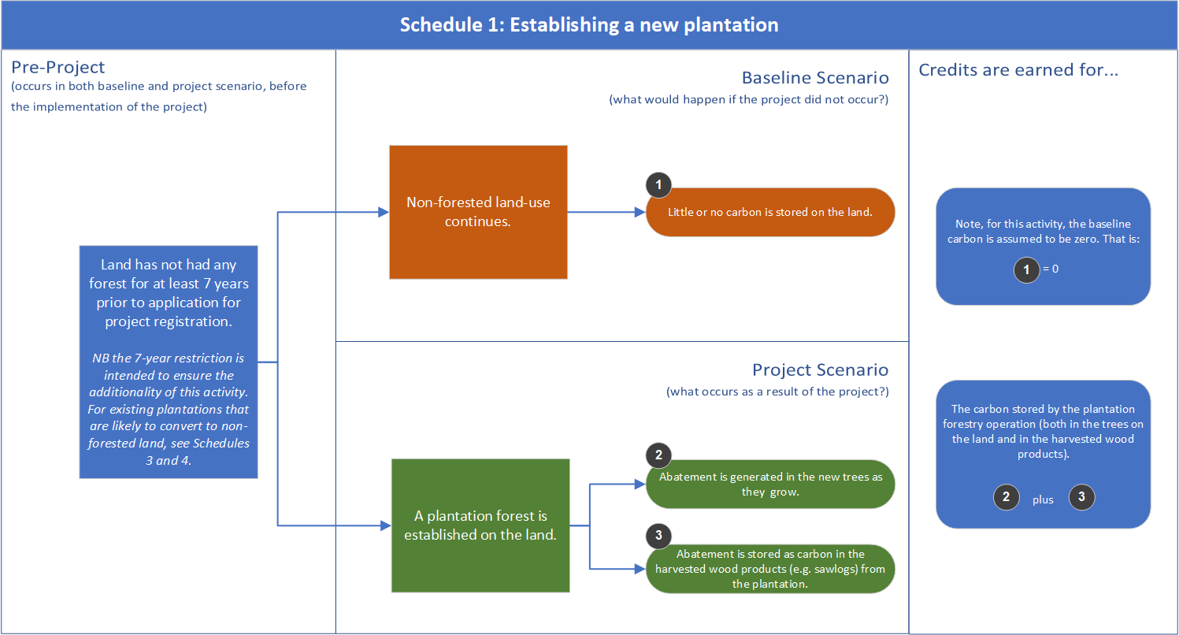

**FIGURE 4: SCHEDULE 1 OVERVIEW**

#### Species restrictions

The method is not restrictive on the tree species that can be grown under Schedule 1, provided:

* The plantation can be expected to reach forest cover (defined in the method) before clearfelling, and
* The plantation does not involve growing a species that is a known weed species.

In the 2017 method, two species (Indian Sandalwood in all NPI regions and African Mahogany in the Northern Territory NPI region) are excluded as evidence available at the time the method was developed indicated that new plantations of that type were likely to occur in a business as usual scenario. The latest available data shows that the estates of these two species have since declined, supporting the removal of the exclusions.

# Schedule 2: Converting an existing plantation from a short rotation to a long rotation

Project activity

Under the 2021 plantation forestry method ACCUs can be issued for projects that convert an existing short rotation plantation to a long rotation plantation to extend the growing time of the trees and sequester more carbon. The conversion can occur either part-way through the short-rotation cycle or following harvest of a short-rotation plantation. ACCUs are issued evenly over 15 years, based on net increases in the carbon stocks stored on the land and in harvested wood products due to this conversion, averaged over 100 years.

The conversion of a plantation from short to long-rotation is considered additional based on the assumption that where land is currently managed for short-rotations it would likely continue to be managed as such. Alternatively, where land is no longer considered viable for short-rotation plantations, it is likely that the land would be converted to non-forest land. In these circumstances, the plantation may be eligible to participate in Schedule 3 or 4.

Project proponents will be required to provide evidence that:

1. At registration, their plantation was being managed as a short rotation, and
2. As a result of implementing the project, their project will be managed as a long rotation.

See ‘Species Restrictions’ below for restrictions on the species permitted to be used for short and long rotation management, and for how to evidence the management regime.

#### Estimating abatement and crediting

Refer to *Step 4: Reporting and Crediting* (pages 32-33) for information on estimating abatement and crediting for Schedule 2.

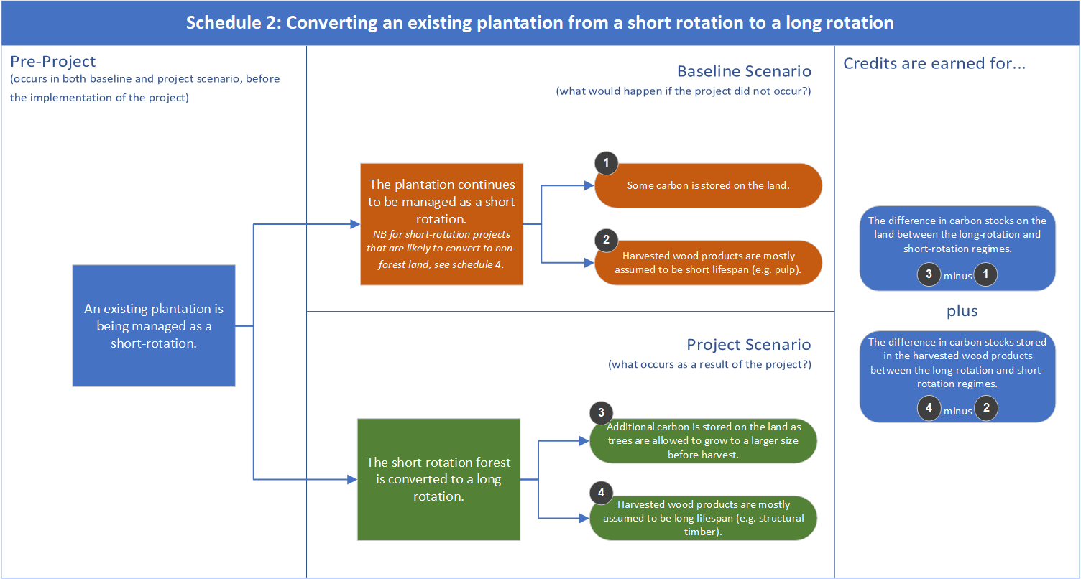

**FIGURE 5: SCHEDULE 2 OVERVIEW**

Species restrictions

The 2017 method contains restrictions on the species that can be grown in the conversion activity, both in the baseline scenario and in the project scenario. These restrictions are designed to ensure that conversion projects only convert from a species that is typically grown as a short rotation to a species that is typically grown as a long rotation.

The 2021 method contains an update of the framework for these species restrictions, to address stakeholder feedback that these are a barrier to entry for species that can be managed as either a long or short rotation. Schedule 2 of the 2021 method divides plantation species into three categories (contained within Schedule 5 Parts 1, 2 and 3 of the draft method):

1. Species that can be presumed to have a short rotation (species in regions where >97%[23] of plantations are managed as a short rotation)
2. Species that can be presumed to have a long rotation (species in regions where >97% of plantations are managed as a long rotation)
3. Species that require additional evidence of intent to manage as either a long or short rotation (species in regions where data shows they can be grown as either a long **or** short rotation)

Note that as Category 3 species will be all species that are not named in Categories 1 or 2, there is no need for an inclusive list of category 3 species. Rather, the method will reference ‘all species that are not named in Categories 1 or 2.

The permissible additional evidence required for category 3 species is:

* Evidence that at least one rotation of the same species has been harvested as a short rotation on the project area (retained from the 2017 method)
* Spatially explicit data to demonstrate that the relevant species has been harvested as a short or long-rotation within 50 kms to the proposed conversion CEA, or
* A financial assessment undertaken by an independent auditor or equivalent showing that a long rotation would not be commercially viable in the baseline scenario.

All participants with a Category 3 species will also be required to provide a signed declaration by the CEO or CFO of the plantation to state their intended management regime (either in the baseline scenario or the project scenario) and a Forest Management Plan signed off by an independent Registered Forestry Professional that outlines how the management of the plantation forest has changed between the baseline and project scenarios.

# Schedule 3: Avoided conversion of a plantation to non-forest land by continuing plantation activity

#### Project activity

The project activity in **Schedule 3** involves the continuation of plantation forestry activity on land where it would otherwise be converted to non-forest land in the absence of the ERF. Schedule 3 projects must meet the requirements of the additionality framework outlined on pages 13-15 to be eligible.

The continuation of the plantation activity can occur by:

1. managing an existing eligible plantation (aged 24 months or older of the average clearfell age for the relevant species and region) until harvest and then replanting at the end of a planned rotation
2. immediately harvesting and replanting, or
3. replanting on land that has been harvested in the last 7 years (and would therefore be excluded under Schedule 1).

#### Forest management plan

Proponents are required to submit a forest management plan that, in addition to the requirements outlined on pages 16-17, is signed off by an independent Registered Forestry Professional who deems the plan as viable for ongoing cycles of harvesting and planting over the permanence period.

#### Estimating abatement and crediting

Refer to *Step 4: Reporting and Crediting* (pages 33-35) for information on estimating abatement and crediting for Schedule 3.

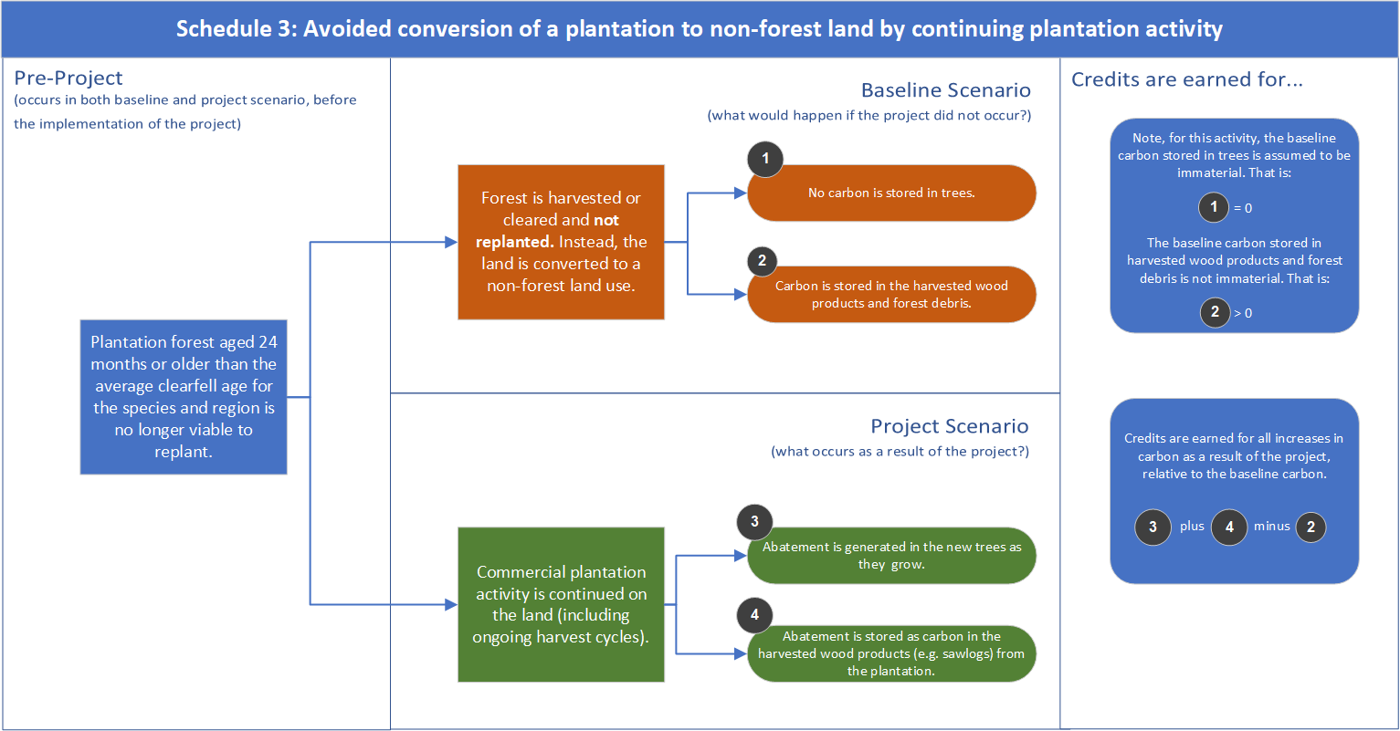

**FIGURE 6: SCHEDULE 3 OVERVIEW**

# Schedule 4: Transition to a permanent forest

#### Background

There is an increasing trend to convert Australia’s plantation estate to non-forest, largely agricultural, land. A project that keeps a land under forest under circumstances where it would have otherwise been converted to non-forest land is considered additional. Schedule 4 projects must meet the requirements of the additionality framework outlined on page 13-15 to be eligible.

Prior to 2020, the CFI Regulations excluded ERF projects that ceased or avoided harvesting of plantation forests (forests established for harvest) based on the assumption that plantation forests are likely to need active management, generally accomplished through harvest and related practices. There was a concern that non-harvest plantations could result in potential adverse land management impacts, such as weed or fire risks. Following amendments to the CFI Regulations in 2020, an exclusion was removed that now allows projects that cease or avoid harvesting of plantation forests to be eligible, subject to development of the 2021 method. The explanatory statement for the amended CFI regulations said that any remaining risks from such projects would be considered and dealt with in the eligibility requirements for this activity under the method.

#### Project activity

The project activity in Schedule 4 involves the transition of an existing eligible for-harvest plantation forest to a permanent, not-for-harvest forest. Land which has had a for-harvest plantation forest on it but harvesting or replanting ceased sometime in the last seven years is also permitted to undertake this activity.

Schedule 4 provides flexibility around how plantation forests are transitioned to a permanent not-for-harvest forest and allows for the scenarios outlined in the table below.

**TABLE 4: PERMITTED SCENARIOS AND ACTIVITIES UNDER SCHEDULE 4**

|  |  |  |  |  |  |
| --- | --- | --- | --- | --- | --- |
| **Scenario** | **Before registration application** | **Before crediting period begins** | | **After crediting period begins** | **Species restriction** |
| No clearing – the plantation forest is retained as a permanent forest. | n/a | | | See restricted activities – thinning only permitted for ecological purposes | n/a |
| Partial clearing - the plantation forest is (or has been) partially cleared/thinned, and subsequently replanted.  or  Full clearing - the plantation forest is (or has been) harvested, and a permanent, not for harvest planting is established. | Clearing or thinning permitted. | | Clearing or thinning permitted. Any cleared trees must be replanted after registration application and before the crediting period begins. | See restricted activities – thinning only permitted for ecological purposes | No restrictions |
| Gradual transition to environmental planting – the plantation forest is retained as a permanent forest at the start of the project and gradually transitioned to an environmental planting. | n/a | | | The remnant plantation is gradually thinned and fully replaced with environmental plantings, with carbon stocks maintained over the permanence period. Also see restricted activities. | Environmental plantings only |

At the commencement of the crediting period, the permanent, not-for-harvest forest (referred to as an ‘ex-plantation CEA’ in the method) will consist of the:

* Retained plantation trees (referred to as a ‘remnant plantations CEA’ in the draft method), and/or
* New plantings (referred to as a ‘permanent planting CEA’ in the draft method).

Please note that Schedule 4 projects that establish permanent environmental plantings[24] will be considered as to have met the ‘water rule’.

To avoid incentivising clearing of naturally regenerated forest, this activity is not permitted to be undertaken on plantation land where a plantation has been historically cleared and native forest[25] has regenerated. Schedule 4 species restrictions are discussed in the next section.

#### Required activities – Forest management plan

The permanent forests will be required to be actively managed and will be subject to different requirements and restrictions to those in Schedules 1, 2 and 3, in order to minimise permanence risks and the risk of adverse impacts associated with permanent forests.

Proponents are required to create and actively manage a permanent forest in accordance with a forest management plan (page 16-17), which is required to:

1. Be provided at registration and be updated with each offsets report if management activities change
2. Be signed off by an independent[26] Registered Forestry Professional[27]
3. Describe all management actions that have been or will be undertaken as part of the project for the purpose of modelling these actions in FullCAM (which supersedes the requirement in the 2017 method for a management schedule)
4. List and assess the potential risks of adverse impacts from the permanent forest, including consideration of weed, pest, fire and other relevant risks
5. Outline how management activities will minimise material risks identified, with evidence where applicable (such as photographs or statements)
6. Outline how restricted activities will be conducted in accordance with the specified restrictions, with evidence where applicable
7. Demonstrate that the forest is being managed for carbon and not for harvest (that is, no thinning or pruning has been undertaken to prepare the trees for harvest during each reporting period. Note that thinning and pruning for ecological purposes (e.g. drought resilience or pest and disease recovery) will be permitted.)
8. Demonstrate that the management activities being undertaken are consistent with that of a viable permanent forest over the permanence period
9. Where necessary, provide evidence of the endemism of any retained commercial plantation trees or infill plantings, to avoid the commercial plantation species discounts discussed on page 28, and
10. Include all requirements of the permanence plan (superseding the requirement for a separate document to be submitted).

For further information on requirements for the forest management plan, please see page 16-17, and refer to the accompanying guidance.

Project proponents are also required to manage the permanent forest so that the carbon stock does not fall below that already credited in the project. For example, if thinning, fire or another disturbance occurs in the area during the project, causing a decline in the amount of carbon stock, regrowth or new planting must be managed to allow the carbon stock to return to previously reported values.

#### Restricted activities

After the commencement of the crediting period, participants are permitted to conduct management activities such that the forest is managed for ecological and risk minimisation purposes, but not commercial harvest activities, including:

1. Thin and prune trees in a CEA, provided:
   1. Where the retained plantation trees are thinned or pruned:
      1. The permanent forest is managed in accordance with Requirement 2 above.
   2. Where the new plantings are thinned or pruned:
      1. The trees are only thinned or pruned for ecological purposes (i.e. drought resilience, pest or disease recovery, biodiversity promotion, enhancement of carbon stocks and fire prevention) in accordance with the forest management plan (i.e. not for commercial harvest), and
      2. 95% of thinned or pruned biomass remains in the CEA over the reporting period.
2. Remove biomass from a CEA, provided where biomass is removed from the in-fill planting, no more than 5% of total biomass from the in-fill planting is removed on average per calendar year.[28]
3. Conduct the following management activities (currently permitted under the 2017 method):
   1. Planting
   2. Seeding
   3. Fertilisation
   4. Weed control
   5. Controlled burn.

#### Species restrictions and discounting

There are two elements to the species restrictions for Schedule 4:

1. Species grown in the baseline period (and potentially retained in the project scenario), and
2. Species planted as new plantings if/when the forest is thinned.

In the interests of flexibility and consistency with other ERF methods, no restrictions are imposed on the tree species that participants can choose for either of these activities (besides the existing restriction on known weed species imposed by CFI Regulation 3.36).

This approach opens a potential permanence risk in situations where participants choose to retain or establish a forest that contains commercial plantation species and elect a 25-year permanence period. Where this occurs, the CER has limited assurance — beyond the requirements to manage the forest for carbon rather than for harvest — that the proponent will not harvest the forest at the expiry of the permanence period, despite being credited on the basis of a permanent forest (i.e. under this schedule participants are not subject to accounting for emissions resulting from harvesting with the result that, all things being equal, the permanent plantings will receive more ACCUs than plantations subject to commercial harvest).

Given the permanence risks of permitting commercial species in Schedule 4, the method imposes a discount on projects that contain commercial plantation species and elect a 25-year permanence period. The discount applies only to abatement from commercial plantation species and is proportionate to the share of commercial species present in the plantation.

#### Estimating abatement and crediting

ACCUs will be earned for emissions avoided from retaining carbon in the existing plantation (less any thinning), both for the initial biomass (which would have cleared in the absence of the scheme) and new carbon stored if the trees are still growing, which will depend on the age of the plantation. ACCUs will also be earned for the carbon in the in-fill plantings, assuming those trees were not present in the baseline.

Refer to *Step 4: Reporting and Crediting* (pages 35-37) for information on estimating abatement and crediting for Schedule 4.

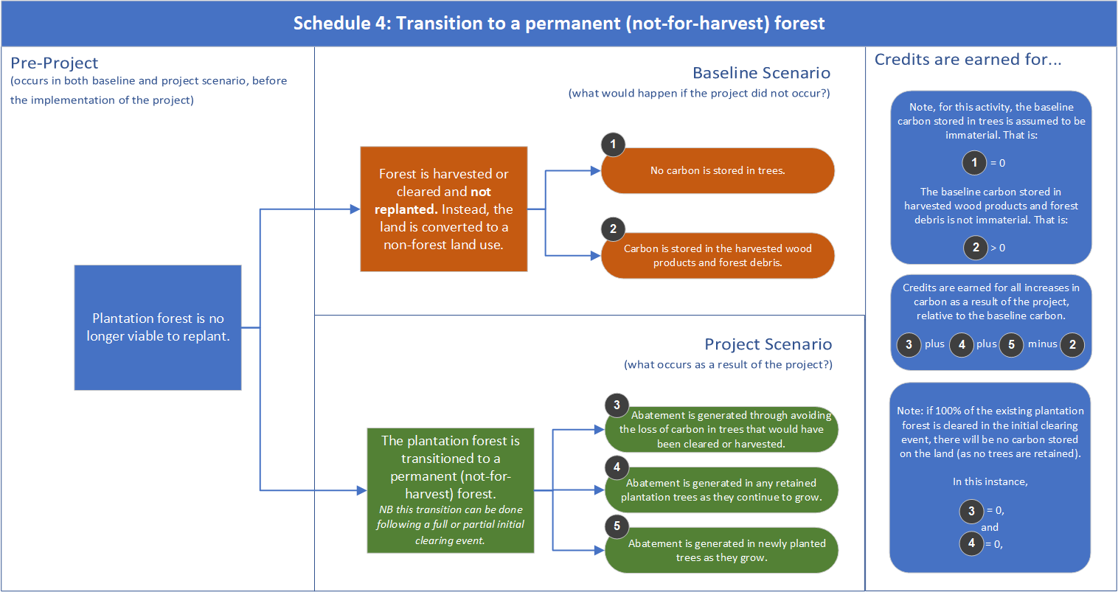

**FIGURE 7: SCHEDULE 4 OVERVIEW**

# Step 4: Reporting and crediting

Earn carbon credits by modelling the change in stored carbon and reporting your results to us.

You choose the length of each reporting period, which can be between 6 months and 5 years. The time between reports is referred to as the ‘reporting period’ and are consecutive within the crediting period (i.e. there can be no gaps between reporting periods).

Importantly, you will also need to deduct material **increases in greenhouse gas emissions that are emitted in undertaking the project** that are above levels in the baseline period (for example, from fuel use, fertiliser application, controlled burning and others).

## Estimating abatement and crediting

#### FullCAM

Projects under the 2021 plantation forestry method will calculate abatement using the Full Carbon Accounting Model ([FullCAM](https://www.industry.gov.au/regulations-and-standards/methods-for-the-emissions-reduction-fund/plantation-forestry-method)) in accordance with the [FullCAM Guidelines](https://www.industry.gov.au/regulations-and-standards/methods-for-the-emissions-reduction-fund/plantation-forestry-method). FullCAM is the model that is used for Australia’s National Inventory emissions reports, which track Australia’s progress towards its Paris target. It is also used to estimate abatement for five existing ERF vegetation methods. Projects use the version of FullCAM in force at the end of the reporting period.

At the time the method was released for public consultation, work was underway at the Department of Industry, Science, Energy and Resources to update the plantations calibrations in FullCAM. The updated version of FullCAM (‘2022 FullCAM’) is expected to be released in 2022. Several more companies have come forward to offer additional data since the Department initially presented on the public release update in May 2021. Given the importance of taking on board all available information to ensure the accuracy of the model calibrations, this has affected timelines for the ongoing calibration work by CSIRO. The Department is now aiming to make a ‘beta’ version of the software available for consultation and review during the first half of 2022. The timing of the official release for use in the method will depend on the feedback and consultation process.

Given the potential lag in timing between the 2021 method being approved and the release of 2022 FullCAM, we have developed [FullCAM guidelines](https://www.industry.gov.au/regulations-and-standards/methods-for-the-emissions-reduction-fund/plantation-forestry-method) for use with 2016 FullCAM to support the release of the 2021 method. New guidelines will be developed to accompany 2022 FullCAM once finalised.

#### Key assumptions

Under the 2021 plantations method, carbon credits are issued based on the difference between the carbon stored as a result of the project and the carbon stored in the baseline scenario.

Activities that rely on ongoing plantation activity (i.e. Schedules 1, 2 and 3) will have fluctuations in the carbon stock as trees are grown and emissions from harvesting occur in an ongoing cycle. To ensure that the projects do not receive more ACCUs than the carbon that would be accrued over the project life, ACCUs are not issued for any growth in trees beyond the estimated long-term average carbon stock for the project. The long-term average carbon stock refers to the net abatement (sequestration from trees growing and carbon stored in harvested wood products minus emissions from harvesting, thinning, fire, fuel and fertiliser use) resulting from the project. The long-term average carbon stock is calculated over 100 years for Schedules 1, 2 and 3, which is also the time period used by convention as a proxy for permanence.

The Schedule 4 project activity permits a single harvest event during the crediting period, where the harvested areas are replanted with a permanent planting. To account for the emissions introduced by this single harvest event, ACCUs are issued based on total carbon that will be present in the permanent forest at the end of the crediting period.

### Schedule 1 crediting

#### Baseline

The carbon stored in the baseline scenario is assumed to be zero, as the land would have continued to be managed as non-forested land in the absence of the project.

#### Project scenario

The project scenario involves the establishment of a new plantation forest. This plantation can be a short rotation or a long rotation.

ACCUs are issued each time a project reports abatement to the Clean Energy Regulator[29], and will directly correlate to increases in carbon during the reporting period up to the long-term average carbon stock for the project.

Figures 8 and 9 below display illustrative abatement profiles for a long and short rotation under Schedule 1. Figures 10 and 11 display the annual illustrative credit issuances to these same projects.

In Figures 10 and 11, ACCUs stop being issued once the cumulative ACCUs that have been issued reaches the long-term average carbon stock.

|  |  |
| --- | --- |
| dd |  |
| **Figure 8: Project carbon and long-term average carbon stock for a new 13-year rotation plantation of Eucalyptus globulus.** | **Figure 9: Project carbon and long-term average carbon stock for a new 30-year rotation plantation of Pinus radiata.** |

|  |  |
| --- | --- |
| dd |  |
| **Figure 10: Annual credit issuances for the plantation presented in figure 8. Credit issuances cease after year 8, as credits issued equal long-term average carbon stock at this point.** | **Figure 11: Annual credit issuances for the plantation presented in figure 9. Credit issuances cease after year 18, as credits issued equal long-term average carbon stock at this point.**  Note that the drop in issuances in year 15 of the project corresponds with a thinning event at year 15 of the project scenario. |

#### Schedule 1 worked example

Under Schedule 1 credits are issued for the abatement generated by the establishment of a new plantation.

Figure 8 provides an illustrative example of the establishment of a new short-rotation plantation – in this case a plantation of *Eucalyptus globulus* that is harvested every 13 years. The carbon stored in the plantation increases over time as the trees grow during the plantation’s growth phase. The trees in the plantation contain 238 tonnes of carbon dioxide equivalent (tCO2-e) per hectare prior to the harvest at the end of the 13 year rotation. During the growth phase, some carbon is also attributed to the debris pool, in the form of deadwood, bark litter, leaf litter and roots. This represents 25 tCO2-e per hectare immediately before the end of the 13 year rotation with the total carbon stock in the plantation being 238+25 = 263 t CO2-e/ha.

After the harvest event in year 13, the carbon in the trees moves out of the trees and into the harvested wood products and debris pools, where it decays at varying rates. Immediately after the harvest event, the harvested wood products contain 146 tCO2-e per hectare and the debris pool contains 117 tCO2-e per hectare (so 263 t CO2-e/ha in total still). The carbon in the harvested wood products becomes emissions very rapidly, as the harvested wood products are mostly paper, which decays almost fully in 3 years. As such, the carbon stored in the plantation declines between years 13 and 16 as emissions from the debris pool or harvested wood pools. From year 16 until the next harvest in year 26, the carbon stored in the plantation increases as the tree regrowth offsets emissions from other carbon pools.

Crediting for this abatement profile occurs on the basis of the long term average carbon stock. This smooths out both the impacts of the harvest events on carbon stocks and the amount credited. In this example, the long term average carbon stock in the project when averaged over the 100-year period, (the light blue line above) is equal to 152 tCO2-e per hectare. This number is calculated by adding up the total carbon present in each month of the project scenario, and then dividing this total by the 1200 months present in the 100 year averaging period. This is the total credit entitlement that the project will be able to be issued throughout the 25-year crediting period.

Figure 12: Carbon stored in trees, debris and harvested wood products over 100 years of a 13-year rotation plantation of *Eucalyptus globulus.*

Credits are apportioned to align with carbon stocks in the project (i.e. the dark blue line above). For this example, the annual credits issued are shown in Figure 10 above, where the project is issued the majority of the credits in years 4-8 of the project, as these are the years where the trees are experiencing the fastest growth, after initial slow growth in years 1-3. At the end of year 8, the project has been issued its total credit entitlement, and as such crediting ceases. However, the project must continue to report until the end of its crediting period at year 25.

Note: all values given in this section are examples only. FullCAM estimates vary by region and species. You should conduct your own FullCAM modelling to obtain abatement estimates for your project.

### Schedule 2 crediting

#### Baseline

* The baseline carbon for Schedule 2 is assumed to be ongoing short-rotation harvest cycles.
* At registration, you are required to model the baseline scenario (which consists of the baseline management regime of harvesting and replanting short rotations repeated over 100 years), and calculate the long-term average carbon stock associated with the continuation of that regime.

#### Project scenario

The project scenario involves converting the short rotation plantation to a long rotation.

* At registration, you are required to model your intended management actions for the long-rotation regime, over 100 years, and calculate the long-term average carbon stock associated with these actions.
* You are entitled to credits for abatement that arises as a result of the change in management activity brought about by the project. Thus, the total credits that you are entitled to over the crediting period as a result of your project can be calculated with the equation:
$$Credit entitlement= {Long term average carbon \atop stored in project scenario} - {Long term average carbon \atop stored in baseline scenario}$$

* This credit entitlement is then split into equal apportionments over the first 15 years of the crediting period. This removes crediting discrepancies between projects that commence with standing forest and those that commence with fallow land. The crediting period itself remains as 25 years and you will need to continue to report for this period regardless of whether you are still receiving credits.

Figure 12 below displays an illustrative abatement profile for a conversion project under Schedule 2. Figure 13 displays the annual illustrative credit issuances to this same project.

**Figure 12: Carbon stored by the project scenario and baseline scenario for a Schedule 2 project. The baseline scenario is a 13-year rotation Eucalyptus globulus plantation, and the project scenario is a 30-year rotation Pinus radiata plantation.**

**Figure 13: An even averaged apportionment of credits is received for the first 15 years of the project, after which crediting ceases.**

### Schedule 3 crediting

#### Baseline

* The baseline carbon for Schedule 3 is assumed to be a single harvest event, followed by conversion to a non-forested land use. As such, the baseline carbon stock is entirely comprised of carbon stored in the debris and harvested wood product pools.
  + The baseline carbon is required to be modelled because the carbon stored in the harvested wood products from a single harvest event are material, particularly for long rotation plantations due to the extended growth age and the greater proportion of harvested wood products being used for construction.
* At registration, participants are required to model the baseline scenario, and calculate the long-term average carbon stock associated with the harvest event.

#### Project scenario

* The project scenario involves continuing the plantation forest.
* At registration, you are required to model your intended management actions for the plantation forest, over 100-years, and calculate the long-term average carbon stock associated with these actions.
* You are entitled to credits for abatement that arises as a result of the of the change in management activity brought about project. Thus, the total credits that you are entitled to as a result of your project can be calculated with the equation:
$$Credit entitlement= {Long term average \atop carbon stored in project scenario} - {Long term average \atop carbon stored in baseline scenario}$$

* This credit entitlement is then split into equal apportionments over the first 15 years of the project. This removes crediting discrepancies between projects that commence with standing forest and those that commence with fallow land. The crediting period itself remains as 25 years and you will need to continue to report for this period regardless of whether you are still receiving credits.

Figures 14 and 15 below display illustrative abatement profiles for short and long rotation Schedule 3 projects. Figures 16 and 17 display the annual credit issuances to these same projects.

**Figure 14: Abatement profile for a Schedule 3 project that continues an eligible Eucalyptus globulus plantation with 10-year rotation lengths. Credits are issued based on the difference between the project average carbon stock (dotted blue line) and the baseline average carbon stock (dotted orange line).**

|  |
| --- |
|  |
| **Figure 15: Abatement profile for a Schedule 3 project that continues an eligible Pinus radiata plantation with 30-year rotation lengths. Credits are issued based on the difference between the project average carbon stock (dotted blue line) and the baseline average carbon stock (dotted orange line).** |

|  |  |  |
| --- | --- | --- |
| v | |  |
| **Figure 16: Annual credit issuances for the Schedule 3 project represented in Figure 14. An even apportionment of credits is received for the first 15 years of the project, after which crediting ceases.** | **Figure 17: Annual credit issuances for the Schedule 3 project represented in Figure 15. An even apportionment of credits is received for the first 15 years of the project, after which crediting ceases.** | |

### Schedule 4 crediting

#### Baseline

* The baseline carbon for Schedule 4 is assumed to be a single harvest event, followed by conversion to a non-forested land use. As such, the baseline carbon stock is entirely comprised of carbon stored in the debris and harvested wood product pools, less any emissions from fuel used for the harvest event.
  + The baseline carbon is required to be modelled because the carbon stored in the harvested wood products from a single harvest event are material, particularly for long rotation plantations due to the extended growth age and the greater proportion of harvested wood products being used for construction.
* At registration, you are required to model the baseline scenario, and calculate the carbon that would have remained in the debris and harvested wood products at the end of the crediting period (year 25).

#### Project scenario

* The project scenario involves transitioning the plantation to a permanent planting. This can be done by:
  + Retaining the extant plantation forest
  + Clearfelling the forest and replanting, or
  + Thinning an area of the forest and replanting in its place.
* At registration, you are required to model your intended management actions for the crediting period and calculate the total carbon that will be present in the project at year 25.
* You are entitled to credits for abatement that arises as a result of the change in management activity brought about by the project – including any abatement arising from retaining trees that would have otherwise been harvested. Thus, the total credits that you will receive for a project can be calculated with the equation:

$Credit entitlement= {Carbon stored at year 25 \atop of project scenario} - {Carbon stored at year 25 \atop of baseline scenario}$

* This credit entitlement is then split into equal apportionments over the first 15 years of the crediting period. This removes crediting discrepancies between projects that commence with standing forest and those that commence with fallow land. The crediting period itself remains as 25 years and you will need to continue to report for this period regardless of whether you are still receiving credits.
* Schedule 4 does not require participants to calculate the long-term average carbon stocks. This is because Schedule 4 does not permit ongoing harvest activities, and as such there is no need to account for emissions from harvesting. Because of this, Schedule 4 projects account for carbon present in the forest at the end of the crediting period, as this represents the cumulative net sequestration that will have occurred as a result of the project.

Figure 18 below displays an illustrative abatement profile for a Schedule 4 project. Note that this is an illustrative example only, and does not represent the many ways you can structure your project under Schedule 4. Figure 19 displays the annual credit issuances to this same project.

**Figure 18: Carbon stored by the project scenario and baseline scenario for a Schedule 4 project. The baseline scenario is a single clearfell harvest at age 13 of a Eucalyptus globulus plantation without replanting. The project scenario involves a single thinning event on 20% of the trees at project registration (with resulting emissions shown in the drop in abatement in year 1) with replacement trees being replanted with environmental plantings accumulating carbon from year 3.**

**Figure 19. An even apportionment of credits is received for the first 15 years of the project, after which crediting ceases.**

### Auditing your project

Your project needs to be audited to align with our legislative requirements. The number of audits required over the 25-year crediting period will depend on the project size and the forward abatement estimate. Most plantation forestry projects will require 3 audits, including one with the first report.

Each audit report is submitted when you apply for carbon credits. We will provide you with an audit schedule when your project is registered, which will tell you what reports need to include audits. For example: “*Audit 2: First project report submitted after 25/07/2024*”.

### Engaging auditors

We recommend you engage an auditor early when developing your project, as this will help you work out audit costs. You can find a list of [registered auditors](http://www.cleanenergyregulator.gov.au/Infohub/Audits/register-of-auditors)[30] on our website.

### Notification requirements

You need to tell us about important changes to your project. For example, if the person running the project changes, you need to inform us.For more information, see[Compliance](http://www.cleanenergyregulator.gov.au/About/Compliance-and-Enforcement/compliance-and-enforcement-approach).

### Making changes to your project

You can make changes to your project to adjust for changing circumstances. You may want to add promising new areas of land or change the person responsible for running the project.

To make changes (variations) to your project, you will need to complete a Project Variation form, available from the [Clean Energy Regulator Client Portal](http://www.cleanenergyregulator.gov.au/OSR/CP).

# Getting started

**Ready to start a plantation forestry project?**

* Visit our website for links to the plantation forestry method, the supplement, other useful resources, or contact us on 1300 553 542.
* Check for eligible and suitable land, see if it is viable to conduct any of the four activities and begin planning project registration.
* Carbon service providers (also known as project developers, aggregators, consultants, or agents) specialise in supporting or running carbon projects, usually for an agreed percentage of earnings. They may be able to help establish, model and report on your project. You can contact a carbon service provider using the Carbon Market Institute’s [Australian Carbon Market Directory](https://marketplace.carbonmarketinstitute.org/)[31].

# Disclaimer

This document provides general guidance on using the 2021 Plantations Forestry Method. It does not replace or supersede any legal requirements, address all applicable legal requirements, or recommend any investment. Figures are indicative and are not necessarily applicable to individual circumstances. Emissions Reduction Fund plantations projects involve ongoing legal obligations and returns can vary. You are encouraged to carefully consider if a project is right for you and seek independent professional advice relating to your unique circumstances.

# 

# Appendix 1: National Plantation Inventory regions

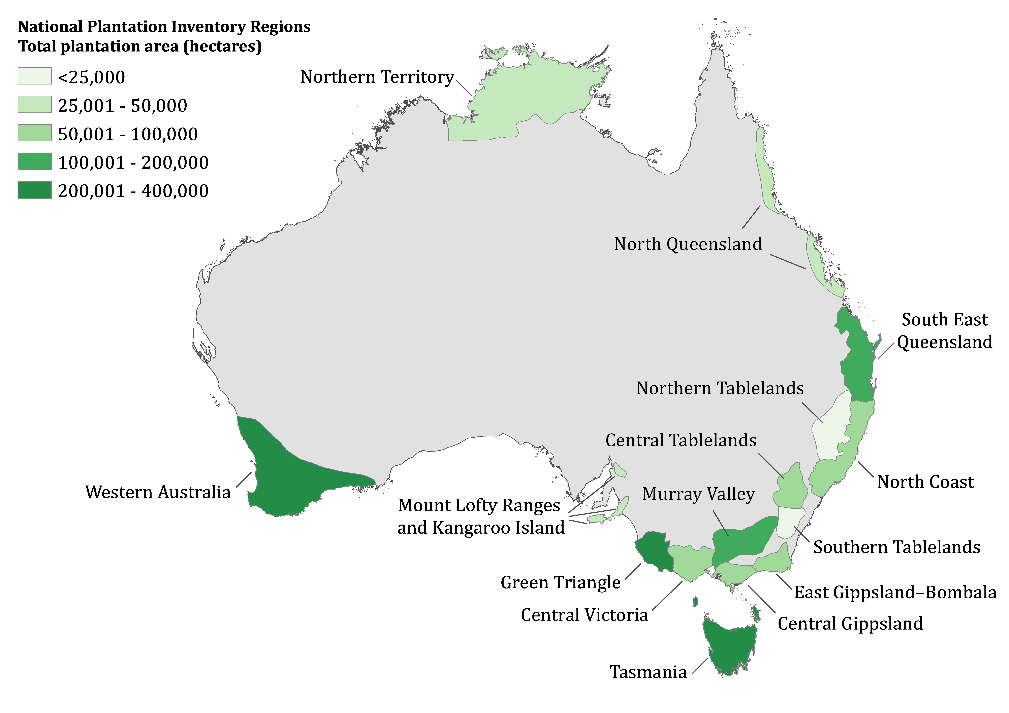

**FIGURE 20: NATIONAL PLANTATION INVENTORY REGIONS**

# Appendix 2: Issues that are out-of-scope

Table 5 below provides an overview of issues that stakeholders have raised with us during the development of the method that have been deemed as out-of-scope in the development of the 2021 method. Some of these issues are being pursued through alternative avenues or are not required for this iteration of the method.

**TABLE 5: ISSUES THAT ARE OUT OF SCOPE**

|  |  |
| --- | --- |
| Issue | Answer |
| Method stacking, compressed crediting, auditing framework changes | We are aware that there is interest in several key issues, including those that impact methods across the ERF. These include method stacking, compressed crediting, reducing the costs of audits and facilitating aggregation, some of which were flagged in the King Review. While we note that these issues may be a barrier to participation in the plantations method, there is a broader work program being undertaken by the Clean Energy Regulator (CER) and the Department of Industry, Science, Energy and Resources (DISER) to address these issues. The 2022 method priorities were announced on 1 October 2022. One of the new method priorities is the integrated farm method, which will consider how separate ERF land-based activities could be combined or ‘stacked’ on the same land. |
| Alternative approaches to estimating carbon abatement | Based on stakeholder feedback, the 2021 method will continue to use a modelled only approach using FullCAM. Work is currently underway at DISER to update FullCAM for the plantation forestry method. Other approaches could be considered in a further iteration of the method, depending on the outcome of the method prioritisation process. |
| The Water Rule | Regulation 3.37 of the CFI Regulations is often referred to as ‘the Water Rule’. It specifies conditions which need to be met under the eligibility requirements for ERF plantations forestry projects to manage the effects of commercial tree plantings on water availability. Changes to the CFI Regulations (including the Water Rule) are outside the CER’s remit. More information on the Water Rule can be found at the DISER [website](https://www.industry.gov.au/regulations-and-standards/methods-for-the-emissions-reduction-fund/plantation-forestry-method). |
| Other abatement activities | To raise suggestions for other abatement activities related to forestry, please engage with DISER’s method prioritisation process (at [emissions-reduction@industry.gov.au](mailto:emissions-reduction@industry.gov.au)).  Please note that the following activities have been deemed as out-of-scope for the 2021 method: harvesting native forests because a new method would be more fit for purpose, and the substitution of harvested wood products for more emissions-intensive materials due to uncertainty around emissions reductions associated with materials substitution and the subsequent leakage. |
| New ERF plantation notification to the Agriculture Minister | S20B of the CFI Rule requires the proponents of new plantation forestry projects to notify the Agriculture Minister. This requirement is to manage undesirable impacts on agricultural production of new or expanding plantation forests. Changes to this requirement are outside the CER’s remit in the 2021 method.  Find more information on the [Department of Agriculture Water and Environment - Emissions Reduction Fund Plantation Forestry Notification](https://www.agriculture.gov.au/ag-farm-food/climatechange/cfi/plantation-forestry-notifications)[32] website. |

1. <http://www.cleanenergyregulator.gov.au/ERF/Want-to-participate-in-the-Emissions-Reduction-Fund/Planning-a-project>
2. Forestry rights are the rights to plant, establish, manage, and maintain vegetation on the land. Each state and territory has its own forestry legislation.
3. <http://www.cleanenergyregulator.gov.au/ERF/Want-to-participate-in-the-Emissions-Reduction-Fund/Planning-a-project/native-title>
4. <http://www.cleanenergyregulator.gov.au/ERF/Choosing-a-project-type/Opportunities-for-the-land-sector/eligible-interest-holder-consent>
5. <http://www.cleanenergyregulator.gov.au/ERF/Want-to-participate-in-the-Emissions-Reduction-Fund/Making-changes-to-your-project#Vary-your-conditional-registration>
6. 6 Carbon Credits (Carbon Farming Initiative) Regulations (2011)
7. 7 Approved regional forestry hubs include:

   North East New South Wales

   South West Slopes of New South Wales and Victoria

   South East South Australian section of the Green Triangle

   South West Western Australia

   North/North West Tasmania.

   Please refer to the link for maps: <https://www.industry.gov.au/sites/default/files/2020-07/plantation-forestry-specified-regions-for-subregulation-3-37-4a.pdf>
8. <https://www.agriculture.gov.au/water/policy/nwi>
9. <http://www.environment.gov.au/climate-change/government/emissions-reduction-fund/publications/cfi-salinity-guidelines>
10. Carbon Credits (Carbon Farming Initiative) Regulations (2011)
11. <http://www.cleanenergyregulator.gov.au/csf/how-it-works/Pages/Being-a-project-proponent-information-for-landholders.aspx>
12. <https://www.awe.gov.au/abares/research-topics/forests/forest-economics/plantation-and-log-supply>
13. The CEO/CFO of the project proponent is the individual who is primarily responsible financial matters in relation to the project proponent. This definition allows individuals such as landholders, or agents or carbon service providers to sign the declaration, in the instance that they are the project proponent.
14. The requirement that the non-forest land use must be viable ensures that it is realistic to assume that the conversion would happen in the BAU scenario. There may be factors relating to specific plantation land such as soil type and slope that mean that not all plantation forest land will be suitable for an agricultural land use.
15. A qualified independent person is a person who is either:

    a qualified auditor, accountant or valuer who has been certified by a nationally recognised professional body and has demonstrated experience in the forestry sector, or

    a Registered Forestry Professional under Forestry Australia’s registered forestry professional accreditation scheme with demonstrated experience in financial assessments or financial reporting, and

    and has no financial interest in the project.
16. The default clearfell ages will be specified in the methodology determination and be informed by data on industry averages.
17. <http://www.cleanenergyregulator.gov.au/ERF/Want-to-participate-in-the-Emissions-Reduction-Fund/Step-1-Apply>
18. <https://www.environment.gov.au/climate-change/government/emissions-reduction-fund/publications/cfi-mapping-guidelines>
19. <http://www.cleanenergyregulator.gov.au/ERF/Want-to-participate-in-the-Emissions-Reduction-Fund/Step-1-Apply/Forward-abatement-estimates>
20. For Schedule 2 projects under specific circumstances, and all Schedule 3 and 4 projects
21. <https://www.agriculture.gov.au/ag-farm-food/climatechange/cfi/plantation-forestry-notifications>
22. <https://www.awe.gov.au/abares/research-topics/forests/forest-economics/plantation-and-log-supply>
23. The 97% threshold is applied to ensure that the only species for which there is a high degree of certainty of the management regime are eligible by default for the conversion activity. Note that alternative means to demonstrate additionality exist for species where there is less certainty.
24. As defined in the CFI regulations, where an environmental planting means a planting that consists of species that:

    (a) are native to the local area of the planting; and

    (b) are sourced from seeds:

    (i) from within the natural distribution of the species; and

    (ii) that are appropriate to the biophysical characteristics of the area of the planting; and

    (c) may be a mix of trees, shrubs, and understorey species where the mix reflects the structure and composition of the local native vegetation community.
25. As defined in the CFI regulations, where native forest means an area of land that:

    (a) is dominated by trees that:

    (i) are located within their natural range; and

    (ii) have attained, or have the potential to attain, a crown cover of at least 20% of the area of land; and

    (iii) have reached, or have the potential to reach, a height of at least 2 metres; and

    (b) is not a plantation.
26. An independent person is someone who has declared that they have no financial interest in the project or any potential conflicts of interest.
27. A Registered Forestry Professional must be currently registered under the Forestry Australia’s RFP scheme. Forest Practice Officers certified under the Forest Practices Code in Tasmania are also considered to be an RFP.
28. Participants should note that while biomass is permitted to be removed from a CEA for commercial purposes, environmental planting projects that do so will not be exempt from the Water Rule, which exempts permanent plantings that are also environmental plantings. As defined in the CFI Regulations, a permanent planting means a planting:

    (a) that is not harvested other than:

    (i) for thinning for ecological purposes; or

    (ii) to remove debris for fire management; or

    (iii) to remove firewood, fruits, nuts, seeds, or material used for fencing or as craft materials, if those things are not removed for sale; or

    (iv) in accordance with traditional indigenous practices or native title rights; and

    (b) that is not a landscape planting.
29. Projects must report at least once every 5 years. See ‘Reporting and Crediting’ on page 29 for more information.
30. <http://www.cleanenergyregulator.gov.au/Infohub/Audits/register-of-auditors>
31. <https://marketplace.carbonmarketinstitute.org/>
32. <https://www.agriculture.gov.au/ag-farm-food/climatechange/cfi/plantation-forestry-notifications>