**FullCAM Guidelines**

**Requirements for use of the Full Carbon Accounting Model (FullCAM) with the Emissions Reduction Fund (ERF) methodology determination:**

*Carbon Credits (Carbon Farming Initiative—Plantation Forestry) Methodology Determination 2021*

Version 1.0

(draft, not in force)

**Disclaimer**

This document has been developed to assist project proponents to calculate abatement in FullCAM as required by the *Carbon Credits Carbon Credits (Carbon Farming Initiative—Plantation Forestry) Determination 2021*. This document is the ‘FullCAM guidelines’ incorporated by reference in various sections of that determination. Project proponents should not use this document as a substitute for complying with the requirements in the Methodology Determination.

Before relying on any material contained in this document, project proponents should familiarise themselves with the following legal documents: *Carbon Credits (Carbon Farming Initiative—Plantation Forestry) Determination 2021*, [*Carbon Credits (Carbon Farming Initiative) Act 2011*](https://www.legislation.gov.au/Details/C2016C00029)*,* [*Carbon Credits (Carbon Farming Initiative) Rule 2015*](https://www.legislation.gov.au/Series/F2015L00156) and the [*Carbon Credits (Carbon Farming Initiative) Regulations 2011*](https://www.legislation.gov.au/Details/F2015C00658). Further explanation of the method can be found in the explanatory statement to the *Carbon Credits (Carbon Farming Initiative—Plantation Forestry) Determination 2021* and the simple method guide for that determination. Project proponents are also advised to obtain professional advice suitable to their particular circumstances.

This document does not displace relevant legislative provisions or other laws. All users are encouraged to read this document in conjunction with the relevant legislation, including the methodology determinations, referenced throughout this document. Where any inconsistencies are apparent, please be aware that the legislative provisions will take precedence.

This document will be updated periodically and users should note that some inputs and values may change over time. It is the user’s responsibility to ensure that they are using the most recent version of this document and any tool/s required in association as in force at the end of the relevant reporting period (consistent with section 7 of the Methodology Determination).

The Commonwealth of Australia will not be liable for any direct, indirect or consequential loss arising out of, or in connection with, or reliance on, information on, or produced by, using this document.

**© Commonwealth of Australia 2021**

# Contents

Contents 3

1. Introduction 5

1.1 Disclaimer 5

1.2 Use of FullCAM in the Carbon Credits (Carbon Farming Initiative—Plantation Forestry) Determination 2021 5

1.3 Format of this document 5

1.4 FullCAM background 6

1.5 FullCAM plots and running simulations 6

1.6 Overview of the FullCAM interface 7

2. Simulations Overview 8

2.1 Project scenario simulation 8

2.2 Long-term project scenario simulation 8

2.3 Baseline scenario simulation 9

2.4 Relevant time periods 9

2.5 Setting up simulations for the project, long-term project and baseline scenarios 10

2.6 Order of setting up plots 10

3. Using FullCAM 2016 10

3.1 Setting up simulations for the project, long-term project and baseline scenarios 10

3.2 Order of setting up plots 10

3.3 Navigating FullCAM 10

3.4 Create a new plot file 11

3.5 Saving a plot file 12

3.6 The Configuration tab 12

3.7 The Timing tab 13

3.8 The Data Builder tab 14

3.9 The Site tab 16

3.10 The Trees tab 16

3.11 The Soil tab 16

3.12 The Initial Conditions tab 16

3.13 The Events tab 19

3.14 Adding a New Event 28

3.15 Cloning events to cover the Modelling Period of the long-term project scenario 30

3.16 Cloning events to cover the Modelling Period of the Baseline Scenario 34

3.17 The Output Windows tab 34

3.18 Running simulations 39

3.19 Viewing outputs 39

3.20 Transferring outputs into a spreadsheet 39

3.21 Setting maximum forest growth for the permanent plantings activity 40

3.22 Calculating project abatement at the end of a reporting period 42

3.23 Variables generated in FullCAM and used in equations in the Determination 43

**Appendix 1** 45

**Example event settings for standard events specified in Section 3.13** 45

**Appendix 2** 52

**Standard parameters for forest products** 52

# Introduction

## Disclaimer

This document contains detailed guidance on how to use the 2016 public release of the Full Carbon Accounting Model (‘FullCAM 2016’) to calculate abatement under the *Carbon Credits (Carbon Farming Initiative—Plantation Forestry) Methodology Determination 2021* (the Determination). The Department of Industry, Science, Energy and Resources (DISER) are responsible for maintaining and updating FullCAM, and are expecting to release an update in 2022 which will update the calibrations used in modelling carbon dynamics for plantation species. Updated FullCAM guidelines will be released for use with FullCAM 2022.

## Use of FullCAM in the Carbon Credits (Carbon Farming Initiative—Plantation Forestry) Determination 2021

The calculation of carbon abatement under the Determination is dependent upon the use of FullCAM consistently with the requirements of this document. In particular, section 39 of the Determination requires that the project scenario, long term project scenario and the baseline scenario (where applicable) for each carbon estimation area (CEA) must be created and run as a FullCAM simulation in accordance with the requirements in both the Determination and this document. Sections of the Determination also require key output data to be produced using FullCAM in accordance with the requirements in the Determination and this document. Where content of this document relates to provisions of the Determination, references are given to the location of those provisions.

Project proponents must only change FullCAM default settings as indicated in this document, and all other settings must not be changed. This is to ensure that defaults will apply where relevant.

The latest version of FullCAM is available for download from industry.gov.au/data-and-publications/full-carbon-accounting-model-fullcam. You should check the Determination to determine which version of FullCAM that you are required to use. If you determine that you must use a version of FullCAM that is unavailable on the website, please contact DISER at [erfforests@environment.gov.au](mailto:erfforests@environment.gov.au) and/or [fullcam@industry.gov.au](mailto:fullcam@industry.gov.au) to obtain a copy.

Note that FullCAM is not compatible with iOS systems, and must be run in a Windows operating environment.

## Format of this document

The sections of this document provide:

1. an overview of FullCAM relevant to the Determination;
2. an overview of the simulations you are required to run in FullCAM by the Determination;
3. a step-by-step walkthrough of using FullCAM 2016 to run those simulations correctly;
4. an overview of the FullCAM outputs as they relate to equations within the Determination; and
5. Appendices:
   1. Example event settings for standard management events
   2. Standard parameters for forest products

## FullCAM background

FullCAM is used in Australia’s National Greenhouse Gas Accounts for the land sector. FullCAM provides fully integrated estimates of carbon pools in forest and agricultural systems for Australia’s land sector reporting. In addition, it accounts for human-induced changes in emission and sequestration of major greenhouse gases. FullCAM was developed under the National Carbon Accounting System (NCAS) at the then Australian Greenhouse Office to provide a dynamic account of the changing stocks of carbon in Australia’s land systems. FullCAM integrates data on land cover change, land use and management, climate, plant productivity, and soil carbon over time. FullCAM estimates carbon stock change and greenhouse gas emissions at fine spatial and temporal scales, and uses a wide range of spatially referenced data.

Users of FullCAM can determine estimates of carbon stock change and greenhouse gas emissions for ERF projects on a similar basis to that used for land use and land use change in Australia’s National Greenhouse Gas Inventory

## FullCAM plots and running simulations

FullCAM can run simulations on a ‘plot’. A plot is defined as a piece of land for which the event history, when modelled in FullCAM in accordance with requirements, is the same across that area of land. Separate plot files are created for each CEA. Where the event history for an area of land differs, a new CEA must be created, with an accompanying plot file (in accordance with section 20 of the determination).

In FullCAM, there are several types of plots that can be selected. Only ‘Forest system’ is relevant to this Determination. This document provides overviews of the simulations that users may be required to create in Section 2, and the steps to run these simulations in Section 3.

FullCAM models abatement using a single ‘model point’ location. Proponents do not need to define CEA boundaries within FullCAM, rather proponents must input the coordinates for a single location within the CEA boundaries that is at the approximate centre of the CEA (the model point – see subsections 15(13)-(15) of the Determination for full model point requirements). The latest spatial data for a plot must be downloaded using the ‘Data Builder’ tab each time the software is run. This process is described in section 3.8 of this document.

Separate plot files must be created for each carbon estimation area (CEA) (see Part 3, Division 4 of the Determination). In order to ensure all settings are correct, including defaults, we recommend creating new plot files each time a new version of FullCAM or these Guidelines is used. Plot files created under previous versions may contain different settings that will affect outputs and users are responsible for any inconsistencies.

For each CEA, separate plot files may need to be created for:

* the long-term project scenario simulation, which models carbon abatement for the project over the modelling period to set the upper limit to which projects can be credited;
* the project scenario simulation to determine the project’s carbon abatement for each reporting period (subject to the baseline reduction); and
* for all CEAs except new plantation CEAs, the baseline scenario simulation to determine the baseline carbon that must be subtracted from the project scenario carbon.

For definitions of the CEA types under the method, see Section 15 of the Determination.

## Overview of the FullCAM interface

The FullCAM software user interface displays menus and a series of tabs. Each tab has a suite of fields in which users may either be required to input information as instructed in section 3 or left unchanged. The program is designed so that certain tabs in a plot file are made available only if required fields have valid information entered in earlier tabs. If the text of a tab or field is red, then FullCAM requires information in that tab or field before a simulation can be run. When all the required fields within a tab have valid information entered, the tab text will become blue. Help is provided within FullCAM by clicking on the  symbol available in most windows. A general overview of each tab follows.

|  |  |
| --- | --- |
| **Tab** | **Explanation** |
| About | Includes a free text field where users can enter information about the plot file that they have created. This is a good space to keep track of information about the plot file such as the CEA and scenario that it represents and any changes that have been made or editing of event parameters. |
| Configuration | Users select the system type (e.g. Forest system, Agricultural system) they want to simulate in the plot. |
| Timing | Enter the timing for starting and ending the simulation and the time steps required for output data. |
| Data Builder | In this tab users enter the latitude and longitude of the ‘Model Point Location’ where they wish to simulate a plot file. Internet access is required to complete this tab. By choosing to ‘Download Spatial Data’ the associated soil and climate data for that latitude and longitude are automatically loaded into relevant parts of the remaining tabs. In the tab users can then download tree and/or crop species information. This information is also automatically loaded into relevant parts of the remaining tabs. |
| Site | Specific parameters for the ‘Model Point Location’ (e.g. water [rainfall], temperature, productivity) are described. |
| Trees | Description of the properties of the tree species. |
| Soil | Description of soil properties. |
| Initial Conditions | In this tab the values for carbon at the start of the simulation are described. Values will automatically be populated by Data Builder using data downloaded from the FullCAM server. |
| Events | All of the events for the entire simulation period are listed in this tab. Users can add or remove events. Care must be taken not to violate requirements for modelling ‘management events’ within the Determination. The names on the event list are colour-coded to indicate whether they are ready, whether they are simulating or not, and what system they affect. The colour codes are:  Red: Event not ready (renders event queue not ready);  Grey: Event non-simulating (outside simulation period, will not affect simulation);  Green: Forest;  Yellow: Agricultural; and  Brown: Mixed.  When a user selects an event with the cursor the event is highlighted in blue. |
| Output Window | Defines Output Windows that can be used to present different outputs in each window. |
| Explorer | Display of the parameter settings for each tab. |
| Plot Digest | This tab only appears when a plot is saved as a ‘plot digest’ by changing the save as type. It allows users to clone and alter the inputs of a given modelling scenario, and combine the results or output them separately. |
| Log | This tab records changes made to the file to assist with analysis and error tracking. |

# Simulations Overview

Three types of scenario simulations are required to be modelled using FullCAM, as specified in Part 4, Division 2 of the Determination: project scenario; long-term project scenario; and baseline scenario. Note that the baseline scenario is not required to be modelled for new plantation CEAs.

The project scenario simulation calculates the carbon abatement for the latest reporting period, subject to the upper abatement crediting limit established by the long-term project scenario and the deduction calculated under the baseline scenario.

The carbon stock calculated under the long-term project scenario applies the upper limit on which a project CEA can earn carbon credits. Projects are only credited up to the long-term average net carbon stock or long-term project scenario net carbon stock as set out in Part 4 of the Determination.

The baseline scenario simulation calculates the baseline carbon that must be deducted from the project scenario carbon. This deduction is applied differently for ex-plantation CEAs than it is for conversion and continuing plantation CEAs.

The FullCAM steps to produce each of these scenario simulations are similar. The timing of each simulation will differ, along with the events required to be modelled. The long-term project scenario simulation will mirror the project scenario simulation, but also simulate events beyond the reporting period for the remainder of the modelling period.

## Project scenario simulation

The project scenario estimates abatement up to the end of the reporting period.

The carbon stock in the project area at the end of the reporting period is calculated based on outputs from FullCAM for *C mass of forest debris*, *C mass of trees* and *C mass of forest products* in the last month of the reporting period. Emissions from fires during the reporting period are calculated based on FullCAM outputs for *CH4 emitted due to fire* and *N2O emitted due to fire*. Predicted fuel emissions are calculated based on the FullCAM output *C mass of forest products* from harvest events that occur during the reporting period.

## Long-term project scenario simulation

The long-term project scenario aims to establish a ‘cap’ on abatement that proponents can be credited to. This is to ensure that emissions from harvesting are accounted for. The long-term project scenario is different for ex-plantation (Schedule 4) CEAs than for CEAs under the other three schedules.

**New plantation, Conversion and Continuing Plantation CEAs**

For new plantation (Schedule 1), conversion (Schedule 2) and continuing plantation (Schedule 3) projects, the long-term project scenario estimates abatement over a 100‑year modelling period beginning on the ‘forest start date’ (see section 5 of the Determination). Proponents are not permitted to be credited for carbon stocks that exceed those of the long-term project scenario, which represents the average carbon stocks over the 100 years.

The predicted long-term average project carbon stock for the modelling period is calculated based on monthly outputs from FullCAM for *C mass of forest debris, C mass of trees* and *C mass of forest products* over a 100-year modelling period. Emissions from fires during the modelling period are calculated based on FullCAM outputs for *CH4 emitted due to fire* and *N2O emitted due to fire*. Predicted fuel emissions are calculated based on the FullCAM output *C mass of forest products* from harvest events that occur during the modelling period.

**Ex-Plantation CEAs**

For permanent planting (Schedule 4) projects, the long-term project scenario estimates abatement over a period from the forest start date until the expiry of the crediting period. Proponents are not permitted to be credited for carbon stocks that exceed those of the long-term project scenario, which for Schedule 4 projects represents the projected carbon stocks at the expiry of the crediting period.

The predicted long-term project scenario carbon stock for the modelling period is calculated based on monthly outputs from FullCAM for *C mass of forest debris, C mass of trees* and *C mass of forest products* at the end of the crediting period. Emissions from fires during the modelling period are calculated based on FullCAM outputs for *CH4 emitted due to fire* and *N2O emitted due to fire*. Predicted fuel emissions are calculated based on the FullCAM output *C mass of forest products* from harvest events that occur during the modelling period.

## Baseline scenario simulation

You do not need to run a baseline scenario simulation for the new plantation activity as the baseline carbon is assumed to be zero, and thus there is no need to model it.

The baseline for each CEA is calculated based on monthly outputs from FullCAM for C mass of forest debris, C mass of trees and C mass of forest products over a 25-year or 100-year modelling period. Emissions from fires during the modelling period are calculated based on FullCAM outputs for CH4 emitted due to fire and N2O emitted due to fire. Predicted fuel emissions are calculated based on the FullCAM output C mass of forest products from harvest events that occur during the modelling period.

For conversion projects (Schedule 2), the baseline scenario will be ongoing short-rotation forestry. For permanent planting (Schedule 4) or continuing plantation (Schedule 3) projects, the baseline scenario is a single clearfell with harvest, followed by fallow land.

## Relevant time periods

At various times, the Determination refers to the “modelling period”, the “crediting period” and the “forest start date” (see Section 5 of the Determination). The dates that these terms reference vary depending on the type of CEA being modelled and the specifics of the project. You should ensure you are aware of these dates for each CEA within your project, as the calculations in the method often reference points in time relative to these dates.

## Setting up simulations for the project, long-term project and baseline scenarios

Simulations for each Carbon Estimation Area (CEA) are undertaken using plot files. Project proponents must use the following steps for entering data into each tab in a FullCAM plot file for each CEA registered under the Determination.

When reopening existing plot files, spatial data must be re-downloaded in the Data Builder tab as described in section 3.7, and other tabs updated as relevant.

## Order of setting up plots

As a long-term project simulation will mirror the project simulation for all events up to the reporting date, you can first setup a project simulation plot file then use this as the base for setting up the long-term project simulation plot. When setting up the latter, open the project simulation plot file, then follow steps given at section 3.3.4 ‘Adding and cloning events for modelling the long-term project scenario’.

# Using FullCAM 2016

## Setting up simulations for the project, long-term project and baseline scenarios

Simulations for each Carbon Estimation Area (CEA) are undertaken using plot files. Project proponents must use the following steps for entering data into each tab in a FullCAM plot file for each CEA registered under the Determination.

When reopening existing plot files, spatial data must be redownloaded in the *Data Builder* tab as described in section 3.7, and other tabs updated as relevant, including updating the *Initial Conditions* tab as described in section 3.12.

## Order of setting up plots

As a long-term project simulation will mirror the project simulation for all events up to the reporting date, you can first setup a project simulation plot file then use this as the base for setting up the long-term project simulation plot. When setting up the latter, open the project simulation plot file, then follow steps 3.4, 3.6, 3.7 and 3.12 onwards to save the plot as a separate file, redownload the spatial data, and reconfigure the timing and events appropriately.

## Navigating FullCAM

The following tips are useful for using FullCAM efficiently.

* Press Tab to move to the next box or command within a window.
* Press Enter to choose the highlighted action in a window (e.g. ‘OK’ or ‘Yes’).
* Press Page Down to move to the next tab.
* If the ‘Save’ icon  contains a red dot, there are unsaved changes to the Plot file. Save the plot file regularly when setting up and running simulations by clicking  or (Ctrl + S) as the program does not have an autosave feature.
* Blue coloured menu means all data for that tab/window is ready to run.
* Red coloured menu means there is missing data or settings that need to be completed before FullCAM is ready to run.
* Press the *Run Plot Simulation* icon  or F9 to run a FullCAM simulation.

## Create a new plot file

Create a new plot under the ‘File’ menu. This plot represents a single CEA.

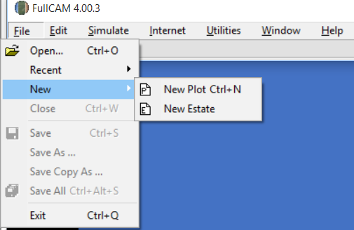

Once you have created a new plot, you will see a window such as below. The plot will default to the *About* tab (in blue text):

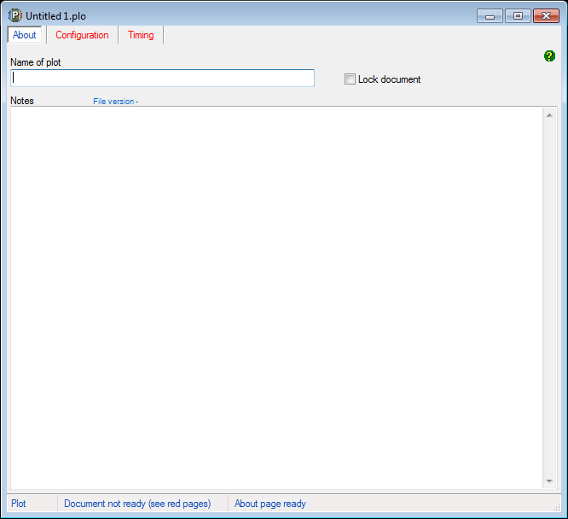

On the *About* tab you can choose what to enter at ‘Name of Plot’. It is recommended to use a name for the plot that reflects the identifier for the CEA and the project name or number as reported to the Clean Energy Regulator and model scenario, e.g. ‘CEA1_project_west_2016 offsets report’. This name does not become the file name for the plot. It is a free text box and is editable from within the plot file. Entering text in this cell is optional, but recommended.

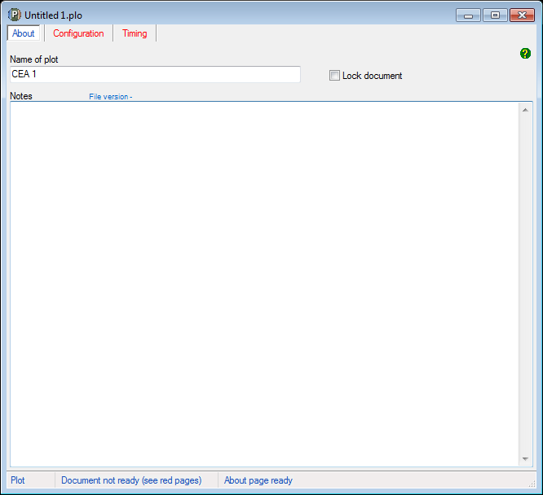

Under ‘Notes’ you may choose to enter information for your own use. This information will not influence the FullCAM outputs.

Do not tick the ‘Lock document’ check box. This stops future changes being made to the Plot file. This feature can be used once the plot file has been finalised and is ready for archiving.

## Saving a plot file

Once you have created a plot file, it is best to save immediately to your nominated storage location and save regularly. Users are responsible for their own document and records management. FullCAM does not provide this function.

If creating a new plot file, save the plot file by selecting *Save* from the ‘File’ menu on the FullCAM toolbar.

If using an existing project simulation plot to setup a long-term project simulation plot, select *Save As* from the ‘File’ menu on the FullCAM toolbar.

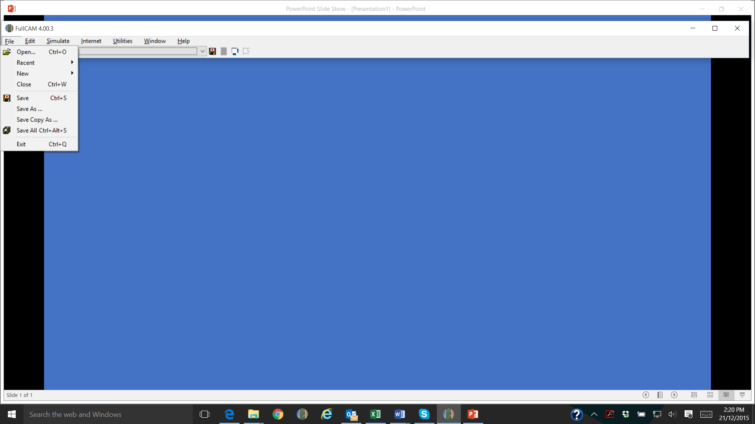

You can choose what to enter for the ‘File name’. This is not linked to the ‘Name of plot’ free text box on the *About* tab. As per the ‘Name of plot’ text box it is recommended that you use a name for the plot that reflects the identifier for the CEA and model scenario, e.g. ‘CEA1_project_west_2015 offsets report’. Ensure that you give long-term project simulation plots created from project simulation plots a different name.

Now navigate to the next tab, *Configuration,* using the mouse or Page Down.

## The Configuration tab

The *Configuration* tab is where you select the type of system to be modelled.

Steps required:

1. Select *Forest system* from the ‘Plot/Type’ drop down menu*.*

Do not change any other settings on the Configuration tab.

The Configuration tab settings must appear as below.

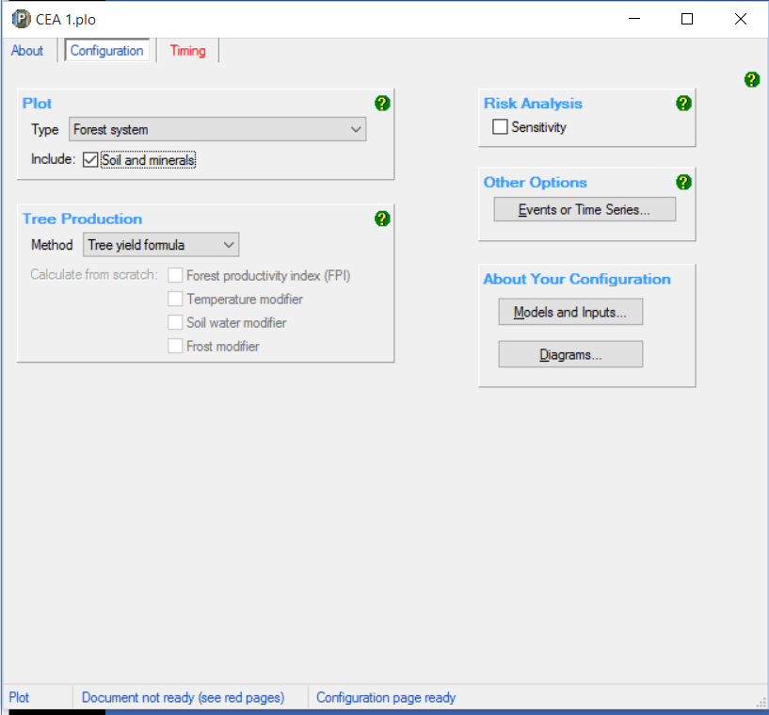

Now navigate to the next tab, *Timing,* using the mouse or Page Down.

## The Timing tab

The *Timing* tab requires you to define the period to be simulated.

Steps required:

On the *Timing* tab:

1. Under *Simulation Timing*, select *Calendar*. (See below).
2. Under *Start and End of Simulation* enter the startdate and end date of the simulation that you will run, in the format ‘DD MMM YYYY’ or ‘DD MM YYYY’ (e.g. ‘1 Jul 2016’ or ‘1 11 2016’).
3. The start date must be the day before the ‘forest start date’ for the CEA as defined in the Determination under Section 5.
4. The end date must be the last day of the relevant period for the scenario that is being modelled. For the project scenario this is the last day of the reporting period. For the long-term project and baseline scenarios for Schedule 1, 2 and 3 projects this is 100 years after the ‘forest start date’. For Schedule 4 projects this is the date that the crediting period ends.
5. Under *Output Steps*, select *Monthly*.

An example of how the *Timing* tab should now appear is below:

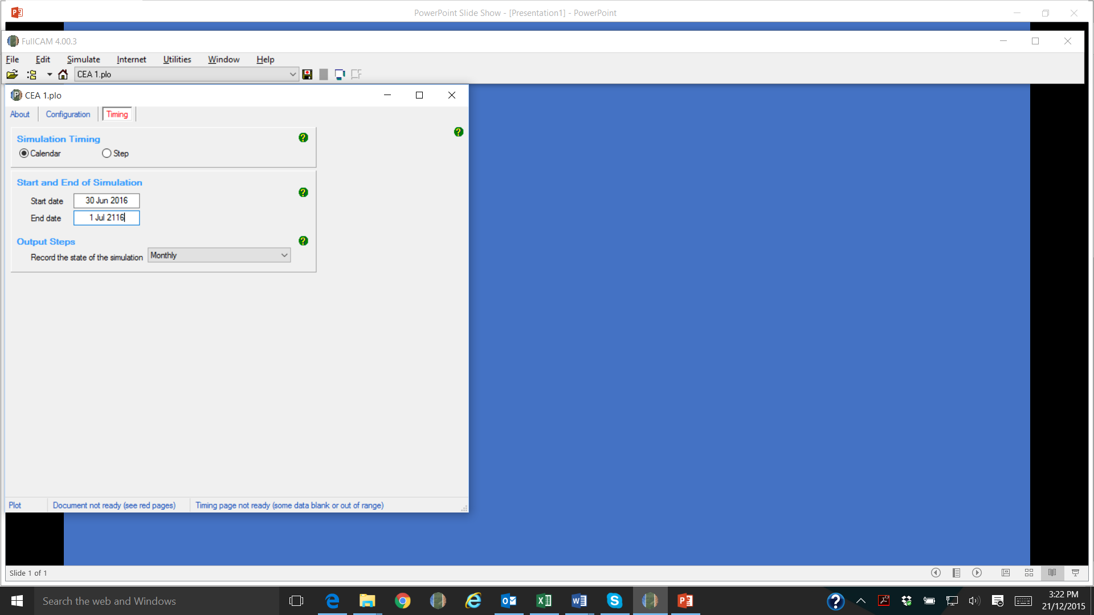

After you have populated all necessary parts of *Timing* and pressed Tab , nine more tabs should have appeared on the menu bar (some blue text, some red text), for example see below:

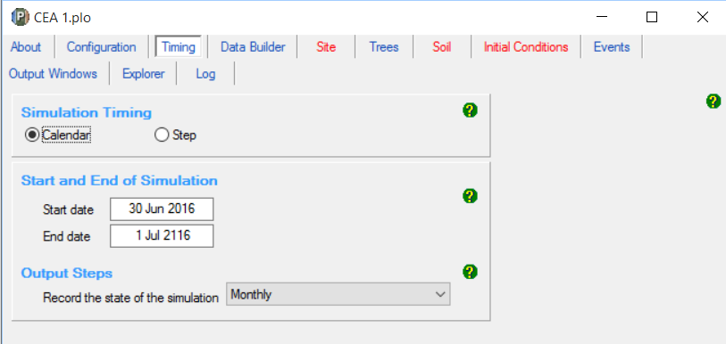

Now navigate to the next tab, *Data Builder,* using the mouse or Page Down.

## The Data Builder tab

The *Data Builder* tab (see image below) allows you to download the data required by FullCAM from extensive databases maintained by DISER. (Note that the default location is Uluru.)

Users setting up long-term project simulations using existing project simulation plot files must also follow the below steps to redownload the spatial data for the location. This is because on restarting FullCAM, or reopening existing plot files, previously downloaded spatial information may not be automatically loaded.

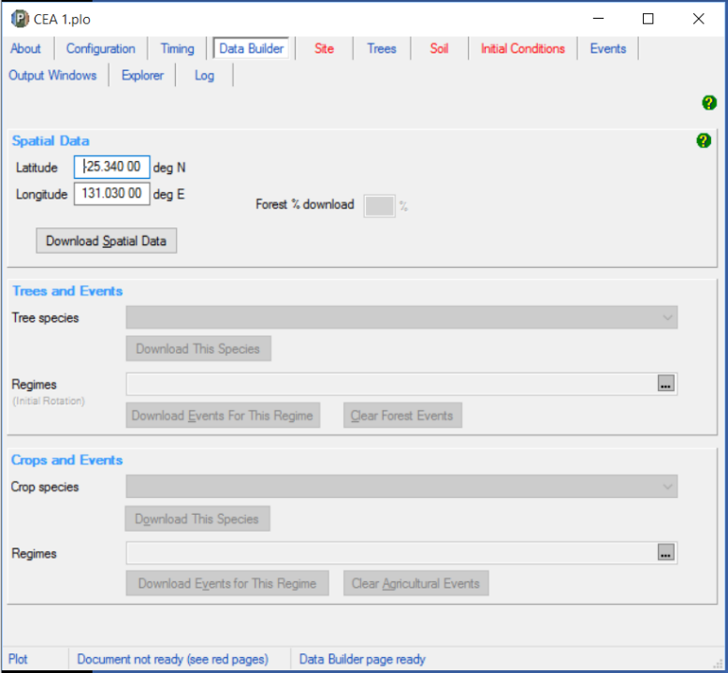

Steps required:

1. Enter the latitude and longitude (in decimal degrees) of the model point location which is central to and representative of the area being modelled as specified in the Determination.
2. Click the button to *Download Spatial Data*, and then click ‘OK’ in the Info Box that pops up.
3. Under *Trees and Events,* select the appropriate *Tree Species* from the *Tree Species* drop down menu. If the species planted in the CEA does not appear within the *Tree Species* options, or if any part of the CEA is located outside an NPI region, you must select the ‘Mixed Species Environmental Planting’ option.

**Note:** Under this Determination only a subset of the *Tree Species* options available for selection in the drop down menu are applicable. Those relevant to conversion from short-rotation to long-rotation plantation forest are listed in Schedule 6 of the Determination.

**Note:** While CEAs are permitted outside of NPI regions in certain circumstances under this determination, the species-specific calibrations are only applicable within the NPI under FullCAM 2016. As such, CEAs with areas outside an NPI region must use the ‘Mixed Species Environmental Planting’ option to ensure conservative carbon abatement modelling. FullCAM 2022 will include a new capability to model plantations outside of NPI regions.

1. Once you have selected the tree species click the *Download This Species* button.
2. A pop-up box will appear asking if you want to make the selected *Tree Species* the ‘initial tree species’. Click ‘Yes’.
3. DO NOT change any other settings on this tab.

An example of how the *Data Builder* Tab should now appear is below:

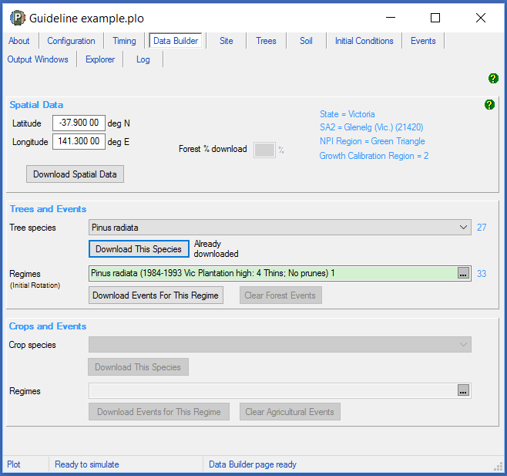

Now navigate to the tab *Initial Conditions,* using the mouse or Page Down.

**Do not change any settings on the *Site*, *Trees*, or *Soil* tabs**

## The Site tab

DO NOT change any settings on this tab.

## The Trees tab

DO NOT change any settings on this tab.

## The Soil tab

DO NOT change any settings on this tab.

## The Initial Conditions tab

The *Initial Conditions tab* will look like this:

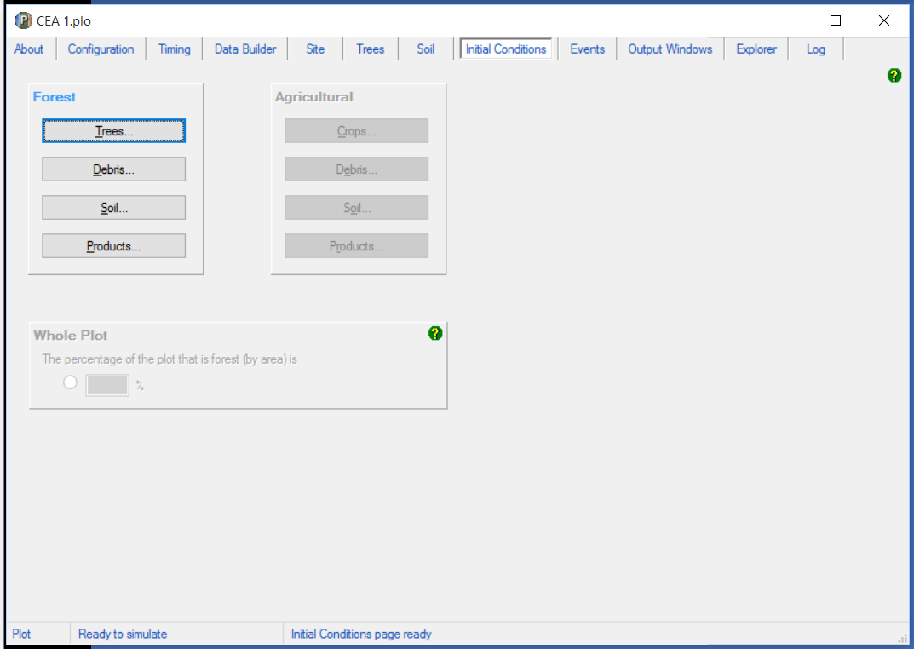

Users setting up long-term project simulations using existing project simulation plot files must also follow the below steps to set up the initial conditions for the plot file. This is because on restarting FullCAM, or reopening existing plot files, previously entered initial conditions may not be automatically loaded.

Steps required:

1. Under the *Forest* group, click the button labelled *Trees*.
2. On the pop-up window, the species you selected at the *Data Builder* tab will be showing in the drop-down box under *Species*.
3. Under *Existence,* ensure that the box (‘The forest has trees growing in it at the start of the simulation’) is un-checked (see below).

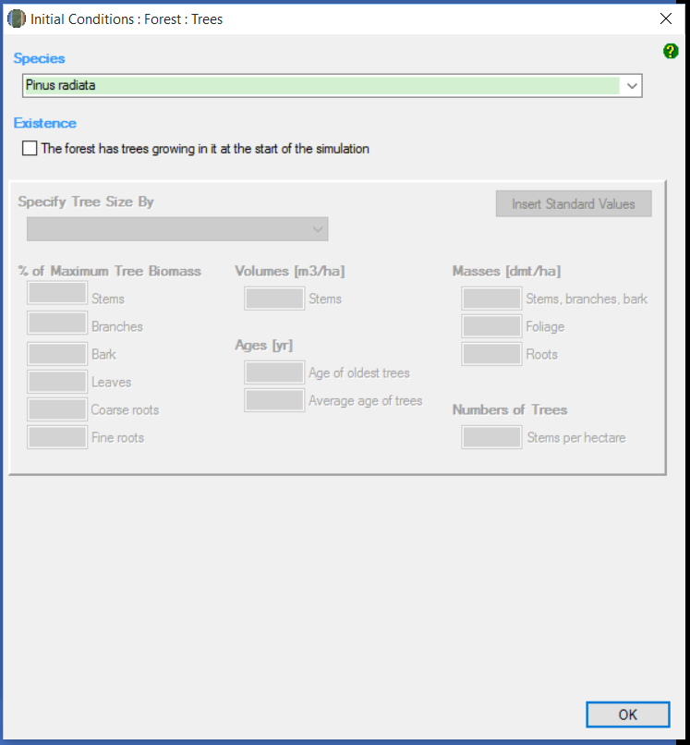

1. Click OK.
2. In the *Initial* *Conditions* tab, under Forest, click the button labelled *Debris*.
3. Ensure all the default settings for each debris pool are set to zero (see below). Press Tab to move between each cell quickly.
4. Once all are set to zero, click OK.

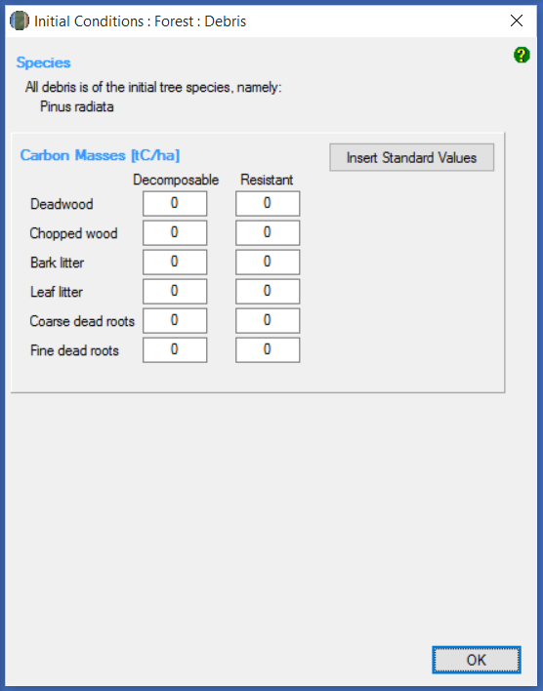

1. DO NOT change any other settings in the *Initial conditions* tab.

Now navigate to the next tab, *Events,* using the mouse or Page Down.

## The Events tab

The Events tab is where the type and timing of each event is specified. The set of management actions and disturbance events applicable to a rotation is referred to as a regime (see section 27 of the Determination). Each of these must be simulated for each CEA consistent with section 39 of the Determination in particular, and this section of this document.

This section begins by providing simulation-specific instructions for modelling events, followed by a list of the permitted events and the settings that must be used to model them. Next, instructions for adding new events, and instructions for how to clone recurring events for long-term and baseline scenario simulations are provided. Appendix 1 provides some examples of the settings windows that will appear when adding new events.

### Scenario-specific requirements for modelling events

*Project scenario simulation*

For the project scenario simulation, you must simulate all of the management actions and disturbance events from the day before the forest start date up to the last day of the reporting period, as recorded in the *management record* (see sections 24 and 39 of the Determination).

*Long-term project scenario simulation*

The long-term project scenario simulation covers the entire modelling period. This period differs depending on the type of CEA being modelled.

For this simulation type, you must simulate all of the management actions and disturbance events in the *management record*, which covers the modelling period.

For new plantation CEAs, conversion CEAs and continuing plantation CEAs, for the period commencing after the reporting period and running until the end of the modelling period, you must simulate any remaining actions in the current management regime, and then the default management actions recurring with a 12-month interval between rotations (see section 41 of the Determination).

For ex-plantation CEAs, for the period commencing after the reporting period and running until the end of the modelling period, you must simulate the projected management actions for the remainder of the modelling period.

*Baseline scenario simulation*

The baseline scenario simulation does not need to be modelled for new plantation CEAs.

For the baseline scenario simulation for conversion CEAs, users must simulate the management actions of the baseline management regime, recurring with a period of 12 months between rotations, and follow the provisions of the Determination at subsection 42(3) for simulating actual natural disturbance events that have occurred (see section 42 of the Determination).

For the baseline scenario simulation for ex-plantation CEAs and continuing plantation CEAs, users must simulate the conversion of the forest to a non-forested land use by clearfell harvest, and follow the provisions of the Determination at subsection 42(3) for simulating actual natural disturbance events that have occurred (see section 42 of the Determination).

### Permitted Events

This section includes a list of all permitted events which can be modelled under this methodology. All permitted management actions and disturbance events that are specified in the *forest management plan* for the project, must be included in model simulations for each relevant CEA. If a CEA is re‑stratified for any of the reasons specified in Part 3 Division 4 of the Determination, then each resulting new CEA must have all permitted management actions and disturbance events included in model simulations.

Fires and natural disturbances must be included in the event queue at the time the events occur, in accordance with section 23 of the Determination. The effect on the carbon stock will be reflected by the severity of the fire event. For a wildfire event where the burnt area is patchy and difficult to demarcate, you must enter the affected portion of a CEA as a percentage—other values remain unchanged. However if a clearly defined area or areas of a CEA have been impacted uniformly (e.g. all trees killed), then re-stratification of the CEA may be appropriate (see section 19 of the Determination for requirements for re-stratification following disturbance events).

Section 3.13.2 describes the user inputs for generating the relevant events. Section 3.14 describes how to enter the events to FullCAM to create the event queue.

The table below contains a summary of permitted events, and the sections in this document that contain more information on each.

| **Action or event** | **Document Section** |
| --- | --- |
| Planting | 3.13.2.1 |
| Coppicing | 3.13.2.2 |
| Seeding | 3.13.2.3 |
| Fertilisation | 3.13.2.4 |
| Weed control | 3.13.2.5 |
| Growth pause | 3.13.2.6 |
| Pruning | 3.13.2.7 |
| Thinning without harvest | 3.13.2.8 |
| Clearfelling without harvest | 3.13.2.9 |
| Natural disturbance other than fire | 3.13.2.10 |
| Thinning with harvest | 3.13.2.11 |
| Clearfelling with harvest | 3.13.2.12 |
| Salvage harvesting | 3.13.2.13 |
| Controlled burn | 3.13.2.14 |
| Fire (<5% trees killed in affected area) | 3.13.2.15 |
| Fire (>5% trees killed in affected area) | 3.13.2.16 |
| Windrow and burn | 3.13.2.17 |
| Chopper rolling | 3.13.2.18 |

#### Planting

A planting event is to be modelled when a plantation starts from planting, as opposed to coppicing or seeding.

The modelling date for the event is defined by section 22(7) of the Determination. For planting completed within a six month-window, and for which at least 80% of the trees planted survive, it is the date within that window when planting is completed. Where planting occurs over a longer window, or less than 80% of trees survive, it is the date when the planting is completed, including for any replacement trees for those that did not survive.

| **Action or event** | **FullCAM Event Type** | **FullCAM Standard Event** | **FullCAM Parameter values** |
| --- | --- | --- | --- |
| Planting | Plant trees | Plant trees: seedlings, normal stocking | Use Defaults |

#### Coppicing

A coppicing event is to be modelled when a plantation starts from coppicing, as opposed to planting or seeding.

As per section 22(8) of the Determination, for modelling, the action of coppicing to start a rotation in a CEA or other area is taken to occur 6 months after the previous clearfelling.

| **Action or event** | **FullCAM Event Type** | **FullCAM Standard Event** | **FullCAM Parameter values** |
| --- | --- | --- | --- |
| Coppicing | Plant trees | Plant trees: seedlings, normal stocking | Use Defaults |

#### Seeding

A seeding event is to be modelled when a plantation starts from seeding, as opposed to coppicing or planting.

The modelling date for the event is defined by section 22(7) of the Determination. For seeding completed within a six month-window, and for which at least 80% of the trees seeded survive, it is the date within that window when planting is completed. Where planting occurs over a longer window, or less than 80% of trees survive, it is the date when the seeding is completed, including for any replacement trees for those that did not survive.

| **Action or event** | **FullCAM Event Type** | **FullCAM Standard Event** | **FullCAM Parameter values** |
| --- | --- | --- | --- |
| Seeding | Plant trees | Plant trees: natural regeneration | Use Defaults |

#### Fertilisation

The fertilisation event has the effect of advancing the tree growth modelled by half a year. As such this event must only be modelled where the actual fertilisation undertaken results in boosting the growth of the trees by a similar amount over the rotation. Users are permitted to model one fertilisation event per rotation at most, where supported by evidence.

| **Action or event** | **FullCAM Event Type** | **FullCAM Standard Event** | **FullCAM Parameter values** |
| --- | --- | --- | --- |
| Fertilisation | Forest treatment | Starter fertiliser: normal | Use Defaults |

#### Weed control

The weed control event has the effect of advancing the tree growth modelled by one year. As such this event must only be modelled where the actual weed control undertaken results in boosting the growth of the trees by a similar amount over the rotation. Users are permitted to model one weed control event per rotation at most, where supported by evidence.

| **Action or event** | **FullCAM Event Type** | **FullCAM Standard Event** | **FullCAM Parameter values** |
| --- | --- | --- | --- |
| Weed control | Forest treatment | Weed control – Standard | Use Defaults |

#### Growth pause

Growth pause events must be modelled when, at the end of the reporting period, the CEA does not satisfy the forest development condition (see section 23(2) of the Determination).

The growth pause event is not included as a standard option in FullCAM 2016. As such, you must enter the FullCAM parameters manually. To do so, select ‘Forest Treatment’ as the FullCAM event type. **Do not select ‘Insert Standard Values’**. In the ‘Forest Treatment’ section:

* Tick the *Type 1: Age Advance On* box.
* For the ‘Age advance due to treatment’, enter a negative number that:
  + represents the time period over which the growth interruption occurred (in years); and
  + is equal to the length of the reporting period multiplied by -1; and
  + may be expressed as a proportion of a year, represented by a decimal number.
* For the ‘Advancement period’, enter a positive number that is equal to the length of the reporting period.
* For the event name, enter ‘Growth interruption’, followed by the period of growth interruption (for example, Growth interruption = -1 years).
* Click *ok*.

#### Pruning

Pruning events must be modelled each time they occur. Users must define the proportion of the biomass that was pruned when modelling this event.

| **Action or event** | **FullCAM Event Type** | **FullCAM Standard Event** | **FullCAM Parameter values** |
| --- | --- | --- | --- |
| Pruning | Thin | Prune (Selective 33%) | Define the portion of the forest biomass that was pruned (thinned) if different to 33%. Your project report must describe how the portion was estimated.  Remainder of parameters – use defaults. |

#### Thinning without harvest

Thinning without harvest events are to be modelled where a thinning event occurs and the removed biomass is not utilised for forest products, such as where a rotation in the baseline scenario simulation is ended early as a consequence of a natural disturbance.

| **Action or event** | **FullCAM Event Type** | **FullCAM Standard Event** | **FullCAM Parameter values** |
| --- | --- | --- | --- |
| Thinning without harvest | Thin | Initial Clearing: no product recovery | Define the portion of the forest biomass that was thinned. The project report must describe how the portion was estimated.  Remainder of parameters – use defaults. |

#### Clearfelling without harvest

Clearfelling without harvest events are to be modelled where a clearfelling event occurs and the removed biomass is not utilised for forest products. This may occur where clearfelling occurs so early in the rotation as to make harvesting for forest products uneconomic. Note that this event is not permitted to be modelled in the baseline scenario for ex-plantation or continuing plantation CEAs, to ensure conservatism of modelled abatement.

| **Action or event** | **FullCAM Event Type** | **FullCAM Standard Event** | **FullCAM Parameter values** |
| --- | --- | --- | --- |
| Clearfelling without harvest | Thin | Initial clearing: no product recovery | Define the portion of the forest biomass that was clearfelled (thinned). Your project report must describe how the portion was estimated.  Remainder of parameters – use defaults. |

#### Natural disturbance other than fire

Where a natural disturbance other than fire (such as flood, pest attack, drought or disease) occurs that is not followed by salvage harvesting, the natural disturbance event must be modelled. The timing of the event must be on or as close as discernible to the date of the natural disturbance.

Where a natural disturbance other than fire occurs that is followed by salvage harvesting, only the salvage harvesting event needs to modelled.

| **Action or event** | **FullCAM Event Type** | **FullCAM Standard Event** | **FullCAM Parameter values** |
| --- | --- | --- | --- |
| A natural disturbance other than a fire:  (a) that affected the whole of the CEA; and  (b) that killed trees; and  (c) that was followed by salvage harvesting. | No FullCAM event for the natural disturbance.  You must model the salvage harvesting by following the instructions for salvage harvesting in Section 3.13.2.13 of this document. | N/A | N/A |

#### Thinning with harvest

Thinning with harvest events are to be modelled where a thinning event is occurs and the removed biomass is utilised for forest products. To model the event, users will need to specify whether the thin is the first, second or third of the rotation, and the biomass that goes to products in accordance with Appendix 2.

| **Action or event** | **FullCAM Event Type** | **FullCAM Standard Event** | **FullCAM Parameter values** |
| --- | --- | --- | --- |
| Thinning with harvest | Thin | Initial Clearing: product recovery | Define the portion of the forest biomass that was thinned. Your project report must describe how the portion was estimated.  The portion of biomass to products must be varied in accordance with Appendix 2 of these guidelines.  Remainder of parameters – use defaults. |

#### Clearfelling with harvest

Clearfelling with harvest events are to be modelled where a clearfelling event occurs and the removed biomass is utilised for forest products. To model the event, proponents must input the biomass that goes to products in accordance with Appendix 2.

| **Action or event** | **FullCAM Event Type** | **FullCAM Standard Event** | **FullCAM Parameter values** |
| --- | --- | --- | --- |
| Clearfelling with harvest | Thin | Initial clearing: product recovery | Define the portion of the forest biomass that was harvested (thinned). Your project report must describe how the portion was estimated.  The portion of biomass to products must be varied in accordance with Appendix 2 of these guidelines.  Remainder of parameters – use defaults. |

#### Salvage harvesting

Salvage harvesting may only be modelled when the preceding fire or natural disturbance affected the whole of the CEA. For a fire or disturbance that affected only part of a CEA, it is necessary first to re‑stratify the CEA in accordance with section 21 before salvage harvesting may be modelled. Salvage harvesting is not available in relation to a modelled disturbance event in a baseline scenario simulation to ensure conservative carbon abatement—see subsection 42(4) of the Determination.

| **Action or event** | **FullCAM Event Type** | **FullCAM Standard Event** | **FullCAM Parameter values** |
| --- | --- | --- | --- |
| Salvage harvesting following a disturbance event | Thin | Initial clearing: product recovery | For the thinning event:  (i) for the start time in the case of a fire—30 days after the date of the fire; and  (ii) for the start time in the case of another disturbance event—the date of the disturbance event; and  (iii) for the portion of the CEA affected by the disturbance event—100% of the CEA.  Any settings that are defined for that national plantation inventory region, species and regime in Appendix 2.  Remainder of parameters – use defaults. |

#### Controlled burn

 A controlled burn is a human-induced fire which kills no trees. Controlled burns must be modelled as per the appropriate fire event below – either fire (< 5% trees killed) or fire (> 5% trees killed).

| **Action or event** | **FullCAM Event Type** | **FullCAM Standard Event** | **FullCAM Parameter values** |
| --- | --- | --- | --- |
| Controlled burn (no trees killed) | Forest fire | Prescribed burn | Tick the ‘Enable biomass based age adjustments’ box*.*  Remainder of parameters – use defaults. |

#### Fire (<5% trees killed in affected area)

Fires other than controlled burns that do not kill trees, and all fires that kill 1-5% of trees, must be modelled as directed for fire (< 5% trees killed in affected area).

| **Action or event** | **FullCAM Event Type** | **FullCAM Standard Event** | **FullCAM Parameter values** |
| --- | --- | --- | --- |
| Fire (< 5% trees killed in affected area) | Forest Fire | Wildfire – trees not killed | For the forest fire event:  (i) the natural disturbance event occurs on the date according to paragraph 23(3)(a) of the Determination; and  (ii) the portion of the CEA affected by the natural disturbance is the amount determined by the project proponent;  Tick the Enable biomass based age adjustments box.  Remainder of parameters – use defaults.  NB: Not repeated each rotation. |

#### Fire (>5% trees killed in affected area)

Fires that kill greater than 5% of trees must be modelled as directed for Fire (> 5% trees killed in affected area).

| **Action or event** | **FullCAM Event Type** | **FullCAM Standard Event** | **FullCAM Parameter values** |
| --- | --- | --- | --- |
| Fire (> 5% trees killed in affected area) | Forest Fire | Wildfire – trees killed | For the forest fire event:  (i) the natural disturbance event occurs on the date according to paragraph 25(3)(a) of the Determination; and  (ii) the portion of the CEA affected by the natural disturbance is the amount determined by the project proponent;  Tick the Enable biomass based age adjustments box.  Remainder of parameters – use defaults.  NB: Not repeated each rotation. |

#### Windrow and burn

Windrow and burning involves piling debris into rows and burning it. Windrow and burn events that occur between rotations must be modelled as directed for windrow and burn.

| **Action or event** | **FullCAM Event Type** | **FullCAM Standard Event** | **FullCAM Parameter values** |
| --- | --- | --- | --- |
| Windrow and burn between rotations | Forest fire | Site prep: windrow and burn | Use defaults |

#### Chopper rolling

Chopper rolling involves mechanical site preparation undertaken using a chopper roller. Chopper rolling events that occur between rotations must be modelled as directed for chopper rolling.

| **Action or event** | **FullCAM Event Type** | **FullCAM Standard Event** | **FullCAM Parameter values** |
| --- | --- | --- | --- |
| Chopper rolling | Chopper Roller | Chopper roller -> 80% (avg) | Use defaults |

## Adding a New Event

Events must be added using the steps below, with reference to the parameters in section 3.13.2, to be consistent with the requirements of Part 4, Division 2, Subdivision 1 of the Determination for modelling management actions and disturbance events. Note that the subsequent sections provide information on cloning recurring events for long-term project and baseline scenarios, to avoid having to add such events more than once.

Steps required:

1. To add a new event, click on the *New* button on the *Event Editing* panel.

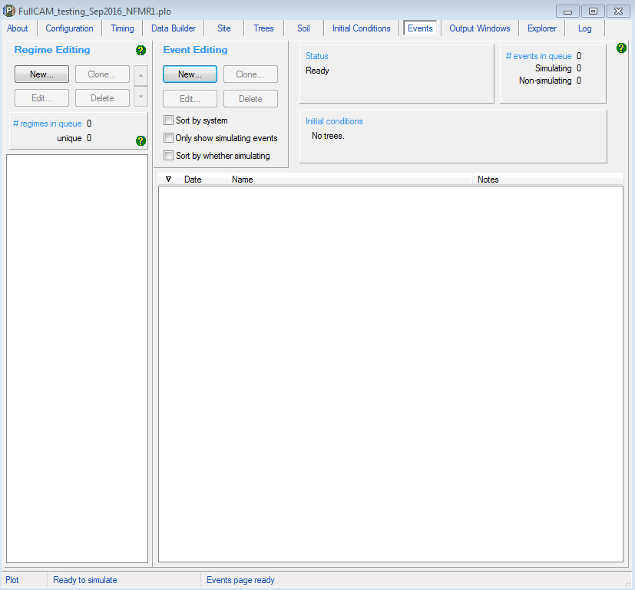

This will produce the following pop-up that needs to be completed.

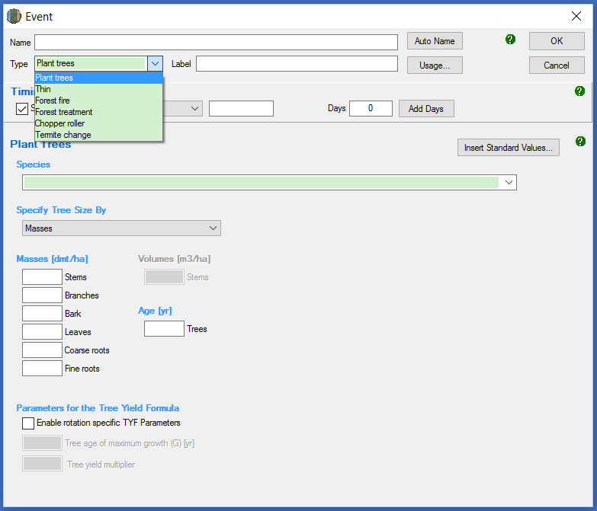

1. There are six event *Types*, of which five are permitted under this Determination (i.e. all except ‘Termite change’). For each event to be added, select the appropriate *Event Type* as indicated in Section 3.13.
2. For each event, insert the calendar date for the event in the box to the right of the Calendar date drop down menu. This must be in the format of 1 Jan 2015 or 1 1 2015.

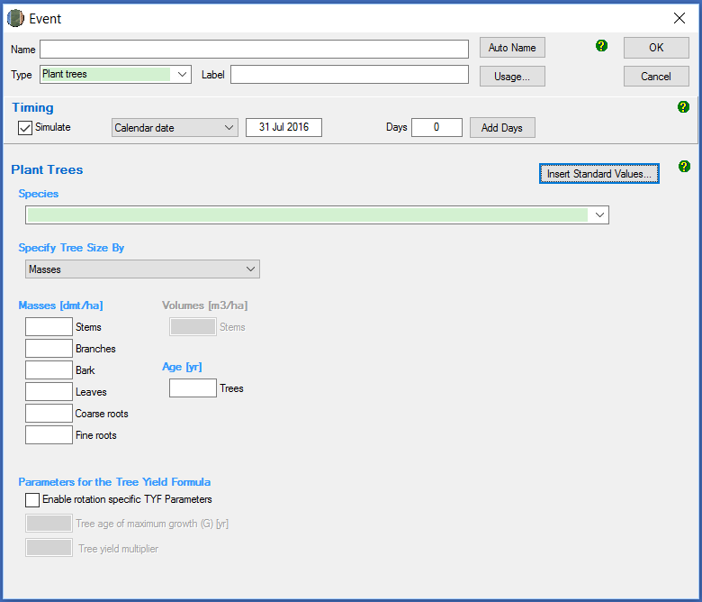

1. For each event added select *Insert Standard Values,* unless instructed not to by Section 3.13.
2. A pop-up window will open that allows you to *Select A Standard Event*. Section 3.13 defines which event *Type* and which *Standard event* must be selected for each management activity. You must use default settings for the standard events unless defined otherwise in Section 3.13. The exceptions are for pruning, thinning and wildfire, whether for trees killed or trees not killed, and for natural disturbances other than a fire, whether for trees killed or trees not killed, for which you must enter the affected portion of the CEA as a percentage. An example of the *Select A Standard Event* menu is shown here:

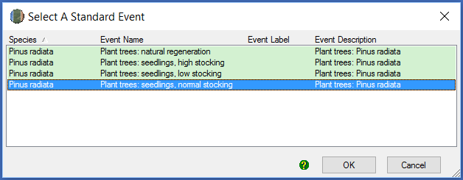

1. After you have selected the appropriate Standard Event, a pop-up window will ask if you would like to also insert the name of the standard event. Click ‘Yes’.
2. If you choose the event type ‘thin’ and standard event ‘initial clearing: product recovery’ (for either a ‘thinning with harvest’ event or a ‘clearfelling with harvest’ event), you will need to change the affected portion and the destination parameters in the affected portion listed under ‘stems to’ in accordance with Appendix 2.
3. Click ‘OK’ to close the *Event* window.

Example settings for each type of standard event in Section 3.13 are shown in Appendix 1.

Now navigate to the next tab *Output Windows* using the mouse or Page Down.

## Cloning events to cover the Modelling Period of the long-term project scenario

For the long-term project scenario, users must simulate all the events in the *management record* up to the end of the reporting period. For beyond the reporting period, users must simulate any remaining events in the current regime, and for new plantation CEAs, conversion CEAs and continuing plantation CEAs, this must be followed by modelling the default management actions recurring for the remainder of the 100‑year modelling period.

The default management actions can be setup and cloned to cover the 100-year modelling period as follows. Cloning the default management actions involves copying the actions from one time period to be modelled in another. This is done as follows, depending on what stage in a rotation you are up to, and whether the most recent rotation features the default management actions:

Steps:

1. Use the plot file already setup with events for the project scenario. Ensure that is has been saved separately, the spatial data has been redownloaded, the timing reconfigured and the initial conditions reset as per steps 3.4, 3.6, 3.7 and 3.12 above.
2. Determine which of the below situations applies for the relevant CEA:
3. CEA is an ex-plantation CEA – do nothing, no cloning necessary.
4. just completed a rotation with the default management actions – go to step 6
5. partially completed a rotation with the default management actions – go to step 3
6. just completed a rotation that differs from the default management actions – go to step 4
7. partially completed a rotation that differs from the default management actions – go to step 5.
8. Beyond the reporting period, add the default management actions as events to complete the current rotation then go to step 6.
9. Add the default management actions as events for the next rotation then go to step 6.
10. Beyond the reporting period, add the remainder of events for the current rotation, then add the default management actions as events for the next rotation. Then go to step 6.
11. Select each of default management actions in the latest queued rotation. To do this, hold Ctrl on the keyboard while clicking on each of the corresponding events in the queue.
12. With the events highlighted, click *Edit* on the Regime Editing panel.
13. Enter a name for the new regime.
14. In the Regime Editing panel, ensure your new regime is selected. Click *Clone* on the Regime Editing panel.
15. For *Calendar years*, enter the length of the rotation comprising the default management actions in years plus one (i.e. 30 years + 1 = 31). Note that one year is added as the Determination subsection 41(2) and subparagraph 42(1)(c)(i) specify that there must be a period of one year between modelled rotations.
16. For *Number of times*, which changes the number of times the events are cloned*,* enter a value high enough to cover the remainder of the modelling period. For example, if there are 70 years remaining in the modelling period beyond the end of the events already modelled, and one rotation of default management actions covers 31 years (varies by species; include the 1 year gap between rotations), you will need to model at least 3 occurrences (3 x 31 = 93).
17. Click OK. Any cloned events occurring beyond the 100‑year modelling period will be highlighted grey. It is not necessary to delete these as they will not affect the simulation.

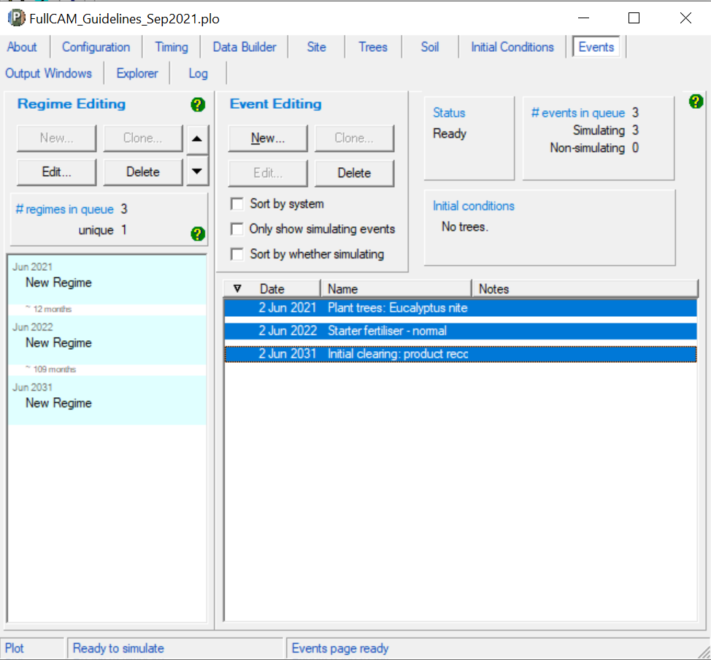

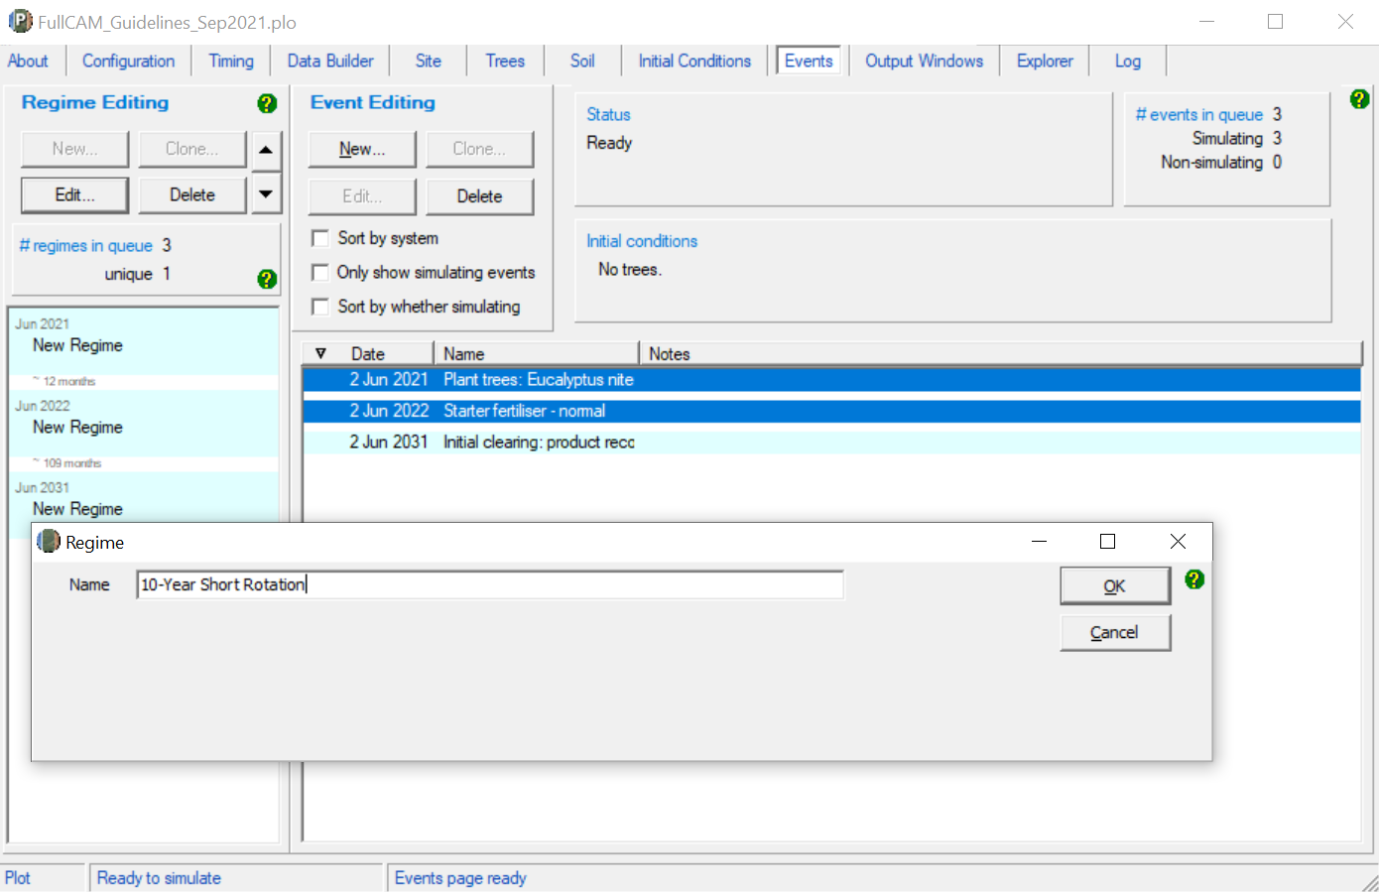

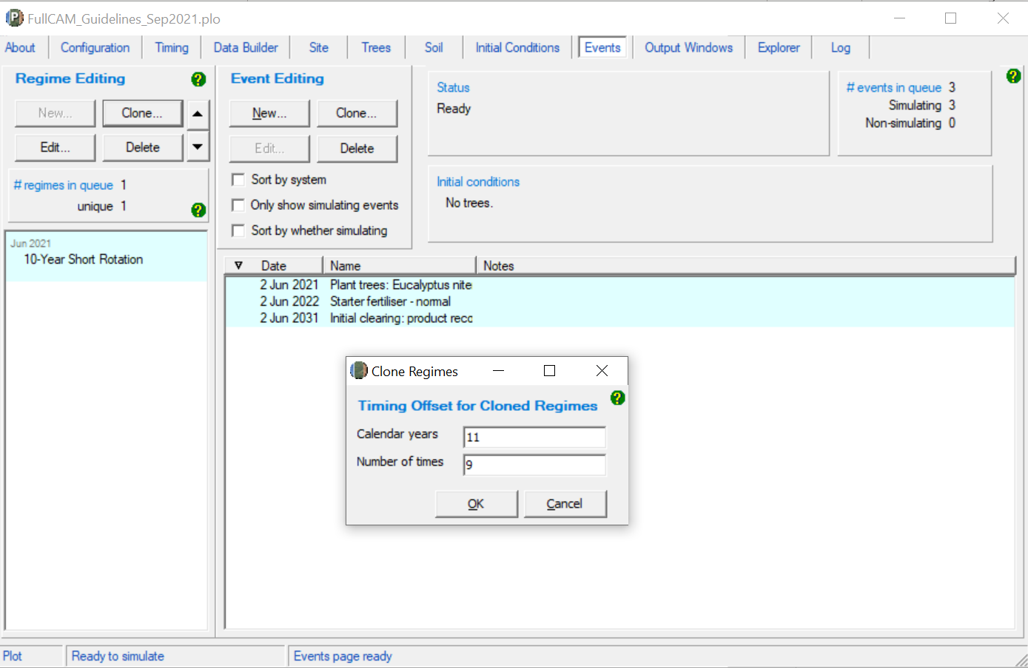

## Cloning events to cover the Modelling Period of the Baseline Scenario

For the baseline scenario, users must simulate all the baseline management actions that applied or would normally have applied (if a rotation still in progress or was subject to a disturbance event) for the baseline rotation period. For the conversion activity, this is ongoing short rotations, recurring over the modelling period with one year between each rotation. For the permanent planting and continuing plantations project activities, this is a single harvest event, followed by permanent fallow. As such, cloning events in the baseline scenario is only required for the conversion activity.

Steps:

1. First ensure all the management actions and disturbance events for the first rotation of the Baseline scenario have been added by following the steps set out in section 3.12.3 – Adding a New Event.
2. If no disturbance events occurred during the first rotation of the Baseline scenario, go to step 4.
3. If disturbance events did occur during the first rotation of the Baseline scenario, you must model a subsequent rotation that only comprises the management actions as they were intended to apply during the baseline rotation had the disturbance event(s) not occurred.
4. Select each of default management actions in the latest queued rotation. To do this, hold Ctrl on the keyboard while clicking on each of the corresponding events in the queue.
5. With the events highlighted, click *Edit* on the Regime Editing panel.
6. Enter a name for the new regime.
7. In the Regime Editing panel, ensure your new regime is selected. Click *Clone* on the Regime Editing panel.
8. For *Calendar years*, enter the length of the rotation comprising the default management actions in years plus one (i.e. 30 years + 1 = 31). Note that one year is added as the Determination subsection 38(2) and subparagraph 42(1)(c)(i) specify that there must be a period of one year between modelled rotations.
9. For *Number of times*, which changes the number of times the events are cloned*,* enter a value high enough to cover the remainder of the modelling period. For example, if there are 70 years remaining in the modelling period beyond the end of the events already modelled, and one rotation of default management actions covers 31 years (varies by species; include the 1 year gap between rotations), you will need to model at least 3 occurrences (3 x 31 = 93).
10. Click OK. Any cloned events occurring beyond the 100‑year modelling period will be highlighted grey. It is not necessary to delete these as they will not affect the simulation.

## The Output Windows tab

Steps required:

1. Double click on Output1 listed in the Output Windows.
2. Click on the *Select Which Outputs to Show* icon at the top of the output window (see below):

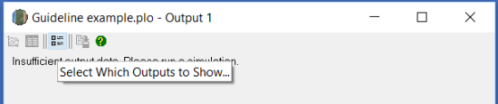

|  |
| --- |
| **Notes**: The outputs are organised into folders and subfolders, just like files are organised into folders in Windows Explorer. Click the drop-down arrow next to a folder to expand and collapse the folders. A single click on the icon or name of a folder selects or deselects everything within the folder.  Selected outputs have a red tick on their icon, and a grey tick on the folder(s) where they are located. (See image below.)  A red tick on a folder indicates that all outputs within that folder and its subfolders are selected. |

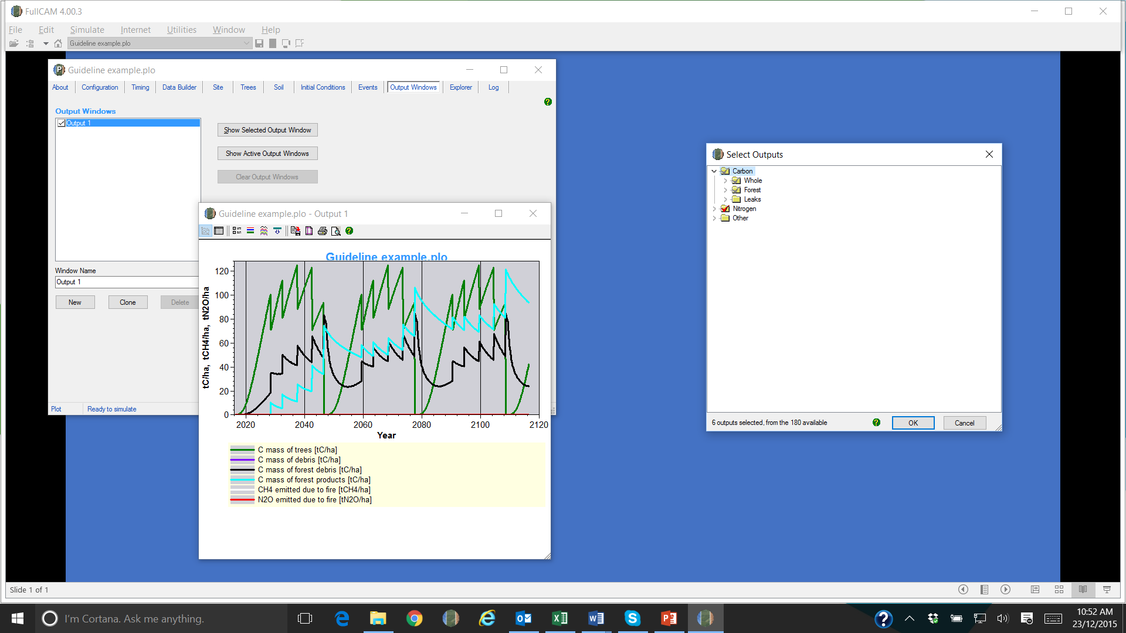

1. Deselect all the pools (by simply clicking on the top-level folders that show a tick, to remove the tick).
2. Use the drop down arrows and navigate through the folders to select:
   1. the following tree carbon pool: Carbon / Forest / Plants / C mass of trees
   2. the following debris carbon pool: Carbon / Forest / Debris / C mass of forest debris
   3. the following harvested wood products carbon pool: Carbon / Forest / Products / C mass of forest products
   4. the following non CO2 emission: Carbon / Whole / Emissions / CH4 emitted due to fire
   5. the following non CO2 emission: Nitrogen / Whole / Emissions / N2O emitted due to fire.
3. Note: only the five pools listed above must be selected. The bottom section of the screen shows how many outputs are selected (see below).
4. Click ‘OK’.

The image below shows the expanded view for the following two outputs:

* tree carbon pool: Carbon / Forest / Plants / C mass of trees.
* debris carbon pool: Carbon / Forest / Debris / C mass of forest debris.

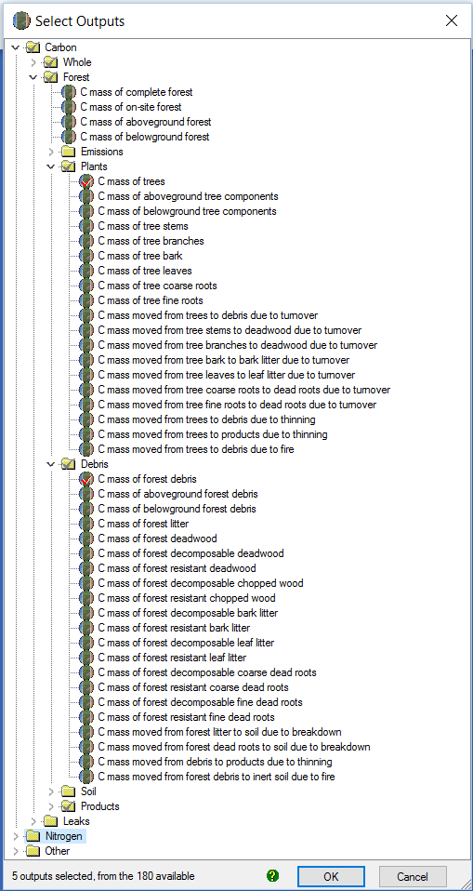

The image below shows the expanded view for the following outputs:

* harvested wood products carbon pool: Carbon / Forest / Products / C mass of forest products
* non CO2 emission: Carbon / Whole / Emissions / CH4 emitted due to fire
* non CO2 emission: Nitrogen / Whole / Emissions / N2O emitted due to fire.

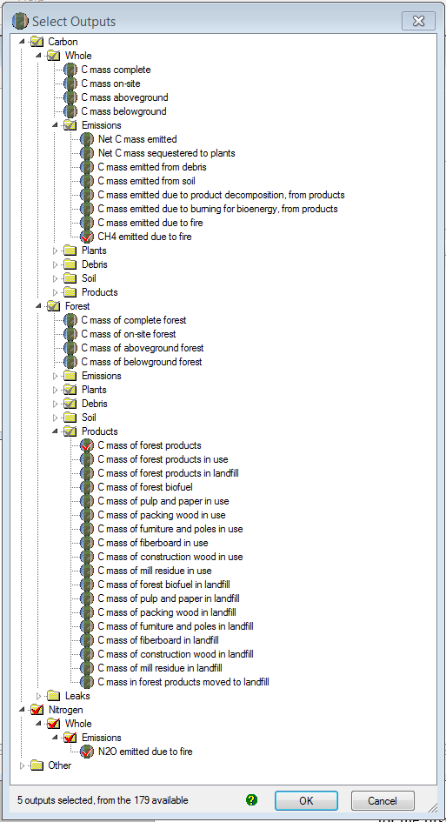

## Running simulations

To run the simulation, press the *Run Plot Simulation* icon in the top menu bar , or F9.

## Viewing outputs

Outputs can be viewed as a graph or a table by clicking one of the icons at the top left of the Output window.



## Transferring outputs into a spreadsheet

Steps required:

To transfer data into a Microsoft Excel or equivalent spreadsheet for analysis:

1. If you are using Microsoft Excel, then click on the Save to File button (see screenshot) and save as an Excel file, then skip steps 2 to 5. Alternatively, follow steps 2-5 below to transfer the data to a spreadsheet.



1. Click on the table icon in the output window to view the simulation output as a table.



1. Select all the output data by clicking on the icon (circled) in the top of the Output window.



1. On the highlighted data, right click and select ‘Copy’.
2. Open Microsoft Excel (or equivalent spreadsheet), and ‘Paste’ the data copied from FullCAM into the spreadsheet with the top left hand corner in cell A1. For example:

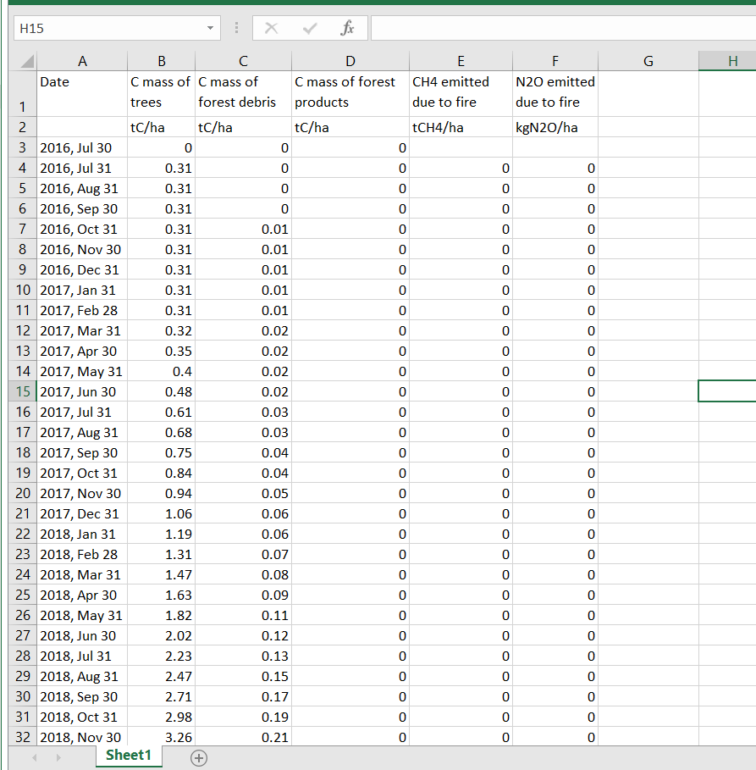

All subsequent calculations are conducted outside FullCAM.

## Setting maximum forest growth for the permanent plantings activity

**This section is only relevant for ex-plantation (Schedule 4) CEAs.** All other CEAs – go to section 3.22.

The growth calibrations for plantation forests in FullCAM are underpinned by data from commercial growers. As such, very few calibration points exist for forests that are older than typical maximum harvest ages. Thus, to ensure conservative crediting outcomes, the forest growth for species using these calibrations must be capped at the upper limit of confidence in the calibrated growth curves. This upper limit of confidence is the oldest age at which FullCAM can accurately predict the growth of a plantation forest.

If, in step 3.8, you selected the ‘mixed species environmental planting’ species for the CEA, no manual abatement capping is required, and the following steps may be disregarded. For all other species, to manually cap the abatement, follow these steps:

1. Locate the species and age in table 1 below.
2. Navigate to the row of the FullCAM output that corresponds to the tree being that age. For example, a *Eucalyptus nitens* plantation planted on 30/06/2021 would be age 21 on 30/06/2042.
3. Copy the value in the column ‘C Mass of Trees (tC/ha)’ that corresponds with the relevant age.
4. Paste the value copied in step 3 into all cells below the cell selected in the same column, such that the value for the C Mass of Trees is constant from that age onwards.

**Table 1 Ages of maximum confidence for FullCAM 2016 calibrations**

|  |  |
| --- | --- |
| **Species** | **Age** |
| *Acacia mangium* | 8 |
| *Araucaria cunninghamii* | 60 |
| *Corymbua citriodora* | 45 |
| *Corymbia maculata* | 45 |
| *Eucalyptus cladocalyx* | 45 |
| *Eucalyptus dunnii* | 34 |
| *Eucalyptus globulus* | 21 |
| *Eucalyptus grandis* | 45 |
| *Eucalyptus nitens* | 21 |
| *Eucalyptus saligna* | 45 |
| *Khaya senegalensis* | 25 |
| *Pinus caribaea* | 40 |
| *Pinus elliottii* | 40 |
| *Pinus radiata* | 40 |
| *Pinus pinaster* | 40 |

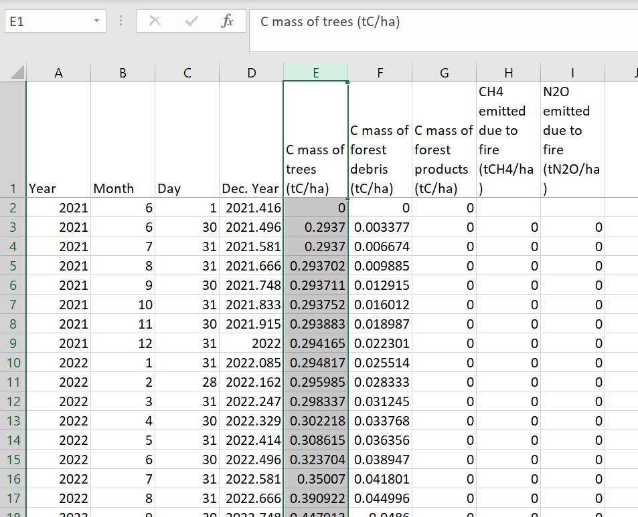

Eucalyptus nitens plantation planted on 30/06/2021.

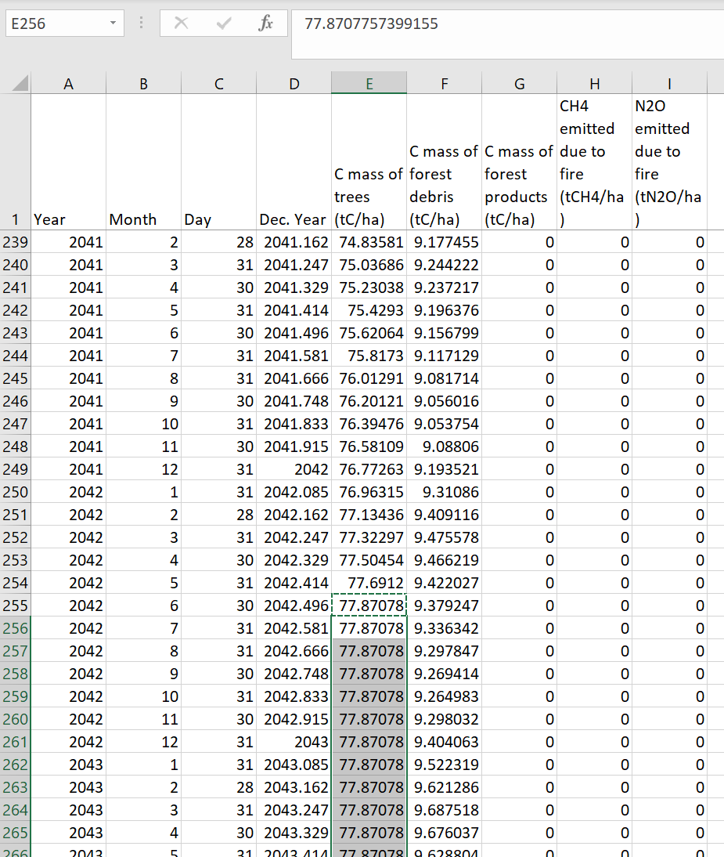

Copy the C Mass of trees at age 21 to all cells below in the same column.

## Calculating project abatement at the end of a reporting period

Project proponents calculate the project net abatement by completing the equations in Division 4.3 of the Determination. The FullCAM outputs required to inform these equations to calculate project net abatement are shown in Table 3 below. They are generated by following the steps in Section 3 of this document.

The project scenario simulation and long-term project scenario simulation, as well as the baseline scenario simulation for *conversion* projects, must be run for each CEA at the end of each reporting period in order to complete the equations set out in the Determination.

## Variables generated in FullCAM and used in equations in the Determination

The outputs generated by modelling the project, long-term project and baseline scenarios in FullCAM are used to calculate the net abatement number using the calculations in Part 4, Division 3 of the Determination. Table 2 shows where the outputs generated by FullCAM feed into the abatement calculations.

Note that for some of the equations the average of the FullCAM output over the simulation period will be required, whereas for others the value of the FullCAM output at the end of the simulation or at a certain date will be used. Refer to the equations within the Determination to determine which value to use. Averages can be calculated using the average function within your spreadsheet software.

**Table 2 Relationship between FullCAM outputs and variables defined in the Determination**

|  |  |  |  |  |
| --- | --- | --- | --- | --- |
| **FullCAM Output** | **Scenario** | **Determination Parameter** | **Project Activity Schedule** | **Determination Equation** |
| C mass of trees | Baseline | $$C_{BT,i,k}$$ | 2, 3 | 1 |
| Long-term project | $$C_{T,i,k}$$ | 1, 2, 3 | 8 |
| 4 | 9 |
| Project | $$C_{T,i}$$ | 1 | 14 |
| C mass of forest debris | Baseline | $$C_{BD,i,k}$$ | 2, 3 | 1 |
| 4 | 4 |
| Long-term project | $$C_{D,i,k}$$ | 1, 2, 3 | 8 |
| 4 | 9 |
| Project | $$C_{D,i}$$ | 1 | 14 |
| C mass of forest products | Baseline | $$C_{FP,B,i,k}$$ | 2, 3 | 1 |
| 4 | 4 |
| Long-term project | $$C_{FP,i,k}$$ | 1, 2, 3 | 4, 12 |
| 4 | 9, 12 |
| Project | $$C_{FP,i,h}$$ | 1, 2, 3, 4 | 19 |
| CH4 emitted due to fire | Baseline |  | 2, 3 | 2 |
| 4 | 5 |
| Long-term project |  | 1, 2, 3, 4 | 10 |
| Project |  | 1, 2, 3, 4 | 17 |
| N2O emitted due to fire | Baseline | $$E_{g,i,k}$$ | 2, 3 | 2 |
| 4 | 5 |
| Long-term project | $$E_{g,i,k}$$ | 1, 2, 3, 4 | 10 |
| Project | $$E_{g,i,k}$$ | 1, 2, 3, 4 | 17 |

**Appendix 1**

**Example event settings for standard events specified in Section 3.13**

| **Management Activity** | **FullCAM Event Type** | **FullCAM Standard Event** | **FullCAM Parameter values** |
| --- | --- | --- | --- |
| Pruning | Thin | Prune  (Selective 33%) | Define the portion of the forest biomass that was pruned (thinned) if different to 33%. Your project report must describe how the portion was estimated.  Remainder of parameters – use defaults. |

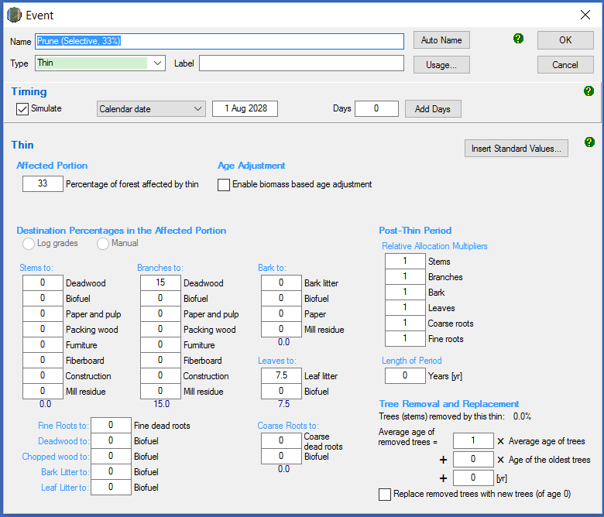

|  |  |  |  |
| --- | --- | --- | --- |
| **Management Activity** | **FullCAM Event Type** | **FullCAM Standard Event** | **FullCAM Parameter values** |
| Commercial Thinning (Thinning with harvest) | Thin | Initial Clearing: product recovery | Define the portion of the forest biomass that was thinned. Your project report must describe how the portion was estimated.  Remainder of parameters – use defaults. |

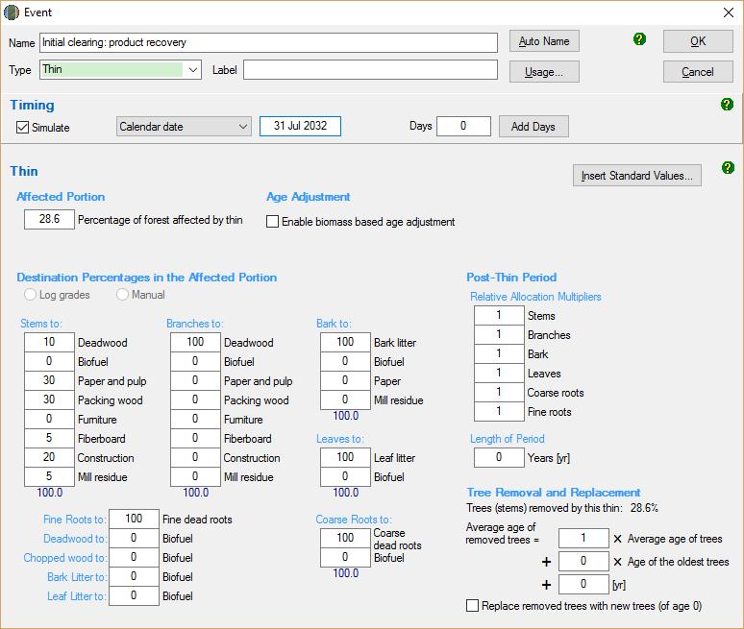

|  |  |  |  |
| --- | --- | --- | --- |
| **Management Activity** | **FullCAM Event Type** | **FullCAM Standard Event** | **FullCAM Parameter values** |
| Wildfire | Forest fire | Wildfire – trees not killed | Amend the portion affected.  Tick the Enable biomass based age adjustments box.  Amend portion of stems, branches, and bark to atmosphere and debris.  NB: Not repeated each rotation. |

Steps required:

1. Add a new ‘Forest fire’ event.
2. Select Insert Standard Values, and *Wildfire - trees not killed*.
3. Insert the *Name of the Standard Event*.
4. Enter the date of the fire event in accordance with the Determination.
5. Tick the *Enable biomass based age adjustment* box.
6. Change the *Affected Portion* to be equivalent to the portion of the area of the CEA affected by the fire (if the entire CEA was burnt, this will be 100).
7. If trees were killed;
   1. Change stems to Atmos and bark to Atmos to 0.1 multiplied by the proportion of biomass killed as estimated in accordance with the Determination.
   2. Change stems to Debris and bark to Debris 0.9 multiplied by the proportion of biomass killed as estimated in accordance with the Determination.
   3. Change branches to Atmos to 0.2 multiplied by the proportion of biomass killed as estimated in accordance with the Determination.
   4. Change branches to Debris to 0.8 multiplied by the proportion of biomass killed as estimated in accordance with the Determination.
8. Leave other values unchanged.

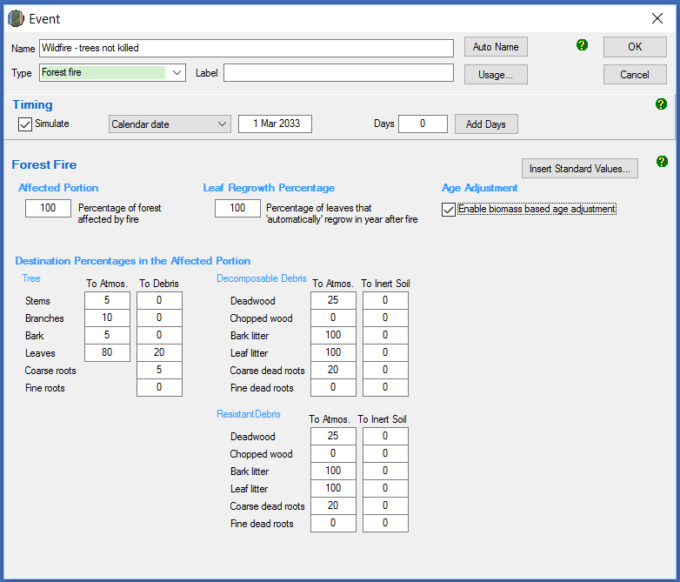

|  |  |  |  |
| --- | --- | --- | --- |
| **Management Activity** | **FullCAM Event Type** | **FullCAM Standard Event** | **FullCAM Parameter values** |
| Wildfire – trees killed | Forest fire | Wildfire – trees killed | Tick the Enable biomass based age adjustments box.  Remainder of parameters – use defaults.  NB: Not repeated each rotation. |

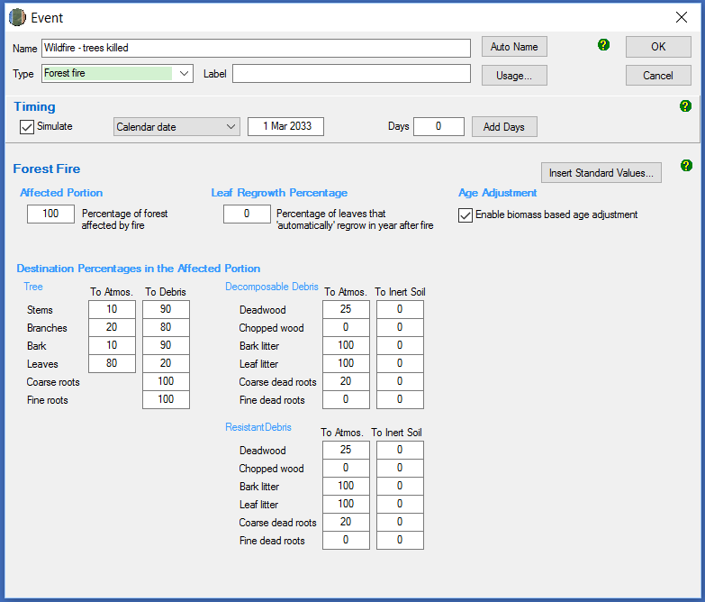

|  |  |  |  |
| --- | --- | --- | --- |
| **Management Activity** | **FullCAM Event Type** | **FullCAM Standard Event** | **FullCAM Parameter values** |
| Growth interruption | Forest treatment | NA | Tick the *Type 1: Age Advance On* box.  Enter *Age advance due to treatment* (negative number) and *Advancement period* (positive number). |

Steps required:

1. Add a new ‘Forest treatment’ event.
2. Enter the date when the growth interruption commenced as the first day of the reporting period that a growth interruption was detected.
3. Tick the *Type 1: Age Advance On* box.
4. Enter *Age advance due to treatment* (negative number). The value represents the time period over which the growth interruption occurred, and is equal to the length of the reporting period, multiplied by -1. This can be a proportion of a year, expressed as a decimal.
5. Enter *Advancement period* (positive number). The value must be equal to the length of the reporting period.
6. Enter the event Name as “Growth interruption” followed by the period of growth interruption (e.g. Growth interruption – 1 year).

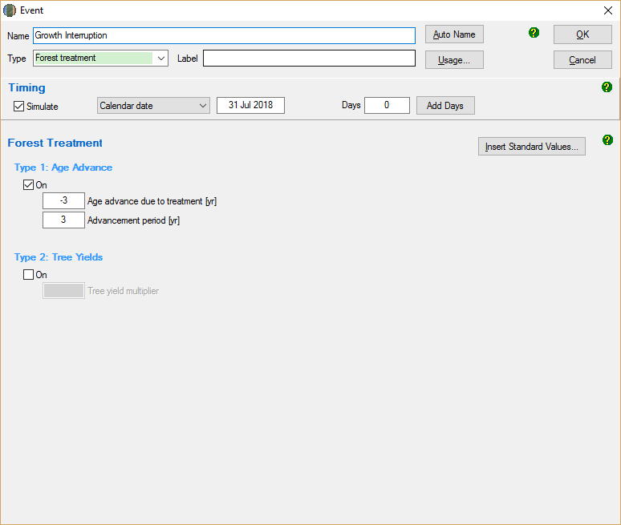

**Appendix 2**

**Standard parameters for forest products**

When adding thinning or clearfelling events within FullCAM where commercial products are taken, users must use Table 3 below to determine which parameters to enter for the forest products relating to stems (the red circled boxes below). Other parameters will be left unedited. Note that a different set of parameters apply to salvage harvesting, which are given below.

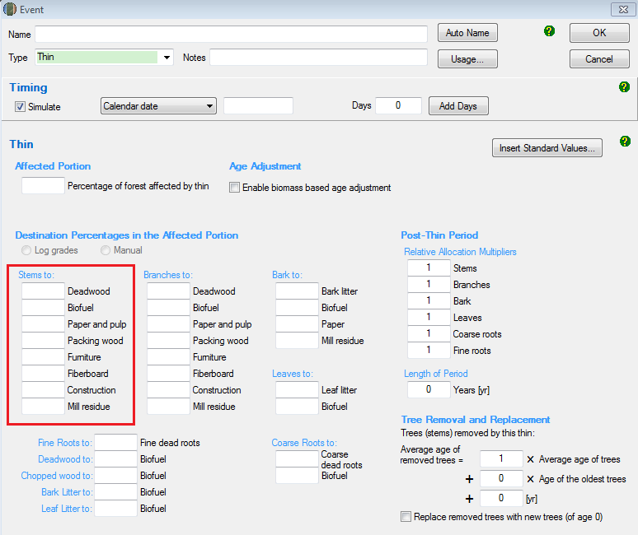

Table 3 lists the parameters to input by National Plantation Inventory (NPI) Region, then species, regime (i.e. pulplog for short-rotations or sawlog for long-rotations), and thin number or clearing (i.e. first thinning of rotation). Use each of these columns to locate the standard parameters that you are required to input with regard to the following notes where you cannot match the species or thin number.

Note that the below is an entirely separate species selection process to that outlined for the Data Builder Tab earlier in this document. It applies to separate sub-components of FullCAM. Please follow each species selection process independent of the other.

Where it is not possible to make an exact match for species, observe the following:

1. For hardwood species, including any of the *Corymbia* genus, use the parameters for the ‘Eucalypt’ species.
2. For softwood species, use the parameters for the ‘Southern Pine’ or ‘Radiata Pine’ species.
3. For all other species, all commercial thins must be modelled as having a ‘deadwood’ parameter of 10, a ‘biofuel’ parameter of 90, and a parameter of 0 for all remaining product categories.

Where a regime has more commercial thinning events than those listed in the table, the thin number prior to the clearfell may be repeated. Where all thin numbers listed in the table have been modelled for this rotation, and the remaining thin affects 100% of the CEA, use the parameters listed under ‘clearfell’ – denoted in Table 3 by ‘C’ in the thin number column.

Where a regime has fewer commercial thinning events than those listed in the table, the thin numbers that do not occur can be skipped. Note that in order to model a sawlog regime, at least one thinning event (with or without harvest) must occur.

Salvage Harvesting

If a salvage harvest following a natural disturbance is being modelled, a different rule regarding parameters applies. In this instance, the following must be observed:

1. The event is to be modelled as a clearfell event but the forest product parameters are to be based on the thin number used to model the thinning event prior to the natural disturbance.
2. Enter the parameters for ‘deadwood’, ‘packaging’, ‘furniture’, ‘construction’ and ‘mill residue’ as listed for that thin number in Table 3.
3. For the ‘biofuel’ parameter, enter the sum of the parameters listed in Table 3 for ‘paper’ and ‘fibreboard’ under that thin number.
4. For the ‘paper’ and ‘fibreboard’ parameters, enter ‘0’.

**Table 3: Standard parameters for forest products for implementation into FullCAM**

| **Region** | **Species** | **Regime** | **Thin number or clearing (c)** | **Deadwood** | **Biofuel** | **Paper and pulp** | **Packing wood** | **Furniture** | **Fibre-board** | **Construction** | **Mill Residue** |
| --- | --- | --- | --- | --- | --- | --- | --- | --- | --- | --- | --- |
| Central Gippsland | E. globulus | Pulplog | C | 10.0% | 0.0% | 88.1% | 0.0% | 0.0% | 0.0% | 0.0% | 1.9% |
| E. globulus | Sawlog | 1 | 20.0% | 0.0% | 78.3% | 0.0% | 0.0% | 0.0% | 0.0% | 1.7% |
| C | 10.0% | 0.0% | 69.3% | 0.0% | 0.0% | 1.4% | 9.7% | 9.6% |
| E. nitens | Pulplog | C | 10.0% | 0.0% | 88.1% | 0.0% | 0.0% | 0.0% | 0.0% | 1.9% |
| E. nitens | Sawlog | 1 | 20.0% | 0.0% | 78.3% | 0.0% | 0.0% | 0.0% | 0.0% | 1.7% |
| C | 10.0% | 0.0% | 69.3% | 0.0% | 0.0% | 1.4% | 9.7% | 9.6% |
| E. regnans | Pulplog | C | 10.0% | 0.0% | 88.1% | 0.0% | 0.0% | 0.0% | 0.0% | 1.9% |
| E. regnans | Sawlog | 1 | 20.0% | 0.0% | 78.3% | 0.0% | 0.0% | 0.0% | 0.0% | 1.7% |
| C | 10.0% | 0.0% | 69.3% | 0.0% | 0.0% | 1.4% | 9.7% | 9.6% |
| Other eucalypts | Sawlog | 1 | 20.0% | 0.0% | 78.3% | 0.0% | 0.0% | 0.0% | 0.0% | 1.7% |
| 2 | 20.0% | 0.0% | 39.5% | 0.0% | 0.0% | 2.9% | 20.0% | 17.6% |
| C | 10.0% | 0.0% | 34.2% | 0.0% | 0.0% | 4.0% | 27.8% | 24.1% |
| P. radiata | Sawlog | 1 | 15.0% | 0.0% | 76.5% | 0.0% | 0.0% | 0.0% | 0.0% | 8.5% |
| 2 | 15.0% | 0.0% | 76.5% | 0.0% | 0.0% | 0.0% | 0.0% | 8.5% |
| C | 10.0% | 0.0% | 54.3% | 0.0% | 0.0% | 2.3% | 20.5% | 12.9% |
| P. radiata | Pulplog | C | 10.0% | 0.0% | 81.0% | 0.0% | 0.0% | 0.0% | 0.0% | 9.0% |
| Spotted gum species | Sawlog | 1 | 20.0% | 0.0% | 67.9% | 0.0% | 0.0% | 0.8% | 5.3% | 6.0% |
| 2 | 20.0% | 0.0% | 51.1% | 0.0% | 0.0% | 2.0% | 14.0% | 12.9% |
| C | 10.0% | 0.0% | 28.7% | 0.0% | 0.0% | 4.4% | 30.6% | 26.3% |
| Central Tablelands | E. globulus | Pulplog | C | 10.0% | 0.0% | 90.0% | 0.0% | 0.0% | 0.0% | 0.0% | 0.0% |
| E. globulus | Sawlog | 1 | 20.0% | 0.0% | 80.0% | 0.0% | 0.0% | 0.0% | 0.0% | 0.0% |
| 2 | 20.0% | 0.0% | 40.0% | 0.0% | 0.0% | 2.9% | 20.0% | 17.1% |
| C | 10.0% | 0.0% | 34.4% | 0.0% | 0.0% | 4.0% | 27.8% | 23.8% |
| E. nitens | Pulplog | C | 10.0% | 0.0% | 90.0% | 0.0% | 0.0% | 0.0% | 0.0% | 0.0% |
| E. nitens | Sawlog | 1 | 20.0% | 0.0% | 80.0% | 0.0% | 0.0% | 0.0% | 0.0% | 0.0% |
| 2 | 20.0% | 0.0% | 40.0% | 0.0% | 0.0% | 2.9% | 20.0% | 17.1% |
| C | 10.0% | 0.0% | 34.4% | 0.0% | 0.0% | 4.0% | 27.8% | 23.8% |
| Other eucalypts | Sawlog | 1 | 20.0% | 0.0% | 80.0% | 0.0% | 0.0% | 0.0% | 0.0% | 0.0% |
| 2 | 20.0% | 0.0% | 40.0% | 0.0% | 0.0% | 2.9% | 20.0% | 17.1% |
| C | 10.0% | 0.0% | 34.4% | 0.0% | 0.0% | 4.0% | 27.8% | 23.8% |
| P. pinaster | Sawlog | 1 | 15.0% | 0.0% | 44.1% | 0.0% | 0.0% | 36.4% | 0.0% | 4.5% |
| 2 | 15.0% | 0.0% | 31.7% | 0.0% | 0.0% | 15.0% | 25.5% | 12.8% |
| 3 | 15.0% | 0.0% | 28.9% | 0.0% | 0.0% | 10.1% | 31.3% | 14.7% |
| C | 10.0% | 0.0% | 34.0% | 0.0% | 0.0% | 16.5% | 26.2% | 13.3% |
| P. pinaster | Pulplog | C | 10.0% | 0.0% | 46.7% | 0.0% | 0.0% | 38.5% | 0.0% | 4.8% |
| P. radiata | Sawlog | 1 | 15.0% | 0.0% | 37.3% | 0.0% | 0.0% | 24.7% | 13.9% | 9.1% |
| C | 10.0% | 0.0% | 30.7% | 0.0% | 0.0% | 10.9% | 32.8% | 15.5% |
| P. radiata | Pulplog | C | 10.0% | 0.0% | 46.7% | 0.0% | 0.0% | 38.5% | 0.0% | 4.8% |
| Central Victoria | E. globulus | Pulplog | C | 10.0% | 0.0% | 90.0% | 0.0% | 0.0% | 0.0% | 0.0% | 0.0% |
| E. globulus | Sawlog | 1 | 20.0% | 0.0% | 80.0% | 0.0% | 0.0% | 0.0% | 0.0% | 0.0% |
| 2 | 20.0% | 0.0% | 80.0% | 0.0% | 0.0% | 0.0% | 0.0% | 0.0% |
| C | 10.0% | 0.0% | 60.6% | 0.0% | 0.0% | 2.1% | 14.7% | 12.6% |
| E. nitens | Pulplog | C | 10.0% | 0.0% | 90.0% | 0.0% | 0.0% | 0.0% | 0.0% | 0.0% |
| E. nitens | Sawlog | 1 | 20.0% | 0.0% | 80.0% | 0.0% | 0.0% | 0.0% | 0.0% | 0.0% |
| 2 | 20.0% | 0.0% | 80.0% | 0.0% | 0.0% | 0.0% | 0.0% | 0.0% |
| C | 10.0% | 0.0% | 60.6% | 0.0% | 0.0% | 2.1% | 14.7% | 12.6% |
| Other eucalypts | Sawlog | 1 | 20.0% | 0.0% | 80.0% | 0.0% | 0.0% | 0.0% | 0.0% | 0.0% |
| 2 | 20.0% | 0.0% | 40.0% | 0.0% | 0.0% | 2.9% | 20.0% | 17.1% |
| C | 10.0% | 0.0% | 34.4% | 0.0% | 0.0% | 4.0% | 27.8% | 23.8% |
| P. radiata | Sawlog | 1 | 15.0% | 0.0% | 85.0% | 0.0% | 0.0% | 0.0% | 0.0% | 0.0% |
| 2 | 15.0% | 0.0% | 64.0% | 0.0% | 0.0% | 1.5% | 13.5% | 6.0% |
| C | 10.0% | 0.0% | 45.5% | 0.0% | 0.0% | 3.2% | 28.6% | 12.7% |
| P. radiata | Pulplog | C | 10.0% | 0.0% | 90.0% | 0.0% | 0.0% | 0.0% | 0.0% | 0.0% |
| Spotted gum species | Sawlog | 1 | 20.0% | 0.0% | 69.3% | 0.0% | 0.0% | 0.8% | 5.3% | 4.6% |
| 2 | 20.0% | 0.0% | 52.0% | 0.0% | 0.0% | 2.0% | 14.0% | 12.0% |
| C | 10.0% | 0.0% | 28.8% | 0.0% | 0.0% | 4.4% | 30.6% | 26.3% |
| Acacia spp. | Sawlog | 1 | 20.0% | 0.0% | 80.0% | 0.0% | 0.0% | 0.0% | 0.0% | 0.0% |
| 2 | 20.0% | 0.0% | 68.8% | 0.0% | 0.0% | 0.8% | 5.6% | 4.8% |
| C | 10.0% | 0.0% | 52.2% | 0.0% | 0.0% | 2.7% | 18.9% | 16.2% |
| East Gippsland - Bombala | E. globulus | Pulplog | C | 10.0% | 0.0% | 90.0% | 0.0% | 0.0% | 0.0% | 0.0% | 0.0% |
| E. globulus | Sawlog | 1 | 20.0% | 0.0% | 80.0% | 0.0% | 0.0% | 0.0% | 0.0% | 0.0% |
| 2 | 20.0% | 0.0% | 80.0% | 0.0% | 0.0% | 0.0% | 0.0% | 0.0% |
| C | 10.0% | 0.0% | 60.6% | 0.0% | 0.0% | 2.1% | 14.7% | 12.6% |
| E. nitens | Pulplog | C | 10.0% | 0.0% | 90.0% | 0.0% | 0.0% | 0.0% | 0.0% | 0.0% |
| E. nitens | Sawlog | 1 | 20.0% | 0.0% | 80.0% | 0.0% | 0.0% | 0.0% | 0.0% | 0.0% |
| 2 | 20.0% | 0.0% | 80.0% | 0.0% | 0.0% | 0.0% | 0.0% | 0.0% |
| C | 10.0% | 0.0% | 60.6% | 0.0% | 0.0% | 2.1% | 14.7% | 12.6% |
| Other eucalypts | Sawlog | 1 | 20.0% | 0.0% | 80.0% | 0.0% | 0.0% | 0.0% | 0.0% | 0.0% |
| 2 | 20.0% | 0.0% | 40.0% | 0.0% | 0.0% | 2.9% | 20.0% | 17.1% |
| C | 10.0% | 0.0% | 34.4% | 0.0% | 0.0% | 4.0% | 27.8% | 23.8% |
| P. pinaster | Sawlog | 1 | 15.0% | 0.0% | 80.0% | 0.0% | 0.0% | 0.0% | 0.0% | 5.0% |
| 2 | 15.0% | 0.0% | 56.3% | 0.0% | 0.0% | 1.9% | 17.4% | 9.4% |
| 3 | 15.0% | 0.0% | 50.9% | 0.0% | 0.0% | 2.4% | 21.3% | 10.4% |
| C | 10.0% | 0.0% | 84.7% | 0.0% | 0.0% | 0.0% | 0.0% | 5.3% |
| P. pinaster | Pulplog | C | 10.0% | 0.0% | 60.3% | 0.0% | 0.0% | 2.0% | 17.9% | 9.8% |
| P. radiata | Sawlog | 1 | 15.0% | 0.0% | 80.0% | 0.0% | 0.0% | 0.0% | 0.0% | 5.0% |
| 2 | 15.0% | 0.0% | 57.4% | 0.0% | 0.0% | 1.8% | 16.6% | 9.2% |
| C | 10.0% | 0.0% | 51.6% | 0.0% | 0.0% | 2.7% | 24.3% | 11.4% |
| P. radiata | Pulplog | C | 10.0% | 0.0% | 84.7% | 0.0% | 0.0% | 0.0% | 0.0% | 5.3% |
| Spotted gum species | Sawlog | 1 | 20.0% | 0.0% | 80.0% | 0.0% | 0.0% | 0.0% | 0.0% | 0.0% |
| 2 | 20.0% | 0.0% | 80.0% | 0.0% | 0.0% | 0.0% | 0.0% | 0.0% |
| C | 10.0% | 0.0% | 60.6% | 0.0% | 0.0% | 2.1% | 14.7% | 12.6% |
| Green Triangle | E. globulus | Pulplog | C | 10.0% | 0.0% | 90.0% | 0.0% | 0.0% | 0.0% | 0.0% | 0.0% |
| E. globulus | Sawlog | 1 | 20.0% | 0.0% | 80.0% | 0.0% | 0.0% | 0.0% | 0.0% | 0.0% |
| 2 | 20.0% | 0.0% | 40.0% | 0.0% | 0.0% | 2.9% | 20.0% | 17.1% |
| C | 10.0% | 0.0% | 34.4% | 0.0% | 0.0% | 4.0% | 27.8% | 23.8% |
| Other eucalypts | Sawlog | 1 | 20.0% | 0.0% | 80.0% | 0.0% | 0.0% | 0.0% | 0.0% | 0.0% |
| 2 | 20.0% | 0.0% | 40.0% | 0.0% | 0.0% | 2.9% | 20.0% | 17.1% |
| C | 10.0% | 0.0% | 34.4% | 0.0% | 0.0% | 4.0% | 27.8% | 23.8% |
| P. radiata | Sawlog | 1 | 15.0% | 0.0% | 73.0% | 0.0% | 0.0% | 11.4% | 0.0% | 0.6% |
| 2 | 15.0% | 0.0% | 64.8% | 0.0% | 0.0% | 9.6% | 7.1% | 3.6% |
| 3 | 15.0% | 0.0% | 48.5% | 0.0% | 0.0% | 5.9% | 21.0% | 9.5% |
| C | 10.0% | 0.0% | 41.6% | 0.0% | 0.0% | 4.1% | 30.6% | 13.7% |
| P. radiata | Pulplog | C | 10.0% | 0.0% | 77.3% | 0.0% | 0.0% | 12.1% | 0.0% | 0.6% |
| Spotted gum species | Sawlog | 1 | 20.0% | 0.0% | 69.3% | 0.0% | 0.0% | 0.8% | 5.3% | 4.6% |
| 2 | 20.0% | 0.0% | 52.0% | 0.0% | 0.0% | 2.0% | 14.0% | 12.0% |
| C | 10.0% | 0.0% | 28.8% | 0.0% | 0.0% | 4.4% | 30.6% | 26.3% |
| Mt Lofty / Kangaroo Island | E. globulus | Pulplog | C | 10.0% | 0.0% | 90.0% | 0.0% | 0.0% | 0.0% | 0.0% | 0.0% |
| E. globulus | Sawlog | 1 | 20.0% | 0.0% | 80.0% | 0.0% | 0.0% | 0.0% | 0.0% | 0.0% |
| 2 | 20.0% | 0.0% | 80.0% | 0.0% | 0.0% | 0.0% | 0.0% | 0.0% |
| C | 10.0% | 0.0% | 60.5% | 0.0% | 0.0% | 2.1% | 14.8% | 12.7% |
| Other eucalypts | Sawlog | 1 | 20.0% | 0.0% | 80.0% | 0.0% | 0.0% | 0.0% | 0.0% | 0.0% |
| 2 | 20.0% | 0.0% | 40.0% | 0.0% | 0.0% | 2.9% | 20.0% | 17.1% |
| C | 10.0% | 0.0% | 34.4% | 0.0% | 0.0% | 4.0% | 27.8% | 23.8% |
| P. radiata | Sawlog | 1 | 15.0% | 0.0% | 85.0% | 0.0% | 0.0% | 0.0% | 0.0% | 0.0% |
| 2 | 15.0% | 0.0% | 79.0% | 0.0% | 0.0% | 0.4% | 3.8% | 1.7% |
| 3 | 15.0% | 0.0% | 67.2% | 0.0% | 0.0% | 1.3% | 11.4% | 5.1% |
| C | 10.0% | 0.0% | 64.1% | 0.0% | 0.0% | 1.9% | 16.7% | 7.4% |
| P. radiata | Pulplog | C | 10.0% | 0.0% | 90.0% | 0.0% | 0.0% | 0.0% | 0.0% | 0.0% |
| Spotted gum species | Sawlog | 1 | 20.0% | 0.0% | 69.3% | 0.0% | 0.0% | 0.8% | 5.3% | 4.6% |
| 2 | 20.0% | 0.0% | 52.0% | 0.0% | 0.0% | 2.0% | 14.0% | 12.0% |
| C | 10.0% | 0.0% | 28.8% | 0.0% | 0.0% | 4.4% | 30.6% | 26.3% |
| Murray Valley | Acacia spp. | Sawlog | 1 | 20.0% | 0.0% | 80.0% | 0.0% | 0.0% | 0.0% | 0.0% | 0.0% |
| 2 | 20.0% | 0.0% | 68.8% | 0.0% | 0.0% | 0.8% | 5.6% | 4.8% |
| C | 10.0% | 0.0% | 52.2% | 0.0% | 0.0% | 2.7% | 18.9% | 16.2% |
| E. globulus | Pulplog | C | 10.0% | 0.0% | 90.0% | 0.0% | 0.0% | 0.0% | 0.0% | 0.0% |
| E. globulus | Sawlog | 1 | 20.0% | 0.0% | 80.0% | 0.0% | 0.0% | 0.0% | 0.0% | 0.0% |
| 2 | 20.0% | 0.0% | 80.0% | 0.0% | 0.0% | 0.0% | 0.0% | 0.0% |
| C | 10.0% | 0.0% | 60.6% | 0.0% | 0.0% | 2.1% | 14.7% | 12.6% |
| E. nitens | Pulplog | C | 10.0% | 0.0% | 90.0% | 0.0% | 0.0% | 0.0% | 0.0% | 0.0% |
| E. nitens | Sawlog | 1 | 20.0% | 0.0% | 80.0% | 0.0% | 0.0% | 0.0% | 0.0% | 0.0% |
| 2 | 20.0% | 0.0% | 80.0% | 0.0% | 0.0% | 0.0% | 0.0% | 0.0% |
| C | 10.0% | 0.0% | 60.6% | 0.0% | 0.0% | 2.1% | 14.7% | 12.6% |
| Other eucalypts | Sawlog | 1 | 20.0% | 0.0% | 80.0% | 0.0% | 0.0% | 0.0% | 0.0% | 0.0% |
| 2 | 20.0% | 0.0% | 40.0% | 0.0% | 0.0% | 2.9% | 20.0% | 17.1% |
| C | 10.0% | 0.0% | 34.4% | 0.0% | 0.0% | 4.0% | 27.8% | 23.8% |
| P. pinaster | Sawlog | 1 | 15.0% | 0.0% | 56.9% | 0.0% | 0.0% | 20.7% | 0.0% | 7.4% |
| 2 | 15.0% | 0.0% | 36.0% | 0.0% | 0.0% | 9.7% | 25.5% | 13.8% |
| 3 | 15.0% | 0.0% | 31.2% | 0.0% | 0.0% | 7.2% | 31.3% | 15.3% |
| C | 10.0% | 0.0% | 38.7% | 0.0% | 0.0% | 10.6% | 26.2% | 14.4% |
| P. pinaster | Pulplog | C | 10.0% | 0.0% | 60.2% | 0.0% | 0.0% | 21.9% | 0.0% | 7.8% |
| P. radiata | Sawlog | 1 | 15.0% | 0.0% | 56.9% | 0.0% | 0.0% | 20.7% | 0.0% | 7.4% |
| 2 | 15.0% | 0.0% | 41.2% | 0.0% | 0.0% | 12.5% | 19.1% | 12.2% |
| C | 10.0% | 0.0% | 29.4% | 0.0% | 0.0% | 5.8% | 37.5% | 17.3% |
| P. radiata | Pulplog | C | 10.0% | 0.0% | 60.2% | 0.0% | 0.0% | 21.9% | 0.0% | 7.8% |
| Spotted gum species | Sawlog | 1 | 20.0% | 0.0% | 69.3% | 0.0% | 0.0% | 0.8% | 5.3% | 4.6% |
| 2 | 20.0% | 0.0% | 52.0% | 0.0% | 0.0% | 2.0% | 14.0% | 12.0% |
| C | 10.0% | 0.0% | 28.8% | 0.0% | 0.0% | 4.4% | 30.6% | 26.3% |
| North Coast | Blackbutt species | Sawlog | 1 | 20.0% | 0.0% | 47.2% | 0.0% | 0.0% | 0.8% | 5.8% | 26.1% |
| 2 | 20.0% | 0.0% | 29.6% | 0.0% | 0.0% | 3.2% | 22.7% | 24.5% |
| C | 10.0% | 0.0% | 30.5% | 0.0% | 0.0% | 4.0% | 28.2% | 27.3% |
| E. grandis (plus hybrids) | Pulplog | C | 10.0% | 0.0% | 60.0% | 0.0% | 0.0% | 0.0% | 0.0% | 30.0% |
| E. grandis (plus hybrids) | Sawlog | 1 | 20.0% | 0.0% | 47.2% | 0.0% | 0.0% | 0.8% | 5.8% | 26.1% |
| 2 | 20.0% | 0.0% | 29.6% | 0.0% | 0.0% | 3.2% | 22.7% | 24.5% |
| C | 10.0% | 0.0% | 30.5% | 0.0% | 0.0% | 4.0% | 28.2% | 27.3% |
| Other eucalypts | Sawlog | 1 | 20.0% | 0.0% | 53.3% | 0.0% | 0.0% | 0.0% | 0.0% | 26.7% |
| 2 | 20.0% | 0.0% | 32.4% | 0.0% | 0.0% | 2.9% | 20.0% | 24.8% |
| C | 10.0% | 0.0% | 30.9% | 0.0% | 0.0% | 4.0% | 27.8% | 27.4% |
| Other Hardwoods (non-eucalypts) | Sawlog | 1 | 20.0% | 0.0% | 53.3% | 0.0% | 0.0% | 0.0% | 0.0% | 26.7% |
| 2 | 20.0% | 0.0% | 47.5% | 0.0% | 0.0% | 0.8% | 5.6% | 26.1% |
| C | 10.0% | 0.0% | 40.2% | 0.0% | 0.0% | 2.7% | 18.9% | 28.2% |
| Other Softwoods | Sawlog | 1 | 15.0% | 0.0% | 85.0% | 0.0% | 0.0% | 0.0% | 0.0% | 0.0% |
| C | 10.0% | 0.0% | 90.0% | 0.0% | 0.0% | 0.0% | 0.0% | 0.0% |
| Pine Hybrids (Southern Pine) | Sawlog | 1 | 15.0% | 0.0% | 85.0% | 0.0% | 0.0% | 0.0% | 0.0% | 0.0% |
| 2 | 15.0% | 0.0% | 85.0% | 0.0% | 0.0% | 0.0% | 0.0% | 0.0% |
| C | 10.0% | 0.0% | 90.0% | 0.0% | 0.0% | 0.0% | 0.0% | 0.0% |
| Spotted gum species | Sawlog | 1 | 20.0% | 0.0% | 47.2% | 0.0% | 0.0% | 0.8% | 5.8% | 26.1% |
| 2 | 20.0% | 0.0% | 29.6% | 0.0% | 0.0% | 3.2% | 22.7% | 24.5% |
| C | 10.0% | 0.0% | 30.5% | 0.0% | 0.0% | 4.0% | 28.2% | 27.3% |
| Non-NPI Region | Biofuel crops and oil extractives | Biofuel | C | 10.0% | 0.0% | 0.0% | 0.0% | 0.0% | 0.0% | 0.0% | 90.0% |
| Generic pulpwood regime | Pulplog | C | 10.0% | 0.0% | 0.0% | 0.0% | 0.0% | 0.0% | 0.0% | 90.0% |
| Generic sawlog regime | Sawlog | 1 | 20.0% | 0.0% | 0.0% | 0.0% | 0.0% | 0.0% | 0.0% | 80.0% |
| 2 | 20.0% | 0.0% | 4.8% | 0.0% | 0.0% | 0.8% | 5.6% | 68.8% |
| C | 10.0% | 0.0% | 16.2% | 0.0% | 0.0% | 2.7% | 18.9% | 52.2% |
| North Queensland | Blackbutt species | Sawlog | 1 | 20.0% | 0.0% | 68.3% | 0.0% | 0.0% | 0.8% | 5.8% | 5.0% |
| 2 | 20.0% | 0.0% | 34.7% | 0.0% | 0.0% | 3.2% | 22.7% | 19.4% |
| C | 10.0% | 0.0% | 33.6% | 0.0% | 0.0% | 4.0% | 28.2% | 24.2% |
| E. grandis (plus hybrids) | Pulplog | C | 10.0% | 0.0% | 27.0% | 0.0% | 0.0% | 4.5% | 31.5% | 27.0% |
| E. grandis (plus hybrids) | Sawlog | 1 | 20.0% | 0.0% | 68.3% | 0.0% | 0.0% | 0.8% | 5.8% | 5.0% |
| 2 | 20.0% | 0.0% | 34.7% | 0.0% | 0.0% | 3.2% | 22.7% | 19.4% |
| C | 10.0% | 0.0% | 33.6% | 0.0% | 0.0% | 4.0% | 28.2% | 24.2% |
| Other eucalypts | Sawlog | 1 | 20.0% | 0.0% | 80.0% | 0.0% | 0.0% | 0.0% | 0.0% | 0.0% |
| 2 | 20.0% | 0.0% | 40.0% | 0.0% | 0.0% | 2.9% | 20.0% | 17.1% |
| C | 10.0% | 0.0% | 34.4% | 0.0% | 0.0% | 4.0% | 27.8% | 23.8% |
| Other Hardwoods (non-eucalypts) | Sawlog | 1 | 20.0% | 0.0% | 68.3% | 0.0% | 0.0% | 0.8% | 5.8% | 5.0% |
| 2 | 20.0% | 0.0% | 34.7% | 0.0% | 0.0% | 3.2% | 22.7% | 19.4% |
| C | 10.0% | 0.0% | 33.6% | 0.0% | 0.0% | 4.0% | 28.2% | 24.2% |
| Other Softwoods | Sawlog | 1 | 15.0% | 0.0% | 79.6% | 0.0% | 0.0% | 0.4% | 3.5% | 1.5% |
| C | 10.0% | 0.0% | 84.3% | 0.0% | 0.0% | 0.4% | 3.7% | 1.6% |
| Pine Hybrids (Southern Pine) | Sawlog | 1 | 15.0% | 0.0% | 82.3% | 0.0% | 0.0% | 0.2% | 1.7% | 0.8% |
| C | 10.0% | 0.0% | 84.8% | 0.0% | 0.0% | 0.4% | 3.3% | 1.5% |
| Spotted gum species | Sawlog | 1 | 20.0% | 0.0% | 68.3% | 0.0% | 0.0% | 0.8% | 5.8% | 5.0% |
| 2 | 20.0% | 0.0% | 34.7% | 0.0% | 0.0% | 3.2% | 22.7% | 19.4% |
| C | 10.0% | 0.0% | 33.6% | 0.0% | 0.0% | 4.0% | 28.2% | 24.2% |
| Northern Territory | Acacia spp. | Pulplog | C | 10.0% | 0.0% | 90.0% | 0.0% | 0.0% | 0.0% | 0.0% | 0.0% |
| Other eucalypts | Sawlog | 1 | 20.0% | 0.0% | 80.0% | 0.0% | 0.0% | 0.0% | 0.0% | 0.0% |
| 2 | 20.0% | 0.0% | 80.0% | 0.0% | 0.0% | 0.0% | 0.0% | 0.0% |
| C | 10.0% | 0.0% | 90.0% | 0.0% | 0.0% | 0.0% | 0.0% | 0.0% |
| Pine Hybrids (Southern Pine) | Sawlog | 1 | 15.0% | 0.0% | 80.8% | 0.0% | 0.0% | 0.0% | 0.0% | 4.3% |
| C | 10.0% | 0.0% | 89.1% | 0.0% | 0.0% | 0.0% | 0.0% | 0.9% |
| Northern Tablelands | E. nitens | Sawlog | 1 | 20.0% | 0.0% | 80.0% | 0.0% | 0.0% | 0.0% | 0.0% | 0.0% |
| 2 | 20.0% | 0.0% | 40.0% | 0.0% | 0.0% | 2.9% | 20.0% | 17.1% |
| C | 10.0% | 0.0% | 34.4% | 0.0% | 0.0% | 4.0% | 27.8% | 23.8% |
| E. nitens | Pulplog | C | 10.0% | 0.0% | 90.0% | 0.0% | 0.0% | 0.0% | 0.0% | 0.0% |
| Other eucalypts | Sawlog | 1 | 20.0% | 0.0% | 80.0% | 0.0% | 0.0% | 0.0% | 0.0% | 0.0% |
| 2 | 20.0% | 0.0% | 40.0% | 0.0% | 0.0% | 2.9% | 20.0% | 17.1% |
| C | 10.0% | 0.0% | 34.4% | 0.0% | 0.0% | 4.0% | 27.8% | 23.8% |
| Other Hardwoods (non-eucalypts) | Sawlog | 1 | 20.0% | 0.0% | 80.0% | 0.0% | 0.0% | 0.0% | 0.0% | 0.0% |
| 2 | 20.0% | 0.0% | 68.8% | 0.0% | 0.0% | 0.8% | 5.6% | 4.8% |
| C | 10.0% | 0.0% | 52.2% | 0.0% | 0.0% | 2.7% | 18.9% | 16.2% |
| P. radiata | Sawlog | 1 | 15.0% | 0.0% | 73.2% | 0.0% | 0.0% | 0.8% | 7.6% | 3.4% |
| C | 10.0% | 0.0% | 62.1% | 0.0% | 0.0% | 2.0% | 17.9% | 8.0% |
| P. radiata | Pulplog | C | 10.0% | 0.0% | 90.0% | 0.0% | 0.0% | 0.0% | 0.0% | 0.0% |
| South East Queensland | Blackbutt species | Sawlog | 1 | 20.0% | 0.0% | 68.3% | 0.0% | 0.0% | 0.8% | 5.8% | 5.0% |
| 2 | 20.0% | 0.0% | 34.7% | 0.0% | 0.0% | 3.2% | 22.7% | 19.4% |
| C | 10.0% | 0.0% | 33.6% | 0.0% | 0.0% | 4.0% | 28.2% | 24.2% |
| E. grandis (plus hybrids) | Sawlog | 1 | 20.0% | 0.0% | 68.3% | 0.0% | 0.0% | 0.8% | 5.8% | 5.0% |
| 2 | 20.0% | 0.0% | 34.7% | 0.0% | 0.0% | 3.2% | 22.7% | 19.4% |
| C | 10.0% | 0.0% | 33.6% | 0.0% | 0.0% | 4.0% | 28.2% | 24.2% |
| E. grandis (plus hybrids) | Pulplog | C | 10.0% | 0.0% | 90.0% | 0.0% | 0.0% | 0.0% | 0.0% | 0.0% |
| Other eucalypts | Sawlog | 1 | 20.0% | 0.0% | 80.0% | 0.0% | 0.0% | 0.0% | 0.0% | 0.0% |
| 2 | 20.0% | 0.0% | 40.0% | 0.0% | 0.0% | 2.9% | 20.0% | 17.1% |
| C | 10.0% | 0.0% | 34.4% | 0.0% | 0.0% | 4.0% | 27.8% | 23.8% |
| Other Hardwoods (non-eucalypts) | Sawlog | 1 | 20.0% | 0.0% | 80.0% | 0.0% | 0.0% | 0.0% | 0.0% | 0.0% |
| 2 | 20.0% | 0.0% | 68.8% | 0.0% | 0.0% | 0.8% | 5.6% | 4.8% |
| C | 10.0% | 0.0% | 52.2% | 0.0% | 0.0% | 2.7% | 18.9% | 16.2% |
| Other Softwoods | Sawlog | 1 | 15.0% | 0.0% | 28.6% | 0.0% | 0.0% | 4.0% | 36.3% | 16.1% |
| C | 10.0% | 0.0% | 30.2% | 0.0% | 0.0% | 4.3% | 38.4% | 17.1% |
| Pine Hybrids (Southern Pine) | Sawlog | 1 | 15.0% | 0.0% | 25.4% | 0.0% | 0.0% | 51.1% | 4.0% | 4.5% |
| 2 | 15.0% | 0.0% | 28.0% | 0.0% | 0.0% | 12.9% | 30.2% | 13.9% |
| C | 10.0% | 0.0% | 30.0% | 0.0% | 0.0% | 8.1% | 35.8% | 16.1% |
| Spotted gum species | Sawlog | 1 | 20.0% | 0.0% | 69.3% | 0.0% | 0.0% | 0.8% | 5.3% | 4.6% |
| 2 | 20.0% | 0.0% | 52.0% | 0.0% | 0.0% | 2.0% | 14.0% | 12.0% |
| C | 10.0% | 0.0% | 28.8% | 0.0% | 0.0% | 4.4% | 30.6% | 26.3% |
| Southern Tablelands | E. globulus | Sawlog | 1 | 20.0% | 0.0% | 80.0% | 0.0% | 0.0% | 0.0% | 0.0% | 0.0% |
| 2 | 20.0% | 0.0% | 40.0% | 0.0% | 0.0% | 2.9% | 20.0% | 17.1% |
| C | 10.0% | 0.0% | 34.4% | 0.0% | 0.0% | 4.0% | 27.8% | 23.8% |
| E. nitens | Sawlog | 1 | 20.0% | 0.0% | 80.0% | 0.0% | 0.0% | 0.0% | 0.0% | 0.0% |
| 2 | 20.0% | 0.0% | 40.0% | 0.0% | 0.0% | 2.9% | 20.0% | 17.1% |
| C | 10.0% | 0.0% | 34.4% | 0.0% | 0.0% | 4.0% | 27.8% | 23.8% |
| E. nitens | Pulplog | C | 10.0% | 0.0% | 90.0% | 0.0% | 0.0% | 0.0% | 0.0% | 0.0% |
| Other eucalypts | Sawlog | 1 | 20.0% | 0.0% | 80.0% | 0.0% | 0.0% | 0.0% | 0.0% | 0.0% |
| 2 | 20.0% | 0.0% | 40.0% | 0.0% | 0.0% | 2.9% | 20.0% | 17.1% |
| C | 10.0% | 0.0% | 34.4% | 0.0% | 0.0% | 4.0% | 27.8% | 23.8% |
| P. radiata | Sawlog | 1 | 15.0% | 0.0% | 76.5% | 0.0% | 0.0% | 0.0% | 0.0% | 8.5% |
| 2 | 15.0% | 0.0% | 44.0% | 0.0% | 0.0% | 2.7% | 24.3% | 13.9% |
| C | 10.0% | 0.0% | 33.5% | 0.0% | 0.0% | 4.0% | 35.6% | 16.9% |
| P. radiata | Pulplog | C | 10.0% | 0.0% | 81.0% | 0.0% | 0.0% | 0.0% | 0.0% | 9.0% |
| Spotted gum species | Sawlog | 1 | 20.0% | 0.0% | 80.0% | 0.0% | 0.0% | 0.0% | 0.0% | 0.0% |
| 2 | 20.0% | 0.0% | 40.0% | 0.0% | 0.0% | 2.9% | 20.0% | 17.1% |
| C | 10.0% | 0.0% | 34.4% | 0.0% | 0.0% | 4.0% | 27.8% | 23.8% |
| Tasmania | Acacia spp. | Sawlog | 1 | 20.0% | 0.0% | 80.0% | 0.0% | 0.0% | 0.0% | 0.0% | 0.0% |
| 2 | 20.0% | 0.0% | 80.0% | 0.0% | 0.0% | 0.0% | 0.0% | 0.0% |
| C | 10.0% | 0.0% | 90.0% | 0.0% | 0.0% | 0.0% | 0.0% | 0.0% |
| E. globulus | Pulplog | C | 10.0% | 0.0% | 90.0% | 0.0% | 0.0% | 0.0% | 0.0% | 0.0% |
| E. globulus | Sawlog | 1 | 20.0% | 0.0% | 80.0% | 0.0% | 0.0% | 0.0% | 0.0% | 0.0% |
| 2 | 20.0% | 0.0% | 80.0% | 0.0% | 0.0% | 0.0% | 0.0% | 0.0% |
| C | 10.0% | 0.0% | 90.0% | 0.0% | 0.0% | 0.0% | 0.0% | 0.0% |
| E. nitens | Pulplog | C | 10.0% | 0.0% | 90.0% | 0.0% | 0.0% | 0.0% | 0.0% | 0.0% |
| E. nitens | Sawlog | 1 | 20.0% | 0.0% | 80.0% | 0.0% | 0.0% | 0.0% | 0.0% | 0.0% |
| 2 | 20.0% | 0.0% | 80.0% | 0.0% | 0.0% | 0.0% | 0.0% | 0.0% |
| C | 10.0% | 0.0% | 90.0% | 0.0% | 0.0% | 0.0% | 0.0% | 0.0% |
| E. regnans | Sawlog | 1 | 20.0% | 0.0% | 80.0% | 0.0% | 0.0% | 0.0% | 0.0% | 0.0% |
| 2 | 20.0% | 0.0% | 80.0% | 0.0% | 0.0% | 0.0% | 0.0% | 0.0% |
| C | 10.0% | 0.0% | 90.0% | 0.0% | 0.0% | 0.0% | 0.0% | 0.0% |
| E. regnans | Pulplog | C | 10.0% | 0.0% | 90.0% | 0.0% | 0.0% | 0.0% | 0.0% | 0.0% |
| Other eucalypts | Sawlog | 1 | 20.0% | 0.0% | 80.0% | 0.0% | 0.0% | 0.0% | 0.0% | 0.0% |
| 2 | 20.0% | 0.0% | 80.0% | 0.0% | 0.0% | 0.0% | 0.0% | 0.0% |
| C | 10.0% | 0.0% | 90.0% | 0.0% | 0.0% | 0.0% | 0.0% | 0.0% |
| P. radiata | Sawlog | 1 | 15.0% | 0.0% | 77.8% | 0.0% | 0.0% | 0.0% | 0.0% | 7.2% |
| 2 | 15.0% | 0.0% | 63.7% | 0.0% | 0.0% | 1.2% | 10.6% | 9.5% |
| C | 10.0% | 0.0% | 42.4% | 0.0% | 0.0% | 3.3% | 30.1% | 14.2% |
| P. radiata | Pulplog | C | 10.0% | 0.0% | 82.4% | 0.0% | 0.0% | 0.0% | 0.0% | 7.6% |
| Western Australia | E. globulus | Sawlog | 1 | 20.0% | 0.0% | 80.0% | 0.0% | 0.0% | 0.0% | 0.0% | 0.0% |
| 2 | 20.0% | 0.0% | 80.0% | 0.0% | 0.0% | 0.0% | 0.0% | 0.0% |
| C | 10.0% | 0.0% | 60.5% | 0.0% | 0.0% | 2.1% | 14.8% | 12.7% |
| E. globulus | Pulplog | C | 10.0% | 0.0% | 90.0% | 0.0% | 0.0% | 0.0% | 0.0% | 0.0% |
| Other eucalypts | Sawlog | 1 | 20.0% | 0.0% | 80.0% | 0.0% | 0.0% | 0.0% | 0.0% | 0.0% |
| 2 | 20.0% | 0.0% | 40.0% | 0.0% | 0.0% | 2.9% | 20.0% | 17.1% |
| C | 10.0% | 0.0% | 34.4% | 0.0% | 0.0% | 4.0% | 27.8% | 23.8% |
| P. pinaster | Sawlog | 1 | 15.0% | 0.0% | 0.0% | 0.0% | 0.0% | 80.8% | 0.0% | 4.3% |
| 2 | 15.0% | 0.0% | 17.0% | 0.0% | 0.0% | 29.8% | 25.5% | 12.8% |
| 3 | 15.0% | 0.0% | 20.9% | 0.0% | 0.0% | 18.2% | 31.3% | 14.7% |
| C | 10.0% | 0.0% | 17.5% | 0.0% | 0.0% | 33.1% | 26.2% | 13.2% |
| P. radiata | Pulplog | C | 10.0% | 0.0% | 0.0% | 0.0% | 0.0% | 85.5% | 0.0% | 4.5% |
| P. radiata | Sawlog | 1 | 15.0% | 0.0% | 0.0% | 0.0% | 0.0% | 80.8% | 0.0% | 4.3% |
| 2 | 15.0% | 0.0% | 15.3% | 0.0% | 0.0% | 34.9% | 23.0% | 11.9% |
| 3 | 15.0% | 0.0% | 15.3% | 0.0% | 0.0% | 34.9% | 23.0% | 11.9% |
| C | 10.0% | 0.0% | 22.8% | 0.0% | 0.0% | 17.2% | 34.2% | 15.9% |
| Spotted gum species | Sawlog | 1 | 20.0% | 0.0% | 80.0% | 0.0% | 0.0% | 0.0% | 0.0% | 0.0% |
| 2 | 20.0% | 0.0% | 80.0% | 0.0% | 0.0% | 0.0% | 0.0% | 0.0% |
| C | 10.0% | 0.0% | 60.5% | 0.0% | 0.0% | 2.1% | 14.8% | 12.7% |

**Appendix 3**

**Maximum Clearfell Ages for Long Rotation Forests**

Table 4 below provides the maximum clearfell ages for long rotation forests, as provided for by Section 24(4)(a) of the Determination. If the species your project uses is not listed in the table below, the maximum clearfell age is 60, as provided for by Section 24(4)(b) of the Determination.

**Table 4: Maximum Clearfell Ages for Long Rotation Forests**

| **National plantation inventory region** | **Species** | **Maximum Clearfell Age (years)** |
| --- | --- | --- |
| East Gippsland – Bombala | Pinus radiata | 40 |
| East Gippsland - Bombala | Pinus pinaster | 40 |
| Central Gippsland | Pinus radiata | 40 |
| Central Gippsland | Pinus pinaster | 40 |
| Central Tablelands | Pinus radiata | 40 |
| Central Tablelands | Pinus pinaster | 40 |
| Central Victoria | Pinus radiata | 40 |
| Central Victoria | Pinus pinaster | 40 |
| Central Victoria | Eucalyptus cladocalyx | 37 |
| Green Triangle | Pinus radiata | 40 |
| Green Triangle | Pinus pinaster | 40 |
| Mount Lofty Ranges and Kangaroo Island | Pinus radiata | 40 |
| Mount Lofty Ranges and Kangaroo Island | Pinus pinaster | 40 |
| Murray Valley | Pinus radiata | 40 |
| Murray Valley | Pinus pinaster | 40 |
| North Coast | Eucalyptus pilularis | 55 |
| North Coast | Corymbia maculata | 55 |
| North Coast | Eucalyptus grandis | 55 |
| North Coast | Eucalyptus aggregata | 55 |
| North Coast | Eucalyptus cloeziana | 55 |
| North Coast | Eucalyptus lavaeopinea | 55 |
| North Coast | Eucalyptus saligna | 55 |
| North Coast | Araucaria cunninghamii | 60 |
| North Coast | Pinus radiata | 40 |
| North Coast | Pinus pinaster | 40 |
| North Coast | Pinus taeda | 40 |
| North Coast | Pinus elliottii | 40 |
| North Coast | Pinus caribaea x Pinus elliottii | 40 |
| North Queensland | Araucaria cunninghamii | 60 |
| North Queensland | Pinus elliottii | 40 |
| North Queensland | Pinus caribaea | 40 |
| North Queensland | Pinus Caribaea x Pinus elliottii | 40 |
| Northern Tablelands | Pinus elliottii | 40 |
| Northern Tablelands | Pinus radiata | 40 |
| Northern Tablelands | Pinus pinaster | 40 |
| Northern Territory | Khaya senegalensis | 35 |
| South East Queensland | Araucaria cunninghamii | 60 |
| South East Queensland | Eucalyptus argophloia | 55 |
| South East Queensland | Eucalyptus cloeziana | 55 |
| South East Queensland | Pinus caribaea | 40 |
| South East Queensland | Pinus elliottii | 40 |
| South East Queensland | Pinus Caribaea x Pinus elliottii | 40 |
| South East Queensland | Corymbia citriodora | 40 |
| Southern Tablelands | Pinus radiata | 40 |
| Northern Tablelands | Pinus pinaster | 40 |
| Western Australia | Pinus pinaster | 40 |
| Western Australia | Pinus radiata | 40 |