Final Report, 28 February 2022, by Beletich Associates - Clean Energy Consultants

Disclaimer

The views, conclusions and recommendations expressed in this report are those of Beletich Associates. While reasonable efforts have been made to ensure that the contents of this publication are factually correct, Beletich Associates does give any warranty regarding their accuracy, completeness, currency or suitability for any particular purpose and to the extent permitted by law, do not accept any liability for loss or damages incurred as a result of reliance placed upon the contents of this publication. This publication is provided on the basis that all persons accessing it undertake responsibility for assessing the relevance and accuracy of its content.

Contents

Contents 3

Figures 3

1. Introduction 1

2. Ballasts 1

2.1 Background 1

2.2 Ballast Sales 2

2.3 Analysis 4

3. ELVCs 6

3.1 Background 6

3.2 ELVC Sales 7

3.3 Analysis 9

4. Product Suppliers - ELVCs and Ballasts 11

5. Discussion - ELVCs and Ballasts 11

6. Conclusions and Recommendations 12

References 13

Figures

Figure 1 - Annual linear fluorescent lamp sales in Australia (source: ABS import data) 2

Figure 2 - Ballast sales in New Zealand (source: aggregated sales data collected by EECA) 2

Figure 3 - Estimated historical & forecast ballast sales for Australia and NZ (including those incorporated in a luminaire) 3

Figure 4 - Share of magnetic versus electronic ballasted luminaires in Australia (source: CLASP 2014) 3

Figure 5 - Ballast MEPS registrations in Australia (source: GEMS registration database) 4

Figure 6 - Estimated energy wastage from repeal of ballast regulations 5

Figure 7 - Estimated additional GHG emissions from repeal of ballast regulations 5

Figure 8 - MEPS requirement for ELVCs (Australia) 6

Figure 9 - ELV halogen lamp sales in Australia (source: ABS import data) 7

Figure 10 - Estimated aggregated sales of ELVCs in New Zealand (source: based on limited sales data collected by EECA) 7

Figure 11 - Estimated historical and forecast annual ELVC sales in Australia 8

Figure 12 - Numbers of new registrations of ELVCs in Australia 9

Figure 13 - Estimated energy wastage from repeal of ELVC regulations 10

Figure 14 - Estimated additional GHG emissions from repeal of ELVC regulations 10

Figure 15 - Historical copper price (source: macrotrends.net) 11

1. Introduction

The purpose of this review is to conclude if the GEMS Determinations for fluorescent ballasts and extra low voltage (ELV) lighting converters are still efficient and effective. The following criteria are used in making this conclusion for each of these products:

* Has there been a significant change in registration numbers and sales quantities?
  + This can provide information on shifts in the market over time and whether the products are becoming obsolete.
* Are the determinations still reducing energy use and greenhouse gas emissions?
* Are the financial benefits higher than the regulatory costs of the determinations?
* If the determination is repealed, is there a risk that imports with lower energy efficiency will enter the market?
* Could the determination be changed to expand the scope and increase the minimum energy performance standards?

These criteria and associated issues are addressed in the following sections.

1. Ballasts
   1. Background

A ballast is required to operate a fluorescent lamp, limiting the electrical current flowing to the lamp. Magnetic ballasts (class D, C, B2 and B1) have much higher electrical power losses than electronic ballasts (class A3, A2, A1). MEPS was introduced in Australia and New Zealand in 2003 in order to eliminate the sales of the least efficient magnetic ballast classes (D and C) in favour of more efficient magnetic ballasts (B2 and B1 in Australia and B1 in New Zealand) as well as electronic ballasts (A3, A2, A1).

Over the past decade, fluorescent lighting systems have been in decline. Discussions with lighting suppliers reveal that new commercial lighting installations are now almost universally LED. We have excellent data for linear fluorescent lamp sales, and this indicates the remaining prevalence of fluorescent lighting systems (i.e. whose lamps are still being replaced with fluorescent lamps when the existing lamps fail, noting that LED tubular lamps can also be installed into most fluorescent luminaires). Figure 1 plots ABS lamp import data for linear fluorescent lamps in Australia, which is a proxy for sales as Australian manufacture of lamps ceased in 2004. Imports declined 80% from 2010 to 2021. This is a result of increased lamp life (due to electronic ballasts) but more so the increase in popularity of LED lighting systems over the past decade.

Figure 1 - Annual linear fluorescent lamp sales in Australia (source: ABS import data)

Sales have decreased from over 20 million in 2006 to less than 5 million in 2021

* 1. Ballast Sales

Ballast sales data have been collected from a number of sources. Ballast sales (including those incorporated into luminaires) for New Zealand can be seen in Figure 2.

Figure 2 - Ballast sales in New Zealand (source: aggregated sales data collected by EECA)

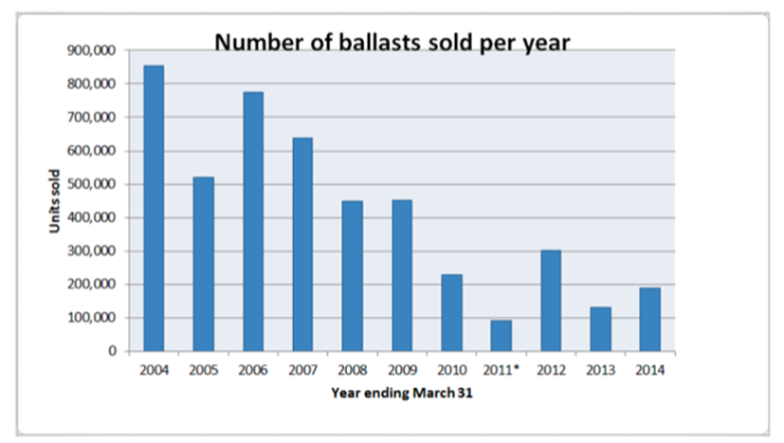

Ballast sales for Australia have been estimated using a number of datasets: the 2001 RIS for ballast MEPS, ABS import data, and applying a 5x multiplier to the New Zealand data (population pro-rata). Figure 3 shows estimates of ballast sales in Australia, including a predicted forecast based on a curve fitted to the historical figures. From this we can see that Australian ballast sales are currently around 250,000 per annum, declining to an estimated 50,000 per annum by 2030. For New Zealand this is likely to be around 50,000 declining to 10,000 per annum by 2030.

Figure 3 - Estimated historical & forecast ballast sales for Australia and NZ (including those incorporated in a luminaire)

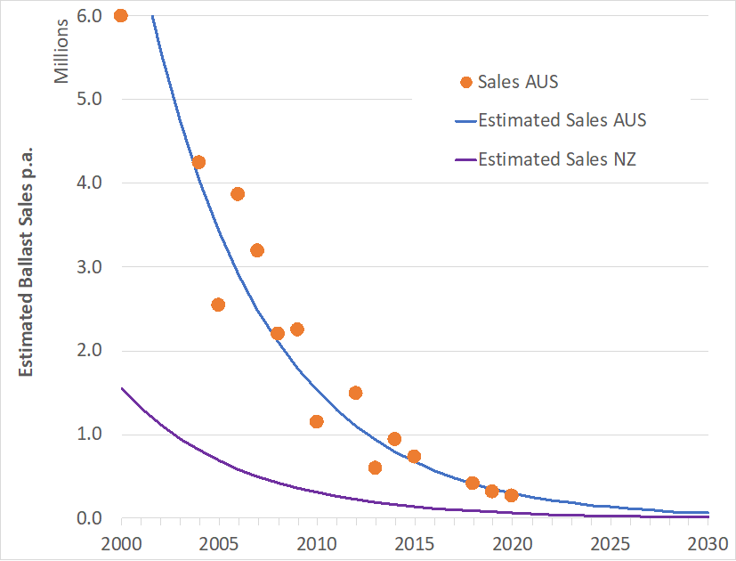

Figure 4 shows historical estimates of the shares of magnetic versus electronic ballasts in Australia.

Figure 4 - Share of magnetic versus electronic ballasted luminaires in Australia (source: CLASP 2014)

In 2009, Magnetic Ballasts and Electronic Ballasts had equal (50%) share of the market. In 2013, this had changed to Magnetic Ballasts having 20% and Electronic Ballasts having 80% market share.

At least one Australian ballast supplier reported that they no longer supply magnetic ballasts into the Australian market. Similarly in New Zealand a supplier reported magnetic ballast sales share dropping from 58% in 2015, to 7% in 2021.

Figure 5 shows the number of GEMS registrations of ballasts per year (where registration data was available). From this we can see that few magnetic ballasts have been registered in recent years. The registration database shows that, of the 50 currently registered and available ballast models, 11 are magnetic type.

Figure 5 - Ballast MEPS registrations in Australia (source: GEMS registration database)

The registrations for Magnetic and Electronic ballasts have decreased with less than 5 in 2020 and none in 2021

* 1. Analysis

MEPS regulations in Australia and New Zealand allow the sale of both magnetic and electronic ballasts, provided that magnetic units are class B2 or B1. However, the vast majority of ballasts sold are now electronic. This means that the impact that the regulations are having has been significantly reduced - the market has essentially ‘leapfrogged’ magnetic ballasts in favour of electronic.

The analysis undertaken in this section attempts to estimate the impact (the energy ‘wasted’ and subsequent greenhouse gas emissions) if ballast regulations were repealed in Australia and New Zealand, in 2023. In order to do this, the following assumptions are made:

* The repeal of the regulations has no impact on the sale of electronic ballasts, as these have already leapfrogged the minimum regulation requirement of a B2 or B1 class (magnetic) ballast.
* Total ballast sales follow the estimation curves shown in Figure 3.
* The share of magnetic ballasts set at 10% for 2023 onwards.
* The repeal of the regulations results in 30% of these magnetic ballasts (currently B2 or B1) reverting to a C or D class magnetic ballast. In the opinion of the author, this is a reasonable estimate, erring on the side of pessimistic.
* As per the AS/NZS MEPS standard for ballast MEPS (AS/NZS 4783.2), C and D class ballasts use around 2W more power than a B2 class ballast).
* Lights are operated 3000 hours p.a. on average (typical commercial building).

The resulting energy ‘wastage’ is shown in Figure 6 and the subsequent additional greenhouse gas emissions are shown in Figure 7 (using greenhouse gas intensities of 0.53 kg/kWh for Australia and 0.09 for New Zealand). For Australia, these greenhouse gas savings represent the equivalent of removing 21 cars from the road by 2030 (1 car for New Zealand).

Figure 6 - Estimated energy wastage from repeal of ballast regulations

Estimated energy wastage was around 30 MWh p.a in Australia and around 10 MWh p.a in NZ in 2023. This increases to 160 MWh p.a in Australia and around 30 MWh p.a in NZ by 2030.

Figure 7 - Estimated additional GHG emissions from repeal of ballast regulations

Estimated GHG Emissions in Australia rise from under 20 tCO2ep.a in 2023 to over 80 tCO2ep.a in 2030. Estimated GHG Emissions in New Zealand rise from around 1 tCO2ep.a in 2023 to around 3tCO2ep.a in 2030

Using a commercial electricity tariff of $0.203/kWh for Australia and $0.166 for New Zealand, the total increased energy cost over the period 2023-2030 would be around $170,000 for Australia and around $30,000 for New Zealand (total cumulative cost over 8 years).

1. ELVCs
   1. Background

MEPS for ELVCs came into effect in 2010 in Australia, however these products have not been regulated in New Zealand. The Australian regulation consists of a mandatory standard that specifies MEPS in terms of minimum full load efficiency. The required efficiency is graphed in Figure 8. The MEPS limit allows for only the most efficient magnetic units to be sold, as well as electronic units (which are significantly more efficient).

Figure 8 - MEPS requirement for ELVCs (Australia)

graph showing Max Power Rating against Efficency at full load

As is the case with fluorescent lighting, halogen downlight lighting systems are in rapid decline in Australia, and indeed worldwide, in favour of LED downlights. This can be seen in Figure 9 which graphs the sales of ELV halogen lamps, revealing a decline of 93% since 2010.

Figure 9 - ELV halogen lamp sales in Australia (source: ABS import data)

Lamp sales have declined in Australia from over 16 million in 2006 to under 2 million in 2021

* 1. ELVC Sales

Sales volumes for ELVCs are more difficult to estimate than for ballasts, because the ABS import codes do not identify lighting transformers/converters separately from all types of electrical transformers. However, New Zealand presents an interesting case study, as it does not regulate the efficiency of ELVCs, meaning that to some extent it might reflect what would happen in Australia in the absence of MEPS for ELVCs. We can see in Figure 10 that total sales of ELVCs have declined rapidly in New Zealand, with magnetic units sales almost insignificant at around 1-2% (almost indistinguishable on the graph).

Figure 10 - Estimated aggregated sales of ELVCs in New Zealand (source: based on limited sales data collected by EECA)

The sales of ELVCs have declined rapidly in New Zealand from 180,000 in 2010, to 40,000 (forcast) in 2025. Magnetic unit sales around 1-2%.

ELVCs sales for Australia have been estimated by applying a 5x multiplier to the New Zealand data (population pro-rata). Figure 11 shows estimates of ELVC sales in Australia, including a predicted forecast based on a curve fit. From this we can see that Australian ELVC sales are currently estimated at around 300,000 per annum, declining to around 150,000 per annum by 2030. Note that the 2030 prediction is based on an exponential curve fit - a more linear curve would suggest that ELVC sales could decline to zero before 2030. For the purpose of conservatism, we have assumed the exponential curve, which will tend to over-estimate the energy consumed by ELVCs.

Figure 11 - Estimated historical and forecast annual ELVC sales in Australia

Sales in Australia of ELVCs have declined from over 900,000 in 2010, to 150,000 (forcast) in 2030.

Figure 12 shows ELVC product registrations for Australia, over time. Currently, there are only 8 models of ELVC registered and available. Three of these are higher wattage magnetic transformers (105-200W) used for garden lighting (noting it is possible for higher wattage transformers to be magnetic and still meet the MEPS level - refer Figure 8). The other 5 are typical electronic converters for use with halogen downlights. Thus, interestingly, in Australia there are no magnetic ELVCs registered that would supply indoor halogen downlights.

Figure 12 - Numbers of new registrations of ELVCs in Australia

 Decline in registerations of ELVCs in Australia. From 17 before 2010 and 1 in 2020.

* 1. Analysis

MEPS regulations in Australia allow the sale of both magnetic and electronic ELVCs, provided that magnetic units are high efficiency. However, the vast majority of ELVCs sold are now electronic.   
As mentioned above, in Australia there are no magnetic ELVCs registered that would supply indoor halogen downlights.

The analysis undertaken in this section attempts to estimate the impact (the energy wasted and subsequent greenhouse gas emissions) if ELVC regulations were repealed in Australia in 2023. In order to do this, the following assumptions are made:

* Total ELVC sales follow the estimation curves shown in Figure 11.
* The ELVCs that revert from electronic to magnetic is assumed to be 5% for 2023 onwards. This is worse than current NZ estimate of 2%. Note that registrations currently indicate that sales of magnetic transformers for use with indoor halogen downlights is currently 0%.
* Magnetic ELVCs are 80% efficient and electronic units 95% efficient (refer Figure 8). ELVCs operate a 35W halogen lamp, resulting in wasted energy of 7 watts per unit.
* Lights are operated 2 hours per day on average (i.e. residential).

The resulting energy ‘wastage’ is shown in Figure 13 and additional GHG emissions in Figure 14. These greenhouse gas savings represent the equivalent of removing 58 petrol-powered cars from the road by 2030.

Figure 13 - Estimated energy wastage from repeal of ELVC regulations

The estimated energy wasted if the regulations are repealed increases from around 75 MWh p.a. in 2023 to almost 450 MWH p.a. in 2030

Figure 14 - Estimated additional GHG emissions from repeal of ELVC regulations

Estimated greenhouse gas emissions (tonnes CO2e p.a) if the regulations are repealed increases from almost 50 in 2023 to around 240 in 2030

Using a residential electricity tariffs of $0.29 for Australia, the total increased energy cost over the period 2023-2030 would be around $600,000 for Australia (total cumulative cost over 8 years).

1. Product Suppliers - ELVCs and Ballasts

Informal discussions held with Lighting Council Australia (LCA) revealed that the market for ballasts and ELVCs is now very small and on a trajectory towards zero, although the tail end of the market may be long and thin. No product development is occurring in this field and the market has been very stable in terms of brands/models over the past decade. LCA state that sales have reduced considerably, especially over recent years as LEDs have dominated. Hence these products are only used for maintenance of existing installations and not for new installations. Electrical contractors are also constantly prompting building owners to update to LED for energy and maintenance savings.

1. Discussion - ELVCs and Ballasts

Fluorescent and halogen lighting systems are becoming obsolete. There are still legacy systems in operation, but the numbers of new installations of these systems is now very small. Ballast and ELVC sales (used for new lighting systems and where a ballast or ELVC has failed) are estimated to have dropped by 80-90% over the past decade.

For the ballasts and ELVCs that are still being installed, the number of magnetic units being installed is estimated to be very low - less than 10% for ballasts (Australia/NZ) and effectively 0% for ELVCs (Australia).

Removal of MEPS regulations for ballasts and ELVCs is unlikely to result in a significant reversion to inefficient magnetic units, for the following reasons:

* For ballasts, magnetic units are still able to be sold, however they must be relatively efficient models. Despite this, sales of electronic ballasts dominate - the market has effectively ‘leapfrogged’ magnetic ballasts in favour of electronic.
* New Zealand, which does not have any MEPS in place for ELVCs, has sales of magnetic ELVCs of around 2%.
* Magnetic ballasts and ELVCs use significant amounts of copper in their windings. The price of copper has risen significantly in the past 20 years (refer Figure 15) whilst the cost of electronics has declined. For example an electronic ELVC can now be purchased for around AUD $12 (retail incl GST). Thus a significant reversion to magnetic technology seems unlikely.

Figure 15 - Historical copper price (source: macrotrends.net)

There is a risk that the removal of the MEPS regulations will change the economics discussed above, such that very cheap, very inefficient magnetic units are dumped into the AUS/NZS market, and these are able to compete with electronic units on price. Given that this has not occurred in New Zealand for ELVCs (no MEPS in place) and that ELVCs and ballasts are quite similar in terms of the materials used, this seems unlikely.

Even though the removal of MEPS is unlikely to result in a significant reversion to magnetic units, a reduction in the efficiency of electronic units should also be examined. This is not considered likely, as the electronic ballasts and ELVCs have efficiencies that are already well above the current MEPS limits, thus removal of the MEPS limits should have no impact on the efficiency of electronic ballasts and ELVCs.

There may be some niche applications for which magnetic ballasts and ELVCs are preferred over electronic units. Higher efficiency magnetic ballasts and ELVCs are currently available under current MEPS regulations. Thus these can be installed into these niche applications. Hence it is suggested that any sales of magnetic units into niche applications is already reflected in the current sales quantities of magnetic ballasts and ELVCs.

Note about the data: there may be some overestimation of coverage of the regulated products where:

* Import figures for magnetic ballasts may also include data for sulphur and mercury vapour lamps (which have niche industries they service: arena lighting, mining and excavation sites etc).
* LED drivers may be included in the data for ELVCs (as per EECA’s advice to the Department)

Consultations with stakeholders may resolve some of this uncertainty.

1. Conclusions and Recommendations

The purpose of this review was to conclude if the GEMS Determinations for fluorescent ballasts and ELVCs are still efficient and effective. Listed below are the criteria used in making a conclusion for each product, along with the logic used to assess each criteria.

* Has there been a significant change in registration numbers and sales quantities?
  + Yes. Sales quantities and registrations have declined markedly for both ballasts and ELVCs. Sales are estimated to have declined 80-90% since the time regulations were introduced.
* Are the determinations still reducing energy use and greenhouse gas emissions?
  + The estimated increases in energy and greenhouse gas emissions, from removing the regulations, can be seen in Figure 6, Figure 7, Figure 13 and Figure 14. For ballasts, a total cumulative energy increase of around 1 GWh could be expected over the period 2023-2030 (0.85 GWh for Australia and 0.15 GWh for NZ). For ELVCs (Australia only) this figure is around 2 GWh.
    - If the ballasts Determination was retained, there may be a case to increase the stringency of the Australian MEPS for Ballasts to align with NZ MEPS (removing B2) and possibly further reduce energy use and greenhouse gas emissions by aligning with EU requirements. Note that it is expected the decline in the overall market would make any gains from such revision minimal.
* Are the financial benefits higher than the regulatory costs of the determinations?
  + For ballasts, the estimated cumulative financial benefits of the regulations over the period 2023-2030 is around $170,000 for Australia and around $30,000 for New Zealand.
  + For ELVCs, the estimated cumulative financial benefits of the regulations over the period 2023-2030 is around $600,000 for Australia.
* Could the Determinations be changed to expand the scope and increase the minimum energy performance standards?
  + Ballasts: increasing the stringency of the Australian MEPS for Ballasts to align with NZ MEPS (removing B2) and possibly further reduce energy use and greenhouse gas emissions by aligning with EU requirements could be explored.
  + ELVC: While the ELVC products currently within scope are becoming obsolete, controllers for extra low voltage LED lighting are present in the market and are regulated for energy efficiency in other markets such as the European Union. There may be a viable case for sunsetting this Determination and evaluate the need for development of a Determination for LED controllers
    - This has already been identified as an area of possible future regulation in the E3 prioritisation plan, and could be tested in the initial public consultation process.
* If the determination is repealed, is there a risk that imports with lower energy efficiency will enter the market?
  + For both ballasts and ELVCs, there is a low risk that this will occur. This is largely because electronic units are now preferred by the market over magnetic units, even though MEPS still allows (higher efficiency) magnetic units to be sold. The risk of a reversion has been quantified in this report, in terms of potential increases in energy consumption, greenhouse gas emissions and consumer energy costs.

It is recommended that E3:

* Allow consultation to occur on the Determinations (refer relevant consultation papers prepared by the Department of Industry, Science and Resources).
* Consider the quantified potential for increased energy consumption, greenhouse gas emissions and consumer energy costs calculated in this report if the regulations were removed, and weigh these against the costs of continuing to regulate these products.
  + Ballasts: If the ballasts Determination was retained, consider the benefits of increasing the stringency of the Australian MEPS for Ballasts to align with NZ MEPS (removing B2) and possibly further reduce energy use and greenhouse gas emissions by aligning with EU requirements).
    - Analysis to date suggests that the decline in the overall market would make any gains from such revision minimal and this is not the recommended approach in the discussion paper.
    - The Department would need to seek advice from the Office of Best Practice Regulation (OPBR) on whether this will be a simple technical update or require a RIS.
  + ELVCs: Consider the benefits of sunsetting this Determination and evaluate the need for development of a new Determination for LED controllers.

NOTE: If E3 recommends to remove the regulations for these products, the Department will continue to monitor sales and efficiencies of products sold, to assess any reversion to magnetic products.

References

CLASP 2014, Mapping of Linear Fluorescent Lighting, Prepared by Beletich Associates for CLASP, 2014.