


Important Notice
Prepared for and under the instruction of
the Australian Building Codes Board
Prepared by
35 South Advisors Pty Ltd
Purpose and reliance
This report has been prepared by 35 South Advisors Pty Ltd for the Australian Building Codes Board to support the feasibility assessment and economic analysis of a proposed voluntary certification scheme for manufacturers of prefabricated construction.
The analysis is based on the project scope, information provided, stakeholder input, available data and assumptions agreed during the engagement. The findings should be read in the context of the assumptions, data limitations and detailed disclaimer set out at the end of this report.
This report does not constitute legal, financial or investment advice and should not be relied upon as the sole basis for any decision.

Table of Contents
Important Notice 2
List of Tables 5
List of Figures 7
1 Executive Summary 9
1.1 Background 9
1.2 Scope of Economic Analysis 9
1.3 Key Findings 10
1.4 Next Steps 13
2 Introduction 15
2.1 Proposed National Voluntary Certification Scheme 15
2.2 Why Now 18
2.3 Role of the Economic Analysis for the Scheme & Report Purpose 19
2.4 Report Structure 21
3 Understanding the Problem 23
3.1 Modern Methods of Construction in Australia 23
3.2 Barriers Affecting MMC Adoption 27
3.3 Comparator Schemes 32
3.4 Problem Definition and Case for Change 36
4 Economic Analysis Methodology 39
4.1 Analysis Scope and Options 40
4.2 General Project Assumptions and Parameters 48
4.3 Benefits 49
4.4 Traceability 65
4.5 Stakeholder Engagement 73
5 Findings 75
5.1 Baseline Costs 75
5.2 Third-Party Certification Costs 77
5.3 Direct Benefits 87
5.4 Indirect Benefits 97
5.5 Sensitivity Analysis 104
6 Conclusions 148
6.1 Summary of Findings 148
6.2 3D Volumetric Construction 148
6.3 2D and Kit-Of-Parts 151
6.4 Ongoing Implementation Considerations 152
7 Appendices 154
7.1 Appendix A Glossary 154
7.2 Appendix B Abbreviations 157
7.3 Appendix C - Mandatory inspection stages for house building in different jurisdictions (Class 1 buildings) 159
7.4 Appendix D - Mandatory inspection stages for apartment building in different jurisdictions (Class 2 buildings) 160
7.5 Appendix E – Plumbing work inspection and notification stages 162
7.6 Appendix F - Traceability Case Studies 164
Disclaimer 170

List of Tables
Table 1 - Summary of direct and indirect benefits to be assessed throughout the analysis 52
Table 2 - Proportion of Completed Dwellings by Jurisdiction, Class 1 and Class 2, December 2025 60
Table 3 - Kit-of-Parts Costs 62
Table 4 – Illustrative Example: Estimated 10-Year Benefits, Mature Kit-of-Parts Manufacturer (20 Houses Per Year with a 2.5% Uplift) 64
Table 5 – Indicative mandatory inspection costs in the base case 76
Table 6 - Summary of Anticipated Costs of Participating in the Scheme 79
Table 7 - Certification costs 80
Table 8 – Surveillance costs 81
Table 9 – Transitional and set-up costs 82
Table 10 – Traceability costs 83
Table 11 – Costs of maintaining certification 84
Table 12 – Costs of re-certification 85
Table 13 – Insurance costs 85
Table 14 – Design approval costs 86
Table 15 – Costs of design re-approval 86
Table 16 - Per-Build Cost Savings by Jurisdiction (Class 1) 89
Table 17 - Per-Build Cost Savings by Jurisdiction (Class 2) 91
Table 18 - Central Case Cost Structure (Mature Manufacturer) 93
Table 19 - Central Case Net Benefits by Year (Class 1) 95
Table 20 - Central Case Net Benefits by Year (Class 2) 97
Table 21 - Central Case Cost Structure (Mature Manufacturer) 99
Table 22 - Central Case Net Benefits by Year (2D and Kit-of-Parts) 100
Table 23 - Sensitivity Analysis Scenario Details 104
Table 24 - Mature Manufacturer Scenario 1 - Cost Structure 107
Table 25 - Scenario 1 - Net Benefits by Year (Class 1) 108
Table 26 - Scenario 1 - Net Benefits by Year (Class 2) 109
Table 27 - Mature Manufacturer Scenario 2 - Cost Structure 110
Table 28 - Scenario 2 - Net Benefits by Year (Class 1) 111
Table 29 - Scenario 2 - Net Benefits by Year (Class 2) 113
Table 30 - Less Mature Manufacturer Scenario 3 Cost Structure 114
Table 31 - Scenario 3 - Net Benefits by Year (Class 1) 115
Table 32 - Scenario 3 - Net Benefits by Year (Class 2) 117
Table 33 - Less Mature Manufacturer Scenario 4 Cost Structure 118
Table 34 - Scenario 4 - Net Benefits by Year (Class 1) 119
Table 35 - Scenario 4 - Net Benefits by Year (Class 2) 120
Table 36 - Less Mature Manufacturer Scenario 5 Cost Structure 121
Table 37 - Scenario 5 - Net Benefits by Year (Class 1) 123
Table 38 - Scenario 5 - Net Benefits by Year (Class 2) 124
Table 39 - Less Mature Manufacturer Scenario 6 Cost Structure 125
Table 40 - Scenario 6 - Net Benefits by Year (Class 1) 127
Table 41 - Scenario 6 - Net Benefits by Year (Class 2) 129
Table 42 - Less Mature Manufacturer Scenario 7 Cost Structure 130
Table 43 - Scenario 7 - Net Benefits by Year (Class 1) 131
Table 44 - Scenario 7 - Net Benefits by Year (Class 2) 132
Table 45 - Less Mature Manufacturer Scenario 8 Cost Structure 133
Table 46 - Scenario 8 - Net Benefits by Year (Class 1) 135
Table 47 - Scenario 8 - Net Benefits by Year (Class 2) 137
Table 48 – 2D and Kit-of-Parts Cost Structure (Mature Manufacturer) 138
Table 49 - Scenario 9 - Net Benefits by Year (2D and Kit-of-Parts) 139
Table 50 - Scenario 10 - Net Benefits by Year (2D and Kit-of-Parts) 140
Table 51 - Scenario 11 - Net Benefits by Year (2D and Kit-of-Parts) 141
Table 52 - Scenario 12 - Net Benefits by Year (2D and Kit-of-Parts) 142
Table 53 - Scenario 13 - Net Benefits by Year (2D and Kit-of-Parts) 143
Table 54 - Scenario 14 - Net Benefits by Year (2D and Kit-of-Parts) 144
Table 55 - Scenario 15 - Net Benefits by Year (2D and Kit-of-Parts) 145
Table 56 - Scenario 16 - Net Benefits by Year (2D and Kit-of-Parts) 146
Table 57 - Summary of Scenarios (Class 1) ($m) 148
Table 58 - Summary of Scenarios (Class 2) ($m) 149
Table 59 - Summary of Scenarios (2D and Kit-of-Parts) ($m) 151
Table 60 - Mandatory inspection stages for house building in different jurisdictions (Class 1 buildings) 159
Table 61 - Mandatory inspection stages for house building in different jurisdictions (Class 2 buildings) 160

List of Figures
Figure 1 - Certification Process under the Scheme 17
Figure 2 - Comparator insights 35
Figure 3 - Problem and case for change summary 37
Figure 4 – Anticipated Benefits Under the Scheme 49
Figure 5 - Total Cost Savings by Jurisdiction and Build Volume (Class 1) 90
Figure 6 - Total Cost Savings by Jurisdiction and Build Volume (Class 2) 92
Figure 7 - Central Case Net Benefits by Build Volume (Class 1) 94
Figure 8 - Central Case Net Benefits by Build Volume (Class 2) 96
Figure 9 - Mature Manufacturer Scenario 1 - Net Benefits by Build Volume (Class 1) 107
Figure 10 - Scenario 1 - Net Benefits by Build Volume (Class 2) 109
Figure 11 - Scenario 2 - Net Benefits by Build Volume (Class 1) 111
Figure 12 - Scenario 2 - Net Benefits by Build Volume (Class 2) 113
Figure 13 - Scenario 3 - Net Benefits by Build Volume (Class 1) 115
Figure 14 - Scenario 3 - Net Benefits by Build Volume (Class 2) 116
Figure 15 - Scenario 4 - Net Benefits by Build Volume (Class 1) 119
Figure 16 - Scenario 4 - Net Benefits by Build Volume (Class 2) 120
Figure 17 - Scenario 5 - Net Benefits by Build Volume (Class 1) 122
Figure 18 - Scenario 5 - Net Benefits by Build Volume (Class 2) 124
Figure 19 - Scenario 6 - Net Benefits by Build Volume (Class 1) 126
Figure 20 - Scenario 6 - Net Benefits by Build Volume (Class 2) 128
Figure 21 - Scenario 7 - Net Benefits by Build Volume (Class 1) 131
Figure 22 - Scenario 7 - Net Benefits by Build Volume (Class 2) 132
Figure 23 - Scenario 8 - Net Benefits by Build Volume (Class 1) 134
Figure 24 - Scenario 8 - Net Benefits by Build Volume (Class 2) 136

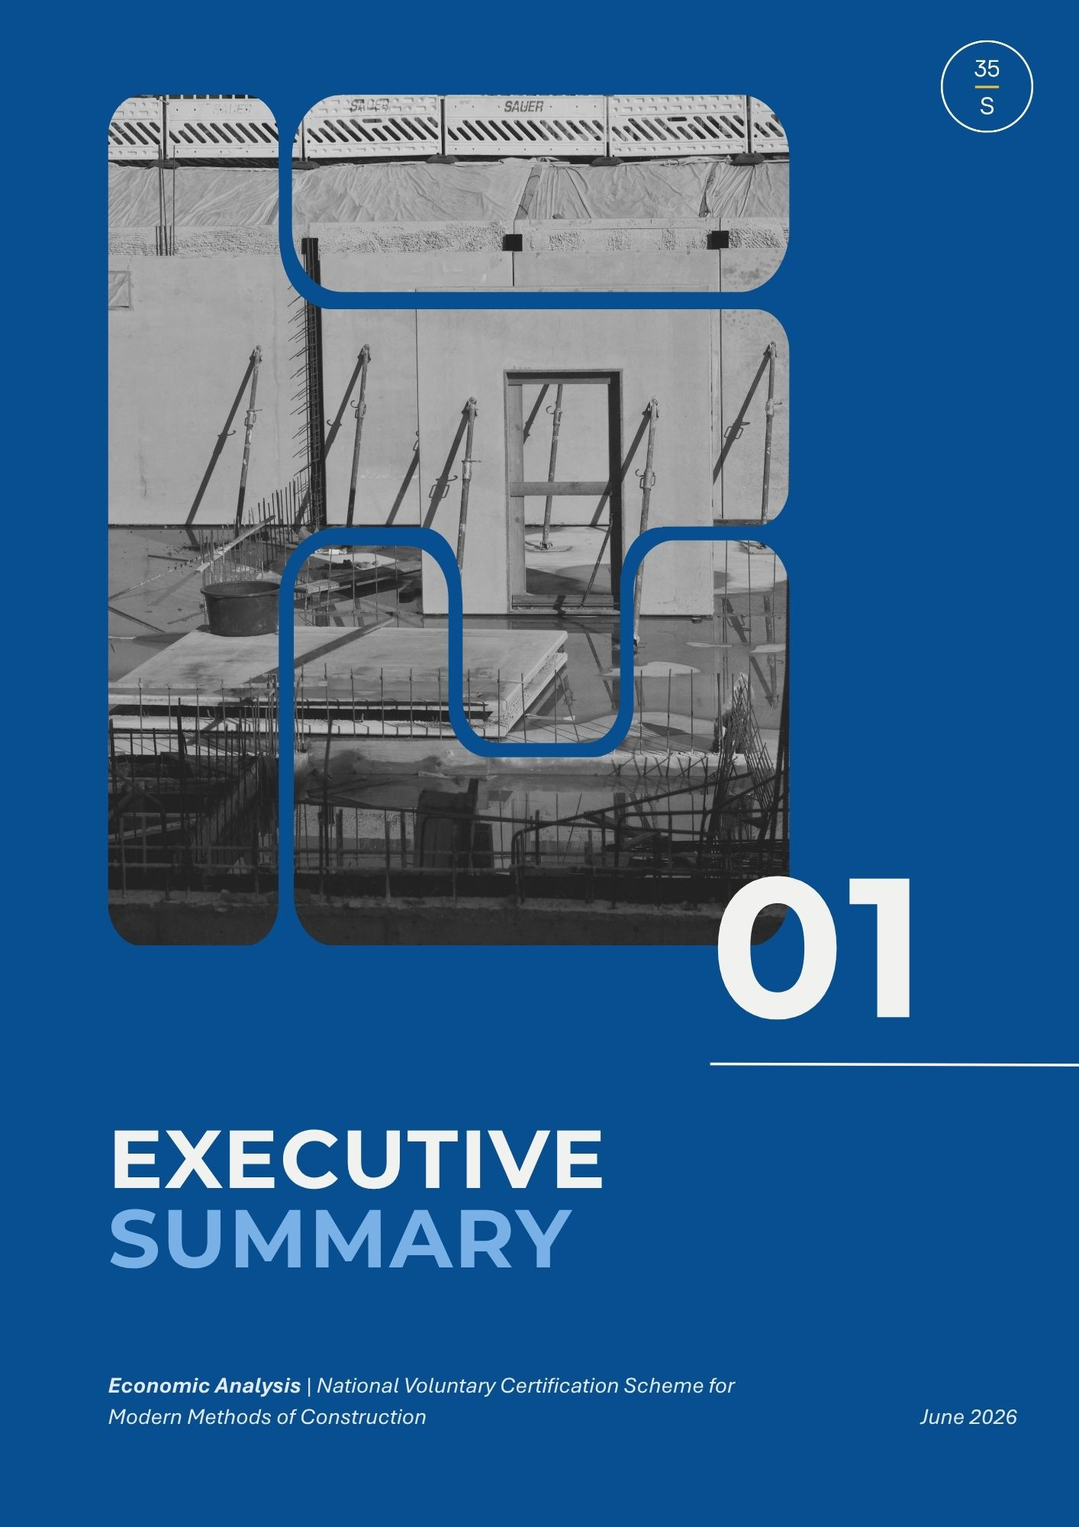

Executive Summary
  - Background
Improving construction sector productivity in Australia, which has declined in recent decades, is a key policy priority for the Australian Government. A significant opportunity lies in increasing the uptake of modern methods of construction (MMC), which has the potential to improve delivery outcomes across the construction sector.
However, the absence of a nationally consistent approach to recognising manufacturer-level assurance for MMC creates a regulatory impediment to broader adoption. This can result in uncertainty for manufacturers and other industry stakeholders, duplicated assurance activities and inconsistent approval and inspection requirements, reducing efficiency and confidence in the regulatory process.
To address these challenges, the Australian Building Codes Board (ABCB) has been tasked with developing a National Voluntary Certification Scheme for Modern Methods of Construction (‘the Scheme’), intended to commence by mid-2028. The Scheme provides a third-party certification pathway to support innovative construction systems and manufacturing approaches, while improving the efficiency, quality and consistency of prefabricated building work. A nationally recognised Scheme would enable more streamlined and reliable approval pathways and support greater uptake of MMC.

  - Scope of Economic Analysis
The economic analysis conducted in this report assesses the impacts of the Scheme against the current state of mandatory inspections. Currently, MMC manufacturers are subject to the same mandatory inspection stages as traditional onsite construction. These requirements vary across jurisdictions and can create inefficient processes that limit the productivity benefits that MMC can deliver. The analysis focuses on the effect the Scheme will have on manufacturers, examining the costs associated with participation, alongside the benefits arising from reduced duplication, more streamlined approval processes, greater regulatory consistency and confidence, and increased uptake of MMC.
Benefits are assessed broadly across two categories including direct and indirect benefits. Direct benefits for the purposes of this analysis related to anticipated financial gains arising from reduced inspection costs for manufacturers of 3D volumetric construction. The focus on 3D volumetric construction for direct benefits reflects both the nature of the proposed inspection impacts arising from the Scheme and the availability of data to support quantitative modelling.
For manufactures of 2D and kit-of-parts products, the primary benefit is not a direct reduction in inspection costs but rather the ability to increase production volume as a result of reduced regulatory burden. This distinction reflects the different ways these manufacturers are assumed to interact with the current inspection regime and is why this benefit is treated as indirect for the purposes of the analysis.
Indirect benefits assessed throughout the analysis include qualitative outcomes such as improved quality assurance and standards, increased consumer and industry confidence, and increased MMC adoption.
As the Scheme is still being developed, the analysis draws on available evidence, stakeholder consultation and numerous data assumptions and limitations to estimate impacts. Where detailed or directly applicable data was unavailable, estimates or proxy information has been used. The results should therefore be interpreted as indicative of the Scheme’s potential economic impact, rather than a precise forecast of future outcomes.

  - Key Findings
The Scheme is designed to deliver tangible benefits to participating manufacturers, with the scale of benefit varying according to build volume, manufacturing maturity and Scheme cost settings. Findings are indicative, reflecting limitations in available data and uncertainty around future participation and market response, and should inform decision-making rather than serve as definitive prediction of outcomes.
Two scenarios are presented as the primary reference points for the findings.
- The Central Case: reflects a mature or established manufacturers, subject to quarterly surveillance activities by the Certification body, with certification valid for three years. This represents the cost structure for an eligible manufacturer based on current Scheme design and is a reference point against which sensitivity analysis scenarios are compared. For 3D volumetric manufacturers, the central case models the direct financial benefits arising from reduced inspection costs. For 2D and kit-of-parts manufacturers, the central case assumes a base production capacity of 50 builds per year and a conservation 1% throughput uplift.
- The Best Case: reflects different settings depending on manufacturer type, illustrating the stronger net benefit available where participation costs are lower or production capacity is higher. For 3D volumetric manufacturers, it reflects the same mature manufacturer profile, subject to annual rather than quarterly CAB surveillance and a five-year certification cycle. For 2D and kit-of-parts manufacturers, it reflects a higher base production capacity of 100 builds per year and a 5% throughput uplift, with the same surveillance settings as the central case.
The sensitivity analysis tests how net benefits change across a range of cost and surveillance settings and identifies the conditions under which participation remains financially worthwhile for manufacturers of varying maturity. For full details, please refer to the Findings sections.
    - Direct Benefits: 3D Volumetric Construction
Under the central case, a mature manufacturer construction 3D volumetric buildings can expect the following outcomes:
  - A Class 1 manufacturer would be required to construct 36 buildings annually to find participation in the Scheme financially beneficial. If they were to construct 100 buildings annually, a direct net benefit of $837,468 is anticipated over 10 years.
  - A Class 2 manufacturer under the same conditions would be required to construct 23 buildings annually to find participation in the Scheme financially beneficial. If they were to construct 50 buildings annually, a direct net benefit of $512,688 is anticipated over 10 years.
- Under the best case, where surveillance frequency is reduced and the certification cycle is extended, manufacturers can expect stronger net benefits at lower build volumes. Key outcomes include:
  - A Class 1 manufacturer would be required to construct 19 buildings annually to find participation in the Scheme financially beneficial. If they were to construct 100 buildings annually, a direct net benefit of $1,047,915 is anticipated over 10 years.
  - A Class 2 manufacturer under the same conditions would be required to construct 14 buildings annually to find participation in the Scheme financially beneficial. If they were to construct 50 buildings annually, a direct net benefit of $697,072 is anticipated over 10 years.
    - Indirect Benefits: 2D and Kit-Of-Parts Construction
For manufacturers of 2D and kit-of-parts products, the primary benefit of the Scheme is the ability to increase production volume as a result of reduced regulatory burden. By reducing the time required for products to progress from manufacturing to installation, the Scheme is expected to allow manufacturers to supply more product to the market each year, generating additional revenue. The scale of this benefit depends on a manufacturer’s base production capacity and the degree of throughput uplift achieved.
Under the central case, a mature manufacturer is subject to quarterly surveillance activities by the Certification Body, with certification valid for three years. Assuming a base production capacity of 50 builds per year and a conservative 1% throughput uplift as a result of participation in the Scheme:
  - A 2D and kit-of-parts manufacturer would be expected to build an additional 5 buildings every year, receiving an indirect financial benefit of $127,385 over 10 years.
- Under the best case, a mature manufacturer is subject to quarterly surveillance activities by the Certification Body, with certification valid for three years. Assuming a higher production capacity of 100 builds per year and a 5% throughput uplift as a result of participation in the Scheme:
  - A 2D and kit-of-parts manufacturer would be expected to build an additional 50 buildings every year, receiving an indirect financial benefit of $5,257,982 over 10 years.
- The Scheme also anticipates a number of qualitative benefits to be realised as a result of participation. This includes reduced time to certification, decreased regulatory burden, increased quality assurance and standards, increased consumer and industry confidence and increased adoption of MMC dwellings.

    - Qualitative Benefits
The Scheme is also expected to generate benefits that apply broadly to participating manufacturers regardless of build volume or construction type. These include reduced time to certification, decreased regulatory burden, increased quality assurance and manufacturing standards, and greater consumer and industry confidence in MMC approaches. Over time, these outcomes are expected to contribute to increased adoption of MMC dwellings, expanding market opportunities for certified manufacturers. These qualitative benefits represent an important component of the Scheme’s overall value proposition and are assessed in detail in the Economic Analysis Methodology and Findings sections.


  - Next Steps
This report, along with the draft Scheme Rules, has been released for public consultation. Questions are included in the public consultation portal and relate to different sections of the report. These have been clearly identified throughout, and stakeholder input is strongly encouraged. Following consultation, feedback will be reviewed and where appropriate, incorporated into a final report.
A key implementation consideration for the Scheme is how ABCB’s ongoing operating costs as the Scheme Administrator will be funded. Government activities can be funded through a range of mechanisms including general taxation, levies and cost recovery charges. Where an individual or organisation creates demand for a government activity, the Australian Government Charging Framework (Charging Framework) provides they should generally be charged for it. Consistent with the Charging Framework, further work will consider cost recovery as a possible funding mechanism for funding the Scheme’s ongoing operation, as part of ongoing Scheme design and implementation.

Introduction
The Australian Government has tasked the Australian Building Codes Board (ABCB) to develop nationally consistent definitions for Modern Methods of Construction (MMC) and a National Voluntary Certification Scheme for Modern Methods of Construction, aimed at increasing the uptake of prefabricated and modular construction that meet National Construction Code (NCC) standards.
In Australia, MMC refers to the wide variety of construction methods that are different to onsite construction. It includes prefabrication, off-site manufacturing, methods that produce modular or volumetric dwellings, and new technologies such as 3D printing, robotics and artificial intelligence. It is not a singular approach, but rather a collection of methods to plan, design and build with evolving workforce, supply chain and advanced technological landscape.
The Scheme remains on track for implementation by mid-2028, with consultation on the Issues paper completed in August 2025 and Scheme Rules in development incorporating feedback received. Scheme milestones from July 2026 onwards include public consultation on the draft Scheme Rules alongside draft definitions outlining nationally consistent terms of prefabricated and modular construction for inclusion in the NCC.

  - Proposed National Voluntary Certification Scheme
The Scheme is a third-party certification pathway aimed at supporting the adoption of innovative construction systems and manufacturing approaches within Australia’s building and construction sector. The Scheme is intended to improve the efficiency, quality, and consistency of prefabricated building work domestically, by enabling more streamlined and reliable approval pathways.
The Scheme is owned by the Commonwealth, acting through the ABCB, on behalf of state and territory governments. Scheme rules will apply to:
- The Scheme Owner: responsible for governance, drafting Scheme rules & oversight and performance;
- The Scheme Administrator: day-to-day Scheme operation including application processes, maintaining documentation, coordinating oversight and reporting;
- Accreditation Bodies: responsible for accrediting Certification Bodies to operate within the Scheme;
- Certification Bodies: third-party conformity assessment bodies authorised to assess and certify Prefabricated Construction manufacturers against Scheme requirements; and
- Manufacturers: responsible for the design and/or manufacture of prefabricated components.

    - Scheme Scope and Application
The Scheme applies to off-site manufacturing activities and approaches produced in controlled manufacturing environments and will not apply to on-site construction methodologies. The Scheme will apply to prefabricated systems for use in Class 1 and Class 2 residential buildings including, but not limited to:
- Panelised systems (including frames);
- Volumetric systems; and
Prefabricated whole buildings.

Figure 1 provides a high-level overview of the certification process under the Scheme, which includes manufacturer application, CAB application review, evaluation planning, risk assessment, evaluation report and review, certification decision, non-conformity and termination, suspension or withdrawal of certification managed through ongoing surveillance and assurance activities.

Figure 1 - Certification Process under the Scheme
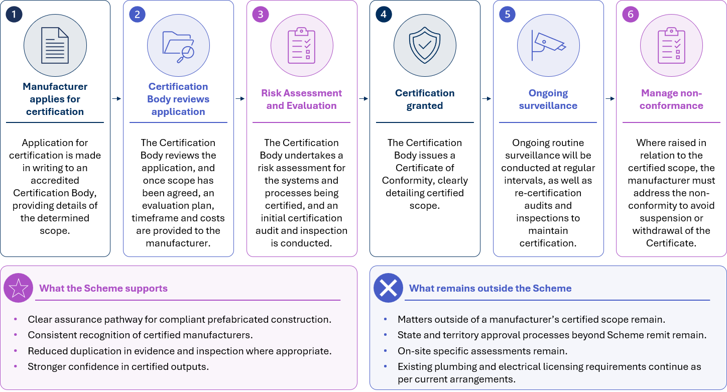
  - Why Now
Australia is facing sustained housing supply and affordability pressures. Improving construction productivity has been identified by the Productivity Commission as a critical mechanism to addressing these challenges. Dwelling construction in Australia has been declining in recent decades, further constrained by complex and slow construction approval processes, lack of innovation, lack of scale within the industry and challenge in attracting and retaining skilled workers.
As part of the Australian Government’s broader housing agenda, the government has stood up the National Housing Accord (the Accord), which brings together all levels of government, investors and the residential, building and construction sector to drive affordable housing in the medium term. The Accord includes a national target of building 1.2 million new homes over five years from mid-2024.
While the Accord is one component of the broader housing agenda, Modern Methods of Construction has also been identified as a key mechanism to support construction productivity and improved housing delivery capacity. The Productivity Commission reports that prefabricated and modular construction can reduce the cost of homes by up to 20%. To address construction industry productivity challenges, the Productivity Commission identified seven reform directives, including Reform direction 4.6, which states “governments should continue to reduce unnecessary regulatory impediments to greater uptake of modern methods of construction in housing construction, including prefabricated and modular construction.”
Further, following revitalisation of the National Competition Policy (NCP), the Australian Government and state and territory governments agreed to a 10-year plan backed by a $900 million National Productivity Fund. As part of the stipulated reforms within the NCP, two targets related to MMC were identified, including:
- Legislating nationally consistent NCC definitions for prefabricated and modular construction, and
- Facilitating the commencement of a Scheme for manufacturers of prefabricated construction.
The 2025-26 Budget further reinforced this commitment, allocation $54 million for prefabricated and modular housing, with $4.7 million to the ABCB to deliver the two projects outlined in the NCP.,
It is within this broader policy context that the Scheme has been established and is a direct regulatory response to Australia’s housing productivity challenges and the need for a consistent national framework to support greater MMC uptake.

  - Role of the Economic Analysis for the Scheme & Report Purpose
The purpose of the economic analysis is to provide policymakers and government with an independent assessment of the costs and benefits associated with the implementation of the Scheme. The analysis is intended to inform decision-making on Scheme implementation activities that provide positive outcomes primarily for MMC manufacturers and industry stakeholders, and whether it is practical, proportionate and likely to deliver net benefits.
Given the current status of the Scheme, findings within the analysis should be read as indicative, with key assumptions subject to ongoing refinement as the Scheme design matures and stakeholder consultation progresses.
The report sets out the evidence base, assessment approach, key assumptions, data limitations, findings and areas where further evidence may be needed. Feedback received during the public consultation period will be incorporated into the final assessment by the end of the 2026.
Costs and benefits are assessed relative to the current state baseline which reflects current compliance pathways across jurisdictions, including mandatory inspection stages for traditional construction methods. Anticipated costs and benefits of the Scheme are assessed against this baseline to determine the overall value of implementation. See Chapter 4 for details of the cost baseline methodology and Chapter 5 for detailed findings.
Economic modelling primarily focuses on costs and benefits arising for MMC Manufacturers as the principal beneficiaries of the Scheme. The analysis provides indicative estimates of certification costs, alongside the potential financial and compliance efficiency benefits that may arise for certified manufacturers. This reflects the key intent of the Scheme, which is to directly address current barriers faced by manufacturers in building certification and inspection processes.
Benefits to other market participants and broader construction industry stakeholders are acknowledged, however will be assessed qualitatively given the absence of robust data sources from which to determine quantitative estimates. Where costs and benefits cannot be reliably quantified or monetised, they are identified and assessed qualitatively to ensure a holistic assessment of the Scheme’s overall value.
The report does not present a final Scheme design, detailed implementation plan or cost recovery implementation. A full cost recovery analysis, including detailed fee setting recommendations will not be provided. The analysis establishes the foundational methodology, baseline assumptions, and cost and benefit parameters which will support a comprehensive cost recovery assessment once the Scheme Framework and Rules are finalised.

  - Report Structure
The remainder of report is structured as follows:
- Chapter 3 Understanding the Problem considers the key environmental drivers and problem the Scheme aims to address.
- Chapter 4 Economic Analysis Methodology is an overview of the analysis methodology including key assumptions, limitations and dependencies.
- Chapter 5 Findings details the analysis findings for the base case and the Scheme, and results of sensitivity analysis.
- Chapter 6 Conclusions outlines ongoing implementation recommendations and a summary of the key findings.
- Appendices includes additional detail on the analysis findings and supporting materials.



Understanding the Problem
As noted in Chapter 2 Introduction, MMC has been identified as a key mechanism to improving construction sector productivity. However, prefabricated construction in Australia remains low accounting for less than 8 per cent of total construction (not just residential construction). The Productivity Commission’s Housing construction productivity: Can we fix it? report identified several barriers to the uptake of prefabricated construction:
- Regulatory barriers: e.g. building regulations were designed with onsite construction in mind, and some planning and zoning rules favour ‘traditional’ homes
- Non-regulatory barriers: e.g. consumer preferences, financing, industry resistance, transport issues, industry readiness.
The Scheme does not attempt to address every barrier to MMC adoption. It focuses specifically on barriers arising from conventional building certification and inspection processes which currently limit the productivity benefits that MMC can deliver.

  - Modern Methods of Construction in Australia
Modern Methods of Construction (MMC) refers to the wide variety of construction methods that are different to traditional onsite construction. It includes prefabrication, off-site manufacturing, methods that produce modular or volumetric dwellings, and new technologies such as 3D printing, robotics and artificial intelligence.

The Scheme will apply to manufacturers of prefabricated construction systems including, but not limited to:
- Panelised systems (including frames);
- Volumetric systems; and
- Prefabricated whole buildings.
Benefits of prefabricated and modular construction include:
- Time savings: factory settings enable multiple trades to work in parallel and be unaffected by weather-related delays.
- Cost savings: can offer significant cost efficiencies, particularly when it achieves economies of scale.
- Certainty: improved predictability across key project dimensions such as cost estimation, manufacturing processes, site management, skill requirements, transport, installation and project completion.
- Safety: shifting work offsite to a controlled factory setting can result in a more predictable and safer work environment.
- Quality: in the context of precision in design and robust quality assurance processes, as well as a reduction in the risk of damage caused by adverse weather conditions.
- Environmental sustainability: MMC reduces the overall weight of waste generated, studies have shown a reduction in greenhouse gas emissions and use less material compared to traditionally built homes.

    - Market Adoption and Housing Delivery Context
Australia’s use of MMC remains relatively low in contrast to comparable international markets. Adoption varies significantly across countries, ranging from markets at similar stages to Australia through to significantly more mature prefabrication industries:
- 20.5% of China’s new building construction in 2020 was prefabricated
- 26.1% of Germany’s new single and duplex houses in 2024 were prefabricated
- 11.75% of Japan’s new dwellings in 2024 were prefabricated
- 39.1% of Singapore’s new buildings in 2020 were prefabricated
- 95% of Sweden’s newly constructed conventional multi-dwelling buildings in 2023 were prefabricated
- 6.64% of the USA’s new construction commencements in 2023 were prefabricated.
Whilst the gap between Australia and more mature markets such as Sweden and Singapore suggests significant opportunities for growth, research indicates uptake is shaped by a specific set of conditions:
“Under certain conditions, it appears that prefabrication uptake is driven by: a large housing industry; sudden spikes in demand; a consumer preference for new housing over renovations; state ownership that promotes prefabricated dwellings; and a large multi-residential building sector.”
Australia meets several of these conditions:
- The housing industry is substantial with the total value of residential dwellings in Australia increasing by $315.9 billion to $12,772.6 billion as of the March Quarter 2026 and the number of residential dwellings rose by 54,200 to 11,495,200 over the same quarter.
- Housing demand pressures remain acute with supply nearing its lowest levels in a decade. In 2024, 177,000 new dwellings were completed falling short of underlying demand for housing estimated at 223,000 in the same period.
- State driven promotion of prefabricated construction is growing. For example, the Western Australian Government has awarded $49 million through its Housing Innovation Fund to manufacturers involved in modular and prefabricated housing. The NSW Government has committed $6.6 billion into social housing including the delivery of 21,000 affordable and market homes. To maximise the impact of this investment, Homes NSW and Building 4.0 CRC have also developed their own MMC Program including a $2 million contribution each to leverage modern manufacturing techniques to deliver social housing. The Australian Government has made a $39.3 million investment to support state and territory uptake of a kit of parts housing construction system. The system, developed in Australia by Building 4.0 Cooperative Research Centre, is open-source and will use standardisation to achieve efficiencies in construction.
However, the condition of consumer preference for new builds is less clearly met, with renovation spending increasing from 34% in 2018-19 to 40% in 2023-24. In contrast, spending on new private residential construction in 2023-24 was 14% compared to five years earlier. This suggests the conditions for growth in MMC uptake are ongoing but not yet fully established.
Even where conditions are favourable, “prefabrication and modular construction in housing is unlikely to be a silver bullet for housing construction productivity.” Some barriers, such as those related to consumer preferences and industry culture, are likely to be slow to shift regardless of regulatory settings.
The Scheme is intended to address one specific subset of those barriers which is the unnecessary regulatory impediments arising from conventional building certification and inspection processes.

    - Current Regulatory and Approval Environment
The National Construction Code (NCC) provides the primary technical standard for building and plumbing work in Australia. It applies to all building technologies, systems and products.
Responsibility for ensuring compliance with the NCC lies with state and territory governments, and each jurisdiction has developed its own building approval, certification and inspection regimes, tailored to traditional onsite construction practices. The issue is not whether prefabricated construction can comply with the NCC. The issue is how compliance is demonstrated, and how certifying authorities should adapt their inspection practices to suit an offsite manufacturing environment.
Offsite manufacturing is currently managed through existing compliance mechanisms. Evidence may include certificates, reports, calculations and any other documents or information.
The ABCB handbook recognises that construction compliance is technically and legally complex. It also notes that the NCC operates within a broader state and territory regulatory framework, including planning, practitioner registration and other legislative requirements.

  - Barriers Affecting MMC Adoption
The following section examines the key barriers to MMC adoption in more detail. The available evidence varies across each type, and the analysis findings in Chapter 5 draws on this information using both quantitative and qualitive approaches where data permits.

    - Fragmented Regulatory Requirements
A key barrier for prefabricated and modular construction is the lack of consistent treatment across jurisdictions, approval pathways and project contexts. Existing building regulations are administered by states and territories, and the practical application of approval, certification and inspection requirements can vary.
Unlike traditional onsite construction, prefabricated components may be manufactured in one jurisdiction and installed in another. A manufacturer seeking to supply prefabricated modules or components nationally must navigate multiple, inconsistent building regulations, planning laws and licensing requirements.
Research has indicated that regulatory ambiguities for prefabricated and modular construction create uncertainty for industry participants and can prevent greater uptake. The report also found that factory output certification could increase confidence where onsite inspections are challenging or unable to fully verify in-situ complex prefabricated or modular units.
Fragmentation can also create practical challenges for manufacturers seeking to operate at scale. A manufacturer may produce the same or similar components across multiple jurisdictions, but face different expectations for evidence, inspection, documentation, practitioner involvement or acceptance. This can reduce the repeatability and scalability that prefabricated construction is intended to support.
The Scheme may reduce uncertainty by providing a nationally recognised assurance pathway for certified manufacturers and certified components, subject to scope, conditions and jurisdictional implementation.

    - Inspection and Certification Requirements
Conventional inspection regimes are based on staged onsite construction which assumes that work is visible, accessible and occurring at a known location when an inspector attends. In contrast, offsite manufacturing can create practical challenges where relevant work is manufactured offsite and may be enclosed, completed or transported before a local authority or building surveyor has an opportunity to inspect it.
Further, where manufacturers operate across jurisdictions or run 24-hour continuous production, physical inspections can be inefficient and may not guarantee the robustness of a systematic quality assurance process.
The Scheme would address this through third-party certification, relying on factory production controls, traceability, inspection and test plans, quality management systems, surveillance and Manufacturer Declarations of Conformity. Certified manufacturers would be required to demonstrate that components are manufactured in accordance with approved specifications, Scheme Rules and the certified scope.
The Scheme’s value will depend on whether these assurance mechanisms are sufficiently robust for regulators, building surveyors and certifiers to rely on them in practice. It will also rely on state and territory legislation being updated to enable appropriate recognition of Scheme outputs.

    - Consumer and Industry Confidence
Confidence is a critical barrier to MMC adoption. Regulators, building surveyors, certifiers, builders, developers, financiers, insurers and consumers need assurance that components produced offsite will perform as intended and comply with applicable requirements.
Post World War II and during periods of rapid urbanisation, many countries adopted prefabricated construction to address housing shortages. However, quality was often compromised in favour of speed and cost-efficiency. Australian consumers’ apparent preference for customised housing products, and their limited knowledge and understanding of prefabricated construction may lead to a lack of comfort with the product, leading to low levels of demand.
The Scheme seeks to address confidence concerns by demonstrating consistent quality in MMC construction, fostering trust, consistency and credibility.
It aims to do this by defining roles, responsibilities, certification requirements, scope controls, surveillance processes and manufacturer obligations. Certification Bodies would assess and certify manufacturers, certified manufacturers would operate within a defined certified scope, and manufacturer Declarations of Conformity would be used to support evidence that components have been manufactured in accordance with the approved specification.
These mechanisms aim to give regulators, certifiers and consumers a reliable basis for confidence in off-site manufactured components and assurance of best practice and more compliant building outcomes.,
Traceability would also support enhanced confidence in participants. By tracking elements through their lifecycle, a verified link can be maintained between off-site manufactured elements and the manufacturer responsible for their production. This provides the evidentiary basis needed to confirm compliance with approved specifications, including when issuing occupancy certificates.
Consumer and industry confidence will also depend on how the Scheme is communicated and governed. This includes how non-conformities are managed, and how complaints, suspensions or certification withdrawals are handled.

    - Market Demand
Lack of demand is one of the largest barriers to greater uptake of prefabricated construction. Unlike traditional construction, prefabricated requires upfront investment in facilities, equipment, design tools and workforce capability. Without sufficient housing pipeline certainty, manufacturers may be reluctant to scale.
The scale of upfront investment required creates a further challenge. Economies of scale are a key driver of cost savings in prefabricated construction, requiring “large-enough factories as well as sufficient output to ensure repeatability, learning, and volume savings on procurement.” Without sufficient scale, costs remain high. Without sufficient demand, manufacturers will not invest in the scale needed to bring costs down. The conditions needed to reduce costs, including scale, repetition, and demand certainty, are “not consistently present in Australia”, compounding the demand challenge.
Finance and insurance settings can also constrain uptake. Traditional construction finance and progress payment models are often designed around key inspection stages,, which do not align well with offsite manufacturing, where a greater proportion of finance is required upfront.
International research suggests that adoption is shaped by context and market factors, not only by regulation. Elements such as housing completions, renovation rates compared to new builds, housing ownership models (i.e. public and private markets) and types of homes constructed can influence whether prefabricated housing is adopted.

  - Comparator Schemes
Comparator schemes provide useful lessons for the Scheme. Scheme effectiveness depends on legal authority, market conditions, participant obligations, scope, regulator confidence, and how certificates or declarations are treated in approval pathways.
The key lesson from these comparators is that certification schemes work best where there is clarity about what is certified, who has assessed it, what legal effect the certificate has, what limitations apply, and what remains subject to site-specific approval. Mandatory schemes, like WaterMark, naturally have greater uptake, and voluntary schemes, like BuiltReady and CodeMark, may require additional support to reach these levels.

    - BuiltReady
BuiltReady is the most directly relevant Scheme comparator for the Scheme. New Zealand’s BuiltReady scheme is a voluntary modular component manufacturer certification scheme established under the Building Act 2004 and the Building (Modular Component Manufacturer Scheme) Regulations 2022.
It is intended to provide a robust framework that shows a modular component manufacturer meets third-party certification requirements. Building consent authorities must accept a manufacturer’s certificate as evidence of Building Code compliance where the certificate is current, valid and the modular component is used in accordance with any limitations or conditions.
BuiltReady provides useful lessons for the Scheme. It highlights the importance of a clear statutory basis, defined roles for accreditation and certification bodies, defined certification pathways, scope controls, public registers, surveillance, and explicit rules for the use of certificates and branding.

    - CodeMark
CodeMark provides a domestic comparator for product certification. It is a voluntary third-party building product certification scheme, administered by the ABCB.
The CodeMark protocol describes how Certification Bodies assess products for conformity with the performance requirements of the Building Code of Australia under the CodeMark Australia Scheme Rules. It emphasises the importance of identifying relevant performance requirements, intended use, and the basis on which compliance is being certified.
Whilst CodeMark is not a manufacturer certification scheme, it is useful in demonstrating the importance of certificate scope, intended use, performance basis and limitations. The Scheme has a different focus, assessing manufacturer systems, factory production quality assurance and quality control, traceability and ongoing conformity within a certified scope.

    - WaterMark
WaterMark is a mandatory certification scheme administered by the ABCB covering certain plumbing and drainage products to ensure they are fit for purpose and appropriately authorised for use in plumbing or drainage installations.
The ABCB Prefabricated, modular and offsite construction handbook notes that prefabricated plumbing modules may be treated either as WaterMark-certified purpose-built plumbing products or as prefabricated plumbing installations regulated in the jurisdiction of installation. If manufacturing or building a bathroom intended to be moved interstate or is being imported, jurisdictions are currently only required to accept a WaterMark product, and do not have to accept regulated work done in another jurisdiction.
The Scheme’s certification of prefabricated components may not automatically resolve all plumbing inspection and connection requirements. The treatment of plumbing should remain a key design and implementation dependency.
Figure 2 - Comparator insights
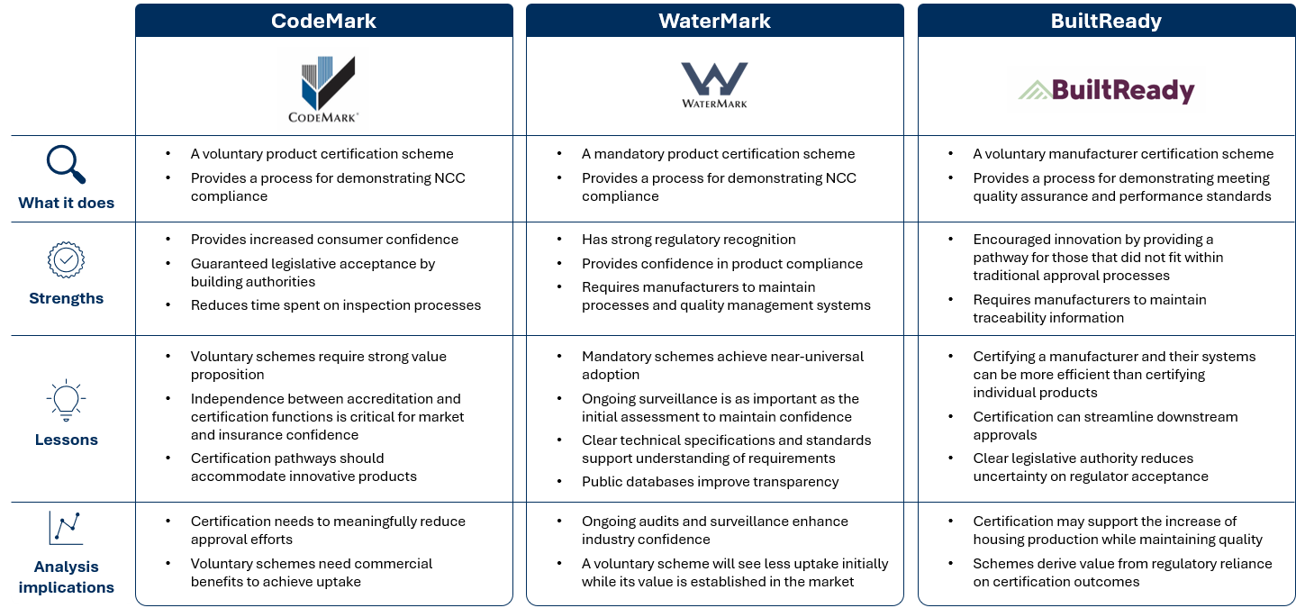

  - Problem Definition and Case for Change
Current approval, certification and inspection pathways do not provide a nationally consistent way to recognise manufacturer-level assurance for prefabricated construction. This creates uncertainty for manufacturers, building surveyors, certifiers, regulators, builders and consumers. It can lead to duplicated assessments, inconsistent evidence requirements, unclear inspection expectations and uncertainty about how factory-based quality assurance should be treated in the building approval process.
Prefabricated construction must comply with the NCC and relevant state and territory legislation. However, current processes do not provide a clear, proportionate and consistent way to demonstrate compliance when parts of the construction process occur offsite.
The case for change is therefore targeted. A national voluntary certification pathway could provide a structured way to certify manufacturer systems and define certification scope. It would also support declarations of conformity, improve traceability and give regulators and certifiers a clearer basis for reliance.
The Scheme will not resolve all barriers to MMC adoption. Market demand, finance, insurance, procurement, supply chain capability, consumer confidence and jurisdictional implementation remain important factors shaped by broader market and policy settings. However, the Scheme may address a specific regulatory and assurance gap that currently limits confidence and consistency in the treatment of compliant prefabricated construction.
The analysis considers whether the Scheme can deliver clearer evidence of compliance, reduced duplication and improved confidence in the treatment of prefabricated construction. The question is whether these benefits justify the costs of establishing, operating and participating in the Scheme.
Figure 3 - Problem and case for change summary
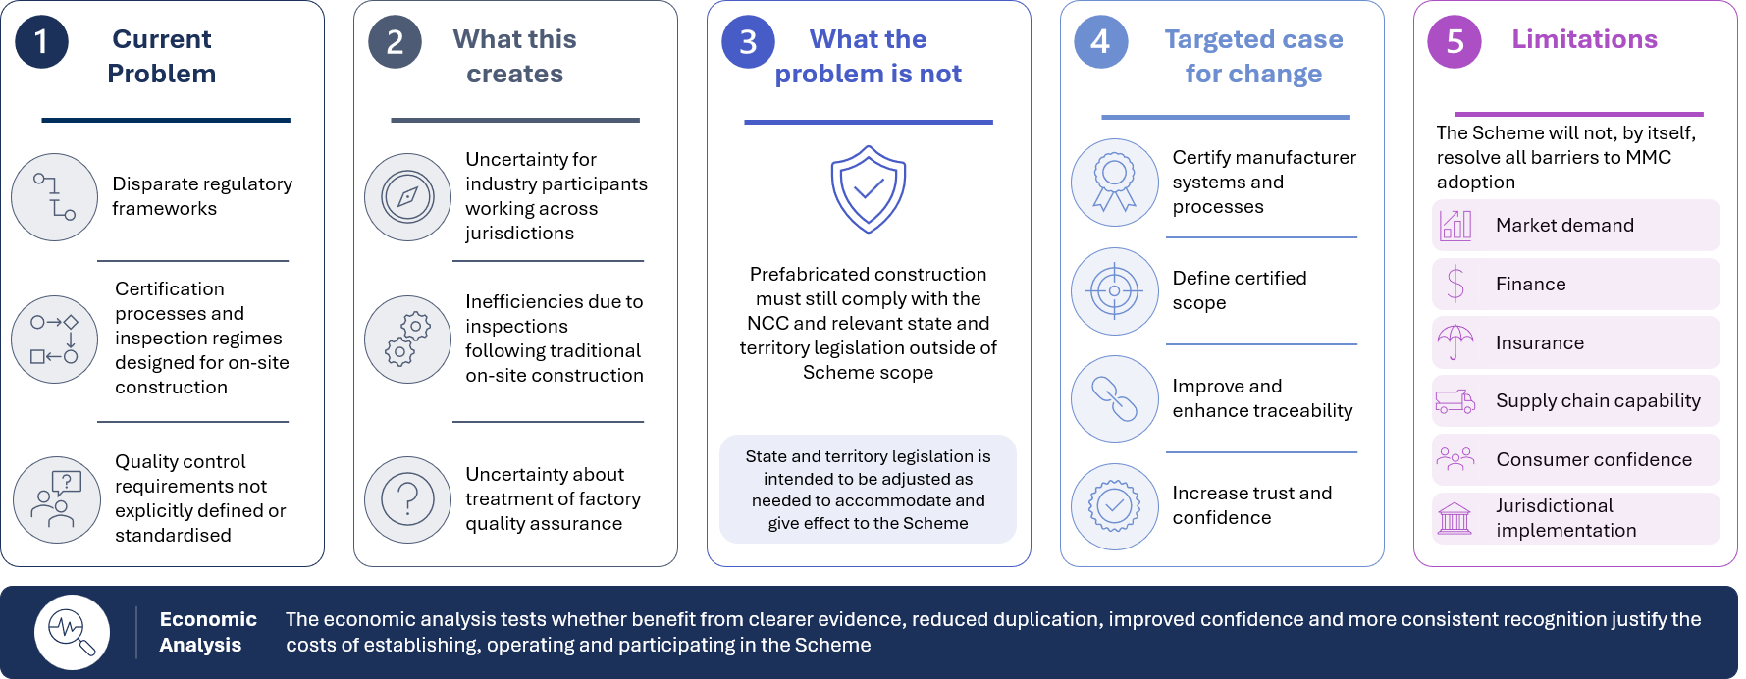
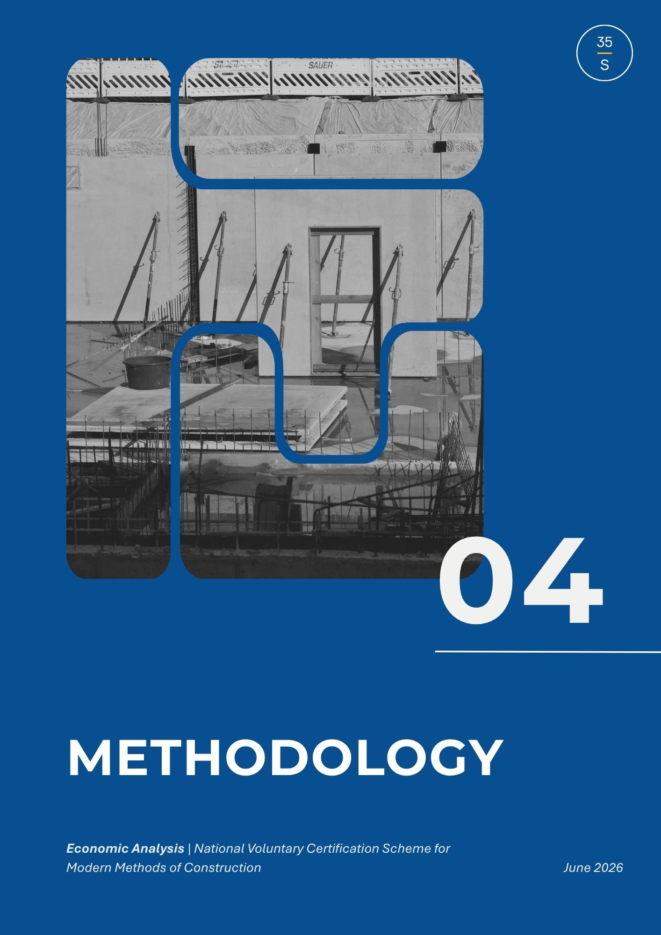

Economic Analysis Methodology
This chapter presents an economic and impact analysis consistent with the Office of Impact Analysis (OIA) Guidelines for regulating impacts and applies cost-benefit analysis principles to evaluate the Scheme. While cost-benefit analysis (CBA) principles are applied where feasible, this analysis represents an early-stage assessment and does not constitute a full cost-benefit analysis.
This analysis is an input to the ongoing evidence base on the Scheme and is intended to support consultation and further development activities. The methodology is designed to identify and test assumptions and cost drivers and will inform ongoing refinement rather than provide a definitive assessment of costs and benefits.
Note, a CBA is separate to a Regulatory Impact Statement (RIS), which is required for any Australian Government entity for regulatory decisions which are likely to impact businesses, community organisations and individuals. A CBA is a core analytical component of a RIS. The analysis conducted is not a CBA, nor is it part of a RIS.
The analysis methodology used includes the following phases:
- Define project parameters. This phase sets the foundation for the analysis. It will clarify the policy problem, the objectives and the range of options to be assessed. It defines what is being analysed, why it is important for government and what alternatives are under consideration.
- Identify and measure costs and benefits. This phase develops the evidence base. It identifies all relevant costs and benefits and gather supporting data. Where feasible, impacts will be monetised to support comparison of options. However, where results cannot be robustly quantified, qualitative assessment will be conducted or through scenario modelling.
- Calculate inflation-adjusted economic benefits. This phase evaluates each option quantitatively. It involves calculating inflation-adjusted economic benefits to assess which option or scenario delivers the higher net benefit and value for money.
- Perform sensitivity analysis. This phase tests robustness. It looks at varying key assumptions to see how sensitive results are, supporting the identification of risks and uncertainties.
- Interpret results. This phase communicates findings. It presents the results of the analysis, including recommendations, assumptions made, limitations as well as qualitative impacts to support informed decision-making.

  - Analysis Scope and Options
The analysis will focus on how the Scheme is anticipated to impact mandatory inspection stages, which are currently designed around traditional onsite construction approaches. The Scheme is intended to impact Class 1 and Class 2 buildings.
Two options are assessed:
- Base Case: reflects the status quo where no Scheme exists; and
- Third-Party Certification: reflects the proposed option.

    - Base Case
      - Overview
The base case (also referred to as the baseline or status quo), represents the environment that exists without the Scheme. Costs and benefits will be measured as incremental changes from this base case to ensure that any changes can be reasonably attributed to the introduction of the Scheme.
In the base case, mandatory inspection requirements continue to apply to MMC, subject to jurisdictional variances. Industry continues to rely on existing evidence, certification, approval and inspection processes to demonstrate compliance with the NCC.
To enable comparison to the proposed option, the base case considers:
- mandatory building inspection stages;
- mandatory plumbing inspection stages;
- jurisdictional variation in inspection requirements;
- differences between Class 1 and Class 2 buildings;
- any mark-ups that may apply to offsite or prefabricated elements; and
- regional or remote delivery cost impacts.
      - Industry Uplift in the Absence of the Scheme
In the absence of the Scheme, it is expected that some level of improvement in MMC manufacturing practices and assurance processes would occur over time. This may include voluntary adoption of quality assurance systems, digital traceability solutions, and process standardisation driven by industry development, market competition, and broader policy and regulatory settings.
These baseline improvements are not explicitly modelled due to limited data availability and variability in how such practices may evolve across firms and jurisdictions. As a result, the quantified benefits of the Scheme are assessed relative to a static baseline, which may not fully capture the extent of improvements that would occur without the Scheme.
Accordingly, the estimated benefits should be interpreted as indicative and subject to a degree of uncertainty, including the potential for overestimation where baseline uplift is not explicitly separated from Scheme-driven impacts.
Where feasible, sensitivity and scenario analysis has been used to test key assumptions and provide a range of possible outcomes.
These limitations are also noted in 4.1.1.4 Limitations.

      - Key Assumptions
The following assumption underpins the base case definition:
- MMC are subject to current mandatory inspection stages as traditional onsite construction. These requirements vary across jurisdictions.
- Analysis has relied on mapping outlined in the ABCB Issues Paper, which provides jurisdictional inspection stage information for Class 1 buildings, Class 2 buildings and plumbing work. In Western Australia, requirements are proposed and not currently in force, except for fire system testing in Class 2 buildings. For modelling purposes, it is assumed that these requirements will become enforced in the future.
- Inspection costs are broadly equivalent to traditional construction unless evidence supports a separate MMC mark-up.
- Regional or remote inspections result in increased costs due to travel, accommodation or per diem allowances.
- Broader compliance costs that are not directly related to or will be impacted by the Scheme are excluded.

      - Limitations
The following limitations should be considered when interpreting the analysis.
- Standardised cost numbers for several cost inputs are not publicly available. Cost data has been obtained through stakeholder engagement with building surveyors across all jurisdictions.
- The base case reflects an indicative view of current arrangements rather than a single uniform national amount.
- Costs for inspections vary on building type, project scale, complexity and geographic location. The base case reflects what stakeholders described as an average dwelling and may not capture outliers.
- The prefabricated construction sector is evolving, and as a result data availability, consistency and comparability is limited.
- Current market behaviours are assumed to continue broadly unchanged over the assessment period, including anticipated industry growth rates.
- Firms not participating in the Scheme may participate in their own uplift activities, including the implementation of selected traceability solutions. The extent of these voluntary uptake activities undertaken by individual firms is not readily quantifiable and are therefore not considered in the baseline and benefits modelling. Further, estimated benefits should be interpreted as including a degree of uncertainty.

      - Dependencies
The following dependencies must remain true for the base case to hold.
- Existing regulatory arrangements remain broadly unchanged over the assessment period.
- No major alternative reform or scheme is introduced that would change current practices.
- Jurisdictions continue to apply current compliance arrangements consistently with the current state.
- Digital adoption and traceability evolve incrementally rather than through major transformation or legislative change.
- Workforce capacity and capability remain sufficient to support current arrangements.
- Construction activity and market demand remain within forecasted ranges used for modelling.
- No major economic disruption materially alters baseline activity costs.
- Information provided by stakeholders reasonably reflect current costs and processes.
- Available baseline data remains sufficiently representative of current industry practices.

    - Third-Party Certification
      - Overview
The Scheme is a national voluntary certification pathway for manufacturers of prefabricated construction. It aims to build confidence among industry, regulators and consumers by delivering sustainable, safe and compliant buildings.
Independent accredited entities inspect manufacturing facilities and processes to assess compliance with certification requirements. Accredited manufacturers are subject to ongoing surveillance of their respective quality assurance (QA) and quality control (QC) processes to maintain their eligibility to participate in the Scheme.
Certified manufacturers would be required to demonstrate their systems and processes consistently produce building components that comply with the NCC and any applicable state and territory regulatory requirements.
Manufacturer declarations issued under the Scheme would be accepted as evidence of compliance with applicable NCC requirements, where it falls within certified scope, remains valid and current, and the relevant component or system is used in accordance with any conditions or limitations.
As a voluntary scheme, manufacturers would decide whether to participate based on expected costs, benefits and risks.
In addition to the costs considered in the base case, this option also considers:
- certification costs;
- scheme administration costs;
- CAB and DAB participation costs;
- surveillance costs;
- transitional and set-up costs;
- traceability costs;
- costs of maintaining certification;
- insurance costs; and
- design approval costs.

      - Organisation Maturity and Option Modelling
The cost of Scheme participation varies depending on the level of MMC manufacturer organisation maturity. Maturity refers to the extent to which a manufacturer’s systems, processes, and quality management practices meet the Scheme’s requirements prior to participating. A manufacturer with established systems is expected to incur lower set-up and ongoing costs than one that requires significant investment to participate and maintain compliance.
To reflect the diversity in manufacturer maturity, the modelling will consider the following profiles:
- Established or mature manufacturer/s reflect organisations with existing systems that meet, or with minimal investment can meet, the Scheme’s requirements. ABCB advice indicated that Scheme rules currently assume a level of manufacturing maturity. This profile is therefore used as the central case within the modelling as it represents the most likely cost structure for an eligible manufacturer.
The central case assumes quarterly CAB surveillance activities and a three-year re-certification cycle. This case has been selected to factor in the surveillance and recertification frequency anticipated in early years of Scheme operation, when surveillance requirements are expected to be more frequent as the Scheme establishes assurance outcomes.
- Lower Maturity Manufacturer/s reflects organisations that will require greater investment in systems, processes and external support to meet Scheme entry requirements. This profile is used through the sensitivity analysis to test how net benefits change where initial and ongoing costs are higher, and to identify the build volume at which Scheme participation becomes financially viable under more demanding cost conditions.
See Chapter 5 Findings for further details including findings of sensitivity analysis.

      - Key Assumptions
The following assumptions underpin the option definition:
- Under the Scheme, mandatory inspections in the factory setting will be replaced by ongoing surveillance activities.
- Costs incurred by other Scheme participants will be passed down to the manufacturer who receives certification. For example, costs incurred by the Scheme Accreditation Body would be passed onto the Certification Body (a Conformity Assessment Body (CAB)), and their costs would be passed onto the certified manufacturer. Likewise, costs incurred by the Scheme Administrator would be passed onto the Design Assessment Body (DAB), and their costs would be passed onto the certified manufacturer.
- Where mandatory inspections are still required and not replaced by surveillance activities, the associated cost reflects the base case (i.e. no change for the specific inspection).
- Scheme participation rates rely on assumptions on industry willingness and capacity to adopt new requirements. Adoption in early years may differ from longer-term levels and may vary across jurisdictions.

      - Limitations
The following limitations should be considered when interpreting the analysis.
- Limited data exists on the Scheme’s performance. International comparators may not be directly comparable due to differences in regulatory context, market structure and maturity.
- Limited cost data is available on Scheme-specific costs. Estimates rely on stakeholder projects and may vary significantly depending on final Scheme design and implementation settings.
- Key inputs are derived from stakeholder engagement, which may reflect differing interpretations of the draft Scheme rules and requirements.

      - Dependencies
The following dependencies must remain true for the proposed option costing to hold.
- Timely establishment of supporting legislative and regulatory instruments across jurisdictions.
- Defined roles and responsibilities for Scheme participants (Scheme Owner, Scheme Administrator, Design Approval Body, Scheme Accreditation Body, Certification Body, Certified Manufacturer).
- Supply chain capacity remains sufficient to support increased demand because of the Scheme.
- Industry behaviour adjusts in line with assumed uptake.
- No widespread avoidance or non-compliance behaviour that materially undermines the Scheme’s effectiveness.
- Information stakeholders have provided reasonably reflect current costs and process arrangements.

    - Risk-Based Framework
The ABCB Issues Paper identified manufacturer self-certification as a potential approach to offsite manufacturing. Following stakeholder feedback and additional research, ABCB determined this was not a viable option for the Scheme.
Concerns related to the suitability of this pathway in Australia due to operational and assurance limitations, unknown cost effectiveness, and potential conflict of interest challenges.
This option will not be considered further in the analysis.
A summary of its key limitations is outlined below:
- Operational limitations: self-certification can be more difficult to administer compared to traditional inspections or independent third-party certification. It depends heavily on strong supporting systems and organisation capability, which can impose additional regulatory burden.
- Cost effectiveness: any additional requirements beyond existing ISO 9001 standards would inevitably increase costs for manufacturers. Increased costs may arise from these activities including for example requiring manufacturers to engage an unrestricted building surveyor (UBS) or obtaining professional indemnity insurance.
- Assurance: without robust quality assurance, quality monitoring practices, and legislative provisions for false or misleading certification, patterns of non-compliance may remain undetected for longer periods. Issues are more likely to emerge through incidents, whistleblowing, or chance, creating a reactive rather than preventative approach. Over time, this could undermine confidence in the integrity and effectiveness of the Scheme framework.
- Independence and conflict of interest concerns: Relying on a UBS directly engaged by the manufacturer may be seen to compromise commercial objectiveness, with potentials risks relating to the integrity, reliability, and safety of the approval process.

  - General Project Assumptions and Parameters
This report will evaluate the impacts (costs and benefits) of the Scheme over a 10-year period (1 July 2028 – 30 June 2038) following implementation. While a 10-year period is consistent with standard cost-benefit analysis practice, this timeframe may also represent the period required for the Scheme to mature and for industry uptake to stabilise. The selected timeframe provides a reasonable basis for modelling early to medium term impacts but may not fully capture longer-term market transformation effects beyond Scheme stabilisation.
Sensitivity testing and scenario analysis has been conducted on cost and benefit parameters to test the robustness of outputs. See Chapter 5 Findings for details.

  - Benefits
    - Overview of Approach
The Scheme is expected to generate benefits through two distinct but related mechanisms. The includes direct measurable impacts arising from a reduced regulatory burden, and indirect broader market effects that may flow from increased MMC adoption in the Australian construction sector.
The logic map in Figure 4 articulates the pathways through which Scheme participation is expected to translate into these outcomes. It has been included to highlight the benefits and causal assumptions that underpin the modelling.
Figure 4 – Anticipated Benefits Under the Scheme
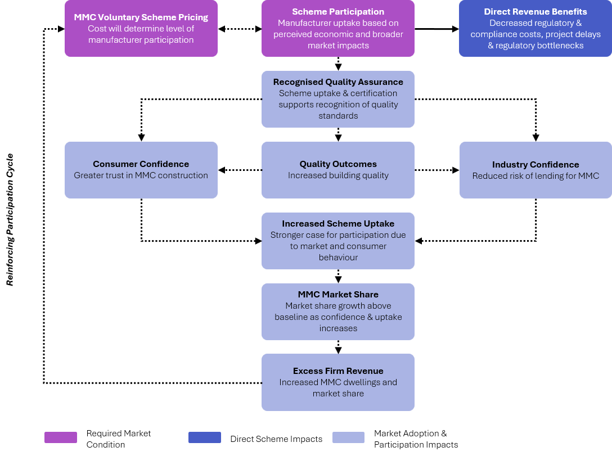

    - Benefits Logic Map
Anticipated cost savings from decreased regulatory and compliance costs provide a direct revenue benefit for manufacturers who participate in the Scheme.
As participation grows, the quality mark provided through Scheme certification becomes more visible and widely recognised across the construction industry. The proposed certification and surveillance framework is intended to support more consistent compliance with NCC requirements, improved manufacturing processes, and reduced risk of defects or noncompliance in delivered buildings. These quality outcomes drive confidence in two ways. Firstly, among consumers who develop greater trust in the quality and standards of dwellings built using MMC methods. Secondly, among broader industry stakeholders such as developers and lenders, who become more comfortable with MMC approaches as a lower-risk approach. A government endorsed quality mark is particularly significant for industry stakeholders, providing an independent verification of standards and processes that lenders and insurers currently lack when assessing MMC projects.
As confidence increases, the case for Scheme uptake is further strengthened. As more manufacturers participate and the quality mark becomes more widely recognised, more buyers can choose MMC with confidence and more developers and builders are willing to specify it. This is expected to increase the proportion of new homes built using MMC above what the market would otherwise deliver.
At the same time, reduced certification requirements mean dwellings move through the approval process more quickly, reducing the time from design to manufacturing to delivery for on-site processes. This directly supports Australia's housing supply objectives by removing a regulatory bottleneck that currently slows delivery.
Note, the benefits pathways depicted in the logic map operate across different time horizons. Direct benefits such as reduced regulatory and compliance costs may materialise in the short to medium term. Confidence and market uptake will likely operate over the medium term while MMC market share growth and dwelling construction impacts are long-term in nature.
Greater MMC market share and faster delivery can also support increased revenue for participating firms. This creates a reinforcing participation cycle where the more manufacturers that join, the more widely recognised the quality mark becomes, the greater the improvement in building quality outcomes, and the greater the market opportunity for those already participating.
However, fundamental to the proposed impacts, is how the Scheme will be priced. If costs are too high, the direct savings may be insufficient to drive the level of uptake needed for the broader market benefits to materialise.
Several associated benefits, including for example housing affordability and supply, workforce skills and development, and improvements to health and safety, sit outside the primary casual benefits modelled. Similarly, improvements in actual building quality outcomes may be difficult to quantify. These impacts nonetheless represent an important component of the Scheme’s value proposition and will be acknowledged qualitatively alongside the other indirect benefits listed. See Chapter 5 Findings for details.
The availability of research and data to inform modelling on identified benefits is varied. The benefits categories included in the logic map and summarised in Table 1 below were selected on the basis of existing evidence. Further detail on the evidence base for each is discussed in 5.3 Direct Benefits.
Identified impacts will be assessed through three approaches:
- quantitative assessment;
- qualitative review; or
- scenario modelling and sensitivity analysis where assumptions are high and the evidence base is low.
The relative weighting of quantitative, qualitative and scenario-based assessment reflects current data limitations and the evolving nature of the Scheme design. Indirect benefits such as increased confidence and market uptake are highly assumption-driven and should be interpreted with caution.
See Table 1 for a summary of the direct and indirect benefits analysed as part of this report.

Table 1 - Summary of direct and indirect benefits to be assessed throughout the analysis
Summary of direct and indirect benefits to be assessed throughout the analysis
Category | Anticipated Benefit | Assessment Approach
Direct Benefit  (considered within the analysis) | - Reduced certification costs per dwelling | Quantifiable
Direct Benefit  (considered within the analysis) | - Reduced time to certification | Qualitative
Direct Benefit  (considered within the analysis) | - Decreased regulatory burden | Qualitative
Indirect Benefit  (considered within the analysis) | - Quality Outcomes | Qualitative
Indirect Benefit  (considered within the analysis) | - Increased quality assurance and standards | Qualitative
Indirect Benefit  (considered within the analysis) | - Increased consumer confidence | Qualitative
Indirect Benefit  (considered within the analysis) | - Increased industry confidence | Qualitative
Indirect Benefit  (considered within the analysis) | - Increased Scheme participation and MMC uptake | Qualitative
Indirect Benefit  (considered within the analysis) | - Increased adoption of MMC dwellings | Qualitative
Indirect Benefit  (considered within the analysis) | - Excess Firm revenue | Quantifiable
Additional Impacts (not considered in the analysis) | - Housing affordability and supply | Qualitative – Additional Consideration
Additional Impacts (not considered in the analysis) | - Sustainability e.g. waste reduction | Qualitative – Additional Consideration
Additional Impacts (not considered in the analysis) | - Industry development e.g. workforce skills, supply chain, health and safety | Qualitative – Additional Consideration

    - Overarching Benefits Assumptions, Limitations and Dependencies
      - Assumptions
The following assumptions underpin the Scheme costing.
- The Scheme is expected to increase MMC adoption above the baseline or the level of MMC uptake that would occur without the Scheme. The scale of this effect is uncertain.
- Direct cost savings per dwelling arise from the removal or reduction of mandatory onsite certification inspections for participating MMC manufacturers, replaced by ongoing surveillance activities under the Scheme. Cost savings are calculated on a per-dwelling basis and vary by jurisdiction and dwelling class, reflecting differences in certification requirements across states and territories.
- The financial viability of Scheme participation for individual firms will depend on the volume of dwellings constructed relative to the annual cost of certification. Below a threshold dwelling volume, the per-dwelling cost saving may be insufficient to offset the annual Scheme fee. Scenario modelling has been used to explore a range of possible outcomes rather than predict a single outcome.
- Indirect benefits (increased consumer and industry confidence, increased Scheme participation and MMC market share growth), are assumed to follow from greater certification and quality assurance. These relationships are assumptions based rather than direct evidence.

      - Limitations
A number of limitations are noted which should be considered when interpreting the analysis.
- There is no post-implementation data available on comparable voluntary MMC certification schemes that directly quantifies the effect of scheme certification on adoption rates, cost savings or dwelling construction outcomes in an Australian context. International comparators, including New Zealand’s BuiltReady scheme, provide limited to no evidence.
- The relationship between scheme participation, consumer and industry confidence, and MMC market share growth is causal but indirect. The scenario modelling captures a range of plausible uptake effects but cannot predict with precision how quickly confidence effects will translate into market behaviour.
- Firm-level benefits are sensitive to Scheme pricing. At higher annual certification costs, smaller firms constructing dwellings may not reach a breakeven point at which Scheme participation is financially viable, potentially concentrating the benefits among larger manufacturers.
- The 10-year assessment period may not fully capture the longer-term market share and dwelling construction benefits of the Scheme, which are expected to grow as certification becomes more widely recognised and the reinforcing participation cycle takes effect.

      - Dependencies
The following dependencies must remain broadly true for the proposed option costing to hold.
- Direct benefits to participating firms are conditional on the annual certification costs being set at a level that is financially viable relative to per-dwelling cost savings. If Scheme pricing is set too high, insufficient manufacturer participation may prevent the broader market confidence and adoption effects from materialising.
- Dwelling construction benefits of MMC adoption depend on sufficient manufacturing capacity existing or being developed to meet increased demand.
- Industry confidence benefits will depend on lenders and insurers recognising Scheme certification as meaningful quality signal.
- Consumer confidence benefits depend on the quality mark becoming sufficiently visible and widely recognised in the construction industry. This will required sustained communication and promotion of the Scheme.

    - Quantitative Modelling Methodology
      - Overview & Scope
The financial benefits of the Scheme cannot be represented by a single figure due to dependencies on several variables. Benefits experienced through cost savings depend on:
- the number of dwellings constructed by manufacturers each year;
- organisation maturity; and
- the price that CABs will charge to firms for certification.
These variations will be accounted for through a series of scenarios that calculate the financial benefit for different volumes of construction and different Scheme prices.

      - Scenario Parameters
Three parameters have been considered in the modelling scenarios to reflect the range of conditions under which manufacturers may participate in the Scheme.
- Annual Dwellings Constructed
The financial benefit experienced by a manufacturer depends directly on the number of dwellings they construct each year. To capture these variations, the financial benefits will be modelled taking into account differing levels of yearly building construction. This allows assessment of companies with different annual outputs to determine at what point it is financially viable for manufacturers to participate in the Scheme.
- Scheme Cost
The annual cost of Scheme participation will directly impact the financial benefit to a manufacturer. The cost manufacturers experience under the Scheme will depend on how much CABs charge for initial certification and ongoing surveillance activities. To capture these conditions, scenarios will be modelled taking into account a range of Scheme costs and firm maturity to indicate what Scheme prices provide a financial incentive for manufacturers to participate.
- Estimated Housing Construction by State and Population Change
To estimate construction volumes over the ten-year assessment period, a combination of a Linear Model and a Bayesian Structural Time Series is used. It draws on ABS data to determine changes in dwelling construction as a function of net population change by state. MMC market share is then applied to the resulting forecast. The MMC industry is expected to grow from 8% by an additional 8% over the next six years, providing a reasonably objective estimate of total MMC dwellings constructed each year.

      - Calculation Method
The direct financial benefit to a participating manufacturer is calculated in three steps, applied across each scenario. This is further described below.
A firm-level assessment framework has been used, as the Scheme is voluntary and participation decisions will be made by individual manufacturers. The individual manufacturer approach has been deemed appropriate because both costs (of participating in the Scheme and being subject to certification and surveillance activities) and benefits (reduced inspection costs and resulting excess firm revenue) are experienced and realised at the individual manufacturer level.
Incurring the costs and realising these benefits are dependent on whether an individual manufacturer decides to participate in the Scheme. Further, participation depends on whether an individual manufacturer will achieve a net benefit, rather than being dependent on the Scheme being beneficial in aggregate.
Assumptions and data sources for costs are noted in Chapter 5 Findings. Due to commercial sensitivities, where information has been sourced through industry consultation, details of who provided this information are not disclosed in this report.

Step 1. Cost Savings Per Year Under the Scheme
For each scenario, costs savings per dwelling is calculated at the jurisdictional level for both Class 1 and Class 2 dwellings. The per-dwelling savings is the difference between current mandatory inspection costs and costs proposed under the Scheme, after applying a state-specific contingency factor to reflect uncertainty with the baseline cost estimates. The contingency discount factor varies from state to state. Savings are then adjusted for CPI annually.
Equation 1 - Cost Savings Per Year
$$Saving{s Per Building}_{juris}= \left(Cost_{base,juris}-Cost_{scheme,juris}\right)\left(1-Con_{juris}\right)\left(1+CPI_{t}\right) \\ Cost_{scheme}=Total Inspection Cost under Voluntary scheme \\ Cost_{base}=Current Total Inspection Cost \\ Con_{juris}=Contigency discount rate for cost saving \\ Savings Per Y Buildings=Y ×Saving{s Per Building}_{juris} \\ CPI_{t}=Relavent CPI Inflator for the year of analysis$$
The current quantitative model focuses on inspection-related cost savings, reflecting the availability of data.
However, additional cost impacts may arise from the Scheme, including administrative efficiencies, reduced approval timeframes, reduced rework, and broader compliance benefits. At present, these impacts are not incorporated into the quantitative model due to limited available data and variability across industry participants.
Please refer to Sections 5.3 Direct Benefits and 5.5 Sensitivity Analysis for application of the above.

Step 2. Financial Benefits Per Year Under the Scheme
The net financial benefit is calculated by subtracting the yearly Scheme cost from the total cost saving across all jurisdictions. Scheme participation consists of the different cost categories outlined in 4.1.2 Third-Party Certification. The net benefit per year is therefore:
Equation 2 - Financial Benefits Per Year
$$Benefit Per Year =\sum_{juris}{\begin{aligned}\left(Saving{s Per Building}_{juris}\right) \\ (Buildings Constructed_{juris})\end{aligned}}-Avg Yearly Scheme Cost$$
The analysis will be extended to identify the conditions under which Scheme participation generates a net financial benefit for manufacturers. Financial benefit under the Scheme is not guaranteed.
Please refer to Sections 5.3 Direct Benefits and 5.5 Sensitivity Analysis for application of the above.
Step 3. Analysing different scenarios to identify where benefits are maximised
The analysis will also identify under which scenarios a firm will experience a financial benefit from participating in the Scheme.
Scenarios will consider:
- differing organisation maturity potential participants may have (i.e. established or mature manufacturers and lower maturity manufacturers)
- differing participation, upfront and ongoing costs
- differing monitoring and surveillance frameworks (i.e. adjustments to the re-certification frequency and surveillance activities).
Please refer to Sections 5.3 Direct Benefits and 5.5 Sensitivity Analysis for application of the above. Where to profit and profitability appear throughout Chapter 4 Economic Analysis Methodology and 5 Findings, these refer to the financial benefit experienced under the Scheme relative to the costs of participation, not a manufacturer’s overall financial position.

References to profit and profitability throughout Chapter 4 Economic Analysis Methodology and 5 Findings represent profitability experienced under the Scheme. It should not be interpreted as a manufacturer’s net profitability holistically, but only as a representation of the costs incurred and cost savings experienced under the Scheme.

Public Consultation Questions
Public Consultation Question 20 relates to section 4.3.4 Quantitative Modelling Methodology.

    - Assumptions and Limitations on Direct Financial Benefits
The direct financial benefits of the Scheme depend on four key factors outlined below.
- Financial Benefit and Scheme incentive is directly proportional to Buildings constructed: The number of dwellings constructed is the biggest determining factor of direct financial benefit to an individual manufacturer. As the primary driver of Scheme incentive, it is also the benefit for which outcomes can be most directly estimated across firms of differing size.
- Only companies that are affected by inspection costs will benefit: Direct financial benefits apply only to manufacturers directly subject to current mandatory inspection costs. Direct financial benefits can only be attributed to companies involved in 3D volumetric construction. For 2D and kit-of-parts benefits, please refer to the Approach to Estimating 2D and Kit-Of-Parts Financial Benefits. This rules out many potential participants from receiving a direct financial benefit, and in many cases, there may be no direct financial benefit for a company to join the Scheme. However, manufacturers who do not participate in 3D volumetric construction currently but join the Scheme may still receive other indirect benefits that are further described in the Benefits Logic Map and Indirect Benefits sections.
- Financial Benefits vary by jurisdiction: The jurisdiction in which a company operates affects the degree to which it receives direct financial benefits. Certification requirements and the resulting cost saving per dwelling vary across states and territories, meaning the financial benefit of the Scheme will differ depending on where dwellings are constructed. For the purposes of this analysis, construction is distributed across jurisdictions in proportion to each state and territory's share of total Australian dwelling completions. Table 2 below sets out this distribution for Class 1 and Class 2 dwellings.
Table 2 - Proportion of Completed Dwellings by Jurisdiction, Class 1 and Class 2, December 2025
Proportion of Completed Dwellings Between January 2024 and Dec 2025 - ABS Total dwelling Completion Data | Class 1 |  | Class 2
 | % | # | % | #
ACT | 1% | 3,848 | 7% | 14,434
NSW | 24% | 80,273 | 42% | 81,664
NT | 0% | 753 | 0% | 0
QLD | 18% | 62,140 | 16% | 31,694
SA | 8% | 26,484 | 2% | 4,113
TAS | 1% | 4,900 | 0% | 364
VIC | 35% | 119,280 | 27% | 51,486
WA | 11% | 38,548 | 5% | 9,392

- Financial Benefits will depend on the cost incurred for the Scheme: The financial benefit experienced by firms is a cost saving on a per dwelling basis, meaning the cost saving increases with the number of dwellings constructed. If the annualised average cost of the Scheme costs more than the total cost saving, the firm has no financial incentive to join the Scheme. The net benefit per year is calculated as follows:
Equation 3 - Net Benefit Per Year
$$Benefit Per Year=Cost Saving ×Buildings Constructed-Avg Yearly Scheme Cost$$

    - Approach to Estimating 2D and Kit-Of-Parts Financial Benefits
Manufacturers of 2D and kit-of-parts products may see increased revenue under the Scheme, as reduction in inspection stages is expected to increase the volume of components a manufacturer can supply.
The current regulatory burden increases the time required to get a kit from a manufacturer to a construction site, and as a result limits the amount of supply the manufacturer can release to the market in a year.
Reduced regulatory burden lowers the timeframe a kit can be delivered to a construction site, which would allow manufacturers to increase output, generating additional revenue each year.
For example, a manufacturer currently delivering an average of 100 kit-of-parts to construction sites annually could theoretically produce 110 kits if delivery time were reduced by 10%. This relies on the assumptions that the manufacturer:
- Has the capacity to produce 110 units; and
- Can find demand in the market for those 110 units.
Modelling assumes both constraints are met. To model the many uncertainties with the benefits, probabilistic methods have been used to estimate benefits under different scenarios.

      - Modelling and Benefits Estimation
This section describes how the analysis estimates the break-even point for 2D and kit-of-parts manufacturers considering entry into the Scheme. Due to the lack of relevant data, Scheme costs for an established, more mature organisation are used to model the additional revenue expected for 2D manufacturers.
Estimated prices for kit-of-parts homes are identified in Table 3 below. Due to difficulties in estimating the distribution of houses a manufacturer produces, a percentage distribution skewed to smaller homes has been assumed. The exact sale price of each build is modelled using a probability distribution using the price ranges in Table 3 as input. The intention is to provide a range of estimates to allow manufacturers to understand the different outcomes they may experience under the Scheme.

Table 3 - Kit-of-Parts Costs
Home Size | Kit Cost Range | Total Build Cost | Price per m² | % Of Overall Builds
2 Bedroom  (80m²) | $45,000 – $85,000 | $120,000 – $200,000 | $1,500 – $2,500 | 50%
3 Bedroom (120m²) | $65,000 – $125,000 | $180,000 – $300,000 | $1,500 – $2,500 | 25%
4 Bedroom (160m²) | $85,000 – $165,000 | $240,000 – $400,000 | $1,500 – $2,500 | 15%
5 Bedroom (200m²) | $105,000 – $205,000 | $300,000 – $500,000 | $1,500 – $2,500 | 10%
The equations below explain the process of estimating the extra revenue the Scheme could generate. There are several components to this equation that allow for the development of confidence intervals for the estimated benefits, given that there is significant uncertainty in the available data. In the equation below, the benefit for any period for a mature manufacturer is taken to be the total revenue generated across all building sizes less the cost of being in the Scheme for any given period.
Equation 4 - Kit-of-Parts Benefits
$$Benefit_{period}= \sum_{j=1 }^{j=4}{(Uplift )(Builds_{period})(Percentage_{j})(Price_{j})}-Inflator*Scheme Cost_{period} \\ Percentage_{j}=\left\{0.5, 0.25, 0.15, 0.1\right\} \\ Price_{1} \sim N\left(\$65000, \$10748\right) we assume the house price is normally distributed for each size \\ Price_{2} \sim N\left(\$95000, \$12897\right), Price_{3} \sim N\left(\$125000, \$17197\right), Price_{4} \sim N\left(\$155000 , \$21496\right) \\ Period=Year of analysis, we consider a total of 10 Years in our analysis \\ Infaltor=CPI adjustment for cost$$
As the exact sale price for each building a manufacturer will sell is unknown, sale prices are modelled as a normal distribution for each size group. An independence property in statistics allows a single distribution for a sale price to be created, which simplifies the calculation and produces the benefit equation below. The equations in bold describe the simplified equations used to estimate the benefit in any given year.
Equation 5 Kit-of-Parts Mean Revenue
$$Benefit_{period}=N\left(mean revenue, standard deviation revenue^{2}\right)- Inflator*Scheme Cost_{period} \\ mean revenue = Builds\left(\begin{aligned} 65000\left(0.50\right)+95000\left(0.25\right)+125000\left(0.15\right)+155000(0.1) \\ \end{aligned}\right)=\$90,500 ×Builds_{period} \\ variance for revenue= Builds^{2}\left({65000}^{2}{(0.5)}^{2}+ {95000}^{2}{(0.25)}^{2}+ {125000}^{2}{(0.15)}^{2}+ {155000}^{2}{(0.1)}^{2}\right)= Builds_{period}^{2}{\left(7109\right)}^{2} \\ Standard Deviation Revenue=Builds_{period} ×7109$$
The final benefits equations simplify to an equation for the mean.
Equation 6 Kit-of-Parts Mean Benefit
$$Mean Benefit in a period=(\$90,500*Builds_{period}*Inflator)- (Inflator*Scheme Cost_{period}) \\ 25\%th Benefit in Period=(Builds_{period}\left(\$90,500-0.674\left(\$7,109\right)\right)*Inflator)-(Inflator*Scheme Cost_{period}) \\ 75\%th Benefit in Period=Builds_{period}\left(\$90,500+0.674\left(\$7,109\right)\right)*Inflator)-(Inflator*Scheme Cost_{period})$$
Uncertainty also exists on the expected uplift in the number of builds a manufacturer can deliver each year. Stakeholder engagement has indicated a variety of different estimates for the time cost of regulatory activity. To model this uncertainty, a small and conservative uplift distribution ranging from 1% to 5% has been assumed.
Combining the above, the expected benefit can be estimated for manufacturers with different production capacities. As an example, if a manufacturer can deliver 20 houses per year with the above price distributions, and the reduction in regulatory activity provides a 2.5% uplift in in the number of houses it can produce in a year, this results in 1 extra build every 2 years. Based on this information and the equations above, a 10-year benefits table can be estimated for a mature manufacturer that experiences lower costs to enter and stay in the Scheme.
Table 4 – Illustrative Example: Estimated 10-Year Benefits, Mature Kit-of-Parts Manufacturer (20 Houses Per Year with a 2.5% Uplift)
Year | CPI inflator | Scheme Cost Per Year | Extra Builds Each Year | Estimated Revenue while not in Scheme | Estimated Revenue while in Scheme with estimated Uplift | Estimated Net Revenue while in Scheme | Estimated Net Benefit Scheme vs Base Case
Year 1 | 1.04 | $46,551 | 0 | $1,886,004 | $1,886,004 | $1,839,452 | -$46,551
Year 2 | 1.09 | $19,734 | 1 | $1,965,216 | $2,063,477 | $2,043,743 | $78,527
Year 3 | 1.13 | $20,563 | 0 | $2,047,755 | $2,047,755 | $2,027,192 | -$20,563
Year 4 | 1.18 | $21,426 | 1 | $2,133,761 | $2,240,449 | $2,219,022 | $85,262
Year 5 | 1.23 | $45,359 | 0 | $2,223,378 | $2,223,378 | $2,178,020 | -$45,359
Year 6 | 1.28 | $23,264 | 1 | $2,316,760 | $2,432,598 | $2,409,335 | $92,574
Year 7 | 1.33 | $24,241 | 0 | $2,414,064 | $2,414,064 | $2,389,823 | -$24,241
Year 8 | 1.39 | $25,259 | 1 | $2,515,455 | $2,641,228 | $2,615,969 | $100,514
Year 9 | 1.45 | $26,320 | 0 | $2,621,104 | $2,621,104 | $2,594,784 | -$26,320
Year 10 | 1.51 | $55,718 | 1 | $2,731,191 | $2,867,750 | $2,812,032 | $80,841
Total |  | $308,434 | 5 | $22,854,688 | $23,437,807 | $23,129,372 | $274,685

  - Traceability
Traceability is considered within this report due to the impacts on costs and benefits arising as a result of participation in the Scheme. Robust traceability supports the realisation of benefits such as quality building outcomes and underpins the quality management processes linked to improved consumer and industry confidence. It may also influence Scheme administration and compliance costs, depending on the traceability approach adopted by manufacturers.
This section is intended to inform the ongoing design and development of the Scheme, assessing key considerations and potential implications for Scheme participants. Detailed case studies are provided in Appendix F - Traceability Case Studies to illustrate practical implementation approaches that may be considered by Scheme participants.
At the current stage of the analysis, the impacts of traceability are not fully quantified and are subject to uncertainty. As such, traceability is primarily incorporated through assumptions within the benefits logic and scenario modelling, rather than as a standalone detailed quantified input. This section outlines key traceability approaches and considerations to:
- inform assumptions used in the economic analysis; and
- support interpretation of cost and benefit pathways associated with the Scheme.
Case studies provided in Appendix F - Traceability Case Studies illustrate potential implementation approaches and are intended to inform the range of possible cost structures and operational models, rather than serve as direct inputs to the quantitative modelling.

    - Overview
For the purposes of this analysis, traceability is defined as “the ability to trace the history, application or location of a building product, component or module”. This definition draws on ISO 9001:2015, which defines traceability as the “ability to trace the history, application or location of an object”, in relation to the origin of materials and parts, processing history, and the distribution and location of a product or service after delivery. It also draws on academic research, which extends the concept to, “the ability to access any or all information relating to that which is under consideration, throughout its entire life cycle, by means of recorded identifications.”
Traceability will also be considered through two frames including internal and external traceability. Internal traceability refers to record keeping within one organisation or manufacturing plant, and external traceability refers to the movement of products throughout the broader supply chain.,
In prefabricated construction, traceability is viewed as crucial for tracking offsite materials through the product lifecycle, with benefits for quality assurance, construction efficiency and onsite management. Growing consumer interest in the origins and quality of residential building components has driven focus to chain of custody requirements and quality assurance processes as mechanisms for building industry confidence.

    - Traceability Solutions
The Scheme is intended to remain technology agnostic, providing manufacturers flexibility in how traceability requirements are met. Alignment with recognised standards may nevertheless support interoperability, consistency and integration with broader industry initiatives.
Consultation feedback on the ABCB Issues Paper identified four solutions that manufacturers may consider adopting, including QR codes, RFID tags, GS1 standards and Digital Product Passports.
      - QR Codes
QR Codes are two-dimensional matrix barcodes readable from any orientation. They can be scanned using any mobile camera, linking users to digital information online.

Box 1 - QR Code Considerations for MMC Manufacturers
Under the Scheme, QR Codes may operate in the following ways:
- Scanning a QR Code could provide access to product specifications, certification status, manufacturing history, installation guidance and other Scheme documentation.
- QR codes would allow products to be identified and/or verified at different stages of the supply chain, from manufacturing and transportation through to delivery and installation.
- Certification bodies could use QR codes to validate product details or access evidence supporting certification and surveillance activities.
QR Codes can operate as a standalone traceability mechanism or can become integrated into more sophisticated systems over time including digital product passports, GS1 standards and RFID technology.
As a low-cost solution requiring limited investment, QR Codes are accessible to manufacturers of varying size and maturity, making them a practical option for Scheme participants.

      - RFID Tags
Radio Frequency Identification (RFID) is a wireless communication technology that captures data linked to the identification attributes of products, including serial numbers, colour, date of purchase, through tags attached to physical items.”RFID systems include a tag attached to the product, a reader that captures tag data, and back-end databases storing tracking locations or product information.

Box 2 - RFID Considerations for MMC Manufacturers
Under the Scheme, RFID systems may operate in the following ways:
- Products would be assigned unique RFID tags linking each item to certification details, manufacturing information and quality assurance records.
- Information could be accessed through systems without requiring direct scanning, reducing reliance on manual data entry.
- Certification bodies could access manufacturing and product information through automated data, improving the reliability and completeness of audit trails.
RFID systems require investment in tags, readers, supporting software and system integration. RFID can function as a standalone traceability solution or form part of a manufacturer’s broader digital ecosystem, with integrations into enterprise resource planning systems, logistics platforms or Digital Product Passports.
Given the required investment, RFID is likely more suitable for manufacturers seeking enhanced operational and assurance outcomes than as a baseline requirement for Scheme participation.

      - GS1 Standards
GS1 standards are internationally recognised standards governing the structure, meaning and exchange of supply chain data. They provide a framework for organisations to design traceability systems around globally consistent product identification, supporting visibility and data accuracy.
z
Box 3 - GS1 Standards Considerations for MMC Manufacturers:
Under the Scheme, GS1 Standards may operate in the following ways:
- Products would be assigned a standardised identifier (e.g. a Global Trade Item Number (GTIN), serial number, etc.), which could be applied through QR codes, barcodes, RFID tags or other technologies.
- GS1 standards would support consistent identification and information sharing practices across the supply chain, also supporting interoperability across the supply chain and digital systems.
- Certification bodies could use standardised identifiers to access information and review supporting evidence during surveillance activities.
GS1 standards don’t require a specific technology solution. Manufacturers can adopt QR codes, RFID tags, Digital Product Passports or other technology while maintaining a consistent identification approach. Adoption costs generally relate to process changes, governance and system alignment activities.
As a standards-based foundation, GS1 can support both baseline and advanced traceability approaches, allowing manufacturers flexibility in implementation while promoting consistency, interoperability and alignment with existing industry and government initiatives.

      - Digital Product Passports
A Digital Product Passport is an electronic tool that captures, processes and shares product-related information across supply chain participants, government agencies and waste management sectors, drawing on data from multiple lifecycle stages. The European Union has mandated Digital Product Passports by 2028 for construction products regulated under the Ecodesign for Sustainable Products Regulation (ESPR).

Box 4 - Digital Product Passport Considerations for MMC Manufacturers:
Under the Scheme, Digital Product Passports may operate in the following ways:
- Products would be assigned a unique identifier (e.g. through a QR Code, GS1 standard identifier, RFID tag or similar technology), linking the physical product to its digital passport.
- Stakeholders would be able to access detailed product information including certification status, manufacturing details, technical specifications, material composition, installation guidance and end-of-life information, with access tailored to different users. Digital Product Passports can record and update information as products move through the supply chain, creating a continuous digital record across the product lifecycle.
- Certification bodies would access the comprehensive evidence base to support product compliance, certification and surveillance activities.
Digital Product Passports can support increasingly sophisticated information requirements over time, making them adaptable to evolving regulatory requirements. However, they require more significant investment than QR Code based approaches, with costs including system development or licensing, data governance, information management processes, system integration and ongoing maintenance. Given this, Digital Product Passports are more suitable as a future-state capability rather than a baseline requirement.
    - Application to the Scheme
The traceability solutions described above, will be assessed against the following principles:
- Accessibility: minimising unnecessary implementation burden, particularly for smaller manufacturers
- Interoperability: supporting alignment with recognised industry standards and data exchange across the supply chain
- Assurance: enabling trusted certification, surveillance and compliance assurance activities
- Scalability: remaining technology agnostic and adaptable to future digital capability developments
Against these principles, traceability options for manufacturers under the Scheme can be framed through three pathways:
- Baseline / minimum viable traceability: QR-enabled product identification and record linkage, supporting accessible and lower-cost traceability uplift, while still enabling key outcomes such as product identification.
- Preferred interoperable pathway: Alignment with GS1 standards to support consistency, interoperability and scalable information exchange.
- Future maturity: Optional digital product passport and advanced digital traceability capabilities for higher-value, higher-risk or more complex MMC systems.

    - Assumptions, Limitations and Dependencies
      - Assumptions
The following assumptions underpin how traceability is treated in the analysis:
- The Scheme will remain technology agnostic on traceability, with manufacturers retaining flexibility in how requirements are met.
- Traceability is assumed to operate at the appropriate level (e.g. product, batch, etc.) depending on the manufacturer’s capability and product type.
- Manufacturers and Scheme participants are assumed to have basic digital capabilities, including the ability to store and retrieve product data electronically.

      - Limitations
The following limitations should be considered when interpreting the analysis.
- There is limited Australian data on traceability costs and benefits, particularly for MMC. International comparators may not be directly reflective, due to differences in regulatory systems, construction practices and participant digital maturity.
- Traceability implementation is expected to vary across product types, manufacturer size and digital maturity.
- Traceability technologies continue to evolve, creating uncertainty on long-term costs and performance assumptions. Future efficiency gains or cost reductions from technological advancements may not be fully captured.

      - Dependencies
The following dependencies must remain broadly true for the analysis to hold.
- Traceability relies on manufacturers having digital systems to host product data, reliable network connections on construction sites and in manufacturing sites, and secure data storage and retrieval systems.
- Interoperability depends on alignment with recognised standards. Inconsistent standards adoption could lead to fragmented or siloed data systems.
- The value of traceability depends on integration with certification processes, surveillance activities, compliance frameworks and regulatory approval processes.
- Traceability requires coordination across multiple supply chain participants, including manufacturers, logistics providers, builders and certifiers. Gaps can result in the reduction of traceability completeness.
- QR code-based systems depend on the ability to print and apply durable identifiers, access to scanning devices, a basic digital system to host linked product information, network access to retrieve information onsite, and processes to ensure linked information remains accurate and current.
- RFID systems depend on the ability to attach tags to products, deploy RFID reader infrastructure and ensure they perform reliably in construction environments (e.g. with dust and moisture). Systems must be in place to automatically record movement, location and status updates, removing the need for manual scanning. Supply chain actors also require sufficient digital capabilities to interpret and use the real-time tracking data
- GS1 standards depend on the assignment of globally unique identifiers and the ability to structure data in standardised formats. Interoperable data exchange relies on agreed standards, and the physical carriers (e.g. QR codes, RFID tags) must encode GS1-compliant identifiers.
- Digital Product Passports depend on the existence of systems capable of storing, managing and updating the comprehensive product lifecycle information. Clear rules for data ownership, auditability and version control are required, along with secure storage infrastructure to support extended product lifecycles (e.g. post-occupancy). Different stakeholders would be granted access to different information depending on their role.

  - Stakeholder Engagement
As part of the analysis, we consulted a range of stakeholders including peak industry groups, state and territory government representatives, and construction industry members. Noting the commercial sensitivity of the information being, explicit stakeholder details cannot be provided. Key points are outlined below:
- A lack of reliable and quantifiable data on current MMC construction on costs and benefits can lead to speculation
- In the absence of nationally consistent standards for MMC construction, cost information is largely market driven. Figures used are based on approximate information disclosed by stakeholders, and should be interpreted accordingly
- Information captured on comparator schemes and international markets whilst useful for context setting and lessons learnt for Scheme implementation, reflect market maturity and conditions vastly different to the domestic operating environment.



Findings
  - Baseline Costs
    - Costing Approach and Assumptions
Cost information presented in this section was primarily informed by consultations with industry stakeholders across all jurisdictions. Recognising limitations in the availability and consistency of market data, the analysis applies average estimates and reasonable assumptions to establish an indicative cost baseline.
Inspection costs are inherently variable and may differ depending on factors such a building size, complexity, location and the scope of the work required. Accordingly, estimates should be interpreted as indicative, rather than universally applicable.
Due to commercial sensitivities, details of industry stakeholders who provided this information are not disclosed in this report.
For further details on assumptions, limitations and dependencies, please refer to:
- 4.1.1.3 Key Assumptions;
- 4.1.1.4 Limitations; and
- 4.1.1.5 Dependencies.
    - Baseline Mandatory Inspection Costs
In the base case, the only cost of interest is mandatory inspections and includes building and plumbing inspections. Any other costs manufacturers bear in undertaking their activities is not considered relevant for this analysis.
Baseline mandatory inspection costs reflect existing regulatory requirements across jurisdictions. These costs are incurred by the market to meet compliance obligations and represent the status quo against which the option is assessed. The analysis accounts for differences in inspection requirements, frequency and associated costs. Baseline costs are not uniform across the market and are based on information provided by consulted stakeholders.
Table 5 outlines indicative inspection costs for a Class 1 and Class 2 dwelling.
Table 5 – Indicative mandatory inspection costs in the base case
Jurisdiction | Class 1 |  |  | Class 2
Jurisdiction | No. of mandatory inspections |  | Total inspection cost | No. of mandatory inspections |  | Total inspection cost
Jurisdiction | Building | Plumbing | Total inspection cost | Building* | Plumbing | Total inspection cost
ACT | 4 | 0 | $1,373 | 9 | 0 | $8,325
NSW | 5 | 0 | $2,575 | 11 | 0 | $10,908
NT | 8 | 2 | $3,842 | 13 | 2 | $6,549
QLD | 4 | 9 | $6,684 | 6 | 9 | $19,741
SA | 0 | 4 | $492 | 6 | 4 | $10,005
TAS | 6 | 0 | $3,050 | 12 | 0 | $6,800
VIC | 4 | 0 | $1,693 | 14 | 0 | $14,247
WA** | 4 | 2 | $2,697 | 15 | 2 | $11,450
* Note for Class 2 Building inspections: stakeholder engagement indicated the number of additional inspections required varied greatly depending on the building size. To address this, an additional 6 inspections have been applied to each building. This is based on a proportional allocation of additional inspections anticipated on the number of storeys a low, medium or high-rise building may have. This assumption applies to both the baseline and the Scheme costs.
** Note for WA: While Western Australia does not prescribed mandatory inspection stages, the figures provided are indicative only and have been derived from feedback from building surveyors on typical inspection practices. As such, they should be treated as approximate and reflective of industry experience rather than regulatory requirements.
Industry consultation did not provide sufficient evidence of an MMC mark-up or a regional on-cost contribution. If these costs were to be justified, this would increase the potential benefits identified.

Public Consultation Questions
Public Consultation Questions 21 to 24 relate to section 5.1.2 Baseline Mandatory Inspection Costs

  - Third-Party Certification Costs
    - Costing Approach and Assumptions
Cost information presented in this section was primarily informed by discussions with the ABCB, industry stakeholders and desktop research. As the Scheme is still under development, these costs are indicative and may not capture all costs in the event of material changes to Scheme requirements.
Costs are incremental to the baseline and present costs incurred as a result of participating in the Scheme. The costs considered include:
- Certification costs – the initial assessment undertaken by the CAB.
- Scheme administration costs: activities conducted by the Scheme Owner, Scheme Administrator and Accreditation Body.
- CAB and DAB participation costs: preparatory activities CABs and DABs undertake to participate in the Scheme and be able to conduct certification activities. For CABs, this may involve accreditation preparation activities, while DABs may have specific registration requirements or skillsets.
- Surveillance costs: ongoing costs of surveillance activities undertaken by the CAB.
- Transitional and set-up costs: costs manufacturers may incur to develop the skills and processes to participate in the Scheme.
- Traceability costs: costs manufacturers may incur to comply with traceability requirements.
- Costs of maintaining certification: activities manufacturers may conduct to ensure ongoing compliance with Scheme requirements.
- Costs of re-certification: the assessment conducted by the CAB prior to the end of the Certification validity period.
- Insurance costs: the potential increase in insurance costs due to liability shifting from building surveyors to manufacturers.
Manufacturers can also elect to have a design approved and is an optional activity. Design approval costs reflect the initial assessment undertaken by the DAB, while design approval re-certification costs captures the assessment conducted by the DAB to the end of the design approval validity period.
Each cost category described above will be discussed in more detail in 5.2.2 Anticipated Costs of Participating in the Scheme.
Where costs are related to activities conducted by CABs and DABs:
- The costs are structured to reflect the time and complexity of the assessment, with higher costs associated with more complex assessments or where additional review or specialist technical guidance is required.
- Certification / approval, surveillance and re-certification / re-approval costs are market-driven and set by CABs and DABs and are not fixed or centrally regulated. Each CAB and DAB determines its own commercial arrangements, their own fee structures based on their cost base, the level of technical expertise and other commercial considerations. Fees may vary between CABs and DABs for comparable services, reflecting variations in overheads, resourcing models, methodologies and market positioning. Manufacturers may consider applying to different CABs and DABs, with pricing influenced by competitive market conditions as well as the complexity and risk profile of the certification.
- The cost estimates applied in this analysis are based on indicative market rates obtained through stakeholder consultation and should be interpreted as averages rather than a fixed or universally applicable fee. Due to commercial sensitivities, details of industry stakeholders who provided this information are not disclosed in this report.
For further details on assumptions, limitations and dependencies, please refer to:
- 4.1.2.3 Key Assumptions;
- 4.1.2.4 Limitations; and
- 4.1.2.5 Dependencies.

    - Anticipated Costs of Participating in the Scheme
Table 6 - Summary of Anticipated Costs of Participating in the Scheme
Cost category | Frequency | Indicative cost range
Certification costs | Once-off | $25,000 - $50,000
Scheme administration costs | N/A | $0
CAB and DAB participation costs | N/A | $0
Surveillance costs | Annual | $20,000
Transitional and set-up costs | Once-off | $1,500 - $80,900
Traceability costs | Annual | $675
Costs of maintaining certification | Annual | $0 - $22,500
Costs of re-certification | Every 3 years | $18,750 - $37,500
Insurance costs | Annual | $7,500 - $15,000
Optional costs
Design approval costs | Once-off | $15,000
Costs of design re-approval | Every 3 years | $7,500
* Note for surveillance costs and costs of re-certification: the cost reflected above are reflective of the central case settings, where an annual cost for surveillance covers 4 audits and inspections (i.e. occurring every 3 months), and a re-certification cost incurred once every 3 years, i.e. where the Certification is valid for 3 years. Scenarios where the number of audits and inspections conducted in a year differ, and where the period of Certification validity differs are described in 5.5 Sensitivity Analysis.
Certification costs
Certification costs are the fees a CAB charges to conduct the initial assessment to provide certification. Manufacturers apply to a CAB for certification, following which the CAB reviews the application, prepares an Evaluation Plan and assessing policies, procedures and systems. The CAB also undertakes a risk assessment and conducts evaluations in accordance with the Evaluation Plan. Based on the evaluation, an Evaluation Report is produced and a certification decision is made. For detailed activities, please refer to the Draft Scheme Rules.
Table 7 - Certification costs
Cost category | Frequency | Indicative cost range
Certification costs | Once-off | $25,000 - $50,000
Scheme administration costs
Scheme administration costs are costs associated with the Scheme Administrator’s role and function. This includes activities such as establishing and maintaining a public Scheme register, reporting requirements on participation, CAB and DAB performance and providing the Coordination and Consistency Forum. For detailed activities, please refer to the Draft Scheme Rules. These costs may also include broader governance functions such as Scheme oversight, guidance development and ongoing improvements to the Scheme, as well as audit activities that the Scheme Administrator or Accreditation Body conducts.
These costs are assumed to be passed onto other Scheme participants, and as a result, to manufacturers. This cost is expected to be passed on through the certification costs.
CAB and DAB participation costs
CAB and DAB participation costs are costs associated with the activities CABs and DABs undertake to participate in the Scheme. This may include:
- Training and competency development: staff training on Scheme rules, technical competence in conducting evaluations, technical training on ISO 17065:2012 Conformity assessment – Requirements for bodies certifying products, processes and services;
- documentation readiness: preparation and development for documentation required for accreditation, such as standard operating procedures, guidance on handling complaints, documenting governance protocols;
- accreditation fees: fees charged by the Accreditation Body to the CAB to become accredited;
- scheme registration fees: fees the Scheme Owner may charge for participation in the Scheme, similar to what ABCB charges in WaterMark;
- recruitment activities: including engaging an Unrestricted Building Surveyor.
These costs and any additional ongoing costs incurred through periodic reassessment or surveillance activities, are assumed to be passed to the manufacturer via certification costs.
Surveillance costs
Surveillance costs are costs associated with the ongoing compliance surveillance activities. CABs are required to undertake routine surveillance of the manufacturer’s facilities. The scope of surveillance is determined with consideration of the risk assessment outlined in the Evaluation Plan developed during the initial certification.
Table 8 – Surveillance costs
Cost category | Frequency | Indicative cost range
Surveillance costs | Annual | $20,000
* Note for surveillance costs: the cost reflected above is an annual cost covering 4 audits and inspections (i.e. occurring every 3 months). Scenarios where the number of audits and inspections conducted in a year differ are described in 5.5 Sensitivity Analysis.
Transitional and set-up costs
Transitional and set-up costs are costs a manufacturer may incur to prepare for participation in the Scheme. These may include:
- Training and competency development: staff training on Scheme rules and technical training on ISO standards;
- Quality Management System (QMS), procedure and documentation readiness: preparation and development of documentation for certification, including updating QMS processes, support in governance arrangements, and standard operating procedures;
- Factory and process changes: updating processes to align with Scheme requirements, establishing quality assurance checkpoints, and reconfiguring production lines to support traceability;
- Issues response set up: developing or updating procedures for identifying, recording and managing issues or non-conformities, defining roles and responsibilities for issues management, establishing corrective and prevention action processes, managing non-conformity and maintaining records to support investigations and surveillance; and
- Administration costs: initial Scheme registration fees and application processing fees, costs of preparing and submitting the initial application, and other registration costs they may incur.
The cost estimates applied in this analysis are based on desktop research and should be interpreted as averages rather than a fixed or universally applicable fee.
Table 9 – Transitional and set-up costs
Cost category | Frequency | Indicative cost range
Transitional and set-up costs | Once-off | $1,500 - $80,900
The costs described above will differ depending on the maturity of the manufacturer. It is assumed that a mature manufacturer will not need to incur majority of the costs, whereas a start-up manufacturer (further discussed in 4.1.2.2 Organisation Maturity and Option Modelling) may incur all the costs.
Traceability costs
Traceability costs are costs associated with implementing systems that provide the ability to trace the history of a product, particularly through the supply chain.
For the purposes of this analysis, manufacturers are assumed to adopt the lowest cost solution that satisfies Scheme requirements. This reflects the assumption of cost-minimisation behaviour by industry, particularly where there are numerous options available. Estimated traceability costs reflect a minimum cost rather than the adoption of higher-cost or more sophisticated systems that some manufacturers may choose to implement based on their existing capabilities or preferences.
Depending on the complexity of the traceability solution adopted, manufacturers may incur costs related to:
- System and/or software costs: subscriptions, licensing fees and data storage costs;
- Identification and/or labelling costs: QR codes, barcodes, RFID tags or other identifiers, labelling materials including labels and printers, systems to support management of product batch identifiers, and installing labelling or scanning equipment on production lines;
- Hardware and infrastructure costs: scanning devices, upgrades to IT infrastructure such as networks or servers;
- Process and system integration costs: redesigning production workflows to incorporate traceability, integrating traceability into quality assurance systems, and testing and validation;
- Labour costs: time required to train staff to use traceability systems and implement the system;
- Ongoing costs: maintaining systems and processes, subscriptions, and updating product records or information;
- Compliance and reporting costs: maintaining records or responding to traceability-related queries.
The cost estimates applied in this analysis are based on desktop research and should be interpreted as averages rather than a fixed or universally applicable fee.
Table 10 – Traceability costs
Cost category | Frequency | Indicative cost range
Traceability costs | Annual | $675
GS1 Standards (barcode solution) | Annual | $675 - $15,000
QR Codes | Annual | $800 - $2,400
RFID Solutions | Annual | $7,000 - $140,000
Digital Product Passport Solutions | Annual | $16,500 - $165,000

Costs of maintaining certification
Costs of maintaining certification are expected to vary depending on the maturity of a manufacturer’s existing quality management systems. Lower maturity manufacturers are likely to incur ongoing costs to maintain certification, to undertake activities such as policy updates, staff training, document control and audit and inspection preparation.
In contrast, mature manufacturers are assumed to have existing quality management systems in place, such as ISO 9001:2015 alignment or equivalent frameworks. For these manufacturers, ongoing activities to maintain certification should already exist within their current processes. As a result, they are assumed to incur minimal or no additional incremental ongoing costs.
As lower maturity manufacturers experience capability uplift through their participation in the Scheme, these costs have the potential to taper off. 5.5.2 Lower Maturity Manufacturers includes a scenario where over 5 years, the cost of maintaining certification may reduce to the levels of an established or mature manufacturer.
The cost estimates applied in this analysis are based on desktop research and should be interpreted as averages rather than a fixed or universally applicable fee.
Table 11 – Costs of maintaining certification
Cost category | Frequency | Indicative cost range
Costs of maintaining certification | Annual | $0 - $22,500
Costs of re-certification
Costs of re-certification are costs associated with the re-certification audit and inspection undertaken by the CAB. CABs are required to undertake a comprehensive reassessment of the full scope of certification and determine if the Evaluation Plan remains appropriate.
Table 12 – Costs of re-certification
Cost category | Frequency | Indicative cost range
Costs of re-certification | Every 3 years | $18,750 - $37,500
* Note for costs of re-certification: the cost reflected above is for a cost incurred once every 3 years, i.e. where the Certification is valid for 3 years. Scenarios where the period of validity differs are described in 5.5 Sensitivity Analysis.
Insurance costs
Insurance costs reflect the potential increase in premiums arising from a shift in liability under the Scheme, from building surveyors to manufacturers, reflecting greater reliance on a manufacturer’s declarations and certification outcomes. As a result, manufacturers may experience increased insurance premiums, particularly in relation to public liability and professional indemnity cover. Insurers may reassess risk profiles in responses to the expanded scope of a manufacturer’s responsibilities and the introduction of formal certification.
Cost estimates applied in this analysis are based on both indicative market rates obtained through stakeholder consultation and desktop research and should be interpreted as averages rather than a fixed or universally applicable fee. Due to commercial sensitivities, details of industry stakeholders who provided this information are not disclosed in this report.
The magnitude of insurance cost impacts is uncertain and likely to vary depending on the extent to which certification is recognised by insurers as a risk mitigation mechanism, as well as individual risk profiles and exiting insurance arrangements.
Table 13 – Insurance costs
Cost category | Frequency | Indicative cost range
Insurance costs | Annual | $7,500 - $15,000
Optional - Design approval costs
Design approval costs are the fees a DAB charges to conduct the initial assessment to provide design approval. Manufacturers will apply to a DAB for design approval, following which the DAB reviews the application, confirms the design approval, and conducts an assessment throughout its evaluation process. Based on the evaluation, an Evaluation Report is produced and an approval decision is made. For detailed activities, please refer to the Draft Scheme Rules.
Table 14 – Design approval costs
Cost category | Frequency | Indicative cost range
Design approval costs | Once-off | $15,000
Optional – Costs of design re-approval
Costs of re-approval are costs associated with the reassessment required to determine whether the design remains compliant and whether any changes are required.
Table 15 – Costs of design re-approval
Cost category | Frequency | Indicative cost range
Costs of design re-approval | Every 3 years | $7,500
* Note for costs of re-approval: the cost reflected above is for a cost incurred once every 3 years, i.e. where the Approval is valid for 3 years.

Public Consultation Questions
Public Consultation Questions 25 to 30 relate to section 5.2 Third-Party Certification Costs.Public Consultation Questions 25 to 30 relate to section 5.2.1

  - Direct Benefits
The following section outlines the net financial benefits manufacturers involved in 3D volumetric construction may experience through Scheme participation. Benefits are measured as a reduction in mandatory inspection costs under the Scheme, offset against the costs of entry and ongoing participation. As outlined in Section 4.1.2.2, these costs vary depending on the organisational maturity of the manufacturer. For benefits experienced by 2D and kit-of-parts manufacturers, please refer to Quantitative Benefits - Excess Firm Revenue.

    - Cost Savings Per Build Under the Scheme
A direct benefit expected to arise from the Scheme is the reduction of certification costs and regulatory burden for MMC manufacturers. Currently, MMC manufacturers must navigate inconsistent state and territory processes designed for traditional onsite construction.
The ABCB issues paper identified that these fragmented regulatory frameworks are impractical and inefficient, creating a barrier for MMC uptake in Australia. Similarly, The Housing Industry Association (HIA) noted that regulatory ambiguities and barries in approvals processes has prevented greater uptake of MMC construction.
Research indicates that regulatory and policy settings are a driving force in the feasibility of prefabricated construction from a cost perspective.
Targeted support through policies, incentives, schemes and regulations strongly encourages utilisation of MMC, which can be seen in countries such as Sweden, China and Japan.
A Scheme providing streamlined compliance for MMC manufacturers would directly reduce the regulatory costs and administrative burden currently imposed, addressing a barrier that research consistently identifies as a material constraint for MMC uptake in Australia.
Manufacturers involved in 3D volumetric construction will experience a direct cost saving on a per build basis under the Scheme. The primary driver is the removal of mandatory inspection stages, which generates a savings for each dwelling constructed. This direct cost saving is dependent on the establishment of supporting legislative and regulatory instruments across jurisdictions. The size of the saving varies by jurisdiction, reflecting differences in existing inspection cost structures across jurisdictions. Manufacturers with higher build volumes will experience large savings under the Scheme. For further details on the methodology used, including how benefits are considered for 2D and kit-of-parts manufacturers, please refer to the Economic Analysis Methodology section.
Table 16 sets the per-build cost savings by state and territory for Class 1 buildings, with a contingency applied, alongside the distribution of national dwelling construction used to allocate savings across jurisdictions. The contingency is reflective of the uncertainty of data received, and the robustness of the data utilised in analysis.
Nationally, total costs are estimated at $51,826 for a manufacturer producing 50 Class 1 buildings per year, rising to $103,080 at 100 buildings per year.
At a per dwelling rate, Queensland records the highest savings at $3,537, followed by the Northern Territory at $1,393, and Western Australia at $1,089. These jurisdictions reflect higher baseline inspection costs relative to other jurisdictions. The ACT records the lowest savings at $249, followed by Victoria at $307, however its 35% share of national dwelling construction means it contributes the largest volume of buildings to the aggregate savings calculation, accounting for 17 of the 50 buildings and 36 of the 100 buildings modelled.
The NT reflect the only jurisdiction where the Scheme generates no cost savings for Class 1 buildings at the aggregate level for 50 and 100 buildings and can be attributed to the lowest dwelling construction allocation at 0%.
Table 16 - Per-Build Cost Savings by Jurisdiction (Class 1)
Juris. | Cost Saving with Contingency | Percentage Allocation to States | Buildings Allocated to State (50 Total) | Total Cost Saving for 50 Class 1 Buildings | Buildings Allocated to State (100 Total) | Total Cost Saving for 100 Class 1 Buildings
ACT | $249 | 1% | 1 | $249 | 1 | $249
NSW | $773 | 24% | 12 | $9,270 | 24 | $18,540
NT | $1,393 | 0% | 0 | $- | 0 | $-
QLD | $3,537 | 18% | 9 | $31,841 | 18 | $63,682
SA | $357 | 8% | 4 | $1,427 | 9 | $3,210
TAS | $788 | 1% | 1 | $788 | 1 | $788
VIC | $307 | 35% | 17 | $5,218 | 36 | $11,049
WA | $1,089 | 11% | 6 | $3,034 | 11 | $5,562
Total |  | 100% | 50 | $51,826 | 100 | $103,080
The curves in Figure 5 below illustrates how per build savings scale with build volumes across jurisdictions for Class 1 buildings, modelled up to 1,000 dwellings. Queensland and the Northern Territory indicate the largest savings whilst the ACT generates negligible savings across most build volumes, with material savings only emerging at close to 1,000 dwellings.
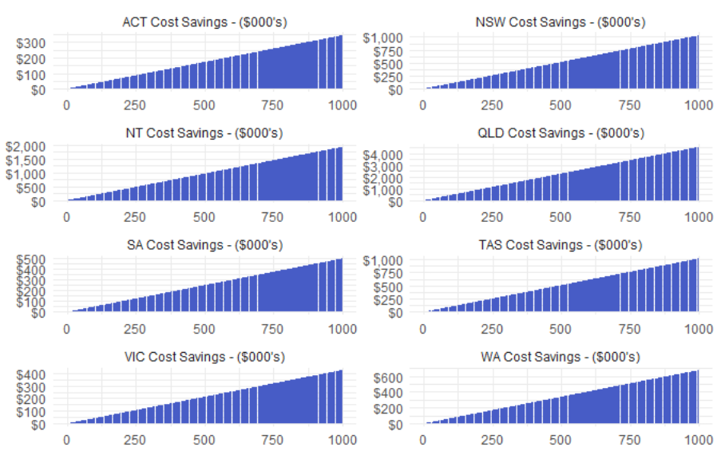
Figure 5 - Total Cost Savings by Jurisdiction and Build Volume (Class 1)

Table 17 sets the per-build cost savings by state and territory for Class 2 buildings, with a contingency applied, alongside the distribution of national dwelling construction used to allocate savings across jurisdictions.
At a per dwelling rate, Queensland records the highest savings at $2,705, followed by New South Wales at $1,488, and Victoria at $1,476. These jurisdictions reflect higher baseline inspection costs relative to other jurisdictions. The ACT records the lowest savings at $0, followed by the Northern Territory at $365.
The ACT, the NT and Tasmania reflect the only jurisdictions where the Scheme generates no cost savings for Class 2 buildings at the aggregate level for 25 or 50 dwellings. The ACT findings are reflective of no anticipated changes to Class 2 inspection requirements under the Scheme, whereas the NT and Tasmania are reflective of the very minor allocation of homes to each jurisdiction (both 0%).
Table 17 - Per-Build Cost Savings by Jurisdiction (Class 2)
Juris. | Cost Saving with Contingency | Percentage Allocation to States | Buildings Allocated to State (25 Total) | Total Cost Saving for 25 Class 2 Buildings | Buildings Allocated to State (50 Total) | Total Cost Saving for 50 Class 2 Buildings
ACT | $- | 7% | 1 | $- | 4 | $-
NSW | $1,488 | 42% | 11 | $16,363 | 21 | $31,238
NT | $365 | 0% | - | $- | - | $-
QLD | $2,705 | 16% | 4 | $10,821 | 8 | $21,641
SA | $357 | 2% | 1 | $357 | 1 | $357
TAS | $878 | 0% | - | $- | - | $-
VIC | $1,476 | 27% | 7 | $10,329 | 13 | $19,182
WA | $1,107 | 5% | 1 | $1,107 | 3 | $3,321
Total |  | 100% | 25 | $38,976 | 50 | $75,738
The curves in Figure 6 below illustrates how per build savings scale with build volumes across jurisdictions for Class 2 buildings, modelled up to 200 dwellings. Queensland, New South Wales and Victoria indicate the largest savings, with material savings only emerging at close to 1,000 dwellings for the Northern Territory and South Australia.
The ACT generates no savings at any volumes. This reflects that the fact that the Scheme is not anticipated to change the current mandatory inspection stages in place. As a result, there are no cost savings associated with participating in the Scheme.
Figure 6 - Total Cost Savings by Jurisdiction and Build Volume (Class 2)
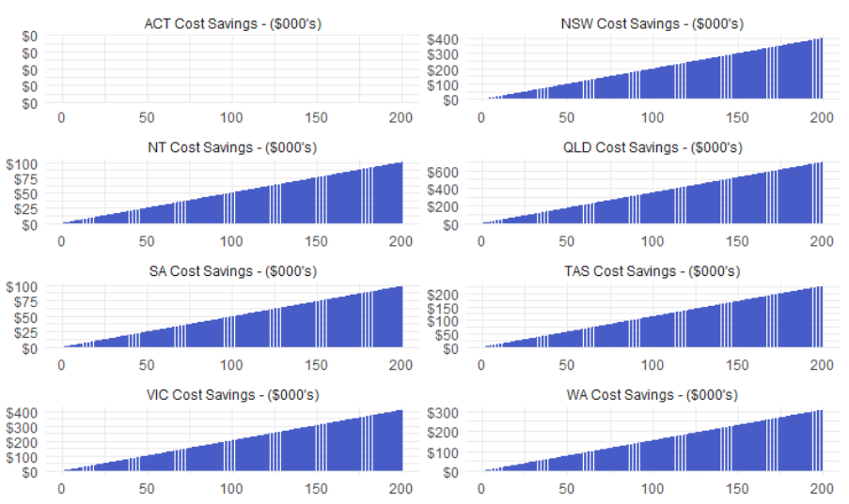
Changes to the percentage allocation rate across states for both Class 1 and Class 2 buildings would impact the total cost saving anticipated for the

      - Central Case – 3D Volumetric Construction
The central case models the net financial benefits of Scheme participation for a mature manufacturer involved in 3D volumetric construction. As outlined in Section 4.1.2.2, these organisations assume a level of organisation capability to meet Scheme entry requirements.
In this profile, transitional costs are reduced to a minimum, resulting in stronger net benefits and a lower dwelling volume required to reach a financial benefit. Surveillance activities occur every quarter, and a Certificate is valid for 3 years.
The cost structure underpinning the central case is set out in Table 18 below. Initial certification costs are at the lower end at $25,000, with transitional set up costs of $1,500. CAB surveillance costs are set at $20,000 per year based on a required audit and inspection every three months. Traceability costs are set at the minimum of $675 per year and insurance costs are expected to increase by $7,500 per year because of Scheme participation. These costs reflect an organisation that has the systems and capabilities in place to participate in the Scheme with lower input costs compared to a less established manufacturer.
Table 18 - Central Case Cost Structure (Mature Manufacturer)
Cost category | Frequency | Cost
Certification costs | Once-off | $25,000
Surveillance costs | Annual | $20,000
Transitional and set-up costs | Once-off | $1,500
Traceability costs | Annual | $675
Costs of re-certification | Every 3 years | $18,750
Insurance costs | Annual | $7,500
The analysis should be read as standalone cases, where if a manufacturer constructs Class 1 dwellings, they should refer to those findings. Likewise, if a manufacturer constructs Class 2 dwellings, they should refer to those findings. The analysis should not be interpreted as requiring manufacturers to construct both Class 1 and Class 2 dwellings at levels described to be financially beneficial.
        - Class 1 Buildings
Under the conditions outlined above a mature Class 1 manufacturer needs to construct on average 36 Class 1 buildings annually to be financially beneficial.
At 50 builds per year, a manufacturer would receive a benefit of $202,538 over the 10-years.
At 100 Class 1 builds per year, a manufacturer would receive a benefit of $837,468 over 10 years, with a cost to benefit ratio of 1:3.0.
Figure 7 below illustrates how net benefits vary across the full range of build volumes modelled. In addition to identifying the financially beneficial threshold at 36 builds, the chart demonstrates that net benefits increase consistently with build volume beyond this point.
The full year-on-year breakdown is set out in Table 19 below. Entry costs in Year 1 are elevated at $56,971 due to once-off certification and set-up costs incurred at the point of joining the Scheme. From Year 2 onwards, annual costs fall to a range of $30,591 to $67,954, with higher cost years reflecting re-certification cycles. Despite the elevated first-year costs, both the 50 and 100 build scenarios generate a net positive benefit from Year 2 onwards.

Figure 7 - Central Case Net Benefits by Build Volume (Class 1)
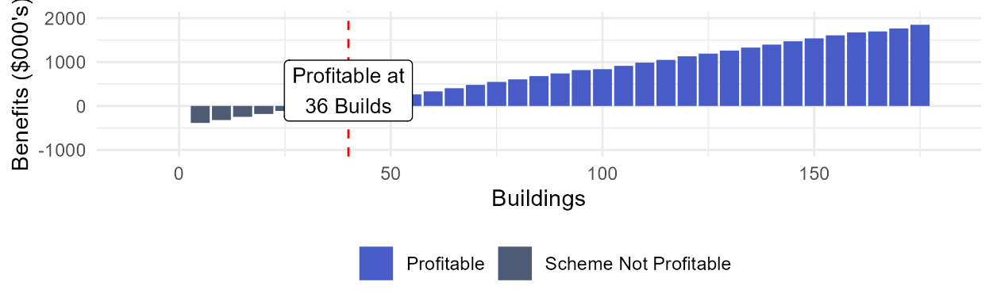
Table 19 - Central Case Net Benefits by Year (Class 1)
Year | Cost to Enter and Stay in Scheme | Inflation Adj Total Cost Saving for 50 Buildings | Benefit Per Year 50 Buildings | Inflation Adj Total Cost Saving for 100 Buildings | Benefit Per Year 100 Buildings
Year 1 | $56,971 | $54,322 | -$2,649 | $106,718 | $49,747
Year 2 | $30,591 | $56,604 | $26,013 | $111,200 | $80,609
Year 3 | $53,089 | $58,981 | $5,892 | $115,870 | $62,781
Year 4 | $33,215 | $61,459 | $28,244 | $120,737 | $87,522
Year 5 | $34,610 | $64,040 | $29,430 | $125,808 | $91,198
Year 6 | $60,063 | $66,730 | $6,666 | $131,092 | $71,028
Year 7 | $37,578 | $69,532 | $31,954 | $136,598 | $99,019
Year 8 | $39,157 | $72,453 | $33,296 | $142,335 | $103,178
Year 9 | $67,954 | $75,496 | $7,542 | $148,313 | $80,359
Year 10 | $42,515 | $78,666 | $36,151 | $154,542 | $112,027
Total | $455,743 | $658,283 | $202,539 | $1,293,213 | $837,468

        - Class 2 Buildings
Under the conditions outlined above a mature Class 2 manufacturer needs to average 23 Class 2 builds annually to be financially beneficial.
At 25 builds per year, a manufacturer would receive a benefit of $34,018 over the 10-years.
At 50 Class 2 builds per year, a manufacturer would receive a benefit of $512,688 over the 10 years, with a cost to benefit ratio of 1:2.1.
Figure 8 below illustrates how net benefits vary across the range of build volumes modelled. In addition to identifying the financially beneficial threshold at 23 builds, the chart demonstrates that net benefits increase consistently with build volume beyond this point.
The full year-on-year breakdown is set out in Table 20 below. Entry costs in Year 1 are elevated at $56,971 due to once-off certification and set-up costs incurred at the point of joining the Scheme. At 25 builds per year, manufacturers experience a loss of $16,555 in Year 1 before a net positive benefit is achieved in Year 2 at $11,522. At 50 builds per year, the Scheme is financially beneficial from the first year, generating $22,945 and increasing to $73,215 in Year 10. From Year 2, annual costs follow the same pattern as Class 1, with higher costs reflecting recertification cycles.
Figure 8 - Central Case Net Benefits by Build Volume (Class 2)
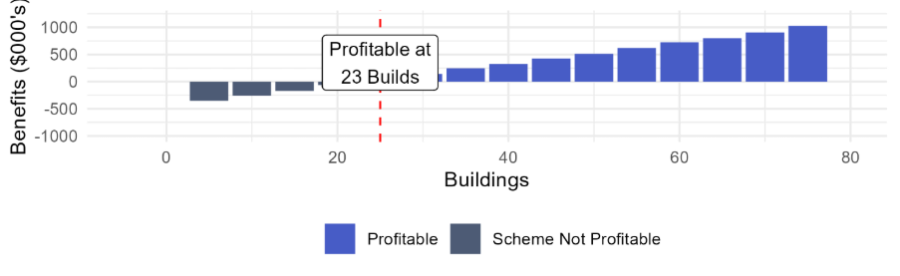
Table 20 - Central Case Net Benefits by Year (Class 2)
Year | Cost to Enter and Stay in Scheme | Inflation Adj Total Cost Saving for 25 Buildings | Benefit Per Year 25 Buildings | Inflation Adj Total Cost Saving for 50 Buildings | Benefit Per Year 50 Buildings
Year 1 | $56,971 | $40,416 | -$16,555 | $79,917 | $22,945
Year 2 | $30,591 | $42,113 | $11,522 | $83,273 | $52,682
Year 3 | $53,089 | $43,882 | -$9,207 | $86,770 | $33,681
Year 4 | $33,215 | $45,725 | $12,510 | $90,415 | $57,200
Year 5 | $34,610 | $47,646 | $13,036 | $94,212 | $59,602
Year 6 | $60,063 | $49,647 | -$10,417 | $98,169 | $38,106
Year 7 | $37,578 | $51,732 | $14,153 | $102,292 | $64,714
Year 8 | $39,157 | $53,905 | $14,748 | $106,589 | $67,432
Year 9 | $67,954 | $56,169 | -$11,785 | $111,065 | $43,111
Year 10 | $42,515 | $58,528 | $16,013 | $115,730 | $73,215
Total | $455,743 | $489,763 | $34,018 | $968,432 | $512,688

  - Indirect Benefits
This section outlines the evidence base underpinning the indirect benefits included within the analysis. These represent broader market, industry and consumer outcomes expected through Scheme participation, rather than direct cost savings (see 4.3 Benefits for details).
The indirect benefits identified for the Scheme have been examined using a combination of quantitative modelling and qualitative research. Quantitative review has been undertaken only where sufficient data exists to support modelling assumptions. Where quantitative evidence is limited or highly variable, benefits have been assessed qualitatively.
Quantitative analysis is limited to excess firm revenue for 2D and kit-of-parts manufacturing approaches. This reflects the availability of evidence to support modelling assumptions. Unlike 3D volumetric construction, where benefits are attributed directly to cost savings associated with reduced inspection requirements, 2D and kit-of-parts manufacturers may realise additional value through increased production throughput.
Quality outcomes, quality assurance as well as consumer and industry confidence are examined qualitatively. Information available from stakeholder engagement and desktop research was insufficient to isolate quantitative impacts with required detail to establish a direct relationship between potential Scheme participation and measurable outcomes. This limitation is compounded by the Scheme still being in development and the limited availability of evidence from comparable Schemes. While not intended to represent a comprehensive literature review, the research focuses on demonstrating that MMC broadly generates each identified benefit.

    - Quantitative Benefits - Excess Firm Revenue
Quantitative analysis is limited to excess firm revenue arising from increased build capacity through Scheme participation.
Manufacturers of 2D and kit-of-parts components may realise additional revenue under the Scheme, as reduced inspection requirements are expected to shorten the time required for products to progress from manufacturer to installation. This may allow manufacturers to increase the volume of products supplied to the market each year, generating additional revenue. This outcome is treated as an indirect benefit, as revenue growth is expected to be driven primarily through broader market adoption of MMC, rather than reductions in inspection related costs.

      - Central Case - 2D and Kit-of-Parts
The central case models the net financial benefits of Scheme participation for a mature manufacturer involved in 2D and kit-of-parts. As outlined in Section 4.1.2.2, these organisations assume a level of organisation capability to meet Scheme entry requirements.
The cost structure underpinning each of the scenarios follows the cost structure underpinning the central case as described in 5.3.1.1 Central Case, and outlined in Table 21 below.
Initial certification costs are at the lower end at $25,000, with transitional set up costs of $1,500. CAB surveillance costs are set at $20,000 per year based on a required audit and inspection every three months. Traceability costs are set at the minimum of $675 per year and insurance costs are expected to increase by $7,500 per year because of Scheme participation. These costs reflect an organisation that has the systems and capabilities in place to participate in the Scheme with lower input costs compared to a less established manufacturer.
Table 21 - Central Case Cost Structure (Mature Manufacturer)
Cost category | Frequency | Cost
Certification costs | Once-off | $25,000
Surveillance costs | Annual | $20,000
Transitional and set-up costs | Once-off | $1,500
Traceability costs | Annual | $675
Costs of re-certification | Every 3 years | $18,750
Insurance costs | Annual | $7,500
The Scheme costs are subtracted to calculate Net Revenue and Net Benefit while in the Scheme.
The central case assumes a manufacturer with current capacity to build 50 kits each year will receive a conservative 1% uplift in capacity. This results in the ability to build 1 extra kit every 2 years, resulting in an expected net benefit over 10 years of $127,385.
Table 22 - Central Case Net Benefits by Year (2D and Kit-of-Parts)
Year | Extra Builds This Year | Estimated Revenue while not in Scheme | Estimated Revenue while in Scheme with estimated Uplift | Estimated Net Revenue while in Scheme | Estimated Net Benefit Scheme vs Base Case
Year 1 | 0 | $4,715,092 | $4,715,092 | $4,658,121 | -$56,971
Year 2 | 1 | $4,913,126 | $5,011,389 | $4,980,797 | $67,671
Year 3 | 0 | $5,119,478 | $5,119,478 | $5,066,388 | -$53,089
Year 4 | 1 | $5,334,496 | $5,441,186 | $5,407,970 | $73,475
Year 5 | 0 | $5,558,544 | $5,558,544 | $5,523,934 | -$34,610
Year 6 | 1 | $5,792,003 | $5,907,843 | $5,847,780 | $55,777
Year 7 | 0 | $6,035,267 | $6,035,267 | $5,997,689 | -$37,578
Year 8 | 1 | $6,288,749 | $6,414,524 | $6,375,367 | $86,618
Year 9 | 0 | $6,552,876 | $6,552,876 | $6,484,922 | -$67,954
Year 10 | 1 | $6,828,097 | $6,964,659 | $6,922,144 | $94,047
Total | 5 | $57,137,728 | $57,720,858 | $57,265,113 | $127,385

    - Qualitative Benefits
      - Quality Outcomes
The certification and surveillance mechanisms within the Scheme are intended to support improved building quality outcomes, through more consistent compliance with NCC requirements, improved manufacturing processes, and reduced risk of defects or non-compliance of components and buildings.
The ABCB Issues Paper identifies that quality can be defined as the “precision in design and robust quality assurance processes, rather than the use of premium materials or additional features”. On this basis, the Scheme is considered to enable increased consumer confidence by ensuring that NCC obligations are met throughout the manufacturing process.
The factory nature of MMC production is recognised in literature as enabling a higher standard of quality control in comparison to traditional onsite construction. This is driven by the nature of construction environments, specifically where building activities are conducted in enclosed and controlled environments, enabling increased scrutiny of activities. These factory settings are also identified as reducing the need for rework and adjustments during assembly, supporting the delivery of high-quality components.
The Brisbane Sky Tower provides an Australian example of this in practice. Bathroom pods and façade panels for a 90-storey, 1,100 plus apartment tower was manufactured offsite and delivered to site ready for installation. In addition to the complexity of delivering prefabricated components in a dense urban setting, the project required quality control systems capable of ensuring components matched the same quality and durability of traditional approaches. In a high-rise setting, enhanced quality control processes supported the delivery of components that met industry standards and the required building codes.
      - Quality Assurance, Consumer and Industry Confidence
As outlined above, the Scheme is expected to support improved building quality outcomes. These improvements provide a key basis for increased consumer and industry confidence in MMC construction approaches.
Consumer confidence is particularly influenced by perceptions of quality. As identified in the ABCB Issues Paper, prefabricated construction continues to be affected by historical perceptions of poor quality. The industry continues to face lingering negative perceptions that prefabricated housing is poor-quality and a mass made solution.
The Swinburne University of Technology and HIA research noted that offsite construction requires assurance with certification of factory outputs, as a means of increasing confidence. McKinsey and Company also found that quality certification standards are a significant driver of consumer confidence and access to financing, as lenders and mortgage providers require formal assurance for the provisioning of loans.
Industry confidence is considered from an insurance and lending perspective, which is well evidenced in international MMC markets. In written evidence submitted to the UK House of Commons, the Association of British Insurers (ABI) identified the lack of information on how MMC construction performs against insurable risks as primary source of insurer caution. Additionally, the House of Lords Built Environment Committee reported that risk aversion on the part of investors and insurers is a significant barrier to MMC uptake.
From an Australian perspective, this barrier persists in the domestic lending market. In January 2025, the Commonwealth Bank became the first major Australian bank to improve access to finance for prefabricated homes, having previously required customers to fund up to 90% of upfront costs.
As consumer and industry confidence in MMC grows through certification and quality assurance, the case for Scheme participation strengthens, generating the broader market adoption benefits identified for the analysis.

      - Increased MMC Adoption
By reducing current regulatory and compliance burdens, the Scheme is expected to enable faster dwelling construction above what MMC alone would deliver without regulatory reform. Whilst these advantages are not yet fully realised under current regulatory arrangements, international evidence on MMC time and cost savings is well-established.
McKinsey and Company found that modular construction has the potential to cut construction costs by up to 20%. They also identified that modular construction can reduce labour requirements by up to 40% and project timelines by up to 50%, while also enabling cost savings when delivered efficiently and at scale.
In the Australian context, a systematic review of the economic challenges of prefabricated construction by Wells et al. found that prefabrication can reduce project duration by up to 60%. Further, where construction activities can be shifted to factory assembly lines, prefabricated methods can yield cost reductions.
These advantages are expected to translate into more dwellings through two channels. Firstly, faster construction increases the delivery of more homes in the same period. Secondly, where cost savings are realised at scale, more approved projects are expected to become financially viable, also increasing supply. The Productivity Commission identifies this mechanism explicitly, noting that improving construction productivity lowers construction costs, meaning more approved projects proceed. The scale of both effects will depend on the level of MMC adoption above the baseline.

  - Sensitivity Analysis
Given the range of assumptions about Scheme participation, costs, and MMC market share, this section tests the sensitivity of the findings through consideration of alternate scenarios. The scenarios are intended to identify conditions under which the Scheme is likely to generate net benefits for participating manufacturers.
For sections 5.5.1 Established/Mature Manufacturers and 5.5.2 Lower Maturity Manufacturers, the analysis should be read as standalone cases, where if a manufacturer constructs Class 1 dwellings, they should refer to those findings. Likewise, if a manufacturer constructs Class 2 dwellings, they should refer to those findings. The analysis should not be interpreted as requiring manufacturers to construct both Class 1 and Class 2 dwellings at levels described to be financially beneficial.
The Central Cases reflects a mature or established manufacturers, subject to quarterly surveillance activities by the Certification body, with certification valid for three years. This represents the most likely cost structure for an eligible manufacturer based on current Scheme design. For 3D volumetric manufacturers, the central case models the direct financial benefits arising from reduced inspection costs. For 2D and kit-of-parts manufacturers, the central case assumes a base production capacity of 50 builds per year and a conservation 1% throughput uplift. For further details on the Central Cases, please refer to 5.3.1.1 Central Case – 3D Volumetric Construction and 5.4.1.1 Central Case - 2D and Kit-of-Parts.
Sensitivity Analysis will address the following scenarios as outlined in Table 23 below. The table outlines how the scenarios differ from the Central Cases.
Table 23 - Sensitivity Analysis Scenario Details
Section | Scenario | Changes from the Central Case
5.5.1 Established/Mature Manufacturers | Scenario 1 – Annual Surveillance | This scenario reflects surveillance reducing to an annual frequency, and re-certification is reduced to a 5-year cycle.
5.5.1 Established/Mature Manufacturers | Scenario 2 – Biannual Surveillance | This scenario reflects surveillance reducing to a biannual frequency, and re-certification is reduced to a 5-year cycle.
5.5.2 Lower Maturity Manufacturers | Scenario 3 – Reduced Maintenance Costs, Annual Surveillance | This scenario reflects a lower maturity manufacturer, with overall higher costs, but experiences a reduction in the cost of maintaining certification over 5 years due to capability uplift. Surveillance is also reduced to an annual frequency, and re-certification is reduced to a 5-year cycle.
5.5.2 Lower Maturity Manufacturers | Scenario 4 - High Entry Cost, Annual Surveillance | This scenario reflects a lower maturity manufacturer, with overall higher costs, where surveillance is reduced to an annual frequency, and re-certification is reduced to a 5-year cycle.
5.5.2 Lower Maturity Manufacturers | Scenario 5 - Moderate Entry Cost, Biannual Surveillance | This scenario reflects a lower maturity manufacturer, with overall higher costs but experiences comparatively lower transitional and set up costs than other lower maturity manufacturers, and surveillance is reduced to a biannual frequency, and re-certification is reduced to a 5-year cycle.
5.5.2 Lower Maturity Manufacturers | Scenario 6 - High Entry Cost, Biannual Surveillance | This scenario reflects a lower maturity manufacturer, with overall higher costs, where surveillance is reduced to a biannual frequency, and re-certification is reduced to a 5-year cycle.
5.5.2 Lower Maturity Manufacturers | Scenario 7 - Moderate Entry Cost, Quarterly Surveillance | This scenario reflects a lower maturity manufacturer, with overall higher costs but experiences comparatively lower transitional and set up costs than other lower maturity manufacturers.
5.5.2 Lower Maturity Manufacturers | Scenario 8 - High Entry Cost, Quarterly Surveillance | This scenario reflects a lower maturity manufacturer, with overall higher costs.
5.5.3 2D and Kit-of-Parts | Scenario 9 – Base Capacity 100 Builds, 5% Uplift | This scenario reflects capacity to deliver increasing to 100 builds each year and experiences a 5% uplift.
5.5.3 2D and Kit-of-Parts | Scenario 10 – Base Capacity 100 Builds, 2.5% Uplift | This scenario reflects capacity to deliver increasing to 100 builds each year and experiences a 2.5% uplift.
5.5.3 2D and Kit-of-Parts | Scenario 11 – Base Capacity 100 Builds, 1% Uplift | This scenario reflects capacity to deliver increasing to 100 builds each year.
5.5.3 2D and Kit-of-Parts | Scenario 12 – Base Capacity 50 Builds, 5% Uplift | This scenario reflects the manufacturer experiencing a 5% uplift.
5.5.3 2D and Kit-of-Parts | Scenario 13 – Base Capacity 50 Builds, 2.5% Uplift | This scenario reflects the manufacturer experiencing a 2.5% uplift.
5.5.3 2D and Kit-of-Parts | Scenario 14 – Base Capacity 20 Builds, 5% Uplift | This scenario reflects capacity to deliver decreasing to 20 builds each year and experiences a 5% uplift.
5.5.3 2D and Kit-of-Parts | Scenario 15 – Base Capacity 20 Builds, 2.5% Uplift | This scenario reflects capacity to deliver decreasing to 20 builds each year and experiences a 2.5% uplift.
5.5.3 2D and Kit-of-Parts | Scenario 16 – Base Capacity 20 Builds, 1% Uplift | This scenario reflects capacity to deliver decreasing to 20 builds each year.

    - Established/Mature Manufacturers
      - Scenario 1 – Annual Surveillance
This scenario tests the effect of reducing audit and inspection frequency for a mature manufacturer. Relative to the central case, annual CAB audit costs are reduced from $20,000 to $5,000, reflecting annual surveillance rather than quarterly audits and inspections, and extends the re-certification cycle from three years to five years. All other costs are assumed to remain consistent with the central case.
Table 24 - Mature Manufacturer Scenario 1 - Cost Structure
Cost category | Frequency | Cost
Certification costs | Once-off | $25,000
Surveillance and audit costs | Annual | $5,000
Transitional and set-up costs | Once-off | $1,500
Traceability costs | Annual | $675
Costs of re-certification | Every 5 years | $18,750
Insurance costs | Annual | $7,500

Class 1 Buildings
Under the conditions outlined above a manufacturer would need to average 19 Class 1 builds annually to be financially beneficial.
At 50 Class 1 builds per year, a manufacturer would receive a benefit of $412,983 over the 10 years.
At 100 Class 1 builds per year, a manufacturer would receive a benefit of $1,047,913 over the 10 years, with a cost to benefit ratio of 1:5.3.
Figure 9 - Mature Manufacturer Scenario 1 - Net Benefits by Build Volume (Class 1)
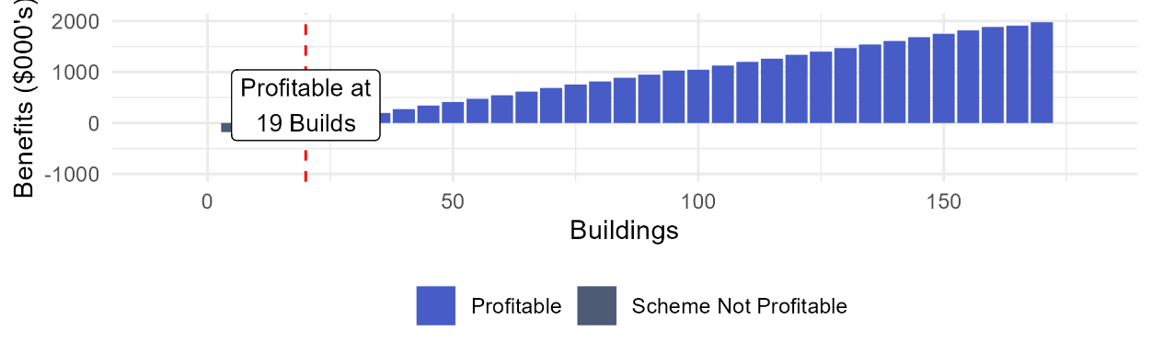
Table 25 - Scenario 1 - Net Benefits by Year (Class 1)
Year | Cost to Enter and Stay in Scheme | Inflation Adj Total Cost Saving for 50 Buildings | Benefit Per Year 50 Buildings | Inflation Adj Total Cost Saving for 100 Buildings | Benefit Per Year 100 Buildings
Year 1 | $41,341 | $54,322 | $12,981 | $106,718 | $65,377
Year 2 | $14,305 | $56,604 | $42,299 | $111,200 | $96,895
Year 3 | $14,906 | $58,981 | $44,076 | $115,870 | $100,965
Year 4 | $15,532 | $61,459 | $45,927 | $120,737 | $105,205
Year 5 | $39,217 | $64,040 | $24,823 | $125,808 | $86,591
Year 6 | $16,864 | $66,730 | $49,866 | $131,092 | $114,228
Year 7 | $17,572 | $69,532 | $51,960 | $136,598 | $119,026
Year 8 | $18,310 | $72,453 | $54,142 | $142,335 | $124,025
Year 9 | $19,079 | $75,496 | $56,416 | $148,313 | $129,234
Year 10 | $48,173 | $78,666 | $30,493 | $154,542 | $106,369
Total | $245,299 | $658,283 | $412,983 | $1,293,213 | $1,047,915

Class 2 Buildings
Under the conditions outlined above a manufacturer would need to average 14 Class 2 builds annually to be financially beneficial.
At 25 Class 2 builds per year, a manufacturer would receive a benefit of $246,846 over the 10 years.
At 50 Class 2 builds per year, a manufacturer would receive a benefit of $697,072 over the 10 years, with a cost to benefit ratio of 1:3.8.
Figure 10 - Scenario 1 - Net Benefits by Build Volume (Class 2)
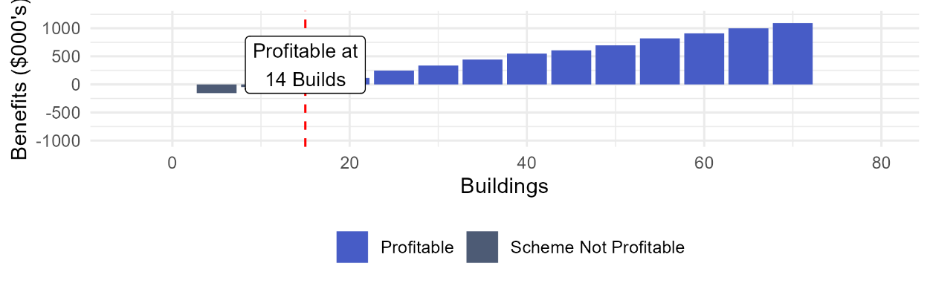
Table 26 - Scenario 1 - Net Benefits by Year (Class 2)
Year | Cost to Enter and Stay in Scheme | Inflation Adj Total Cost Saving for 50 Buildings | Benefit Per Year 50 Buildings | Inflation Adj Total Cost Saving for 100 Buildings | Benefit Per Year 100 Buildings
Year 1 | $41,341 | $40,613 | -$729 | $77,766 | $36,425
Year 2 | $14,305 | $42,318 | $28,013 | $81,032 | $66,727
Year 3 | $14,906 | $44,096 | $29,190 | $84,435 | $69,530
Year 4 | $15,532 | $45,948 | $30,416 | $87,982 | $72,450
Year 5 | $39,217 | $47,877 | $8,661 | $91,677 | $52,460
Year 6 | $16,864 | $49,888 | $33,024 | $95,527 | $78,664
Year 7 | $17,572 | $51,984 | $34,411 | $99,540 | $81,967
Year 8 | $18,310 | $54,167 | $35,857 | $103,720 | $85,410
Year 9 | $19,079 | $56,442 | $37,363 | $108,076 | $88,997
Year 10 | $48,173 | $58,812 | $10,639 | $112,616 | $64,442
Total | $245,299 | $492,145 | $246,845 | $942,371 | $697,072

      - Scenario 2 – Biannual Surveillance
This scenario tests the effect of reducing audit frequency on the net benefit for a mature manufacturer. Relative to the central case, annual CAB audit costs are reduced from $20,000 to $10,000 reflecting six-monthly rather than quarterly audits and extends the re-certification cycle from three years to five years. All other costs are assumed to remain consistent with the central case.
The full cost structure for this scenario is set out in Table 27 below.
Table 27 - Mature Manufacturer Scenario 2 - Cost Structure
Cost category | Frequency | Cost
Certification costs | Once-off | $25,000
Surveillance and audit costs | Annual | $10,000
Transitional and set-up costs | Once-off | $1,500
Traceability costs | Annual | $675
Costs of re-certification | Every 5 years | $18,750
Insurance costs | Annual | $7,500

Class 1 Buildings
Under the conditions outlined above a manufacturer would need to average 25 Class 1 builds annually to be financially beneficial, lower than the 36 builds required under the central case.
At 50 Class 1 builds per year, the manufacturer would receive a benefit of $349,848 over the 10 years.
At 100 Class 1 builds per year, the manufacturer would receive a benefit of $984,778 over the 10-years, with a cost to benefit ratio of 1:4.5.
Both results represent a material improvement on the central case outcomes. Figure 11 below highlights that net benefits increase consistently beyond the financially beneficial threshold at 25 builds.
The full year-on-year breakdown is set out in Table 28 and outlines that entry costs in Year 1 are lower than the central case at $46,551, reflecting the reduced audit frequency. Annual costs from Year 2 range from $19,734 to $55,718 with higher cost years reflecting the five-year recertification cycle in Year 5 and Year 10. Both the 50 and 100 build scenarios generate a positive net benefit from the first year of participation.
Figure 11 - Scenario 2 - Net Benefits by Build Volume (Class 1)
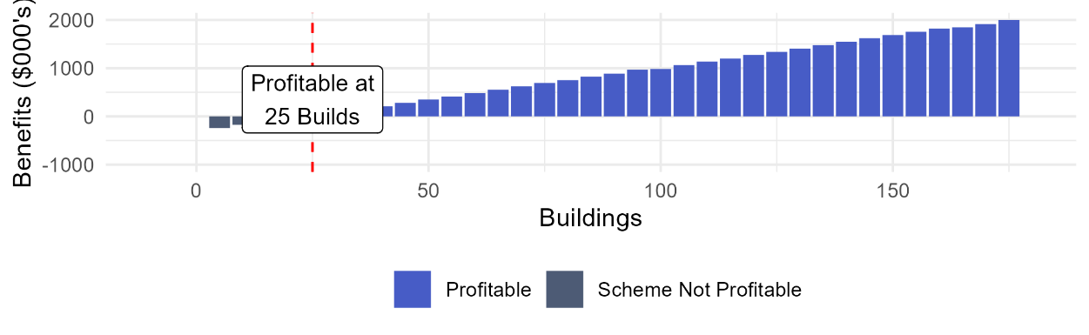

Table 28 - Scenario 2 - Net Benefits by Year (Class 1)
Year | Cost to Enter and Stay in Scheme | Inflation Adj Total Cost Saving for 50 Buildings | Benefit Per Year 50 Buildings | Inflation Adj Total Cost Saving for 100 Buildings | Benefit Per Year 100 Buildings
Year 1 | $46,551 | $54,322 | $7,771 | $106,718 | $60,167
Year 2 | $19,734 | $56,604 | $36,870 | $111,200 | $91,466
Year 3 | $20,563 | $58,981 | $38,419 | $115,870 | $95,308
Year 4 | $21,426 | $61,459 | $40,032 | $120,737 | $99,311
Year 5 | $45,359 | $64,040 | $18,681 | $125,808 | $80,449
Year 6 | $23,264 | $66,730 | $43,466 | $131,092 | $107,828
Year 7 | $24,241 | $69,532 | $45,291 | $136,598 | $112,357
Year 8 | $25,259 | $72,453 | $47,194 | $142,335 | $117,076
Year 9 | $26,320 | $75,496 | $49,176 | $148,313 | $121,993
Year 10 | $55,718 | $78,666 | $22,948 | $154,542 | $98,824
Total | $308,435 | $658,283 | $349,848 | $1,293,213 | $984,779

Class 2 Buildings
Under the conditions outlined above a manufacturer would need to average 17 Class 2 builds annually to be financially beneficial, lower than the 23 builds required under the central case.
At 25 Class 2 builds per year, a manufacturer would receive a benefit of $181,329 over the 10 years, representing a material improvement compared to the central case outcomes.
At 50 Class 2 builds per year, a manufacturer would receive a benefit of $659,998 over the 10-years, with a cost to benefit ratio of 1:3.1.
Figure 12 highlights that net benefits increase consistently beyond the financially beneficial threshold at 17 builds.
The full year-on-year breakdown is set out in Table 28. At 25 builds per year, manufacturers experience a loss of $6,135 in Year 1 with a net positive achievable in Year 2 with savings of $22,380. At 50 builds per year, the Scheme is financially beneficial from the first year generating $33,365 and increasing in future years. Annual costs follow the same pattern as Class 1, with lower ongoing costs relative to the central case reflecting reduced audit and recertification activities.

Figure 12 - Scenario 2 - Net Benefits by Build Volume (Class 2)
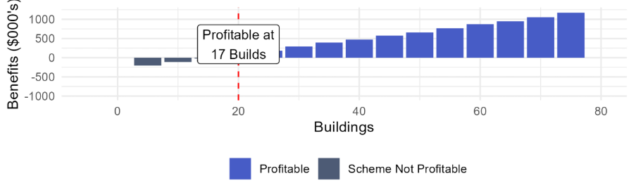
Table 29 - Scenario 2 - Net Benefits by Year (Class 2)
Year | Cost to Enter and Stay in Scheme | Inflation Adj Total Cost Saving for 25 Buildings | Benefit Per Year 25 Buildings | Inflation Adj Total Cost Saving for 50 Buildings | Benefit Per Year 50 Buildings
Year 1 | $46,551 | $40,416 | -$6,135 | $79,917 | $33,365
Year 2 | $19,734 | $42,113 | $22,380 | $83,273 | $63,539
Year 3 | $20,563 | $43,882 | $23,320 | $86,770 | $66,208
Year 4 | $21,426 | $45,725 | $24,299 | $90,415 | $68,989
Year 5 | $45,359 | $47,646 | $2,287 | $94,212 | $48,854
Year 6 | $23,264 | $49,647 | $26,383 | $98,169 | $74,905
Year 7 | $24,241 | $51,732 | $27,491 | $102,292 | $78,051
Year 8 | $25,259 | $53,905 | $28,646 | $106,589 | $81,330
Year 9 | $26,320 | $56,169 | $29,849 | $111,065 | $84,745
Year 10 | $55,718 | $58,528 | $2,809 | $115,730 | $60,012
Total | $308,435 | $489,763 | $181,329 | $968,432 | $659,998

    - Lower Maturity Manufacturers
These scenarios are intended to test how net benefits change for a less mature organisation or those that will require greater investment to enter and maintain compliance with the Scheme.
      - Scenario 3 – Reduced Maintenance Costs, Annual Surveillance
This scenario represents the least demanding cost conditions modelled for this manufacturer profile. Initial certification costs are $50,000 and transitional set-up costs are $80,900 reflecting the investment required to meet Scheme entry requirements. CAB audit costs are $5,000 per year for annual audits and recertification occurs every 5 years at $18,750. The cost of maintaining certification reduces to $0 over a 5 year period. Insurance costs are expected to increase by $15,000 per year. The full cost structure for this scenario is set out in Table 30 below.
Table 30 - Less Mature Manufacturer Scenario 3 Cost Structure
Cost category | Frequency | Cost
Certification costs | Once-off | $50,000
Surveillance and audit costs | Annual | $5,000
Transitional and set-up costs | Once-off | $80,900
Traceability costs | Annual | $675
Costs of maintaining certification | Annual | $22,500 to $0 in 5 Years
Costs of re-certification | Every 5 years | $18,750
Insurance costs | Annual | $15,000

Class 1 Buildings
Under the conditions outlined above a manufacturer needs to average 41 Class 1 builds annually to be financially beneficial (see Figure 13 below).
At 50 Class 1 builds per year, a manufacturer would lose $133,412 over the 10 years.
At 100 Class 1 builds per year, the Scheme generates a net benefit of $768,342 over the 10 years, with a cost to benefit ratio of 1:1.2.
The full year-on-year breakdown is set out in Table 31. Entry costs in Year 1 are $136,893, materially higher than the central case of $56, 971 and is driven by the combination of high certification and transitional set-up costs.
Figure 13 - Scenario 3 - Net Benefits by Build Volume (Class 1)
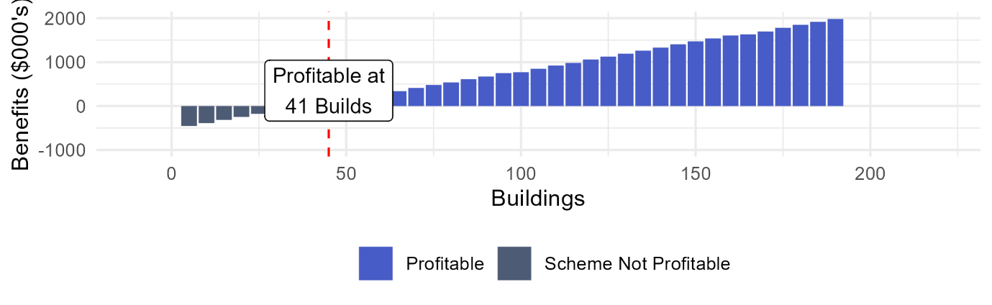
Table 31 - Scenario 3 - Net Benefits by Year (Class 1)
Year | Cost to Enter and Stay in Scheme | Inflation Adj Total Cost Saving for 50 Buildings | Benefit Per Year 50 Buildings | Inflation Adj Total Cost Saving for 100 Buildings | Benefit Per Year 100 Buildings
Year 1 | $136,893 | $54,322 | -$82,570 | $106,718 | -$30,175
Year 2 | $41,992 | $56,604 | $14,612 | $111,200 | $69,208
Year 3 | $41,210 | 58,981 | $17,771 | $115,870 | $74,660
Year 4 | $40,288 | $61,459 | $21,170 | $120,737 | $80,449
Year 5 | $62,249 | $64,040 | $1,791 | $125,808 | $63,559
Year 6 | $37,984 | $66,730 | $28,746 | $131,092 | $93,108
Year 7 | $36,578 | $69,532 | $32,954 | $136,598 | $100,020
Year 8 | $34,987 | $72,453 | $37,465 | $142,335 | $107,347
Year 9 | $33,199 | $75,496 | $42,297 | $148,313 | $115,114
Year 10 | $59,491 | $78,666 | $19,176 | $154,542 | $95,051
Total | $524,871 | $658,283 | $133,412 | $1,293,213 | $768,341

Class 2 Buildings
Under the conditions outlined above a manufacturer would need to average 28 Class 2 builds annually to be financially beneficial (see Figure 14 below).
At 25 Class 2 builds per year, a manufacturer would lose $32, 726 over the 10 years.
At 50 Class 2 builds per year, a manufacturer would receive a benefit of $417,500 over the 10 years, with a cost to benefit ratio of 1:1.34.
The full year-on-year breakdown is set out in Table 32. At 50 Class 2 builds per year, manufacturers achieve positive results from Year 2 onwards.

Figure 14 - Scenario 3 - Net Benefits by Build Volume (Class 2)
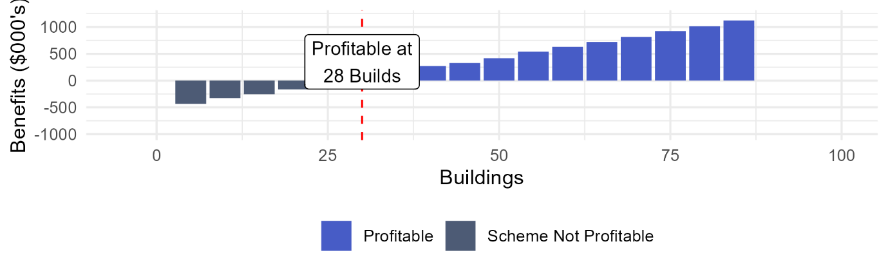
Table 32 - Scenario 3 - Net Benefits by Year (Class 2)
Year | Cost to Enter and Stay in Scheme | Inflation Adj Total Cost Saving for 25 Buildings | Benefit Per Year 25 Buildings | Inflation Adj Total Cost Saving for 50 Buildings | Benefit Per Year 50 Buildings
Year 1 | $136,893 | $40,613 | -$96,280 | $77,766 | -$59,127
Year 2 | $41,992 | $42,318 | $326 | $81,032 | $39,040
Year 3 | $41,210 | $44,096 | $2,886 | $84,435 | $43,225
Year 4 | $40,288 | $45,948 | $5,659 | $87,982 | $47,693
Year 5 | $62,249 | $47,877 | -$14,372 | $91,677 | $29,428
Year 6 | $37,984 | $49,888 | $11,905 | $95,527 | $57,544
Year 7 | $36,578 | $51,984 | $15,406 | $99,540 | $62,961
Year 8 | $34,987 | $54,167 | $19,180 | $103,720 | $68,733
Year 9 | $33,199 | $56,442 | $23,243 | $108,076 | $74,878
Year 10 | $59,491 | $58,812 | -$678 | $112,616 | $53,125
Total | $524,871 | $492,145 | -$32,725 | $942,371 | $417,500

      - Scenario 4 - High Entry Cost, Annual Surveillance
This scenario includes initial certification costs are $50,000 and transitional set-up costs are $80,900 reflecting the investment required to meet Scheme entry requirements. CAB audit costs are $5,000 per year for annual audits and recertification occurs every 5 years at $18,750. Insurance costs are expected to increase by $15,000 per year. The full cost structure for this scenario is set out in Table 33 below.
Table 33 - Less Mature Manufacturer Scenario 4 Cost Structure
Cost category | Frequency | Cost
Certification costs | Once-off | $50,000
Surveillance and audit costs | Annual | $5,000
Transitional and set-up costs | Once-off | $80,900
Traceability costs | Annual | $675
Costs of maintaining certification | Annual | $22,500
Costs of re-certification | Every 5 years | $18,750
Insurance costs | Annual | $15,000

Class 1 Buildings
Under the conditions outlined above a manufacturer would need to average 52 Class 1 builds annually to be financially beneficial (see Figure 15 below).
At 50 Class 1 builds per year, a manufacturer would lose $32,463 over the 10 years.
At 100 Class 1 builds per year, a manufacturer would receive a benefit of $602,467 over the 10 years, with a cost to benefit ratio of 1:1.8.
The full year-on-year breakdown is set out in Table 34. Entry costs in Year 1 are $197,016, materially higher than the central case of $56, 971 and is driven by the combination of high certification and transitional set-up costs. At 50 builds per year, manufacturers do not achieve any profit at any point in the assessment period. At 100 builds per year, manufacturers achieve a benefit of $55,685 in Year 2. However, recertification in Year 3, Year 6 and Year 9 push costs up significantly, reducing the benefit in those years.
Figure 15 - Scenario 4 - Net Benefits by Build Volume (Class 1)
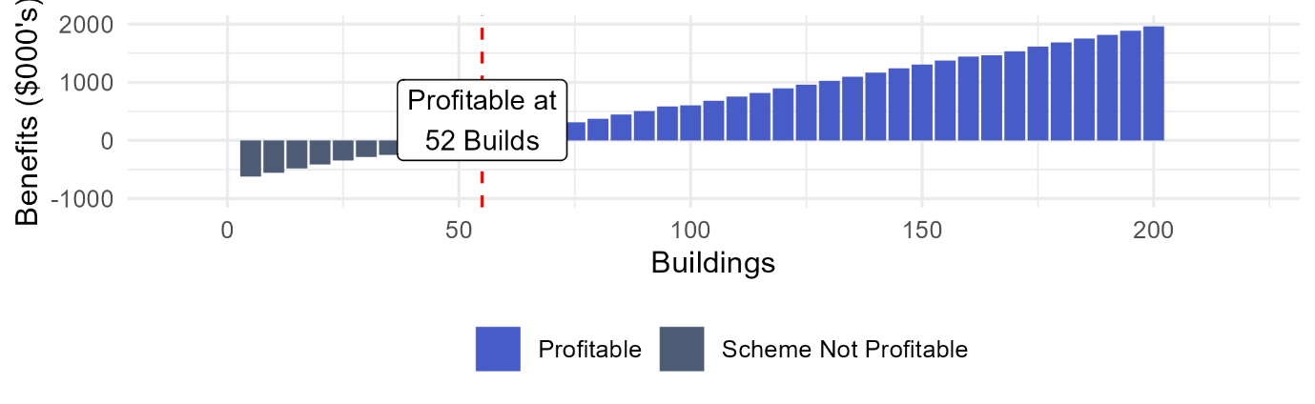
Table 34 - Scenario 4 - Net Benefits by Year (Class 1)
Year | Cost to Enter and Stay in Scheme | Inflation Adj Total Cost Saving for 50 Buildings | Benefit Per Year 50 Buildings | Inflation Adj Total Cost Saving for 100 Buildings | Benefit Per Year 100 Buildings
Year 1 | $139,237 | $54,322 | -$84,915 | $106,718 | -$32,519
Year 2 | $46,878 | $56,604 | $9,726 | $111,200 | $64,322
Year 3 | $48,847 | $58,981 | $10,135 | $115,870 | $67,024
Year 4 | $50,898 | $61,459 | $10,560 | $120,737 | $69,839
Year 5 | $76,068 | $64,040 | -$12,029 | $125,808 | $49,739
Year 6 | $55,264 | $66,730 | $11,466 | $131,092 | $75,828
Year 7 | $57,585 | $69,532 | $11,948 | $136,598 | $79,013
Year 8 | $60,003 | $72,453 | $12,449 | $142,335 | $82,332
Year 9 | $62,523 | $75,496 | $12,972 | $148,313 | $85,790
Year 10 | $93,442 | $78,666 | -$14,776 | $154,542 | $61,100
Total | $690,745 | $658,283 | -$32,464 | $1,293,213 | $602,468

Class 2 Buildings
Under the conditions outlined above a manufacturer would need to average 36 Class 2 builds annually to be financially beneficial (see Figure 16 below).
At 25 Class 2 builds per year, a manufacturer would lose $198,601 over the 10 years.
At 50 Class 2 builds per year, a manufacturer would receive a benefit of $251,626 over the 10 years, with a cost to benefit ratio of 1:1.34.
The full year-on-year breakdown is set out in Table 35. At 25 builds per year, manufacturers do not achieve profits at any point in the assessment period. At 50 builds per year, manufacturers achieve modest positive results from Year 2 onwards.

Figure 16 - Scenario 4 - Net Benefits by Build Volume (Class 2)
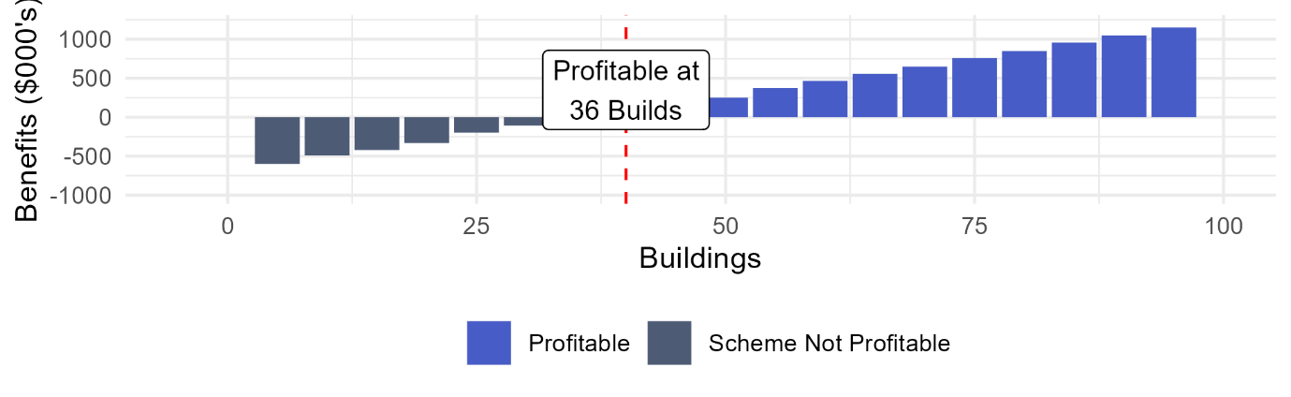
Table 35 - Scenario 4 - Net Benefits by Year (Class 2)
Year | Cost to Enter and Stay in Scheme | Inflation Adj Total Cost Saving for 25 Buildings | Benefit Per Year 25 Buildings | Inflation Adj Total Cost Saving for 50 Buildings | Benefit Per Year 50 Buildings
Year 1 | $139,237 | $40,613 | -$98,625 | $77,766 | -$61,471
Year 2 | $46,878 | $42,318 | -$4,560 | $81,032 | $34,154
Year 3 | $48,847 | $44,096 | -$4,751 | $84,435 | $35,589
Year 4 | $50,898 | $45,948 | -$4,951 | $87,982 | $37,083
Year 5 | $76,068 | $47,877 | -$28,191 | $91,677 | $15,608
Year 6 | $55,264 | $49,888 | -$5,375 | $95,527 | $40,264
Year 7 | $57,585 | $51,984 | -$5,601 | $99,540 | $41,955
Year 8 | $60,003 | $54,167 | -$5,836 | $103,720 | $43,717
Year 9 | $62,523 | $56,442 | -$6,081 | $108,076 | $45,553
Year 10 | $93,442 | $58,812 | -$34,630 | $112,616 | $19,173
Total | $690,745 | $492,145 | -$198,601 | $942,371 | $251,625

      - Scenario 5 - Moderate Entry Cost, Biannual Surveillance
This scenario assumes transitional set-up costs of $40,450, six-monthly CAB surveillance at $10,000 a year and a five-year certification cycle. Initial certification remains at $50,000, with annual insurance cost increases of $15,000 and traceability costs of $675. The combination of moderate set-up costs and less frequent auditing produces a lower overall participation cost relative to the other less mature manufacturer scenarios. The full cost structure for this scenario is set out in Table 36 below.
Table 36 - Less Mature Manufacturer Scenario 5 Cost Structure
Cost category | Frequency | Cost
Certification costs | Once-off | $50,000
Surveillance costs | Annual | $10,000
Transitional and set-up costs | Once-off | $40,450
Traceability costs | Annual | $675
Costs of maintaining certification | Annual | $22,500
Costs of re-certification | Every 5 years | $37,500
Insurance costs | Annual | $15,000

Class 1 Buildings
Under the conditions outlined above a manufacturer would need to average 59 Class 1 builds annually to be financially beneficial (see Figure 17 below).
At 50 builds Class 1 builds per year, a manufacturer would lose $119,884 over the 10 years.
At 100 Class 1 builds per year, a manufacturer would receive a benefit of $576,961 over the 10 years, with a cost to benefit ratio of 1:7.
The full year-on-year breakdown is set out in Table 37. Entry costs in Year 1 are $144,447, reflecting the effect of reduced transitional set-up costs and lower surveillance costs. At 50 builds per year, manufacturers achieve modest benefit from Year 2 in non-certification years. However, the high entry cost and losses in recertification years results in an overall ten-year loss of $119,883. At 100 builds per year, the manufacturers achieve a benefit from Year 2 at $66,542. However increased costs from five-year recertification activities impacts benefits in Year 5 and Year 10.
Figure 17 - Scenario 5 - Net Benefits by Build Volume (Class 1)
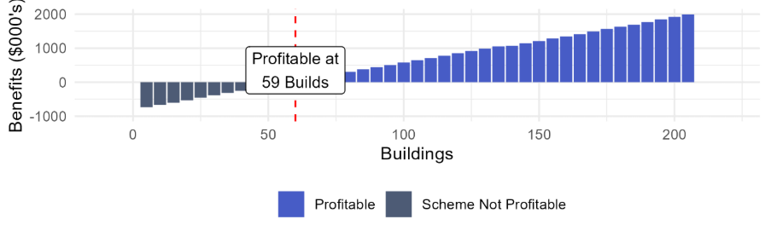
Table 37 - Scenario 5 - Net Benefits by Year (Class 1)
Year | Cost to Enter and Stay in Scheme | Inflation Adj Total Cost Saving for 50 Buildings | Benefit Per Year 50 Buildings | Inflation Adj Total Cost Saving for 100 Buildings | Benefit Per Year 100 Buildings
Year 1 | $144,447 | $56,554 | -$87,893 | $114,059 | -$30,389
Year 2 | $52,307 | $58,929 | $6,622 | $118,849 | $66,542
Year 3 | $54,504 | $61,404 | $6,901 | $123,841 | $69,337
Year 4 | $56,793 | $63,983 | $7,190 | $129,042 | $72,249
Year 5 | $105,243 | $66,670 | -$38,573 | $134,462 | $29,219
Year 6 | $61,663 | $69,471 | $7,807 | $140,109 | $78,446
Year 7 | $64,253 | $72,388 | $8,135 | $145,994 | $81,740
Year 8 | $66,952 | $75,429 | $8,477 | $152,125 | $85,173
Year 9 | $69,764 | $78,597 | $8,833 | $158,515 | $88,751
Year 10 | $129,280 | $81,898 | -$47,382 | $165,172 | $35,892
Total | $805,206 | $685,323 | -$119,883 | $1,382,168 | $576,960

Class 2 Buildings
Under the conditions outlined above, a manufacturer needs to average 41 Class 2 builds annually to be financially beneficial (see Figure 18 below).
At 25 Class 2 builds per year, a manufacturer would lose $315,442 over the 10 years.
At 50 Class 2 builds per year, a manufacturer would receive a benefit of $163,226 over the 10 years, with a cost to benefit ratio of 1:1.2.
The full year-on-year breakdown is set out in Table 38. At 25 builds per year, manufacturers experience a loss throughout the assessment period, with recertification years producing the largest losses. At 50 builds per year, manufacturers achieve modest returns from Year 2, with losses in Year 5 and Year 10 due to recertification.
Figure 18 - Scenario 5 - Net Benefits by Build Volume (Class 2)
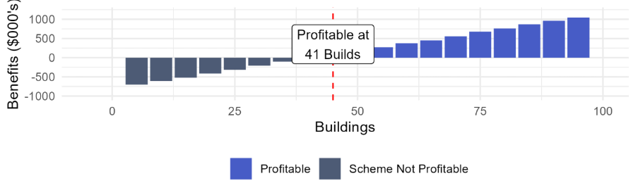
Table 38 - Scenario 5 - Net Benefits by Year (Class 2)
Year | Cost to Enter and Stay in Scheme | Inflation Adj Total Cost Saving for 25 Buildings | Benefit Per Year 25 Buildings | Inflation Adj Total Cost Saving for 50 Buildings | Benefit Per Year 50 Buildings
Year 1 | $144,447 | $40,416 | -$104,031 | $79,917 | -$64,531
Year 2 | $52,307 | $42,113 | -$10,193 | $83,273 | $30,966
Year 3 | $54,504 | $43,882 | -$10,621 | $86,770 | $32,267
Year 4 | $56,793 | $45,725 | -$11,068 | $90,415 | $33,622
Year 5 | $105,243 | $47,646 | -$57,597 | $94,212 | -$11,031
Year 6 | $61,663 | $49,647 | -$12,017 | $98,169 | $36,506
Year 7 | $64,253 | $51,732 | -$12,521 | $102,292 | $38,039
Year 8 | $66,952 | $53,905 | -$13,047 | $106,589 | $39,637
Year 9 | $69,764 | $56,169 | -$13,595 | $111,065 | $41,301
Year 10 | $129,280 | $58,528 | -$70,752 | $115,730 | -$13,550
Total | $805,206 | $489,763 | - $315,442 | $968,432 | $163,226
      - Scenario 6 - High Entry Cost, Biannual Surveillance
This scenario retains the high entry costs of Scenario 4 but increases the surveillance frequency from annually to biannually, halving the CAB surveillance costs from $20,000 to $10,000. The recertification cycle is also extended from three to five years. Transitional costs remain at $80,900 and initial certification costs remain at $50,000. The full cost structure for this scenario is set out in Table 39 below.
Table 39 - Less Mature Manufacturer Scenario 6 Cost Structure
Cost category | Frequency | Cost
Certification costs | Once-off | $50,000
Surveillance costs | Annual | $10,000
Transitional and set-up costs | Once-off | $80,900
Traceability costs | Annual | $675
Costs of maintaining certification | Annual | $22,500
Costs of re-certification | Every 5 years | $37,500
Insurance costs | Annual | $15,000

Class 1 Buildings
Under the conditions outlined above a manufacturer needs to average 64 Class 1 builds annually to be financially beneficial (see Figure 19 below), materially higher than the 34 builds under the central case.
At 50 Class 1 builds per year, a manufacturer would lose $162,033 over the 10 years.
At 100 Class 1 builds per year, a manufacturer would receive a benefit of $534,812 over the 10 years, with a cost to benefit ratio of 1:1.6.
The full year-on-year breakdown is set out in Table 40. Entry costs in Year 1 remain high at $186,596, reflecting the unchanged certification and transitional costs. At 100 builds per year, manufacturers achieve a financial benefit from Year 2 at $66,542. Due to the five-year recertification costs, benefits drop in Year 5 and Year 10.

Figure 19 - Scenario 6 - Net Benefits by Build Volume (Class 1)
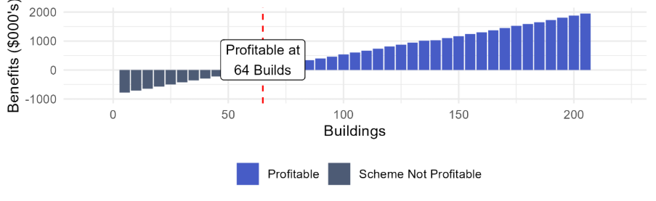

Table 40 - Scenario 6 - Net Benefits by Year (Class 1)
Year | Cost to Enter and Stay in Scheme | Inflation Adj Total Cost Saving for 50 Buildings | Benefit Per Year 50 Buildings | Inflation Adj Total Cost Saving for 100 Buildings | Benefit Per Year 100 Buildings
Year 1 | $186,596 | $56,554 | -$130,042 | $114,059 | -$72,538
Year 2 | $52,307 | $58,929 | $6,622 | $118,849 | $66,542
Year 3 | $54,504 | $61,404 | $6,901 | $123,841 | $69,337
Year 4 | $56,793 | $63,983 | $7,190 | $129,042 | $72,249
Year 5 | $105,243 | $66,670 | -$38,573 | $134,462 | $29,219
Year 6 | $61,663 | $69,471 | $7,807 | $140,109 | $78,446
Year 7 | $64,253 | $72,388 | $8,135 | $145,994 | $81,740
Year 8 | $66,952 | $75,429 | $8,477 | $152,125 | $85,173
Year 9 | $69,764 | $78,597 | $8,833 | $158,515 | $88,751
Year 10 | $129,280 | $81,898 | -$47,382 | $165,172 | $35,892
Total | $847,355 | $685,323 | -$162,032 | $1,382,168 | $534,811

Class 2 Buildings
Under the conditions outlined above a manufacturer needs to average 44 Class 2 builds annually to be financially beneficial (see Figure 20 below).
At 25 Class 2 builds per year, a manufacturer would lose $357,591 over 10 years.
At 50 Class 2 builds per year, a manufacturer would receive a benefit of $121,077 over the 10 years, with a cost to benefit ratio of 1: 1.1.
The full year-on-year breakdown is set out in Table 41. At 25 builds per year, manufacturers experience a loss throughout the assessment period, with recertification years producing the largest losses. At 50 builds per year, manufacturers achieve positive results from Year 2 in most years, with losses incurred in Year 5 and Year 10 reflecting recertification costs.
Figure 20 - Scenario 6 - Net Benefits by Build Volume (Class 2)
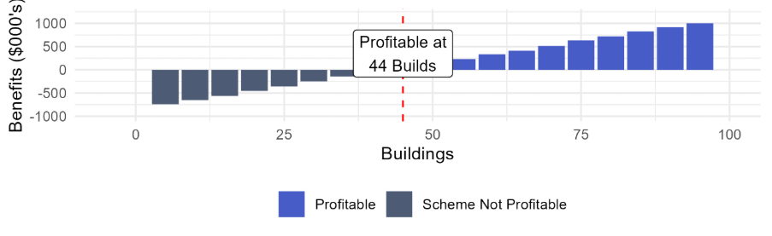

Table 41 - Scenario 6 - Net Benefits by Year (Class 2)
Year | Cost to Enter and Stay in Scheme | Inflation Adj Total Cost Saving for 25 Buildings | Benefit Per Year 25 Buildings | Inflation Adj Total Cost Saving for 50 Buildings | Benefit Per Year 50 Buildings
Year 1 | $186,596 | $40,416 | -$146,180 | $79,917 | -$106,680
Year 2 | $52,307 | $42,113 | -$10,193 | $83,273 | $30,966
Year 3 | $54,504 | $43,882 | -$10,621 | $86,770 | $32,267
Year 4 | $56,793 | $45,725 | -$11,068 | $90,415 | $33,622
Year 5 | $105,243 | $47,646 | -$57,597 | $94,212 | -$11,031
Year 6 | $61,663 | $49,647 | -$12,017 | $98,169 | $36,506
Year 7 | $64,253 | $51,732 | -$12,521 | $102,292 | $38,039
Year 8 | $66,952 | $53,905 | -$13,047 | $106,589 | $39,637
Year 9 | $69,764 | $56,169 | -$13,595 | $111,065 | $41,301
Year 10 | $129,280 | $58,528 | -$70,752 | $115,730 | -$13,550
Total | $847,355 | $489,763 | - $357,591 | $968,432 | $121,077

      - Scenario 7 - Moderate Entry Cost, Quarterly Surveillance
This scenario reduces transitional set-up costs from $80,900 to $40,450 and retain the quarterly CAB audits and inspections at $20,000 and a three-year certification cycle. Initial certification remains at $50,000. The reduction in the transitional set-up costs represents organisations that require less initial investment to meet Scheme entry requirements but still face higher ongoing compliance costs due to the surveillance frequency. The full cost structure for this scenario is set out in Table 42 below.

Table 42 - Less Mature Manufacturer Scenario 7 Cost Structure
Cost category | Frequency | Cost
Certification costs | Once-off | $50,000
Surveillance costs | Annual | $20,000
Transitional and set-up costs | Once-off | $40,450
Traceability costs | Annual | $675
Costs of maintaining certification | Annual | $22,500
Costs of re-certification | Every 3 years | $37,500
Insurance costs | Annual | $15,000

Class 1 Buildings
Under the conditions outlined above a manufacturer needs to average 72 Class 1 builds annually to be financially beneficial (see Figure 21 below), reflecting the limited benefit of reduced set-up costs when ongoing surveillance and recertification costs remain high.
At 50 Class 1 builds per year, a manufacturer would lose $288,233 over the 10 years.
At 100 Class 1 builds per year, a manufacturer would receive a benefit of $408,611 over the 10 years, with a cost to benefit ratio of 1:1.4.
The full year-on-year breakdown is set out in Table 43. Entry costs in Year 1 are $154,867, lower than Scenarios 5 and 6 reflecting the reduced transitional set-up costs. However, these are still materially higher than the central case entry cost of $56,971. At 100 builds per year, manufacturers achieve a benefit from Year 2, however recertification years continue to significantly reduce returns in Year 3, Year 6 and Year 9.
Figure 21 - Scenario 7 - Net Benefits by Build Volume (Class 1)
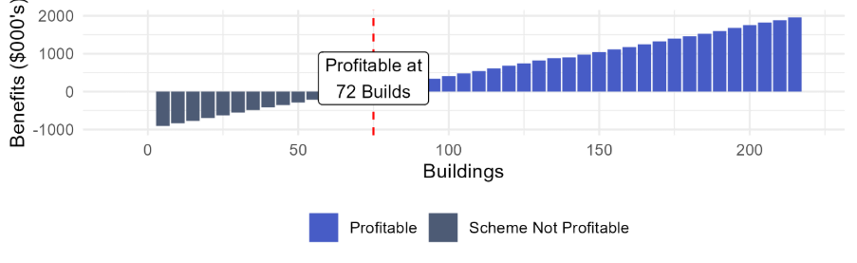

Table 43 - Scenario 7 - Net Benefits by Year (Class 1)
Year | Cost to Enter and Stay in Scheme | Inflation Adj Total Cost Saving for 50 Buildings | Benefit Per Year 50 Buildings | Inflation Adj Total Cost Saving for 100 Buildings | Benefit Per Year 100 Buildings
Year 1 | $154,867 | $56,554 | -$98,313 | $114,059 | -$40,809
Year 2 | $63,164 | $58,929 | -$4,235 | $118,849 | $55,685
Year 3 | $108,243 | $61,404 | -$46,839 | $123,841 | $15,597
Year 4 | $68,582 | $63,983 | -$4,598 | $129,042 | $60,460
Year 5 | $71,462 | $66,670 | -$4,792 | $134,462 | $63,000
Year 6 | $122,463 | $69,471 | -$52,992 | $140,109 | $17,646
Year 7 | $77,591 | $72,388 | -$5,203 | $145,994 | $68,403
Year 8 | $80,850 | $75,429 | -$5,421 | $152,125 | $71,276
Year 9 | $138,550 | $78,597 | -$59,954 | $158,515 | $19,964
Year 10 | $87,784 | $81,898 | -$5,886 | $165,172 | $77,389
Total | $973,556 | $685,323 | - $288,233 | $1,382,168 | $408,611

Class 2 Buildings
Under the conditions outlined above a manufacturer would need to average 51 Class 2 builds annually to be financially beneficial (see Figure 22 below).
At 25 Class 2 builds per year, a manufacturer would lose $483,793 over the 10 years.
At 50 Class 2 builds per year, a manufacturer would lose $5,125 over the 10 years, with a cost to benefit ratio of 1: 0.995.
The full year-on-year breakdown is set out in Table 44. At 25 builds per year, manufacturers experience a loss throughout the assessment period. At 50 builds per year, manufacturers achieve modest returns from Year 2, however recertification in Year 3, Year 6 and Year 9 and Year 1 entry costs result in an overall loss across the assessment period.
Figure 22 - Scenario 7 - Net Benefits by Build Volume (Class 2)
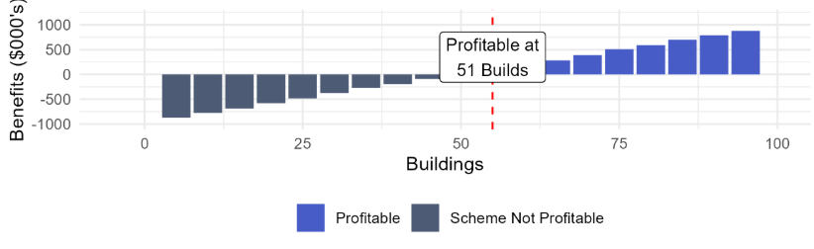
Table 44 - Scenario 7 - Net Benefits by Year (Class 2)
Year | Cost to Enter and Stay in Scheme | Inflation Adj Total Cost Saving for 25 Buildings | Benefit Per Year 25 Buildings | Inflation Adj Total Cost Saving for 50 Buildings | Benefit Per Year 50 Buildings
Year 1 | $154,867 | $40,416 | -$114,451 | $79,917 | -$74,951
Year 2 | $63,164 | $42,113 | - $21,051 | $83,273 | $20,109
Year 3 | $108,243 | $43,882 | -$64,361 | $86,770 | -$21,473
Year 4 | $68,582 | $45,725 | -$22,856 | $90,415 | $21,833
Year 5 | $71,462 | $47,646 | -$23,816 | $94,212 | $22,750
Year 6 | $122,463 | $49,647 | -$72,816 | $98,169 | -$24,294
Year 7 | $77,591 | $51,732 | -$25,859 | $102,292 | $24,701
Year 8 | $80,850 | $53,905 | -$26,945 | $106,589 | $25,739
Year 9 | $138,550 | $56,169 | -$82,382 | $111,065 | -$27,485
Year 10 | $87,784 | $58,528 | -$29,256 | $115,730 | $27,946
Total | $973,556 | $489,763 | - $483,793 | $968,432 | -$5,125

      - Scenario 8 - High Entry Cost, Quarterly Surveillance
This scenario represents the most demanding cost conditions modelled for this manufacturer profile. Initial certification costs are $50,000 and transitional set-up costs are $80,900 reflecting the investment required to meet Scheme entry requirements. CAB surveillance costs are $20,000 per year for quarterly audits and inspections and recertification occurs every three years at $37,500. Insurance costs are expected to increase by $15,000 per year. The full cost structure for this scenario is set out in Table 45 below.
Table 45 - Less Mature Manufacturer Scenario 8 Cost Structure
Cost category | Frequency | Cost
Certification costs | Once-off | $50,000
Surveillance costs | Annual | $20,000
Transitional and set-up costs | Once-off | $80,900
Traceability costs | Annual | $675
Costs of maintaining certification | Annual | $22,500
Costs of re-certification | Every 3 years | $37,500
Insurance costs | Annual | $15,000

Class 1 Buildings
Under the conditions outlined above a manufacturer would need to average 74 Class 1 builds annually to be financially beneficial (see Figure 23 below), more than double the 34 builds required under the central case.
At 50 Class 1 builds per year, a manufacturer would lose $330,383 over the 10 years.
At 100 Class 1 builds per year, a manufacturer would receive a benefit of $366,462 over the 10 years, with a cost to benefit ratio of 1:1.4.
The full year-on-year breakdown is set out in Table 46. Entry costs in Year 1 are $197,016, materially higher than the central case of $56, 971 and is driven by the combination of high certification and transitional set-up costs. At 50 builds per year, manufacturers do not achieve any financial benefit at any point in the assessment period. At 100 builds per year, manufacturers achieve a financial benefit of $55,685 in Year 2. However, recertification in Year 3, Year 6 and Year 9 push costs up significantly, reducing the benefit in those years.
Figure 23 - Scenario 8 - Net Benefits by Build Volume (Class 1)
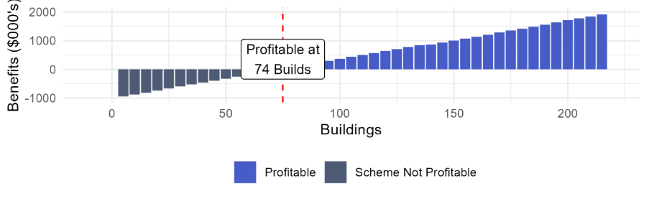

Table 46 - Scenario 8 - Net Benefits by Year (Class 1)
Year | Cost to Enter and Stay in Scheme | Inflation Adj Total Cost Saving for 50 Buildings | Benefit Per Year 50 Buildings | Inflation Adj Total Cost Saving for 100 Buildings | Benefit Per Year 100 Buildings
Year 1 | $197,016 | $56,554 | -$140,462 | $114,059 | -$82,958
Year 2 | $63,164 | $58,929 | -$4,235 | $118,849 | $55,685
Year 3 | $108,243 | $61,404 | -$46,839 | $123,841 | $15,597
Year 4 | $68,582 | $63,983 | -$4,598 | $129,042 | $60,460
Year 5 | $71,462 | $66,670 | -$4,792 | $134,462 | $63,000
Year 6 | $122,463 | $69,471 | -$52,992 | $140,109 | $17,646
Year 7 | $77,591 | $72,388 | -$5,203 | $145,994 | $68,403
Year 8 | $80,850 | $75,429 | -$5,421 | $152,125 | $71,276
Year 9 | $138,550 | $78,597 | -$59,954 | $158,515 | $19,964
Year 10 | $87,784 | $81,898 | -$5,886 | $165,172 | $77,389
Total | $1,015,705 | $685,323 | -$330,382 | $1,382,168 | $366,462

Class 2 Buildings
Under the conditions outlined above a manufacturer would need to average 54 Class 2 builds annually to be financially beneficial (see Figure 24 below).
At 25 Class 2 builds per year, a manufacturer would lose $525, 944 over the 10 years.
At 50 Class 2 builds per year, a manufacturer would lose $47,272 over the 10 years, with a cost to benefit ratio of 1:0.96.
The full year-on-year breakdown is set out in Table 47. At 25 builds per year, manufacturers do not achieve financial benefits at any point in the assessment period. At 50 builds per year, manufacturers achieve modest positive results from Year 2 onwards. However, recertification in Year 3, Year 6 and Year 9 push manufacturers back into a loss position, resulting in an overall net loss across the ten-year period.
Figure 24 - Scenario 8 - Net Benefits by Build Volume (Class 2)
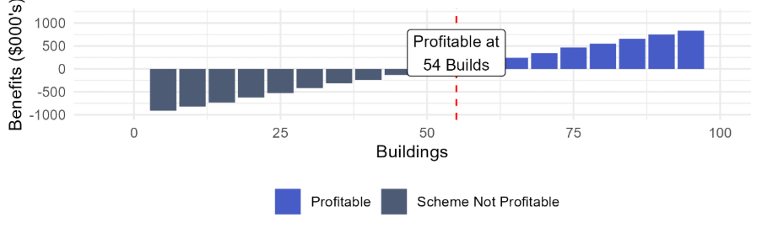

Table 47 - Scenario 8 - Net Benefits by Year (Class 2)
Year | Cost to Enter and Stay in Scheme | Inflation Adj Total Cost Saving for 25 Buildings | Benefit Per Year 25 Buildings | Inflation Adj Total Cost Saving for 50 Buildings | Benefit Per Year 50 Buildings
Year 1 | $197,016 | $40,416 | -$156,600 | $79,917 | -$117,100
Year 2 | $63,164 | $42,113 | -$21,051 | $83,273 | $20,109
Year 3 | $108,243 | $43,882 | -$64,361 | $86,770 | -$21,473
Year 4 | $68,582 | $45,725 | -$22,856 | $90,415 | $21,833
Year 5 | $71,462 | $47,646 | -$23,816 | $94,212 | $22,750
Year 6 | $122,463 | $49,647 | -$72,816 | $98,169 | -$24,294
Year 7 | $77,591 | $51,732 | -$25,859 | $102,292 | $24,701
Year 8 | $80,850 | $53,905 | -$26,945 | $106,589 | $25,739
Year 9 | $138,550 | $56,169 | -$82,382 | $111,065 | -$27,485
Year 10 | $87,784 | $58,528 | -$29,256 | $115,730 | $27,946
Total | $1,015,705 | $489,763 | -$525,942 | $968,432 | -$47,274

    - 2D and Kit-of-Parts
This section presents a series of scenarios outlining the financial benefits for 2D and kit-of-part manufacturing companies. Each scenario assumes a mature organisation experiencing the Scheme costs associated with that maturity level. The following base capacities are presented:
- Base Capacity of 20 Builds per year
- Base Capacity of 50 Builds per year
- Base Capacity of 100 Builds per year
Each base capacity includes scenarios on differing capacity uplift.
In each case it is assumed that a reduction in administrative burden increases the number of builds per year a manufacturer can construct.
The cost structure underpinning each of the scenarios follows the cost structure underpinning the central case as described in 5.4.1.1 Central Case - 2D and Kit-of-Parts, and outlined below.
Table 48 – 2D and Kit-of-Parts Cost Structure (Mature Manufacturer)
Cost category | Frequency | Cost
Certification costs | Once-off | $25,000
Surveillance costs | Annual | $20,000
Transitional and set-up costs | Once-off | $1,500
Traceability costs | Annual | $675
Costs of re-certification | Every 3 years | $18,750
Insurance costs | Annual | $7,500
In each scenario described below, the Scheme costs are subtracted to calculate Net Revenue and Net Benefit while in the Scheme.

      - Scenarios Related to Base Capacity of 100 Builds Per Year
At a base capacity of 100 builds per year, net benefits scale further, returning $5,257,982 at 5%, $1,829,835 at 2.5% and $686,972 at 1%. Similar to the 50 build capacity, all three uplift levels remain financially beneficial over the 10-year period.

        - Scenario 9 – Base Capacity 100 Builds, 5% Uplift
This scenario tests the effect of a 5% uplift, resulting in 5 extra builds completed each year. A mature manufacturer is expected to receive a net benefit of $5,257,982 over 10 years. The full year-on-year breakdown is set out in Table 49 below.
Table 49 - Scenario 9 - Net Benefits by Year (2D and Kit-of-Parts)
Year | Extra Builds Each Year | Estimated Revenue while not in Scheme | Estimated Revenue while in Scheme with estimated Uplift | Estimated Net Revenue while in Scheme | Estimated Net Benefit Scheme vs Base Case
Year 1 | 5 | $9,430,108 | $9,901,613 | $9,844,642 | $414,534
Year 2 | 5 | $9,826,173 | $10,317,481 | $10,286,890 | $460,717
Year 3 | 5 | $10,238,872 | $10,750,815 | $10,697,726 | $458,854
Year 4 | 5 | $10,668,904 | $11,202,350 | $11,169,135 | $500,230
Year 5 | 5 | $11,116,998 | $11,672,848 | $11,638,238 | $521,240
Year 6 | 5 | $11,583,912 | $12,163,108 | $12,103,045 | $519,132
Year 7 | 5 | $12,070,437 | $12,673,959 | $12,636,380 | $565,943
Year 8 | 5 | $12,577,395 | $13,206,265 | $13,167,108 | $589,713
Year 9 | 5 | $13,105,646 | $13,760,928 | $13,692,974 | $587,328
Year 10 | 5 | $13,656,083 | $14,338,887 | $14,296,372 | $640,289
Total | 50 | $114,274,528 | $119,988,255 | $119,532,510 | $5,257,982

        - Scenario 10 – Base Capacity 100 Builds, 2.5% Uplift
This scenario tests the effect of a 2.5% uplift, resulting in 2 extra builds completed each year. A mature manufacturer is expected to receive a net benefit of $1,829,835 over 10 years. The full year-on-year breakdown is set out in Table 50 below.
Table 50 - Scenario 10 - Net Benefits by Year (2D and Kit-of-Parts)
Year | Extra Builds Each Year | Estimated Revenue while not in Scheme | Estimated Revenue while in Scheme with estimated Uplift | Estimated Net Revenue while in Scheme | Estimated Net Benefit Scheme vs Base Case
Year 1 | 2 | $9,430,475 | $9,619,085 | $9,562,113 | $131,638
Year 2 | 2 | $9,826,555 | $10,023,086 | $9,992,495 | $165,940
Year 3 | 2 | $10,239,270 | $10,444,056 | $10,390,966 | $151,696
Year 4 | 2 | $10,669,320 | $10,882,706 | $10,849,491 | $180,171
Year 5 | 2 | $11,117,431 | $11,339,780 | $11,305,170 | $187,739
Year 6 | 2 | $11,584,363 | $11,816,051 | $11,755,987 | $171,624
Year 7 | 2 | $12,070,907 | $12,312,325 | $12,274,746 | $203,840
Year 8 | 2 | $12,577,885 | $12,829,442 | $12,790,286 | $212,401
Year 9 | 2 | $13,106,156 | $13,368,279 | $13,300,325 | $194,169
Year 10 | 2 | $13,656,614 | $13,929,747 | $13,887,232 | $230,617
Total | 20 | $114,278,977 | $116,564,556 | $116,108,812 | $1,829,835

        - Scenario 11 – Base Capacity 100 Builds, 1% Uplift
This scenario tests the effect of a 1% uplift, resulting in 1 extra build completed each year. A mature manufacturer is expected to receive a net benefit of $686,972 over 10 years. The full year-on-year breakdown is set out in Table 51 below.
Table 51 - Scenario 11 - Net Benefits by Year (2D and Kit-of-Parts)
Year | Extra Builds Each Year | Estimated Revenue while not in Scheme | Estimated Revenue while in Scheme with estimated Uplift | Estimated Net Revenue while in Scheme | Estimated Net Benefit Scheme vs Base Case
Year 1 | 1 | $9,429,874 | $9,524,173 | $9,467,201 | $37,327
Year 2 | 1 | $9,825,929 | $9,924,188 | $9,893,596 | $67,668
Year 3 | 1 | $10,238,618 | $10,341,004 | $10,287,914 | $49,297
Year 4 | 1 | $10,668,639 | $10,775,326 | $10,742,111 | $73,471
Year 5 | 1 | $11,116,722 | $11,227,890 | $11,193,279 | $76,557
Year 6 | 1 | $11,583,625 | $11,699,461 | $11,639,397 | $55,773
Year 7 | 1 | $12,070,137 | $12,190,838 | $12,153,260 | $83,123
Year 8 | 1 | $12,577,083 | $12,702,853 | $12,663,697 | $86,614
Year 9 | 1 | $13,105,320 | $13,236,373 | $13,168,420 | $63,099
Year 10 | 1 | $13,655,744 | $13,792,301 | $13,749,786 | $94,043
Total | 10 | $114,271,690 | $115,414,407 | $114,958,662 | $686,972

      - Scenarios Related to Base Capacity of 50 Builds Per Year
At a base capacity of 50 builds per year, all uplift levels modelled return a positive net benefit over 10 years including $1,829,763 at 5% and $686, 911 at 2.5%. Note 1% uplift at base capacity of 50 builds per year represents the central case for 2D and kit-of-parts.

        - Scenario 12 – Base Capacity 50 Builds, 5% Uplift
This scenario tests the effect of a 5% uplift, resulting in 2 extra builds completed each year. A mature manufacturer is expected to receive a net benefit of $1,829,763 over 10 years. The full year-on-year breakdown is set out in Table 52 below.
Table 52 - Scenario 12 - Net Benefits by Year (2D and Kit-of-Parts)
Year | Extra Builds Each Year | Estimated Revenue while not in Scheme | Estimated Revenue while in Scheme with estimated Uplift | Estimated Net Revenue while in Scheme | Estimated Net Benefit Scheme vs Base Case
Year 1 | 2 | $4,715,089 | $4,903,692 | $4,846,721 | $131,632
Year 2 | 2 | $4,913,122 | $5,109,647 | $5,079,056 | $165,933
Year 3 | 2 | $5,119,473 | $5,324,252 | $5,271,163 | $151,690
Year 4 | 2 | $5,334,491 | $5,547,871 | $5,514,656 | $180,165
Year 5 | 2 | $5,558,540 | $5,780,882 | $5,746,271 | $187,732
Year 6 | 2 | $5,791,999 | $6,023,679 | $5,963,615 | $171,616
Year 7 | 2 | $6,035,263 | $6,276,673 | $6,239,095 | $203,832
Year 8 | 2 | $6,288,744 | $6,540,293 | $6,501,137 | $212,393
Year 9 | 2 | $6,552,871 | $6,814,986 | $6,747,032 | $194,161
Year 10 | 2 | $6,828,091 | $7,101,215 | $7,058,700 | $230,609
Total | 20 | $57,137,682 | $59,423,189 | $58,967,445 | $1,829,763
        - Scenario 13 – Base Capacity 50 Builds, 2.5% Uplift
This scenario tests the effect of a 2.5% uplift, resulting in 1 extra build completed each year. A mature manufacturer is expected to receive a net benefit of $686,911 over 10 years. The full year-on-year breakdown is set out in Table 53 below.
Table 53 - Scenario 13 - Net Benefits by Year (2D and Kit-of-Parts)
Year | Extra Builds Each Year | Estimated Revenue while not in Scheme | Estimated Revenue while in Scheme with estimated Uplift | Estimated Net Revenue while in Scheme | Estimated Net Benefit Scheme vs Base Case
Year 1 | 1 | $4,714,685 | $4,808,979 | $4,752,008 | $37,322
Year 2 | 1 | $4,912,702 | $5,010,956 | $4,980,365 | $67,663
Year 3 | 1 | $5,119,035 | $5,221,416 | $5,168,327 | $49,291
Year 4 | 1 | $5,334,035 | $5,440,716 | $5,407,501 | $73,466
Year 5 | 1 | $5,558,064 | $5,669,226 | $5,634,616 | $76,551
Year 6 | 1 | $5,791,503 | $5,907,333 | $5,847,270 | $55,767
Year 7 | 1 | $6,034,746 | $6,155,441 | $6,117,863 | $83,117
Year 8 | 1 | $6,288,206 | $6,413,970 | $6,374,813 | $86,607
Year 9 | 1 | $6,552,310 | $6,683,356 | $6,615,403 | $63,092
Year 10 | 1 | $6,827,507 | $6,964,057 | $6,921,543 | $94,035
Total | 10 | $57,132,795 | $58,275,451 | $57,819,706 | $686,911

      - Scenarios Related to Base Capacity of 20 Builds Per Year
At a base capacity of 20 builds per year, the Scheme is financially beneficial at 5% and 2.5% uplift, returning a 10-year net benefit of $686,971 and $127,406 respectively. At 1% uplift, the additional build (one build every 5 years) is insufficient to offset Scheme costs over the same period, resulting in a net loss of $208,005.

        - Scenario 14 – Base Capacity 20 Builds, 5% Uplift
This scenario tests the effect of a 5% uplift, resulting in 1 extra build completed each year. A mature manufacturer is expected to receive a net benefit of $686,971 over 10 years. The full year-on-year breakdown is set out in Table 54 below.
Table 54 - Scenario 14 - Net Benefits by Year (2D and Kit-of-Parts)
Year | Extra Builds Each Year | Estimated Revenue while not in Scheme | Estimated Revenue while in Scheme with estimated Uplift | Estimated Net Revenue while in Scheme | Estimated Net Benefit Scheme vs Base Case
Year 1 | 1 | $1,885,972 | $1,980,271 | $1,923,300 | $37,327
Year 2 | 1 | $1,965,183 | $2,063,442 | $2,032,851 | $67,668
Year 3 | 1 | $2,047,721 | $2,150,107 | $2,097,018 | $49,297
Year 4 | 1 | $2,133,725 | $2,240,411 | $2,207,196 | $73,471
Year 5 | 1 | $2,223,342 | $2,334,509 | $2,299,899 | $76,557
Year 6 | 1 | $2,316,722 | $2,432,558 | $2,372,495 | $55,773
Year 7 | 1 | $2,414,024 | $2,534,726 | $2,497,147 | $83,123
Year 8 | 1 | $2,515,413 | $2,641,184 | $2,602,027 | $86,614
Year 9 | 1 | $2,621,061 | $2,752,114 | $2,684,160 | $63,099
Year 10 | 1 | $2,731,145 | $2,867,703 | $2,825,188 | $94,042
Total | 10 | $22,854,309 | $23,997,025 | $23,541,280 | $686,971
        - Scenario 15 – Base Capacity 20 Builds, 2.5% Uplift
This scenario tests the effect of a 2.5% uplift, resulting in 1 extra build completed every 2 years. A mature manufacturer is expected to receive a net benefit of $127,406 over 10 years. The full year-on-year breakdown is set out in Table 55 below.
Table 55 - Scenario 15 - Net Benefits by Year (2D and Kit-of-Parts)
Year | Extra Builds Each Year | Estimated Revenue while not in Scheme | Estimated Revenue while in Scheme with estimated Uplift | Estimated Net Revenue while in Scheme | Estimated Net Benefit Scheme vs Base Case
Year 1 | 0 | $1,886,105 | $1,886,105 | $1,829,134 | -$56,971
Year 2 | 1 | $1,965,322 | $2,063,588 | $2,032,997 | $67,675
Year 3 | 0 | $2,047,865 | $2,047,865 | $1,994,776 | -$53,089
Year 4 | 1 | $2,133,876 | $2,240,570 | $2,207,355 | $73,479
Year 5 | 0 | $2,223,499 | $2,223,499 | $2,188,889 | -$34,610
Year 6 | 1 | $2,316,886 | $2,432,730 | $2,372,666 | $55,781
Year 7 | 0 | $2,414,195 | $2,414,195 | $2,376,616 | -$37,578
Year 8 | 1 | $2,515,591 | $2,641,370 | $2,602,214 | $86,623
Year 9 | 0 | $2,621,246 | $2,621,246 | $2,553,292 | -$67,954
Year 10 | 1 | $2,731,338 | $2,867,905 | $2,825,390 | $94,052
Total | 5 | $22,855,922 | $23,439,073 | $22,983,328 | $127,406

        - Scenario 16 – Base Capacity 20 Builds, 1% Uplift
This scenario tests the effect of a 1% uplift, resulting in 1 extra build completed every 5 years. This scenario is not financially beneficial, with an expected net loss of $208,005 over 10 years. The full year-on-year breakdown is set out in Table 56 below.
Table 56 - Scenario 16 - Net Benefits by Year (2D and Kit-of-Parts)
Year | Extra Builds Each Year | Estimated Revenue while not in Scheme | Estimated Revenue while in Scheme with estimated Uplift | Estimated Net Revenue while in Scheme | Estimated Net Benefit Scheme vs Base Case
Year 1 | 0 | $1,886,090 | $1,886,090 | $1,829,118 | -$56,971
Year 2 | 0 | $1,965,305 | $1,965,305 | $1,934,714 | -$30,591
Year 3 | 0 | $2,047,848 | $2,047,848 | $1,994,759 | -$53,089
Year 4 | 0 | $2,133,858 | $2,133,858 | $2,100,643 | -$33,215
Year 5 | 1 | $2,223,480 | $2,334,654 | $2,300,044 | $76,564
Year 6 | 0 | $2,316,866 | $2,316,866 | $2,256,802 | -$60,063
Year 7 | 0 | $2,414,174 | $2,414,174 | $2,376,596 | -$37,578
Year 8 | 0 | $2,515,570 | $2,515,570 | $2,476,413 | -$39,157
Year 9 | 0 | $2,621,224 | $2,621,224 | $2,553,270 | -$67,954
Year 10 | 1 | $2,731,315 | $2,867,881 | $2,825,366 | $94,051
Total | 2 | $22,855,729 | $23,103,469 | $22,647,724 | -$208,005



Conclusions
  - Summary of Findings
The analysis assessed the costs and benefits of the Scheme for manufacturers of prefabricated construction over a 10-year period. The central case and a range of sensitivity scenarios were modelled to test how net benefits change under different cost, surveillance and organisation maturity.
This section draws out the key conclusions from that analysis, identifies the scenarios under which participation is most financially beneficial, and highlights the cost factors that most significantly influence outcomes across the sensitivity analysis.

  - 3D Volumetric Construction
Across the sensitivity analysis, the scenarios generating the strongest net benefits for 3D volumetric manufacturers are those combining mature manufacturer cost profiles with reduced surveillance frequency and extended certification cycles.
The two summary tables below set out the key findings across all scenarios for Class 1 and Class 2 buildings respectively.
Table 57 - Summary of Scenarios (Class 1) ($m)
Scenario | Dwellings required to be profitable | 10 Year Net Benefits 50 Buildings | 10 Year Net Benefits 100 Buildings
Central Case | 36 | $0.20 | $0.84
Scenario 1 | 19 | $0.41 | $1.05
Scenario 2 | 25 | $0.35 | $0.98
Scenario 3 | 41 | $0.13 | $0.77
Scenario 4 | 52 | -$0.03 | $0.60
Scenario 5 | 59 | -$0.12 | $0.58
Scenario 6 | 64 | -$0.16 | $0.53
Scenario 7 | 72 | -$0.29 | $0.41
Scenario 8 | 74 | -$0.33 | $0.37

Table 58 - Summary of Scenarios (Class 2) ($m)
Scenario | Dwellings required to be profitable | 10 Year Net Benefits 25 Buildings | 10 Year Net Benefits 50 Buildings
Central Case | 23 | $0.03 | $0.51
Scenario 1 | 14 | $0.25 | $0.70
Scenario 2 | 17 | $0.18 | $0.66
Scenario 3 | 28 | -$0.03 | $0.42
Scenario 4 | 36 | -$0.20 | $0.25
Scenario 5 | 41 | -$0.32 | $0.16
Scenario 6 | 44 | -$0.36 | $0.12
Scenario 7 | 51 | -$0.48 | -$0.005
Scenario 8 | 54 | -$0.53 | -$0.05
Scenario 1 produces the strongest net benefits across both Class 1 and Class 2 buildings. Under this scenario, a mature manufacturer with annual rather than quarterly surveillance and a five-year certification cycle require only 19 Class 1 builds or 14 Class 2 builds per year to receive a financial benefit through Scheme participation. At 100 Class 1 builds per year, the 10-year net benefit reaches $1.05 million, and at 50 Class 2 builds per year, $0.70 million. Lower surveillance costs and less frequent recertification are the main drivers of these stronger outcomes.
Scenario 2, which retains the same mature manufacturer profile but with biannual rather than quarterly surveillance and a five-year cycle, produces the second strongest outcomes. The breakeven volume is slightly higher at 25 Class 1 builds and 17 Class 2 builds per year, with 10-year net benefits of $0.98 million and $0.66 million respectively at the higher build volumes modelled.
Scenarios 3 and 4 apply to less mature manufacturers facing high entry and ongoing costs. Scenario 3 includes a reduction in maintenance costs, tapering to zero over five years, as the manufacturer builds capability. Scenario 4 retains the same high entry costs but without this tapering reduction, meaning ongoing maintenance costs remain at $22,500 per year throughout the assessment period.
Under Scenario 3, net benefits are positive at both build volumes for Class 1, returning $0.13 million at 50 builds and $0.77 million at 100 builds. For Class 2, the 50-build outcome is positive at $0.42 million, though the 25-build outcome is slightly negative at -$0.03 million. Under Scenario 4, Class 1 net benefits at 100 builds remain positive at $0.60 million, while the 50-build outcome is marginally negative at -$0.03 million. The stronger outcomes under Scenario 3 reflect the benefit of capability investment reducing ongoing costs over time.
Across all scenarios, net benefits at 100 Class 1 builds per year are positive, ranging from $0.37 million in the most demanding conditions (Scenario 8) to $1.05 million in the most favourable (Scenario 1). For Class 2, net benefits at 50 builds per year are positive across Scenarios 1 through 6. Scenarios 7 and 8, which reflect the highest cost conditions for less mature manufacturers, produce small losses of -$0.005 million and -$0.05 million respectively. This shows that manufacturers building at sufficient scale can achieve a positive financial outcome across a wide range of cost and surveillance conditions.

  - 2D and Kit-Of-Parts
For 2D and kit-of-parts manufacturers, net benefits are driven primarily by base production capacity and throughput uplift achieved. In comparison to the 3D volumetric scenarios, surveillance and certification settings remain consistent across all scenarios, as all assume a mature manufacturer profile.
Table 59 - Summary of Scenarios (2D and Kit-of-Parts) ($m)
Base Capacity (builds/year) | 1% Throughput Uplift 10-Year Net Benefit ($m) | 2.5% Throughput Uplift 10-Year Net Benefit ($m) | 5% Throughput Uplift 10-Year Net Benefit ($m)
Note: 50 builds/year at 1% uplift represents the central case ($0.13m)
20 Builds/Year | -$0.21 | $0.13 | $0.69
50 Builds/Year | $0.13 | $0.69 | $1.83
100 Builds/Year | $0.69 | $1.83 | $5.26
The most financially beneficial outcomes arise at higher base production capacity combined with higher throughput uplift. At 100 builds per year with a 5% uplift, a manufacturer can expect a 10-year net benefit of $5.26 million.
At 50 builds per year, all three uplift levels modelled return a positive outcome, ranging from $0.69 million at 1% uplift to $1.83 million at 5% uplift.
At 20 builds per year, participation remains worthwhile at 2.5% and 5% uplift, returning $0.13 million and $0.69 million respectively. Only at 20 builds per year with a conservative 1% uplift does participation result in a net loss, at -$0.21 million over 10 years.
This reflects that at low production volumes, the additional revenue generated from a small number of extra builds is not sufficient to offset Scheme participation costs.

  - Ongoing Implementation Considerations
A key implementation consideration for the Scheme is how ongoing operating costs will be funded. Government activities can be funded through a range of mechanisms including appropriations and cost recovery charges and levies. Where an individual or organisation creates demand for a government activity, the Australian Government Cost Recovery Policy and the Australian Government Charging Framework (Charging Framework) provide they should generally be charged for it. The ABCB already applies this approach to the WaterMark Certification Scheme, which operates on a cost recovery basis.
The ABCB Issues Paper identified cost neutrality as a guiding principle of the Scheme with the Commonwealth to provide oversight on a cost-recovery basis. This report identifies cost recovery as a possible mechanism for funding the Scheme’s ongoing operation, in line with this principle and the Charging Framework more broadly.



Appendices
  - Appendix A Glossary

Key Terms | Description
Australian Building Codes Board (ABCB) | A standards writing body responsible for the National Construction Code, WaterMark and CodeMark Certification Schemes and regulatory reform in the construction industry.
Accreditation | An attestation by the Accreditation Body that a Certification Body is competent to carry out the specific Conformity Assessment tasks required by the Scheme.
Accreditation Body | The authoritative body appointed by the Scheme Owner responsible for providing accreditation of Certification Bodies.
Benefit Cost Ratio (BCR) | Determines financial benefit by comparing present value of benefits to costs.
Certification | The independent, third-party process by which a Certification Body evaluates a manufacturer against the requirements of the Scheme and, where those requirements are met, grants a Certificate of Conformity; and, where the context requires, the status of holding a valid and current Certificate of Conformity issued under the Scheme.
Certification Body | An independent organisation, accredited by the Accreditation Body under the Scheme, that is authorised to issue Certificates of Conformity to manufacturers and is operationally independent of both the Scheme Owner and the manufacturers it certifies.
Class 1 building | As defined in Part A6 of the NCC.
Class 2 building | As defined in Part A6 of the NCC.
CodeMark | A voluntary third-party building product certification scheme, owned by the ABCB.
Design Assessment Body | An independent organisation that is suitably qualified and recognised by the Scheme Owner to review and assess repeatable Prefabricated Building or Component designs, plans and supporting documentation against the National Construction Code and issue Design Approval Certificates.
Interoperability | The ability of a system, product, or service to communicate and function with other (technically different) systems, products or services.
Jurisdiction | The Commonwealth of Australia, a state of Australia, the Australian Capital Territory or the Norther Territory of Australia.
National Construction Code (NCC) | The National Construction Code is Australia’s primary set of technical design and construction provisions establishing the minimum standards for safety, health, amenity, accessibility and sustainability of buildings.
Net Present Value (NPV) | The value of all future cash flows and outflows over time.
Panelised Systems | As defined in the current edition of SA HB 268.
Prefabricated Construction | A method of construction in which a building, in whole or in part, is made in a location separate from the site of installation.
Profit or Profitability | . Where to profit and profitability appear throughout Chapter 4 Economic Analysis Methodology and 5 Findings, these refer to the financial benefit experienced under the Scheme relative to the costs of participation, not a manufacturer’s overall financial position.

  - Appendix B Abbreviations

Acronym | Full Name
ABCB | Australian Building Codes Board
ABI | Association of British Insurers
ACRS | Australasian Certification Authority for Reinforcing and Structural Steels
APS | Australian Public Service
BCR | Benefit Cost Ratio
CAB | Certification Body/Conformity Assessment Body
CPI | Consumer Price Index
CRIS | Cost Recovery Implementation Statement
DAB | Design Approval Body
DAFF | Department of Agriculture, Fisheries and Forestry
DCMP | Digital Construction Material Passport
DPP | Digital Product Passport
EL | Executive Level
ESPR | Ecodesign for Sustainable Products Regulation
GBA | Global Battery Alliance
GTIN | Global Trade Item Numbers
HIA | Housing Industry Association
JASANZ | Joint Accreditation System of Australia and New Zealand
MMC | Modern methods of construction
NCC | National Construction Code
NCP | National Competition Policy
NPV | Net Present Value
OIA | Office of Impact Analysis
PC | Productivity Commission
RFID | Radio Frequency Identification
QA | Quality Assurance
QC | Quality Control
QMS | Quality Management System
QR Codes | Quick Response Codes
UBS | Unrestricted Building Surveyor

  - Appendix C - Mandatory inspection stages for house building in different jurisdictions (Class 1 buildings)
Table 60 - Mandatory inspection stages for house building in different jurisdictions (Class 1 buildings)
Inspection stages | NSW | VIC | QLD | WA* | SA† | TAS | ACT | NT‡
Before pouring footing | X | X | X | X |  | X | X | X
Before pouring in-situ reinforced concrete element | X | X |  |  |  | X | X§ | X
Before pouring concrete slab |  |  | X | X |  |  |  | X
After covering foundations of the work |  |  |  |  |  | X
Before lining/covering framework | X | X | X# | X |  | X | X | X
Before pouring reinforced masonry or block walls |  |  |  |  |  |  |  | X
Before covering walls, floors, or ceilings to check fire resistance levels |  |  |  |  |  |  |  | X
Waterproofing in a wet area | X |  |  |  |  | X |  | X
Upon completion | X | X | X | X |  | X | X | X

* WA requirements are proposed and not currently in force.
† SA requires a minimum 66% of house construction to be inspected at least once during construction or on completion.
‡ NT has a 2-tier system of building control areas. Tier 1 areas have full certification requirements for all building work. Tier 2 areas have full certification requirements for most building work and part certification requirements for some building work.
§ ACT does not specify ‘in-situ’
# If bracing consists of cladding or lining, then frame inspection takes place after lining/covering.
  - Appendix D - Mandatory inspection stages for apartment building in different jurisdictions (Class 2 buildings)
Note: Table 61 is currently only for Class 2 buildings (Apartments) and has not included all plumbing inspections.
Table 61 - Mandatory inspection stages for house building in different jurisdictions (Class 2 buildings)
Inspection stages | NSW | VIC | QLD* | WA† | SA‡ | TAS | ACT | NT§
Before placing footing membrane/concrete | X | X |  | X |  |  | X | X
Before pouring in-situ reinforced concrete element |  | X |  |  |  |  | X# | X
Before pouring concrete slab |  |  |  |  |  | X
After covering foundations of the work |  |  |  |  |  | X
Before lining/covering framework |  | X |  |  |  | X |  | X
Before pouring reinforced masonry or block walls |  |  |  |  |  |  |  | X
Before covering walls, floors, or ceilings to check fire resistance levels |  |  |  |  |  |  |  | X
Reinforcing steelwork for settings and structural elements before pouring concrete |  |  |  | X
Structural framework before covering |  |  |  | X
Inspection stages | NSW | VIC | QLD* | WA† | SA‡ | TAS | ACT | NT§
Fire and smoke resisting building elements in each story |  | X
Junction of internal fire-resisting construction bounding a sole-occupancy unit and another building element required to resist internal fire spread | X |  |  | X
Lightweight construction building element required to resist fire spread in at least one sole occupancy unit in each story. Also, its components and junctions. |  | X
One of each lightweight construction stair shaft, lift shaft or service shaft required to resist the spread of fire. Also, its components and junctions. |  | X
fire protection methods for service penetration | X | X |  | X |  | X
external waterproofing membranes, flashing, sarking or like materials |  |  |  | X
waterproofing in wet areas | X |  |  | X |  | X |  | X
Upon completion | X | X |  | X |  | X | X | X
Fire safety system testing |  |  |  | X
* QLD has no mandatory requirements for Class 2-9 buildings as these are as prescribed in the building development approval by the building certifier
† WA requirements are proposed and not currently in force, except for fire safety system testing
‡ SA requires a minimum 90% of Class 2-9 buildings to be inspected at least once during construction or upon completion
§ NT has a two-tier system of building control areas. Tier 1 areas have full certification requirements for all building work. Tier 2 areas have full certification requirements for most building work and part certification requirements for some building work.
# ACT does not specify ‘in-situ’
  - Appendix E – Plumbing work inspection and notification stages
Inspection stages | NSW* | VIC* | QLD | WA* | SA | TAS* | ACT* | NT*
Sewer installed and ready for visual inspection & air /water test, before back filling | N | N | I | S | I | N | N | N
Stormwater installed and ready for visual inspection & air /water test, before back filling | N | N | I | - | S | N | N | N
Rough-in Stage  Drinking Water Pipes: Before covering walls, floors, ceilings | N | N | I | S | I | N | N | N
Rough in Stage  Gas Pipes: Before covering walls, floors, ceilings | N | N | I | - | - | - | N | -
Rough in Stage  Sanitary waste Pipes: Before covering walls, floors, ceilings | N | N | I | S | I | N | N | N
Stormwater Drainage above ground | N | N | I | S | S | N | N | N
Final Completion of all fixtures and fitted are connected and ready to be occupied | N | N | I | S | I^ | N | N | I
Final Non-Drinking Water/ Recycled Water Completion of all fixtures and fitted are connected and ready to be occupied | N | N | I | I | I | N | N | I
Final Gas Appliance installed and commissioned | N | N | I | I | - | - | N | -

N | Mandatory notification
I | Mandatory inspection
S | Self-regulated/ not regulated
- | No information
* | Inspectors can attend construction site and issue rectification notices for non-compliant work at any time during construction.
^ | Commercial projects only

  - Appendix F - Traceability Case Studies
    - QR Code Case Studies
      - ACRS Cloud digital traceability
The Australasian Certification Authority for Reinforcing and Structural Steels (ACRS), a steel certifier accredited by JAS-ANZ, has developed a cloud-based verification platform linking QR codes on steel products to digital certificates. It provides a secure environment for industry to verify product conformance with Australian and New Zealand Standards, enabling compliance and reliable and verifiable information for end users.
The ACRS Cloud platform highlights how QR Codes can provide a practical and accessible mechanism for linking physical building products to trusted compliance information. In the MMC Scheme context, manufacturers could attach QR codes to certified products, enabling builders, certifiers or consumers to verify certification status, product history and supporting documentation throughout the supply chain. This example illustrates how a relatively low-cost solution can strengthen assurance outcomes, improve confidence in products and support compliance activities without the requirement for a highly complex digital infrastructure.

      - The Department of Agriculture, Fisheries and Forestry (DAFF) and Griffith University Traceability Research
DAFF funded a research initiative led by Griffith University examining how traceability can support Australian exporters in demonstrating product origin and quality to Southeast Asian markets. The research focussed on Murray Cod and premium horticultural products including nectarines and cherries. Vietnam has strong demand for premium imported produce positioned as safe, authentic and high quality, and Australia has a positive reputation in the region.
The traceability system involved Australian growers, freight operators and Vietnamese retailers uploading supply chain information into dynamic QR codes, which consumers could scan while in-store, allowing shoppers to see when fruit was packaged, transported to Vietnam and arrived in the retail store.
The research found that consumers were willing to pay a premium for products when traceability information was clearly explained and verified at the point of purchase. Retailer reputation, visible quality and country of origin remained the primary drivers of trust, with traceability strengthening those perceptions when presented meaningfully.
This research demonstrates how QR code enabled traceability can increase consumer confidence in products by making supply chain information transparent and verifiable. While food traceability differs from the construction context, this example highlights how traceability can reinforce confidence in products, enabling builders, certifiers and owners to readily access reliable information about product origin, compliance status and certification history.

    - RFID Case Studies
      - Track & Trace concrete blocks – Netherlands
A construction consortium (Levvel) was established to renew the Afsluitdijk enclosure dam in the Netherlands, which separates the IJsselmeer from the Wadden Sea. The dam is protected against high sea waves with a patented concrete block. To guarantee quality, Levvel requires full traceability of the concrete blocks, from production to installation.
RFID tags were embedded intro each concrete block during manufacturing, linking the physical products to its information record. RFID antennas and readers were installed on cranes in the production hall and in drying area, with the system engineered to operate reliably in sea conditions. Tag data was stored in the cloud, and accessible to Levvel and its partners through a web platform at all times. Integration with crane GPS systems provided insights into the exact position of every block.
These activities eliminated manual counting and data processing, with product information automatically captured. Specific reports can be generated on demand, and the system also enabling timely intervention where quality or compliance issues were identified with individual block.
The Afsluitdijk project highlights how RFID technology can provide end-to-end traceability and rapid identification of non-conforming products in construction environments. For the Scheme, this illustrates how RFID tracking could support certification, surveillance and compliance activities across the MMC supply chain. The scale of infrastructure in this case study may exceed baseline Scheme requirements but presents a future capability for manufacturers seeking enhanced assurance and operational efficiencies.

      - Real-time visibility - BE Switchcraft
BE Switchcraft manufacturers customised electrical switchboards for large building applications, including the Parliament House in Canberra and the Adelaide Convention Centre. Prior to adopting RFID, tracking project status relied on manual data entry into their ERP solution, a process that produced information with up to two days delay.
By adopting simple RFID technology, managers gained real-time visibility of manufacturing processes and product delivery status. Staff uptake of data capture has also increased with the ease of use of the RFID solution over barcode scanning, improve data integrity.
For the Scheme, this example demonstrates how RFID technology can automate product information capture within a manufacturing environment, reducing reliance on manual data entry and improving the accuracy and timeliness of traceability records. It also illustrates how RFID can integrate with existing business systems to improve a manufacturer’s operations.

    - GS1 Standards Case Studies
      - The Australian Meat Industry
Exporting meat to the US require unique shipping marks applied to all cartons, with estimates at a cost of 10-15 cents per carton, with Australia exporting over 250,000 tonnes of meat to the US each year. Until recently, tens of thousands of cartons were being rejected and destroyed at the US border due to damaged or missing shipping labels, with exporters bearing the cost of remarking or destruction.
GS1 barcodes were agreed between the Australian and US Governments as the simplest and most cost-effective solution for identifying and verifying individual cartons.
The Australian meat industry also developed the Meat Messaging system, a GS1 online tool used by exporters and US import inspects to deliver traceability for every certified carton in a shipment, manage rectification of issues and support traceback on samples. The adoption of GS1 standards has delivered estimated at more than $200 million annually to the industry.
This example demonstrates how standardised product identification can improve traceability, reduce compliance costs and facilitate efficient verification across organisations and jurisdictions. For the Scheme, GS1 standards could support consistent product identification and information sharing between manufacturers, certifiers, builders and other supply chain participants. It demonstrates how common standards can deliver benefits beyond individual entities by enabling information exchange across the entire supply chain ecosystem.

      - Scalable growth with GS1 Standards for Legrand UK & Ireland
Legrand designs and manufactures electrical and digital infrastructure products including wiring devices, cable management solutions and building automation systems. The company operates multiple distribution centres with an inventory spanning approximately 30,000 internally manufactured items and 12,000 products sourced from international suppliers.
Inventory was being managed through spreadsheets and physical stocktakes, with data entered manually into their ERP system. This was becoming increasingly difficult to manage as order volumes and product ranges increased. Data inconsistencies also complicated integration with wholesalers and customers delivering large-scale infrastructure projects.
Legrand adopted GS1 standards and implemented a new Warehouse Management System integrate with both GS1 standards and its existing ERP system. This new system automated data flows between operational and administrative processes, reducing data errors and improving reliability of data for enhanced decision-making capabilities.
For the Scheme, the Legrand example highlights how GS1 standards can improve data consistency, reduce manual processes and support integration between manufacturers, certifiers and builders. GS1 standards can provide a scalable and interoperable foundation for traceability, enabling consistent product verification while remaining compatible with a range of technology solutions in the Scheme.

    - Digital Product Passport Case Studies
      - Digital Construction Material Passport (DCMP)
The DCMP is an open-source, free data standard designed to support information sharing about construction products. It functions as a digital material passport, capturing information on a product’s composition, material inputs, manufacturing processes and suitability for circular economy and sustainable construction outcomes. The format is based on XML, enabling brad adoption and integration without licensing requirements, supported by a freely available online editor for creating, viewing and updating files.
A material passport is supplied by the manufacturer and accompanies the product through the supply chain. Developed for both European and global markets, the open data format ensures that information can be transferred between supply chain participants without becoming obsolete.
The DCMP demonstrates a future pathway for the Scheme where traceability information is maintained in a structured and transferable format throughout the product lifecycle, supporting compliance activities and interoperability between manufacturers, certifiers and other industry participants.

      - GBA Battery Passport
The Global Battery Alliance’s (GBA) Battery Passport is a sustainability reporting and certification scheme that uses supply chain data to gather, verify and compare environmental and social performance across battery facilities and products. The passport is digitally attached to batteries, recording raw material origins, production process data, final product specifications and sustainability information across the value chain, accessible to relevant stakeholders throughout the battery’s lifecycle.
Initial pilots were conducted in 2023 with Audi and Tesla, followed by additional pilots in 2024 with participants accounting for over 80% of global electric vehicle battery manufacturing capacity. Operational trials are underway, with companies across the battery value chain, supporting suppliers map out supply chains, collect data in accordance with benchmarks and rules, test digital solutions and build trust with independent assurance providers.
The Battery Passport provides an example of how Digital Product Passports can support transparency, traceability and assurance across complex supply chains. While the Battery Passport represents an advanced traceability solution, it outlines the long-term benefits of maintaining lifecycle information that is accessible to multiple stakeholders. As the prefabricated industry’s digital maturity evolves, Digital Product Passports may represent future-state pathways for extending traceability beyond certification and compliance activities.

Disclaimer
General information
This report has been prepared by 35 South Advisors Pty Ltd (35 South Advisors) for the Australian Building Codes Board (ABCB) to support the feasibility assessment and economic analysis of a proposed voluntary certification scheme for manufacturers of prefabricated construction. It has been prepared solely for ABCB’s purpose described above. It is not intended for, and should not be relied upon by, any other person or entity. 35 South Advisors accepts no duty of care or liability to any party other than the ABCB in connection with this report, and any party other than the ABCB who chooses to rely on this report does so entirely at their own risk.
It has been prepared in accordance with the agreed project scope and is intended to support policy, regulatory and implementation consideration by the ABCB.
Reliance on information provided
The analysis, findings and conclusions are based on information available during the engagement, including documentation provided by the ABCB, stakeholder input, publicly available material, comparable scheme information, available cost data and agreed modelling assumptions.
35 South Advisors has relied on the accuracy, completeness and currency of information provided by the ABCB, stakeholders and third parties. Unless expressly stated, underlying data, source material and assumptions have not been independently audited or verified.
This report is based on conditions, data and information available at the date of preparation.
Data limitations and assumptions
The economic analysis and modelling are dependent on the quality, completeness and availability of the underlying data and assumptions.
Where complete, verified or directly comparable datasets were unavailable, reasonable assumptions, proxies and professional judgement were applied using the best available evidence at the time of preparation.
The findings should be interpreted as indicative and subject to the assumptions, limitations and sensitivities described in this report.
No warranty and limitation of liability
To the maximum extent permitted by law, 35 South Advisors makes no representation or warranty as to the accuracy, completeness, currency or fitness for purpose of the information contained in this report.
35 South Advisors excludes all liability (including for negligence) for any direct, indirect or consequential loss, damage, claim or expense arising from use of this report, reliance on its content, or use for any purpose other than that for which it was prepared.
No responsibility is accepted for any use of, or reliance on, this report by any third party.
This report may not be reproduced, quoted or distributed, in whole or in part, without prior written consent of 35 South Advisors or the ABCB.
Nothing in this disclaimer excludes any rights or remedies that cannot be excluded under Australian law.


PC (The Productivity Commission), Housing construction productivity: Can we fix it? - Research Paper, PC, Australian Government, 2025, p. 6.
Ibid., p. 13.
ABCB (Australian Building Codes Board), Draft Scheme Rules: National Voluntary Certification Scheme for Manufacturers of Prefabricated Construction, ABCB, Commonwealth of Australia and the States and Territories of Australia, 2026, p.2.
ABCB (Australian Building Codes Board), Issues paper National Voluntary Certification Scheme for Manufacturers of Modern Methods of Construction, ABCB, Commonwealth of Australia and the States and Territories of Australia, 2025, p.3
Department of Finance, Implementing the Charging Framework (RMG 302), Australian Government, 2023.
ABCB (Australian Building Codes Board) Modern Methods of Construction, ABCB, Commonwealth of Australia and the State and Territories of Australia, 2026.
ABCB (Australian Building Codes Board), Prefabricated, modular and offsite construction handbook, ABCB, Commonwealth of Australia and the States and Territories of Australia, 2024, p. 5.
Blake J, September CEO Update, ABCB, Commonwealth of Australia and the State and Territories of Australia, 2025.
ABCB (Australian Building Codes Board), Issues paper National Voluntary Certification Scheme for Manufacturers of Modern Methods of Construction, ABCB, Commonwealth of Australia and the States and Territories of Australia, 2025, p.16.
ABCB (Australian Building Codes Board), Draft Scheme Rules: National Voluntary Certification Scheme for Manufacturers of Prefabricated Construction, ABCB, Commonwealth of Australia and the States and Territories of Australia, 2026, p.2.
Ibid.
Ibid., p.6.
Ibid., p.10-11.
Ibid., p.12.
PC (The Productivity Commission), Housing construction productivity: Can we fix it? - Research Paper, PC, Australian Government, 2025, p. 2.
Ibid., p. 13.
Ibid., p. 6.
The Hon Dr Jim Chalmers MP, National Housing Accord: working together to help tackle housing challenges | Treasury Ministers, Ministers Treasury Portfolio, The Treasury, Australian Government, 2022.
Australian Government, National Housing Accord 2022 [PDF 515 KB], Australian Government, 2022, p.1.
The Treasury, Delivering the National Housing Accord, Australian Government, n.d.
PC (The Productivity Commission), Housing construction productivity: Can we fix it? - Research Paper, PC, Australian Government, 2025, p. 6.
ABCB (Australian Building Codes Board), Modern Methods of Construction, ABCB, Commonwealth of Australia and the State and Territories of Australia, 2026.
PC (The Productivity Commission), Housing construction productivity: Can we fix it? - Research Paper, PC, Australian Government, 2025, p. 8.
Australian Government, National Competition Policy Federal Funding Agreement – Affordable Housing, Community Services and Other, Australian Government, 2025, p. 2.
Ibid., pp. 24-25.
The Hon Clare O’Neil MP, The Albanese Labor Government is building more homes more quickly and making them easier to buy, Ministers Treasury Portfolio, The Treasury, Australian Government, 2025.
Ibid.
ABCB (Australian Building Codes Board), Issues paper National Voluntary Certification Scheme for Manufacturers of Modern Methods of Construction, ABCB, Commonwealth of Australia and the States and Territories of Australia, 2025, p. 3.
Johnson R, Are 'innovative' prefab homes the answer to the housing crisis?, Money Magazine, 2025.
PC (The Productivity Commission), Housing construction productivity: Can we fix it? - Research Paper, PC, Australian Government, 2025, p. 30.
ABCB (Australian Building Codes Board), Issues paper National Voluntary Certification Scheme for Manufacturers of Modern Methods of Construction, ABCB, Commonwealth of Australia and the States and Territories of Australia, 2025, p. 3.
ABCB (Australian Building Codes Board), Prefabricated, modular and offsite construction handbook, ABCB, Commonwealth of Australia and the States and Territories of Australia, 2024, p. 5.
ABCB (Australian Building Codes Board), Draft Scheme Rules: National Voluntary Certification Scheme for Manufacturers of Prefabricated Construction, ABCB, Commonwealth of Australia and the States and Territories of Australia, 2026, p. 12.
ABCB (Australian Building Codes Board), Issues paper National Voluntary Certification Scheme for Manufacturers of Modern Methods of Construction, ABCB, Commonwealth of Australia and the States and Territories of Australia, 2025, pp. 17-23.
Ibid., pp. 59-62.
Steinhardt D and Manley K, ‘Adoption of prefabricated housing – the role of country context’ [PDF 432 KB], Queensland University of Technology, 2016, p. 17. This article was published as ‘Adoption of prefabricated housing–the role of country context’ in Sustainable Cities and Society, vol. 22 April 2016, pp. 126-135.
Australian Bureau of Statistics (ABS), Total Value of Dwellings, ABS, Australian Government, 2026.
National Housing Supply and Affordability Council (NHSAC), National Housing Supply and Affordability Council Calls for reform, investment and innovation, NHSAC, Australian Government, 2025.
The Government of Western Australia, Cook Government delivering $49 million for local housing manufacturers, The Government of Western Australia, 2026.
Homes NSW, Building Homes for NSW, NSW Government, 2024.
Building 4.0 CRC, Homes NSW MMC Program: Solving the Housing Crisis, Building 4.0 CRC, 2024.
The Hon Clare O’Neil MP, Homes for Australia: a national plan, Kit-of-Parts Investment, Ministers Treasury Portfolio, Australian Government, 2026.
KMPG Australia, Renovation Domination: decline in new builds while home renovations surge, KMPG Australia, 2024.
PC (The Productivity Commission), Housing construction productivity: Can we fix it? - Research Paper, PC, Australian Government, 2025, p. 56.
Ibid., p. 56.
ABCB (Australian Building Codes Board), Prefabricated, modular and offsite construction handbook, ABCB, Commonwealth of Australia and the States and Territories of Australia, 2024, p. ii.
ABCB (Australian Building Codes Board), Issues paper National Voluntary Certification Scheme for Manufacturers of Modern Methods of Construction, ABCB, Commonwealth of Australia and the States and Territories of Australia, 2025, p. 32.
ABCB (Australian Building Codes Board), Prefabricated, modular and offsite construction handbook, ABCB, Commonwealth of Australia and the States and Territories of Australia, 2024, p. 9.
Ibid., p. 1.
HIA (Housing Industry Association) and AMGC (Advanced Manufacturing Growth Centre), ‘Regulatory barriers associated with prefabricated and modular construction’, Swinburne University of Technology, 2022, p. 28.
ABCB (Australian Building Codes Board), Issues paper National Voluntary Certification Scheme for Manufacturers of Modern Methods of Construction, ABCB, Commonwealth of Australia and the States and Territories of Australia, 2025, p. 35.
HIA (Housing Industry Association) and AMGC (Advanced Manufacturing Growth Centre), ‘Regulatory barriers associated with prefabricated and modular construction’, Swinburne University of Technology, 2022, p. iii.
Ibid.
Ibid., pp. 25-26.
Ibid., p. 35.
ABCB (Australian Building Codes Board), Issues paper National Voluntary Certification Scheme for Manufacturers of Modern Methods of Construction, ABCB, Commonwealth of Australia and the States and Territories of Australia, 2025, p. 33.
Ibid., p. 29.
PC (The Productivity Commission), Housing construction productivity: Can we fix it? - Research Paper, PC, Australian Government, 2025, p. 30.
ABCB (Australian Building Codes Board), Issues paper National Voluntary Certification Scheme for Manufacturers of Modern Methods of Construction, ABCB, Commonwealth of Australia and the States and Territories of Australia, 2025, p. 31.
HIA (Housing Industry Association) and AMGC (Advanced Manufacturing Growth Centre), ‘Regulatory barriers associated with prefabricated and modular construction’, Swinburne University of Technology, 2022, p. iii.
ABCB (Australian Building Codes Board), Issues paper National Voluntary Certification Scheme for Manufacturers of Modern Methods of Construction, ABCB, Commonwealth of Australia and the States and Territories of Australia, 2025, p. 41.
PC (The Productivity Commission), Housing construction productivity: Can we fix it? - Research Paper, PC, Australian Government, 2025, p. 30.
Wells B, Shou W, Wang J, Ruan X and Sun H, 'Unpacking the economic challenges of prefabricated construction in Australia: a systematic review', International Journal of Construction Management, 23 February 2026, p. 10.
Bertram N, Fuchs S, Mischke J, Palter R, Strube G, and Woetzel J, ‘Modular construction: from projects to products’, McKinsey & Company, 2019, p.23.
Wells B, Shou W, Wang J, Ruan X and Sun H, 'Unpacking the economic challenges of prefabricated construction in Australia: a systematic review', International Journal of Construction Management, 23 February 2026, p. 13.
PC (The Productivity Commission), Housing construction productivity: Can we fix it? - Research Paper, PC, Australian Government, 2025, p. 30.
HIA (Housing Industry Association) and AMGC (Advanced Manufacturing Growth Centre), ‘Regulatory barriers associated with prefabricated and modular construction’, Swinburne University of Technology, 2022, p. 29.
prefabAUS, Australia's smart building revolution: a prefabrication industry roadmap 2023-2033 [PDF 1.99 MB], prefabAUS, 2023, p. 64.
Steinhardt D and Manley K, ‘Adoption of prefabricated housing – the role of country context’ [PDF 432 KB], Queensland University of Technology, 2016, p. 2. This article was published as ‘Adoption of prefabricated housing–the role of country context’ in Sustainable Cities and Society, vol. 22 April 2016, pp. 126-135.
HIA (Housing Industry Association), Principles and scope of a Building Product Registration Scheme HIA response to Consultation October 2024 [PDF 2.89 MB], HIA, 2024, p. 16.
MBIE (Ministry of Business, Innovation and Employment), BuiltReady Scheme Rules 2024-1, MBIE, New Zealand Government, 2024, p. 4.
Ibid.
ABCB (Australian Building Codes Board), CodeMark Protocol for the Assessment of Products against BCA Performance Requirements, ABCB, Commonwealth of Australia and the States and Territories of Australia, 2019, pp. 3–7.
ABCB (Australian Building Codes Board), Manual for the WaterMark Certification Scheme, ABCB, Commonwealth of Australia and the States and Territories of Australia, 2016, p. 3.
ABCB (Australian Building Codes Board), Prefabricated, modular and offsite construction handbook, ABCB, Commonwealth of Australia and the States and Territories of Australia, 2024, p. 16.
Office of Impact Analysis, Regulatory Impact Analysis Guide for Ministers’ Meetings and National Standard Setting Bodies, Department of Prime Minister and Cabinet, p.6.
ABCB (Australian Building Codes Board), Issues paper National Voluntary Certification Scheme for Manufacturers of Modern Methods of Construction, ABCB, Commonwealth of Australia and the States and Territories of Australia, 2025, Appendices E. F and I.
ABCB (Australian Building Codes Board), Issues paper National Voluntary Certification Scheme for Manufacturers of Modern Methods of Construction, ABCB, Commonwealth of Australia and the States and Territories of Australia, 2025, pp. 13-17.
ABCB (Australian Building Codes Board), Draft Scheme Rules: National Voluntary Certification Scheme for Manufacturers of Prefabricated Construction, ABCB, Commonwealth of Australia and the States and Territories of Australia, 2026, p. 2.
Ibid., p. 11.
ABCB (Australian Building Codes Board), Issues paper National Voluntary Certification Scheme for Manufacturers of Modern Methods of Construction, ABCB, Commonwealth of Australia and the States and Territories of Australia, 2025, pp. 32-33.
ibid, p. 16.
Johnson R, Are 'innovative' prefab homes the answer to the housing crisis?, Money Magazine, 2025.
Mordor Intelligence, Australia Prefabricated Construction Market Report 2031, Mordor Intelligence, 2026.
Australian Bureau of Statistics (ABS), Building Activity, Australia, December 2025, ABS, Australian Government, 2026.
Kit Home Floor Plans, How Much Does It Cost to Build a Kit Home? | Full Budget (2026), Kit Home Floor Plans website, 2026, accessed 18 June 2026.
Ibid.
Ibid.
Ibid.
ABCB (Australian Building Codes Board), Issues paper National Voluntary Certification Scheme for Manufacturers of Modern Methods of Construction, ABCB, Commonwealth of Australia and the States and Territories of Australia, 2025, p. 47.
The International Organization of Standardization, ISO 9000:2015 Quality management systems — Fundamentals and vocabulary.
Schuitemaker R and Xu X, ‘Product traceability in manufacturing: A technical review’, Procedia CIRP, vol. 93, 2020, p. 701.
Argilovski A, Jovanoski B, Minovski R and Peneva G, ‘Product traceability in manufacturing - A review of the concepts for enhanced digital transformation’, XXI International Scientific Conference Management and Engineering ’23 (ISCME23), Sozopol, Bulgaria, 2023, p. 3.
ABCB (Australian Building Codes Board), Issues paper National Voluntary Certification Scheme for Manufacturers of Modern Methods of Construction, ABCB, Commonwealth of Australia and the States and Territories of Australia, 2025, p. 42.
Rose T, Makasi T, Kajewski S and Rashidian S, ‘Improving Supply Chain Efficiency through Traceability Technology Adoption in Residential Construction: A Waste Process Approach’, CIB Conference, vol. 1 The Proceedings of the 23rd CIB World Building Congress, Article 104, 2025, pp. 1-2.
GS1 US, ‘What is a QR Code’, GS1 US website, n.d. accessed 5 June 2026.
Chetouane F, ‘An Overview on RFID Technology Instruction and Application’, IFAC-PapersOnLine, vol. 48(3), p. 382.
GS1, GS1 System Architecture, GS1 website, n.d.
Gazeau B, Zaman A, Minunno R and Shaikh F, Developing Traceability Systems for Effective Circular Economy of Plastic: A Systematic Review and Meta-Analysis, Sustainability, vol. 16(22), 2024, p. 3.
Zhang A and Seuring, S, ‘Digital product passport for sustainable and circular supply chain management: a structured review of use cases’, Internal Journal of Logistics Research and Applications, vol. 27, 2024, p. 2513.
Ruismäki W, zu Castell-Rüdenhausen M, Pohjalainen E and Wahlström M, ‘Stakeholder perspectives on digital product passports for construction products’, Cleaner Logistics and Supply Chain, vol. 17, December 2025, p. 1.
ABCB (Australian Building Codes Board), Draft Scheme Rules: National Voluntary Certification Scheme for Manufacturers of Prefabricated Construction, ABCB, Commonwealth of Australia and the States and Territories of Australia, 2026, pp. 40-46.
Ibid., pp. 18-22.
Ibid., p. 25.
Ibid., p. 48.
ABCB (Australian Building Codes Board), Draft Scheme Rules: National Voluntary Certification Scheme for Manufacturers of Prefabricated Construction, ABCB, Commonwealth of Australia and the States and Territories of Australia, 2026, pp. 47-48.
Ibid., pp. 51-53.
Ibid.
ABCB (Australian Building Codes Board), Issues paper National Voluntary Certification Scheme for Manufacturers of Modern Methods of Construction, ABCB, Commonwealth of Australia and the States and Territories of Australia, 2025, p. 24.
Housing Industry Association, ‘Regulatory barriers associated with prefabricated and modular construction’, Advanced Manufacturing Growth Centre’s Prefab Innovation Hub, 2022.
Wells, B et al, ‘Unpacking the economic challenges of prefabricated construction in Australia: a systematic review’, International Journal of Construction Management’, 2026, p.11.
Khan, A., Yu, R., Liu, T., Guan, H., Oh, E. ‘Drivers towards Adopting Modular Integrated Construction for Affordable Sustainable Housing: A Total Interpretive Structural Modelling (TISM) Method’, Buildings, 2022, p.14.
Ibid., p.14-15.
Australian Bureau of Statistics (ABS), Building Activity, Australia, December 2025, ABS, Australian Government, 2026.
ABCB (Australian Building Codes Board), Issues paper National Voluntary Certification Scheme for Manufacturers of Modern Methods of Construction, ABCB, Commonwealth of Australia and the States and Territories of Australia, 2025, p. 22.
Ibid.
Bertram, N., Fuchs, S., Mischke, J., Palter, R., Strube, G and Woetzel, J., Modular Construction: From Projects to Produce, McKinsey & Company, 2019, p.15.
Adeyemi,A B., Ohakawa, T C., Okwandu, A C., Iwuanyanwu, O., and Gil-Ozoudeh, I., Integrating modular and prefabricated construction techniques in affordable housing: Architectural design considerations and benefits, Comprehensive Research and Reviews in Science and Technology, 2024, p.12.
Lakhani, B., The Role of Prefabrication and Modular Construction in Reducing Construction Time and Costs, Journal of Civil Engineering and Technology, 2024, p.4-5.
Ibid.
ABCB (Australian Building Codes Board), Issues paper National Voluntary Certification Scheme for Manufacturers of Modern Methods of Construction, ABCB, Commonwealth of Australia and the States and Territories of Australia, 2025, p. 29.
Bertram N, Fuchs S, Mischke J, Palter R, Strube G, and Woetzel J, ‘Modular construction: from projects to products’, McKinsey & Company, 2019, p.20.
Housing Industry Association, ‘Regulatory barriers associated with prefabricated and modular construction’, Advanced Manufacturing Growth Centre’s Prefab Innovation Hub, 2022, p.iii.
Nick, B., Fuchs, S., Mischke, J., Palter, R., Strube, G., Woetzel, J, ‘Modular Construction: From projects to products’, McKinsey & Company, 2019, p.21
UK Parliament, Modern Methods of Construction: Written Evidence (MMC0029), Housing, Communities and Local Government Committee, House of Commons, London, 2019, 2.3-2.5.
Thomas Brown, Modern methods of construction in the housing industry, House of Lords Library, UK Parliament, 2024.
Commonwealth Bank of Australia (CBA), CBA backs prefabricated construction industry to boost housing supply, CBA Newsroom, 2025.
Nick, B., Fuchs, S., Mischke, J., Palter, R., Strube, G., Woetzel, J, ‘Modular Construction: From projects to products’, McKinsey & Company, 2019, p.2.
Sjodin, R., Chandrasekaran, S., Dauphinais, D., Putting the pieces together: Unlocking success in modular construction, McKinsey and Company, 2025.
Wells, B., Shou, W., Wang, J., Ruan, X., Sun, H, Unpacking the economic challenges of prefabricated construction in Australia: a systematic review, International Journal for Construction Management, p.1.
Ibid.
PC (The Productivity Commission), Housing construction productivity: Can we fix it? - Research Paper, PC, Australian Government, 2025, p. 2.
Department of Finance, Implementing the Charging Framework (RMG 302), Australian Government, 2023.
ABCB (Australian Building Codes Board), Issues paper National Voluntary Certification Scheme for Manufacturers of Modern Methods of Construction, p 13.
ABCB (Australian Building Codes Board), Draft Scheme Rules: National Voluntary Certification Scheme for Manufacturers of Prefabricated Construction, ABCB, Commonwealth of Australia and the States and Territories of Australia, 2026, p.46.
Ibid., p.6.
Ibid., p.7.
Ibid, p.8.
Ibid.
ABCB (Australian Building Codes Board), Part A6 Building classification | NCC, ABCB, Commonwealth of Australia and the States and Territories of Australia, 2026.
Ibid.
ABCB (Australian Building Codes Board), Issues paper National Voluntary Certification Scheme for Manufacturers of Modern Methods of Construction, ABCB, Commonwealth of Australia and the States and Territories of Australia, 2025, p.46.
ABCB (Australian Building Codes Board), Draft Scheme Rules: National Voluntary Certification Scheme for Manufacturers of Prefabricated Construction, ABCB, Commonwealth of Australia and the States and Territories of Australia, 2026, p.9.
ABCB (Australian Building Codes Board), Issues paper National Voluntary Certification Scheme for Manufacturers of Modern Methods of Construction, ABCB, Commonwealth of Australia and the States and Territories of Australia, 2025, p.46.
Ibid., p.47.
ABCB (Australian Building Codes Board), National Construction Code | NCC, ABCB, Commonwealth of Australia and the States and Territories of Australia, 2026.
ABCB (Australian Building Codes Board), Draft Scheme Rules: National Voluntary Certification Scheme for Manufacturers of Prefabricated Construction, ABCB, Commonwealth of Australia and the States and Territories of Australia, 2026, p.10.
Ibid.
ABCB (Australian Building Codes Board), National Voluntary Certification Scheme for Manufacturers of Modern Methods of Construction - Australian Building Codes Board, ABCB, Commonwealth of Australia and the States and Territories of Australia, 2025, p.55.
Ibid., p.57-58.
Ibid., p.66.
ACRS (Australasian Certification Authority for Reinforcing and Structural Steels), ACRS Cloud App | Digital Traceability for Compliant Steel, ACRS website, n.d.
DAFF (Department of Agriculture, Fisheries and Forestry), Agricultural Traceability Grants - DAFF, DAFF website, 2026.
Moriarty J, From QR codes to consumer confidence: DAFF traceability project strengthens Australia–Vietnam food trade, Griffith University News and analysis, Griffith University, published 14 May 2026.
Ibid.
Ibid.
Aucxis RFID Solutions, Levvel: Track & Trace concrete blocks with RFID, Aucxis RFID Solutions website, n.d.
Ibid.
Ibid.
GS1 Australia, GS1 Australia Case Study Book 2023, GS1 Australia, pp. 10-11.
Ibid.
GS1, Saving the meat industry over $200 million each year, GS1 website, n.d.
Ibid.
Ibid.
Ibid.
Ibid.
GS1 UK, Legrand UK & Ireland: laying the foundations for scalable growth with GS1 standards,GS1 UK, n.d., p. 5.
Ibid., p. 6.
Ibid., p. 8.
Global Alliance for Buildings and Construction, Digital Construction Material Passport (DCMP), Global Alliance for Buildings and Construction, UN environment programme, 2023.
Materialpass, Material passport and its value, Materialpass, n.d.
Global Battery Alliance, Battery Passport, Global Battery Alliance, 2026.
Tallgrass Institute, Global Battery Alliance’s Battery Passport: Implications for Indigenous Peoples and Opportunities for Feedback, Tallgrass Institute, University of Colorado Boulder, 2024.
Global Battery Alliance, 2023 Battery Passport Pilots, Global Battery Alliance, n.d.
Ibid.

