Proposed Industry Funding Model  
for the Australian Securities and Investments Commission

Proposals Paper

November 2016

© Commonwealth of Australia 2016

ISBN 978-1-925504-08-8

This publication is available for your use under a [Creative Commons Attribution 3.0 Australia](mailto:medialiaison@treasury.gov.au) licence, with the exception of the Commonwealth Coat of Arms, the Treasury logo, photographs, images, signatures and where otherwise stated. The full licence terms are available from [http://creativecommons.org/licenses/by/3.0/au/legalcode](http://creativecommons.org/licenses/by/3.0/au/deed.en).

CC by_grey

Use of Treasury material under a [Creative Commons Attribution 3.0 Australia](http://creativecommons.org/licenses/by/3.0/au/deed.en) licence requires you to attribute the work (but not in any way that suggests that the Treasury endorses you or your use of the work).

*Treasury material used ‘as supplied’.*

Provided you have not modified or transformed Treasury material in any way including, for example, by changing the Treasury text; calculating percentage changes; graphing or charting data; or deriving new statistics from published Treasury statistics – then Treasury prefers the following attribution:

*Source: The Australian Government the Treasury*.

**Derivative** **material**

If you have modified or transformed Treasury material, or derived new material from those of the Treasury in any way, then Treasury prefers the following attribution:

*Based on The Australian Government the Treasury data*.

**Use of the Coat of Arms**

The terms under which the Coat of Arms can be used are set out on the It’s an Honour website (see [www.itsanhonour.gov.au](http://creativecommons.org/licenses/by/3.0/au/legalcode)).

**Other uses**

Enquiries regarding this licence and any other use of this document are welcome at:

Manager  
Communications  
The Treasury  
Langton Crescent  
Parkes  ACT  2600  
Email: [medialiaison@treasury.gov.au](http://www.itsanhonour.gov.au)

# Consultation Process

Request for feedback and comments

The Government seeks your feedback on the measures outlined in this proposals paper. The information obtained through this process will inform the Government’s approach to implementation and aid it in meeting the objectives of best practice regulation.

While submissions may be lodged electronically or by post, electronic lodgement is preferred. For accessibility reasons, please email responses in a Word or RTF format. An additional PDF version may also be submitted.

All information (including name and address details) contained in submissions will be made available to the public on the Treasury website, unless you indicate that you would like all or part of your submission to remain in confidence. Automatically generated confidentiality statements in emails do not suffice for this purpose. Respondents who would like part or all of their submission to remain in confidence should provide this information marked as such in a separate attachment. A request made under the *Freedom of Information Act 1982* for a submission marked ‘confidential’ to be made available will be determined in accordance with that Act.

Submissions

Written submissions will be accepted during the formal consultation period, ending **16 December 2016.**

Round table meetings

Round table meetings will be scheduled during the week of 28 November 2016. Please register your interest by emailing your details and nominate which industry sector meetings you are interested in attending to [asicfunding@treasury.gov.au](mailto:asicfunding@treasury.gov.au).

Closing date for submissions: 16 December 2016

Email: [asicfunding@treasury.gov.au](mailto:asicfunding@treasury.gov.au)

Mail: Corporations and Schemes Unit (CSU)  
Financial System Division   
The Treasury  
100 Market Street  
Sydney  NSW  2000

Enquiries: Enquiries can be directed to Percy Bell (02 6263 2048)

Contents

[Consultation Process iii](#_Toc466038541)

[Foreword 1](#_Toc466038542)

[Chapter 1: Context and environment for proposed industry funding model 3](#_Toc466038543)

[ASIC Capability Review 4](#_Toc466038544)

[The Australian Government Charging Framework 4](#_Toc466038545)

[Chapter 2: Overview of proposed industry funding model 7](#_Toc466038546)

[ASIC costs to be recovered 7](#_Toc466038547)

[Model design objectives 9](#_Toc466038548)

[Model description 9](#_Toc466038549)

[Chapter 3: ASIC stakeholder engagement and accountability 13](#_Toc466038550)

[Cost Recovery Implementation Statement (CRIS) 13](#_Toc466038551)

[Ongoing stakeholder engagement and data collection 14](#_Toc466038552)

[Sector level Dashboard Reporting 15](#_Toc466038553)

[Other accountability measures 16](#_Toc466038554)

[Chapter 4: Implementation 17](#_Toc466038555)

[Transition arrangements with other industry levies 17](#_Toc466038556)

[Chapter 5: Regulatory impact 21](#_Toc466038557)

[Chapter 6: Summary of previous consultation 22](#_Toc466038558)

[Stakeholder feedback 22](#_Toc466038559)

[Schedule 1: Proposed definitions for industry subsectors 25](#_Toc466038560)

[Schedule 2: Proposed definitions of levy metrics 31](#_Toc466038561)

[Schedule 3: Proposed Indicative levies based on financial year 2016-17 37](#_Toc466038562)

# Foreword

Australia’s financial system is of critical importance to our economy. It touches the lives of every individual, family and business. It helps us manage risks, holds our savings, and provides the credit we need to innovate and invest. Given this, it is critical that we ensure that the financial system is delivering the right outcomes for Australians.

ASIC plays an important role in achieving Australia’s sound and effective financial and corporate regulatory framework. In order for ASIC to fulfil this role it must have the appropriate governance, capabilities, funding and systems to deliver its mandate to ensure that Australians continue to benefit from a resilient financial system that effectively services the needs of consumers.

In July 2015 the Government established an expert panel to review the capabilities of ASIC, including ASIC’s ability to perform as a capable and transparent regulator. The findings of the review have also assisted the Government’s consideration of the Financial System Inquiry’s recommendation for ASIC’s regulatory activities to be funded by industry.

The expert panel found that ASIC’s regulatory capabilities were in line with, or at the forefront of, global best practice and that it was broadly discharging its mandate. However, there were some aspects of strategy, IT, data infrastructure, management information systems and ASIC’s approach to stakeholder engagement that required improvement.

In response to these findings, on 20 April 2016, the Government announced a package of reforms to bolster the role of ASIC and to reform the regulation of Australia’s financial services sector in order to deliver better outcomes for consumers. Additional funding included in the package will allow ASIC to effectively assess large quantities of data and information, to spot trends and patterns and use this to focus surveillance and enforcement resources in areas that pose the biggest threats. This will mean that ASIC can identify wrongdoing earlier, and respond more quickly – meaning less investors and consumers being affected. The package also provides ASIC with ongoing funding to increase surveillance and enforcement in the areas of financial advice, responsible lending, life insurance and breach reporting.

The reform package also included a commitment to introduce an industry funding model for ASIC to commence in the second half of 2017. The proposed industry funding model will include measures to support ASIC becoming a stronger regulator, through increased accountability, transparency and engagement with consumers and its regulated entities. In particular the funding model will:

* Increase accountability – ASIC will annually explain its regulatory priorities, the means by which it intends to address those priorities and the allocation of resources to each regulatory activity. The Government expects that ASIC will develop a communications strategy consistent with the recommendations of the Capability Review that clearly explains to industry and consumers its choice of regulatory tools or pursuit of particular objectives in making regulatory decisions.
* Create a richer dataset to help ASIC prioritise resources — ASIC will be required to improve its collection and use of data generated by financial entities which will assist with regulation, compliance and prioritisation – by developing technological systems that are both agile and adaptable.

Whilst the industry funding model will ensure greater transparency and accountability of ASIC’s regulatory activities for stakeholders, the Government still recognises and values the statutory independence of ASIC. Continued confidence in the regulatory framework requires that ASIC is, and is seen to be, exercising independent judgment about the application of the statutory regulatory framework to individual circumstances.

This proposals paper contains a detailed model, developed with the benefit of the extensive feedback received through stakeholder consultations during 2015. Elements from successful industry funding models in Australia and overseas have been incorporated in the model, where appropriate.

Submissions on this proposals paper will inform the Government’s decision on the final design of the model. Additional public consultation will be held on the legislation and related legislative instruments prior to its introduction in Parliament.

I encourage all those who have an interest in the effective operation of ASIC to comment on this proposals paper.

The deadline for submissions is 16 December 2016.



The Hon Kelly O’Dwyer MP  
Minister for Revenue and Financial Services

# Chapter 1: Context and environment for proposed industry funding model

ASIC is the corporate, markets, financial services and consumer credit regulator. It is an independent Australian government statutory authority, set up under the Australian Securities and Investments Commission Act 2001 (ASIC Act). While much of ASIC’s work is carried out under the *Corporations Act 2001* (Corporations Act), ASIC also administers other Acts, for example the *National Consumer Credit Protection Act 2009*.

Specifically, the ASIC Act requires ASIC to:

* maintain, facilitate and improve the performance of the financial system and entities within it in the interests of commercial certainty, reducing business costs, and the efficiency and development of the economy
* promote confident and informed participation by investors and consumers in the financial system
* administer the law effectively and with minimal procedural requirements
* enforce and give effect to the law
* receive, process and store, efficiently and quickly, information given to ASIC
* make information about companies and other bodies available to the public as soon as practicable
* take whatever action ASIC can, and which is necessary, to enforce and give effect to the law.

ASIC's purpose is to contribute to Australia's economic reputation and wellbeing by ensuring that Australia's financial markets are fair and transparent, supported by confident and informed investors and consumers.

To achieve this purpose, ASIC's objectives are to:

* promote investor and consumer trust and confidence
* ensure fair and efficient markets, and
* provide efficient registration services.

ASIC’s *Corporate Plan 2016–17 to 2019–2020* provides an overview of ASIC’s strategic objectives. To achieve its strategic objectives, ASIC undertakes a range of regulatory activities that can be broadly categorised as: stakeholder engagement, education, guidance, surveillance, enforcement and policy advice.

Under the accountability mechanisms that form part of the proposed industry funding model ASIC would explain how it allocates its resources to meet its statutory objectives given its current assessment of the risk environment. Further detail on the activities that ASIC currently undertakes and how they align to its strategic objectives is provided in ASIC’s supporting attachment to the Government’s Proposals Paper on the funding model.

The Government will determine the overall policy design and legislative framework of the model, as well as continuing its existing role of determining ASIC’s funding envelope and the setting of financial and corporate legislation and regulations. In making these determinations, the Government will be informed by the advice of ASIC and industry on the form that an industry funding model may take which best achieves the objectives of the Government, as well as the flexibility to adjust as ASIC’s priorities evolve.

ASIC will administer the model once it has been agreed by Government, including functions such as data collection to inform the model’s metrics, invoicing and bill collection.

## ASIC Capability Review

An independent Capability Review of ASIC was undertaken during 2015, with the report provided to the Government in December 2015, and the Government’s and ASIC’s response released in   
April 2016.[[1]](#footnote-2)

The Panel found that some of ASIC’s regulatory capabilities are in line with, or at the forefront of, global best practices. It also found that there were some aspects of strategic communications, governance, IT, data infrastructure, management information systems and stakeholder engagement that could be improved. The Government has accepted the five recommendations addressed to it and ASIC’s Implementation Plan addresses the other recommendations.

The proposed industry funding model will support the delivery of the Panel’s recommendations:

* ASIC will be **more transparent and accountable** — ASIC would publish its indicative spending for each regulated sector and engage with stakeholders on its strategic risks and cost drivers before the start of each financial year.
* ASIC would have a richer dataset to **prioritise its resources** — additional business activity metrics would support ASIC’s identification of strategic risks and regulatory activities to address those risks.

## The Australian Government Charging Framework

In July 2015, the Australian Government agreed to implement a whole-of-government Charging Framework (Charging Framework) to apply across the general government sector. The Charging Framework covers activities where the government charges the non-government sector for a specific government activity such as regulation, goods, services, or access to resources or infrastructure.

The Charging Framework builds on the Australian Government Cost Recovery Guidelines (CRGs).[[2]](#footnote-3) It encourages a common approach to planning, designing, implementing and reviewing government charging activities, which should lead to improvements in government charging.

Charging for government activities can:

* promote equity, whereby the recipients who create the need for a government activity, rather than the general public, bear its costs
* influence demand for government activities
* improve the efficiency, productivity and responsiveness of government activities and accountability for those activities
* increase cost consciousness for all stakeholders by raising awareness of how much a government activity costs.

The Framework provides that where an individual or organisation creates the demand for a government activity, they should generally be charged for it, unless the Government has decided to fund the activity.

The Charging Framework requires that for regulatory charging activities the CRGs apply. The CRGs set out the requirements of how government entities design, implement and review regulatory activities.

The CRGs are underpinned by the following three principles:

* efficiency and effectiveness
* transparency and accountability
* stakeholder engagement

The industry funding model for ASIC has been designed to comply with these principles. To further build on these principles and to ensure consistency across ASIC’s regulated population, a number of objectives have been developed for the industry funding model as discussed in **Chapter 2**.

### Setting a regulatory charge

The Charging Framework requires that there is an alignment between the expenses of the regulatory activity (the costs involved in providing it) and the revenue (the income generated through charges for it). Regulatory charges are required to be:

* clear and easy to understand
* closely linked to the specific activity
* set to recover the full efficient costs of the specific activity[[3]](#footnote-4)
* efficient to determine, collect and enforce
* set to avoid volatility, while still being flexible enough to allow for changes based on fluctuations in demand or costs.

Ideally, the expenses and revenue should be aligned on a yearly basis. However, where justified, they can be aligned over a longer period (for example, the business cycle of the activity). There must not be systematic over- or under-recovery of costs over time.

The characteristics of a government activity determine the type of charge to be used. There are two types of regulatory charges:

* **regulatory levies** - charges imposed when a good, service or regulation is provided to a group of individuals or organisations (for example, an industry sector or subsector) rather than to a specific individual or organisation.
* **regulatory fees** - fees charged when a good, service or regulation (in certain circumstances) is provided directly to a specific individual or organisation. Examples of activities that are charged through a regulatory fee include licences, registrations and approvals.

### Portfolio Charging Review

As part of the Charging Framework, periodic reviews of all existing and potential charging activities within each portfolio must be conducted on a rolling five year basis.[[4]](#footnote-5) The Treasury portfolio charging review is being undertaken this year with the outcomes to feed into the 2017-18 Budget process.

# Chapter 2: Overview of proposed industry funding model

## ASIC costs to be recovered

This paper seeks views on the proposed industry funding model (the model) to recover the regulatory costs of the ASIC through annual levies and fees-for-service. It provides an updated proposed model following extensive consultation in 2015 (see **Chapter 7** for a summary of consultation and responses).

It is intended that ASIC’s regulatory activities would continue to be funded through direct appropriation from the Commonwealth Budget, with the appropriation to be offset by levies and fees charged to industry. Industry funding would recover ASIC regulatory costs for the 2017-18 financial year, with $240 million projected as the anticipated cost of ASIC’s regulatory activities for the period in the 2016-17 Budget.

This amount excludes the additional $121.3 million over four years to Improve Outcomes in Financial Services, a funding package announced by the Government on 20 April 2016. The additional funding consists of: $61.11 million to enhance ASIC’s data analytics and surveillance capabilities as well as modernise ASIC’s data management systems; $57 million to enable increased surveillance and enforcement of financial advice, responsible lending, life insurance and breach reporting; and $3.3 million to accelerate implementation of key Financial System Inquiry recommendations.

For simplicity, it is proposed that funding for non-ongoing expenditure under the package to improve outcomes in financial services would continue to be recouped through the Financial Institutions Supervisory Levies (FISL) applied to APRA regulated entities, until the funding ends in 2018-19. Funding recovered for the Superannuation Complaints Tribunal (SCT) is also proposed to continue to be recovered through the FISL as APRA is responsible for the bulk of regulatory activity related to superannuation.

### ASIC activities not consistent with cost recovery framework

#### Previously excluded regulatory activities

In the 2015 model, five regulatory activities were considered for exclusion from the industry funding model:

* the ASIC Enforcement Special Account (ESA)
* financial literacy
* administration of unclaimed moneys
* administration of the Assetless Administration Fund
* operation of the North Queensland Insurance aggregator website.

The proposed model presented in this paper includes the recovery of all of the costs of ASIC’s regulatory activities from industry. Activities that are consistent with the Government’s Charging Framework will be recovered from industry via a cost recovery levy. Other activities will be recovered from industry via a statutory industry levy.

Full recovery of all of ASIC’s regulatory activities from industry would ensure that ASIC is accountable for all of its regulatory costs in each sector.

Statutory industry levies would be included in the same legislation, regulations, invoice and Cost Recovery Implementation Statement (CRIS) as the other cost recovery levies. There is no difference proposed in the methodology to calculate each of the levies.

#### Enforcement Special Account

ASIC’s operating budget includes approximately $27 million which is credited to ASIC’s ESA annually to investigate and litigate matters of significant public interest.

Due to the nature of investigations and litigation, expenditure funded by the ESA is subject to fluctuations from year to year. As a result, the actual amount expended from the ESA may be more or less than the $27 million credited annually.

To limit volatility in levies charged to industry arising from matters funded by the ESA, ASIC will recover $27 million annually from industry subsectors in the same proportion as the actual investigations funded by the ESA. The budget figures in this paper are based on a three year average from 2012–13 to 2014–15.

#### Registry business

Costs associated with ASIC’s registry business are not proposed to be recovered through the industry funding model.

ASIC’s registry business focuses on maintaining data on the 31 registers for which ASIC is responsible. For example, ASIC’s registry business provides information about Australian companies, business names, Australian Financial Services (AFS) Licensees, Australian Credit Licensees and other professionals registered with ASIC.

In a separate process, the Government is undertaking a competitive tender process to test the market on the capacity of a private operator to upgrade and operate the ASIC registry.

#### Commonwealth Director of Public Prosecutions (CDPP) litigation costs

The CDPP’s litigation costs for criminal actions to enforce the law referred by ASIC to the CDPP would not be recovered through the industry funding model. This is consistent with the Australian Government Charging Framework, which recommends that these activities be excluded from cost recovery.

|  |
| --- |
| Question   1. Do you agree with the proposal that all of ASIC’s regulatory costs should be included in the industry funding model, excluding ASIC’s registry costs and criminal prosecutions incurred by the DPP? If not, please describe your preferred approach and reasons for it. |

## Model design objectives

The below design objectives for the industry funding model have been developed following feedback received from stakeholders. They have been used to apply a consistent approach to setting levies across ASIC’s regulated population. These are in addition to, and consistent with, the cost recovery principles described in **Chapter 1**.

Table : Model design objectives

|  |  |
| --- | --- |
| Objectives | Description |
| Simple | The model should be simple and enable any entity to calculate its applicable levy. |
| Certain | Levies should, wherever possible, provide enough certainty for entities to allow them to incorporate the levies into commercial decisions. |
| Proportional | Levies for each sector should be calculated from readily available metrics of business activity, such as revenue generated or funds under management. Selection of each sector’s activity metric should:  align to expected regulatory oversight, including the level of anticipated consumer or investor exposure  ensure that the reporting burden for industry is kept to a minimum. |
| Commercially-based | Sector definitions should group together entities that are providing similar services, and compete in the same market — for example, group together all investment banking activity in Australia. |
| Efficient processing | Billing and business activity collection should be done through a web portal that users find simple, clear and fast to use, and that is seamlessly connected to ASIC databases. |

|  |
| --- |
| Question   1. Will the proposed model design objectives ensure consistency of approach to setting levies and fees across ASIC’s regulated population? Are there other objectives that should be considered? If so, why? |

## Model description

In line with the principles of the Cost Recovery Framework, only the efficient costs of ASIC’s regulatory activities would be recovered. The efficient costs represent the minimum necessary costs for ASIC to undertake these activities. ASIC would publish its actual costs of regulating each subsector in the previous year prior to calculating and issuing invoices for that period.

ASIC’s activities can be broken up into two categories: ongoing regulatory activities; and  
user-initiated service costs.

* Ongoing regulatory activities, such as the cost of regulating financial advisers, would be recovered via a levy.
* User-initiated service costs, such as licensing, would be recovered via fees-for-service.

### Ongoing regulatory activities – levies

Under the proposed model approximately 88% of ASIC’s regulatory costs would be recovered through levies (Chart 1) with the remainder recovered through fees-for-service.

Chart 1: Forecast cost to be recovered through levies by sector 2016-17

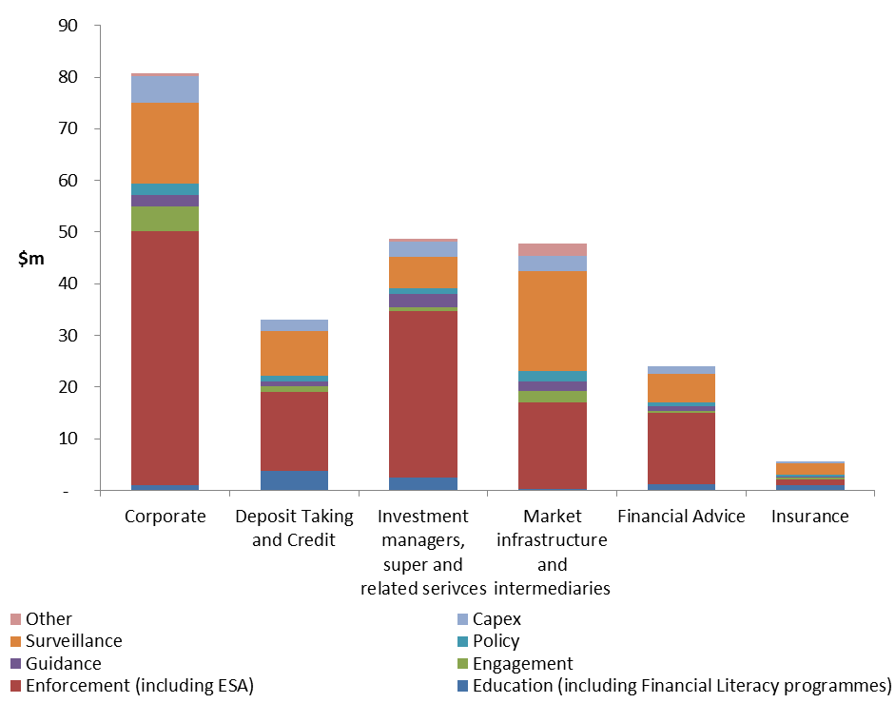

ASIC’s supporting attachment to the Government’s Proposals Paper has further detail on the amounts to be recovered from industry.

The model for recovering ASIC’s regulatory costs via levies is designed to ensure that only the efficient costs of regulating each sector are recovered in a transparent and accountable way.

There are two steps in the cost allocation process.

Figure 1: Levy calculation: Step One

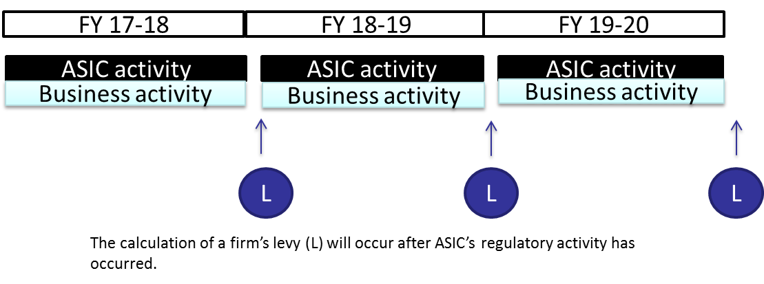

#### Step 1

The model allocates levies to each subsector based on ASIC’s actual reported regulatory effort for the previous year. Levies would be calculated after the business activity has occurred and ASIC has finalised its regulatory costs (that is, ‘ex-post’).

* Sectors are broken down further where it is possible to define groups of entities within a sector who share similar regulatory oversight. For example, within the deposit taking and credit sector, credit providers are grouped together into a subsector as they share common regulatory oversight requirements. (See **Schedule 3** for a complete list).

Figure 2: Levy calculation: Step Two

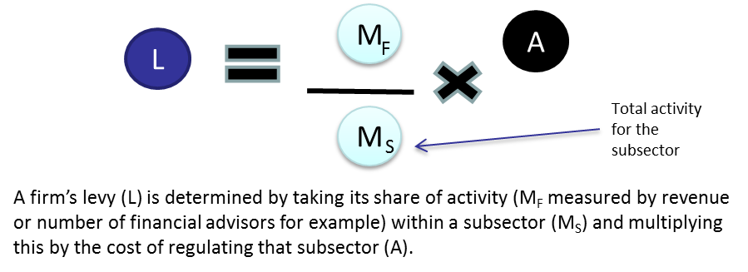

#### Step 2

Individual entity levies are then allocated based on their actual reported business activity metrics or for some subsectors as a flat levy where there is no relevant activity metric.

The activity metrics chosen for each subsector are those judged to most closely represent ASIC’s cost of regulating and the extent to which entities create the need for regulation. Metrics used include for example:

* the number of financial advisers employed by an entity is the metric that reflects ASIC’s regulatory cost, as the greater the number of advisers, the larger the number of clients being serviced and the higher the level of regulatory oversight required by ASIC.
* the market capitalisation of public listed companies is the metric judged to reflect the quantum of potential investor harm from any misconduct, as well as the rising cost and complexity of regulation with increasing company size.

In some cases an appropriate metric is not available, or it was judged too burdensome to collect information on a particular business activity only for the purpose of calculating the levy. In this case, the regulatory costs would be shared equally across entities in a subsector. For example:

* for large proprietary companies, each would pay a small levy of $350 reflecting the costs of regulating this subsector.

There would be a minimum levy to reflect the minimum cost for ASIC in regulating any entity. In many cases these minimum levies are lower than those proposed in the 2015 consultation reflecting the more precise model design.

In response to stakeholder feedback, the proposed model has a graduated levy that incorporates a minimum levy rather than the previously proposed tiering approach for most industry sectors. This change spreads levy costs more equitably between small and larger entities. It also prevents potentially large threshold shifts in levy costs for small changes in business activities.

The minimum levy for a subsector recovers ASIC’s actual direct and indirect costs from undertaking the activities of stakeholder engagement, policy advice, guidance, education and for a portion of ASIC’s capital allowance. These costs are generally more stable over time. As all industry participants have similar access to the output of these activities, these costs are shared across all participants in the subsector through the minimum levy (refer to **Figure 2**).

The graduated (variable) component of the levy for a subsector recovers ASIC’s remaining costs to regulate the subsector using the total reported industry metric, for example, total industry funds under management for Responsible Entities of Managed Investment Funds.

It is proposed that a maximum levy cap would be applied to the levy for publicly listed companies. This recognises that the regulatory effort does not increase indefinitely with size in this sector. The benefit derived from participating in a market would continue to increase with scale but this would be counterbalanced by a proportionally reduced need for additional regulatory resources.

In response to stakeholder feedback the proposed model simplifies the levy applied to Australian Financial Services Licences (ASFL) into a single levy. AFSLs would pay an activity-based levy for each AFSL authorisation they hold, for example, personal financial advice providers on Tier 1 products or retail Over-The-Counter (OTC) derivatives issuers. This price signal on the full cost to ASIC of supervising licenses and authorisations in time may encourage industry to review and rationalise, where appropriate, their suite of licences or licence authorisations.

ASIC would incorporate the business activity information reported to it into its resource allocation decisions, supporting improved targeting of regulatory activity and levy collection over time.

ASIC’s supporting attachment to the Government’s Proposals Paper provides further details of the costs of regulating each sector and how the levies are calculated for each sector to reflect these costs. It also explores the additional data reporting requirements for subsectors.

|  |
| --- |
| Questions   1. Do you agree with the proposed model for calculating levies? Is there an alternate approach you would prefer? If so, please explain why. 2. Do you agree with the proposed definitions for industry subsectors and levy metrics at **Schedule 1**? Is there an alternative approach you would prefer? If so, please explain why. |

## 

# Chapter 3: ASIC stakeholder engagement and accountability

Feedback from the 2015 consultation was that most stakeholders expressed in‑principle support for an ASIC industry funding model, provided that it was accompanied by transparency and accountability measures. A range of transparency and accountability measures are included in the proposed industry funding model.

The Government recognises and respects the statutory independence of ASIC, as well as its responsibility for financial and corporate regulation as provided by the ASIC Act. Confidence in the regulatory framework requires that ASIC is, and is seen to be, exercising independent judgment about the application of the regulatory framework to individual circumstances.

As such the government does not propose that industry groups be given any oversight function in relation to ASIC’s decision-making. Under the model ASIC would consult with stakeholders prior to the start of each period on its strategic risks and expected levies, and then ASIC would be accountable for how it actually allocated its budget at the end of the period. ASIC would remain independent in its decision making.

The Government would continue to determine ASIC’s total funding through the annual budget process. In determining ASIC’s funding each year, the Government would take account of feedback from stakeholders on:

* whether funding levels are appropriate;
* whether cost recovery charges are being minimised through the efficient implementation of regulatory activities; and
* whether the proposed levy and fee mechanisms continue to be appropriate.

## Cost Recovery Implementation Statement (CRIS)

As required under the CRGs, ASIC would publish a Cost Recovery Implementation Statement (CRIS) each October. The CRIS would provide information on how ASIC’s regulatory activities are cost recovered from the relevant sectors. It would also include information on the breakdown of each regulatory activity, an explanation of how the activity was costed and an explanation of the design of levy or fee charges.

The information included in the CRIS includes:

* Policy and statutory authority
* Cost recovery model – outputs, costs, charges
* Risk assessment
* Stakeholder engagement
* Financial estimates – 4 years
* Financial performance – past 4 years
* Non-financial performance – for example, KPIs, etc.

A draft CRIS is intended to be published in October 2017 for comment.

## Ongoing stakeholder engagement and data collection

Information gathering

Between July and October of each year businesses would report their activity from the previous year through an online portal.

Figure 3: Illustration of portal for online reporting

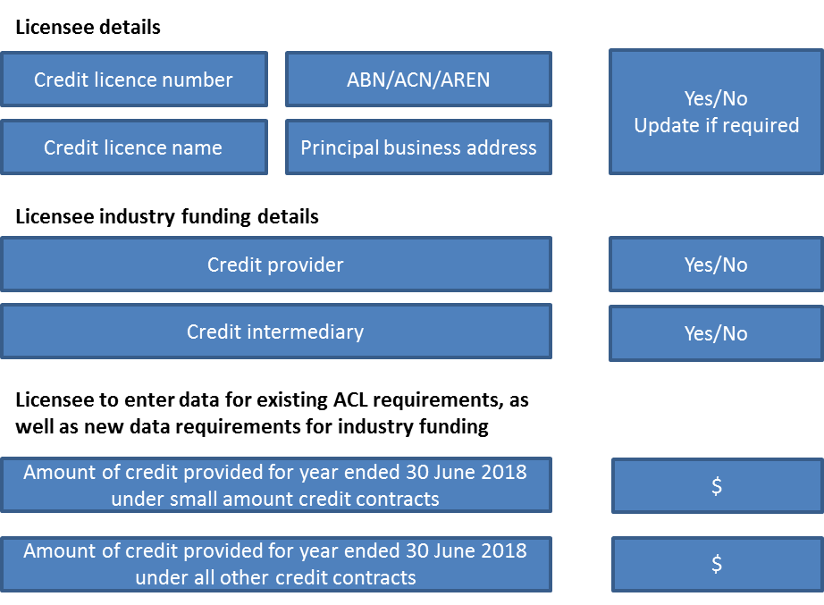

Assessing risk and engaging with stakeholders

In October to December, ASIC would use information obtained through industry funding data collection and elsewhere to conduct its environmental scan. In March of every year ASIC would consult on the strategic risks for the coming financial year. The outcome of the consultation would feed into ASIC’s allocation of resources to address those risks.

Accounting for regulatory activity

In October of each financial year, ASIC would publicly report on its performance relative to its stated objectives in its Annual Report and through sector-level Dashboard Reporting – see further details below.

Figure 4: ASIC information collection and reporting cycle

**ASIC information collection and reporting cycle**

Sector level Dashboard Reporting

The proposed model includes sector-level activity reporting through an annual industry funding dashboard report.

* The dashboard report would include a breakdown of ASIC’s costs by regulatory activity. It would also include a breakdown by direct costs (staff and supplier expenses), indirect costs (IT, compliance, governance, leadership and property) and capital costs.
* Stakeholders would be able to understand the levy cost drivers for each sector ASIC regulates.
* There would be transparency in how the funding has been spent, the regulatory activities that ASIC has undertaken and the outcomes delivered.
* Stakeholders and ASIC would be able to scrutinise the levy cost drivers for each sector ASIC regulates. It would also help stakeholders to benchmark the efficiency of ASIC’s regulatory costs over time and see how regulatory intensity changes the cost profile for each sector.

Figure 5: Example of dashboard report for the deposit taking and credit sector

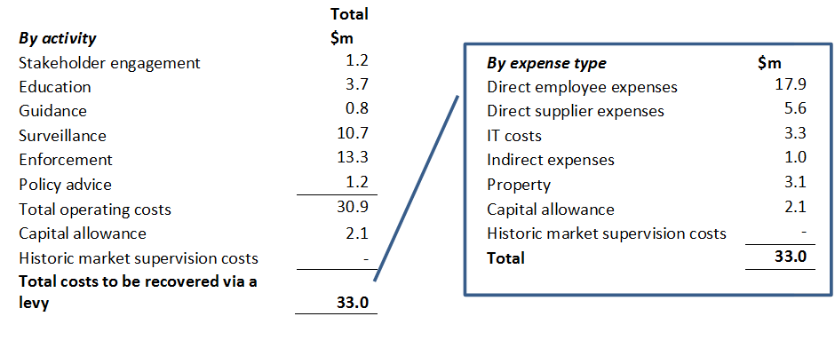

## Other accountability measures

### Annual consultation

Annual consultation on the industry funding model would occur in October each year. This would be an opportunity for stakeholders to provide feedback on how the model is working and the model methodology.

Government would receive stakeholder feedback on the industry funding model through this annual consultation, rather than establishing a formal Cost Recovery Stakeholder Panel.

### ASIC Corporate Plan

The ASIC Corporate Plan is published each August. The Corporate Plan details the strategic risks that ASIC intends to focus on in the coming year, as well as the emerging risks over the forward three years. The identified risks are the result of consultation that ASIC would undertake with stakeholders in March each year.

|  |
| --- |
| Questions   1. Do you agree with the proposed timeline for the annual reporting? Are there any reasons as to why the suggested timelines may not work for your organisation’s business cycle? 2. Do you agree with the proposed engagement and accountability measures? Are there additional measures you would prefer? If so, please explain why. |

# 

# Chapter 4: Implementation

The Government has announced that the industry funding model will commence in the second half of 2017. Given the ex-post nature of the proposed model, the first payable bill would be issued in early 2019, allowing industry time to prepare and adjust their systems as required.

## Transition arrangements with other industry levies

From 2017-18 onwards, the intention is that, as practically possible, all of ASIC’s regulatory costs be recovered via the industry funding model. Ongoing ASIC funding would no longer be recovered through the current levy mechanisms, including the Market Supervision Cost Recovery levies and the Financial Institutions Supervisory Levies (FISL).

Market Supervision Cost Recovery arrangements for ASIC would continue until the proposed funding model is in place. Once in place, the amounts currently cost recovered under the Markets Supervision Cost Recovery arrangements, around $20 million per annum, would cease and be replaced with new levies or fees.

Around $23 million of ASIC’s current ongoing regulatory activities are recovered through the annual Financial Institutions Supervisory Levies applied to APRA regulated entities. This includes levies that fund: financial literacy; the operation of the Superannuation Complaints Tribunal (SCT); over the counter (OTC) derivatives market supervision and ASIC’s MoneySmart programmes.

The costs relating to the operation of the SCT would continue to be collected under the Financial Institutions Supervisory Levies as APRA undertakes the bulk of regulatory activities related to superannuation. Non-ongoing costs such as the implementation and capital costs from the ASIC reform package announced in April 2016 to improve outcomes in financial services would continue to be collected through the FISL for the remaining two years of funding.

If entities have already paid these costs through either of these levy arrangements, these would be deducted from industry funding levies in the first year of transitioning to industry funding.

Figure 6 below demonstrates how the FISL levies would shift to industry funding in 2017-18.

The diagram depicts when the various levies are to be paid, not when the costs are incurred. For example, the last quarter for the 2017-18 market supervision levies is not shown in 2017-18 as the levy will be due to be paid in the first quarter of 2018-19.

Figure 6: Proposed transition arrangements with other levies

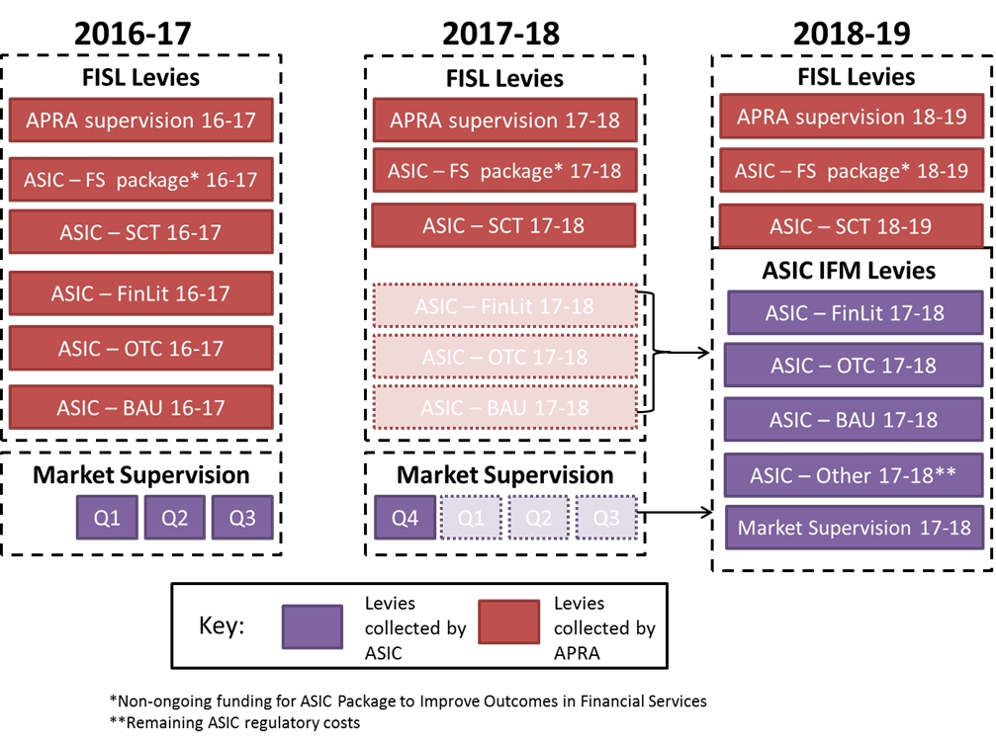

### User-initiated service costs

ASIC’s regulatory activities that are user-initiated and transaction-based would be recovered by a fee that reflects ASIC’s average cost in providing the specific service to individual entities. ASIC’s regulatory fee-for-service activities are licence and registration applications, cancellations, deregistrations, variations, document reviews and applications for relief. ASIC’s fee-for-service type activities account for approximately 12 per cent of its total annual budget for regulatory expenditure.

Stakeholder feedback has supported the principle that a fee should be paid for ASIC’s  
demand-driven services, such as processing a licence or registration application, provided that the quantum of the fee represents the efficient allocation of effort to provide the services. Stakeholders were concerned that there was little information to support the sizing of the fees.

Some stakeholders have expressed concern that the fees may also raise potential barriers to innovation. Most significantly, the $21,000 fee for novel relief applications considerably increases the costs for first movers bringing new products to market that may require ASIC regulatory relief.

To address the feedback received the implementation of the revised fees‑for‑service proposal would be delayed to allow time to refine the model by gathering further data to support the sizing of these fees, for example through time recording.

The existing fees in the *Corporation (Fees) Act 2001* and regulations would continue to apply from commencement of an industry funding model in the second half of 2017 until the new  
fees-for-service schedule for industry funding is introduced. Consultation on the fees-for-service activities would commence at this time.

### Legislative framework for cost recovery levies

Legislation is required to give effect to the industry funding model. Legislation will be consulted upon in detail subsequent to this consultation. Broadly, the legislation would create a framework that supports digital interactions with ASIC, and makes the calculation of sector levies, as well as ASIC’s costs in respect of each sector and sub-sector, fully transparent.

The cost recovery and statutory industry levies are a tax for constitutional purposes, and require the imposition of the tax to be made through a separate Act. The imposition Act would set out which entities are liable to pay a levy, and imposes that levy on the entity.

The levy would be imposed on an ex-post basis starting with ASIC’s regulatory costs for the 2017-18 financial year. Where an entity was a regulated entity in the previous financial year, it would be subject to pay a levy in the current financial year. For example, if an entity was a small proprietary company in the 2017-18 financial year, it would be subject to pay a levy for the cost of ASIC’s activity in the 2018-19 financial year.

The method for determining the rates of the levies would be set out in the regulations to the Imposition Act, and would apportion ASIC’s regulatory costs for the previous financial year for a  
sub-sector across the entities in that sub-sector. The apportionment method for each sub-sector is discussed in **Schedule 3**.

After ASIC has collected all the information necessary to determine the rates of levy it would issue an instrument that includes all of the information relied on to calculate the rate of levy. This would be based on information that ASIC has collected in the previous financial year.

The legislative framework would recover ASIC’s regulatory costs (excluding the registry and  
fees-for-service) in the previous financial year, from entities that:

* met one of the statutory definitions outlined in **Schedule 1**;
* should have been licensed or registered in the previous financial year, and were not exempted from the requirement to hold a licence or be registered.

Were ASIC to over or under collect its regulatory costs in a year, for example, because it discovered after the rates of levy are calculated that there were more entities in the regulated population, this would be offset or recouped against ASIC’s regulatory costs in later financial years.

ASIC’s power to collect levies would be set out in a separate Collection Act. Levies would be due no earlier than 30 days after ASIC has issued a notice to a leviable entity setting out their liability to levy. If an entity fails to pay the levy by the due date, it would be subject to pay a late payment penalty of 20 per cent per annum on any amounts that remain unpaid. Similarly, there would also be penalties for non-lodgement of information.

ASIC would have the power to waive any amount of levy or late payment penalty, where there are exceptional circumstances justifying a waiver.

The Collection Act would also set out reporting obligations on entities that they must report information that is necessary for ASIC to calculate the levy for a sector. As the method for levy calculations may change from year to year, ASIC would have administrative ability to specify the information that it requires to be reported, provided that it is for the purposes of the calculation of the levy.

Where an entity has not reported information to ASIC, or has gone more than twelve months without paying the levy or late payment penalty, then ASIC may take administrative actions against it, such as licence suspension or deregistration, as appropriate.

Any decision of ASIC to decline to waive either the amount of levy payable or late payment penalty would be subject to internal review and appeal to the Administrative Appeals Tribunal.

|  |
| --- |
| Question   1. Do you have any preliminary comments on the legislative arrangements? |

### Timeline for implementation

An outline of the key processes and indicative timing for implementing industry funding is set out below.

| Timing | Process |
| --- | --- |
| November 2016 | Consultation roundtables held during the consultation period |
| First quarter of 2017 | Consult on legislative package, regulations and final model |
| March 2017 | ASIC consults on strategic risks |
| March - July 2017 | Passage of legislation and regulations approved by Executive Council |
| June 2017 | ASIC publishes forecast cost data and indicative levies for 2017-18 |
| August 2017 | ASIC publishes *Corporate Plan for 2017-18 – 2020-21* |
| Sep-Oct 2017 | ASIC portal open for last year’s activity (data collection only) |
| October 2017 | ASIC publishes Annual Report and the Cost Recovery Implementation Statement – allocation of resources to address strategic risks |
| December 2017 | Environmental scan concludes |
| March 2018 | ASIC releases detailed levies, Activity metrics, ASIC consults on Strategic risks (annual) |
| June 2018 | ASIC publishes forecast cost data and indicative levies for 2018-19 |
| September 2018 | ASIC portal open for last year’s activity |
| October 2018 | ASIC publishes Annual Report and the Cost Recovery Implementation Statement – allocation of resources to address strategic risks |
| December 2018 | Environmental scan concludes |
| January 2019 | ASIC publishes a Notifiable Instrument with business activity details and sends invoices |
| February 2019 | Invoices due for payment |

|  |
| --- |
| Question   1. Do you have any comments on the proposed implementation timetable? Please provide details of any concerns. |

# Chapter 5: Regulatory impact

In addition to the direct financial impact of the levies this paper also seeks views on the indirect or regulatory costs of providing the information needed to calculate levies and related administrative tasks:

* administrative costs — the costs incurred primarily to demonstrate compliance with the regulation (for example, keeping records, filling in forms, or reporting requirements)
* substantive compliance costs — costs that directly lead to the regulated outcome (for example, training, providing information to third parties, and fees for professional advice)

|  |
| --- |
| Question   1. What do you estimate the regulatory cost of complying with the new requirements in the model to be? In order to answer this, you may wish to consider information such as the following:  * How many hours will it take to train relevant staff about the new compliance requirements? * How many hours will it take to implement / update systems to ensure compliance? * Will you need to procure professional advice or services to comply with the model? What is your estimate of the total cost of this procurement? * How many hours will it take for relevant staff to evaluate and plan for the new regulatory requirements? * How many hours will it take for staff to assemble and report any information required? * What is the estimated total labour cost of these activities?   Please only consider the cost of additional activities, beyond compliance activities that you currently perform. Please do not include the costs of levies and fees to be paid or opportunity costs in answer to this question. We seek this feedback elsewhere. |

# Chapter 6: Summary of previous consultation

In August 2015, the Government released a consultation paper on a possible industry funding model for ASIC. The consultation period ran for six weeks and during that time Treasury and ASIC held nine roundtable meetings with industry and consumer representatives. The Government received 77 submissions, including 15 confidential submissions, from a range of industry and consumer groups.

Submissions, together with the findings of the ASIC Capability Review Panel which reported to Government in December 2015, informed the Government’s decision to recover the costs of ASIC’s regulatory activities from industry.

## Stakeholder feedback

Most submissions expressed in‑principle support for an ASIC industry funding model, provided that the model is accompanied by transparency and accountability measures. **Chapter 3** discusses the proposed ASIC transparency and accountability measures for this funding model.

Detailed feedback and the proposed response to the feedback is provided in the table below.

Table 2: Consultation feedback

|  |  |
| --- | --- |
| Feedback | Response |
| Elements of the proposed model could have an adverse effect on competition and innovation. | The model has been refined to:  **incorporate lower minimum levies** in sectors, such as publicly listed companies and market participants. This would ensure that smaller entities are not paying high levies proportional to their activities compared to large entities. Maintaining a minimum levy recognises that there is a base cost to regulating each entity in a sector, regardless of size.  where possible introduce an **activity-based metric** to distribute the costs within a sector. Each entity’s regulatory costs to be calculated based on the entities’ level of activity compared with others in the sector. The activity measure is selected to reflect the typical cost of regulating each entity.  address a concern that the current market supervision cost recovery model does not include all who drive ASIC’s costs in this area because only market participants and market infrastructure providers are included. The proposed model assigns costs to all entities driving ASIC’s market supervision costs. |
| The proposed tiered levy approach in some sectors would result in some entities being subject to a large increase in their levy if they cross a specific threshold. | The refined model replaces tiers with a graduated levy based on a relevant business activity metric. |

Table 2: Consultation feedback (continued)

|  |  |
| --- | --- |
| Feedback | Response |
| A preference for a risk weighted levy, with reference to the Financial Institutions Supervisory Levy methodology. | No change to the model. Calculating more detailed risk weighted levies requires considerable administrative burden for industry and ASIC. It would mean forming a judgement about the risks posed by each regulated entity in a population of approximately 40,000. Given the breadth of ASIC’s regulatory activity it is considered that appropriate business activity metrics are a valid approximation for the regulatory burden across the regulated population. |
| Mixed views on whether there should be a legislative mechanism to enable specific pass through of costs to consumers. | No change to the model. It would be inconsistent with the Australian Cost Recovery Guidelines for Government to mandate legal pass through of the cost of ASIC’s regulation from the entities who generate the need for regulation to those entities’ customers. However, the Government will not be restricting entities ability to pass on these costs through normal commercial practices.  Entities will be aware of their indicative levies ahead of each year allowing them to factor this information into their commercial decisions. |
| No clear case in submissions to exclude some regulatory activities from the model. | The refined model includes the cost of all of ASIC’s regulatory activities. Full cost recovery would ensure that ASIC would be accountable for all of its regulatory cost in each sector.  The industry funding model would not recover ASIC’s registry costs or DPP litigation costs. |
| Australian Financial Services (AFS) Licence levy calculations were unclear. | The refined model simplifies the levy applied to AFSLs into a single levy rather than a three-part methodology. AFSLs would either pay an activity-based levy or flat levy for each AFSL authorisation they hold, for example, personal financial advice providers on Tier 1 products or retail OTC derivatives issuers. |
| Fees-for-service: submissions supported the principle that a fee should be paid for ASIC’s demand-driven services, but were concerned that there was little information to support the sizing of the fees and that fees could have an adverse effect on competition and innovation. | The existing fee schedule would remain in place until additional refinement to a new fees-for-service schedule is undertaken. Further consultation will be undertaken by the Government on the fees-for-service proposal in 2017-18, with revised fees to be in place by 1 July 2018. |
| The Government may have little incentive to constrain increases in ASIC’s budget if industry funding is adopted. | The Government will continue to determine ASIC’s total funding through the annual budget process and the model includes additional accountability requirements to mitigate this risk. |
| Industry funding should be supported by measures to assess the efficiency and quality of service levels, as well as relevant performance metrics for ASIC. | The refined model has been designed to ensure that the independence of ASIC is strongly protected in applying the transparency and accountability measures.  ASIC would engage with stakeholders ahead of each year on how it expects to allocate resources, based on a strategic risk assessment.  At the end of each financial year, ASIC would publicly report on its performance relative to its stated objectives in its Annual Report and through the introduction of sector-level dashboard reporting. See **Chapter 3** for further discussion on ASIC engagement and accountability. |

Table 2: Consultation feedback (continued)

|  |  |
| --- | --- |
| Feedback | Response |
| Clear industry oversight arrangements should be established to monitor the governance and management of ASIC. Plus ASIC’s independence should be protected against any risk of industry capture. | ASIC’s strong statutory independence will be maintained under this model. Confidence in the regulatory framework requires that ASIC is, and is seen to be, exercising independent judgment about the application of the regulatory framework to individual circumstances. Therefore, no additional industry oversight arrangements are proposed to ensure that this independence remains.  The introduction of the model would support ASIC’s engagement with stakeholders on strategic risks and cost drivers. Through this engagement it is expected that ASIC would identify opportunities to collaborate with industry on opportunities to deliver better regulatory outcomes, including lower costs and more effective and efficient regulation. |

# Schedule 1: Proposed definitions for industry subsectors

Table 3: Proposed industry subsector definitions

|  |  |
| --- | --- |
| Industry subsector | Proposed definitions |
| Corporate | |
| Public company  (listed, disclosing) | A public company as defined in section 9 of the Corporations Act, satisfying the ‘disclosing entity’ definition in section 111AC of the Corporations Act and listed as defined in section 9 of the Corporations Act. |
| Public company (unlisted, disclosing) | A public company as defined in section 9 of the Corporations Act, satisfying the ‘disclosing entity’ definition in section 111AC of the Corporations Act, which is not listed as defined in section 9 of the Corporations Act. |
| Public company (unlisted, non-disclosing) | A public company as defined in section 9 of the Corporations Act, which is not a ‘disclosing entity’ as defined in section 111AC of the Corporations Act. |
| Listed foreign company | A foreign company as defined in section 9 of the Corporations Act, satisfying the ‘disclosing entity’ definition in section 111AC and 'listed' as defined in section 9 of the Corporations Act. ` |
| Small Pty Ltd company | A small proprietary company as defined in section 45A(2) of the Corporations Act. |
| Large Pty Ltd company | A large proprietary company as defined in section 45A(3) of the Corporations Act. |
| Registered liquidator | A person registered as a liquidator as defined by section 9 of the Corporations Act. |
| Audit firm | A firm that consents to be appointed, or is appointed, as auditor of a company, or registered scheme as defined in section 9 of the Corporations Act or a disclosing entity as defined by section 111AC of the Corporations Act. |
| Authorised audit company | A company that is registered with ASIC as an authorised audit company under Part 9.2A of the Corporations Act. |
| Registered company auditor | A person registered with ASIC as a company auditor under Part 9.2 of the Corporations Act. |
| Deposit Taking and Credit | |
| Credit provider | A credit provider, as defined in s5 of the *National Consumer Credit Protection Act 2009*, who holds an Australian credit licence, authorising them to engage in credit activities as a credit provider. |
| Credit intermediary | A holder of an Australian credit licence authorising them to engage in credit activities other than as a credit provider. |
| Small amount credit provider | A holder of an Australian credit licence that:   1. has a licence authorisation to engage in credit activities as a credit provider; and 2. in the last 12 months has engaged in credit activities in relation to a small amount credit contract (as defined in section 5 of the *National Consumer Credit Protection Act 2009*) |

Table 3: Proposed industry subsector definitions (continued)

|  |  |
| --- | --- |
| Industry subsector | Proposed definitions |
| Deposit Taking and Credit (continued) | |
| Deposit product provider | An Australian financial services licensee with a licence authorisation to deal, or arrange for a person to deal, in a financial product by issuing deposit products (including basic deposit and non-basic deposit products). |
| Payment product provider | An Australian financial services licensee with a licence authorisation to deal, or arrange for a person to deal, in a financial product by issuing deposit and payment products limited to non-cash payment products. |
| Margin lender | An Australian financial services licensee with a licence authorisation to provide a margin lending facility as defined under section 761EA(1) of the Corporations Act. |
| Investment Management, Superannuation and Related Services | |
| Superannuation trustee | A registerable superannuation entity (RSE) licensee as defined by section 10 of the *Superannuation Industry (Supervision) Act 1993*. |
| Responsible entity | A company that is an Australian financial services licensee with a licence authorisation to operate a registered scheme. |
| Wholesale trustee | An Australian financial services licensee with an authorisation to deal, or arrange for a person to deal, in a financial product by issuing interests in a managed investment scheme to wholesale clients. |
| Operator of an Investor Directed Portfolio Service | An Australian financial services licensee with a licence authorisation to operate an Investor Directed Portfolio Service being that has the same meaning as in ASIC Class Order [CO 13/763] as at the date of the licence. |
| Custodian | An Australian financial services licensee with a licence authorisation to provide a custodial [or depository] service. |
| Approved SMSF auditor | An approved SMSF auditor, as defined in section 10 of the SIS Act. |
| Traditional trustee company service provider | A trustee company that holds an Australian financial services licence covering the provision of one or more traditional trustee company services, as defined in section 601RAC of the Corporations Act. |
| Managed discretionary account operator | An Australian financial services licensee with a licence authorisation to provide a Managed Discretionary Account service under ASIC Class Order [CO 04/194] as at the date of the licence. |
| Market Infrastructure and Intermediaries | |
| Credit rating agency | An Australian financial services licensee with a condition on its licence to comply with the IOSCO *Code of Conduct for Credit Rating Agencies*. |
| Large equity market operator (domestic) | The operator of a licensed market as defined in section 761A of the Corporations Act on which more than 10 million transactions in Equity Market Products were executed in the previous financial year.  Equity Market Product: has the meaning given by section 1.4.3 of the ASIC Market Integrity Rules (Competition in Exchange Markets) 2011. |
| Large futures market operator | The operator of a licensed market as defined in section 761A of the Corporations Act on which more than 10 million transactions in derivatives were executed in the previous financial year.  Derivative: has the meaning given by section 761D of the *Corporations Act 2001*. |

Table 3: Proposed industry subsector definitions (continued)

|  |  |
| --- | --- |
| Industry subsector | Proposed definitions |
| Market Infrastructure and Intermediaries (continued) | |
| Small equity market operator (domestic) | The operator of a licensed market as defined in section 761A of the Corporations Act on which less than 10 million transactions in equity market products were executed in the previous financial year. |
| Small futures market operator (domestic) | The operator of a licensed market on which less than 10 million transactions in derivatives were entered into in the previous financial year. |
| Small derivatives market operator (domestic) | The operator of a licensed market on which:   1. less than 10 million transactions in derivatives were entered into in the previous financial year; and 2. only professional investors trading on their own behalf or on behalf of other professional investors may trade. |
| Small equity market operator with self-listing function only (domestic) | The operator of a licensed market as defined in section 761A of the Corporations Act on which:   1. less than 10 million transactions were executed in the previous financial year; and 2. only ordinary shares of the market operator may be traded. |
| Foreign market operator | A person who holds an Australian market licence granted under subsection 795B(2) of the Corporations Act. |
| Australian derivative trade repository licensee | A holder of an Australian derivative trade repository licence, as defined in section 761A of the Corporations Act. |
| Exempt market | A facility exempted from Part 7.2 under subsection 791C(1) and from Part 7.3 under subsection 820C(1) of the Corporations Act. |
| CS facility licensee:  Tier 1: Systemically important, domestically connected | The operator of a CS facility determined to be systemically important in Australia with a strong connection to the Australian financial system (strong domestic connection). |
| CS facility licensee:  Tier 2: Systemically important, not domestically connected | The operator of an overseas CS facility determined to be systemically important in Australia without a strong connection to the Australian financial system. |
| CS facility licensee:  Tier 3: Entry level | The operator of an Australian CS facility that is not systemically important in Australia and is not strongly connected to the Australian financial system. |
| CS facility licensee:  Tier 4: clears and settles trades in its own ordinary shares only | The operator of an Australian CS facility for the purposes of clearing and settling facility relating to its own shares only.[[5]](#footnote-6) |
| Exempt CS facility licensee | A facility exempted from Part 7.2 under subsection 820C(1) of the Corporations Act |

Table 3: Proposed industry subsector definitions (continued)

|  |  |
| --- | --- |
| Industry subsector | Proposed definitions |
| Market Infrastructure and Intermediaries (continued) | |
| Market participant | An Australian financial services licensee who is a participant in relation to a financial market, as defined in section 761A of the Corporations Act. |
| Securities dealer | An Australian financial services licensee authorised to deal, arrange, issue and apply in securities that are in a class of products that are traded on a licensed market but is not a participant as defined in s761A of the Corporations Act. |
| Retail OTC derivative issuers | An entity that:   1. holds an Australian financial services licence with a licence authorisation to provide the following financial services to retail investors: 2. dealing in a financial product by issuing derivatives; and 3. making a market for derivatives; and 4. is not a body regulated by APRA; a market participant; or a participant in a CS facility; and 5. promotes that they provide margin Foreign Exchange, Contract For Difference, binary options or other retail OTC derivative services. |
| Wholesale electricity dealer | An entity that:   1. issues derivatives; and/or 2. makes a market for derivatives; and 3. incurs liabilities by dealing or making a market in OTC derivatives relating to the wholesale price of electricity as part of the ordinary course of their business; and 4. is not a body regulated by APRA; a market participant or a participant in a CS facility. |
| Investment bank | 1. A person who: 2. is an Australian financial services licensee; or 3. carries on a financial services business in Australia but is exempt from s911A(1) of the Corporations Act;   and who provides, or holds out that it will provide, the following financial services:   1. financial product advice to wholesale clients in the course of advising on any of the following: 2. takeover bids or merger proposals; 3. the structure, pricing, acquisition or disposal of assets or enterprises; 4. raising or reducing capital through the issue or acquisition of equity or debt; 5. managing risk through dealing in OTC derivatives; or 6. by doing either of the following: 7. dealing in a financial product by underwriting the issue, acquisition or sale of financial products; 8. dealing in financial products in the course of securities lending arrangements or under a securities repurchase agreement for the acquisition of particular securities. |

Table 3: Proposed industry subsector definitions (continued)

|  |  |
| --- | --- |
| Industry subsector | Proposed definitions |
| Market Infrastructure and Intermediaries (continued) | |
| Investment bank (continued) | 1. For the purposes of this definition: 2. ***OTC derivative*** means a derivative that is not able to be traded on a financial market. 3. A person who is exempt from s911A(1) of the Corporations Act because of ASIC Class Order [CO 03/824] is not an investment bank for the purposes of this definition. 4. For the purpose of paragraph (1), a person is taken to: 5. provide a financial service that is provided by any subsidiary of the person; and 6. hold out that it provides a financial service if the person holds out that the service is provided by a subsidiary of the person. |
| Financial advice | |
| Licensees that provide personal advice on Tier 1 products to retail clients | An Australian financial services licensee that provides financial product advice, which is personal advice:   1. on all financial products other than general insurance products, consumer credit insurance (as defined in reg 7.1.15 of the Corporations regulations), basic deposit products and non-cash payment products; and 2. where the client is not a wholesale client. |
| Licensees that provide personal advice to Tier 2 products only to retail clients | An Australian financial services licensee that provides financial product advice, which is personal advice:   1. on general insurance products, except for personal sickness and accident (as defined in reg 7.1.14 of the Corporations Regulations), consumer credit insurance (as defined in reg 7.1.15 of the Corporations Regulations), basic deposit products, non-cash payment products; and 2. where the client is not a wholesale client. |
| Licensees that provide general advice only to retail or wholesale clients | An Australian financial services licensee that provides financial product advice, which is general advice. |
| Licensees that provide personal advice to wholesale clients only | An Australian financial services licensee that provides financial product advice, which is personal advice given in circumstances where the advice is provided to a person who is a wholesale client, a professional investor or a sophisticated investor. |
| Insurance | |
| Insurance product issuer | An Australian financial services licensee with a licence authorisation to deal in a financial product by issuing general and life risk insurance products (including friendly societies). |

Table 3: Proposed industry subsector definitions (continued)

|  |  |
| --- | --- |
| Industry subsector | Proposed definitions |
| Insurance (continued) | |
| Insurance product distributor | An Australian financial services licensee that has:   1. a licence authorisation to deal in a financial product by arranging for another person to issue general insurance products or life risk insurance products; and 2. does not have an authorisation to deal in a financial product by issuing general and/or life risk insurance products. |
| Risk management product provider | A person who deals, in a product for managing financial risk that is not a specific financial product described in s764A of the Corporations Act. |

# Schedule 2: Proposed definitions of levy metrics

Table 4: Proposed definitions of levy metrics

|  |  |  |
| --- | --- | --- |
| Industry subsector | Proposed levy metric | Proposed definition |
| Corporate | | |
| Public company  (listed, disclosing) | Market capitalisation | The value of a company that is traded on a licensed market, calculated by multiplying the total number of shares at close of the market by the share price at 30 June. |
| Authorised audit companies and audit firms that audit publicly listed entities, and registered company auditors | Audit fee revenue | Total fees paid or payable to the appointed audit firm, authorised audit company or registered company auditor that are attributable to the audit and review of the full year and half-year financial reports for the financial year that ended during the relevant 12 month period of each entity with equity securities listed and any of the controlled entities of such an entity.  For this purpose ‘control’ has the same meaning as in accounting standards dealing with consolidated financial statements for the purposes of Chapter 2M of the Corporations Act. |
| Registered liquidators | Number of external administration appointments for the registered liquidator | *Number of external administration appointments for the registered liquidator:*   1. The total number of external administration appointments accepted by the registered liquidator during the relevant financial year; adjusted so that: 2. where two or more registered liquidators in the firm are jointly/ jointly and severally appointed as external administrator of a company, the external administration is only counted once (refer (**2**) below); 3. where an external administration appointment transitions from one type of external administration to another with no change to the registered liquidators appointed, this is counted as a single external administration appointment; 4. where the company is under two or more types of external administration, this is counted as two separate external administration appointments; |

Table 4: Proposed definitions of levy metrics (continued)

|  |  |  |
| --- | --- | --- |
| Industry subsector | Proposed levy metric | Proposed definition |
| Corporate (continued) | | |
| **Registered liquidators (continued)** | Number of external administration appointments for the registered liquidator (continued) | 1. where a registered liquidator is replaced as external administrator by a registered liquidator from another firm, this is counted as an external administration appointment by both firms; 2. the appointment of a registered liquidator from another firm as a special purpose liquidator, is counted as an external administration appointment by both firms; 3. where two or more registered liquidators from different firms are appointed jointly/jointly and severally appointed as external administrator of a company, the external administration is only counted once (refer (**2**) below). 4. Where two or more registered liquidators are appointed jointly and severally as external administrators of a company, it is proposed that a "Principal Appointee" be nominated at the commencement of the external administration as the appointee responsible for providing information about the external administration to allow the industry levy to be determined.   ***External administration appointment:*** includes the appointment of a registered liquidator as a controller, provisional liquidator, liquidator, voluntary administrator or administrator of a deed of company arrangement. |
| Deposit Taking and Credit | | |
| Credit providers | Credit lent | The total amount of credit provided under credit contracts (other than small amount credit contracts) by the credit provider.[[6]](#footnote-7) |
| Credit intermediaries | Credit intermediated | The total amount of credit provided under credit contracts in relation to which the person provided a credit service.7 |
| Small amount credit providers | Credit lent | The total amount of credit provided under small amount credit contracts by the credit provider.7 |

Table 4: Proposed definitions of levy metrics (continued)

|  |  |  |
| --- | --- | --- |
| Industry subsector | Proposed levy metric | Proposed definition |
| Deposit Taking and Credit (continued) | | |
| Deposit product providers | Deposits | Total deposits comprise transaction deposit accounts, non-transaction deposit accounts, certificates of deposit and foreign currency deposits, but exclude intra-group deposits.[[7]](#footnote-8) |
| Payment product providers | Revenue from payment product activity | Total revenue received less expenses incurred by the licensee from non-cash payment facilities the licensee has dealt in. |
| Investment Managers, Superannuation and Related Services | | |
| Responsible entities | Funds under management | The total gross assets of each registered scheme from the scheme’s financial reports lodged with ASIC under section 319 of the Corporations Act. |
| Superannuation trustees | Funds under management | The total gross assets of an RSE licensee, based on data reported to APRA, as at 30 June each financial year.**[[8]](#footnote-9)** |
| Operator of an Investor Directed Portfolio Service | Revenue from IDPS activity | Any revenue, or other amount paid or payable out of IDPS property, for the performance of the obligations imposed on the licensee as an operator of an IDPS, for the financial year ending on the relevant date even if those obligations are performed by another entity. |
| Wholesale trustees | Gross assets | The market value as at 30 June of the gross assets in managed investment schemes managed by the wholesale trustee. |
| Market Infrastructure and Intermediaries | | |
| Large equity market operators (domestic) | Transactions and messages | 1. If the function is performed in relation to the operator ASX Limited:   where:   1. Transactions are the total number of transactions executed or reported under the operating rules of the financial market operated by ASX Limited during the billing period that are recognised by ASIC’s Market Surveillance System as executed transactions. |

Table 4: Proposed definitions of levy metrics (continued)

|  |  |  |
| --- | --- | --- |
| Industry subsector | Proposed levy metric | Proposed definition |
| Market Infrastructure and Intermediaries (continued) | | |
| **Large equity market operators (domestic) (continued)** | Transactions and messages (continued) | 1. Messages are the total number of messages from the financial market operated by ASX Limited during the billing period that are recognised by ASIC’s Market Surveillance System as orders or executed transactions. 2. If the function is performed in relation to the operator Chi-X Australia Pty Ltd:   where:   1. Transactions are the total number of transactions executed or reported under the operating rules of the financial market operated by Chi-X Australia Pty Ltd during the billing period that are recognised by ASIC’s Market Surveillance System as executed transactions. 2. Messages are the total number of messages from the financial market operated by Chi-X Australia Pty Ltd during the billing period that are recognised by ASIC’s Market Surveillance System as orders or executed transactions. |
| Market participants | Transactions and messages | Transactions are the total number of transactions executed on, or reported to, the cash equity and futures markets by a participant during the billing period that:   1. are reported by the operators of the cash equity markets to ASIC’s Market Surveillance System; and 2. are recognised by ASIC’s Market Surveillance System as executed transactions.   Messages are the total number of messages by a participant in the cash equity and futures markets during the billing period that:   1. are reported by the operators of the cash equity markets to ASIC’s Market Surveillance System; and 2. are recognised by ASIC’s Market Surveillance System as orders or executed transactions. |

Table 4: Proposed definitions of levy metrics (continued)

|  |  |  |
| --- | --- | --- |
| Industry subsector | Proposed levy metric | Proposed definition |
| Market Infrastructure and Intermediaries (continued) | | |
| Securities dealers | Annual transaction turnover | Total value of a securities dealer’s completed transactions in securities (as measured by the buy price plus the sale price of securities) that are reported to the cash equity markets by a participant during the previous billing period that:   1. are reported by the operators of the cash equity markets to ASIC’s Market Surveillance System as executed transactions; and 2. are recognised by ASIC’s Market Surveillance System as executed transactions. |
| Investment banks | Investment banking revenue | 1. Total revenue received, in Australia, from any of the financial services set out in the definition of ‘investment banks’ that an investment bank provides plus any revenue from dealing in financial products in Australia by: 2. arranging for a person to acquire or dispose of OTC financial products; 3. issuing or arranging for a person to issue OTC financial products; 4. acquiring or disposing of OTC financial products with a purpose of creating liquidity for those OTC financial products for other persons. 5. For the purposes of this definition:   ***OTC financial product*** means a financial product that is not able to be traded on a financial market. |
| Financial advice | | |
| Personal advice providers on Tier 1 products | Adviser on the Financial Advisers Register (Relevant provider) | A person is a relevant provider if the person:   1. is a natural person; and 2. is: 3. a financial services licensee; or 4. an authorised representative of a financial services licensee; or 5. an employee or director of a financial services licensee; or 6. an employee or director of a related body corporate of a financial services licensee; and 7. is authorised, as the licensee or on behalf of the licensee, to provide personal advice to retail clients. |

Table 4: Proposed definitions of levy metrics (continued)

|  |  |  |
| --- | --- | --- |
| Industry subsector | Proposed levy metric | Proposed definition |
| Insurance | | |
| General insurance product issuer | Net premium revenue | Net premium revenue comprises of gross earned premiums less outwards reinsurance expense relating to current and prior years cover. |
| Life insurance product issuer and friendly societies | Net policy revenue | Net policy revenue comprises policy revenue net of outward reinsurance premiums. |

# Schedule 3: Proposed Indicative levies based on financial year 2016-17

The below figures are reflective of the anticipated ASIC expenses for 2016-17 and should be used as a guide only for anticipated levies in the 2017-18 period. For detailed description please refer to ASIC’s supporting paper to the Government's Proposals Paper

|  |  |  |  |  |
| --- | --- | --- | --- | --- |
| Sector | Subsector | Levy metric | Anticipated ASIC expense | Proposed Indicative levy |
| Corporate (including companies, their auditors and liquidators) | Public companies (listed, disclosing) | Market capitalisation | $48.5 million | $4,000 minimum levy proposed for all public listed, disclosing entities plus $0.33 per $10,000 of market capitalization above $5 million. The proposed maximum levy is $662,000 for entities with a market capitalization greater than $20 billion. |
| Public companies (non-listed disclosing) | Flat levy | $2.8 million | $3,350 annual levy |
| Public companies (non-disclosing) | Flat levy | $3.1 million | $170 annual levy |
| Large proprietary companies | Flat levy | $3 million | $350 annual levy |
| Small proprietary companies | Flat levy | $9.7 million | $5 annual levy |
| Registered liquidators | **Y1:** Number of appointments  **Y2:** Assets realised | $8.5 million | **2017-18:** A proposed fixed levy of $5,000 for all registered liquidators plus a graduated levy based on the number of appointments for the entity compared to the total number of appointments industry wide (estimated to be $550 per appointment).  **2018-19:** Consideration will be given to moving to an ‘assets realised’ levy based on information provided to ASIC in Annual Administration Returns lodged by registered liquidators. |
| Authorised audit companies / Audit firms that audit publicly listed entities | Audit fee revenue | $4.3 million | (Entity’s Audit Fee Revenue/Total Audit Fee Revenue) x ASIC’s Costs for the subsector. |
| Registered company auditors | Flat levy | $0.8 million | $170 annual levy |

|  |  |  |  |  |
| --- | --- | --- | --- | --- |
| Sector | Subsector | Levy metric | Anticipated ASIC expense | Proposed Indicative levy |
| Deposit taking and credit | Credit providers | Credit lent | $9.3 million | $2,000 proposed minimum levy for all credit providers plus an estimated $0.15 per $10,000 of credit provided (other than under a small amount credit contract) greater than $100 million. |
| Credit intermediaries | Credit brokered | $15.8 million | $1,000 proposed minimum levy for all credit intermediaries plus an estimated $1.14 per $10,000 of credit provided greater than $100 million. |
| Small amount credit providers | Credit lent | $2.0 million | Small amount credit providers are proposed to be liable for the $2,000 minimum levy payable by all credit providers. In addition, a graduated levy is proposed to be charged based on the amount of credit provided under small amount credit contracts. |
| Payment product providers | **Y1**: Flat. **Y2**: Revenue from payment product activity | $2.4 million | **2017-18**: $9,000 flat levy.  **2018-19**: graduated levy based on payment product provider revenue with a minimum levy payable by all payment product providers. |
| Deposit product providers | Deposit liabilities | $3.1 million | $2,000 proposed minimum levy payable by all deposit product providers plus an estimated $0.02 for each $10,000 of deposit liabilities greater than $10 million. |
| Margin lenders | Flat levy | $0.2 million | $11,100 annual levy |
| Investment management, superannuation and related services | Responsible entities | Funds Under Management | $23.5 million | $7,000 proposed minimum levy payable by all responsible entities plus an estimated $0.24 per $10,000 of FUM greater than $10 million. |
| Superannuation trustees | Funds Under Management | $8.5 million | $18,000 proposed minimum levy payable by all superannuation trustees plus $0.05 per $10,000 of FUM greater than $250 million. |
| SMSF auditors | Flat levy | $0.4 million | $60 annual levy |
| Sector | Subsector | Levy metric | Anticipated ASIC expense | Proposed Indicative levy |
| Investment management, superannuation and related services (continued) | Wholesale Trustees | Funds Under Management | $13.8 million | **2017-18**: $8,000 flat levy.  **2018-19**: graduated levy based on FUM with a minimum levy payable by all wholesale trustees. |
| Operators of an Investor-Directed Portfolio Service (IDPS) | **Y1**: Flat levy **Y2**: Revenue from IDPS activity | $1.6 million | **2017-18**: $47,000 annual levy **2018-19**: graduated levy based on revenue from IDPS activity with a proposed minimum levy payable by all operators of an IDPS |
| Traditional Trustee company service providers | Flat levy | $0.2 million | $20,500 annual levy |
| Managed Discretionary Account (MDA) operators | Flat levy | $0.2 million | $3,000 annual levy |
| Custodians | Flat levy | $0.5 million | $560 annual levy |
| Market infrastructure and intermediaries | Market participants | Trades and messages | $19 million | $9,000 proposed fixed levy payable by all market participants plus $0.02 per transaction plus; $0.002 per message. |
| Securities dealers | Trade value | $2.9 million | $250 proposed fixed levy payable by all securities dealers plus an estimated $0.34 per $10,000 of annual trade value. |
| Australian market licensees | **Large AML**: trades and messages; **Other AML**: flat levy | $8.1 million | Dependent upon the category of Australian market licensee. See **pages 79–80** of ASIC's Supporting attachment to the Government’s Proposals Paper. |
| Clearing & Settlement facilities | Levy based on systemic importance | $2.1 million | Based on systemic importance and domestic connection. See **page 80** of ASIC’s supporting attachment to the Government’s Proposals Paper Supporting Paper. |
| Trade repositories | Flat levy | $0.4 million | $140,000 annual levy |

|  |  |  |  |  |
| --- | --- | --- | --- | --- |
| Sector | Subsector | Levy metric | Anticipated ASIC expense | Proposed Indicative levy |
| Market infrastructure and intermediaries (continued) | Exempt markets and exempt clearing and settlement facilities | Flat levy | $1.345 million | $45,000 per market/facility |
| Investment banking | Investment banking revenue | $9.7 million | $1,000 proposed fixed levy payable by all investment banks plus a graduated levy based on investment banking activities above $100,000 relative to total investment banking industry revenue. |
| Wholesale electricity dealers | Flat levy | $0.1 million | $1,600 annual levy |
| Credit rating agencies | Flat levy | $0.2 million | $34,000 annual levy |
| Retail OTC derivatives issuers | Flat levy | $4.0 million | $61,400 annual levy. |
| Financial Advice | Licensees that provide personal advice providers on Tier 1 products to retail clients | Financial advisers | $22 million | Estimated $960 per adviser listed on the financial advisers register (with a minimum levy of $960 payable for entities with no advisers registered on the FAR) |
| Licensees that provider personal advice providers on Tier 2 products to retail clients | Flat levy | $0.9 million | $1,500 annual levy |
| Licensees that provide general advice only to retail or wholesale clients | Flat levy | $0.8 million | $920 annual levy |
| Licensees that provide personal advice to wholesale clients only | Flat levy | $0.2 million | $170 annual levy |
| Insurance | Insurers | **Issuer**: Gross written premiums; **Distributor**: flat levy | $5.2 million | **Issuer:** $20,000 proposed minimum levy payable by all insurance product providers plus an estimated $0.59 for each $10,000 of net premium revenue or net earned premium above $5 million.  **Distributor**: $2,400 annual levy. |
| Risk management product providers | Flat levy | $0.2 million | $4,500 annual levy |

|  |
| --- |
| Questions   1. Do you agree with the proposed business activity metrics and subsector groupings for calculating levies? If not, please outline you preferred approach and reasons for this preference. 2. Which levy metrics are available within your business? And which are you currently reporting?   **Specific sector questions:**   1. For the public company (listed, disclosing) levy, do you agree that the levy should apply to foreign companies listed on a domestic exchange and stapled securities? Is there an alternate approach you would prefer for levying this subsector? If so please explain why, ensuring that any proposed alternative is consistent with the model design objectives. 2. For registered liquidators, do you agree the levy should include a graduated component based on number of external administration appointments? Or do you support, once accurate data is available, that the levy be based on the assets realised throughout the period? Is there an alternate approach you would prefer for levying this subsector? If so, please explain why, ensuring that any proposed alternative is consistent with the model design objectives. |

1. The Capability Review report and both the Government’s and ASIC’s response can be access via this link <http://www.treasury.gov.au/PublicationsAndMedia/Publications/2016/ASIC-capability-review>. [↑](#footnote-ref-2)
2. The CRGs can be accessed via <http://www.finance.gov.au/sites/default/files/australian-government-cost-recovery-guidelines.pdf>. [↑](#footnote-ref-3)
3. Or at the level set by the Australian Government if partial cost recovery has been agreed. [↑](#footnote-ref-4)
4. The schedule of portfolio charging reviews is available on the Department of Finance website ([www.finance.gov.au](http://www.finance.gov.au)). [↑](#footnote-ref-5)
5. That is, a Small Equity Market Operator with self-listing function only that also clears and settles only those products. [↑](#footnote-ref-6)
6. The phrase ‘amount of credit’ is defined in the National Credit Code. [↑](#footnote-ref-7)
7. Transaction deposit accounts, non-transaction deposit accounts, certificates of deposits, foreign currency deposits and intra-group deposits are defined in section 4 of the Financial Sector (Collection of Data) (reporting standard) determination No. 30 of 2008 - Reporting standard ARS 320.0 Statement of Financial Position (Domestic Books). [↑](#footnote-ref-8)
8. The calculation should be based on item 11 of APRA’s SRF 320.0 (or any replacement APRA item relating to total assets). Items on SRF 320.0 must be reported as at the end of the reporting period, at 30 June or with respect to transactions that occurred during the reporting period. [↑](#footnote-ref-9)