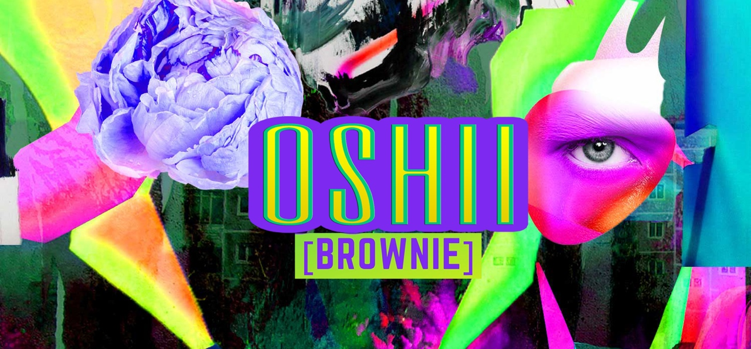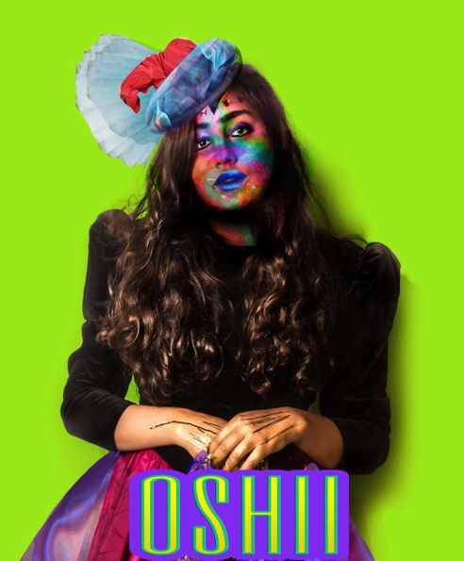

**OSHII BROWNIE**

**Founder and Visual Artist Ayesha M. Ali**

Oshii Brownie translates into “Delicious Brownie” in Japanese, a character that rebels mainstream fashion trends and beauty standards that are not ideal to follow. This becomes a safe space, which is inclusive and yet allows artistic self-expression and character development through pop-cultural imagery.

OSHII Brownie is a character, an alter-ego constructing a different truth, trying to investigate culture and its possibilities, what is allowed, and who decides the rules for aesthetics, fashion, and how to act. This is a bizarre fashion archive founded by Ayesha M.Ali a Visual Artist from Pakistan, an idea that explores fashion, absurdity, beauty, and feminism through the lens of appropriation and popular understanding of culture.

**What form of Archive is it?**

An Archive form of Digital Art that preserves culture and digitizes how information is transformed or reinterpreted. Art itself can be printed on many material forms like canvas, wood, tile, glass, acrylic, giclée prints and fashion products. It’s a fun initiative to fill the gap of colorful pop/psychedelic visual art that can be consumed through products but also has an initiative to represent Pakistan through a tech-futuristic standpoint.

**Motive:** Preserving traditional symbolism in costumes, dresses, artefacts and archiving culture in a contemporary/futuristic way to reinterpret and present local culture through emerging technologies of costume modelling / digital photo art Softwares to keep up with the global evolution in ways culture is mass represented and documented.

**Statement of Purpose**

The way we see or interpret images can shape the way we understand other people, ultimately defining how we identify with ourselves. Self-projection into the perfect human forms like dolls and mannequins can induce in us the covetousness of an ideal. This ideal is imagined, familiar and yet could be an uncanny ‘other’. Unrecognizable ideals created in the subconscious of one’s mind, are reflected as a staged ‘curated self’, displaying all documentation as evidence over the web, for that particular event. Through this fictional personification of the ‘self’, performing digitally, I have tried to dissect the web of complex visibility patterns in relation to the ideas of simulation, to generate new dialogue regarding the narration of captured reality through the lens of a camera. Curated ‘self’, therefore becomes another way to live experiences you might not otherwise will, as ‘false’ evidence. These ‘simulated’ avatars retain themselves as a byproduct of global image rotation, collective cultural aesthetics, and western fashion trends. With myself as a subject under scrutiny, this project aims to highlight, propagate and exaggerate the bizarre eccentricity of daily encounters, from a position of a model/subject/woman but also through the lens of photographer, mirror, female and spectacle. My practice, therefore, interrogates bizarreness and blurred boundaries between reality and illusions, collective memory and desires, genders, and set roles. I am interested in exploring costumes, drama, and the role of acted truth in the construction of how larger meaning is perceived by society. Costumes become a response towards observed/transforming culture but also an extension of the human body as a lab specimen. This specimen can be studied with new research methodologies in response to how the camera can catalog, document, and make it visible. A specimen that only exists/is visible for a larger spectacle.

**Contact Me:**

**https://www.instagram.com/ayesharayy/**

**https://www.behance.net/AyeshaMAli**

**https://www.facebook.com/AyeshaMubarakAli/**

**Visual Works**

**https://www.instagram.com/oshiibrownie/**

**https://www.facebook.com/oshii.brownie**

**Online Shops**

**https://www.mipic.co/oshiibrownie/**

**https://www.saatchiart.com/AyeshaMAli**

**https://www.vsual.co/shop/oshii-brownie**



