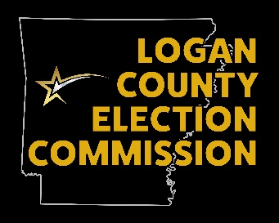County Election Commission

Meeting Minutes

June 23, 2025

5:30 pm

REASON: Discussion of Budget issues and early poll sites

Attendance: Russ Parish, Chairperson; Lee Lane, Commissioner; Jeff Glover, Commissioner; Jo Dawn Carter, Election Coordinator; Lyn Jones, Guest

**MEETING:**

Called to order

1. Minutes – Motion to accept by Jeff Glover and second by Lee Lane, passed
2. Budget issue discussion – First payment to BrooksJeffrey was assigned incorrectly – The Logan County Treasurer has written a county court order to correct the first payment. After some discussion, Jeff Glover made a motion to ask for a correction to the Grant fund and to talk to the county attorney about writing that up and adding it to the existing ordinance. Lee Lane seconded that motion and it passed. Jo Dawn Carter will get with the attorney next week to work on this.
3. We are receiving some of the security items from the grant next week and a requirement of that grant is that the equipment must be labeled. A label maker was presented, and Lee Lane made a motion to purchase to meet this requirement and Jeff Glover seconded. Motion passed.
4. The OEM building is still a consideration for a polling site. We will continue to explore more options and discuss again at the next meeting.

Motion to adjourn by Lee Lane and second by Jeff Glover, adjourned.