

Subscribe to DeepL Pro to edit this document.  
Visit [www.DeepL.com/pro](https://www.deepl.com/pro?cta=edit-document)for more information.

DEMOCRATIC REPUBLIC OF THE CONGO

***MINISTRY OF PUBLIC HEALTH, HYGIENE AND PREVENTION***

**EXPANDED PROGRAMME ON IMMUNISATION**



**REPORT OF THE REVIEW**

**INTRA-ACTION (RIA)**

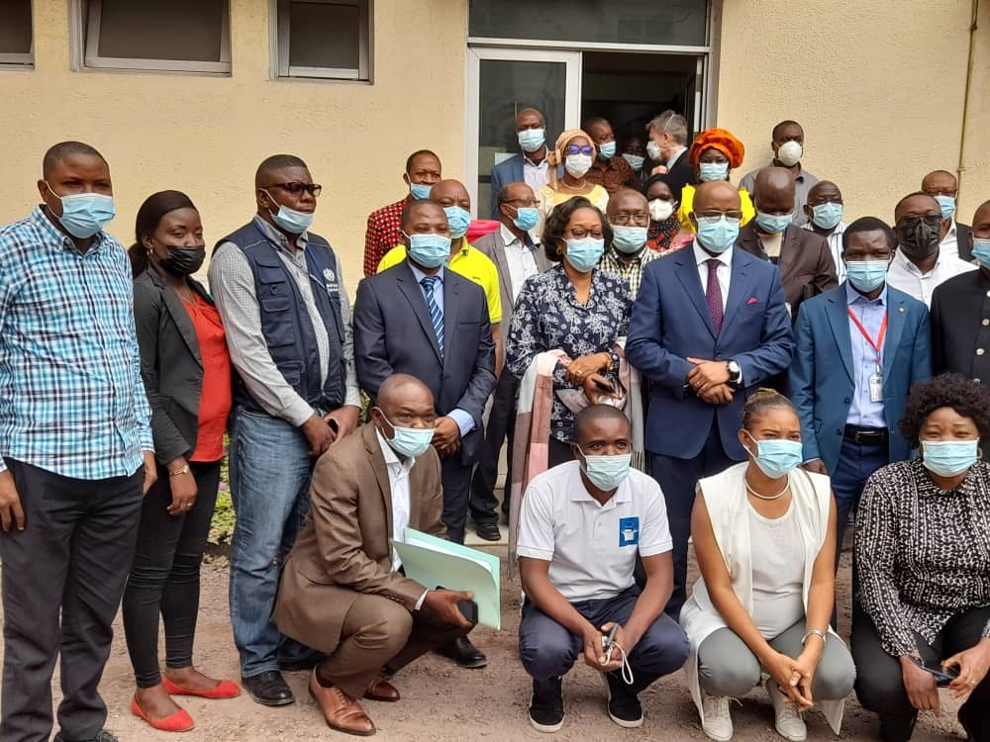

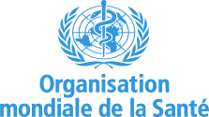

**August 2021**

## List of abbreviations

|  |  |  |
| --- | --- | --- |
| APA | : | Political-administrative authority |
| CDC | : | Centers for Disease Control and Prevention |
| CNC | : | National Coordination Committee |
| COVID-19 | : | Coronavirus disease 2019 |
| CREC | : | Risk Communication and Community Engagement |
| CTCO | : | COVID-19 Treatment Centre |
| EHR | : | Epidemiological Surveillance Directorate |
| DHIS2 | : | District Health Information Software 2 |
| DPS | : | Provincial Health Division |
| PPE | : | Personal Protective Equipment |
| FOSA : | : | Sanitary Training |
| HTA | : | High blood pressure |
| INRB | : | National Institute for Biomedical Research |
| MCZS | : | Chief Medical Officer of the Health Zone |
| MNT | : | Non-communicable diseases (NCDs) |
| MVE | : | Ebola Virus Disease |
| WHO | : | World Health Organization |
| DTP | : | Operational Action Plan |
| PCI | : | Infection Prevention and Control |
| PDSS/WB | : | Health System Development Project, funded by the World Bank |
| PEC | : | Medical care |
| PNC | : | Congolese National Police |
| RDC | : | Democratic Republic of Congo |
| RHS | : | Human Resources in Health |
| RIA | : | Intra-action review |
| IHR (2005) | : | International Health Regulations 2005 |
| SARS-CoV-2 | : | Severe Acute Respiratory Syndrome Coronavirus 2 (SARS-CoV-2), the virus that causes COVID-19 |
| SOP | : | Standard Operating Procedures |
| EU | : | European Union |
| UNICEF | : | United Nations Children's Fund |
| ZS | : | Health zone |

Table of contents

0. List of abbreviations 2

**1.** **RATIONALE AND METHODOLOGY OF THE RIA** 5

1.1. OBJECTIVES 5

**a.** **General objective** 5

**b.** **Specific objectives** 6

**2.** **OPERATION** 6

**3.** **RESULTS** 8

3.1 Coordination, planning and monitoring at country level 8

3.2. Delivery 9

3.3 Risk communication and community engagement 10

3.4. Monitoring, 12

3.5. Logistics 14

3.6. Data management and monitoring and evaluation 15

**4.** **THE WAY FORWARD** 17

**5.** **LESSONS LEARNED** 33

**6.** **RECOMMENDATIONS** 33

**7.** **ANNEXES** 34

# **RATIONALE AND METHODOLOGY OF THE RIA**

Since May 2021, the Democratic Republic of Congo (DRC) has been confronted with the thirdème wave of the COVID-19 pandemic, whose epidemiology is evolving rapidly throughout the world and is accompanied by the emergence of new variants. As of 11 July 2021, the DRC was the 17ème most affected country in the WHO-AFRO region with a total of 44,333 confirmed cases and 18ème countries with the most deaths (984) with a case fatality rate of 2.2%. A total of 25 (96.2%) of the country's 26 provinces are affected. In terms of cumulative figures since the beginning of the epidemic, the province of Kinshasa is the epicentre of COVID-19 (71.5%), followed by the provinces of North Kivu (8.2%), Central Kongo (5.6%), Haut Katanga (5.2%), Lualaba (2.6%) and South Kivu (2.2%).

In response to the pandemic, in addition to other control measures, the global community is making efforts to develop new vaccines and make them available. It is within this framework that the COVAX initiative has been set up with the aim of guaranteeing equitable access to vaccines for all countries. It is within this framework that the country has been supplied with vaccine (1,766,000 doses of AZD1222) since 2 March 2021.

Since 19 April 2021, the DRC has gradually introduced the COVID-19 vaccine in the six most affected provinces, starting in the provincial city of Kinshasa. The extension of this vaccination is continuing in other provinces of the country, taking into account the epidemiological evolution of the pandemic and the level of preparation of each province. The deployment of this vaccination against Covid-19 is marked by slowness and poor adherence by the beneficiary populations, which has led to the redeployment of the bulk of the vaccine doses to other countries to avoid their expiry. As of 10 July 2021, vaccination was organised in 344 vaccination sites in 13 provinces and reached 78,871 people for the first dose and 2,513 for the second.

## OBJECTIVES

### **General objective**

To contribute to the improvement of the implementation of the NDPV against Covid-19 in DR Congo.

### **Specific objectives**

The specific objectives of the RIA of the COVID-19 vaccination were as follows:

* Present the process and results of the ongoing vaccine response;
* identify challenges and best practices in implementation in the following phases;
* Establish a realistic roadmap of critical activities to be carried out to improve the implementation of the activity.
* Reviewing the National Immunisation Roll-out Plan
* Identify lessons learned from the response to date to enable health system strengthening;

# **OUTLINE**

The intra-action review was organised by the Ministry of Public Health, Hygiene and Prevention through the Expanded Programme on Immunisation with the support of its main partners: WHO, UNICEF, IOM, CDC, IMC, PATH, VillageReach.

The coordination of the IAM is ensured by the General Secretariat of Health represented by the Expanded Programme on Immunisation. The main facilitators are the Heads of Division, the heads of the commissions and the technical and financial partners including WHO, Unicef and VillageReach.

In practice, the RIA was carried out in 3 stages:

1. **Preparatory stage of a three-day pre-workshop in Kinshasa:**

* Organised from 23 to 25 July 2021 in the EPI meeting room. It consisted of a literature review of

1. **Stage of the 6-day RIA workshop itself in Kinshasa, from 26 July to 02 August 2021**;

The activities took place in mixed mode (face-to-face and online) according to the agenda designed by the organisers and adapted from day to day according to the progress of the activities. For 6 days, the participants, with the support of the facilitators, analysed the implementation of the first phase of vaccination against Covid-19 in DR Congo. They were divided into 6 groups; each group was composed of an average of 10 participants and was supported by 1 facilitator and 1 note taker. Each time online rooms were created to allow remote participation; the sessions consisted of an introduction to the topic, a group work session, a plenary presentation followed by discussion.

The group work consisted of discussions on the topics in order to analyse the problems and share experiences. Media such as lap tops and LCDs were used where appropriate.

The first session led to the analysis and identification of what was done well, to identify the facilitating and limiting factors. The second session dealt with challenges, i.e. identifying gaps between planning and practice, analysing what worked well, what did not work so well, and why.

The third session proposed activities for improvement taking into account the challenges, defined the date of implementation of the activities by category and the deadlines; designated the focal points for the follow-up of the implementation of the different activities (challenges to be achieved, best practices and proposed solutions to implement these activities) and set indicators.

The work continued with the review of the National Immunisation Deployment Plan (NIDP). The discussions took place in a spirit of openness and frankness, thanks in particular to the orientation given at the beginning of the session. The chairmen of the committees moderated the group work and a secretary was appointed to take notes.

The team of rapporteurs supported by a team of general rapporteurs prepared the synthesis of the day. The prepared report was presented and discussed in plenary the next day before the start of the day's session

1. **Compilation stage of additional comments from independent observers and drafting of the final consolidated report, from 03 to 07 August 2021.**

# **RESULTS**

|  |  |
| --- | --- |
| 3.1. Country-level coordination, planning and monitoring | |
| Comments | |
| **Best Practices** | * + Establishment of a working group composed of 6 sub-groups;   + Coordination with the COVAX initiative with other countries for redeployment of vaccines;   + Participation in the RMC COVID-19 meeting;   + Involvement of the private sector in immunisation (establishment of immunisation sites, CDF, etc.);   + Use of teleconferencing, zoom, teams, whatsApp, DHIS2, Mail, field monitoring.   + Elaboration of the different plans and operational guidelines (PNDV, communication plan,...) involving all stakeholders;   + Flexibility in the implementation of the plan (readjustment of targets, geographical extension, adaptation of strategies).   + Strong mobilisation of local partners in financing operational costs at central level and in some provinces |
| **Challenges** | * + Not all stakeholders (related sectors) were involved in the coordination;   + Weak collaboration with other coordination structures (technical secretariat, Task Force);   + Low commitment of some DPSs and SLAs.   + Lack of micro planning ;   + Lack of specific strategies to reach special populations (refugees, internally displaced persons, island populations) and populations living in highly concentrated areas (prisons, markets, military camps, old people's homes);   + Lack of a mechanism to monitor preparations at provincial level.   + Low government contribution to operational costs;   + Low mobilisation of operational costs from partners ;   + Low disbursement of resources mobilised for operational costs. |
| Recommended actions | |
| 1. For immediate implementation :    * Advocacy for involvement of other sectors in immunisation; including authorities in provinces under siege ....    * Issue a weekly newsletter for information sharing    * Set up a command post    * Update the standard operating procedures for vaccination against COVID-19    * Carry out bottom-up micro planning using the vulnerability index. Integrate cross-border activities.    * Setting up a PSO and the implementation monitoring tool    * Propose an algorithm to guide the choice of beneficiaries in the face of multiple vaccines    * Include an item on funding at each Strategic ICC meeting, especially the easing of disbursement procedures    * Sharing information on available funds with different stakeholders    * Drafting the PRS for resource mobilisation in the shortest possible time 2. For medium and long-term implementation to improve the response to the ongoing COVID-19 epidemic:    * Develop the job description of the coordination structure    * Harmonise the coordination mechanisms for COVID immunisation, between different stakeholders under the leadership of the Minister of Public Health, Hygiene and Prevention    * Develop measures for the implementation of law 18/035 of 13 December 2018, making vaccination mandatory    * Organising other IAMs | |
| 3.2. Benefit | |
| Comments | |
| **Best Practices** | * Regular updating of the VIRAT tool, for monitoring vaccine introduction preparedness; * NITAG advice obtained for introduction of Covid-19 vaccine and validation of target groups; * Equity in the selection of provinces to receive immunization ; * Installation of vaccination sites in certain prisons (Uvira, Bukavu, Ndolo), military health zones, mining sites (Likasi, KCC, Watsha), certain covid-19 treatment centres (CTCO), police camp; SOMIKA mining site in Lubumbashi; * The use of mobile immunisation teams in some outreach sessions; |
| **Challenges** | * The low quality of the training provided, with the result that the quality of the service is low; * Formative supervision visits not organised in the majority of provinces; * Low staff permanence in the vaccination site and insufficient number of providers in several sites; * Weak implementation of prospective visits for the selection of vaccination sites * No action plan to reach identified vulnerable groups; * Low proportion of operational vaccination sites. |
| Recommended actions | |
| 1. For immediate implementation :    * Organise a validation workshop for the tools and modules developed    * Develop a micro planning framework and guide for Health Zones and Health Areas (and/or Health Structures)    * Develop training modules, guidelines, data sheets and supervision tools for new vaccines to be introduced    * Developing the Training Plan    * Develop the supervision plan (TOR, selection, briefing of supervisors and MOE timeline)...    * Elaborate the plan for the prospection visit (TOR, selection, briefing of actors and MOE timeline)    * Develop a tool for monitoring preparations at all levels of the System    * Monitoring the preparations for the 2ndème phase of the Covid-19 vaccination    * Share the updated VIRAT tool with the global level 2. For medium and long-term implementation to improve the response to the ongoing COVID-19 epidemic:    * Organise cascading face-to-face training ....    * Organising the micro planning process at the peripheral level    * Organise prospecting visits    * Organise supervision ....    * Organising independent monitoring    * Organising the RIAs at national and provincial level | |
| 3.3. Risk communication and community engagement | | |
| Comments | | |
| **Best Practices** | * Management of rumours related to misinformation about the vaccine and vaccination and related to severe cases of IPD * The production of audio-visual media: poster, spot, banner, giant billboards; * Extension of the partnership to civil society associations and professional bodies in support of COVID-19; * Involvement of religious leaders in communication activities for COVID-19 vaccination; * Particularly important is the support of the WHO Infodemia Consultant. | |
| **Challenges** | * Late response to infodemia on vaccination ; * Weak mobilization of PWAs and influencers at all levels for vaccination against COVID-19; * Weak implementation of interpersonal communication, outreach mobilisation (CODESA, CAC/ReCo) ; * Weak accompaniment of the provincial level by the central level (supervision of communication activities by the central level); | |
| Recommended actions | | |
| * For immediate implementation :   + Update and popularise the communication plan taking into account new vaccines   + Develop SOPs in relation to COVID-19   + Promoting the EPI website   + Train 13 DPS/ZS in Infodemiology: Implementing data collection with the KOBOCOLECT tool   + Training users on the Info-Monitoring system in 7 cities   + Installing the system   + Support DPSs in sensitising frontline providers to adhere to and promote vaccination against COVID-19   + To support their members in raising awareness of COVID-19 vaccination in their structures   + Support technically and financially the implementation of PARTICOM structures (CAC/CODESA) for immunisation communication   + Advocacy with religious leaders, opinion leaders, special groups, public and private service providers and influencers,   + Advocacy with the ABS and military authorities   + Produce radio and television programmes on vaccination against COVID-19 with experts from the Ministry and partners on national coverage and on Canal +.   + broadcasting radio and television programmes on vaccination against COVID-19 with experts from the Ministry and partners on national coverage and on Canal +   + Produce 2-minute spots/video clips promoting vaccination against COVID-19   + Broadcast the 2 minute spots/video clips on Facebook, WhatsApp, Twitter   + To sensitize the REPACAV committee in sensitizing honourable members of parliament of both chambers for their involvement in the vaccination against Covid-19   + organise supervision at all levels   + Holding the meetings   + Hold weekly communication coordination meetings with the provinces on a monthly basis   + Publish monthly newsletters * For medium and long-term implementation to improve the response to the ongoing COVID-19 epidemic:   + Produce a documentary on COVID-19 vaccination   + Organise a quarterly CAP survey on the demand for immunisation   + Write activity reports Quarterly | | |
| 3.4. Monitoring, | | |
| Comments | | |
| **Best Practices** | * Observation for at least 30 minutes after the injection of any vaccinated person; * Sensitization of vaccinated persons and their relatives to report cases of IPD and inform the vaccination site manager; * Completion and updating of forms and registers required for vaccine safety monitoring; * Free treatment of IBD cases in identified facilities; * Recording of the complete identity of the person vaccinated: name, post name and first name, age, sex, address, telephone ; * Report on the appropriate form any PAD that occurs within 30 minutes of observation at the vaccination site. | |
| **Challenges** | * Effective involvement of the SZs (SZCOs and SAs) in the activities ; * Establishment of a team of providers at each SLA level; * Implementation of active surveillance of IBD cases ; * Completeness, quality and transmission of recorded data of target persons vaccinated at all vaccination sites; * Informing immunisation providers and the local APA of the preliminary results of the investigation; * Conversation of line listings and detailed information at the health centre; * Functionality of the Expert Committee ; * Functionality of MAPI's management committees (COVID-19) at all levels. | |
| Recommended actions | | |
| 1. For immediate implementation :    * Develop TORs for coordination committees at DPS and SLA levels    * Hold weekly coordination meetings with action points and share the account with all stakeholders at different levels    * Hold weekly committee meetings at all levels    * Provide sufficient management tools for reporting and investigating IPMs to all structures in the target SDAs    * Provide training in MAPI management for actors at all levels (taking into account the different components)    * Organise active collection of MAPIs from those vaccinated and in health facilities (with paper forms, telephone and electronic call on ODK (AEFI MAPI)    * Organise passive collection of MAPI from vaccinated people and in health facilities    * Share the guidelines (SOP) with the field staff in order to carry out the preliminary investigations within the required timeframe (24-48 hours)    * Hold data validation meetings at all levels and provide feedback    * Share the reports of the preliminary MAPI investigations with all stakeholders including the local ABS    * Refer severe PADI cases that require further management to the tertiary level    * Sharing information with anyone who has been vaccinated on the mapping of the nearest severe IPM facilities    * Equip health facilities with PECs and MAPIs at primary and secondary levels    * Ensure supervision of immunisation activities and monitoring of IPM by all levels    * Carrying out home visits to people who have presented IBD 2. For medium and long-term implementation to improve the response to the ongoing COVID-19 epidemic: | | |

|  |  |
| --- | --- |
| 3.5. Logistics | |
| Comments | |
| **Best Practices** | * Good availability of vaccines; * Availability of functional cold chain equipment and required capacity; * Development and reproduction of the Astra Zeneca vaccine use and waste management guidelines; |
| **Challenges** | * Procurement of vaccines with earlier expiry dates (i.e. 3 months); * Insufficient PCI materials ; * Insufficient logistical supervision ; * Low availability of management tools (hard and electronic) |
| Recommended actions | |
| 1. For immediate implementation :    * Advocate with the manufacturer for vaccines with a longer expiry date    * Receiving vaccines at country level    * Deploy vaccines as quickly as possible to vaccination sites    * Acquire PCI materials and MAPI Kits    * Conducting integrated supervisions taking into account logistical aspects    * Review and reproduce sufficient management tools and complete the logistics-related modules in DHIS2    * Monitor waste disposal at immunization sites,    * Hold at least 2 meetings of the Logistics Committee per week    * Update the logistics plan,    * Monitor the stock of vaccines on a daily basis    * Train providers in the use of the vaccine (Pfizer, Moderna, J&J and SinoVac),    * Update inventories,    * Review guidelines for the use of new vaccines (Pfizer, Moderna, J&J and SinoVac),    * Reproduce the guidelines documents for the use of the new vaccines (Pfizer, Moderna, J&J and SinoVac),    * Disseminate guidelines for the use of new vaccines (Pfizer, Moderna, J&J and SinoVac) at all levels. 2. For medium and long-term implementation to improve the response to the ongoing COVID-19 epidemic:    * Acquire 6020 temperature monitoring devices    * Acquire 191 refrigerators, 519 freezers, 520 coolers, 15 deep freezers, 42 Arktek and 1400 vaccine carriers for the storage and transport of vaccines    * Install 242 refrigerators    * Train technicians to install new Ultra Cold Chain equipment    * Deploying CdF and temperature monitoring equipment in storage sites  |  |  | | --- | --- | | 3.6. Data management and monitoring and evaluation | | | Comments | | | **Best Practices** | * + Implementation of an electronic register in the DHIS2 with the possibility of printing an electronic vaccination card;   + Availability of standards (data collection guidelines, definition of data standards, monitoring and evaluation plan, availability of a user guide for the DHIS application2 ;   + Availability of a batch of 125 tablets already operational and 500 SIMs with a 6-month monthly internet package;   + Face-to-face training (Kinshasa, Haut Katanga, North Kivu) in the context of the pandemic;   + Technical support for data managers from the central and intermediate level;   + Establishment of a team from the province of Kinshasa to encode data in sites with high attendance. | | **Challenges** | * + Non-optimal use of DHIS2 ;   + Unavailability of tablets with SIM port ;   + Partial analysis of the data ;   + Data collection tools (tally sheet, daily summary sheet, MAPI notification and investigation sheet) are out of stock; | | Recommended actions | | | * For immediate implementation :   + Make tablets available at all sites   + Establish teams of data managers at provincial level to support sites with delayed data entry into DHIS2   + Follow up on the encoding of site data in DHIS2   + Organise cascade training for data managers   + Organise supervision at all levels   + Produce the Covid 19 vaccination data bulletin (frequency to be determined)   + Implement an electronic and physical reminder system for the 2nde dose   + Create a pre-registration platform (manual and electronic) * For medium and long-term implementation to improve the response to the ongoing COVID-19 epidemic:   + Update data analysis and validation guidelines   + Estimating the need for data management equipment for sites in the expanding provinces   + Finalise the pre-registration platform for vaccinated persons (manual and electronic) | | | |

# **THE WAY FORWARD**

|  |  |  |  |  |  |  |
| --- | --- | --- | --- | --- | --- | --- |
|  | **Pillar 1: Coordination, planning and financing** | | | | | |
| N° | Recommended activities | | Desired completion date | Focal point in charge | Support needed | Indicators |
|  | a. Immediate implementation | | | | | |
| 1 | Advocacy for involvement of other sectors in immunisation; including authorities in provinces under siege | | week of 09 to 13 August 2021 | EPI Director | REPACAV, MSPHP, Partners | Number of advocacy sessions held |
| 2 | Issue a weekly newsletter for information sharing | | one week after launching the vaccination | Head of Monitoring & Evaluation Committee | MSPHP, Partners | Number of bulletins produced |
| 3 | Set up a command post | | 04 August 2021 | EPI Director, CDS | MSPHP, Partners | Existence of a command post |
| 4 | Update the standard operating procedures for vaccination against COVID-19 | | Week of 09 to 31 August 2021 | Head of Monitoring & Evaluation Committee | MSPHP, Partners | Existence of algorithm |
| 5 | Carry out bottom-up micro planning using the vulnerability index. Integrate cross-border activities. | | Week of 09 to 31 August 2021 | Head of Monitoring & Evaluation Committee | MSPHP, Partners | Existence of micro plans at each level |
| 6 | Setting up a PSO and the implementation monitoring tool | | Week of 09 to 13 August 2021 | Head of Monitoring & Evaluation Committee | MSPHP, Partners | Existence of PSO tool |
| 7 | Propose an algorithm to guide the choice of beneficiaries in the face of multiple vaccines | | Week of 09 to 13 August 2021 | Head of Monitoring & Evaluation Committee | MSPHP, Partners | Existence of algorithm |
| 8 | Follow up so that the cost of the COVID-19 vaccination is included by the DEP and DAF in the general state budget for 2022 | | 30 July 2021 | EPI Director | DEP, DAF | Existence of a budget line in the 2022 budget |
| 9 | Advocacy to secure government (central and provincial) funding for operational costs and purchase of additional vaccines | | End of August 2021 | EPI Director | REPACAV, MSPHP, Partners, Ministries of Budget and Finance | Availability of funds for operational costs and vaccine procurement |
| 10 | Advocacy with partners for funding for the purchase of vaccines and operational costs | | End of August 2021 | EPI Director | REPACAV, MSPHP, Partners | Availability of funds for operational costs and vaccine procurement |
| 11 | Include an item on funding at each Strategic ICC meeting, especially the easing of disbursement procedures | | 2 times a year on average | EPI Director | MSPHP, Partners | Number of ICC meetings that addressed immunisation financing COVID-19 |
| 12 | Sharing information on available funds with different stakeholders | | every week | EPI Director | MSPHP, Partners | Number of newsletters with an item on available funding |
| 13 | Drafting the PRS for resource mobilisation in the shortest possible time | | each quarter | EPI Director | REPACAV, MSPHP, Partners | Availability of PRS |
|  | b. Medium and long term implementation | | | | | |
| 1 | Develop the job description of the coordination structure | | end of 2021 | EPI Director | MSPHP, Partners | Existence of a job description document |
| 2 | Harmonise COVID immunisation coordination mechanisms between different stakeholders under the leadership of the Minister of Public Health, Hygiene and Prevention. | | end of 2021 | EPI Director | MSPHP, Partners | Harmonised mechanisms |
| 3 | Develop measures to implement law 18/035 of 13 December 2018, making vaccination compulsory | | end of 2021 | EPI Director | REPACAV, MSPHP, Partners | Existence of implementing measures |
| 4 | Organising other IAMs | | timely | EPI Director | MSPHP, Partners | Existence of implementing measures |
|  | **Pillar: Delivery** | | | | | |
| N° | Recommended activities | | Desired completion date | Focal point in charge | Support needed | Indicators |
| a. For immediate implementation : | | | | | | |
| 1 | Organise a validation workshop for the tools and modules developed | | 17 to 21 August 2021 | Dr Crispin Kazadi | EPI and WHO (Dr Beatrice Mukaji) | Existence of validated tools and modules |
|
|  | Develop a micro planning framework and guide for Health Zones and Health Areas (and/or Health Structures) | | 05 - 07 August 2021 | Dr Crispin Kazadi (EPI) | Technical assistanceDr  Béatrice Mukaji (WHO) Dr Trésor Zola (EPI) Dr Raoul (BMGF) Dr Nasaka Pablito (WHO) | Existence of a |
| 3. | Develop training modules, guidelines, data sheets and supervision tools for new vaccines to be introduced | | 05 - 12 August 2021 | Mr Brave Kassongo (EPI) | Technical assistanceProf  Michel Kabamba (EPI) Dr André Tonda (JSI) Dr John Otomba (WHO) | Existence of training modules, guidelines, data sheets and supervision tools |
| 4. | Developing the training plan | | 12 - 14 August 2021 | Mr Brave Kassongo (EPI) | Prof Michel Kabamba (EPI) Dr André Tonda (JSI) Dr John Otomba (WHO) | Existence of a training plan |
| 5 | Develop the supervision plan (TOR, selection, briefing of supervisors and MOE timeline)... | | 05 - 07 August 2021 | Dr André Kasogo (DGLM) | Dr Jean Rirangira (UNICEF) Dr Mymy Mwika (EPI) Dr Koko Djo Roy (WHO) | Existence of a supervision plan |
| 6 | Elaborate the plan for the prospection visit (TOR, selection, briefing of actors and MOE timeline) | | 12 - 14 August 2021 | Dr André Kasogo (DGLM) | Dr Jean Rirangira (UNICEF) Dr Mymy Mwika (EPI) | Existence of a prospecting visit plan |
| 7 | Develop a tool for monitoring preparations at all levels of the System | | 02-04 August 2021 | Prof Michel Kabamba | Dr John Otomba (WHO) Dr Mymy Mwika (EPI) Dr Moise Yapi (WHO) Bishop Albert Mbule | Existence of a tool for monitoring preparations |
| 8 | Monitoring the preparations for the 2ndème phase of the Covid-19 vaccination | | From 23 August 2021 | Dr Christophe Luhata | Dr Pablito NasakaBishop  Cédrick MwangaBishop  Arsène KabwayaBishop  Albert Mbule | Proportion of provinces reporting in timeProportion of  feedback sent to provinces |
| 9 | Share the updated VIRAT tool with the global level | | From 23 August 2021 | Dr Christophe Luhata | Dr Pablito NasakaBishop  Cédrick MwangaBishop  Arsène KabwayaBishop  Albert Mbule | Timeliness and completeness of reporting |
|  | b. Medium and long term implementation | | | | | |
| 1 | Organise cascading face-to-face training | 31 August - 14 September 2021 | | Dr Crispin Kazadi | Partners and EPI (central and provincial levels) | Number of central level staff trained;  Number of provinces that organised the training;  Number of SLAs that organised the training |
| 2 | Organising the micro-planning process at the peripheral level | 31 August - 14 September 2021 | | Dr Crispin Kazadi | Partners and EPI (central and provincial levels) | Proportion of SZs with micro plans;  Proportion of provinces with micro plans |
| 3 | Organise prospecting visits | 21- 25 September 2021 | | Dr Crispin Kazadi | Partners and EPI (central and provincial levels) | Proportion of vaccination sites surveyed |
| 4 | Organising supervision | To be specified | | Dr Crispin Kazadi | Partners and EPI (central and provincial levels) | Proportion of supervisions organised (supervised sites, supervised SZs,...) |
| 5 | Organising independent monitoring | To be specified | | WHO |  |  |
| 6 | Organising the IAMs at national and provincial level | To be specified | | EPI |  |  |
|  | **Pillar 3: Demand generation** | | | | | |
| N° | Recommended activities | | Desired completion date | Focal point in charge | Support needed | Indicators |
| a. For immediate implementation : | | | | | |  |
| 1 |  | | S1 AUGUST 2021 | CS Communication | ALL PARTNERS | Existence of an updated and popularised communication plan |
| 2 | Develop SOPs in relation to COVID-19 | | AUGUST 2021 | EPI | ALL PARTNERS | Existence of SOPs |
| 3 | Promoting the EPI website | | August and ongoing | EPI and GAVI | EPI and GAVI | existence and functionality of the EPI website |
| 4 |  | | S4 AUGUST 2021 in the 7 DPS ( kinshasa, central kongo, Haut katanga, lualaba , Ituri, north and south kivu) | CS COMMUNICATION | MRITE, IMC, UNICEF | Number of DPSs who have received infodemia trainingNumber of  DPSs who collect data with the KOBOCOLLECT tool |
| 5 |  | | S1 AUGUST 2021 in the 7 cities ( kinshasa, Matadi, lubumbashi, kolwezi , Bunia, Goma and bukavu, ) | CS COMMUNICATION | MRITE, IMC, UNICEF | Number of cities that have installed the Info-Monitoring System |
|  | |  | Number of cities that have been trained in Info-Monitoring systems |
| 6 | Support DPSs in sensitising frontline providers to adhere to and promote vaccination against COVID-19 | | AUGUST & SEPTEMBER 2021 | COMMUNICATION | MRITE, IMC, UNICEF | Proportion of DPSs and ZSs that have organised awareness-raising sessions for front-line providers |
| 7 | To support their members in raising awareness of COVID-19 vaccination in their structures | | AUGUST 2021 | CS COMMUNICATION | MRIT,IMC,UNICEF | Number of professional associations and corporations that have benefited from support in raising awareness about vaccination against COVID-19Number of  professional associations and corporations ORGANISATION that have drawn up their roadmap |
| 8 |  | | SEPTEMBER 2021 | COMMUNITY | SANRU, IMC, RED CROSS, UNICEF | Number of community participation structures that have benefited from technical and financial support for implementation in the SLAs/SAs |
| 9 | Advocacy with religious leaders, opinion leaders, special groups, public and private service providers and influencers, | | AUGUST 2021 | CS COMMUNCTION | Villae Reach, MRITE, UNICE, WHO... | Number of faith leaders, opinion leaders and influencers reachedNumber of  public statements or actions in support of immunization made by target leaders and influencers  Number of influencers reached |
| 10 |  | | AUGUST 2021 | COMMUNICATION PEV | VillageReach, MRITE, UNICE, IMC... | Number of ABS/authorities reached |
| Number of declarations/ gesture Public |
| 11 |  | |  | COMMUNICATION PEV |  | Number of radio broadcasts on COVID-19 vaccination with ministry experts and partners with national coverage produced |
| 12 | broadcasting radio and television programmes on vaccination against COVID-19 with experts from the Ministry and partners on national coverage and on Canal + | |  | COMMUNICATION PEV |  | Number of radio programmes on vaccination against COVID-19 with experts from the Ministry and partners broadcast nationally and on Canal+ broadcast |
| 13 | Produce 2-minute spots/video clips promoting vaccination against COVID-19 | | AUGUST 2021 | COMMUNICATION PEV | MRITE, UNICEF, VillageReach, IMC | Number of 2-minute spots/video clips in support of COVID-19 vaccination produced |
| 14. | Broadcast the 2 minute spots/video clips on Facebook, WhatsApp, Twitter | | AUGUST 2021 | COMMUNICATION PEV | MRITE, UNICEF, VillageReach, IMC | Number of 2-minute spots/video clips promoting vaccination against COVID-19 broadcast |
| 15. | To sensitize the REPACAV committee in sensitizing honourable members of parliament of both chambers for their involvement in the vaccination against Covid-19 | | Sept. 21 | COMMUNICATION PEV | MRITE, UNICEF, VillageReach | Number of REPACAV members reachedNumber of  MPs and Senators reached |
| ...16 | organise supervision at all levels | | Cfr Service provision for date harmonisation | COMMUNICATION PEV | all partners | Number of supervisions carried out |
| 17 | Hold monthly communication coordination meetings with the provinces | | AUGUST 2021 | COMMUNICATION PEV | all partners | Number of meetings held with minutes |
| 18 | Hold weekly communication coordination meetings | | AUGUST 2021 | COMMUNICATION PEV | all partners | Number of meetings held with minutes |
| 19 | Publish monthly newsletters | | S1 SEPTEMBER | COMMUNICATION PEV | PARTNER | Existence of the monthly EPI newsletter |
|  | b. Medium and long term implementation | | | | | |
| 1. | Produce a documentary on COVID-19 vaccination | | Nov-21 | ENP/PARTNER | PARTNERS | Existence of a documentary on vaccination against COVID-19 |
| 2. | Organise a quarterly CAP survey on the demand for immunisation | | SEPTEMBER 2021(September, October and November) | EPI | ALL PARTNERS | Number of surveys conducted on planned |
| 3. | Write activity reports Quarterly | | T3, T4,,,, | ENP/PARTNER | ENP/PARTNER | Number of reports written |
|  | **Pillar 4: Monitoring** | | | | | |
| N° | Recommended activities | | Desired completion date | Focal point in charge | Support needed | Indicators |
|  | a. Immediate implementation | | | | | |
| 1. | Develop TORs for coordination committees at DPS and SLA levels | | Immediate | EPI | TF partners | TRDs developed and shared |
| 2. | Hold weekly coordination meetings with action points and share the account with all stakeholders at different levels | | Weekly | CD/MCZ | EPI National/Provincial Governor and local ABS and TF partners | Number of meetings held |
| 3. | Hold weekly committee meetings at all levels | | Each week | CD/MCZ | EPI National/Provincial Governor and local ABS and TF partners | Number of meetings held |
| 4. | Provide sufficient management tools for reporting and investigating IPMs to all structures in the target SDAs | | Continue | EPI | Government Prov and Partners | of SZs with sufficient tools for monitoring IPM |
| 5. | Provide training in MAPI management for actors at all levels (taking into account the different components) | | S1 and S2 August 2021 | EPI | Partners | Number of people trained |
| 6. | Organise active collection of MAPIs from those vaccinated and in health facilities (with paper forms, telephone and electronic call on ODK (AEFI MAPI) | | Continue | MCZS/IT | EPI/CD Director | of activity reports submitted |
| 7. | Organise passive collection of IPMs from vaccinated people and in health facilities | | Continue | MCZS/IT | EPI/CD Director | of activity reports submitted |
| 8. | Share the guidelines (SOP) with field staff in order to conduct preliminary investigations within the required timeframe (24-48 hours) | | S1 and S2 August 2021 | EPI Directorate | Partners | % of SZs with directives |
| 9. | Hold data validation meetings at all levels and provide feedback | | Every month/week/day | EPI (national and provincial), MCZS/IT/immunization site team | TF partners | Number of validation meetings held |
| 10. | Share the reports of the preliminary MAPI investigations with all stakeholders including the local ABS | | Continue | Dir EPI/CD/MCZS/IT | TF partners | Number of reports shared |
| 11 | Referring severe PADI cases that need further management to the tertiary level | | Continue | EPI (national and provincial) | TF partners |  |
| 12. | Sharing information with anyone who has been vaccinated on the mapping of the nearest severe IPM facilities | | Continue | Vaccination site manager | Community relays | Number of informed vaccinees |
| 13. | Equip health facilities with PECs and MAPIs at primary and secondary levels | | August 21 | DPM and PFT |  |  |
| 14. | Ensure supervision of immunisation activities and monitoring of IPM by all levels | | Monthly/ weekly/ daily | SG/CD/MCZS/IT | Minister of Health (nat and prov), Gov and others ABS | Proportion of supervisions carried out |
| 15. | Carrying out home visits to people who have presented IBD | | Continue | Epidemiological Surveillance Focal Point/IT/CoDESA/RECO Chair | MCZS (ECZ) | Number of VADs carried out |
|  | **Pillar 5: Data management, monitoring and evaluation** | | | | | |
| N° | Recommended activities | | Desired completion date | Focal point in charge | Support needed | Indicators |
| 1 | Make tablets available at all sites | | 9 August 2021 | Dr Christophe and Arsène | Partners | Proportion of sites with tablets |
| Follow up on requests for the acquisition of 4G modems | | 44407 | Arsène and Steve / DAF | Unicef | Number of modems acquired on time |
| 2 | Establish teams of data managers at provincial level to support sites with delayed data entry into DHIS2 | | 3 August 2021 | Arsène, Cédric and Steve | EPI and partners | Proportion of sites that are up to date |
| 3 | Follow up on the encoding of site data in DHIS2 | | 30 July 2021 | Arsène, Cédric and Steve | EPI and partners | Completeness and timeliness rate |
| 4 | Follow up the request for the purchase of printers, accessories and consumables (Specifications) | | 30 July 2021 | Arsène, Steve / DAF | Sanru | Number of printers acquired on time per branch |
| 5 | Organise cascade training for data managers | | 10 August 2021 | Dr Christophe, Cédric, CDC and M-RITE | EPI and partners | Proportion of training courses organised on the planned onesNumber of  data managers trained on the planned one |
| 6 | Organise supervision at all levels | | 15 August 2021 | Dr Christophe and Dr Christelle, CDC, RTI and M-RITE | EPI and partners | Number of supervisions carried out out of those planned per level |
| 7 | Monitoring the payment process of additional data managers | | 30 July 2021 | Dr Christophe and CDC | EPI and partners | Number of paid claimants out of total number |
| 8 | Monitoring the process of reproduction and distribution of collection tools | | 15 August 2021 | Dr Christophe | EPI and partners | Number of sites with collection tools |
| 9 | Produce the Covid 19 vaccination data bulletin (frequency to be determined) | | 8 August 2021 | Dr Christelle, Steve and CDC | EPI and partners | Number of bulletins published |
| 10 | Implement an electronic and physical reminder system for the 2nde dose | | 15 August 2021 | Arsène, Dr Perry and Cédric | Framework for cooperation between delivery, logistics, monitoring and data management | Existence of the system |
| 11 | Create a pre-registration platform (manual and electronic) | | 1 October 2021 (subject to vaccine availability) | Arsène, Dr Perry and Cédric | EPI and partners | Existence of the platform |
|  | b. Medium and long term implementation | | | | | |
| 1. | Update data analysis and validation guidelines | | 2 weeks | Dr Christophe, Dr Angèle Dr Pitchou and Dr David | EPI and partners | Existence of updated guidelines for data collection and analysis |
| Data analysis |
| 2. | Estimating the need for data management equipment for sites in the expanding provinces | | 15 August 2021 | Dr Pitchou, Dr Christelle, Arsène and Cédric | Framework for consultation between data delivery and management | Existence of the extension plan |
| 3. | Finalise the pre-registration platform for vaccinated persons (manual and electronic) | | 15 September 2021 | Dr Christophe, Dr Perry, Arsène and Cédric | EPI and partners | Existence of the platform |
|  | **Pillar 6: Logistics** | | | | | |
| N° | Recommended activities | | Desired completion date | Focal point in charge | Support needed | Indicators |
|  | a. Immediate implementation | | | | | |
| 1 | Advocate with the manufacturer for vaccines with a longer expiry date | | EPI | 1 August 2021 |  | Availability of vaccines with a longer expiry date (i.e. more than 6 months) |
| 2 | Receiving vaccines at country level | | CD Logistics | 23 August 2021 |  | Number of doses received/expected |
| 3 | Deploy vaccines as quickly as possible to vaccination sites | | CD Logistics | 30 August 2021 |  | Number of sites that received the vaccines on time/ |
| 4 | Acquire PCI materials and MAPI Kits | | WHO Logistics | 44406 |  | Number of PCI materials received/plannedNumber of  MAPI Kits received/planned |
| 5 | Conducting integrated supervisions taking into account logistical aspects | | CD Logistics | From 16 August to 30 September 2021 |  | Number of integrated supervisions carried out |
| 6 | Revise and reproduce sufficient management tools and complete the logistics-related modules in the DHIS2 | | CD Logistics | From 2 to 16 August 2021 |  | Number of tools revised and reproduced/expected;  Number of logistics items found in DHIS2/planned |
| 7 | Monitor waste disposal at immunisation sites | | CD Logistics | 44454 |  | Number of vaccination sites that have disposed of waste according to the guidelines (destruction report) |
| 8 | Hold at least 2 meetings of the Logistics Committee per week | | CD Logistics | continues |  | Number of minutes of meetings |
| 9 | Update the logistics plan | | CD Logistics | 44407 |  | Availability of the updated logistics plan |
| 10 | Monitor the stock of vaccines on a daily basis | | CD Logistics | Continue |  | Number of days available |
| 11 | Train providers in the use of the vaccine (Pfizer, Moderna, J&J and SinoVac) | | CD Logistics | 16 August 2021 (to be harmonised with other groups) |  | Number of trained providers |
| 12 | Updating inventories | | CD Logistics | From 29 July to 09 August 2021 |  | Updated database of CdF equipment inventories |
| 13 | Review guidelines for the use of new vaccines (Pfizer, Moderna, J&J and SinoVac) | | CD Logistics | From 02 to 16 August 2021 |  | Availability of revised guidelines |
| 14 | Reproduce guidance documents on the use of new vaccines (Pfizer, Moderna, J&J and SinoVac) | | CD Logistics | 16 August 2021 |  | Quantity of documents reproduced / planned |
| 15 | Disseminate guidelines for the use of new vaccines (Pfizer, Moderna, J&J and SinoVac) at all levels | | CD Logistics | 20 August 2021 |  | Number of structures with guidelines / existing structures |
|  | b. Medium and long term implementation | | | | | |
| 1 | Acquire 6020 temperature monitoring devices | | CD Logistics | 44440 |  | Number of materials received / planned |
| 2 | Acquire 191 refrigerators, 519 freezers, 520 coolers, 15 deep freezers, 42 Arktek and 1400 vaccine carriers for the storage and transport of vaccines | | CD Logistics | 44470 |  | Number of materials received / planned |
| 3 | Install 242 refrigerators | | CD Logistics | From 16 August to 30 September 2021 |  | Number of refrigerators installed |
| 4 | Train technicians to install new Ultra Cold Chain equipment | | CD Logistics | From 01 to 05 October 2021 |  | Number of technicians trained |
| 5 | Deploying CdF and temperature monitoring equipment in storage sites | | CD Logistics | From 9 August to 30 September 2021 |  | Number of materials shipped |

# **LESSONS LEARNED**

* The importance of having secure funding to meet the operational cost of activities improves delivery in the field;
* The involvement of political and administrative authorities at all levels is an important strategy for ensuring public support for immunisation;
* The adherence of health personnel to vaccination is a prerequisite for convincing the vast majority of the population to adhere to vaccination;
* active leadership is a guarantee of success in a crisis situation;
* the readiness of some partners to meet operational costs in a context of lack of funds

# **RECOMMENDATIONS**

|  |  |  |  |
| --- | --- | --- | --- |
| N° | **Recommendations** | **Responsible for** | **Deadline** |
| 1 | Clarify the equity approach in prioritising target persons. | Delivery Group. | When planning. |
| 2 | Share working group presentations with the coordination for centralisation. | Chairs of the working groups. | At the end of each day of the RIA. (Immediate) |
| 3 | Consider how to readjust the micro planning process for Covid-19 vaccination. | Groups performance. | When planning. |
| 4. | Identify all sites or facilities for monitoring diabetic patients and share with the EPI. | Directorate for Non-Communicable Diseases (diabetes) | In a fortnight. |
| 5. | Continue to monitor the activity of identifying people with co-morbidities. | Delivery group. | Continue. |
| 6. | Identify focal points and assign responsibilities. | Coordination and group chairs. | After the RIA. |
| 7. | Adapting training courses to the country's vaccine portfolio. | All working groups. | Before the cascade formations. |
| 8. | Create a slot during the RIA for the WHO expert to present the Costing tool to be used for budgeting. | Coordination. | During the RIA. |
| 9. | Include a column in the consultation register with information on immunisation status to enable the system to search for immunisation information at this level. | Data Management Group. | Continue. |
| 10. | Take into account the need to organise the workshops face-to-face to allow effective and easy participation of all stakeholders, insisting on respecting barrier gestures. (adopt a residential method to make the work easy) | EPI Directorate. | Continue. |
| 11. | Work with the delivery group to discuss strategies, modalities for the rate of loss to be taken into account and aspects of estimating needs taking into account 25%. | Logistics group. | Immediate. |

# **ANNEXES**

1. Participants :

| **N°** | **NAMES AND SURNAMES** | **FUNCTIONS/INSTITUTION** | **PROVINCE** | **PHONE** | **E-MAIL** |
| --- | --- | --- | --- | --- | --- |
| **MINISANTE/PARTICIPANTS** | | | | | |
| 1 | Ms WAMU Henriette | Parliamentarian | Kinshasa | 0815003013 | honorablewamu@gmail.com |
| 2 | Mr MANGAY Hon Patrick | Parliamentarian | Kinshasa | 0990078428 | patrickmangay128@gmail.com |
| 3 | Dr MUKAMBA MUSENGA Elisabeth | Medical Director / EVP | Kinshasa | 0824192070 | Emukamba2@gmail.com |
| 4 | Dr CIKOMOLA Aimé | ENP/Deputy Director | Kinshasa | 0813178011 | aimcik@yahoo.fr |
| 5 | AG. KONSO Justin | Head of Administrative Division & Finance | Kinshasa | 0816004925 | justkonso@gmail.com |
| 6 | Dr LORA Bertin | Head of Support Division | Kinshasa | 0998947449 | Lorabertin2021@gmail.com |
| 7 | Dr CHUNGU Donat | Head of Technical Division | Kinshasa | 0814210181 | donat.chungu@unikin.ac.cd |
| 8 | Mr DJOGO BASOME Jean Paul | Head of Logistics Division | Kinshasa | 0816189366 | djogobasome@gmail.com |
| 9 | Ms KALUMBA Clémentine | EPI/Cs MOSO | Kinshasa | 0814096195 | clementinekalumba@gmail.com |
| 10 | Dr LUHANGA Gisèle | EPI/Cs Monitoring | Kinshasa | 0997697115 | luhangagis@gmail.com |
| 11 | Dr MOMA Space | EPI/Cs Monitoring | Kinshasa | 0811630394 | espacecolombe@gmail/com |
| 12 | Mr AKARASIS MAKSAS | ENP/Communication | Kinshasa | 0822214709 | [a46_mcsas@yahoo.fr](mailto:a46_mcsas@yahoo.fr) |
| 13 | Dr KATEMBO Laurent | SG/Expert | Kinshasa | 0998385372 | [kirikughuda@yahoo.fr](mailto:kirikughuda@yahoo.fr) |
| 14 | Dr KAZADI Crispin | Head of New Vaccine Department | Kinshasa | 0810004638 | [kazadicrispin1@gmail.com](mailto:kazadicrispin1@gmail.com) |
| 15 | Mr KASSONGO Brave | Head of Training and Supervision | Kinshasa | 0816580579 | [bravekassongo@gmail.com](mailto:bravekassongo@gmail.com) |
| 16 | Dr LUHATA Christophe | Head of Monitoring and Evaluation Section | Kinshasa | 0815250040 | christophe.luhata@gmail.com |
| 17 | Dr KABAMBA Michel | Head of Operational Research | Kinshasa | 0978467432 | [michelnzaji@yahoo.fr](mailto:michelnzaji@yahoo.fr) |
| 18 | Mr OLELA David | Head of EPI Communication Department | Kinshasa | 0991039305 | [davidolela@gmail.com](mailto:davidolela@gmail.com) |
| 19 | Dr MWIKA Mymy | EPI/Cs Monitoring & Evaluation | Kinshasa | 0814885805 | drmwikamymy@gmail.com |
| 20 | Ms KILUBA Marie Claire | ENP/Partnership | Kinshasa | 0825906471 | [luciamarieclaire@yahoo.fr](mailto:luciamarieclaire@yahoo.fr) |
| 21 | Dr KALIKAT Christelle | EPI/Cs Monitoring & Evaluation | Kinshasa | 0815401683 | [christellekalikat@gmail.com](mailto:christellekalikat@gmail.com) |
| 22 | Dr HANS BATEYI Stéphane | EPI/CPM | North Kivu | 0998611109 | [drstephanehans@gmail.com](mailto:drstephanehans@gmail.com) |
| 23 | Dr KONGOLO Joseph | EPI | Kinshasa | 0840703191 | [jkongolokapinga@gmail.com](mailto:jkongolokapinga@gmail.com) |
| 24 | Mr MAKONGOTE Héritier | EPI/Data Logistics | Kinshasa | 0816924501 | [heritiermakongote@gmail.com](mailto:heritiermakongote@gmail.com) |
| 25 | Ph/ LOHOSE Nathalis | Cs Logistics | Kinshasa | O812082117 | [nlolose@gmail.com](mailto:nlolose@gmail.com) |
| 26 | Dr SHIDI Calixte | EPI/Monitoring | Kinshasa | 081514308 | [shidicalixte@gmail.com](mailto:shidicalixte@gmail.com) |
| 27 | Dr WABULA Moise | EPI/Monitoring | Kinshasa | 0824935708 | [musawabula@yahoo.fr](mailto:musawabula@yahoo.fr) |
| 28 | Dr ADHAKU Raymond | EPI/CS Monitoring | Kinshasa | 0817655385 | [dradhakuray@gmail.com](mailto:dradhakuray@gmail.com) |
| 29 | Ms ALEKO Dominique | EPI/Cs Supervision | Kinshasa | 0812780619 | [alekomanie@yahoo.fr](mailto:alekomanie@yahoo.fr) |
| 30 | Mr NGWANGWA Papin | ENP/Communication | Kinshasa | 0813557138 | [papinngwangwa@gmail.com](mailto:papinngwangwa@gmail.com) |
| 31 | Mr KBWAYA Arsène | EPI/DATA | kINSHASA | 0812134966 | Arsène kabwaya@yahoo.fr |
| 32 | Dr NLANDU Pitchu | EPI/Monitoring and Evaluation | Kinshasa | 0810620353 | [pitchounlandu.@gmail.com](mailto:pitchounlandu.@gmail.com) |
| 33 | Dr ZOLA Trésor | EPI/New vaccine | Kinshasa | 0810046306 | [zolanga@yahoo.fr](mailto:zolanga@yahoo.fr) |
| 34 | Dr DILU KETI Angèle | SG/Monitoring and Evaluation | Kinshasa | 0821692309 | [angeldilu@gmail.com](mailto:angeldilu@gmail.com) |
| 35 | Mr KABEYA Serge | Logistician | Kinshasa | 0818150249 | [sergekabeya@gmail.com](mailto:sergekabeya@gmail.com) |
| 36 | Dr MATUNDANYA Joseph | EPI/CPM | South Kivu | 0994034359 | [matundanya@gmail.com](mailto:matundanya@gmail.com) |
| 37 | Dr BAKATUAMBA Joseph | EPI/Cs Routine EPI | Kinshasa | 0812919972 | [jkatuamba241@yahoo.fr](mailto:jkatuamba241@yahoo.fr) |
| 38 | Mr SALAZAKU Samuel | EPI/Cs Monitoring & Evaluation | Kinshasa | 0824237973 | [samuelsalaza@gmail.com](mailto:samuelsalaza@gmail.com) |
| 39 | Dr MASUMU Jean Claude | EPI/Monitoring | Kinshasa | 0817535482 | [jcmasumu1@gmail.com](mailto:jcmasumu1@gmail.com) |
| 40 | Ms PHOLA Harmandine | REPACAV/Press Officer | Kinshasa | 0815998282 | [pholaharmandine@gmail.com](mailto:pholaharmandine@gmail.com) |
|  | **PARTNERS** | | | |  |
|  | **WHO** | | | |  |
| 41 | Dr NIMPA MENGOUO Morcelhin | TL IVD/WHO | Kinshasa | 0856287617 | [nimpamengouom@who.int](mailto:nimpamengouom@who.int) |
| 42 | Dr YAPI Moïse Désiré | WHO/SO-R | Kinshasa | 08197 | [yapimo@who.int](mailto:yapimo@who.int) |
| 43 | Dr KINUANI MBULU Léon | Head of Unit V.R. WHO | Kinshasa | 0817152336 | mbulukinanil@who.int |
| 44 | Mr TONDUANGU Thierry | WHO/Logistician | Kinshasa | 0817504004 | [tonduangumelayt@who.int](mailto:tonduangumelayt@who.int) |
| 45 | Dr MUKAJI Beatrice | WHO | Kinshasa | 0817006424 | [mukajib@who.int](mailto:mukajib@who.int) |
| 46 | Mr MUYA Albert | WHO/INFODEMIA | Kinshasa | 0813335550 | [alkabu@outlool.com](mailto:alkabu@outlool.com) |
| 47 | Dr NASAKA Pablito | WHO/Consultant | Kinshasa | 0818009290 | [pnasaka@gmail.com](mailto:pnasaka@gmail.com) |
| 48 | Ir MAWEJA Camille | WHO/Logistics | Kinshasa | 0823904848 | [mawejacamille@gmail.com](mailto:mawejacamille@gmail.com) |
| 49 | Dr LUNGANGA MUKENDI Tim | WHO/Consultant | Kinshasa | 0810092224 | [lungangam@who.int](mailto:lungangam@who.int) |
|  | **CDC** | | | |  |
| 50 | FONJUNGO Peter | CDC-Director | Kinshasa | 0972619414 | [Pdf4@cdc.gou](mailto:Pdf4@cdc.gou) |
| 51 | MANIANNE Laurent | CDC/ | Kinshasa | 0826650779 | [qus4@cdc.gou](mailto:qus4@cdc.gou) |
| 52 | BUKASSA Germain | CDC/ | Kinshasa | 0970849523 | [germain@cdc.gou](mailto:germain@cdc.gou) |
| 53 | KANGOYE David | CDC/Surveillance Specialist | Kinshasa | 0820981582 | [quk9@cdc.gou](mailto:quk9@cdc.gou) |
| 54 | Dr COULIBALY SOUMAILI | CDC/Consultant Surveillance | Kinshasa | 0818281520 | qu1cdc.gou |
| 55 | Dr PERRY Robert | CDC/Physician Epidemiologist | Kinshasa | 0999912582 | [rmp9@cdc.gou](mailto:rmp9@cdc.gou) |
| 56 | Dr KABWE Constantin | CDC/Lab Manager | Kinshasa | 0971012017 | [xad8@cdc.com](mailto:xad8@cdc.com) |
| 57 | MBAH Henry | CDC/Contractor | Kinshasa | 0812233420 | [VGJ5@cdc.gou](mailto:VGJ5@cdc.gou) |
|  | **M-RITE** | | | |  |
| 58 | ALIMASE Christophe | M-RITE | Kinshasa | 0829884967 | [christophe0koko1@gmail.com](mailto:christophe0koko1@gmail.com) |
|  | **UNICEF** | | | |  |
| 59 | Dr MANIRAKIZA Déogratias | UNICEF | Kinshasa | 0826914340 | [dmanirakiza@unicef.org](mailto:dmanirakiza@unicef.org) |
| 60 | Dr NACOULMA Daniel | UNICEF | Kinshasa | 0828370059 | rnacoulma@unicef.org |
| 61 | Dr RIRANGIRA Jean | UNICEF | Kinshasa | 0814280817 | [jean.rirangira@gmail.com](mailto:jean.rirangira@gmail.com) |
| 62 | Mr AMAGBEGNON Joseph | UNICEF/Consultant | Kinshasa | 085405407 | [amagbegnonjoseph@yahoo.fr](mailto:amagbegnonjoseph@yahoo.fr) |
|  | **ACASUS** | | | |  |
| 63 | MAHESHU Steve | ACASUS /Consultant | Kinshasa | 0823376692 | [stevemalushu@acasus.com](mailto:stevemalushu@acasus.com) |
|  | **VILLAGEREACH** | | | | |
| 64 | Dr NGOIE Guillaume | VillageReach/Programm/Budget | Kinshasa | 0817975023 | [guillaumemwamba@villagereach.org](mailto:guillaumemwamba@villagereach.org) |
| 65 | Mr MUPENDA Jean | VillageReach/Vaccine Manager | Kinshasa | 0813185147 | [jeanmupenda@villagereach.org](mailto:jeanmupenda@villagereach.org) |
| 66 | Ms WAULA Benedicte | VillageReach/Assistant Programm | Kinshasa | 0816700545 | [benedicte.waula@villagereach.org](mailto:benedicte.waula@villagereach.org) |
|  | **JSI** | | | |  |
| 67 | Dr TONDA André | JSI/PEV ADVISOR | Kinshasa | 08215155350 | [andre_tonda@cd.jsi.com](mailto:andre_tonda@cd.jsi.com) |
|  | **SAVE THE CHILDREN** | | | |  |
| 68 | Dr MUSINWA Serge | SAVE THE CHILDREN/Medical Coordinator | Kinshasa | 0828300777 | musinwa ;serge@savethechildren.org |
|  | **BMI** | | | |  |
| 69 | Dr KATOKE AKIYA Rémy | BMI | Kinshasa | 0997619780 | [rkatoke@internationalmedical.org](mailto:rkatoke@internationalmedical.org) |
| 70 | Dr CIBANVUNYA Vincent | BMI | Kinshasa | 0811022202 | [vcibavunya@internationalmedical.org](mailto:vcibavunya@internationalmedical.org) |
| 71 | MBONG NPOLE Fta | IMC/Programm Director | Kinshasa | 085450577 | [mngode@internationalmedicalcorps.org](mailto:mngode@internationalmedicalcorps.org) |
| **APPOINTS** | | | | | |
| 72 | Ms NGOY Julie | Secretary DIR/PEV | Kinshasa | 0810083830 | [ngoyjulie30@yahoo.com](mailto:ngoyjulie30@yahoo.com) |
| 73 | Mr KAKULE Michel | EPI Driver | Kinshasa | 0810825348 |  |
| 74 | Mr MFUMUABANA Constant | EPI Driver | Kinshasa | 0810595149 | mfumuabacost@yahoo.fr |
| 75 | Ms NZAMBE Adrienne | Secretary DIR/PEV | Kinshasa | 0824996868 | mamie_adri@yahoo.fr |

1. Photos :

**Coordination, Planning and Funding Working Group**

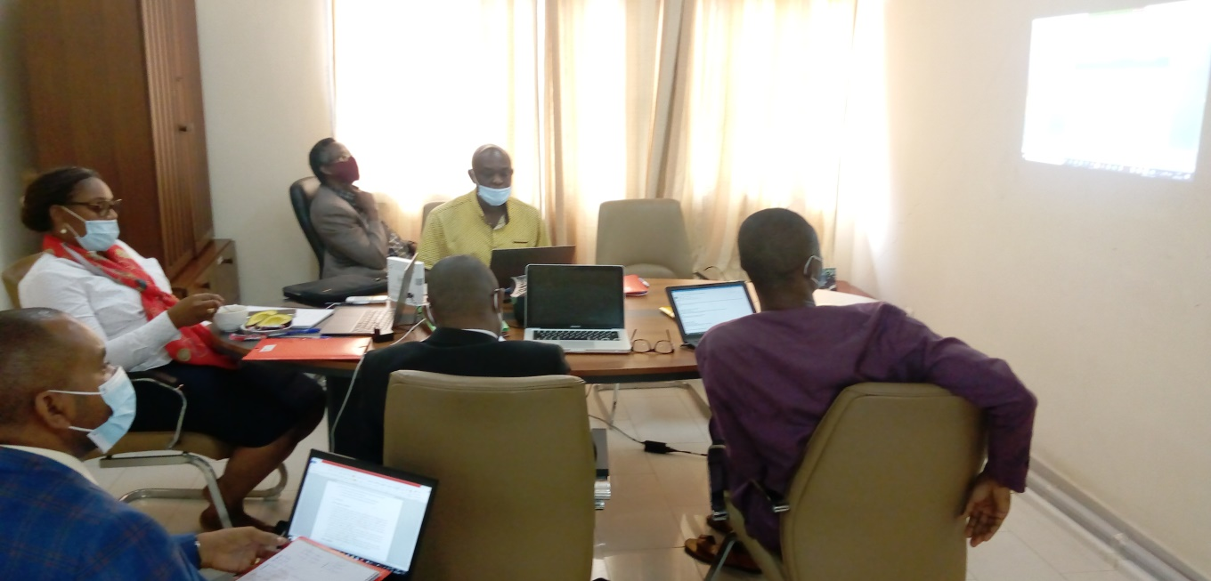

**Working Group Delivery :**

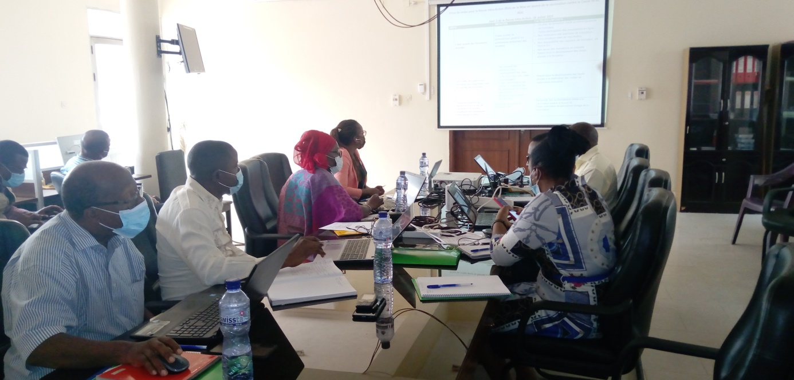

**Data Management Working Group :**

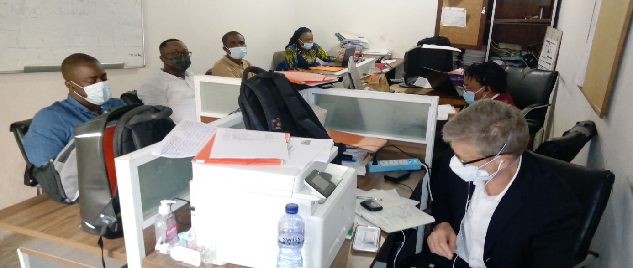

**Logistics Working Group :**

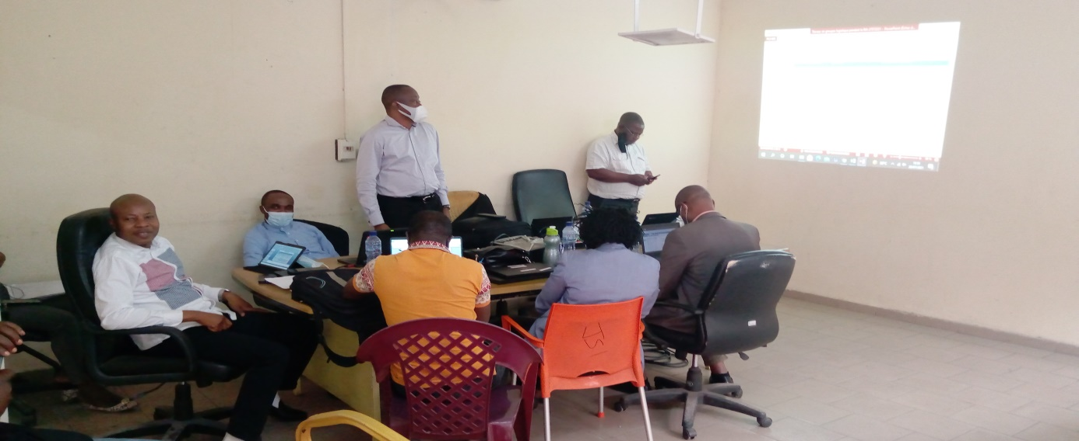

**Working Group on Vaccine Safety Surveillance :**

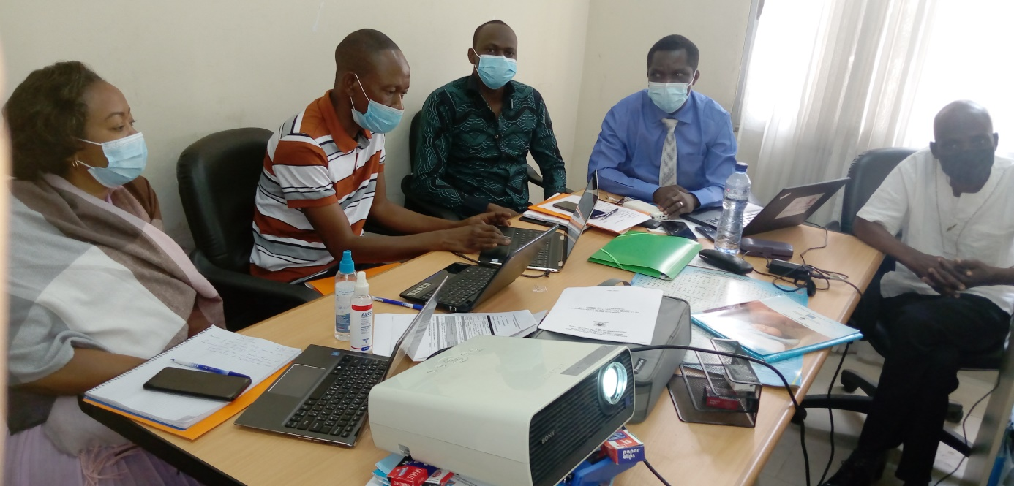

**Demand Generation Working Group :**

