Human Papilloma Virus Vaccination

Data Management

Standard Operations Procedure



Protecting South African Girls Against

Cancer of the Cervix

 

Contents

Back ground 4

1 Transcription of data from the school register 5

2 Completion of the vaccination register 5

2.1 The 1st Sheet (White) 5

2.2 The 2nd Sheet (Pink) 7

2.3 The 3rd Sheet (Green) 8

2.4 The 4th Sheet (Blue) 9

3 Completing the register 10

3.1 Register Fields or columns 10

HPV2 (Date given): Should be filled when the second dose of the vaccine is administered (HPV2). 11

4 Completing the weekly summary sheet 12

5 Data Flow 14

5.1 School Health Team Level 14

5.2 HPV collection site 15

5.3 Sub-District/District Level (Which ever applies per your province) 15

5.4 Province Level 16

5.5 National Level 16

6 Feedback Procedure 17

7 Capturing on to DHIS 18

8 Validation rules 18

9 Annexure A 20

10 Annexure B 32

# List of Figures and Tables

Figure 1 Original (White) sheet of the Vaccination Register 5

Figure 2 The Pink Sheet (1st carbonated copy of the register) 6

Figure 3 Green Sheet (second carbonated copy of the register) 7

Figure 4 Blue Sheet (third carbonated copy of the register) 8

Figure 5 Immunisation Summary Age Groups 10

Figure 6 Schematic Presentation of the Data Flow 13

Figure 7 Selecting the Data Period for HPV Data File 17

Table 1 List of Feedback recipients 16

# List of Abbreviations

HPV Human Papillomavirus

HPV1 First dose of the Human Papillomavirus vaccination

HPV2 Second dose of the Human Papillomavirus vaccination

EMIS Education Management Information System

AEFI Adverse Events Following Immunisation

DHIS District Health Information System

Back ground

There are over 200 types of HPV and serotype 16 and 18 cause 70% of the cases of cancer of the cervix. HPV is a sexually transmitted infection and can come and go without a person ever knowing you are infected. HPV can be identified through a pap smear and persistent infection with HPV can cause Cancer of the Cervix. HPV infection can be prevented but cannot be treated. The HPV Vaccine can prevent HPV infections thus preventing cancer of the cervix.

The HPV vaccine is registered for girls 9 and older. In South Africa Introduction was through a campaign mode through the Integrated School Health Programme platform. Girls in grade 4 ≥9 yrs and older are given two doses of the vaccine dose.

The purpose of this standard operation procedure is to outline the data management process for HPV vaccination campaigns. It is intended for use by the HPV vaccinators, the health information officers and the data captures. It outlines the procedure to be followed for (1) completion of the register, (2) Compiling the weekly summary sheet (3) to capturing of data in the DHIS and (4) providing feedback.

# Transcription of data from the school register

The team leader should arrange with the schools to get access to the Grade 4 school register prior to arrival. If this is not practical based on the logistics this can be arranged on arrival at the school. Once the register is received the names of all girl learners should be transcribed to the vaccination register by the administrator (nursing auxiliary, Community health worker, clerk or volunteer).

# Completion of the vaccination register

**The register has 4 sheets; the original page and 3 carbonated copies.** The administrator then proceeds to complete the vaccination register during administration of the vaccine. Please refer to the instructions on the register dividing cardboard sheet for guidance on how to complete the register, following are page images from the register;

## The 1st Sheet (White)

The 1st sheet is **White** in colour (Image 1**)** and must be completed with the demographic information for each learner.

**NOTE:**  This sheet (White) is the original and must remain in the book and “**MUST NOT BE TORN OFF”.**

**Add example of a completed register**

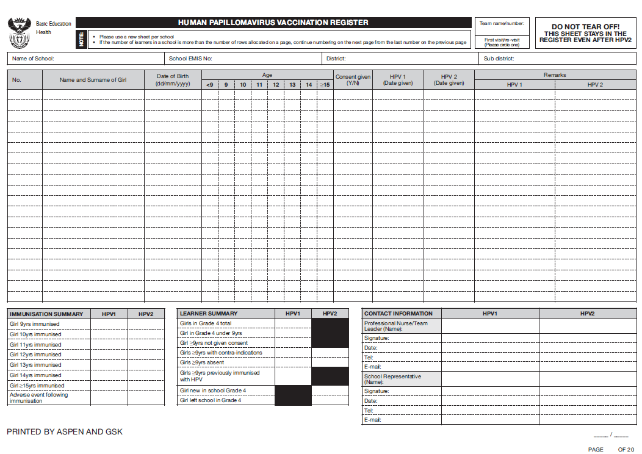

Figure Original (White) sheet of the Vaccination Register

## The 2nd Sheet (Pink)

The 2nd sheet is **Pink** in colour (Image 2**)** and is the first carbon copy which must be torn off and attached to the weekly summary sheet at the end of the week when the first **dose (HPV1)** is administered.

**REMBER:** To tear off this sheet (Pink) after administration of HPV1 and attach to the Weekly Summary Sheet.

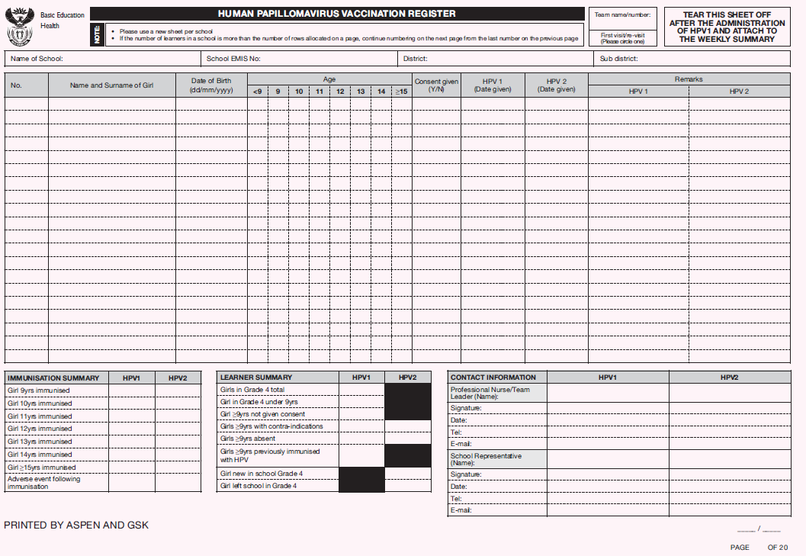

Figure The Pink Sheet (1st carbonated copy of the register)

## The 3rd Sheet (Green)

The 3rd sheet is **Green** in colour (Image 3**)** and is the second carbon copy that must be also torn off when the second **dose (HPV2)** is administered and attached to the weekly summary sheet at the end of the week.

**REMBER:** To tear off this sheet (Green) after administration of HPV2 and attach to the Weekly Summary Sheet.

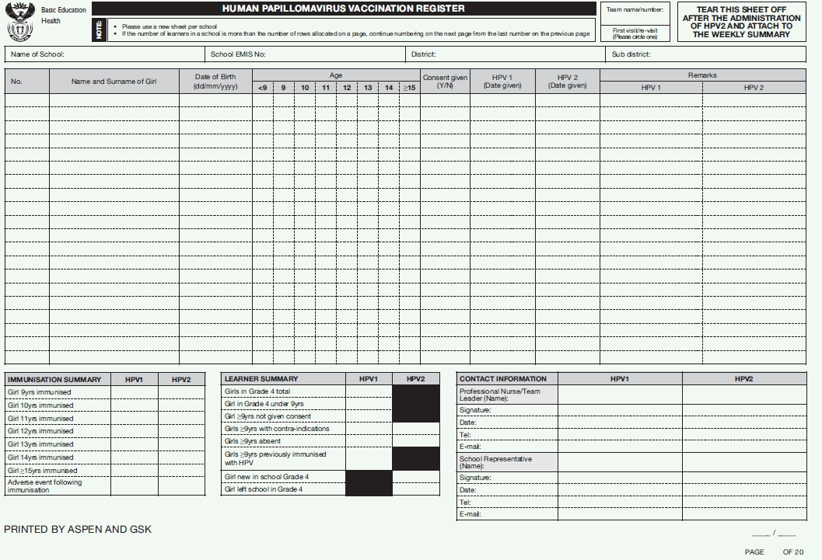

Figure Green Sheet (second carbonated copy of the register)

## The 4th Sheet (Blue)

The 4th sheet is **Blue** in colour (Image 4**)** and is the third carbon copy that must be also torn off when the second **dose (HPV2)** is administered and handed to the relevant school representative.

**REMBER:** To tear off this sheet (Blue) after administration of HPV2 and submit to the school

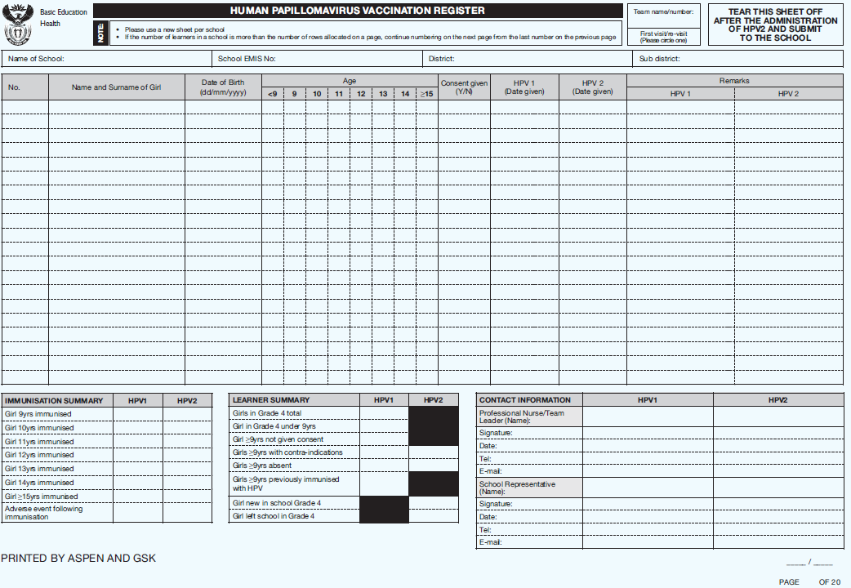

Figure Blue Sheet (third carbonated copy of the register)

# Completing the register

1. ALL the fields on the register must be completed, use a **new** white sheet (with the 3 copies of this sheet) of the register **per school**
2. The register sheets are **self-carbonated** so you must insert the register dividing cardboard sheet after the fourth sheet (blue), before writing on the register
3. Use a hard tipped ball point pen (**DO NOT** use a felt tip pen or pencil)
4. You must only write on the white sheet which must be the first sheet of your register.
5. After completing the first entry check to see that the imprint is legible in the three copies
6. After all the entries for a school are entered into the register complete the summary totals at the bottom of the original (White) sheet or page
7. For each vaccination session (dose 1 and dose 2) the Professional Nurse/Team Leader should validate the data and sign on the last day the school was visited. (see 5.1 item3)

**IMPORTANT TO NOTE:** *If more than one page is used, all the pages should be signed and the totals should be recorded on the last page (White sheet) for the relevant school. This should be done by indicating on the first page, the page on which the summary totals are recorded by writing e.g.* ***SEE THE TOTALS ON PAGE 2/2*** *if two sets were used.*

## Register Fields or columns

**Team name/number**: This is a name or number (to identify the teams) allocated by the HPV coordinator/ supervisor responsible for the teams

**First visit/re-visit:** Ignore this field on the register.

**School EMIS No**: This number is allocated by Education Management Information System (EMIS) for each school. This number can be obtained from the school list provided to the province/district/sub-district.

**The Field No**: This is the number allocated to each leaner as entered in the register in the numerical order (e.g. for the first girl entered in the register, No. will be 1). If the number of learners in a school is more than the number of rows allocated on a page continue to a new page. The numbering must be continued from the first page and any other subsequent pages.

**Name and Surname of Girl**: ***Enter the name of every girl in grade 4 in this field***. Use the list of grade 4 girl names provided by the school

**REMEBER:** At the bottom of the page indicate the number of pages that were completed for that school for e.g. Page 1 of 5

**Age:** Tick one of the boxes depending on the age of the girl. Make sure that the age corresponds with the date of birth by calculating the age. Example subtract the year of birth from the current year (2014 – 2005= 9),

* If the month of birth has passed at the time of the vaccination then it means that the learner(s) has completed the year; AND
* If the month of birth is the same as the vaccination month and the date has passed, the learner has completed the year; BUT
* If the date has not passed then it means the learner has not completed the year

**Consent given**: Parental consent given to the child to receive the vaccine.

* Tick ***Yes (Y)*** if consent form is received and signed.
* Tick ***No (N)*** if no consent form is returned
* Tick ***No (N)*** if the form is returned indicating that the child should not be vaccinated.
* Children aged 12 yrs and above can give assent and in such cases record consent as ***Yes (Y).***

**HPV1 (Date given):**Should be filled when the first dose of the vaccine is administered (HPV1).

# HPV2 (Date given): Should be filled when the second dose of the vaccine is administered (HPV2).

**Remarks** in this column you may record the following:

* If the girl is absent from school on the day of vaccination.
* Adverse Events Following Immunisation (AEFI) and what was done about it (i.e. was the AEFI form filled and child referred)
* If the girl is younger than 9 yrs and therefore, not eligible for vaccination.
* If a girl is not eligible for vaccination because of contra-indications.
* If a girl has already received the vaccine from the private sector

**IMPORTANT TO NOTE:**

The column under remarks marked **“*HPV1”*** is for comments applicable for the first dose.

The column under remarks marked **“*HPV2”*** is for comments applicable for the second dose.

**IMMUNISATION SUMMARY**

1. Add the number of girls immunised in age group as reflected in columns 5 to 11.
2. Ensure that only the girls immunised are counted in the respective columns by checking HPV1 date given or HPV2 date given.
3. Record the total number for each age group in the respective columns e.g. “***HPV1”*** or “***HPV2”***.
4. The total number of girls recorded in columns HPV1 and HPV2 in the first 7 rows of the immunisation summary should correspond with the total number in the respective columns HPV1 (Date given) or HPV2 (Date given).
5. If the totals in these two columns do not correspond, recount the number of girls immunised.

 ADD ADVERSE EVENTS

Figure Immunisation Summary Age Groups

**Adverse Events Following Immunisation**:

* The total number of girls that had Adverse Events Following Immunisation (AEFI).
* The AEFI total should be summarised from the remarks column to the immunisation summary table.
* Record the total number of AEFI for *HPV1* and *HPV2* respectively, in the bottom row of the immunisation summary table.
* Make sure to complete the AEFI Case Investigation Form for each AEFI that occurs.
* If the AEFI is reported after the day of vaccination, record the date the AEFI is reported on the register, and also the AEFI total on the weekly summary sheet for, completing only the AEFI section.

**LEARNER SUMMARY**

**Girls in Grade 4 total**: The total number of girls in Grade 4 at that school. This includes both (a) girls that were vaccinated on the day of vaccination and (b) girls not vaccinated for the reasons listed below;

* **Girls in Grade 4 under 9 years:** The total number of girls not yet 9 yrs old on the day of the administration of the first dose (HPV1).
* **Girl ≥ 9 yrs not given consent:** The total number of girls whose parents (or personally if ≥ 12 yrs) refused consent to be given/receive the vaccine indicated on the consent form.
* **Girl ≥ 9 yrs with contra-indications:** The total number of girls who had a medical condition that prevented them from receiving the vaccine on the day of vaccination i.e. girls with bleeding disorders, or girls who had severe illness in the previous seven days, or girls who are allergic to other vaccines.
* **Girl ≥ 9 yrs absent:**The total number of girls not present at the school on the day of vaccination.
* **Girl ≥ 9 yrs already vaccinated:**The total number of girls previously vaccinated elsewhere (e.g. private sector) with the HPV vaccine will not be vaccinated.
* **Girl new in school Grade 4:** The total number of girls who joined the school after the first dose of the vaccine was already administered.
* The new girls in a school should be added to the HPV vaccination register irrespective of whether they have been vaccinated in their previous school
* If eligible to receive the vaccine, the girl should produce the learner card before receiving the second dose of the vaccine.
* If these is no vaccination card the girl can be issued with a new vaccination card and record the dose accordingly.
* **Girl left school in Grade 4:** The total number of girls that left the school after the first dose of the vaccine was already administered.

**IMPORTANT TO NOTE:**

* **Name and Contact details of the Professional Nurse/Team Leader**: Should be completed in the appropriate space during first and second dose of vaccination (HPV1 and HPV2)
* **Name and Contact details of the School Representative:** Should be completed in the appropriate space during first and second dose vaccination (HPV1 and HPV2). Ascertain from the school principal who is authorised to sign as the **school representative**.

**RECORDING INFORMATION ON REGISTER FOR SECOND/FOLLOW-UP VISITS**

1. Use the sheet on the register recorded for that school during the first visit.
2. The entries of girls vaccinated during the second visit must be recorded in either columns HPV1 (Date given) or HPV2 (Date given).
3. The additional girls immunised during the second/follow-up visit must be added and recorded as a + number in the respective columns of the first 7 rows following the same process used during the recording of the first visit.
4. If the copy of the register for the school revisited was already sent with a weekly summary sheet for capturing then copy the register and capture on a new weekly summary sheet with the total number of girls immunised (the totals from the first visit and the second visit must be added).

# 

# Completing the weekly summary sheet

1. The weekly summary sheet must be completed by the Professional Nurse/Team Leader every week.
2. The source of data for the weekly summary sheet is the HPV register summaries (**immunisation and learner summaries)**.
3. At the end of the week, each team will enter the data for all the schools visited in that week on a weekly summary sheet
4. Ensure that the correct totals are entered on to the corresponding columns on the weekly summary sheet
5. **In round two where 2 groups of girls are vaccinated (Dose 1 and Dose 2) record summary of girls receiving dose 1 and dose 2 as two separate entries for each school (i.e. dose 1 and dose 2 on separate lines)**
6. Please indicate under the field HPV (1 or 2) if this is dose 1 with the number “1” or dose 2 with the number “2”
7. After entering all of the information from the individual school registers, calculate the total number of girls vaccinated in each age group and enter the total number of girls immunised for that week in the block Girls ≥9 years immunised.
8. In addition to information obtained from the HPV registers please also complete the following fields on the register using the HPV vaccine stock card:

**“Weekly vials issued”** isthe total number of vials issued daily as recorded on the stock card

**“Weekly vials returned”** is the total number of vials returned daily as recorded on the stock card

**“Weekly vials used”** should be calculated and will be the difference between **“Weekly vials issued”** and **“Weekly vials returned”** returned less the vials that were damaged

**“Weekly vials damage”** is the total number of vials damage in any form per week

1. The Professional Nurse/Team Leader should verify and sign the weekly summary sheet.
2. If possible before submission, data should be verified by the designated person at the collection site.

**IMPORTANT FACTORS TO CONSIDER IF A SECOND VISIT IS CONDUCTED**

* 1. **You visit a school today and there are learners that were missed equivalent to 60% of the total number of learners eligible for vaccination, then you should revisit the school to vaccinate the learners that missed the vaccination due non-return of the consent forms or absenteeism**
  2. **Once the vaccinations for both the first and second visits are completed add the data from the first and second visits from the summaries at the bottom of the register and enter on the relevant fields of the weekly summary sheet.**
  3. **Make sure to attach the copies of the register (first and second visit) to the weekly summary sheet**
  4. **If the copy of the first visit has already been submitted to the next level for capturing, make a photocopy and attach to the weekly summary sheet together with the copy of the second visit.**

# Data Flow

# 

Figure Schematic Presentation of the Data Flow

## School Health Team Level

|  |  |  |
| --- | --- | --- |
| **Activity** | **Timeline** | **Responsible person (s)** |
| 1. Record all girls in the vaccination register during vaccination | **Daily** | **Administrator**: A sub-category of the Nursing auxiliary, community health worker, clerk or volunteer responsible for recording of doses and other duties |
| 1. Summarise the data at the bottom of the register   **NOTE**: *Check with the Team Leader a re-visit to the school will not be required before summarising the data and* ***if the school will be re-visited do not summarise*** |
| 1. Validation of HPV Register by the Professional Nurse/Team Leader    1. Check that all the required fields on the register are complete and correctly recorded.    2. The summary data on the bottom of the page is complete.    3. If more than 1 register sheet is used check that the data from all sheets are include in the final summary.    4. Verify the summary data:       1. **Immunisation summary** – the total of first 7 rows must correspond with total number in column HPV 1 (Date given) for dose 1 or HPV 2 (Date given) for dose 2       2. **Girls in grade 4 total** (should tally with the total number of girls in column 1)       3. Check that girls recorded as <9 were not immunised | **Daily** | **Team Leader**: Professional Nurse, responsible for overall management of the team and session. |
| 1. Transfer data to the weekly summary sheet |
| 1. Give feedback to school representative and inform him/her **if the school will be revisited** before leaving the school |
| 1. Check that the data in the weekly summary sheet is correct, address any queries found, sign and attach all the relevant vaccination register copies | **End of the week** |
| 1. Take forms to the HPV collection site | **Monday morning** |

## HPV collection site

|  |  |  |
| --- | --- | --- |
| **Activity** | **Timeline** | **Responsible person(s)** |
| 1. Ensure each HPV vaccination team has submitted the weekly summary sheet with the copies of the school registers attached | **Every Monday Morning** | **Designated** person |
| 1. Verify the data in the weekly summary sheet by checking that:   2.1 Check that all the required fields on the register are complete and correctly recorded.  2.2 All schools that were visited are entered on the weekly summary sheets and the names of the schools are correctly recorded  2.3 Check that the total number of Girls ≥9 years immunised corresponds with the total number of vaccines used.  **NB:** The number of vaccines issued and the number of vaccines returned less the damaged vaccine vials will provide you with the number of vaccines used. |
| 1. Sign the weekly summary sheet to indicate that the data has been verified and approved |
| 1. Transfer all the weekly summary sheets to the sub-district office for capturing in the DHIS   **NOTE**: *Arrange with the HPV coordinator for transport if the facility has e-mail or connectivity challenges*) | **Monday afternoon** |
| 1. Give feedback to the Facility Pharmacist and Team Leaders on discrepancies | **Tuesday Morning** |

## Sub-District/District Level (Which ever applies per your province)

|  |  |  |
| --- | --- | --- |
| **Activity** | **Timeline** | **Responsible person** |
| 1. Check for discrepancies and liaise with the Team Leader responsible to ensure that queries are addressed | **Tuesday morning** | **Data Capturer** |
| 1. Capture data onto the DHIS data file |
| 1. Validate the data: run the validation rules on the DHIS |
| 1. Export data and send to province (**NOTE**: *Arrange with the HPV coordinator for transport if the facility has e-mail or connectivity challenges*) | **Tuesday afternoon** |
| 1. Give feedback to supervisor (HPV sub-district/district coordinator) on indicator performance and data quality   **NOTE**: *See Section No. 6 (Feedback Procedure) for guidance*) | **Wednesday Morning** |
| 1. Give feedback to HPV teams on indicator performance and data quality | **Wednesday afternoon** | **Sub-District/District HPV coordinator** |

## Province Level

|  |  |  |
| --- | --- | --- |
| **Activity** | **Timeline** | **Responsible person** |
| 1. Collate sub-district/district data | **Wednesday morning** | **Provincial Health Information Officer** |
| 1. Validate the data |
| 1. Export data and send to national | **Wednesday afternoon** |
| 1. Give feedback to provincial HPV coordinator on indicator performance and data quality   **NOTE**: *See Section No. 6 (Feedback Procedure) for guidance*) |
| 1. Give feedback to HPV Sub-District/District coordinator on indicator performance and data quality   **NOTE**:   * *Because the responsibility for HPV coordination lies in different programmes in different province, the designation of individuals who need the feedback may vary depending on the Sub-district and/or District set-up in each Province* * *See Section No. 6 (Feedback Procedure) for guidance*) | **Thursday morning** | **Provincial HPV Coordinator** |
|  |  |  |

## National Level

|  |  |  |
| --- | --- | --- |
| **Activity** | **Timeline** | **Responsible person** |
| 1. Collate provincial data | **Thursday morning** | **EPI Data Manager** |
| 1. Validate the data: run the validation rules on the DHIS |
| 1. Give feedback to the HPV Provincial coordinator on indicator performance and data quality   **NOTE**:   * *Because the responsibility for HPV coordination lies in different programmes in different province, the designation of individuals who need the feedback may vary depending set-up in each Province* * *See Section No. 6 (Feedback Procedure) for guidance*) | **Thursday afternoon** |

# Capturing on to DHIS

The HPV campaign data file is based on the DHIS 1.4 and the section below highlights differences between this data file and the routine data file

1. The data period for the HPV campaign data file does not auto formatted (it does not show automatically) and may need to be manually selected
2. To select the data period select show/hide future periods as shown in figure7.

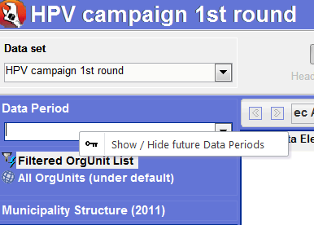

Figure Selecting the Data Period for HPV Data File

1. HPV campaign reporting is weekly but capturing is yearly 2014 (yearly).

**NOTE: DO NOT CHANGE CAPTURING TO WEEKLY OR DAILY AS IT WILL CREATE DUPLICATE ENTRIES IN THE DATA FILE**

1. Export to Datamart should everytime be yearly (from 1 Jan 2014 – 31 Dec 2014).
2. **DO NOT** prune the datafile so that you able to search for schools that may have not been allocated to the correct district. To check whether the school is not in another Sub-District/District go to Maintenance and click > Ctrl + O and type the name of the school
   1. Department of Education (DOE) and Health District demarcations are not the same thus it has proven difficult to place schools in the correct District during the first round. GIS was used but some GIS co-ordinates have been found to be wrong.
   2. Use the __OrgunitSearchQuery_HPV.xlsx document to search on the OrgunitCode field by entering the unique EMIS number of the school.
   3. If it is in the incorrect sub-district and you are sure of its location simply move the orgunit to the correct sub-district
3. If you cannot find a school on the data base, please complete the “Form for HPV campaign registration of schools not in the HPV/IHSP data base”. This form should be forwarded to EPI data manager national to add the school in the database.

# Validation rules

There are currently two validation rules in the HPV data file

1. HPV CAMPAIGN 1 dose v/s School learners ≥ 9 yrs
   1. The total number of learners immunised for HPV1 must be less than or equal to the total number of learners ≥9yrs minus the learners that could not receive the immunisation
2. HPV CAMPAIGN 2 dose v/s School learners ≥ 9 yrs
   1. The total number of learners immunised for HPV2 must be less than or equal to the total number of learners ≥9yrs minus the learners that could not receive the immunisation

# Annexure A

| **Sort**  **Order** | **Data**  **Element**  **Name** | **Definition** | **Definition**  **Extended** | **Use and Context** | **Inclusions** | **Exclusions** | **Calculated** | **Save**  **Calculated** | **IndGroup** | **Freq** | **Editing**  **Period** | **Keep Zero Values** | **Collected By** | **Collection Points** | **Tools** |
| --- | --- | --- | --- | --- | --- | --- | --- | --- | --- | --- | --- | --- | --- | --- | --- |
| 1 | Grade 3 girl in previous year total | All grade 3 girl learners in a school during the previous year including girls younger 9 yrs. This element must be captured with a validity period for the following year. |  | This element is pre-entered from previous year learner totals as an estimation of how many learners will be in grade 4 for the year of the immunisation |  |  | 0 | 0 | Learner Totals | OnChange | 0 | 0 | HPV vaccination teams | Primary Schools and special schools | HPV vaccination register and weekly summary sheet |
| 2 | Grade 4 girl total | All grade 4 girl learners in a school including girls younger 9 yrs |  | For special schools the target age group is 9 yrs < 10 yrs |  |  | 0 | 0 | Learner Totals | Yearly | 0 | 0 | HPV vaccination teams | Primary Schools and special schools | HPV vaccination register and weekly summary sheet |
| 3 | Grade 4 girl under 9 yrs | All grade 4 girl learners younger than 9 yrs. These learners should not receive the vaccine |  |  |  |  | 0 | 0 | Learner Totals | Yearly | 0 | 0 | HPV vaccination teams | Primary Schools and special schools | HPV vaccination register and weekly summary sheet |
| 4 | Grade 4 girl 9 yrs and older | Total number of grade 4 girl learners 9 years and older, excluding girls younger than 9 years. |  | Only girls above or equal to 9 years |  |  | 1 | 0 | Learner Totals | Yearly | 0 | 0 | HPV vaccination teams | Primary Schools and special schools | HPV vaccination register and weekly summary sheet |
| 5 | Girl 9 yrs and older without consent | All grade 4 girl learners 9 years or older whose parents refused to give them consent to receive the vaccine |  |  |  |  | 0 | 0 | Learner Totals | Yearly | 0 | 0 | HPV vaccination teams | Primary Schools and special schools | HPV vaccination register and weekly summary sheet |
| 6 | Girl 9yrs and older absent | All grade 4 girl learners 9 years or older absent on the day of vaccination | These learners will not receive the vaccine during the first or 2nd round of the campaign |  |  |  | 0 | 0 | Learner Totals | Yearly | 0 | 0 | HPV vaccination teams | Primary Schools and special schools | HPV vaccination register and weekly summary sheet |
| 7 | Girl 9yrs and older with contra-indications | All grade 4 girl learners 9 years and older who could not be vaccinated because of a medical contra-indication. These learners should not receive the vaccine. |  |  |  |  | 0 | 0 | Learner Totals | Yearly | 0 | 0 | HPV vaccination teams | Primary Schools and special schools | HPV vaccination register and weekly summary sheet |
| 8 | Girl previously immunised with HPV | All grade 4 girl learners who have already been immunised with the HPV vaccine from the private provider. These learners should not receive the HPV vaccine |  |  |  |  | 0 | 0 | Learner Totals | Yearly | 0 | 0 | HPV vaccination teams | Primary Schools and special schools | HPV vaccination register and weekly summary sheet |
| 9 | Grade 4 girl 9yrs and older new in school since HPV 1 | All grade 4 girl ≥ 9yrs who are in the school during the 2nd round of the campaign but were not in the school during the first round | These learners will increase the expected number of vaccinations given during the 2nd round |  |  |  | 0 | 0 | Learner Totals | Yearly | 0 | 0 | HPV vaccination teams | Primary Schools and special schools | HPV vaccination register and weekly summary sheet |
| 10 | Grade 4 girl 9yrs and older left school since HPV 1 | All grade 4 girl ≥ 9yrs who have left the school since the first round of the campaign | These learners will reduce the expected number of vaccinations given during the 2nd round |  |  |  | 0 | 0 | Learner Totals | Yearly | 0 | 0 | HPV vaccination teams | Primary Schools and special schools | HPV vaccination register and weekly summary sheet |
| 11 | Girl 09yrs HPV 1st dose | All grade 4 girl learners 9 years old vaccinated 1st dose |  |  |  |  | 0 | 0 | HPV campaign | Yearly | 0 | 0 | HPV vaccination teams | Primary Schools and special schools | HPV vaccination register and weekly summary sheet |
| 12 | Girl 10yrs HPV 1st dose | All grade 4 girl learners 10 years old vaccinated 1st dose |  |  |  |  | 0 | 0 | HPV campaign | Yearly | 0 | 0 | HPV vaccination teams | Primary Schools and special schools | HPV vaccination register and weekly summary sheet |
| 13 | Girl 11yrs HPV 1st dose | All grade 4 girl learners 11 years old vaccinated 1st dose |  |  |  |  | 0 | 0 | HPV campaign | Yearly | 0 | 0 | HPV vaccination teams | Primary Schools and special schools | HPV vaccination register and weekly summary sheet |
| 14 | Girl 12yrs HPV 1st dose | All grade 4 girl learners 12 years old vaccinated 1st dose |  |  |  |  | 0 | 0 | HPV campaign | Yearly | 0 | 0 | HPV vaccination teams | Primary Schools and special schools | HPV vaccination register and weekly summary sheet |
| 15 | Girl 13yrs HPV 1st dose | All grade 4 girl learners 13 years old vaccinated 1st dose |  |  |  |  | 0 | 0 | HPV campaign | Yearly | 0 | 0 | HPV vaccination teams | Primary Schools and special schools | HPV vaccination register and weekly summary sheet |
| 16 | Girl 14yrs HPV 1st dose | All grade 4 girl learners 14 years old vaccinated 1st dose |  |  |  |  | 0 | 0 | HPV campaign | Yearly | 0 | 0 | HPV vaccination teams | Primary Schools and special schools | HPV vaccination register and weekly summary sheet |
| 17 | Girl 15yrs and older HPV 1st dose | All grade 4 girl learners = 15 years old vaccinated 1st dose |  |  |  |  | 0 | 0 | HPV campaign | Yearly | 0 | 0 | HPV vaccination teams | Primary Schools and special schools | HPV vaccination register and weekly summary sheet |
| 18 | Girl with adverse events after HPV 1st dose | Total number of grade 4 girl learners with adverse events following immunisation | The total number of grade 4 learners with adverse events following HPV1 immunisation |  |  |  | 0 | 0 | HPV campaign | Yearly | 0 | 0 | HPV vaccination teams | Primary Schools and special schools | HPV vaccination register and weekly summary sheet |
| 19 | Girl 9yrs and older HPV 1st dose - total | All grade 4 girl learners vaccinated 1st dose - Total |  |  |  |  | 1 | 1 | HPV campaign | Yearly | 0 | 0 | HPV vaccination teams | Primary Schools and special schools | HPV vaccination register and weekly summary sheet |
| 20 | Grade 4 girl not immunised HPV 1st dose | This data element will be calculated by the DHIS |  |  |  |  | 1 | 0 | HPV campaign | Yearly | 0 | 0 | HPV vaccination teams | Primary Schools and special schools | HPV vaccination register and weekly summary sheet |
| 21 | Girl 09yrs HPV 2nd dose | All grade 4 girl learners 9 years old vaccinated 2nd dose |  |  |  |  | 0 | 0 | HPV campaign | Yearly | 0 | 0 | HPV vaccination teams | Primary Schools and special schools | HPV vaccination register and weekly summary sheet |
| 22 | Girl 10yrs HPV 2nd dose | All grade 4 girl learners 10 years old vaccinated 2nd dose |  |  |  |  | 0 | 0 | HPV campaign | Yearly | 0 | 0 | HPV vaccination teams | Primary Schools and special schools | HPV vaccination register and weekly summary sheet |
| 23 | Girl 11yrs HPV 2nd dose | All grade 4 girl learners 11 years old vaccinated 2nd dose |  |  |  |  | 0 | 0 | HPV campaign | Yearly | 0 | 0 | HPV vaccination teams | Primary Schools and special schools | HPV vaccination register and weekly summary sheet |
| 24 | Girl 12yrs HPV 2nd dose | All grade 4 girl learners 12 years old vaccinated 2nd dose |  |  |  |  | 0 | 0 | HPV campaign | Yearly | 0 | 0 | HPV vaccination teams | Primary Schools and special schools | HPV vaccination register and weekly summary sheet |
| 25 | Girl 13yrs HPV 2nd dose | All grade 4 girl learners 13 years old vaccinated 2nd dose |  |  |  |  | 0 | 0 | HPV campaign | Yearly | 0 | 0 | HPV vaccination teams | Primary Schools and special schools | HPV vaccination register and weekly summary sheet |
| 26 | Girl 14yrs HPV 2nd dose | All grade 4 girl learners 14 years old vaccinated 2nd dose |  |  |  |  | 0 | 0 | HPV campaign | Yearly | 0 | 0 | HPV vaccination teams | Primary Schools and special schools | HPV vaccination register and weekly summary sheet |
| 27 | Girl 15yrs and older HPV 2nd dose | All grade 4 girl learners ≥ 15 years old vaccinated 2nd dose |  |  |  |  | 0 | 0 | HPV campaign | Yearly | 0 | 0 | HPV vaccination teams | Primary Schools and special schools | HPV vaccination register and weekly summary sheet |
| 28 | Girl with adverse events after HPV 2nd dose | Total number of grade 4 girls learners with adverse events after HPV 2nd dose following immuisation on the day of vaccination | The total number of grade 4 learners with adverse events following HPV2 immunisation |  |  |  | 0 | 0 | HPV campaign | Yearly | 0 | 0 | HPV vaccination teams | Primary Schools and special schools | HPV vaccination register and weekly summary sheet |
| 29 | Girl 9yrs and older HPV 2nd dose - total | All grade 4 girl learners vaccinated 2nd dose - Total |  |  |  |  | 1 | 1 | HPV campaign | Yearly | 0 | 0 | HPV vaccination teams | Primary Schools and special schools | HPV vaccination register and weekly summary sheet |
| 30 | Grade 4 girl not immunised HPV 2nd dose | This data element will be calculated by the DHIS |  |  |  |  | 1 | 0 | HPV campaign | Yearly | 0 | 0 | HPV vaccination teams | Primary Schools and special schools | HPV vaccination register and weekly summary sheet |
| 34 | Girl 9 years 1st dose not immunised during the 1st round | All grade 4 girl learners 9 years old who were not vaccinnated in the 1st round and receving the 1st dose during the 2nd round of the campaign |  | The reason for not being immunised can be varied, e.g. the girl only turned 9 years after the first round completed or the girl was absent during the first round our the girl did not have consent during the first round or the girl had contra-indications during the first round which is no longer existing. |  |  | 0 | 0 | HPV campaign | Yearly | 0 | 0 | HPV vaccination teams | Primary Schools and special schools | HPV vaccination register and weekly summary sheet |
| 35 | Girl 10 years 1st dose not immunised during the 1st round | All grade 4 girl learners 10 years old who were not vaccinnated in the 1st round and receving the 1st dose during the 2nd round of the campaign |  | The reason for not being immunised can be varied, e.g. the girl was absent during the first round our the girl did not have consent during the first round or the girl had contra-indications during the first round which is no longer existing. |  |  | 0 | 0 | HPV campaign | Yearly | 0 | 0 | HPV vaccination teams | Primary Schools and special schools | HPV vaccination register and weekly summary sheet |
| 36 | Girl 11 years 1st dose not immunised during the 1st round | All grade 4 girl learners 11 years old who were not vaccinnated in the 1st round and receving the 1st dose during the 2nd round of the campaign |  | The reason for not being immunised can be varied, e.g. the girl was absent during the first round our the girl did not have consent during the first round or the girl had contra-indications during the first round which is no longer existing. |  |  | 0 | 0 | HPV campaign | Yearly | 0 | 0 | HPV vaccination teams | Primary Schools and special schools | HPV vaccination register and weekly summary sheet |
| 37 | Girl 12 years 1st dose not immunised during the 1st round | All grade 4 girl learners 12 years old who were not vaccinnated in the 1st round and receving the 1st dose during the 2nd round of the campaign |  | The reason for not being immunised can be varied, e.g. the girl was absent during the first round our the girl did not have consent during the first round or the girl had contra-indications during the first round which is no longer existing. |  |  | 0 | 0 | HPV campaign | Yearly | 0 | 0 | HPV vaccination teams | Primary Schools and special schools | HPV vaccination register and weekly summary sheet |
| 38 | Girl 13 years 1st dose not immunised during the 1st round | All grade 4 girl learners 13 years old who were not vaccinnated in the 1st round and receving the 1st dose during the 2nd round of the campaign |  | The reason for not being immunised can be varied, e.g. the girl was absent during the first round our the girl did not have consent during the first round or the girl had contra-indications during the first round which is no longer existing. |  |  | 0 | 0 | HPV campaign | Yearly | 0 | 0 | HPV vaccination teams | Primary Schools and special schools | HPV vaccination register and weekly summary sheet |
| 39 | Girl 14 years 1st dose not immunised during the 1st round | All grade 4 girl learners 14 years old who were not vaccinnated in the 1st round and receving the 1st dose during the 2nd round of the campaign |  | The reason for not being immunised can be varied, e.g. the girl was absent during the first round our the girl did not have consent during the first round or the girl had contra-indications during the first round which is no longer existing. |  |  | 0 | 0 | HPV campaign | Yearly | 0 | 0 | HPV vaccination teams | Primary Schools and special schools | HPV vaccination register and weekly summary sheet |
| 40 | Girl 15 years 1st dose not immunised during the 1st round | All grade 4 girl learners 15 years old who were not vaccinnated in the 1st round and receving the 1st dose during the 2nd round of the campaign |  | The reason for not being immunised can be varied, e.g. the girl was absent during the first round our the girl did not have consent during the first round or the girl had contra-indications during the first round which is no longer existing. |  |  | 0 | 0 | HPV campaign | Yearly | 0 | 0 | HPV vaccination teams | Primary Schools and special schools | HPV vaccination register and weekly summary sheet |
| 41 | Girl received first dose but absent during 2nd round | A girl (between 9 and 15 years) who received the first dose but were absent during the 2nd round and could not receive the 2nd round campaign dose. |  |  |  |  | 0 | 0 | HPV campaign | Yearly | 0 | 0 | HPV vaccination teams | Primary Schools and special schools | HPV vaccination register and weekly summary sheet |
| 42 | Grade 4 girl turned 9 years since 1st round | All grade 4 girls who turned 9 years since the 1st round campaign. |  | These learners could not receive the vaccine during the 1st round but will receive the vaccine during the 2nd round. |  |  | 0 | 0 | HPV campaign | Yearly | 0 | 0 | HPV vaccination teams | Primary Schools and special schools | HPV vaccination register and weekly summary sheet |

# Annexure B

| **Sort**  **Order** | **Indicator**  **Name** | **Numerator** | **Numerator Formula** | **Denominator** | **Denominator Formula** | **Definition** | **Use and Context** | **Type** | **Annualized** | **IndGroup** | **Freq** |
| --- | --- | --- | --- | --- | --- | --- | --- | --- | --- | --- | --- |
| 1 | HPV 1st dose coverage | Girls 9 years and older HPV 1st dose | SUM([Girl 09yrs HPV 1st dose]) + SUM([Girl 10yrs HPV 1st dose]) + SUM([Girl 11yrs HPV 1st dose]) + SUM([Girl 12yrs HPV 1st dose]) + SUM([Girl 13yrs HPV 1st dose]) + SUM([Girl 14yrs HPV 1st dose]) + SUM([Girl 15yrs and older HPV 1st dose]) | Grade 4 girl learners ≥ 9 years | SUM([Grade 4 girl total ]) - SUM([Grade 4 girl under 9 yrs]) | Proportion of grade 4 girl learners ≥ 9 years vaccinated per year with the 1st dose of the HPV vaccine during the first round | This indicator will provide overall yearly coverage value which will aggregate as the campaign progress and reflect the coverage so far | % | N | HPV campaign | Yearly |
| 2 | HPV 2nd dose coverage | Girls 9 years and older HPV 2nd dose | SUM([Girl 09yrs HPV 2nd dose]) + SUM([Girl 10yrs HPV 2nd dose]) + SUM([Girl 11yrs HPV 2nd dose]) + SUM([Girl 12yrs HPV 2nd dose]) + SUM([Girl 13yrs HPV 2nd dose]) + SUM([Girl 14yrs HPV 2nd dose]) + SUM([Girl 15yrs and older HPV 2nd dose]) | Grade 4 girl learners ≥ 9 years during 2nd round | SUM([Grade 4 girl total ]) - SUM([Grade 4 girl under 9 yrs]) + SUM([Grade 4 girl 9yrs and older new in school since HPV 1]) - SUM([Grade 4 girl 9yrs and older left school since HPV 1]) | Proportion of grade 4 girl learners ≥ 9 years vaccinated per year with the 1st dose of the HPV vaccine during the first round based on learner totals obtained during the campaign | This indicator will calculate as the campaign progress based on both numerator and denominator data captured for each school and should be interpreted carefully since coverage for schools not yet done are not included | % | N | HPV campaign | Yearly |
| 3 | HPV 1st dose school coverage | Schools reached with HPV 1st dose vaccine | IIF(SUM([Girl 9yrs and older HPV 1st dose - total])>0,1,0) | Number of schools (including special schools) | COUNT([Grade 3 girl in previous year total]) | Proportion of schools (including special schools) that were reached with the 1st dose of HPV Vaccine | It is essential that each school only provide one report per campaign round for this indicator to calculate properly | % | N | HPV campaign | Yearly |
| 4 | HPV 2nd dose school coverage | Schools reached with HPV 2nd dose vaccine | IIF(SUM([Girl 9yrs and older HPV 2nd dose - total])>0,1,0) | Number of schools (including special schools) | COUNT([Grade 3 girl in previous year total]) | Proportion of schools (including special schools) that were reached with the 2nd dose of HPV Vaccine |  | % | N | HPV campaign | Yearly |
| 5 | HPV 1st dose coverage projected | Girls 9 years and older HPV 1st dose | SUM([Girl 09yrs HPV 1st dose]) + SUM([Girl 10yrs HPV 1st dose]) + SUM([Girl 11yrs HPV 1st dose]) + SUM([Girl 12yrs HPV 1st dose]) + SUM([Girl 13yrs HPV 1st dose]) + SUM([Girl 14yrs HPV 1st dose]) + SUM([Girl 15yrs and older HPV 1st dose]) | Grade 3 girls in 2013 | SUM([Grade 3 girl in previous year total]) | Proportion of grade 4 girl learners ≥ 9 years vaccinated per week with the 1st dose of the HPV vaccine during the first round | This indicator will provide a weekly coverage value which can be added up over the weeks of the campaign to aggregate the overall coverage | % | N | HPV campaign | Yearly |
| 6 | HPV 2nd dose coverage projected | Girls 9 years and older HPV 1st dose | SUM([Girl 09yrs HPV 2nd dose]) + SUM([Girl 10yrs HPV 2nd dose]) + SUM([Girl 11yrs HPV 2nd dose]) + SUM([Girl 12yrs HPV 2nd dose]) + SUM([Girl 13yrs HPV 2nd dose]) + SUM([Girl 14yrs HPV 2nd dose]) + SUM([Girl 15yrs and older HPV 2nd dose]) | Grade 3 girls in 2013 | SUM([Grade 3 girl in previous year total]) | Proportion of grade 4 girl learners ≥ 9 years vaccinated per week with the 2nd dose of the HPV vaccine during the first round | This indicator will provide a weekly coverage value which can be added up over the weeks of the campaign to aggregate the overall coverage | % | N | HPV campaign | Yearly |
| 7 | HPV 1-2 dropout rate | Girl received first dose but absent during 2nd round | SUM([Girl received first dose but absent during 2nd round]) | HPV 1st dose | SUM([Girl 09yrs HPV 1st dose]) + SUM([Girl 10yrs HPV 1st dose]) + SUM([Girl 11yrs HPV 1st dose]) + SUM([Girl 12yrs HPV 1st dose]) + SUM([Girl 13yrs HPV 1st dose]) + SUM([Girl 14yrs HPV 1st dose]) + SUM([Girl 15yrs and older HPV 1st dose]) | Proportion of grade 4 girl learners ≥ 9 years vaccinated with the 1st dose of the HPV vaccine, but not with the 2nd dose of the HPV vaccine during the 2nd round | This indicator will provide overall yearly coverage value which will aggregate as the campaign progress and reflect the coverage so far | % | N | HPV campaign | Yearly |
| 8 | HPV 1st dose adverse event rate | Girl with adverse event after HPV 1st dose | SUM([Girl with adverse events after HPV 1st dose]) | Grade 4 girl learners ≥ 9 years | SUM([Girl 09yrs HPV 1st dose]) + SUM([Girl 11yrs HPV 1st dose]) + SUM([Girl 12yrs HPV 1st dose]) + SUM([Girl 13yrs HPV 1st dose]) + SUM([Girl 14yrs HPV 1st dose]) + SUM([Girl 15yrs and older HPV 1st dose]) | Proportion of grade 4 girl learners who had an adverse event after HPV 1st dose |  | % | N | HPV campaign | Yearly |
| 9 | HPV 2nd dose adverse event rate | Girl with adverse event after HPV 2nd dose | SUM([Girl with adverse events after HPV 2nd dose]) | Grade 4 girl learners ≥ 9 years | SUM([Girl 09yrs HPV 2nd dose]) + SUM([Girl 10yrs HPV 2nd dose]) + SUM([Girl 11yrs HPV 2nd dose]) + SUM([Girl 12yrs HPV 2nd dose]) + SUM([Girl 13yrs HPV 2nd dose]) + SUM([Girl 14yrs HPV 2nd dose]) + SUM([Girl 15yrs and older HPV 2nd dose]) | Proportion of grade 4 girl learners who had an adverse event after HPV 1st dose |  | % | N | HPV campaign | Yearly |
| 10 | Girl ≥ 9 yrs with out consent rate | Girl ≥ 9 yrs with out consent | SUM([Girl 9 yrs and older without consent]) | Grade 4 girl learners ≥ 9 years | SUM([Grade 4 girl total ]) - SUM([Grade 4 girl under 9 yrs]) | Proportion of grade 4 girl learners ≥ 9 years not vaccinated due to lack of consent in the 1st round of the campaign | Learners without consent will also not receive the 2nd round dose | % | N | HPV campaign | Yearly |
| 11 | Girl ≥9yrs with contra-indications rate | Girl with contra-indications | SUM([Girl 9yrs and older with contra-indications]) | Grade 4 girl learners ≥ 9 years | SUM([Grade 4 girl total ]) - SUM([Grade 4 girl under 9 yrs]) | Proportion of grade 4 girl learners ≥ 9 years not vaccinated due to contra-indications |  | % | N | HPV campaign | Yearly |
| 12 | Girl ≥ 9yrs absenteeism rate | Girl ≥ 9yrs absent | SUM([Girl 9yrs and older absent]) | Grade 4 girl learners ≥ 9 years | SUM([Grade 4 girl total ]) - SUM([Grade 4 girl under 9 yrs]) | Proportion of grade 4 girl learners ≥ 9 years not vaccinated due to being absent during the first round of the campaign | These learners will also not receive the vaccination during the second round | % | N | HPV campaign | Yearly |
| 13 | Girl previously immunised with HPV rate | Girl previously immunised with HPV | SUM([Girl previously immunised with HPV]) | Grade 4 girl learners ≥ 9 years | SUM([Grade 4 girl total ]) - SUM([Grade 4 girl under 9 yrs]) | Proportion of grade 4 girl learners ≥ 9 years not vaccinated due to previously receiving the vaccination | These learners will also not receive the vaccination during the second round | % | N | HPV campaign | Yearly |
| 14 | HPV 1st dose coverage overall after 2nd round | Girls 9 years and older HPV 1st dose during 1st or 2nd round | SUM([Girl 09yrs HPV 1st dose]) + SUM([Girl 10yrs HPV 1st dose]) + SUM([Girl 11yrs HPV 1st dose]) + SUM([Girl 12yrs HPV 1st dose]) + SUM([Girl 13yrs HPV 1st dose]) + SUM([Girl 14yrs HPV 1st dose]) + SUM([Girl 15yrs and older HPV 1st dose]) + SUM([Girl 9 years 1st dose not immunised during the 1st round]) + SUM([Girl 10 years 1st dose not immunised during the 1st round]) + SUM([Girl 11 years 1st dose not immunised during the 1st round]) + SUM([Girl 12 years 1st dose not immunised during the 1st round]) + SUM([Girl 13 years 1st dose not immunised during the 1st round]) + SUM([Girl 14 years 1st dose not immunised during the 1st round]) + SUM([Girl 15 years 1st dose not immunised during the 1st round]) | Grade 4 girl learners ≥ 9 years | SUM([Grade 4 girl total ]) - SUM([Grade 4 girl under 9 yrs]) + SUM([Grade 4 girl turned 9 years since 1st round]) | Proportion of grade 4 girl learners ≥ 9 years vaccinated per year with the 1st dose of the HPV vaccine during the first round plus those who were vaccinated for the 1st dose during the 2nd round | This indicator also includes the girls who could not receive the 1st dose during the 1st round but now received it | % | N | HPV campaign | Yearly |